

CertHE Computing Skill for Workplace
Learning in the Digital Era - ACCA4025
Student Name: Oana Stoica Student Id: 2536754@student.uwtsd.ac.uk
Lecturer: Malik Mehmood

ASSESSMENT
E-PORTFOLIO
Table of Contents
E-PORTFOLIO 2
Task 1: IEEE Referencing and Written Summary on Essential Academic and Employment Skills 3
Task 1a. Essential skills for study and employment in Logistics and Administration 3
Task 1b - Turnitin Similarity check practice 4
Task 2: Collaborative Teamwork and Professional Academic poster 5
Considerations of effective teamwork (MIND – MAP) 5
Professional academic poster: “Life is a Team Sport” in Logistics and Administration 6
Virtual Collaboration: Forming a Team 7
Use of Refworks 8
Task 4: E-Portfolio Creation and Review 11
Online e-portfolio 11
Bibliography 17

E-PORTFOLIO

Link


Task 1: IEEE Referencing and Written Summary on Essential Academic and Employment Skills

Task 1a. Essential skills for study and employment in Logistics and Administration
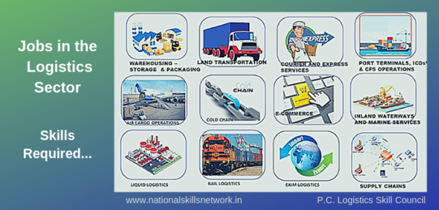
Figure 1 essential skills [1]

A successful career in logistics and administration depends on a strong combination of academic, technical, and interpersonal skills. During higher education, students develop communication, organisation, teamwork, problem-solving, time management, critical thinking, academic writing, and digital literacy. These capabilities are essential not only for academic achievement but also for professional practice.
Communication is widely recognised as a core skill in logistics, administration, and supply chain management [2]. Employers value graduates who can communicate clearly and professionally with customers, suppliers, managers, and colleagues. Digital communication tools are equally important in modern workplaces because they support coordination across departments. As a result, effective communication helps prevent misunderstandings, reduce operational errors, and ensure that essential information is conveyed accurately. [3]
Organisational and time-management skills are also essential because logistics professionals frequently manage schedules, documentation, deliveries, and multiple responsibilities simultaneously.[4] Effective time management streamlines workflows, reduces delays, and supports productivity and profitability. In academic settings, the same skill enables students to balance assignments, deadlines, and independent study, showing its value in both education and employment.
Digital literacy is another essential competency, as modern logistics and administrative roles require confident use of computer systems, databases, spreadsheets, and communication platforms. Many organisations also invest in training programmes to help employees strengthen their digital capabilities and adapt to ongoing technological change within the sector. Consequently, digital literacy does not simply support routine tasks; it underpins the ability to work effectively in increasingly data-driven and technology-enabled environments.
Critical thinking and problem-solving are essential for success in the digital era because they support informed judgement and effective responses to workplace challenges. In logistics and administration, employees must often identify delays, resolve scheduling conflicts, respond to unexpected disruptions, and make practical decisions under pressure.
Overall, the development of these skills during university study provides a strong foundation for future career progression. Communication supports professional relationships and accurate information exchange, organisational ability enables effective workload and deadline management, and digital literacy allows confident use of logistics software and administrative systems. When combined with critical thinking and problem-solving, these competencies enhance employability and prepare graduates to contribute effectively to modern logistics and administrative environments.

Task 1b - Turnitin Similarity check practice

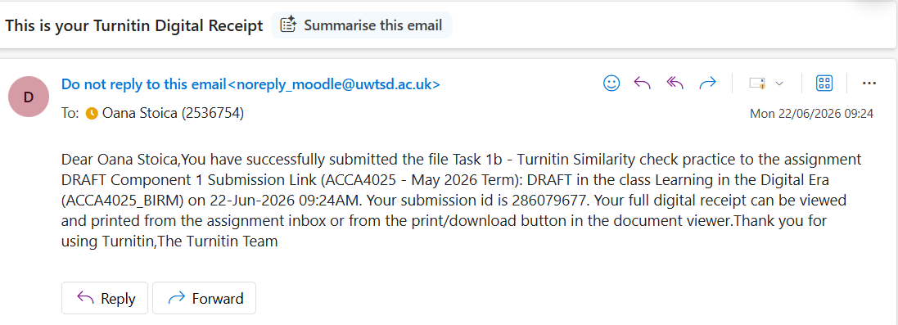

I received a similarity score 15% but this includes all the titles and biography list, after taking this out my similarity score was less than 5%
Engagement with Literature Skills – 40%. I have some omissions and minor errors that I rectified after my draft submission. I provided evidence of my research, using IEEE referencing system, including in-text citations and a biography list at the end of my work. My assessment include reference to at least 10 sources including academic poster and online e-portfolio. I used more the 350 words required on one of my tasks, but I also rectified after my draft submissions.
Knowledge and Understanding Skills – 80% I can demonstrate knowledge of the underlying concepts and principles associated with my area(s) of study.
Cognitive and Intellectual Skills 50% Limited attempt at evaluation of the underlying concepts and principles, tending towards description.
Practical Skills 80%– I will mark myself now after submissions with 18 marks because now, my assessment presents my work in a clear structured and accessible way and provide evidence of engaging with the module’s online learning content.
Transferable Skills for Life and Professional Practic 60% - Completing this assignment helped me develop a range of transferable skills that are valuable for both everyday life and professional practice.

Task 2: Collaborative Teamwork and Professional Academic poster

Considerations of effective teamwork (MIND – MAP)

This section includes a mind map outlining the key features of effective teamwork, including communication, trust, shared goals, role clarity, and cooperation in logistics and administrative contexts.

Link https://mm.tt/map/4022138578?t=qzViX76hAc

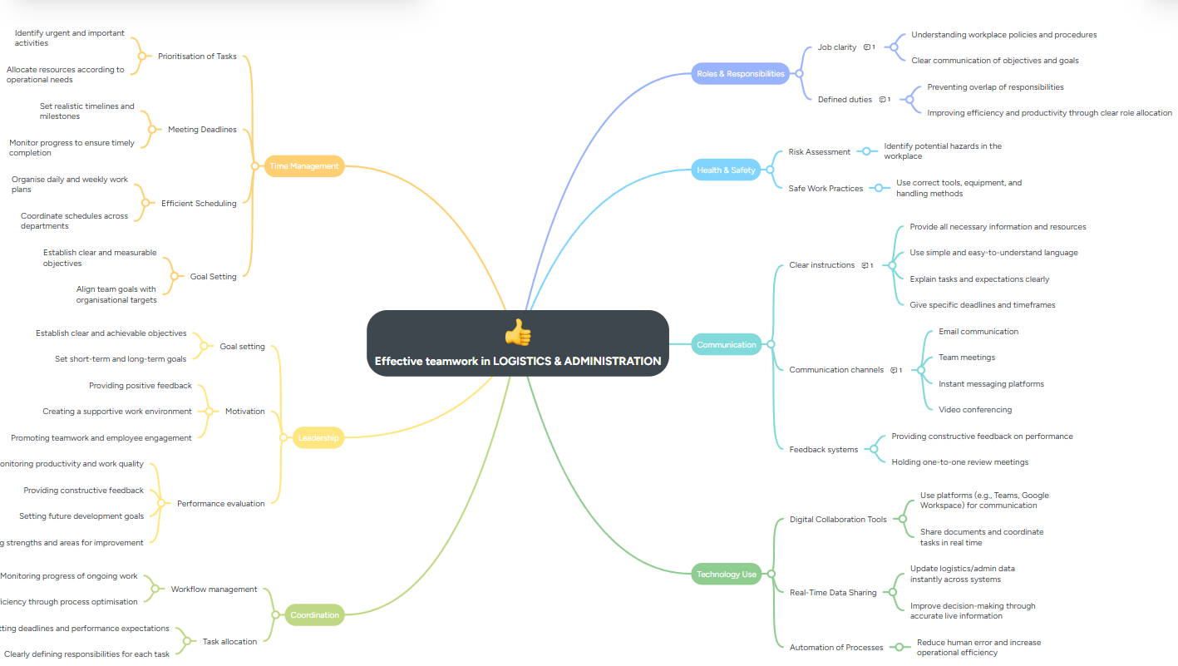

Professional academic poster: “Life is a Team Sport” in Logistics and Administration

The poster in this section is intended to communicate the value of teamwork in a concise and visually engaging format. Its message reinforces the idea that collaboration, mutual support, and shared responsibility are essential to effective performance in logistics and administration.

Academic Poster.docx
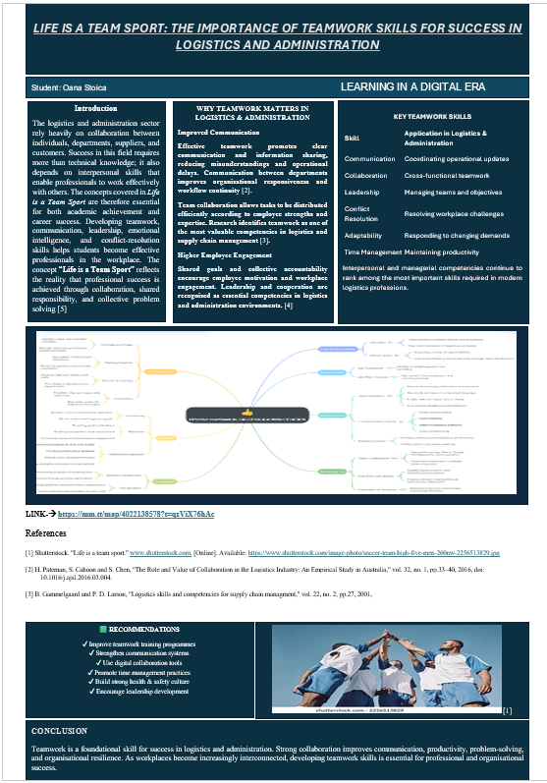
Task 3: Automatic Referencing Tool

Virtual Collaboration: Forming a Team

Virtual Communication in Team Formation within Logistics and Administration
Virtual communication is central to team formation in logistics and administration, particularly when organisations operate across multiple locations. Digital communication tools enable teams to coordinate tasks, clarify objectives, and maintain continuity across departments, sites, and time zones. As a result, effective virtual communication supports both operational efficiency and organisational cohesion.
When establishing a virtual team, clear roles and responsibilities are essential so that each member understands their duties and performance expectations. This reduces misunderstandings and improves coordination, which is particularly important in logistics, where delays or errors can affect the wider supply chain [5]. Structured communication therefore strengthens accountability and supports timely, accurate task completion.
A key advantage of virtual communication is that it keeps team members connected regardless of location. In logistics, staff may work across warehouses, distribution centres, and offices, while administrative employees may operate remotely or across multiple sites. Tools such as video conferencing, email, instant messaging, and collaborative platforms enable rapid communication and improve responsiveness when timely updates are required [6].
Because teams in logistics and administration often include members from different cultural and professional backgrounds, cultural awareness is also essential. Understanding different communication styles and working practices helps prevent conflict, promote inclusion, and strengthen collaboration. Effective virtual communication therefore supports a more engaged and consistently performing team [7].
Trust is another critical factor in successful virtual teams. Because members may have limited face-to-face interaction, managers should encourage open communication and regular engagement. Feedback, recognition, and active participation in virtual meetings help build trust and support collaboration among team members.[8] Overall, effective virtual communication improves teamwork, coordination, and performance in logistics and administrative settings.

Use of Refworks

RefWorks was used as an automatic reference management tool to organise and generate citations efficiently during the preparation of this work. The software supported the collection, storage, and management of academic sources in a central library. References were imported directly from online databases and organised into folders according to topic. RefWorks was then used to automatically generate in-text citations and compile the reference list in the required referencing style, reducing manual formatting errors and improving consistency.
Using RefWorks improves accuracy, maintains consistency in referencing, and helps streamline the overall academic writing and research process.
- Citation 5
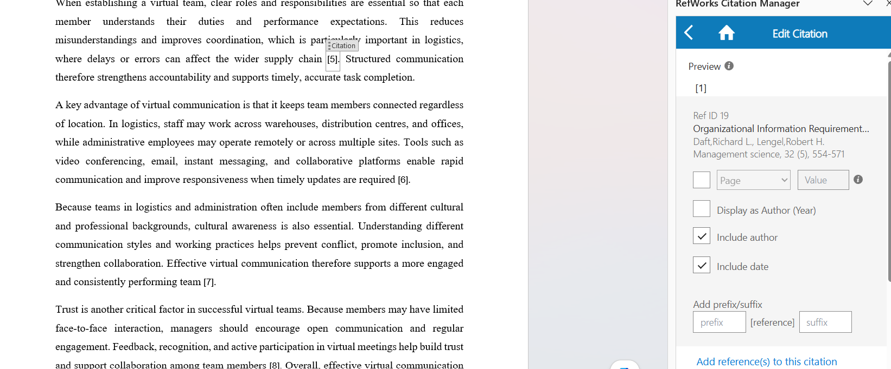
- Citation 6
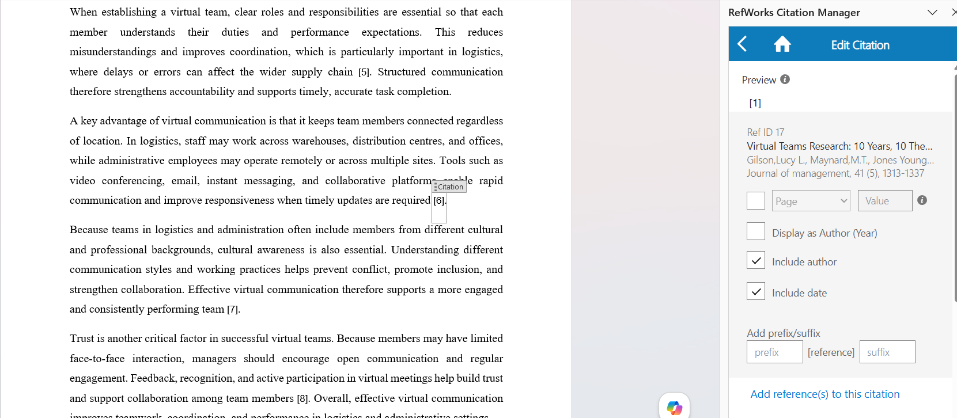
- Citation 7
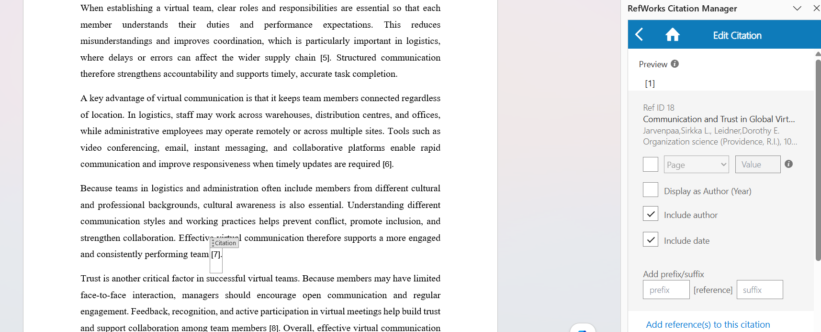
- Citation 8

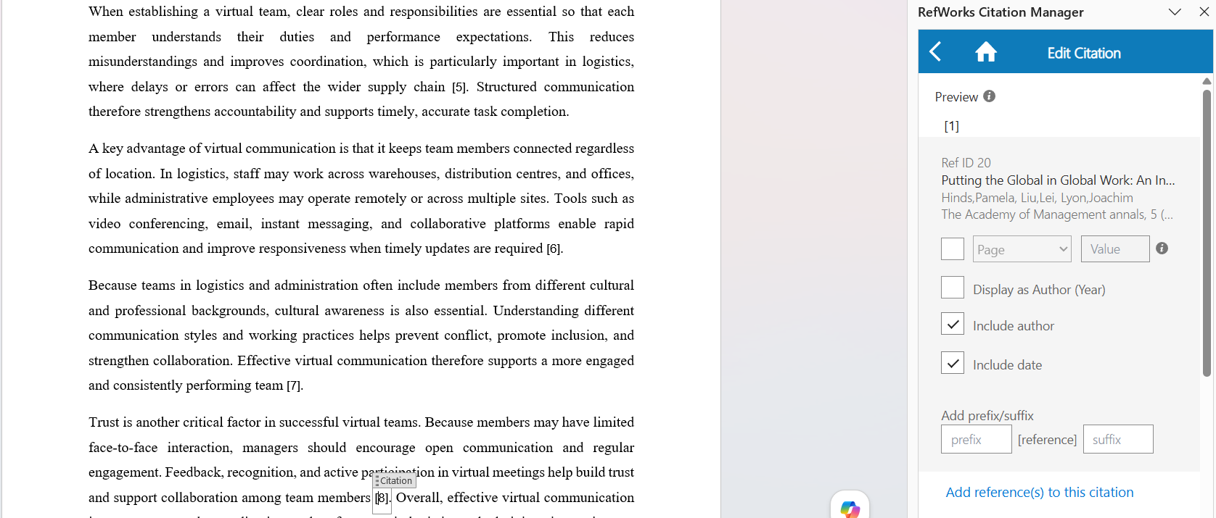
- Create references manually
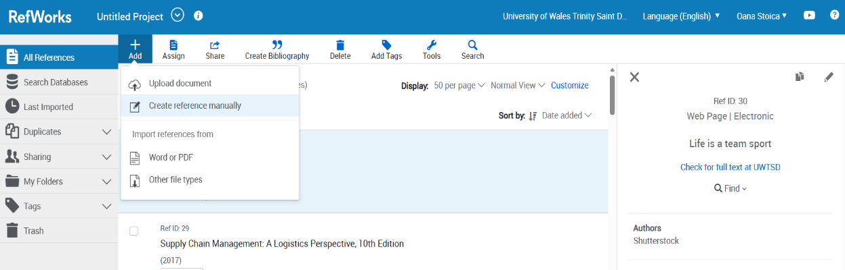

- Bibliography tab
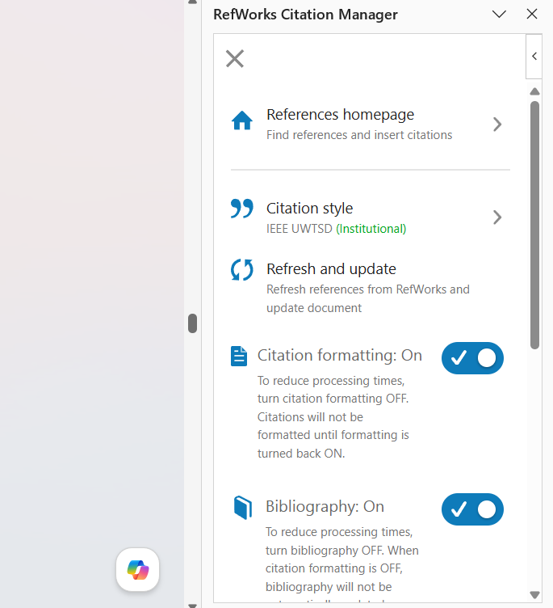
- IEEE Style
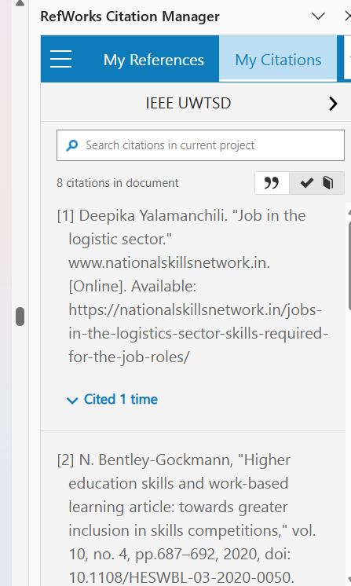

Task 4: E-Portfolio Creation and Review

Online e-portfolio

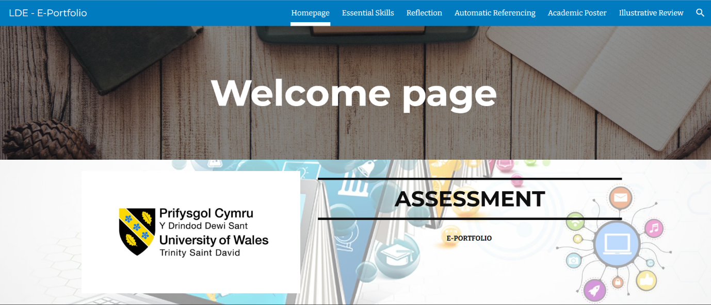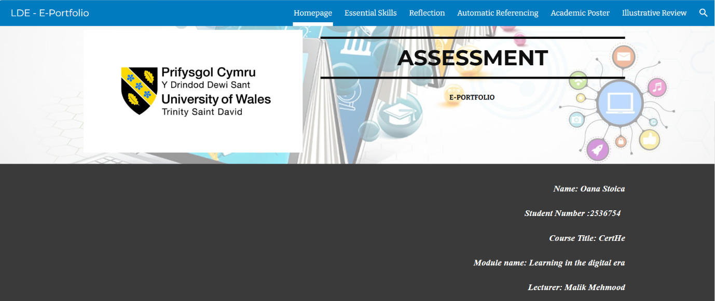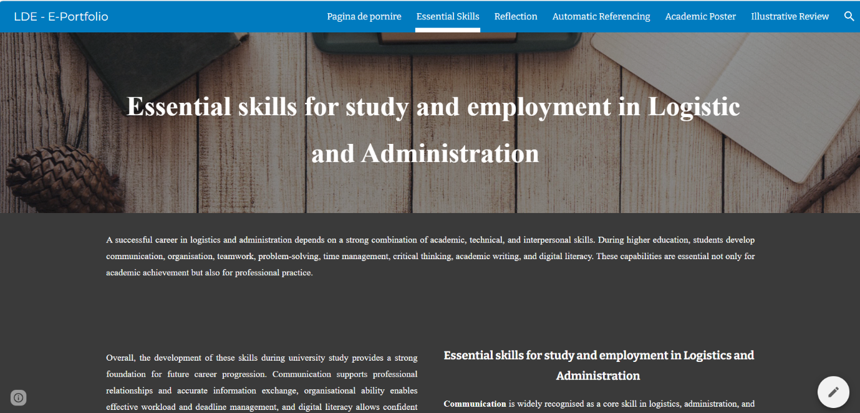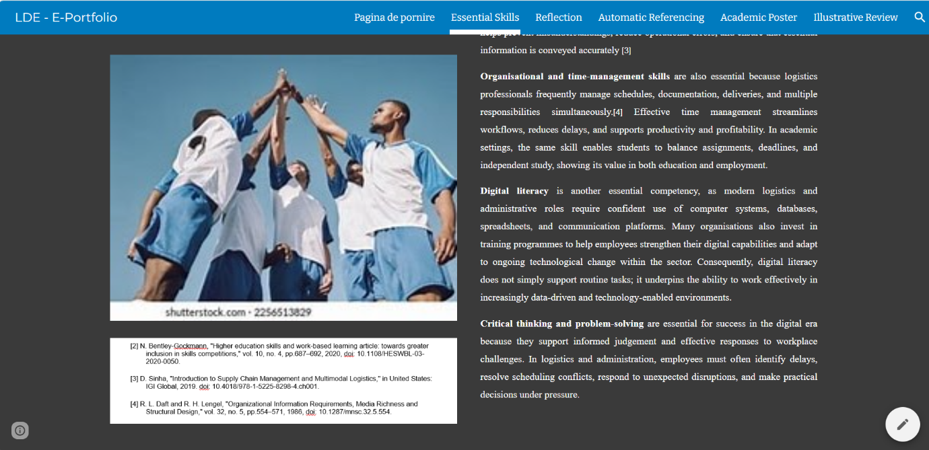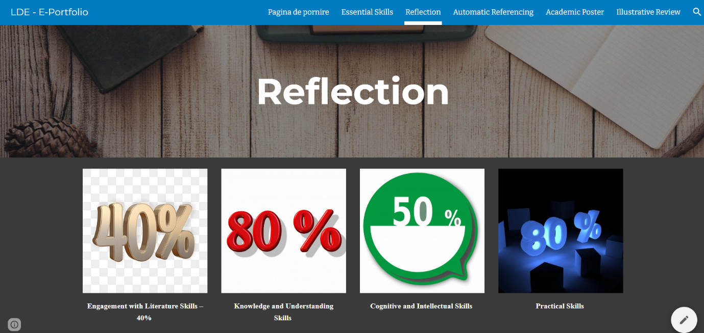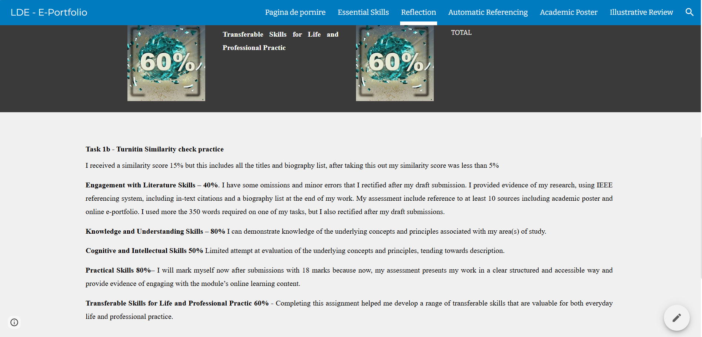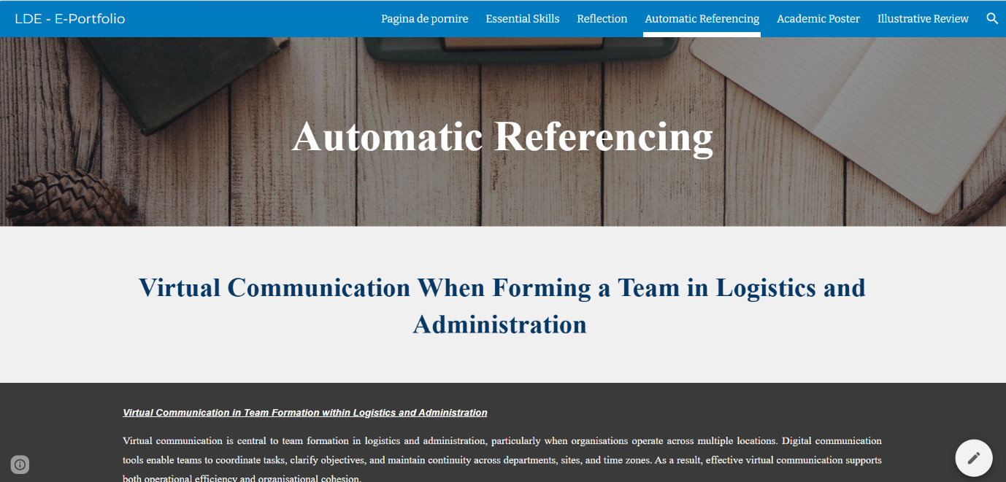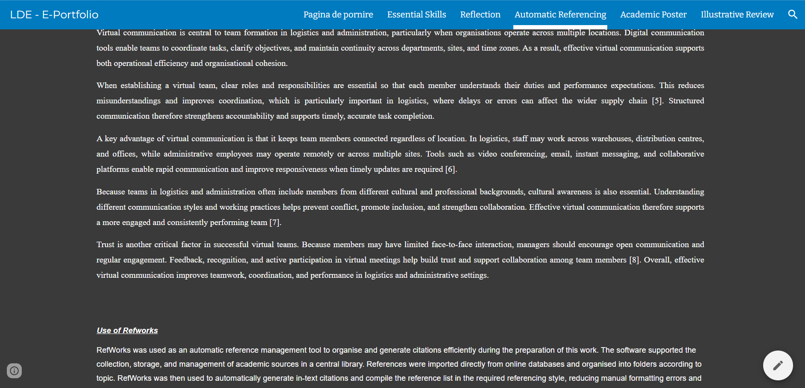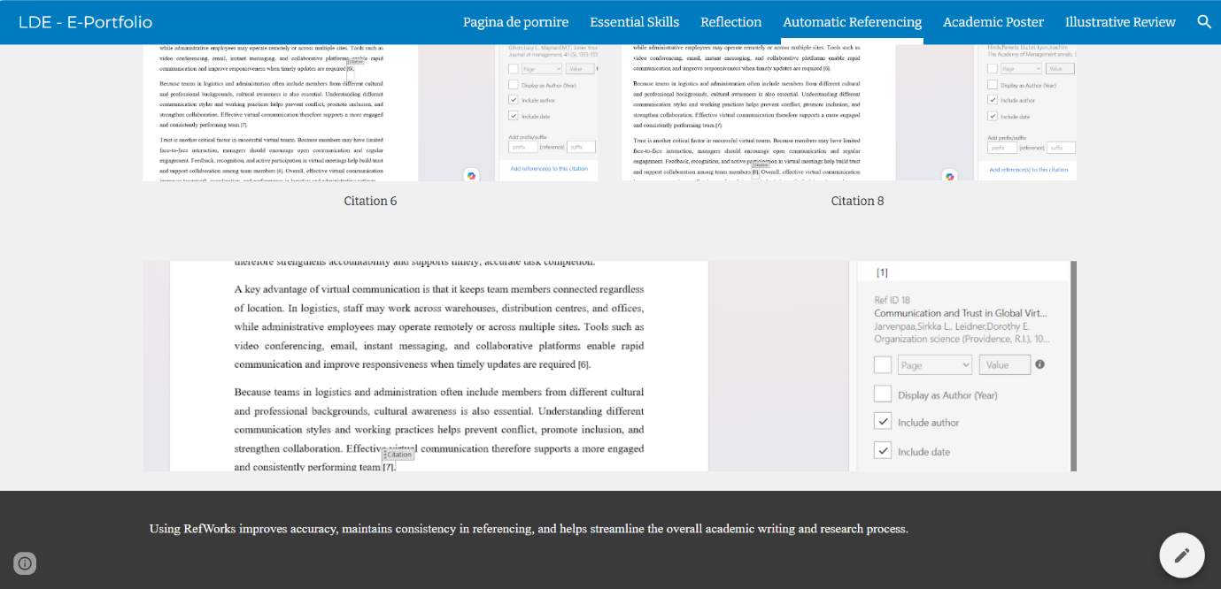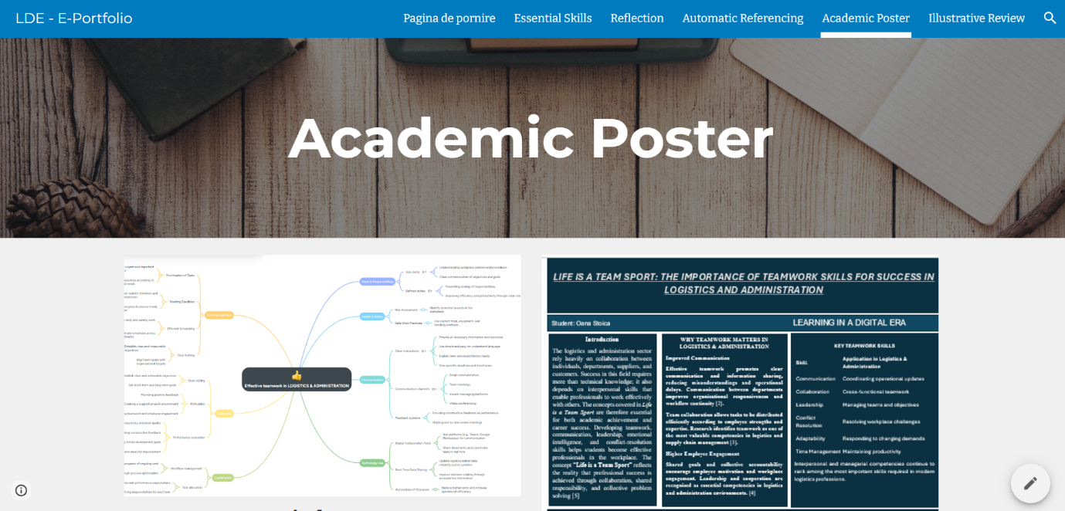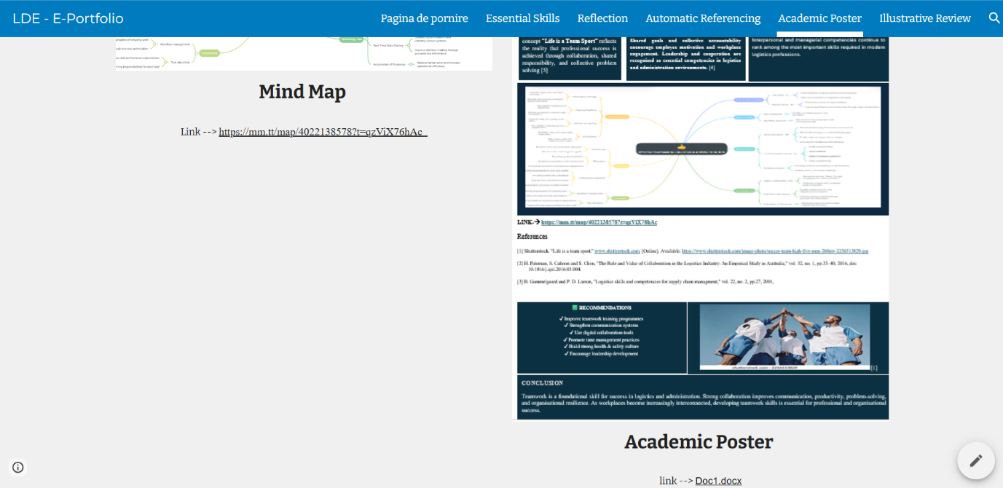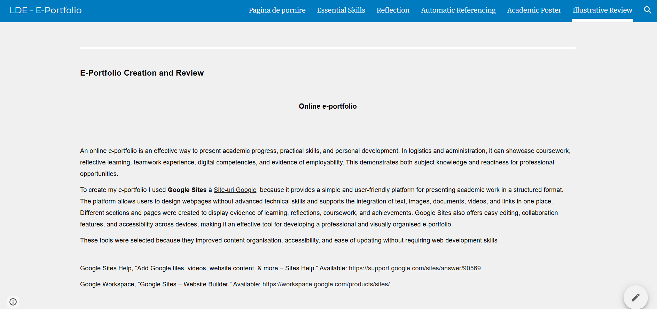
An online e-portfolio is an effective way to present academic progress, practical skills, and personal development. In logistics and administration, it can showcase coursework, reflective learning, teamwork experience, digital competencies, and evidence of employability. This demonstrates both subject knowledge and readiness for professional opportunities.
To create my e-portfolio I used Google Sites Site-uri Google because it provides a simple and user-friendly platform for presenting academic work in a structured format. The platform allows users to design webpages without advanced technical skills and supports the integration of text, images, documents, videos, and links in one place. Different sections and pages were created to display evidence of learning, reflections, coursework, and achievements. Google Sites also offers easy editing, collaboration features, and accessibility across devices, making it an effective tool for developing a professional and visually organised e-portfolio.
These tools were selected because they improved content organisation, accessibility, and ease of updating without requiring web development skills [9][9]
Google Sites Help, “Add Google files, videos, website content, & more – Sites Help.” Available: https://support.google.com/sites/answer/90569
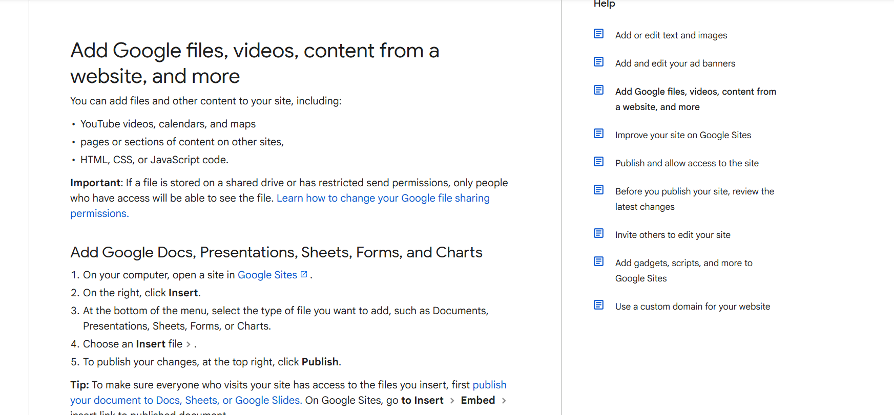
Google Workspace, “Google Sites – Website Builder.” Available: https://workspace.google.com/products/sites/

Bibliography
[1] Deepika Yalamanchili. "Job in the logistic sector." www.nationalskillsnetwork.in. [Online]. Available: https://nationalskillsnetwork.in/jobs-in-the-logistics-sector-skills-required-for-the-job-roles/
[2] N. Bentley-Gockmann, "Higher education skills and work-based learning article: towards greater inclusion in skills competitions," vol. 10, no. 4, pp.687–692, 2020, doi: 10.1108/HESWBL-03-2020-0050.
[3] D. Sinha, "Introduction to Supply Chain Management and Multimodal Logistics," in United States: IGI Global, 2019. doi: 10.4018/978-1-5225-8298-4.ch001.
[4] R. L. Daft and R. H. Lengel, "Organizational Information Requirements, Media Richness and Structural Design," vol. 32, no. 5, pp.554–571, 1986, doi: 10.1287/mnsc.32.5.554.
[5] L. L. Gilson, M. T. Maynard, N. C. Jones Young, M. Vartiainen and M. Hakonen, "Virtual Teams Research: 10 Years, 10 Themes, and 10 Opportunities," vol. 41, no. 5, pp.1313–1337, 2015, doi: 10.1177/0149206314559946.
[6] S. L. Jarvenpaa and D. E. Leidner, "Communication and Trust in Global Virtual Teams," vol. 10, no. 6, pp.791–815, 1999, doi: 10.1287/orsc.10.6.791.
[7] P. Hinds, L. Liu and J. Lyon, "Putting the Global in Global Work: An Intercultural Lens on the Practice of Cross-National Collaboration," vol. 5, no. 1, pp.135–188, 2011, doi: 10.1080/19416520.2011.586108.
[8] "Google Sites Suport page." www.google.com. [Online]. Available: https://support.google.com/sites/answer/90569
[10] Aldi handbook – Internal document

