
University of Wales Trinity Saint David Birmingham

Report title: Reflective report on principles of health and social care practice
Name of the student: Azra Munirali Habib
Student ID:2507358
Module title: Principle of health and social care (BMHP5016)
Assignment title: Component 1 reflective report
Word count :2100

Contents
Introduction 2
Task 1: Reflection on importance of principles 3
Task 2: Practical example in practice 4
Task 3: Self-reflection 6
Conclusion 7
Reference list 9

Introduction
This reflective report aims to explore the principles of health and social care practice and their importance in delivering safe, effective and high-quality support. The purpose of this report is to reflect on real-life practice, develop professional understanding and identify how care workers can improve the experiences and outcomes of individuals. The report will examine three key principles: person-centred care, partnership working and ethical practice.
Person-centred care involves respecting individuals’ choices, needs, preferences and dignity, ensuring that support promotes independence and wellbeing (Department of Health and Social Care, 2014). Partnership working focuses on collaboration between care professionals, individuals, families and other relevant services to provide coordinated and effective support (NHS England, 2022). Furthermore, the report will explore ethical principles, including confidentiality, respect, equality and informed consent, and how these guide professional decision-making.
These principles will be explored through Robyn’s case study, published by NHS England, which highlights the challenges faced by an individual living with a spinal cord injury who experienced difficulties with inconsistent care and staffing. Robyn’s experience demonstrates how person-centred care, partnership working and ethical practice, supported by a personal health budget, helped her regain independence, pursue personal interests and improve her quality of life (NHS England, n.d.). Through reflection on this case study, the report will examine how these principles can be applied in everyday health and social care settings to improve individuals’ experiences, wellbeing and outcomes.

Task 1: Reflection on importance of principles
Person-centred care involves recognising that every individual is different and ensuring that their needs, wishes, beliefs and preferences are considered when providing care. The National Institute for Health and Care Excellence (NICE, 2018) emphasises the importance of involving people in decisions about their care and ensuring that the support they receive reflects their individual needs and aspirations. This approach helps promote dignity, independence and a sense of control over daily life. For example, when supporting an older person, a care worker should respect their usual routines and personal choices rather than making decisions on their behalf. Person-centred care can also be linked to Maslow’s (1943) theory of human motivation, which highlights the importance of belonging, self-esteem and personal fulfilment. However, staff shortages and time constraints can make it challenging for care workers to provide support that fully meets each individual’s needs.
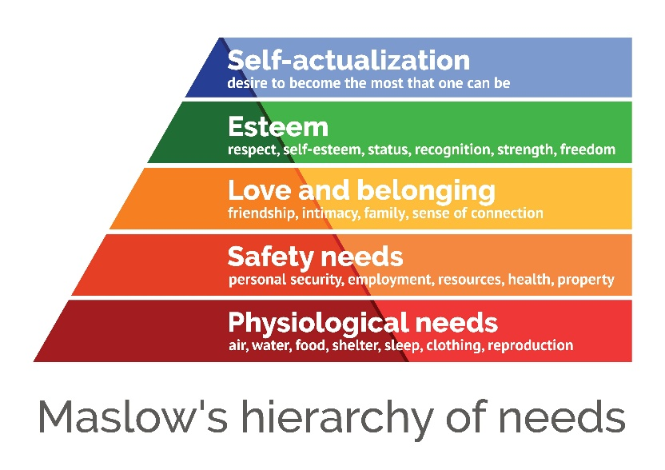

Figure 1: Maslow hierarchy of needs (Source: McLeod (2026)
Partnership working involves different professionals, individuals and, where appropriate, their families working together to provide effective care. NICE (2015) highlights the importance of coordinated support, particularly for older people receiving care at home. Good communication between professionals can prevent misunderstandings, reduce duplicated work and help individuals receive more consistent support. This also relates to Bronfenbrenner’s (1979) ecological systems theory, which explains how people are influenced by their relationships and wider social environment. Despite these benefits, partnership working can be difficult when professionals have different priorities or fail to share information effectively. Clear communication, mutual respect and agreed responsibilities are therefore essential.

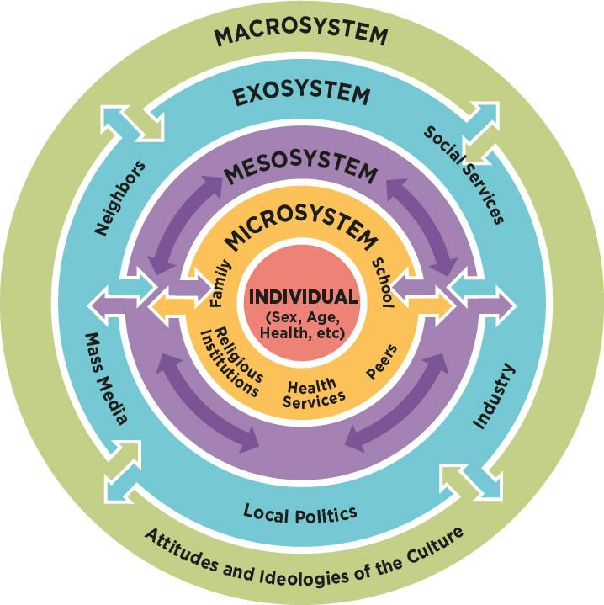
Figure 2: Bronfenbrenner’s ecological systems theory (Source: Wattpad (n.d.).
Ethical practice means making decisions that respect people’s rights and help protect their wellbeing. Beauchamp and Childress (2019) identify four important ethical principles: autonomy, beneficence, non-maleficence and justice. These relate to respecting individual choices, promoting wellbeing, avoiding harm and treating people fairly. In practice, a care worker should respect an individual’s decisions while also considering any risks to their safety. However, ethical challenges can arise when a person’s wishes conflict with safeguarding concerns. Practitioners must consider the circumstances carefully and follow relevant legislation and professional guidance to reach appropriate decisions.
These three principles are supported by the Care Act 2014, which emphasises individual wellbeing, involvement and control over day-to-day life in adult social care (Great Britain, 2014). Together, they can improve the quality of care by helping people feel valued and ensuring that support reflects their needs. However, putting them into practice consistently can be challenging because of limited resources, staff pressures and poor communication between services. Overall, person-centred practice, partnership working and ethical decision-making are essential to effective health and social care. When practitioners apply these principles consistently, they are better able to protect individuals’ rights, promote independence and provide compassionate care.

Task 2: Practical example in practice
Spinal cord injuries can have a significant impact on an individual’s independence, wellbeing and daily life. The Spinal Injuries Association reports that approximately 105,000 people in the UK live with a spinal cord injury (Spinal Injuries Association, 2025). This highlights the importance of appropriate, long-term health and social care support.
Robyn’s story, published by NHS England, demonstrates how person-centred care, partnership working and ethical practice can improve a person’s quality of life. Following a spinal injury in 2006, Robyn became tetraplegic and required 24-hour care. However, the care agency initially supporting her struggled with staff shortages and high turnover, leaving her with 36 different personal assistants in one year. This affected her independence and prevented her from maintaining her usual lifestyle (NHS England, n.d.).
Person-centred care became important when Robyn expressed her wish to take control of her support. Through a personal health budget (PHB), she was able to employ personal assistants who understood her needs and shared her interest in animals. This enabled her to return to carriage driving, work part-time and enjoy a more active social life. The Care Quality Commission (CQC, 2025) emphasises that care should reflect people’s individual needs and preferences. Robyn’s experience also reflects the NHS 6C’s: Care, Compassion, Competence, Communication, Courage and Commitment. These principles highlight the importance of listening to individuals, understanding their concerns and responding to what matters most to them (NHS England, 2015). By adopting this approach, practitioners helped Robyn rebuild her confidence and regain her independence.
Partnership working between Robyn, her personal health budget nurse and the Personal Budget Support Service (PBSS) helped her move away from the care agency. The nurse discussed her needs and goals, while the PBSS supported recruitment and employment arrangements. This demonstrates how collaboration can help people achieve outcomes that would be difficult to manage alone. The Department of Health and Social Care (2022) highlights the importance of integrating health and social care services to improve coordination and provide more person-centred support. For professionals, partnership working provided opportunities to coordinate support around Robyn’s priorities. However, the process took 18 months, and periods without updates left Robyn uncertain about progress. Better communication and regular updates could have reduced this frustration.
Ethical practice was demonstrated by respecting Robyn’s right to make decisions about her own life and care. Rather than focusing only on her physical needs, the support provided increasingly recognised her personal ambitions and independence. NICE (2018) recommends involving people in decisions about their care and supporting them to maintain independence. This approach benefited Robyn emotionally and socially, while encouraging professionals to recognise her abilities rather than focusing solely on her disability. Nevertheless, managing a personal health budget brought responsibilities, including recruiting staff and arranging reliable cover. Support with payroll and legal advice helped Robyn manage these responsibilities more confidently.
Robyn’s experience shows that personalised care does not always work perfectly from the beginning. The lengthy process and an initial support plan that failed to fully reflect her personality highlighted weaknesses in implementation. Robyn later rewrote her plan as her confidence grew, demonstrating the importance of listening and adapting support. Overall, her story illustrates how person-centred care, partnership working and ethical decision-making can improve independence, wellbeing and professional practice. It also highlights the need for consistent communication and practical support to make these principles effective.

Task 3: Self-reflection
Gibbs’ Reflective Cycle (1988) provides a structured way to reflect on experiences, identify learning and recognise areas for improvement. In this reflection, I will explore how my personal experience of helping a family member with a daily task relates to person-centred care, partnership working and ethical practice in health and social care. I will consider what I learned from this experience and how I can apply this learning to my future practice.
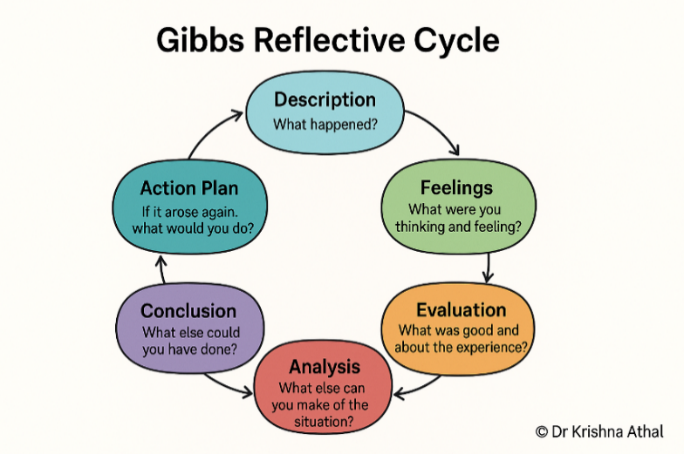
Figure 3: Gibbs’ reflective cycle (Source: Athal, 2025)
Stage 1: Description
I helped a family member with a daily task and recognised that people have different preferences, abilities and support needs. I wanted to be helpful and make the task easier for them. However, I realised that I should not assume that everyone wants the same type of support. This experience made me consider the importance of understanding another person's needs while respecting their independence and dignity.
Stage 2: Feelings
At the time, I wanted to help my family member, but I was not always certain whether I was providing the type of support they wanted. Looking back, I realise that asking questions and listening carefully would have helped me understand their preferences. This made me more aware of how communication can affect another person's confidence and willingness to express their needs. It also helped me recognise that I need to become more confident when communicating in unfamiliar situations.
Stage 3: Evaluation
One positive aspect of my approach was my willingness to help and my patience. I understood that people should be treated with dignity and respect. However, I could have improved my approach by asking more questions to establish what support my family member preferred. This experience taught me that although having good intentions is important, I also need to consider the other person's wishes rather than make assumptions.
Stage 4: Analysis
This personal experience helped me understand the importance of person-centred care. Every individual has different preferences, abilities and goals, so support should be adapted to their needs. The Nursing and Midwifery Council (NMC, 2018) emphasises the importance of treating people as individuals and respecting their dignity. Although I was helping a family member rather than working in a professional care setting, I can apply this learning to future practice by listening to individuals, asking about their preferences and encouraging independence wherever possible.
The experience also helped me understand the importance of partnership working. Although I was not working with a professional care team, helping another person showed me the value of listening, communicating and understanding their needs. In a health and social care setting, partnership working involves individuals, families and professionals communicating appropriately and working towards shared goals. I will need to develop my confidence in asking questions, sharing relevant information appropriately and working cooperatively with others.
Ethical practice is also relevant to my experience because it involves respecting individual rights, dignity and choices. I learned that helping someone should not mean making decisions on their behalf or taking away their independence. In future practice, I will aim to respect individuals' preferences, maintain confidentiality and follow appropriate safeguarding procedures. If I am unsure how to respond to a situation, I will seek guidance from an appropriate supervisor.
Stage 5: Conclusion
Reflecting on this experience has helped me recognise that patience and willingness to help are strengths, but I also need to improve my communication skills and confidence. I have learned that person-centred care, partnership working and ethical practice can be applied to everyday interactions as well as professional settings. If I experienced a similar situation again, I would ask the person what support they wanted and listen carefully to their response. This would help me respect their independence, dignity and personal choices.
Stage 6: Action Plan
To improve my future practice, I will develop my communication skills by practising active listening and asking questions to understand individual preferences. I will seek opportunities to gain experience through volunteering or work experience in a health or social care setting. I will also develop my knowledge of person-centred care, confidentiality, equality and safeguarding. When I begin working with professionals, I will aim to communicate clearly, understand my responsibilities and seek advice when necessary. I will continue reflecting on my experiences and using feedback to identify areas for improvement so that I can become a more confident and responsible practitioner.

Conclusion
In conclusion, person-centred care, partnership working and ethical practice are essential for providing safe, respectful and effective health and social care. Person-centred care ensures that individuals’ needs, preferences and choices are respected, while partnership working encourages effective communication and collaboration between individuals, families and professionals. Ethical practice promotes dignity, fairness, confidentiality and responsible decision-making. Reflecting on these principles has helped me recognise the importance of listening to others, respecting individual choices and understanding my professional responsibilities. It has also highlighted the need to improve my communication skills, gain practical experience and seek guidance from experienced professionals. By continuing to learn through training, feedback and reflective practice, I aim to develop my confidence and competence. Applying these principles consistently will help me provide compassionate, individualised care while continuing to grow professionally.

Reference list
Athal, K. (2025) Gibbs’ reflective cycle explained: A framework for structured self-reflection. Available at: https://drkrishnaathal.com/blog/gibbs-reflective-cycle-explained-a-framework-for-structured-self-reflection/ (Accessed: 20th October 2026).
Beauchamp, T.L. and Childress, J.F. (2019) Principles of Biomedical Ethics. 8th edn. New York: Oxford University Press.
Bronfenbrenner, U. (1979) The Ecology of Human Development: Experiments by Nature and Design. Cambridge, MA: Harvard University Press.
Care Quality Commission (CQC) (2025) Regulation 9: Person-centred care. Available at: https://www.cqc.org.uk/guidance-regulation/providers/regulations-service-providers-and-managers/health-social-care-act/regulation-9 (Accessed: 16th October 2026).
Department of Health and Social Care (2022) Health and social care integration: joining up care for people, places and populations. Available at: https://www.gov.uk/government/publications/health-and-social-care-integration-joining-up-care-for-people-places-and-populations (Accessed: 19th October 2026).
Department of health and Social care (2014) care act 2014. Available at https://www.legislation.gov.uk/ukpga/2014/23/contents(Accessed: 20th October 2026).
Gibbs, G. (1988) Learning by Doing: A Guide to Teaching and Learning Methods. Oxford: Further Education Unit, Oxford Polytechnic.
Great Britain (2014) Care Act 2014. Available at: https://www.legislation.gov.uk/ukpga/2014/23/contents (Accessed: 18th October 2026).
Maslow, A.H. (1943) ‘A theory of human motivation’, Psychological Review, 50(4), pp. 370–396. Available at: https://psychclassics.yorku.ca/Maslow/motivation.htm (Accessed: 21 October 2026).
McLeod, S. (2026) ‘Maslow’s hierarchy of needs’, Simply Psychology. Available at: https://www.simplypsychology.org/maslow.html (Accessed: 21 October 2026).
National Institute for Health and Care Excellence (NICE) (2015) Home care: delivering personal care and practical support to older people living in their own homes. NICE guideline NG21. Available at: https://www.nice.org.uk/guidance/ng21 (Accessed: 17th October 2026).
National Institute for Health and Care Excellence (NICE) (2018) People’s experience in adult social care services: improving the experience of care and support for people using adult social care services. NICE guideline NG86. Available at: https://www.nice.org.uk/guidance/ng86 (Accessed: 18th October 2026).
NHS England (2015) The 6 Cs: values for compassionate care. Available at: https://www.england.nhs.uk/6cs/wp-content/uploads/sites/25/2015/04/cnl-reading-120315.pdf (Accessed: 16th October 2026).
NHS England (n.d.) Robyn’s story. Available at: https://www.england.nhs.uk/personalisedcare/comprehensive-model/case-studies/robyns-story/ (Accessed: 16th October 2026).
NHS England (2022) working in partnership with people and communities: statutory guidance. Available at: https://www.england.nhs.uk/long-read/working-in-partnership-with-people-and-communities-statutory-guidance/
Nursing and Midwifery Council (NMC) (2018) The Code: Professional standards of practice and behaviour for nurses, midwives and nursing associates. Available at: https://www.nmc.org.uk/standards/code/ (Accessed: 18th October 2026).
Spinal Injuries Association (2025) Spinal cord injury awareness day – nine charities, one day, one goal. Available at: https://www.spinal.co.uk/news/spinal-cord-injury-awareness-day-2025/ (Accessed: 18th October 2026).
Wattpad (n.d.) Prof Ed Tidbits: Urie Bronfenbrenner – Ecological. Available at: https://www.wattpad.com/1278240723-prof-ed-tidbits-urie-bronfenbrenner-ecological (Accessed: 20th October 2026).

