
MSc Project Report
Privacy-Preserving Presentation Attack Detection Using a Low-Resolution Thermal Sensor Array
By
Khawja Redwanul Islam
MSc Data and Artificial Intelligence
University of Wales Trinity Saint David
Supervisor: Dr Abdallah Naser

Contents
1. Introduction and Background 3
2. Problem Statement 3
3. Research Question and Objectives 3
4. Related Work and Research Gap 4
5. Methodology 4
6. Expected Contributions 5
7. Indicative Timeline 6
8. Risks and Mitigation 7
9. References 7

List of Figures
Figure 1. Presentation attack detection processing pipeline 4
Figure 2. Indicative project timeline (Gantt chart) 6

List of Tables
Table 1. Indicative project timeline by phase 6
Table 2. Key project risks and mitigations 7

1. Introduction and Background
Biometric authentication systems such as facial recognition are increasingly used to secure personal devices and restricted spaces. A central vulnerability of these systems is the presentation attack, in which a person presents an artefact - for example, a printed photograph, a face image or video replayed on a screen, or a wearable mask - to be accepted as a genuine, live user. Presentation Attack Detection (PAD), also referred to as liveness detection, is the countermeasure that determines whether the biometric sample originates from a real, living person rather than from such an artefact.
Conventional PAD relies on high-resolution visible-light or near-infrared cameras. These approaches are effective but capture rich, personally identifiable imagery, which raises privacy concerns, and they can themselves be deceived by high-quality replays. Thermal imaging offers a complementary signal: a living human face emits a characteristic, structured pattern of body heat that inert artefacts such as paper or display screens do not reproduce. This project investigates PAD using a very low-resolution thermal sensor array, the Melexis MLX90640, which produces a 32x24-pixel (768-point) thermal image. At this resolution, the device cannot capture a recognisable face, so identity is protected by the hardware itself, while the gross thermal structure needed to separate a live face from a spoof is preserved.
This direction has been confirmed with the project supervisor, Dr Abdallah Naser, whose own research applies low-resolution thermal sensor arrays to privacy-preserving human monitoring [5]. The work is explicitly framed as presentation attack detection, not facial recognition. The system is not required to determine who a person is, only whether a genuine living person is present.

2. Problem Statement
High-resolution biometric PAD is mature but privacy-invasive and computationally demanding. Conversely, the use of ultra-low-resolution thermal sensors for PAD is comparatively unexplored, and there is no established public dataset that pairs the MLX90640 sensor with a representative set of presentation attacks. It is therefore an open question whether a 32x24 thermal array carries sufficient discriminative information to reliably distinguish bona fide presentations from attacks, and which machine-learning approach is best suited to such constrained data.

3. Research Question and Objectives

3.1 Research question
Can a low-resolution thermal sensor array (Melexis MLX90640, 32x24) reliably distinguish a live human face from presentation attacks - printed photographs, digital screen replays, and masks - in a privacy-preserving manner, and which lightweight machine-learning model performs best under this resolution constraint?

3.2 Objectives
- Design and assemble a thermal capture rig based on the MLX90640 sensor and a Raspberry Pi single-board computer.
- Prototype a processing and classification pipeline using existing public thermal face datasets.
- Collect a purpose-built dataset of bona fide and attack presentations captured on the MLX90640.
- Train and compare lightweight classifiers suitable for low-resolution data and CPU-only deployment.
- Evaluate detection performance using the standard PAD metrics defined in ISO/IEC 30107-3.

4. Related Work and Research Gap
Presentation attack detection for face recognition is surveyed comprehensively by Ramachandra and Busch [4], who categorise methods by the sensing modality and the cues exploited. The majority of published systems use visible or near-infrared imagery at relatively high resolution. Large thermal face resources such as the ARL Visible-Thermal Face Dataset [2] and the Tufts Face Database [3] have advanced thermal face analysis, but they are oriented toward recognition and cross-spectral matching rather than attack detection, and they are captured with high-resolution thermal cameras rather than a low-cost 32x24 array. The standardised evaluation framework for PAD is provided by ISO/IEC 30107-3 [1]. The gap addressed by this project is the combination of three elements that are rarely studied together: an extremely low-resolution thermal sensor, the presentation-attack-detection task, and an explicit privacy-preserving motivation arising from the sensor's inability to reveal identity.
This project also builds directly on the work of the supervisor, Dr Abdallah Naser. In a study of human distance estimation with a low-resolution thermal sensor array, Naser and colleagues note that conventional visual cameras raise “serious concerns about people’s privacy in indoor environments,” while high-resolution thermal cameras are costly, and they show that a low-resolution array is nonetheless sufficient for accurate human-centred sensing, reporting 96.8% accuracy in discrete distance estimation [5]. The same privacy-preserving rationale and the demonstrated adequacy of low-resolution thermal data motivate the present application of such a sensor to presentation attack detection.

5. Methodology

5.1 Hardware and capture setup
The sensing platform is the Melexis MLX90640 far-infrared array [6], which provides a 32x24 thermal image (768 pixels) at a programmable frame rate of up to 64 Hz over an I2C interface, with a typical accuracy of plus or minus 1 degree Celsius and a noise-equivalent temperature difference of about 0.1 K. A complete MLX90640 evaluation board is being provided by the supervisor, so no additional components need to be sourced. It is interfaced with a Raspberry Pi, which handles acquisition, storage and inference. The sensor and processing both operate comfortably on CPU, with no graphics accelerator required. The overall processing pipeline is shown in Figure 1.
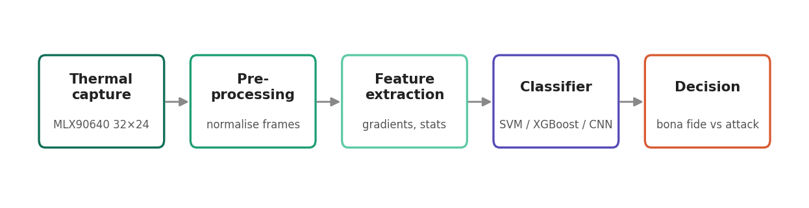
Figure 1. Presentation attack detection processing pipeline

5.2 Data
The project follows a two-stage data strategy agreed with the supervisor. In the first stage, publicly available thermal face datasets - principally the ARL Visible-Thermal Face Dataset and the Tufts Face Database - are used to develop and validate the processing pipeline and to establish baseline behaviour. In the second stage, a purpose-built dataset is collected on the MLX90640 itself. This dataset will contain bona fide presentations (live faces from multiple participants under varied distance and ambient conditions) together with the principal attack types: printed photographs, faces replayed on phone and tablet screens, and masks. Because no existing public dataset combines this exact sensor with presentation attacks, the custom dataset is itself a deliberate contribution of the work.

5.3 Models
Given the very small feature dimensionality (768 values per frame) and a modestly sized dataset, lightweight models are expected to outperform large deep networks, which would be prone to overfitting and unnecessary for CPU deployment. The study will compare classical classifiers - a Support Vector Machine and gradient-boosted trees (XGBoost) operating on extracted thermal features - against a compact convolutional neural network trained directly on the thermal frame. Features under consideration include the spatial temperature distribution, thermal gradients, and simple statistical descriptors of the heat map.

5.4 Evaluation
Performance is reported using the metrics standardised in ISO/IEC 30107-3: the Attack Presentation Classification Error Rate (APCER, the proportion of attacks wrongly accepted as genuine), the Bona Fide Presentation Classification Error Rate (BPCER, the proportion of genuine presentations wrongly rejected), and the Average Classification Error Rate (ACER, the mean of the two). Models are compared on these metrics under a common decision threshold, supported by ROC analysis and cross-validation.

6. Expected Contributions
- A demonstration of whether commodity low-resolution thermal hardware can support reliable presentation attack detection.
- A purpose-built MLX90640 dataset of bona fide and attack presentations for future research.
- A comparison of lightweight, CPU-friendly classifiers for thermal PAD, evaluated with standardised metrics.
- An assessment of the privacy advantage that follows from a sensor that cannot reveal identity.

7. Indicative Timeline
The schedule below covers the remaining nine weeks of active work, from 11 June to 12 August 2026, within the overall 16-week project. It includes a live demonstration of the system in the week of 30 July. Table 1 lists the phases with dates, and Figure 2 presents the same schedule as a Gantt chart, with the demonstration milestone marked.
Table 1. Indicative project timeline by phase
Phase | Activity | Dates (2026)
1 | Set up supervisor's MLX90640 evaluation board; build capture pipeline | 11-24 Jun
2 | Prototype on public thermal datasets (ARL-VTF, Tufts); baseline model | 25 Jun-1 Jul
3 | Custom dataset collection: bona fide + spoof presentations | 2-15 Jul
4 | Model training, tuning and evaluation (APCER / BPCER / ACER) | 16-29 Jul
5 | Build real-time demonstration and present it | 30 Jul-5 Aug
6 | Analysis, write-up and report submission | 6-12 Aug
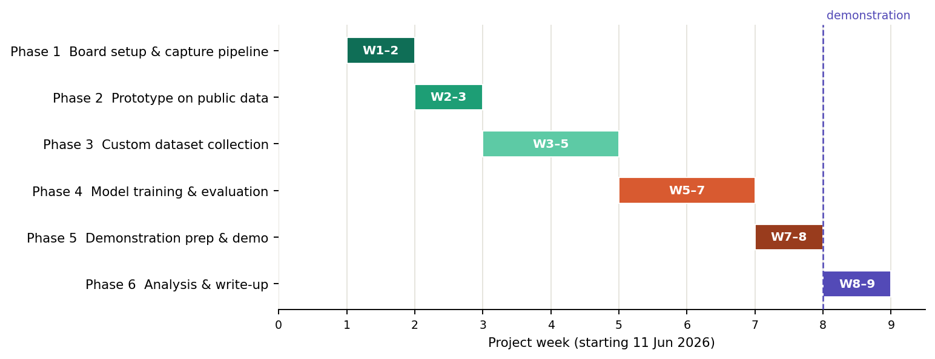
Figure 2. Indicative project timeline (Gantt chart)

8. Risks and Mitigation
Table 2. Key project risks and mitigations
Risk | Mitigation
No public dataset matches the 32x24 sensor and spoof types | Treat custom data collection as a core deliverable; use public sets only for prototyping the pipeline
Low resolution limits separability of subtle attacks | Focus first on high-contrast attacks (print, screen); add thermal-specific features (gradients, temperature distribution)
Small dataset causes overfitting in deep models | Prefer lightweight classifiers (SVM, XGBoost) and a shallow CNN; use cross-validation and augmentation
Environmental heat sources affect readings | Record under varied ambient conditions; document protocol; normalise per-frame temperature

9. References
References follow the IEEE citation style and are cited numerically in the text above.
- ISO/IEC, "Information technology - Biometric presentation attack detection - Part 3: Testing and reporting," ISO/IEC 30107-3:2017, International Organization for Standardization, 2017.
- D. Poster, M. Thielke, R. Nguyen, S. Havvaei, K. Brody, et al., "A large-scale, time-synchronized visible and thermal face dataset," in Proc. IEEE Winter Conf. Applications of Computer Vision (WACV), 2021, pp. 1559-1568.
- K. Panetta, Q. Wan, S. Agaian, S. Rajeev, et al., "A comprehensive database for benchmarking imaging systems," IEEE Trans. Pattern Anal. Mach. Intell., vol. 42, no. 3, pp. 509-520, Mar. 2020.
- R. Ramachandra and C. Busch, "Presentation attack detection methods for face recognition systems: A comprehensive survey," ACM Comput. Surv., vol. 50, no. 1, pp. 1-37, 2017.
- A. Naser, A. Lotfi, and J. Zhong, "Towards human distance estimation using a thermal sensor array," Neural Computing and Applications, vol. 35, no. 32, pp. 23357-23367, 2021, doi: 10.1007/s00521-021-06193-2.
- Melexis Technologies NV, "MLX90640 32x24 IR array datasheet," Melexis, 2019. [Online]. Available: https://www.melexis.com

