Kai Probert 2200897
15/05/2023
Introduction to web and data concepts (acca4023) gareth

Table of Contents
Introduction 1
Requirements 1
Implementation 2
Home Page: 2
General History Page: 2
Live Tours Page: 3
New Music Page: 3
Contact Us Page: 4
Validation 4
Validation for Homepage HTML: 4
Validation for Homepage CSS: 5
Evaluation 5
Evaluating Web Usability 5
Web Accessibility 6
Search engine optimization 6
Evaluation of website 7
Usefulness 7
SEO 7
Accessibility 7
References 8
Appendices 8

Introduction
In this report I will cover the requirements to my website, all of the implementation via screenshots, show validation and if necessary, explain errors. I will also evaluate my website and explain certain terms and how they affect the quality of my website.

Requirements
My website was created for the purpose of explaining the band Paramore, explaining all the albums they made, the bands history when they are expected to be touring ect. I aimed to cover all of the band’s major history points into a condensed easy to understand format that anyone can read and learn about the band. I intend to make my webpage for other Paramore enthusiasts, around the age of 18-28. Although, I believe that anyone can use the webpage and learn more about the band.

Implementation

Home Page:
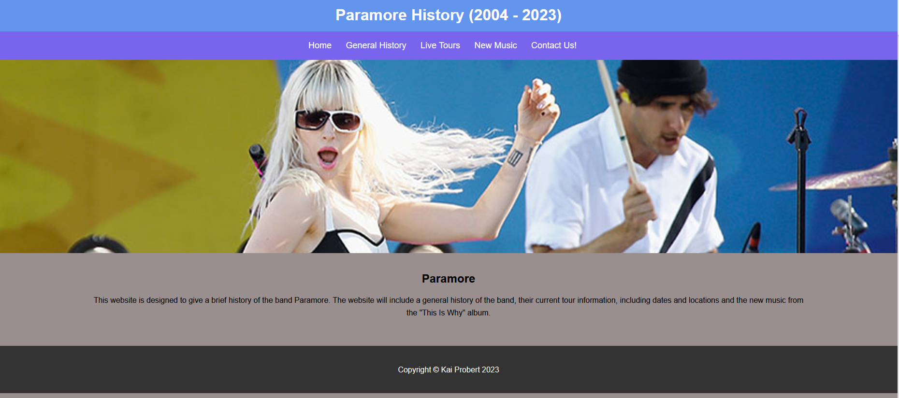

General History Page:
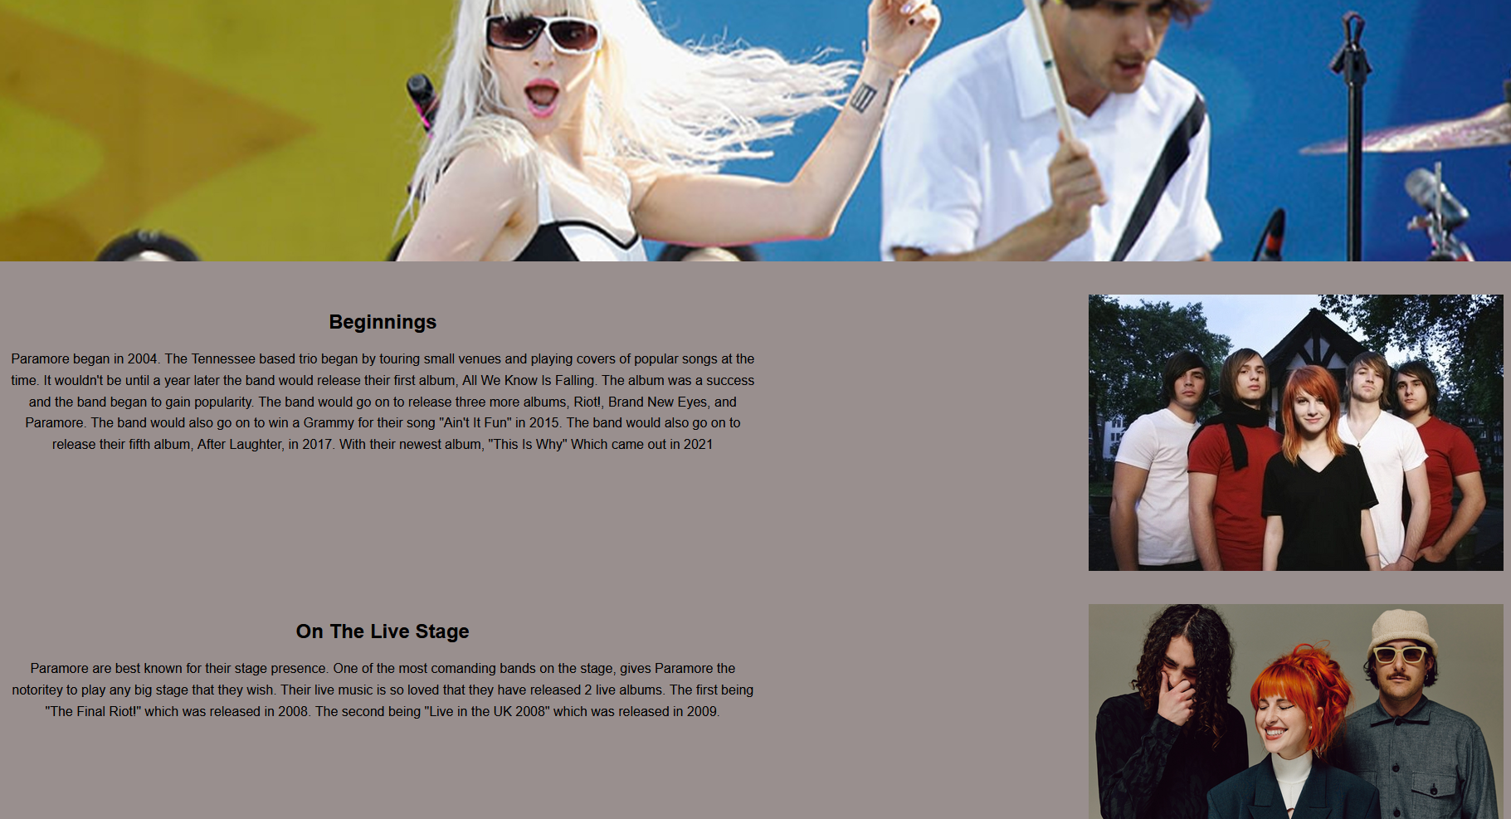

Live Tours Page:
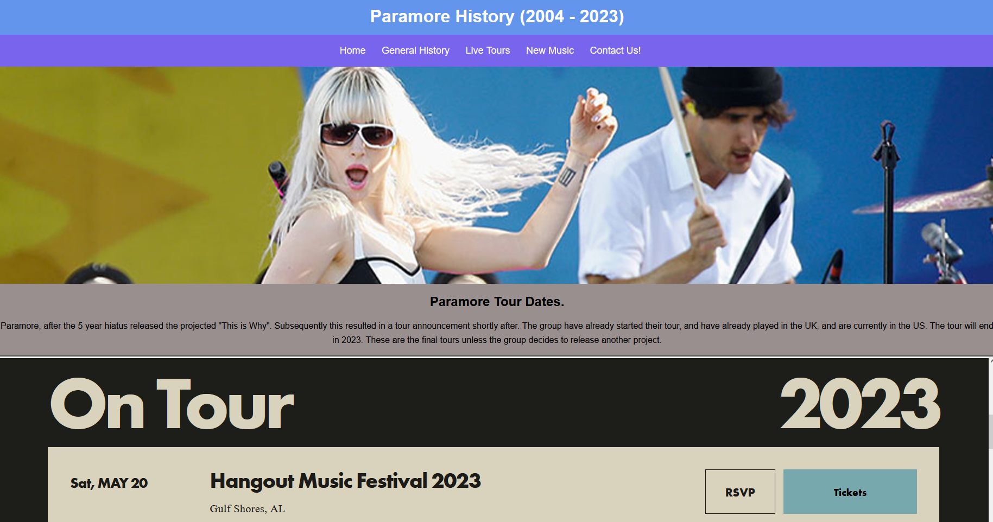

New Music Page:
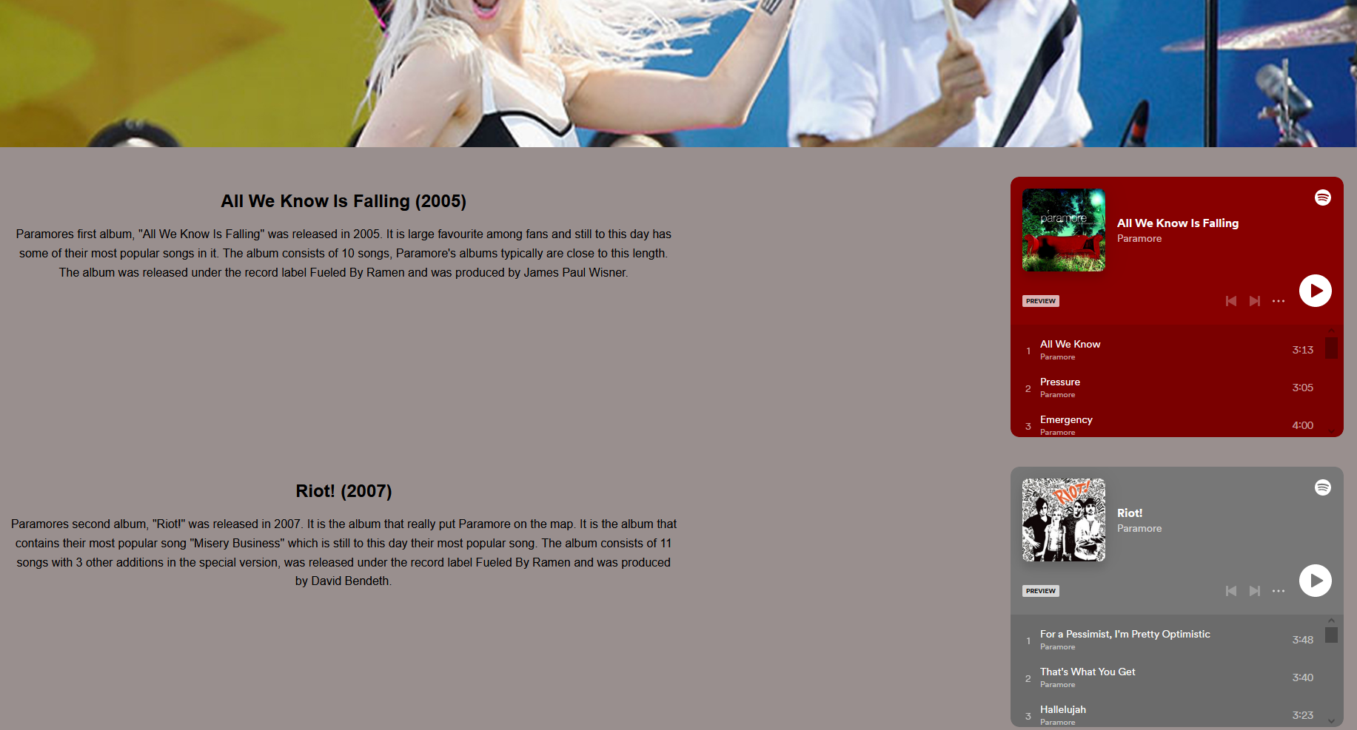

Contact Us Page:
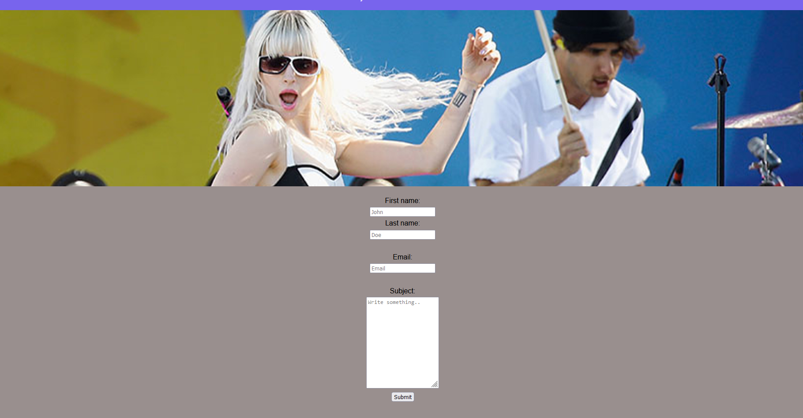

Validation

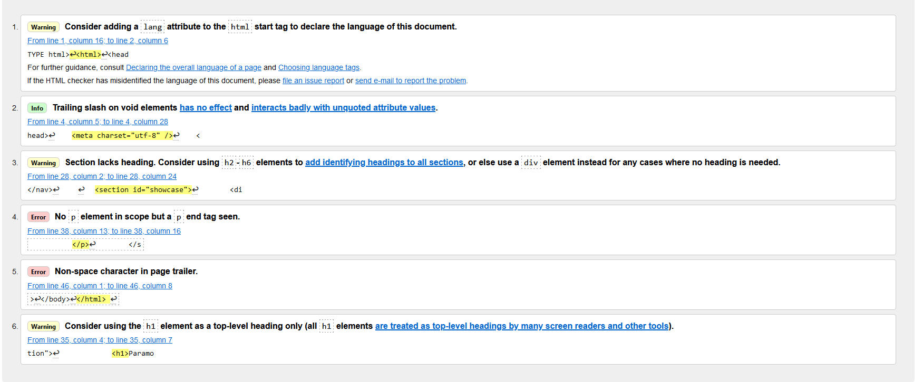
Validation for Homepage HTML:

For the first error (4.) I accidentally placed a </p>, where I had already closed that paragraph. So, I simply removed the extra element to fix the error.
For the second and last error, an invisible character was at the end of my </html> tag, so I removed it to get rid of this error.

Validation for Homepage CSS:
There was one error. I accidentally labelled an element as float, this wasn’t necessary in my CSS, so I removed it. That removed the error.

Evaluation

Evaluating Web Usability
Web usability focuses on certain elements and processes that allow the web page to be easier to use for the end user. This paper is written to display the uses for a student website that has been deemed underutilized. The project is described as a “opportunity to make an investment in a university’s website.” ^{[1]} It makes observations about what parts of the webpage is underused and how a solution can be found for it.
Web usability is vital for a website to gain success and traffic. If a website doesn’t utilize Web usability correctly, it can lead to a lack of engagement with the pages elements, lower rate of users going from one page to another leading to people leaving the page without viewing it all. There are many ways to solve this problem, its important to contrast the nature of the problem, so you can efficiently solve it. The most obvious option to increase a websites usability, is by giving it a redesign to more effectively reach its target audience while remaining to be interactive and engaging. A website that doesn’t efficiently reach this goal could be due to it having a lack of general options to allow the user to bounce to other pages, or also having too many making the website come across as far to complex in nature. Making sure you have an option to easily search the website is extremely important. Otherwise storing information inside of other pages making it non accessible without clicking can be a major downside as the end user may believe that what they are looking for isn’t on the page. So, reducing the number of clicks to a reasonable amount, while still having containers for all the information is paramount.
The paper that I’m referring to covers a student web page and its underutilization. It explains multiple ways that they could change the page using observations from the page’s users, while also using peer University pages to allow for a better understanding of what the website requires. They also used focus groups to figure out the problems with the page, from unbiased sources. It covers possible causes of the performance gap and recommends different intervention methods to bring fixes. Overall, it recommends that the site gets a redesign, while also focusing on fixing the navigation methods to get around the page.

Web Accessibility
Web Accessibility is key to allow all users to visit pages and get the information that they require. Web accessibility is defined by users who require extra assistance to get around a web page (Persons With a Disability). The WCAG (Web Content Accessibility guidelines) provides a strong overview of what a website and its creators should focus on to make it accessible to anyone. In the age of information, its growing more and more important to allow any users a way to allow them to use any information that is online. There should be no barriers to accessing this information.
This paper is focused on the Indian population, it focuses and lays out the amount of disabled non-working population. The large majority being in seeing, hearing and speech. Using online free to access tools, most importantly the aXe online web extension. They could use it to report on any WCAG guidelines that are violated ^{[2]} by any page they check. The highest number of violations was in the websites not having sufficient colour contrast. This affects the visually impaired the most. While also affecting people with Dyslexia, due to text being harder to read. Also, a large number of images that did not contain alt texts were found to be violations, while also links not having visible text. All these affect the visually impaired the most. While other elements having violations that affect others, also. There where a small selection of pages with Violations in the hundreds.
Overall, there is a large gap in websites following the guidelines to help assist those that requires it. A good website will make sure that all of their images are given a alternative text that is related to the image. Having a colour contrast that won’t affect the user’s ability to read and making sure links are visible. These are just a few of the things that a good website should deliver on to allow the user to have a good experience and find all the information they were looking for.

Search engine optimization
SEO (search engine optimization) is an extremely important tool that is utilized by the highest visited websites to its fullest. It is what determines a websites success, as the higher you are on the web result, the higher your chance of client turnover.
To get a high SEO result, you need to make sure that your website covers all current trends, while also still being marketed to your target audience. Certain options are more viable than others. It is believed that what browser you are using and the search engine that you used can affect your SEO result. It also massively matters what age you are, what you typically use the web for and what devices you use.
The paper focuses on generating lots of results using surveys and getting a unbiased result that can be used to determine a SEO result for each user. It asks questions of the users age web usage, what they browse for typically ^{[3]} and other questions of a similar vein. It compiles the results, puts them into a final form that interprets the data given. They found that users that typically use the internet for e-commerce or social media in their professional work typically have a high Affinity to SEO. It is also found that depending on the screen size that you are using, it can give you different advertisements based on it.
Overall, SEO is one of the most important features to making a website successful, noticing current trends and advertising to people who are SEO sensitive, allows for the website creator to more efficiently target their audience.

Evaluation of website

Usefulness
The overall design of my website is simple to understand and navigate. All relevant information is on each page and the navigation menu is at the top of the page and is hard to miss. I think it is functional as the user can find any information they are looking for on each different page. I made sure to add context for understanding while not making the page overly unbearable and unbalanced. It looks simple, but I think the specific font type and background colour allow the end user to easily read the webpage without problem. I also made sure that the website was easy to navigate as I made sure the navigation bar was always at the top correctly labelled. The website is useful to anyone that is looking for specific information about Paramore.

SEO
Some of the SEO techniques I implemented was making sure keywords were contained in the page. Allowing my website to have a higher SEO scoring than some other pages. I also made sure to add images with alt text so that a user looking up something specific would still allow the SEO to find my page easier thanks to the use of the alt text on every image. I made sure that I used specific album names, and the full names of any band members so that people looking for a specific member of the band can also find my webpage. I think my SEO is strong and allows for a user to find my website without much struggle. I also named each tab “We Are Paramore!” as it is the bands key phrase when starting a set live. It has become very popular within the Paramore subculture and is one of the most defining things that people search for when looking for certain live performances. Although I think I could have added more to my website to improve the SEO. If I added social media to the webpage, I think it could have added more to it allowing for a better SEO result. I also believe that I could have improved my Metadata optimization. Doing this would make the website more concise and gave it a higher search engine ranking, while also improving my clickthrough rate.

Accessibility
To make my website accessible to all users I made sure that I used a specific background colour that doesn’t clash with the text, allowing the user to easily read and understand what I am writing. All my images contained alt text which allow people to understand what the image contains regardless of their given impairments. I also made sure that all the headings, subheadings and text where all clearly different and was legible. I made sure that I used a legible font type face to not clash with anyone’s visual or other impairments. The text is also large on my webpage allowing for people to find it easier to read, while still making sure that the website looks good. Any audio that is played on my website is adjustable, allowing for the users to fine tune the audio to what they require. I think that I could of made some improvements to my accessibility in my webpage. Firstly I think that I could of done a better job of making a more concise and neat heading structure. My heading structure is somewhat unclear at times and resizing the headings using (h1,h2,h3 ect) would of massively helped improve the readability of my website. I also think my form could have had a better description in the placeholder values, making it easy to understand for the people who need it.
I used the contrastchecker.com website to find what I required to make improvements on and what I got correct on my first try and the site.
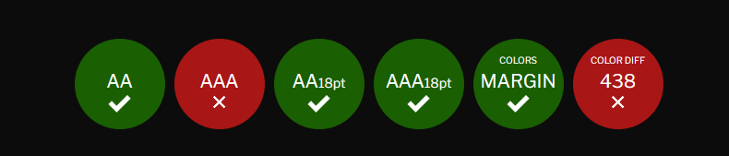
These where my results. Overall I am quite happy with it for a first try, although I think I could of done a better job with the text sizing as the readability for some of my font choices below 18 become hard to read. My colour choice I still like, I think it is a good contrast and allows the text to be readable. The reason I failed this part of the test was to do with my text sizing below 18 becoming harder to read and therefore failing. Next time I would make sure that my font choice makes it easier to read for any person. As this I believe was my one major improvement point.

References
[1] J. Snider and F. Martin, “Evaluating web usability,” Performance improvement (International Society for Performance Improvement), vol. 51, no. 3, pp. 30–40, 2012, doi: 10.1002/pfi.21252.
[2] S. Schultheiß and D. Lewandowski, "Data set of a representative online survey on search engines with a focus on search engine optimization (SEO): a cross-sectional study. [version 1; peer review: 1 approved, 1 approved with reservations]," F1000 Research; F1000Res, vol. 11, pp. 376, 2022. . DOI: 10.12688/f1000research.109662.1.
[3] A. Ismail and K. S. Kuppusamy, "Web accessibility investigation and identification of major issues of higher education websites with statistical measures: A case study of college websites," Journal of King Saud University.Computer and Information Sciences, vol. 34, (3), pp. 901-911, 2022. . DOI: 10.1016/j.jksuci.2019.03.011.

Appendices
Index.html
<!DOCTYPE html>
<html>
<head>
<meta charset="utf-8" />
<title>We Are Paramore!</title>
<link rel="stylesheet" type="text/css" href="css.css">
<link rel="stylesheet" type="text/css" href="home.css">
</head>
<body>
<header id="main-header">
<div class="container">
<h1>Paramore History (2004 - 2023) </h1>
</div>
</header>

<nav id="navbar">
<div class="container">
<ul>
<li><a href="index.html">Home</a></li>
<li><a href="GeneralHistory.html">General History</a></li>
<li><a href="LiveTours.html">Live Tours</a></li>
<li><a href="NewMusic.html">New Music</a></li>
<li><a href="ContactUs.html">Contact Us!</a></li>
</ul>
</div>
</nav>

<section id="showcase">
<div class="container">
</div>
</section>

<div class="container">
<section id="Description">
<h1>Paramore</h1>
<p>This website is designed to give a brief history of the band Paramore.
The website will include a general history of the band, their current tour information, including dates and locations and the new music from the "This Is Why" album. </p>
</section>
</div>

<footer id="main-footer">
<p> Copyright &copy; Kai Probert 2023</p>
</footer>
</body>
</html>

GeneralHistory.html
<!DOCTYPE html>
<html>
<head>
<meta charset="utf-8" />
<title>We Are Paramore!</title>
<link rel="stylesheet" type="text/css" href="css.css">
<link rel="stylesheet" type="text/css" href="about.css">
</head>
<body>
<header id="main-header">
<div class="container">
<h1>Paramore History (2004 - 2023) </h1>
</div>
</header>
<nav id="navbar">
<div class="container">
<ul>
<li><a href="index.html">Home</a></li>
<li><a href="GeneralHistory.html">General History</a></li>
<li><a href="LiveTours.html">Live Tours</a></li>
<li><a href="NewMusic.html">New Music</a></li>
<li><a href="ContactUs.html">Contact Us!</a></li>
</ul>
</div>
</nav>
<section id="showcase">
<div class="container">
</div>
</section>
<section id="Beginnings" class="container2 clear">
<div class="text">
<h1>Beginnings</h1>
<p>Paramore began in 2004. The Tennessee based trio began by touring small venues and playing covers of popular songs at the time. It wouldn't be until a year later
the band would release their first album, All We Know Is Falling. The album was a success and the band began to gain popularity. The band would go on to release
three more albums, Riot!, Brand New Eyes, and Paramore. The band would also go on to win a Grammy for their song "Ain't It Fun" in 2015. The band would also go on
to release their fifth album, After Laughter, in 2017. With their newest album, "This Is Why" Which came out in 2021</p>
</div>
<div class="image">
<img src="paramore.jpg" alt="Riot! Album Cover" height="333" width="500"
</div>
</section>

<section id="LiveStage" class="container2 clear">
<div class="text">
<h1>On The Live Stage</h1>
<p>Paramore are best known for their stage presence. One of the most comanding bands on the stage, gives Paramore the notoritey to play any big stage that they wish.
Their live music is so loved that they have released 2 live albums. The first being "The Final Riot!" which was released in 2008. The second being "Live in the UK 2008" which was released in 2009.
</p>
</div>
<div class="image">
<img src="thisiswhy.jpg" alt="Riot! Album Cover" height="333" width="500"
</div>
</section>

<section id="Fighting" class="container2 clear">
<div class="text">
<h1>In Band Fighting</h1>
<p>Although they are one of the most successful bands of all time, they are not immunue to contriversy. Almost all of this coming from directly inside the band.
Paramore has had a long history of band members leaving the band. The first being Josh and Zac Farro in 2010. The two brothers left the band due to creative differences.
They would go on to form their own band, Novel American from 2011 to 2014. The next member to leave the band was Jeremy Davis in 2015. He left the band due to personal reasons.
Although, Davis would sue the band for unpaid royalties. This was settled in 2017, outside of the court.
The most recent member to leave the band was Zac Farro in 2017. He left the band due to creative differences.
He would go on to form his own band, HalfNoise. Although Zac Farro and Taylor York are back in the band, and both worked on the new album.
</p>
</div>
<div class="image">
<img src="bandsplit.jpg" alt="Riot! Album Cover" height="333" width="500"
</div>
</section>

<section id="Recent" class="container2 clear">
<div class="text">
<h1>Where are they now?</h1>
<p>The band are currently touring the world with the new Album "This Is Why". They show no signs of slowing down and there are rumours of the band going to work on a New
album already.</p>
</div>
<div class="image">
<img src="paramore.jpg" alt="Riot! Album Cover" height="333" width="500"
</div>
</section>
<footer id="main-footer">
<p>Kai Probert &copy; 2023</p>
</body>
</html>

LiveTours.html
<!DOCTYPE html>
<html>
<head>
<meta charset="utf-8" />
<title>We Are Paramore!</title>
<link rel="stylesheet" type="text/css" href="css.css">
<link rel="stylesheet" type="text/css" href="tour.css">
</head>
<body>
<header id="main-header">
<div class="container">
<div id="header-text">
<h1>Paramore History (2004 - 2023)</h1>
</div>
</div>
</header>

<nav id="navbar">
<div class="container">
<ul>
<li><a href="index.html">Home</a></li>
<li><a href="GeneralHistory.html">General History</a></li>
<li><a href="LiveTours.html">Live Tours</a></li>
<li><a href="NewMusic.html">New Music</a></li>
<li><a href="ContactUs.html">Contact Us!</a></li>
</ul>
</div>
</nav>

<section id="showcase">
<div class="container">
</div>
</section>

<section id "text">
<h1> Paramore Tour Dates. </h1>
<p>Paramore, after the 5 year hiatus released the projected "This is Why". Subsequently this resulted in a tour announcement shortly after. The group have already
started their tour, and have already played in the UK, and are currently in the US. The tour will end in 2023. These are the final tours unless the group decides to
release another project. </p>
</section>

<div class="iframe-container">
<iframe src="Paramore Upcoming Tour Dates.htm" width="100%" height="700px"></iframe>
</div>
</body>
<footer id="main-footer">
<p> Copyright &copy; Kai Probert 2023</p>
</footer>
</html>

NewMusic.html
<!DOCTYPE html>
<html>
<head>
<meta charset="utf-8" />
<title>We Are Paramore!</title>
<link rel="stylesheet" type="text/css" href="css.css">
<link rel="stylesheet" type="text/css" href="NewMusic.css">
</head>
<body>
<header id="main-header">
<div class="container">
<h1>Paramore History (2004 - 2023) </h1>
</div>
</header>

<nav id="navbar">
<div class="container">
<ul>
<li><a href="index.html">Home</a></li>
<li><a href="GeneralHistory.html">General History</a></li>
<li><a href="LiveTours.html">Live Tours</a></li>
<li><a href="NewMusic.html">New Music</a></li>
<li><a href="ContactUs.html">Contact Us!</a></li>
</ul>
</div>
</nav>
<section id="showcase">
<div class="container">
</div>
</section>
<section id="AllWeKnowIsFalling" class="container2 clear">
<div class="text">
<h1>All We Know Is Falling (2005)</h1>
</h1>
<p>Paramores first album, "All We Know Is Falling" was released in 2005. It is large favourite among fans and still to this day has some of their most popular songs in it.
The album consists of 10 songs, Paramore's albums typically are close to this length. The album was released under the record label Fueled By Ramen and was produced by James Paul Wisner.</p>
</div>
<div class="iframes">
<iframe style="border-radius:12px" src="https://open.spotify.com/embed/album/67f6SSb8yKduNCK15DsafC?utm_source=generator" width="50%" height="352" frameBorder="0" allowfullscreen="" allow="autoplay; clipboard-write; encrypted-media; fullscreen; picture-in-picture" loading="lazy"></iframe>
</div>
</section>

<section id="riot" class="container2 clear">
<div class="text">
<h1>Riot! (2007)</h1>
<p>Paramores second album, "Riot!" was released in 2007. It is the album that really put Paramore on the map. It is the album that contains their most popular song "Misery Business" which is still to this day their most popular song.
The album consists of 11 songs with 3 other additions in the special version, was released under the record label Fueled By Ramen and was produced by David Bendeth.</p>
</div>
<div class="iframes">
<iframe style="border-radius:12px" src="https://open.spotify.com/embed/album/3UoOO8m0oxxvUHXUKf3qcZ?utm_source=generator" width="50%" height="352" frameBorder="0" allowfullscreen="" allow="autoplay; clipboard-write; encrypted-media; fullscreen; picture-in-picture" loading="lazy"></iframe>
</div>
</section>

<section id="BrandNewEyes" class="container2 clear">
<div class="text">
<h1>Brand New Eyes (2009)</h1>
<p>Paramores third album, "Brand New Eyes" was released in 2009. This album again delivers with the hard alt rock sound the band is known for. It has 11 songs, with a extra from the work they did for the Twilight movies. It was produced by Rob Cavallo.</p>
</div>
<div class="iframes">
<iframe style="border-radius:12px" src="https://open.spotify.com/embed/album/3CaQTJU2Cpx7GXTgenmb2r?utm_source=generator" width="50%" height="352" frameBorder="0" allowfullscreen="" allow="autoplay; clipboard-write; encrypted-media; fullscreen; picture-in-picture" loading="lazy"></iframe>
</div>
</section>

<section id="Paramore" class="container2 clear">
<div class="text">
<h1>Paramore (2013)</h1>
<p>Paramores fourth album and first album without the Farro brothers after their departure 3 years prior, "Paramore" (self titled) was released in 2013. It is by far the bands longest album, coming in at 17 songs. This is far beyond the length we've ever become to expect
with the band. The album was released under the record label Fueled By Ramen and was produced by Justin Meldal-Johnsen. The album is also the first to feature the bands new bassist, Justin York. Justin is the brother of Taylor York, the bands lead guitarist.</p>
</div>
<div class="iframes">
<iframe style="border-radius:12px" src="https://open.spotify.com/embed/album/4sgYpkIASM1jVlNC8Wp9oF?utm_source=generator" width="50%" height="352" frameBorder="0" allowfullscreen="" allow="autoplay; clipboard-write; encrypted-media; fullscreen; picture-in-picture" loading="lazy"></iframe>
</div>
</section>

<section id="After Laughter" class="container2 clear">
<div class="text">
<h1>After Laughter (2017)</h1>
<p>Paramores fifth album sees the return the farro brothers, although Josh Farro, would confirm he had not yet rejoined the band and was just filling in on drums. "After Laughter" was released in 2017. It is the first album that really sees the band move away from their core alt rock sound and more into a pop sound.
The album consists of 12 songs, it was released under Fuled By Ramen and was produced by the bands lead gituarist, Taylor York alongside Justin Meldal-Johnson.</p>
</div>
<div class="iframes">
<iframe style="border-radius:12px" src="https://open.spotify.com/embed/album/1c9Sx7XdXuMptGyfCB6hHs?utm_source=generator" width="50%" height="352" frameBorder="0" allowfullscreen="" allow="autoplay; clipboard-write; encrypted-media; fullscreen; picture-in-picture" loading="lazy"></iframe>
</div>
</section>

<section id="ThisIsWhy" class="container2 clear">
<div class="text">
<h1>This Is Why (2021)</h1>
<p>Paramores sixth album, "This Is Why" was released in 2021. It is the bands most recent album and is the first album to feature the bands new drummer, Zac Farro. Zac was the bands original drummer before he left in 2010.
The album consists of 11 songs, was released under the record label Fueled By Ramen and was produced by David Bendeth.</p>
</div>
<div class="iframes">
<iframe style="border-radius:12px" src="https://open.spotify.com/embed/album/6tG8sCK4htJOLjlWwb7gZB?utm_source=generator" width="50%" height="352" frameBorder="0" allowfullscreen="" allow="autoplay; clipboard-write; encrypted-media; fullscreen; picture-in-picture" loading="lazy"></iframe>
</div>
</section>
<footer id="main-footer">
<p> Copyright &copy; Kai Probert 2023</p>
</footer>

ContactUs.html
<!DOCTYPE html>
<html>
<head>
<meta charset="utf-8" />
<title>We Are Paramore!</title>
<link rel="stylesheet" type="text/css" href="css.css">
<link rel="stylesheet" type="text/css" href="NewMusic.css">
</head>
<body>
<header id="main-header">
<div class="container">
<h1>Paramore History (2004 - 2023) </h1>
</div>
</header>

<nav id="navbar">
<div class="container">
<ul>
<li><a href="index.html">Home</a></li>
<li><a href="GeneralHistory.html">General History</a></li>
<li><a href="LiveTours.html">Live Tours</a></li>
<li><a href="NewMusic.html">New Music</a></li>
<li><a href="ContactUs.html">Contact Us!</a></li>
</ul>
</div>
</nav>
<section id="showcase">
<div class="container">
</div>
</section>
<section id="Form">
<form>
<label for="fname">First name:</label><br>
<input type="text" id="fname" name="fname" placeholder="John"><br>
<label for="lname">Last name:</label><br>
<input type="text" id="lname" name="lname" placeholder="Doe"><br><br>
<label for="email">Email:</label><br>
<input type="text" id="email" name="email" placeholder="Email"><br><br>
<label for="subject">Subject:</label><br>
<textarea id="subject" name="subject" placeholder="Write something.." style="height:200px"></textarea><br>
<input type="submit" value="Submit">

</form>
</section>
<footer id="main-footer">
<p> Copyright &copy; Kai Probert 2023</p>
</footer>

css.css
body{
background-color:#998F8E;
color:#000;
font-family:Arial, Helvetica, san-serif;
font-size:16px;
line-height:1.6em;
margin:0;
}
body {
font-family: system-ui;
background: white;
color: #000;
text-align: center;
}

.container{
width:80%;
margin:auto;
overflow:hidden;
}

#main-header{
background-color:#6495ED;
color:#fff;
}

#navbar{
background-color:#7864ED;
color:#fff;
}

#navbar ul{
padding:0;
list-style:none;
}

#navbar li{
display:inline;
}

#navbar a{
font-size:18px;
padding-right:25px;
}

a{
color:white;
text-decoration: none;
}

a:hover{
color:yellow;
}

#main-footer {
background:#333;
color:#fff;
text-align:center;
padding:20px;
margin-top:40px;
}
#main{
width:70%;
padding:10px;
box-sizing: content-box;
}

#sidebar{
float:left;
width:30%;
background:#ED64DA;
color:#fff;
padding:10px;
box-sizing: content-box;
}

#showcase{
background-image:url("Layer\ 2.jpg");
background-size: 2000px;
opacity:1.0;
background-position:center right;
min-height:400px;
margin-bottom:20px;
text-align:center;
}

#showcase h1{
color:#fff;
font-size:30px;
line-height:1.6em;
padding:30px;
}

@media(max-width:600px){
#main{
width:100%;
float:none;
}

#sidebar{
width:100%;
float:none;
}

#navbar li{
display:block;
}

}

About.html
body{
background-color:#998F8E;
color:#000;
font-family:Arial, Helvetica, san-serif;
font-size:16px;
line-height:1.6em;
margin:0;
}
.clear::after {
content: "";
display: table;
clear: both;
}

.container2 {
display: flex;
padding: 20px;
}

.text {
flex: 1;
float: left;
}

.image {
flex: 1;
display: flex;
justify-content: flex-end;
float: right;
}

NewMusic.css
body{
background-color:#998F8E;
color:#000;
font-family:Arial, Helvetica, san-serif;
font-size:16px;
line-height:1.6em;
margin:0;
}
.clear::after {
content: "";
display: table;
clear: both;
}

.container2 {
display: flex;
padding: 20px;
}

.text {
flex: 1;
float: left;
}

.iframes {
flex: 1;
display: flex;
justify-content: flex-end;
float: right;
}

Tour.css
body{
background-color:#998F8E;
color:#000;
font-family:Arial, Helvetica, san-serif;
font-size:16px;
line-height:1.6em;
margin:0;
}
.text {
position: relative;
right: 10px;
transition: 0.5s;
outline: 0px;
border: 0px;
border-radius: 1px;
background-color: hsl(172deg 18% 27% / 0%);
font-size: 25px;
top: 100px;
text-align:center;
color:red;
}

