

LCLM5002- Developing and Managing Individuals and Teams

BA (Hons) Leadership and Management Skills for the Workplace
Component 2- Individual Report

Student ID: 2332190

Student Name: Vasile Slevoaca

Lecturer: Gregory Cowan

Module Leader: Nishi Ramsurrun, Doreen Nyaa Amundam

Table of Contents
1. Introduction 3
2. Factors related to business transformation, digital technology trends and flexible working arrangements 3
2.1 Business transformation factors 3
2.2 Digital technology trend factors 4
2.3 Flexible working arrangement factors 5
3. Contemporary HR practices addressing each factor 6
3.1 HR practices towards business transformation 6
3.2 HR practices towards digital technology 7
3.3 HR practices towards flexible working arrangements 7
4. Implementation procedures opted for departmental managers 8
4.1 Contemporary practices of departmental managers 8
4.2 Key strategies of contemporary practices of departmental managers 9
4.3 Challenges faced by departmental managers to deliver contemporary practices urgently 9
4.4 Evaluation framework of contemporary practices by departmental managers 9
5. Recommendations 10
6. Conclusion 10
7. References 11

1. Introduction
The HR role remains affected by various factors emerging from the internal and external environment of organisations. Issues related to trends, transformation and working arrangements remain critical to determine the essence of organisational performance. This report will explore the dynamics of HR practice, emerging technology trends and flexible working arrangements affecting Barclays Bank’s human resources. Since the organisation engages with each aspect of HR practice, the report has identified the suitability of Barclays to underline the implications. While each HR issue is highlighted, suitable HR practice will also be identified that are practiced contemporarily to address them.

2. Factors related to business transformation, digital technology trends and flexible working arrangements

2.1 Business transformation factors
Business transformation for the HR dynamics remains a significant corporate interest, which emerges from the changing landscape and the vision perceived by the leaders. While trying to implement the changes, the HR dynamics remain a major mediator between the processes. The foremost factor associable is the UK government’s response towards digital growth through the “Electronic Trade Documents Act” (ETDA), which has influenced the clarity of digital transformation (Barclays Corporate, 2025). Barclays Bank, in its banking sector, has effectively considered the movement towards digitalised transformation to lead and enhance the trade ecosystem. While considering the digital trade act, Barclays Bank has shown a massive interest in aligning the activities and legal considerations effectively.
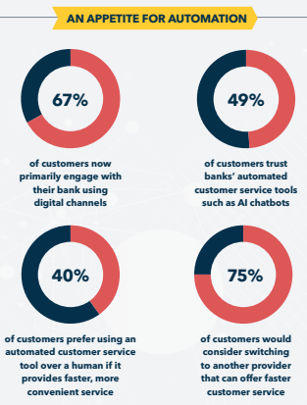
Figure 1: Barclays Bank’s interest in automated transformation
(Source: SAS, 2022)
Another major factor identified from the aspects of business transformation is the drive for customer experience in the fintech market. This is identified from the adoption of hyper automation in the corporation, highlighting a major transformation to orchestrate the business experience for the customers (SAS, 2022). Armstrong and Taylor (2023) also defined the development of digital capabilities in HR practice to align with modern market needs. This is also exemplified in Barclays’ partnership with Microsoft’s hyper automation.

2.2 Digital technology trend factors
Competitiveness and striving for innovation are major components of Barclays Bank as a corporation, which remains connected through the adoption of various initiatives and elements. Within the dynamics of digital trends, the fintech industry observes the rise of GenAI, which is addressed by Barclays to suit the needs of operations and workforce management. While competitiveness and innovation remain the core concern, the adoption of GenAI has addressed the procedures of sustainability and transformation for the business (Barclays Group, 2025). The figure below (Figure 2) describes the key activities related to the use of GenAI in the banking corporation to meet the organisational and market needs. It can also be contemplated that the necessity of the digital trend emerging in the market remains critical for HR and operations. The necessity of adaptive AI is considered a primary solution for achieving future endeavours and the competitive scale of the organisation spearheading the business operations effectively.
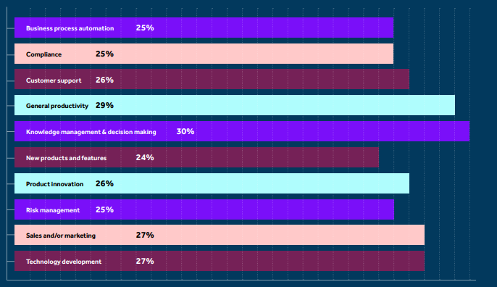
Figure 2: Uses of GenAI in Barclays Bank
(Source: Barclays Group, 2025)

2.3 Flexible working arrangement factors
The fintech industry is affected by the changing landscape revolving around the key factors of working arrangements. One of the major considerations is work-life balance and dynamics, which has become an emerging issue for the human resources in fintech to tackle. Budihal and Sathyanarayana (2025) described the rising issue of work-life balance, as the workers are reportedly facing heavy stress and job burnout. Emerging from this, a trend regarding the need for HRs to increase the focus on flexible working arrangements. This can be regarded as a major factor describing the necessity of HR functioning and consideration.
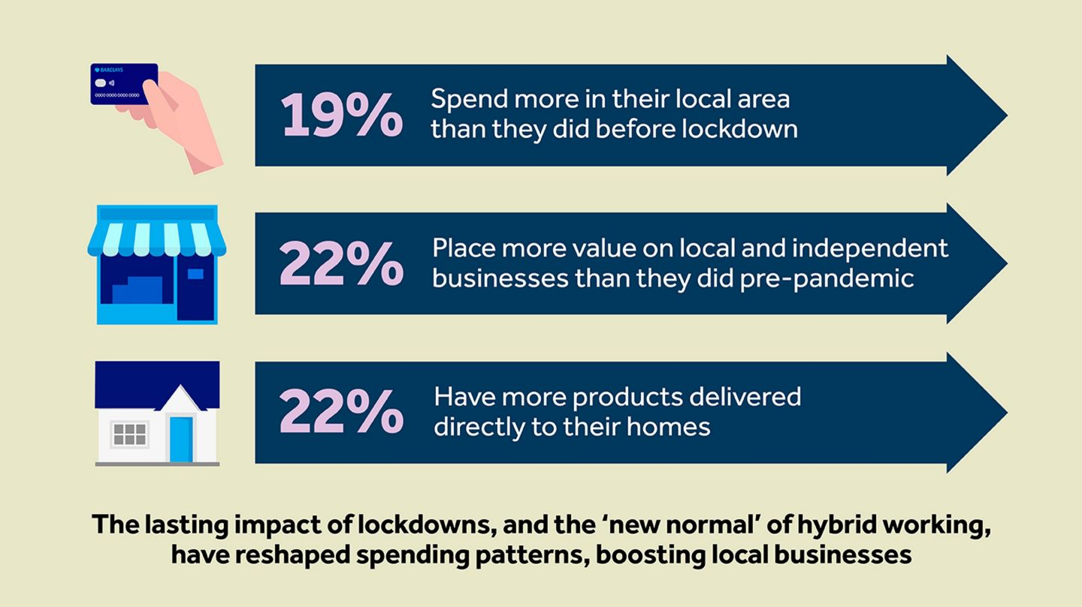
Figure 3: Need of hybrid working in Barclays Bank
(Source: Barclays Bank PLC, 2025)
Another major identified from the recent developments and trends is the necessity for hybrid working. This has affected the HR dynamics in enabling better working patterns and employee support towards their workload and minimising their stress (Torrington et al. 2020). Three major perspectives are identified from Barclays’ HR initiatives towards hybrid working, which are home delivery, supporting local businesses and the evolution of office culture (Barclays Bank PLC, 2025). These factors have pushed the HR practice to consider a better working environment.

3. Contemporary HR practices addressing each factor

3.1 HR practices towards business transformation
The core component in the development of HR practices towards business transformation is productivity, which is driven by Barclays through training and upskilling. This has been a major consideration for fintech regarding the necessity for achieving a positive performance and transformation thereafter. Through this way, HR in Barclays brings high impact on combatting employee challenges and skill issues. An effective way to increase the transformative power is associated with the upskilling motive of the corporation. As a result, a major corporate shaping feature emerges from the upskilling motive, which enables the productivity factors for organisations. The HR practice for Barclays brings emphasis in driving more investment and prioritisation in training. Ultimately, the purpose of training in the organisation is to address the requirement of customer experience and the performance of the fintech organisation.

3.2 HR practices towards digital technology
The necessity of addressing the digitalisation of the business and the customers to keep them on the same alignment is achieved by training and upskilling of employees and enabling greater communication with the customers. A major consideration towards understanding consumers' awareness and ability to use the digital technology is primarily considered by the human resource. Therefore, to create an effective response to the overall factors of customer relationships, the organisation has drawn a major consideration towards the advancement of the relationship. This required the upskilling of the employees to enable greater communication and relationship with the people closely embedded in the process (CIPD, 2023). Through the lens of the Technology Acceptance Model, the achievement of greater employee capacity can be identified. Singh and Sinha (2025) also helped term this theory to understand the capability of employees to get along with organisational technology. Figure 4 below also indicates the significance of technology in Barclays enabling usability, customer experience and relationship.
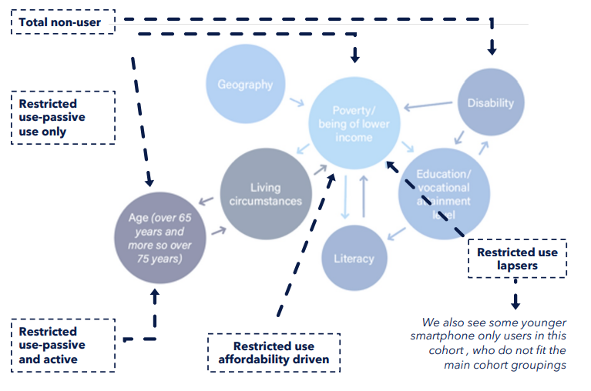
Figure 4: Process of HR practice towards digital technology
(Source: Barclays Group, 2024)

3.3 HR practices towards flexible working arrangements
HR practices directly influence the ability to secure flexible working arrangements at Barclays Bank. Barclays Bank provides flexible working opportunities by amending its dynamic working model to balance personal and professional life responsibilities through options such as hybrid working and flexible working hours (Barclays Life Skills, n.d.). Cavaliere et al. (2021) opined that flexible working arrangements are essential for enhancing the efficiency of workers, improving versatile job aptitude in flexible working time. It becomes easier for employees to efficiently balance personal life responsibilities without hampering organisational productivity. After the COVID pandemic, the hybrid working culture has become a new dimension of flexible working arrangement, allowing employees to work from the office as well as from any comfort zone.
A hybrid working policy has been amended by Barclays Bank to restrict the minimum number of days of office presence. A total of 85000 employees is restricted from coming to the office for three days a week (Clark, 2025). However, Barclays Bank is expecting to knuckle down on remote working procedures and is indicating that the company would shift towards in-office presence since most businesses are refraining from flexible working arrangements. There is a dilemma in the flexible working policy of Barclays, as front-office and client handling employees are expected to attend the office for five days a week (Clark, 2025). Staff were previously restricted to come to the office for 3 days a week in September 2024; however, staff were mandated to Return to the Office (RTO). As a result, a larger number of employees have resigned from the company.

4. Implementation procedures opted for departmental managers

4.1 Contemporary practices of departmental managers
Contemporary practices of departmental managers focus on employee empowerment, collaboration and ensuring well-being. According to Kobayashi et al. (2024), contemporary cohorts are likely to undergo advanced therapies to address high-risk situations. A total of five main divisions is present in contemporary practices of Barclays Bank. These core departments are “Barclays UK (Consumer & Business)”, “Barclays UK Corporate Bank”, “Barclays Private Bank & Wealth Management”, “Barclays Investment Bank”, and the “Barclays US Consumer Bank”. Core values of Barclays Bank are respect, integrity, service, excellence and stewardship (Barclays, n.d). Contemporary practices of departmental managers ensure adherence to the core values of the organisation in customer servicing and business practices (Nyangoma et al., 2024). Departmental managers focus on ensuring flexible working, opt for digital transformation, admire ethical conduct and perform accountability and ensure employee empowerment.

4.2 Key strategies of contemporary practices of departmental managers
Real-time problem solving, incorporating market trends of technology-driven banking services, is the fundamental key strategy implemented by the departmental manager of Barclays Bank. The sustainability initiatives in contemporary practice are transitioning to a low-carbon economy, supporting communities to build an inclusive economy and founding a sustainability resource hub (Barclays, n.d.b). Apart from that, to align with market trends, Barclays Bank have applied cloud-based AI models in its business. For example, Barclays UK have launched GenAI colleague assistance for providing instant support to colleagues regarding customer preferences to cut down average call handling times (Barclays, n.d.c). In order to improve customer experience, Barclays UK has implemented AI as an augmenter to connect AI tools in every aspect of customer service and find solutions based on mutual support.
Training and development are the departmental management strategy to improve employee productivity and efficiency by upskilling and enriching knowledge. According to Wajidi et al. (2023), training and development programs have a potential impact on strengthening employee job satisfaction by maintaining and enhancing key skills and knowledge that would benefit the firm. Through training and development initiatives, departmental managers try to ensure the holistic growth of employees (Obeng-Tuaah, 2025). The “Barclays’ LifeSkills” program offers access to all sorts of resources for developing key skills of 13m people with a combination of online resources, lesson plans, and exciting working experience opportunities (Barclays, 2021). These training and development programs not only boost key skills of employees but also strengthen the confidence of staff for problem-solving and decision-making.

4.3 Challenges faced by departmental managers to deliver contemporary practices urgently
Challenges anticipated by departmental managers of Barclay while delivering contemporary practices are prioritising short-term targets over innovation. However, internal resistance from legacy systems and interdepartmental silos often causes delays in delivering urgent solutions. According to Jeske and Olson (2025), silo mentality among the team members causes hindrance to internal collaboration and organisational development. Hence, internal silos, priority to short-term targets over innovation, are potential challenges faced by departmental managers while delivering contemporary practices on an urgent basis.

4.4 Evaluation framework of contemporary practices by departmental managers
A balanced scoreboard framework helps in assessing progress based on quantitative data from implementation completion percentage and qualitative feedback responses from employee surveys. The balanced scorecards are cascaded into different business units and function scorecards (Barclays, n.d.c). The adherence to the 5cs theory of balanced scorecard incorporates Customer & Client, Colleague, Citizenship, Conduct and Company factors to set individual performance of employees. The adherence to this theory helps employees in achieving ambitions in a planned way with proper direction.
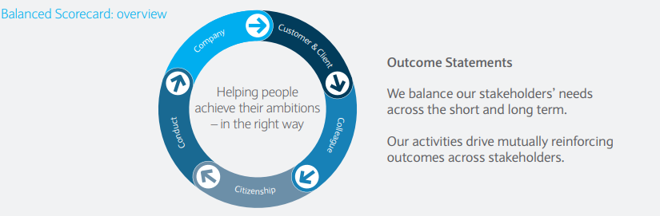
Figure 5: Balance scorecard framework of Barclays
(Source: Barclays, n.d.c)

5. Recommendations
Hybrid working amendments of Barclays in in danger due to the RTO approach that puts restrictions on remote working opportunities. The HR professionals are recommended to implement incentive, motivation principles to encourage employees to abide RTO framework. According to Zhu and Xie (2023), incentives and compensations are effective methods to motivate employees and foster workplace enthusiasm. The strict conversion of 3 days a 3-day-a-week hybrid working opportunity into an RTO caused dissatisfaction among employees, leading to a huge number of employee resignations. Therefore, to encourage employees, HR managers are recommended to foster employee motivation incentive policies, recognition practices to encourage staff.

6. Conclusion
The contemporary HR practices of Barclays focus on improving employee productivity, flexible working arrangements. However, from 2024, HR managers of Barclays have shifted to an RTO approach in place of 3 days a 3-day-a-week office policy. In conclusion, HR managers are recommended to initiate employee recognition, incentive, compensation and motivation practices to increase employee job satisfaction.

7. References
Armstrong, M. and Taylor, S. (2023) Armstrong’s Handbook of Human Resource Management Practice. 16th edn. London: Kogan Page.
Barclays (2021) Skill set? Getting ready for the future of work. Available at: https://home.barclays/news/2021/07/Skill-set--Getting-ready-for-the-future-of-work/ (Accessed: 14 December 2025).
Barclays (n.d) Barclays core values and purpose. Available at: https://home.barclays/who-we-are/our-strategy/purpose-and-values/#:~:text=Our%20five%20Values%20%E2%80%93%20Respect%2C%20Integrity,what%20we%20believe%20is%20right. (Accessed: 14 December 2025).
Barclays (n.d.b) Sustainability. Available at: https://home.barclays/our-sustainability-/ (Accessed: 13 December 2025).
Barclays (n.d.c) Building the 'Go-To' bank. Available at: https://home.barclays/content/dam/home-barclays/documents/investor-relations/annualreports/ar2013/barclays-strategic-report-final.pdf (Accessed: 14 December 2025).
Barclays (n.d.c) Scaling AI at Barclays: implementation, efficiency, and the future of customer experience. Available at: https://home.barclays/insights/2025/07/scaling-AI-at-Barclays/#:~:text=Scaling%20AI%20to%20enhance%20customer,reducing%20average%20call%20handling%20times. (Accessed: 14 December 2025).
Barclays Bank (2025) Hybrid working: the ‘new normal’ reshaping how we spend. Available at: https://home.barclays/insights/2025/06/hybrid-working-the-new-normal/ (Accessed: 13 December 2025)
Barclays Bank PLC (2025) Business is looking to productivity and the power of AI, but not at the expense of people. Available at: https://home.barclays/insights/2025/06/uk-business-productivity-ai/ (Accessed: 14 December 2025)
Barclays Corporate (2025) UK digital trade: from strategy to scalable action. Available at: https://www.barclayscorporate.com/insights/from-strategy-to-scalable-action/ (Accessed: 13 December 2025
Barclays Group (2024) Empowering digital choice. Available at: https://home.barclays/content/dam/home-barclays/documents/news/PressReleases/Empowering-Digital-Choice-Barclays.pdf (Accessed: 13 December 2025)
Barclays Group (2025) Fintech embraces GenAI: A transformative year ahead in 2025. Available at: https://home.barclays/content/dam/home-barclays/documents/misc/Fintech_Embraces_GenAI.pdf (Accessed: 13 December 2025)
Barclays Life Skills (n.d) How to make a flexible working request - advice & FAQs. Available at: http://barclayslifeskills.com/working-life/skills-for-the-workplace/why-trust-and-communication-are-the-keys-to-successful-flexible-working/ (Accessed: 14 December 2025).
Budihal, P. and Sathyanarayana, D. (2025) ‘Fintech Solutions: The Key to Transforming Work-Life Dynamics’, IOSR Journal of Business and Management. pp.24-29.
Cavaliere, L.P.L., Chabani, Z., Chowdhury, A.R., Padma, S., Koti, K., Chakravarthi, M.K., Rajest, S.S. and Regin, R., 2021. The Impact of Part-Time and Full-Time Work on Employees' Efficiency the Importance of Flexible Work Arrangements. Turkish Online Journal of Qualitative Inquiry, 12(7), p. 9580 – 9613.
CIPD (2023) Learning and Development Practice. London: Chartered Institute of Personnel and Development.
Clark, E. (2025) Barclays tightens hybrid work policy: could this be an RTO mandate by stealth? Available at: https://startups.co.uk/news/barclays-bank-hybrid-rto-policy/ (Accessed: 14 December 2025).
Jeske, D. and Olson, D. (2025) ‘Silo mentality in teams: emergence, repercussions and recommended options for change’, Journal of Work-Applied Management, 17(1), pp. 20-33.
Kobayashi, T., Pugliese, S., Sethi, S.S., Parikh, S.A., Goldberg, J., Alkhafan, F., Vitarello, C., Rosenfield, K., Lookstein, R., Keeling, B. and Klein, A. (2024) ‘Contemporary management and outcomes of patients with high-risk pulmonary embolism’, Journal of the American College of Cardiology, 83(1), pp. 35-43.
Nyangoma, D., Adaga, E.M., Sam-Bulya, N.J. and Achumie, G.O. (2024) ‘Designing quality control and compliance models for customer-centric service industries: A process-driven approach’, Journal of Frontiers in Multidisciplinary Research, 5(1), pp. 133-140.
Obeng-Tuaah, M. (2025) ‘Employees training and development to enhance organisational performance’, International Journal of Multidisciplinary Studies and Innovative Research, 13(1), pp. 1-15.
SAS (2022) Hyperautomation: At Barclays. Available at: https://www.sas.com/content/dam/SAS/documents/marketing-whitepapers-ebooks/ebooks/en/hyperautomation-at-barclays.pdf (Accessed: 12 December 2025)
Singh, V.K. and Sinha, K. (2025) ‘Application of the Technology Acceptance Model (TAM) in the Context of NBFC Customers’, International Journal of Latest Technology in Engineering, Management & Applied Science, 14(7). pp.846-854.
Torrington, D., Hall, L., Taylor, S. and Atkinson, C. (2020) Human Resource Management. 11th edn. Harlow: Pearson.
Wajidi, F.A., Baig, M.D., Razzak, T., Rehan, E.W. and Saeed, M. (2023) ‘The impact of efficient training and development on employee job satisfaction’, Voyage Journal of Educational Studies, 3(1), pp. 127-145.
Zhu, Z. and Xie, Z. (2023) ‘The role and optimisation strategies of compensation incentives in human resource management’, Acad. J. Bus. Manag, 5(27), pp. 63-67.

