CPD Log - Reflection

Review and reflection

Since starting my apprenticeship and university it has been a quick and steep learning curve as I have had to learn to balance my life and re-adjust to being back into education again and all this entails, such as attending lectures, completing assignments and independent research on top of working full-time. I have adjusted to this by seeking help where needed by speaking to my mentor or other colleagues and my university lecturers and throwing myself into both aspects to try and achieve my targets. I feel I have adjusted well to this new way of working, but understand there is still a way to go but I am determined to make the most of my opportunity.

What i could’ve done differently

I am pleased with how I have settled so far but looking back there are some things I could’ve done differently. For example taking lecture notes, in the very first lecture I struggled to keep up with the pace as I was making notes that weren’t required where I should have just focused on the key points that i needed. Also at the start I was quite reserved within work and university as I was new to both and didn’t know an awful lot about the subject and was not confident with asking questions therefore this is definitely one thing that I could’ve done better.

Strengths

I see my strengths as being able to adapt quickly. I say this because I feel again that being out of the education system for a while was difficult at the start and i had to adapt to the learning environment and quickly get back into the swing of things and feel this has been a major strength, I have learnt how to take more relevant notes, manage my time and submit assignment. within work I have the determination to succeed and I am always willing to take on new tasks and ask relevant questions to achieve the required results. At the start I was nervous about asking questions but now see this as a strength as I have quickly realised there is no thing as a stupid question. This again has allowed me to learn quickly and become trusted by my peers.

Weaknesses

I see my weaknesses to be time management, Research. I chose time management because I feel it is my biggest weakness because I struggle to find time to fit everything in after finishing work as I also lead a healthy lifestyle by going to the gym or doing other forms of physical activity so need to find the correct work-life balance. This can also be an issue in work where on times I need to recognise what is urgent and what can wait as i have had the habit of completing tasks in order when on times I need to prioritise what needs to be done now and what can wait. I don’t really consider research a weakness but I feel as if I need to do more wether it be researching and watching videos on things I need to know or do for work, or wether it be to broaden my knowledge on certain aspects of the modules I am learning. As mentioned in my CPD reflections there have been occasions in work when I have been shown how to use certain equipment or when I have attended courses such as the effect of construction on the environment I need to complete the learning by researching myself and further understanding the subject and expanding my knowledge.

Long term goals

After 2 years I hope to have passed my HND with higher class honours which will require determination, hard work perseverance, this will allow me to begin my degree with confidence. I also aim to gain further experience working more on my own and not relying as heavily upon my mentor.

After 5 years i hope to again achieve higher class honour in my degree and become competent in all aspects of being a site engineer and be fully qualified which in turn will open up more job opportunities for me.

Short term goals

My short term goals are to keep on gaining the relevant experience to keep on improving and learning new skills that are relevant to my role. I will hopefully do this by having new opportunities on different projects which would allow me to gain the experience from the ground up. For university I hope to keep on improving with my assignments and hope to find a way to manage my time better.

Conclusion

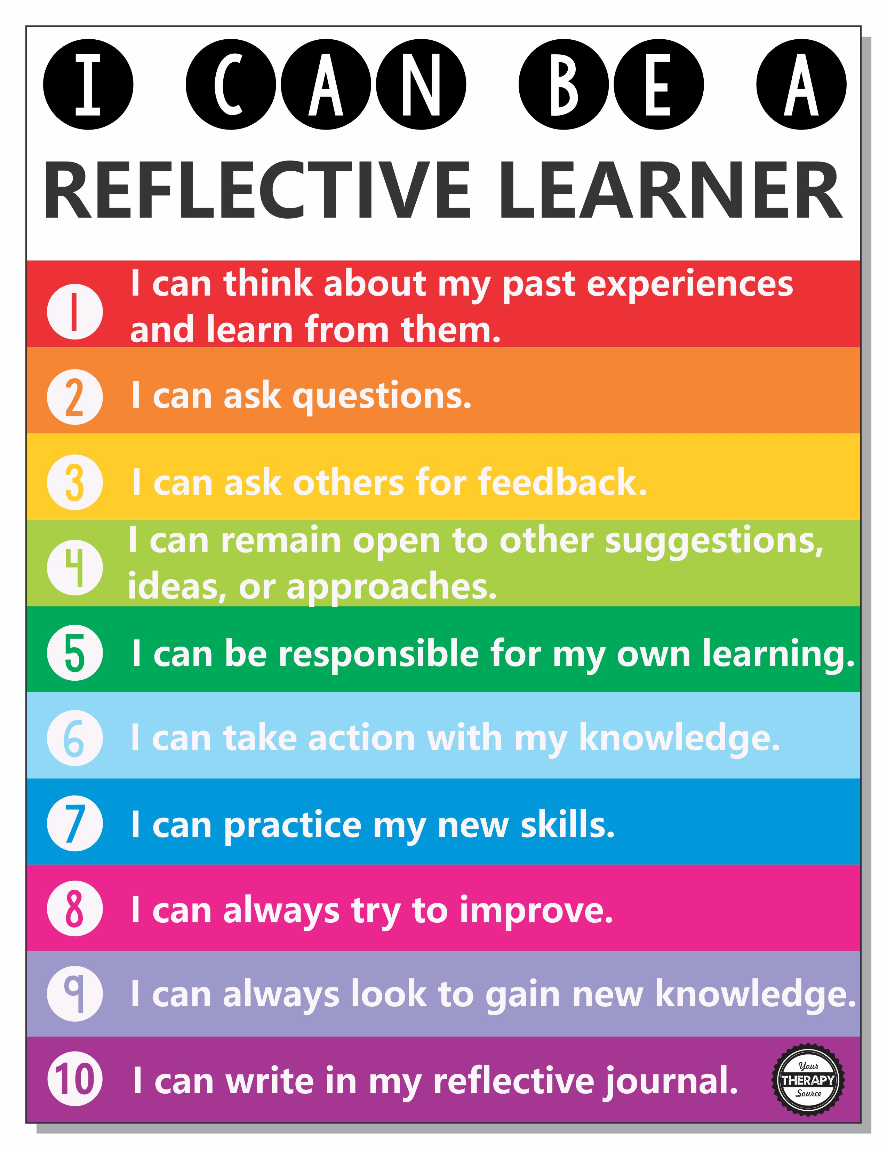
Having done some research regarding what type of learner I am and how best I learn from reflection I have settled on the below chart as I feel it best explains in simple terms how to put into practice what you are learning via the different mediums wether this be the practical skills on site or the academic skills in university lectures. I have looked at Gibbs’ reflective learning cycle and also Kolb reflective learning and feel the chart takes the best out of these two theories and puts into simple terms how best to implement reflective learning into my work and studies. The whole idea is that once I have completed a task I can reflect and learn and put this into practice and ultimately improve my work. I am already starting to use this as a reference in work to help reflect at the end of the day to help apply what new skills I have learnt and make sure I ask for feedback and remain open to their suggestions.
(https://www.yourtherapysource.com/blog1/2018/10/19/reflective-learning-style-or-passive-learning-style/)

