Why is Information Design important?

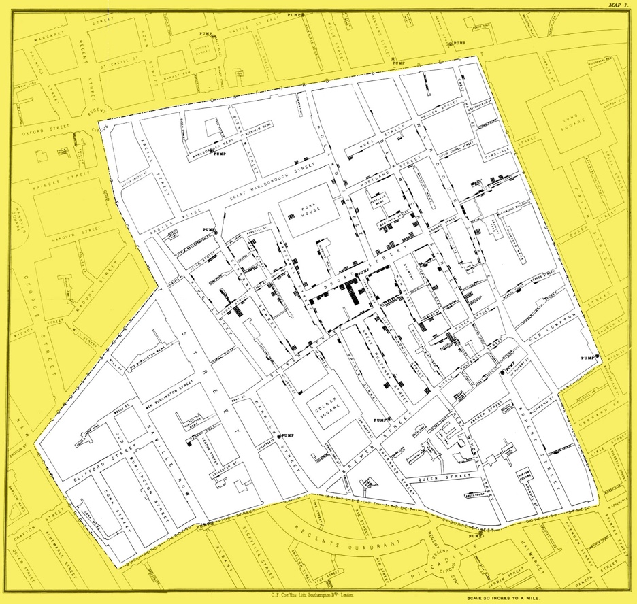
This essay discusses the importance of information design and how it helps to shape the world. Information design is defined as the presentation of information in an easy-to-understand way (Guthrie, 2021). This is a graphic design subsection that is particularly relevant to presenting information most simply and effectively (Guthrie, 2021). The messages can be put across in a variety of classifications such as sign systems, charts, tables maps, explanatory panels, etc (Kim, 1997). Information design is correlated with the age of technology however it does have its historical background. This first sign of information design occurred as far back as the 1800s when John Snow created spot maps, which located the source of the deadly cholera outbreak in 1854 London.

Figure 1. (Snow, 1854)

Throughout our history, people have been able to deliver information systematically in the effort to come to the same mindset or conclusion on a topic. (Jacobson and Jacobson, 2000). The Nazi version of history was manipulated and twisted to persuade the German people’s minds during the second world war using propaganda which was created by chief Joseph Goebbels (Jacobson and Jacobson, 2000). Most professions have a set of guidelines that they follow to keep the process clear, consistent, and up to standard. For example, writers follow style guidelines and engineers follow code standards, information designers follow their strategy in design thinking (Kirsch, 2021). Similarly, to user experience designers (UX), information designers consider the needs of the audience above anything else, which gives them a process to follow, the end goal of the procedure is to satisfy the user and not to confuse or overwhelm (Kirsch, 2021). Design thinking is a procedure for creative problem solving that puts others first. The process that is followed by infographic designers is to empathize, define, ideate, prototype and test. This is called user research where you take steps as a designer to understand the audience’s needs (Velarde, 2020). Information Design is all around us, we need it to understand information quickly and effectively therefore this essay will explore how information design is applied in communication, education, and society to make the world around us less complicated.

Communication is becoming extremely visualized. The popularity of visualizations continues to significantly rise due to them being eye-catching, engaging, and approachable to digest complex data and content. Captivating as they may be, visualizations are only effective when they communicate the content and ideas. Achieving that quality takes major experience. In today’s fast-paced international trade and travel world, all cultures and ethnic groups require reliable and effective communication to be appealing and easy to understand (Kim, 1997). As previously mentioned, information graphics started appearing during late 1800, however now more than ever in the computer technology era, the industrialized nations require gathering, packaging, and selling of information worldwide which demand clear visual language that appeals to everyone (Kim, 1997). These visual communicators are reliable to make learning efficient and to get the concept across any cultural or language barrier which therefore eases travel and trade by designing tools that include media and printed tools (Kim, 1997). Furthermore, infographics were created to condense down complex information into a web-based image to help the audience understand the content in the most presentable and digestible form (Albers, 2015). One of their many advantages is that complex information can be easier to understand by using a combination of texts and visuals rather than just text (Albers, 2015). While this is the case, infographics are not useful for all types of content, however, infographics can offer visuals to show bonds in data, anatomy, hierarchy, chronology, and geography (Albers, 2015). In addition, high content websites which are filled with many important pieces of information spread across it, are turning towards including infographics to help narrow the information down to become more fundamental (Albers, 2015). Moving on, an example of information graphics can be seen used in manufacturing. Instructions of manual skills with ICT’s such as virtual reality and augmented reality (Fox, 2010). The decrease of manual skills has been reported by manufacturers throughout the world (Fox, 2010). In the present time, manual skills are often taught through face-to-face interaction between two people, one being the expert and one being the learner (Fox, 2010). Due to the shortage of experienced people, information design is there to help the learners with the manual skill by looking and the design rather than having to have 1 to 1 session with an expert. Moreover, the design of any interactive product needs to be efficient enough to communicate with the end-user (Wroblewski, 2005). Each product needs to be capable enough to tell the user what features it holds and how to use those features and why they should be cautious in some products as well (Wroblewski, 2005). Information graphics is beneficial in this sense as the features can be portrayed visually, which helps the user get a better understanding of the use of the product.

Visuals are not always considered as higher ranked than text. However, the concept that is known as the picture superiority effect considers that using effective visuals will improve a person’s learning (Malamed, n.d.). Graphics allow a person to improve many aspects of learning, such as recognition, recollection, understanding, and problem solving (Malamed, n.d.). Many teachers turn their heads towards graphic design and information design to convey their education materials more simply and effectively (Valli, 2017). When the graphics have been well thought out, they can give an extreme boost in the students understanding as it can add valuable context and information nevertheless, when chosen poorly it could lead to confusion (Valli, 2017). Creativity is commonly defined as the capability to create useful products in each social setting (Dong, Zhu, Li, 2021). Furthermore, creativity is a subject of a large extent that is crucial at both social and individual levels for a broad range of tasks (Dong, Zhu, Li, 2021). At the social level, creativity was defined as the formation of value, useful product, idea, procedure, or process by individuals working collectively in a complex social organisation (Dong, Zhu, Li, 2021). Whereas, in an individual sense, creativity is used to solve problems, and it is an outcome of three main components which are expertise, motivation and creative thinking skills (Dong, Zhu, Li, 2021). Sustainable creativity can be defined as the foundation of the creative process (Dong, Zhu, Li, 2021). Creativity and innovation have been discovered to be crucial to ensure a competitive advantage, added values and even survival which distinguish humans from animals (Dong, Zhu, Li, 2021). Information / graphic design is one of the leading fundamental disciplines for creative potential in students (Dong, Zhu, Li, 2021). Furthermore, it can expand students thinking abilities and imagination, added to this it can boost their creativity (Dong, Zhu, Li, 2021). Mind mapping is a form of information design, and they have been found to produce the highest level of originality and fluidity in a harder task (Dong, Zhu, Li, 2021). Moreover, they can help people activate and condense knowledge systematically and portray highlighting the mindset in a clear way (Dong, Zhu, Li, 2021). At present, a lot of people suffer from dyslexia which is becoming a rising problem without a concrete solution. This type of disability can majorly affect a child’s ability to learn effectively as it affects reading and writing skills. Dyslexia produces a mass of struggles for a child who is attempting to learn traditionally, with having homework which is set in books and written tests. Dyslexia creates a lack of self-confidence within the child and creates a fear of new situation. Due to this, it may seem as the child is falling behind and not coping, so how does information design / graphic design can help this problem? Graphic/information design is all about communication. The end goal of a successful design is for it to be aesthetically appealing, and it must get the message across. Designers must consider things like the psychology of colour, the fonts, the shapes, spacing, simplicity and complexity of the design, and how well these all play together. Therefore, a child with dyslexia may find it easier to learn with these visuals, picking up the tones they communicate. Colour psychology in design has a major part in the palette that they use, as certain colours mean certain things for a dyslexic child. Learning this type of way may be easier to understand since no written texts need to be involved. Added to this, choosing a certain typeface may help a person with dyslexia with letter confusion. While reading is a difficulty for a dyslexic person, being picky with fonts can help a person to be attracted to the look of certain letters which then can benefit them from being confused on how to distinguish one from another.

Using visuals is a powerful way to convey a message and to communicate something quickly in a society that is always on the go. Information design is the one thing that can change the game. Whether you work for a company, or you are an individual or an institution, information/graphic design can completely change the way they are perceived. Long-term memory is created through graphic design. Imagine a world without visuals at all; only communicating with words. It would not only be ineffective, but it would also be boring and tiresome. Humans like to take breaks from reading now and then, so having pleasant visual stimuli is essential. Without well-chosen colours, organised design elements, order, etc., people would be constantly exposed to a chaotic environment that would at some point become dull. During the 19th century, avant-garde movements started showing up and graphic design was shaped as a result. Since modernism became the focal point in our history at this time, people were open to new ideas and distanced themselves from regularity. Through this, some doors opened, and people started noticing the aftermath. It was now apparent that information / graphic design and avant-garde movements had influenced entire societies by promoting aesthetic values. There are many ways in which graphic design impacts our lives, such as its impact on culture, information delivery, decision making and more. Moreover, there has been a lot of scientific study of the psychological effects of visual content. Information / graphic design has gained a significant amount of attention since people began to realize how much impact visuals have on the brain. The work of Donald Norman provided a framework for looking at products holistically, including their attractiveness, behaviour, and the image they project to the user and to their owner. The work on design identified these aspects of the product with different levels of processing by humans: visceral, behavioural, and reflective (Norman, 2005). Each of these levels corresponds to a different kind of design (Norman, 2005). Visceral design is concerned with the initial impression it makes. Behavioural design is about the overall experience of using a product. As for reflection, it is the feeling it gives a person, the image it evokes, the message it conveys about the owner's taste (Norman, 2005).

To conclude, Information design is everywhere we look. Websites have huge amounts of content that require to be sorted through and put into sections to be presented in a way that makes them effortless to navigate. Added to this, food packaging contains global parts such as nutritional values and product branding. Without information design, the world that we know to date would be a miserable and dull place. Things like posters, textbooks and other data would become plain words and maps become extremely difficult to understand. Maps such as Harry Beck’s London Underground topological map provide a sense of convenience for a person. People who operate on different levels would possibly miss out on important information due to the difficulty of understanding text. In today’s world, we are overloaded with an endless amount of data and information, from things like media feeds, emails, texts. Information design allows users to effortlessly channel through icons, texts, figures and charts without the worry and struggle to understand and process data. Excellent information design presents information in a way that targets the audience, as it is formed to appeal to the different sexes, age groups and cultural groups. In my opinion, with the complexity of information problems we will face in the years to come, information design will become ever more vital.
Bibliography

Albers, M.J., 2015, August. Infographics and communicating complex information. In International conference of design, user experience, and usability (pp. 267-276). Springer, Cham.

DesignyUp. 2020. The Importance of Graphic Design in Today’s Society | Graphic Design Blog. [online] Available at: <https://www.designyup.com/importance-of-graphic-design-in-todays-society/> [Accessed 6 December 2021].

Designative information design. 2021. What is Information Design?. [online] Available at: <https://www.designative.info/about/what-is-information-design/> [Accessed 2 December 2021].

Dong, Y., Zhu, S. and Li, W., 2021. Promoting Sustainable Creativity: An Empirical Study on the Application of Mind Mapping Tools in Graphic Design Education. Sustainability, 13(10), p.5373.

Guthrie, G., 2021. What is information design, and why is it important? | Cacoo. [online] Cacoo. Available at: <https://cacoo.com/blog/what-is-information-design-and-why-is-it-important/> [Accessed 28 November 2021].

Fox, S., 2010. The importance of information and communication design for manual skills instruction with augmented reality. Journal of Manufacturing Technology Management. https://www.emerald.com/insight/content/doi/10.1108/17410381011014369/full/html (communication)

Jacobson, R.E. and Jacobson, R. eds., 2000. Information design. MIT press. [Accessed on 28 November 2021].

Logodesign.net. n.d. Learning Graphic Design Helps Kids with Dyslexia. [online] Available at: <https://www.logodesign.net/learn-graphic-design-kids-dyslexia> [Accessed 6 December 2021].

https://books.google.co.uk/books?hl=en&lr=&id=vnax4nN4Ws4C&oi=fnd&pg=PR9&dq=Information+design&ots=PbG8_2hwKe&sig=zygNVTQBqn9hMlRJX-F8rPzkmxY&redir_esc=y#v=onepage&q=Information%20design&f=false

Kim, Y., 1997. The Anatomy of information design. Thesis. Rochester Institute of Technology. Accessed from: https://scholarworks.rit.edu/cgi/viewcontent.cgi?article=5755&context=theses

Kirsch, K., 2021. What is Information Design + How It Can Help You as a Marketer. [online] Blog.hubspot.com. Available at: <https://blog.hubspot.com/marketing/information-design> [Accessed 5 December 2021].

Malamed, C., n.d. Using Graphics To Improve Learning. [online] The eLearning Coach. Available at: <https://theelearningcoach.com/media/graphics/using-graphics-to-improve-learning/> [Accessed 6 December 2021].

Norman, D.A., 2005. Emotional design: People and things. Retrieved February, 1.

Senseinfodesign.com. 2017. The Value of Information Design Expertise. [online] Available at: <https://senseinfodesign.com/the-value-of-information-design-expertise/> [Accessed 5 December 2021].

Snow, J., 1854. Cholera Map 1. [image] Available at: <https://www.ph.ucla.edu/epi/snow/snowmap1_1854_lge.htm> [Accessed 2 December 2021].

Valli, H., 2017. Educational Graphics: Five Considerations - Duke Learning Innovation. [online] Duke Learning Innovation. Available at: <https://learninginnovation.duke.edu/blog/2017/03/educational-graphics-five-considerations/> [Accessed 6 December 2021].

Wroblewski, L., 2005. Design is communication. Use it as such.. [online] Lukew.com. Available at: <https://www.lukew.com/ff/entry.asp?232> [Accessed 5 December 2021].

