

Assignment 2

Unit Title: Digital Intelligence& Analytics
Assessor Name: Chris Thomas
Candidate Name: WENXUAN WU
ID Number: 1905078
Group Award: BA In international Business
Submission Date: 17/01/2020

Table of Contents

1.0 Introduction 3
2.0 Main finding 3
2.1 The role of excel 3
2.2 The role of IF 4
2.3 The role of LOOKUP 4
2.4 The role of PIVOT TABLES 5
2.5 The role of charts, as well as graphs 6
2.6 How does excel help analyze data 6
3.0Weka 7
3.1 How Excel documents can be imported into WEKA 7
3.2 Classify 8
3.3 Association 12
3.4 Cluster 13
4.0 Data analysis in business management 14
4.1The role of data analysis in business management 14
4.2 The importance of data analysis in enterprise management 15
5.0 Conclusion 16

Introduction
This report aims to demonstrate how to assess and analyze issues through Microsoft Excel, as well as discuss how valuable WEKA's data mining programs are to the company. This report details some functions in Excel and their operation methods, including IF, LOOKUP, PIVOT TABLES, charts and graphics.

Main finding

2.1 The role of excel
The basic function of Excel is to record, calculate and analyze data. During practical applications, it is very small, and it can even be used as a general-purpose calculator. In addition, it can also be used to calculate personal income and expenses, calculate loans or savings. Meanwhile, it is also very large, it can perform professional scientific statistical operations, what is more, it can be achieved by analyzing a large amount of data. The formulation of the company's financial policy provides an effective reference. Because every important decision is more convincing if supported by the data. In actual industry applications, most departments and staff in the company will use Excel more or less. It is still very positive to improve the efficiency of our study and work.

2.2 The role of IF
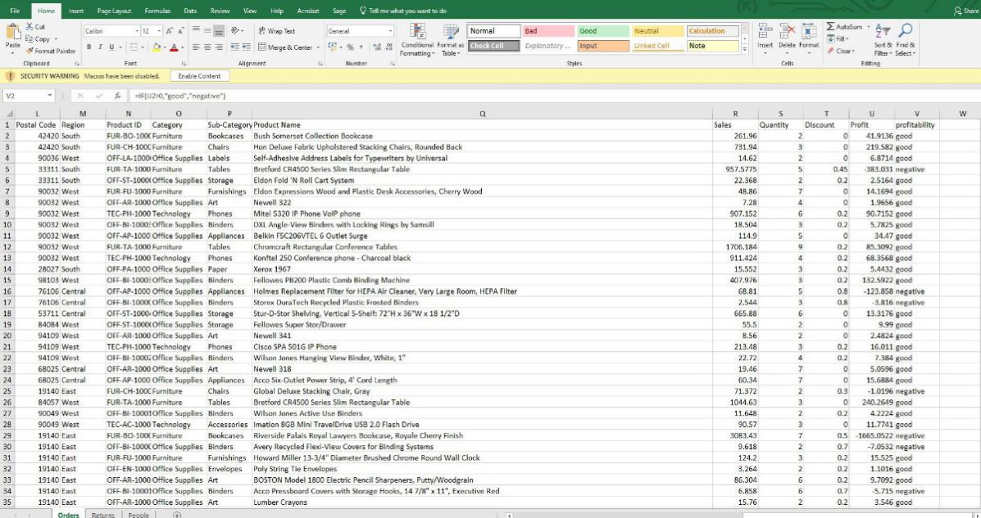
First, an Excel file called kwikeemart.csv needs to be opened. In the blank field next to profit, profitability needs to be entered. The formula = IF (U2> 0, "good", "negative") needs to be entered in the next column of profitability. to be more specific, this formula shows if the data in the profit column is less than 0, then the corresponding negative value will appear. When the data in the profit column is bigger than 0, it is "good" in the profit column. As it can be shown above, it is easy to determine whether an order is profitable by using "good" and "negative".

2.3 The role of LOOKUP
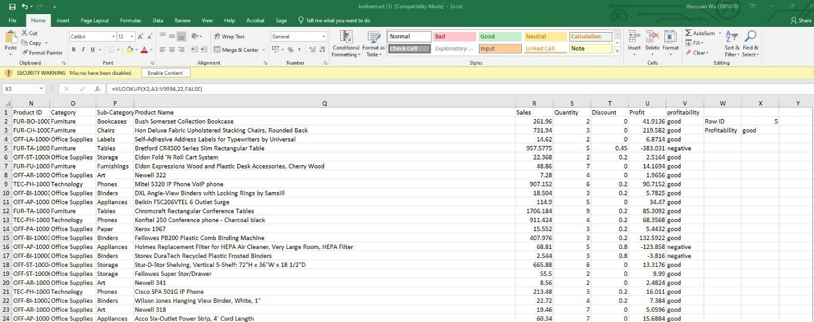
The row ID and profitability need to be entered in the blank fields next to "Profitability". In the blank field next to the row ID, the number to be entered is 5. The formula = VLOOKUP (X2, A1: V9994, 22, False) should be entered in the corresponding profitability column. In this function, X2 is the first parameter. Therefore, the search is based on "row ID 5". The corresponding profitability needs to be found, based on "row ID 5". "A1: V9994" is the second parameter, which indicates that the search range is from A1 to V9994. "22" is the third parameter and has profitability in the 22nd column of the selected search area "A5: V9994". The fourth parameter can be entered as "False" directly, which means it matches exactly. When no value can be got, the error is returned. Last, the picture given above is displayed. With the help of this formula, whether the order is profitable can be determined immediately by entering the row ID number.

2.4 The role of PIVOT TABLES
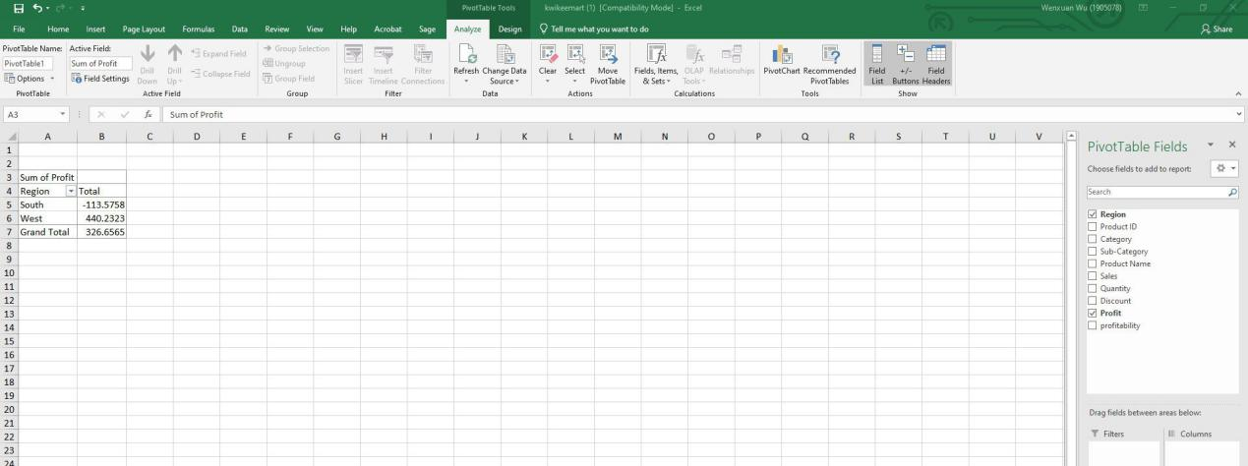
In the Excel table, the range A1: U24 is selected. In order to select the pivot table, the "Insert" button is clicked. Find the PivotTable field on the right and add "Region" and "Profit" to your report. The area needs to be dragged to the area named row, then drag the profit to the value area. last step, which shows the picture shown above. With a pivot table, profits in the South and West can be understood.

2.5 The role of charts, as well as graphs
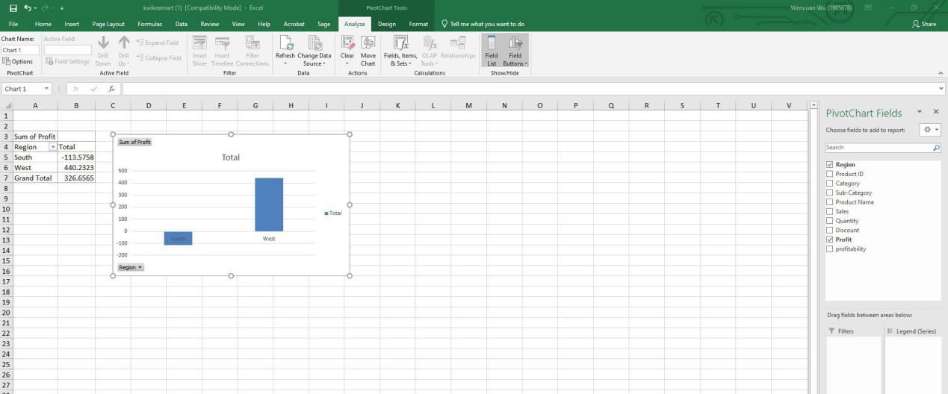
Based on the existing PivotTable, the Insert button needs to be clicked. In order to get the picture shown above, the Insert Histogram needs to be selected. it can be shown directly from the chart that the profitability of each region is presented. It can be concluded from the above figure that the western region is profitable, while the southern region is losing money because only the western region has a profit higher than zero, and the southern region has a profit lower than zero.

2.6 How does excel help analyze data
After using Excel to perform calculations and statistics on the data in the worksheet, the calculation and statistical results obtained still cannot better show the development trend or distribution of the data. In order to solve this problem, Excel will process the data into various statistical charts, so that it can more intuitively represent the processed data. In Excel, users can easily create, edit and modify various charts. In order to express the data in the worksheet more intuitively, the data can be represented in the form of a chart. Through the chart, you can clearly understand the size of each data and the change of the data, which is convenient for comparison and analysis of the data. Excel comes with a variety of charts, such as bar charts, line charts, pie charts, bar charts, area charts, scatter charts, etc. Each chart has its own advantages and is suitable for different occasions.

For office automation, Excel is very important software. Forms can be efficiently processed, and visual analysis can be performed. In the automatic processing, as well as the process of calculating data, more powerful functions are demonstrated. What is more, Excel is very easy to operate. The easy processing and interaction of network data has brought many positive effects. The operation of the pivot table is very simple, what is more, the data analysis is very reliable. Functional formulas can be used simply to sum and compare the data. It can sort and filter data through simple operations.

3.0Weka

3.1 How Excel documents can be imported into WEKA
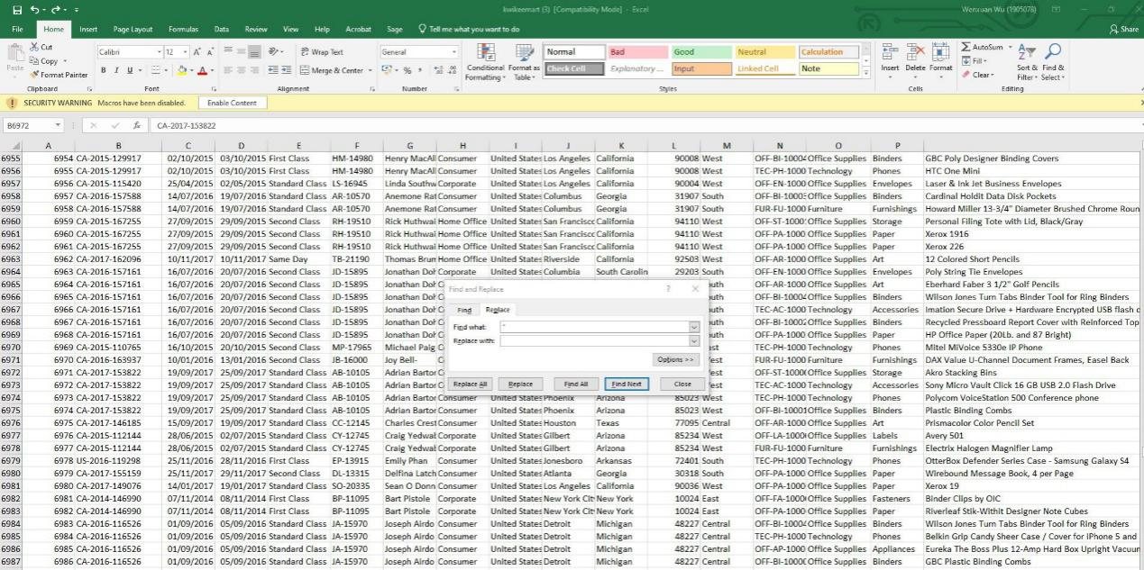
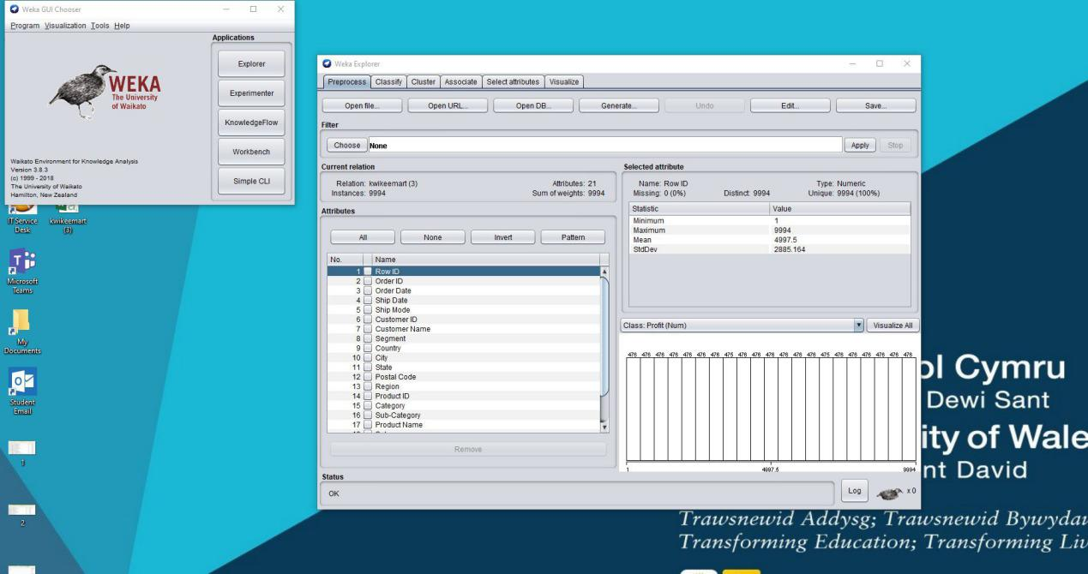

Firstly, save the Excel file named kwikwwmart in CSV format. Open the WEKA import Excel file in CSV format. Then, WEKA pops up a prompt indicating an error in the document. According to WEKA, for error correction, the Excel file is returned in CSV format. Such as, the "Find and Select" button is located in the upper right corner of Excel. After it is clicked, "Replace" is selected, and a prompt box pops up. Enter "" in the "Find what" field and enter blank in the "Replace with" field. The Replace All button needs to be clicked, and the change is implemented. It can be successfully imported into WEKA, when the errors in the document through the above method are corrected.

3.2 Classify
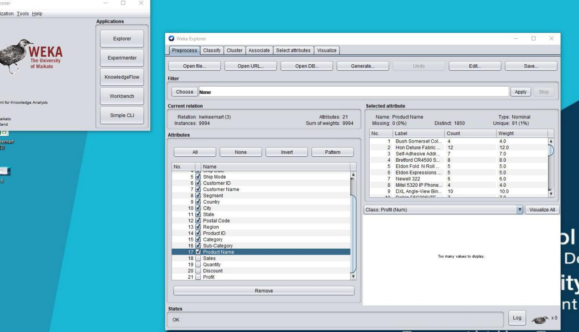
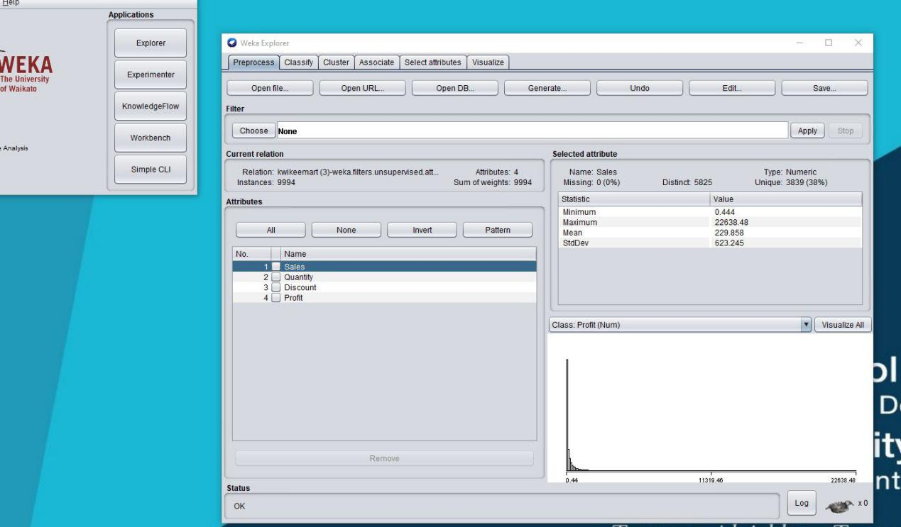
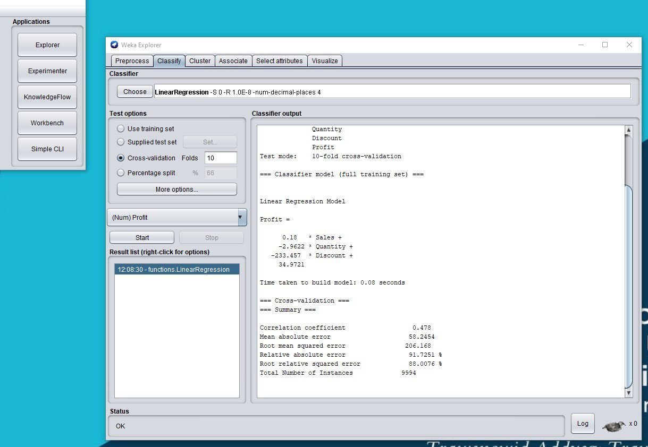
As discussed, No. 1 is moved to No. 17 with only sales, quantity, discounts as well as profits. The classify button and the selection button needs to be clicked to select LinearRegression. Last step is to obtain the results of the predictive analysis, Start button needs to be clicked.
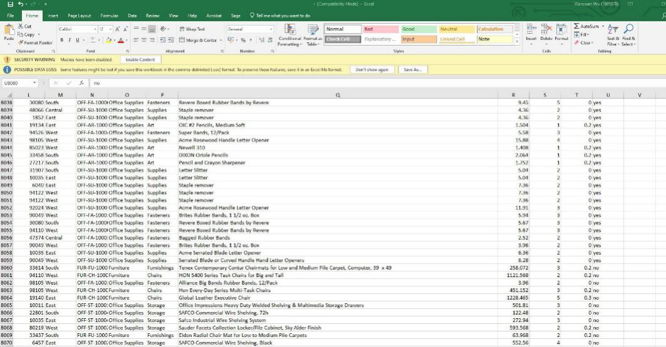
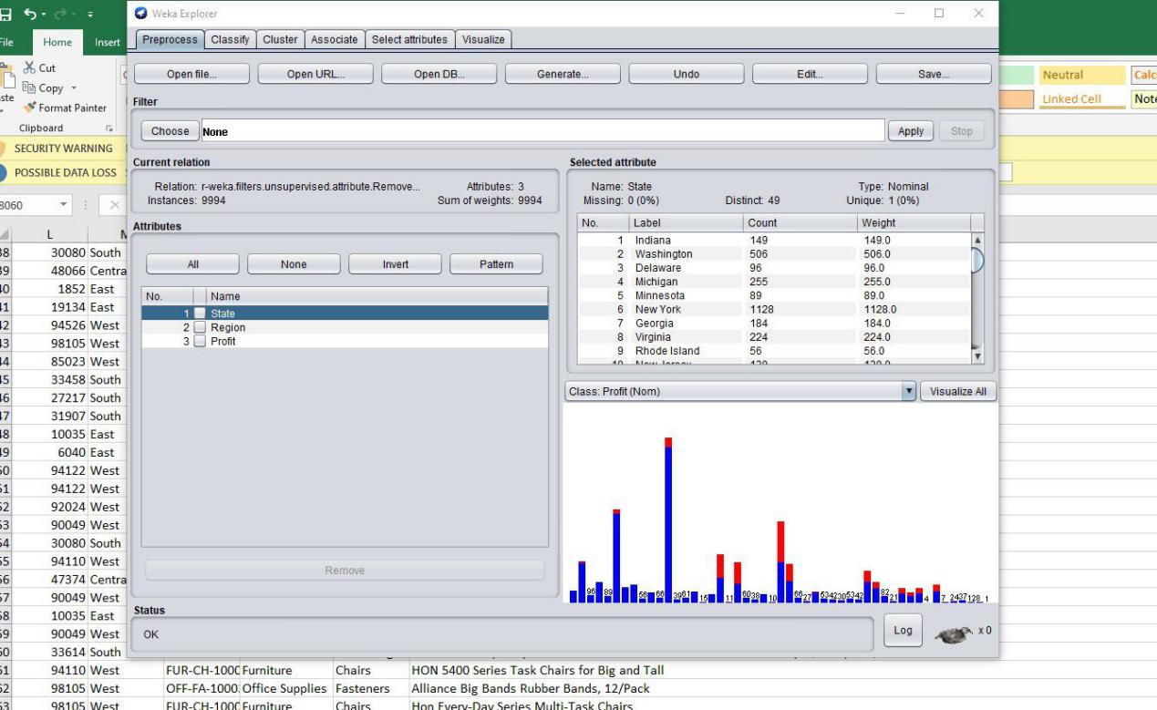
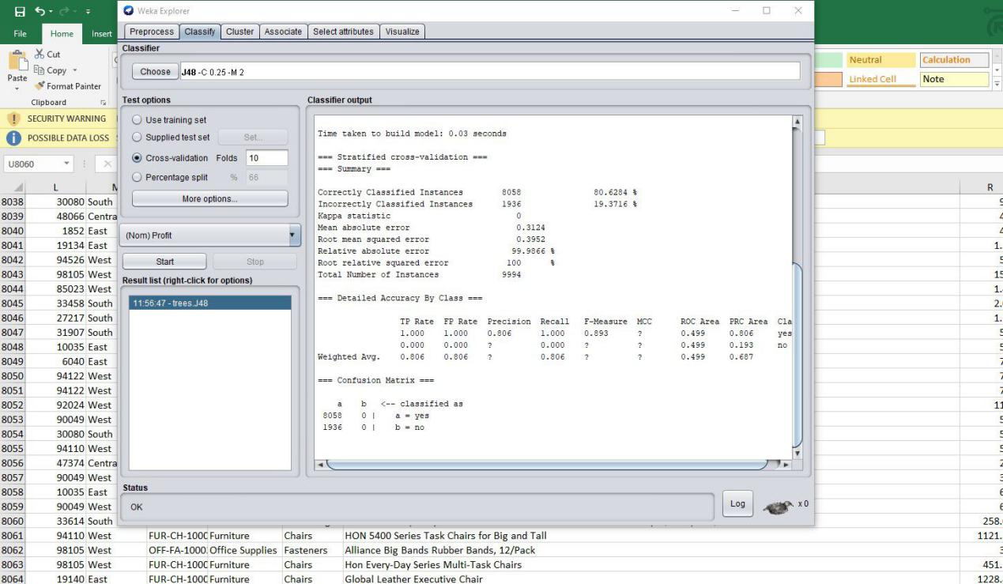
First of all, the profit column needs to be selected, the sort and filter buttons need to be clicked. The filter needs to be selected. The buttons in the profit column need to be clicked, and the order of the data is preferably from large to small. The data is delimited with 0 as the standard, the data bigger than 0 is changed to YES, while the remaining data is changed to NO. The document needs to be saved, this format is CSV format. Next, the file needs to be imported into WEKA. In the pre-processing column, the status, region and profit need to be deleted. Then in order to select J48 in the tree button, the sort button and select button need to be selected. Last, Start needs to be clicked.

3.3 Association
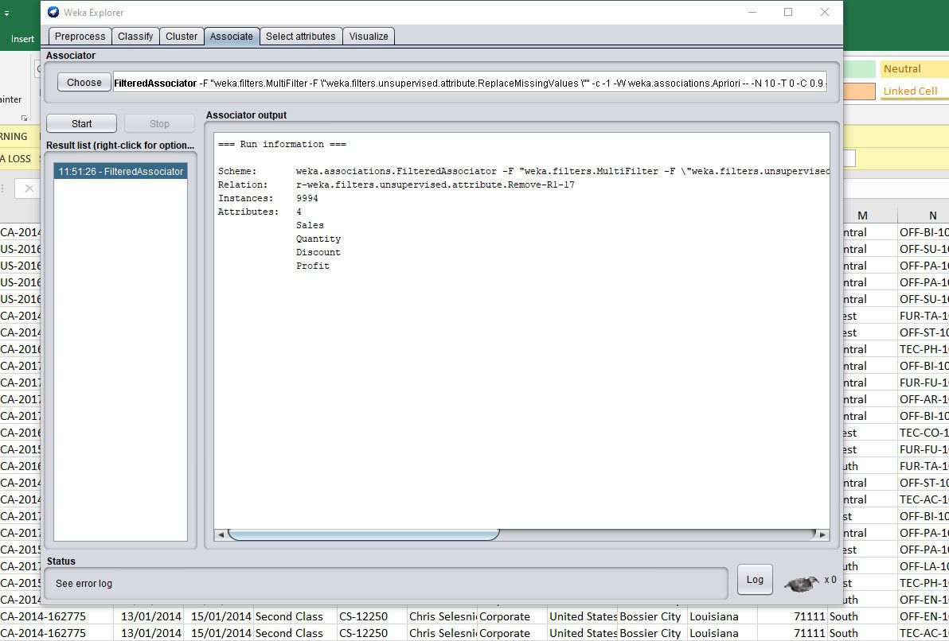
As analyzed before, the associate button is clicked. And we click select one more time, then FilteredAssociator, then click start. Last, after correlation analysis, we will obtain the result.

3.4 Cluster
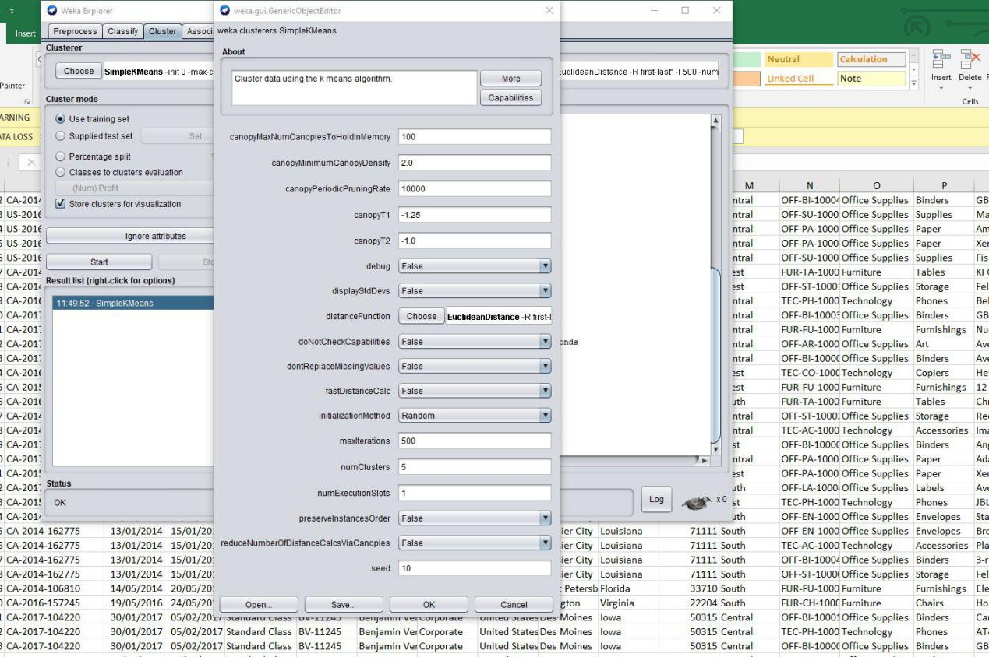
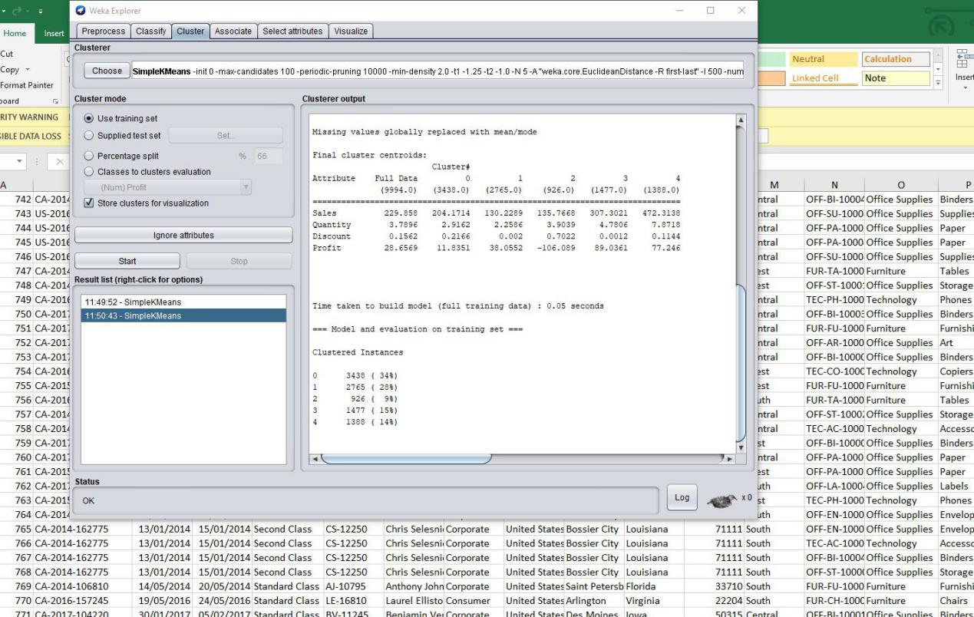
As illustrated before, the cluster button is clicked. We click the select button again and select SimpleKMeans. In order to obtain the cluster analysis results, we click the start button. Clicking SimpleKMeans aims to adjust clustering algorithm’s properties. As presented above, the prompt will pop up when SimpleKMeans is right-clicked. The numClusters column needs to be found, and the data needs to be changed to 5 to be determined. Last, in order to obtain the results of the modified cluster analysis, click Start again. Based on cluster 2, we can conclude when the discount is 0.7022, the company is in deficit.

4.0 Data analysis in business management

4.1The role of data analysis in business management
In the business field, data analysis aims to gather and extract the information hidden behind the data, as well as conclude the internal laws of the research objects. It is positive for managers to make effective judgments and decisions. In general, data analysis has three main functions in the daily business analysis of enterprises: first, the status quo analysis. First of all, tell you the overall operation of the enterprise at the present stage, through the completion of various indicators to measure the operation of the enterprise, to explain the enterprise operation is good or bad all day, how good, bad degree to where. Then, tell you the composition of the business, so that you can learn the development of the business as well as the changes in the situation of the operation of the enterprise have a deeper understanding. Secondly, cause analysis. In short, it tells you why something is happening. Through the analysis of the current situation, we can basically understand the operation of the enterprise, but do not understand what is good about the operation, what is the difference, and what causes it. At this point, it is necessary to carry out cause analysis to further determine the specific causes of revenue decline and make adjustments and optimizations to the operation strategy. Finally, predictive analysis. In short, It tells you what will happen in the future. It is also necessary to predict the future development trend of the enterprise, after understanding the current status of the enterprise operation. This is to ensure the sustainable development of the enterprise. The healthy development of the enterprise, because it provides effective reference and decision basis for the formulation of business objectives and strategies. This analysis can be achieved through thematic analysis, which is usually carried out when formulating the company's quarterly and annual plans. The frequency of predictive analysis is not as high as current situation analysis and cause analysis.

4.2 The importance of data analysis in enterprise management
First of all, in order to give data and theoretical support to the operation and management of enterprises. Not only the study and management of enterprise operation data, but also the study and discussion of the enterprise has brought a lot of reference to the business strategy of the enterprise. Data analysis technology develops with IT’s increasing development. What is more, user data can be fully mined and researched. Based on the company's operational management strategy, comprehensive comprehensive decisions can be made. The user's needs and the development needs of the enterprise are met at the same time. On the other hand, insights into market conditions are also provided to companies by data analysis. It has become the basis for companies to formulate marketing strategies. The short-term development opportunities in the market are grasped, management efficiency is improved, and a good environment is created. Based on the feedback of user information and analysis of market data, when a new product is developed, a reasonable product spokesperson can be selected. This helps to increase youthfulness and personalization, and at the same time to succeed, because the consumption characteristics of young users can be grasped.

Secondly, it can improve the intelligent operation process of companies. Internet channels brings positive impacts, modern enterprises have a better communication with users, and they have more equipment resources through the Internet. They also obtain better services by their experience’s regularly feedback. Third, the practice in the management of small results. Use of big data read function will inventory, financial cost, contract management, the human cost, sales statistics statistical analysis of many factors, such as indexes and make all kinds of operation index into quantitative management stage, for the company provide the decision-making basis of digital objectivity, so as to avoid the subjective influence, in the daily management of the adverse factors such as vague impression, make decision effectively guide management direction.

5.0 Conclusion
Data is very important for enterprises. Data can help enterprises to obtain more information and promote the development of enterprises. Therefore, data is essential in enterprises.

