ECGE6001: Skills for Life: Employability and Future Pathways
Maisie Morgan

3 Component Portfolio, plus 1000 Words Reflective Account
COMPONENT 1: Old CV

Name: Maisie Rae Morgan
Address: 83 Arail Street, Sixbells, Abertillery, NP13 2NH
Contact number: 07765 823251
Email address: maisiemorganxx@hotmail.com

PERSONAL PROFILE:
I am a caring, trustworthy and hard-working individual, I am an easy and effective communicator with outstanding interpersonal skills, and can communicate with people of all abilities due to my previous experience of volunteering work with older people, people with mental health issues and children. I am also very aware of working with the members of public due to my previous employment. I am an intelligent person, I enjoy being challenged and experiencing new things to better my knowledge and understanding. I am able to work well on my own initiative, as well as working within a team environment. I am very organised and able to keep everything in order. I am a very reliable person and there when I am needed.
EDUCATION:
I attended secondary education at Abertillery Comprehensive School (September 2010 – September 2015) where I left at leavers standards after completing my GCSE grades. I now currently study Health and Social Care Level 3 at Blaenau Gwent Learning Zone (September 2015 – Present).
In secondary school I was vice captain, I was also on school council. This shows my independence and shows I can work well within a team. Now I attend Blaenau Gwent Learning Zone I am currently a class representative. I attend meeting throughout my college years to voice my opinions and give my own views on how the college can improve and represent students.
ACADEMIC QUALIFICATIONS:
GCSE’s:
- Media - Grade B
- Catering – Grade C
- Mathematics – Grade C
- Health and social – Grade B
- ICT – Distinction *
- Problem solving – Pass
- English – Grade C
- Welsh – Grade C
- Application of number – Level 2
Further Qualifications:
- First Aid – Pass
- Food Hygeine – Pass

WORK HISTORY:
The Railway Inn – Part Time:
August 2016 – November 2016
I worked under the general guidance of the Bar Manager, I assisted in the running of the bar area to deliver a high standard of service and customer service, alongside their satisfaction. I also took part in preparing meals and ensuring that customer requests and queries were responded to effectively.
My duties involved:
- Operating a digital till and taking cash from the customers, then ensuring that they were given the correct change back
- Ensuring all cash, till and float procedures are carried out in accordance with our policy
- Serving customers from behind the bar and behind the hot meals stand
- Preparing the bar for service, including restocking any drinks that were empty and changing barrels
- Keeping the bar clean and tidy, including collecting empty plates and glasses to clean them
- Providing a friendly and professional service to all customers that used our service
- Working wedding parties, private parties, dart tournaments and meetings
- At the end of the shift, making sure that the bar and table area, toilets and kitchen was clean and tidy for the next person’s shift.
I now have a great knowledge of the high standards of personal presentation and customer service. I have the ability and willingness to work in a social and fast-working environment in late nights and weekends. I have the experience of serving many customers at different types of functions and events, and ensuring to keep the high standard of customer service while being under pressure which means I have the ability to work well within a busy and fast-paced environment. I am also able to work as an individual behind a bar, but also as a great team player.
Tesco – Part Time:
October 2016 – Present
Currently I am working part time as a customer assistant. This is based in a busy shop, providing helpful, friendly and professional service to all customers. I am responsible for stock rotation when stacking shelves, supporting staff with deliveries in the warehouse, and making sure that the aisle I work on is kept tidy and clear so customers can walk freely down them. I work as part of a team to hit the sales targets and make a high success.
My duties involve:
- High standards of cleanliness and tidiness in all areas for the customers to access them
- Meeting and greeting customers
- Highlighting promotions to customers to ensure they know what they special offers are
- Providing product advice and guidance to customers
- Stacking shelves with the deliveries
- Following health and safety procedures throughout the job
- If a customer looks like they need help finding a product, ensuring that I offer my help
- Offer my help when a customer asks where a product is
I am also till trained, therefore when I am needed I have the duty to greet customers as they come to my till, maintain conversation in a friendly and professional way and taking cash from the and processing their credit card payments. I also have the duty to help customers pack their shopping if they need any help doing so.
HOBBIES:
I like to socialise with my friends and family on a regular basis, I like to keep up to date with my college course work alongside my social life. I like to attend my local gym to keep fit, healthy and to maintain a good diet. I also attend kickboxing classes once a week.

COMPONENT 1: Updated CV

Maisie Rae Morgan
1 Woodland Walk, Blaina, NP13 3JS
Maisiemorgan4@icloud.com
07493924097

I am an empathetic, energetic, self-motivated third, final-year Mental Health undergraduate student, with experience in working with a variety of abilities, I excel within a team, on my own initiative and have expertise in customer service in retail industry. I have impeccable verbal and written communication skills, as well as exceptional interpersonal skills. As a student, I have effective time management and organisation skills. I am keen to apply my existing knowledge and professional skills developed through university, employment and volunteering to further my career in Mental Health.
Education
University of Wales Trinity Saint David (2017-2020)
- BSc (Hons) Mental Health
Relevant modules:
- Skills for Life: Employability and Future Pathways
- Independent Research Project
Blaenau Gwent Learning Zone (2015-2017)
- Health and Social Care Level 3 Triple Distinction
Abertillery Comprehensive Secondary School (2010-2015)
- 8 GSCEs, including English Language, English Literature, Mathematics and Welsh.

Completed further courses, i.e. Autism Awareness Training, Dementia Friend, First AID at Work and Food Hygiene.
Employment
Tesco Customer Assistant (2016-Present)
- Helping and assisting customers, relaying information, guidance and advice, providing a five-star service and deliver high standards of quality, careful customer service
- Managing a checkout service and money
- Ensuring quality and compliance with standards and competencies
- Following the relevant procedures to ensuring the work is done correctly, including following health and safety procedures
- Maintaining a friendly, professional manner throughout the service provided
The Railway Inn Pub (2016)
- Helping and assisting customers, relaying information, guidance and advice, providing a five-star service
- Serving customers, while maintaining a friendly, professional manner
- Keeping the bar clean, tidy and approachable
- Preparing the bar for service
Volunteering
Women’s Aid (2019-Present)
- Delivering an informative, educational presentation, providing a five-star service
- Maintained effective communication throughout, with service users, as part of a team and on my own initiative
- Advised activities, working alongside a team of volunteers
- Being aware of relevant policies, procedures and legislation
- Provided the relevant support, advice and guidance to those of all abilities.
Cwrt Mytton Nursing Home (2016-2017)
- Read care plans
- Planned and carry out activities for residents
- Worked as part of a multi-disciplinary team to ensure needs where met
- Helped and supported residents, i.e. at meal times
Mini-Me’s Nursery (2016)
- Helped prepare activities and meal times with the children
- Worked as part of a team, alongside the teachers to ensure the children’s needs were met
- Provided support to teachers and children
Bryngwyn Primary School (2015-2016)
- Provided help and support to the children when carrying out activities
- Planned learning/educational activities for the children to carry out, i.e. mathematical activities
- Worked closely with parents and teachers, to ensure a safe, secure environment was provided.
QCare LTD (2015)
- Provided planning and support within an office environment
- Maintained a professional, but friendly, supportive, advisory manner
- Greeted staff and general public
- Managed diaries
- Assisted interviews

Component 2: Professional Behaviour Evaluation Work Sheet

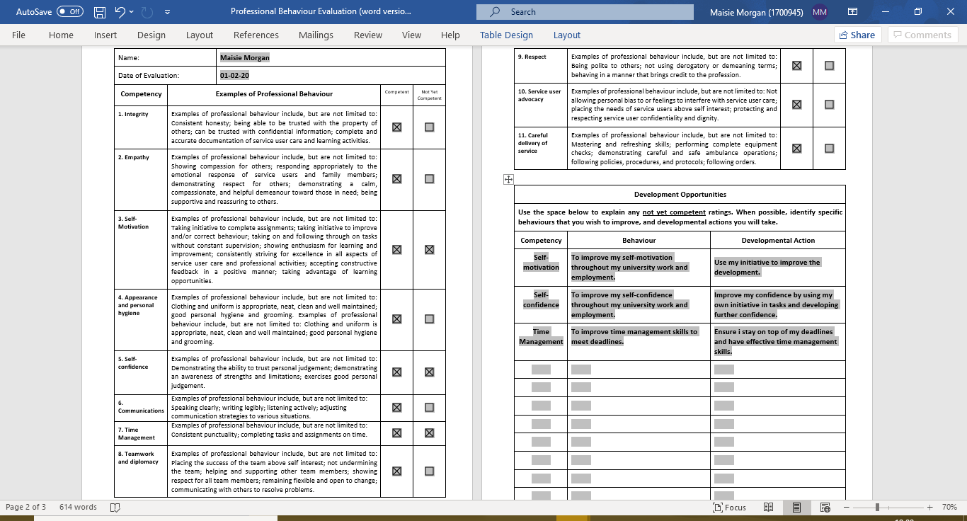

Component 3: Big Five Inventory-10 (BFI-10). Adapted from Rammstedt, B. & John, O.P. (2017).
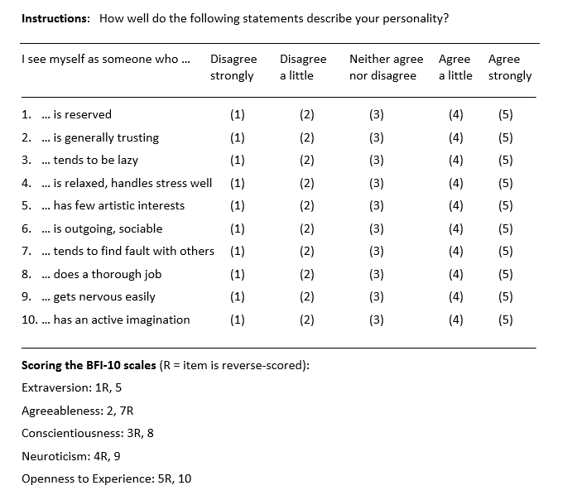

2 + 3 = 5
6
3 + 4 = 7
4 + 3 = 7
4 + 5 = 9
4 + 3 = 7

Reflective Account (1000 words)
The module ‘Skills for Life: Employability and Future Pathways’ was delivered through sessions by lecturers Ceri Phelps and Stacey Coleman. The module aimed to work towards expanding competencies regarding employability and enterprise, and to provide myself and others with skills that are required in the workplace and for further opportunities. The module helped to reflect on personal development needs and to critically reflect on them. I initially thought the module was going to be exciting and helpful, but was going to be a lot of information to take in and to process. Although this was the case, the module was very interesting and has helped me gain further knowledge regarding professional behaviours, skills, employability and enterprise. I feel as if it is important to develop existing employability and enterprise skills further as it will support me in the future with potential career pathways. Within the module, there were many sessions and activities put in place, for us to critically reflect on our own personal and professional behaviours and competencies, and how we could develop those further.
The first component I chose to analyse was an old version of my CV and an updated version. Having being provided with the professional behaviours expected, I was aware of what skills to empathise on within my updated CV. Certain parts of my CV was tailored to apply for the position stated. According to Landrum, a CV must be customised to match the environment you are applying to work within (Smith, 2015). As shown, my CV clearly states what field of work I would like to go into and what I potentially would like to further my career in. The ‘Skills for Life’ module in university has helped me gain the correct knowledge on how to set up a CV. My old CV was lengthy and did not focus on my aims, skills or voluntary work I have carried out. My updated CV includes a list of voluntary settings I have volunteered at. Stated by the APA, the importance of including volunteering services are often forgotten. To demonstrate volunteering service shows commitment to the field or society (Smith, 2015). A core skill demonstrated on my CV is teamworking skills. Effective teamwork is as an essential skill for effective delivery of care within the healthcare system (Babiker et al., 2014). For example, if the group lacks communication, there could be a lack of critical information being processed, information can be misinterpreted and changes can become overlooked (O’Daniel & Ronenstein, 2008). Furthermore, effective communication skills is another core skill that I am competent in. Having effective communication skills is vital (Kourkouta & Papathansiou, 2014).
The second component I chose to analyse was a Professional Behaviour Evaluation. The evaluation included a list of competencies and examples of the professional behaviours behind the competencies. I was required to fill out this form to assess what professional behaviours I believe I am or not competent in. According to Parandeh et al. (2015), professional values are important behaviours regarding performance. Although I believe I am competent in the majority of the behaviours, such as demonstrating empathy, integrity and having effective communication skills, there were some behaviours that I know I could improve on. For example, self-motivation, self-confidence and time management skills. Although I am self-motivated, I believe sometimes I can improve on being motivated. Having self-motivation is a key aspect which is applied voluntary in order to achieve an objective in the workplace (Papathanasiou, 2014). It is important that to feel positive towards a goal to remain motivated to provide quality standards of the work I am carrying out (Bajwa et al., 2010). Another professional behaviour I can improve on is self-confidence. Confidence is demonstrated as one of the most essential components within the health organisation (Papathanasiou, 2014). Therefore, it is important to improve this component by potentially furthering my knowledge and being able to trust my own initiatives. The last behaviour that I set to improve on is time management skills. Although I believe I am in some ways competent in this, I believe I can improve. Porta, Anderson and Stelle (2013) suggests we must prioritise our goals (Vaccro, 2002), create a schedule or list, and position them in order of significance (Lutz, 2010) in order to have effective time management skills. Having faulty time management skills can have detrimental effects (Davant, 2005), therefore, it is important to be aware that I can improve and develop.
The third component I chose to analyse was the Big Five Inventory 10-Item (BFI-10), adapted from Rammstedt, B. & John, O.P. (2017). The Big Five personality traits is a popular model used to distinguish approaches to define and evaluate individual variations in personality (Power & Pluess, 2015). I was required to fill out the BFI-10 within a session. I found this personality test interesting to try and find any links between personality traits and certain skills we may have. I was able to find certain links between some of the personality traits I demonstrated and some of the skills I am competent in, and some that I need to improve on. For example, High scores of neuroticism demonstrates personality traits of being irritable, worrying, anxiety and insecure (Fleeson & Wilt, 2010), therefore, this could explain why I sometimes lack in self-confidence and self-motivation. Individuals with higher scores of agreeableness demonstrate helpful, kind, considerate and generous traits (Shrestha, 2017). Therefore, this links to the career pathway I want to take. The Big Five personality traits are linked to many life outcomes (Soto, 2019).
This module has provided me with the relevant knowledge and understanding to move towards future employment. It has demonstrated the professional behaviours, competencies and skills I require in order to move forward within employment.

References

American Society for Microbiology, American Cleaning Institute. (2010). A Survey of Handwashing Behaviour. Rochester, NY: Harris Interactive.

Babiker, A., Husseini, M.E., Nemri, A.A., Fryah, A.A., Juryyan, N.A., Faki, M.O., Assiri, A., Saadi, M.A., Shaikh, F. & Zamil, F.A. (2014). Health Care professional development: Working as a team to improve patient care. Sudan J Paediatr. 14(2): 9-16

Bajwa, S.J.S., Virdi, S.S., Bajwa, S.K., Ghai, G.K., Singh, K., Rana, C.S., Singh, J.P. Raj, S. & Puri, A. (2010). In depth analysis of motivational factors at work in the health industry. Ind Psychiatry J. 19(1):20-29

Beach, M.C., Sugarman, J., Johnson, R.L., Arbelaez, J.J., Duggan, P.S. & Cooper, L.A. (2005). Do patients treated with dignity report higher satisfaction, adherence, and receipt of preventive care? Ann Fam Med. 3(4):331-338

Davant, C. (2005). You can get home in time for dinner. Med Econ. 82(21):76-78

Dickert, N.W. & Kass, N.E. (2009). Understanding respect: learning from patients. J Med Ethics. 35(7):419-423

Fleeson, W. & Wilt, J. (2010). The Relevance of Big Five Trait Content in Behaviour to Subjective Authenticity: Do High Levels of Within-Person Behavioural Variability Undermine or Enable Authenticity Achievement? J Pers. 78(4):1353-1382

Garzonis, K., Mann, E., Wyrzykowska, A. & Kanellakis, P. (2015). Improving Patient Outcomes: Effectively Training Healthcare Staff in Psychological Practice Skills: A Mixed Systematic Literature Review. Eur J Psychol. 11(3):535-556

Herzberg, P.Y. & Brathler, E. (2006). Assessing the Big Five per-sonality domains via short forms: A cautionary note and a proposal. European Journal of Psychological Assessment. 22:139-148

Janssen, P.P., Jonge, J.D. & Bakker, A.B. (1999). Specific determinants of intrinsic work motivation, burnout and turnover intentions: a study among nurses. J Adv Nurs. 29(6):1360-9

Kreuter, M.W. & Wray, R.J. (2003). Tailored and Targeted Health Communication: strategies for enhancing information relevance. Am J Health Behav. 27(3):227-232

Kourkouta, L. & Papathanasiou, I.V. (2014). Communication in Nursing Practice. Mater Sociomed. 26(1): 65-67

Lutz, D.J. (2010). The time in your life: use it wisely. Am J Obstet Gynecol. 202(3): 302-305

McCrae, R.R. & John, O.P. (1991). An Introduction to the Five-Factor Model and Its Application. National Institute on Aging: University of California at Berkeley: 3-7

Mohammadreza, K. (2012). “Viewpoint: Guiding Medical Students Toward Empathetic Patient Care – AAMC Reporter – Newsroom”. Web.

Montana, P. & Charnov, B. (1993). Kledarithmos. (2)

O’Daniel, M. & Rosenstein, A.H. (2008). Professional Communication and Team Collaboration. Patient Safety and Quality: An Evidence-Based Handbook for Nurses. Rockville (MD): Agency for Healthcare Research and Quality. (ch.33).

O’Donnell, J. & Vogenberg. F.R. (2012). Polices and Procedures: Enhancing Pharmacy Practice and Limiting Risk. Pharmacy & Therapeutics. 37(6):341-344

Ostendorf, F. & Angleitner, A. (2004). Personality Inventory from Costa and McCrae. Gottingen:Hogrefe

Parandeh, A., Khaghanizade, M., Mohammadi, E. & Nouri, J.M. (2014). Factors Influencing Development of Professional Values Among Nursing Students and Instructors: A Systematic Review. Glob J Health Sci. 7(2):284-293

Papathanasiou, I.V., Fradelos, E.C., Kleisiaris, C.F., Tsaras, K., Kalota, M.A. & Kourkouta, L. (2014). Motivation, Leadership, Empowerment and Confidence: Their Relation with Nurses’ Burnout. Mater Sociomed. 26(6): 405-410

Porta, C.R., Anderson, M.R. & Steele, S.R. (2013). Effective Time Management: Surgery, Research, Service, Travel, Fitness, and Family. Clin Colon Rectal Surg. 26(4): 239-243

Power, R.A. & Pluess, M. (2015). Heritability estimates of the Big Five personality traits based on common genetic variants. Transl Psychiatry. 3(7):e604

Rosen, M.A., DiazGranados, D., Dietz, A.S., Benishek, L.E., Thompson, D., Pronovost, P.J. & Weaver, S.J. (2018). Teamwork in Healthcare: Key Discoveries Enabling Safer, High-Quality Care. Am Psychol. 73(4):433-450

Rammstedt, B. (2007). The 10Item Big Five Inventory: Norm Values and Investigation of Sociodemographic Effects Based on a German Population Representative Sample. Journal of Psychological Assessment. (1):10

Shrestha, P. (2017). The Big Five Personality Traits (Five-factor Model). Psychestudy. https://www.psychestudy.com/general/personality/big-five

Smith, B.L. (2015). Build a better CV. https://www.apa.org/gradpsych/2015/01/curriculum-vitae

Soto, C.J. (2019). How Replicable Are Links Between Personality Traits and Consequential Life Outcomes? The Life Outcomes of Personality Replication Project. Sage Journals. doi.org/10.1177/0956797619831612

Srivastava, S., John, O.P., Gosling, S.D. & Potter, J. (2002). Development of personality in early and middle adulthood: Set like plaster or persistent change? Journal of Personality and Social Psychology, 84:1041-1053

Tsang, M. (2013). The Importance of Empathy- As I have Studied and Experienced It. Hawaii J Med Public Health. 72(9-4):79-80

Vaccaro, P.J. (2002). Time management tips that work. Fam Pract Manag. 9(3):64

Wong, S.S.H., Lim, S.W.H. & Quinlan, K.M. (2016). Integrity in and Beyond Contemporary Higher Education: What does it mean to University Students? Front Psychol. 7:1094

WHO (2005). Human Resources and Training in Mental Health, (Mental Health Policy and Service Guidance Package); (ch. 4).

