Shaping Culture and Behaviours
Module Course: BMHR7013
Task 2
Word count: 982

Nia Milcoy
0600733

*I confirm that this is my own work

Task 2
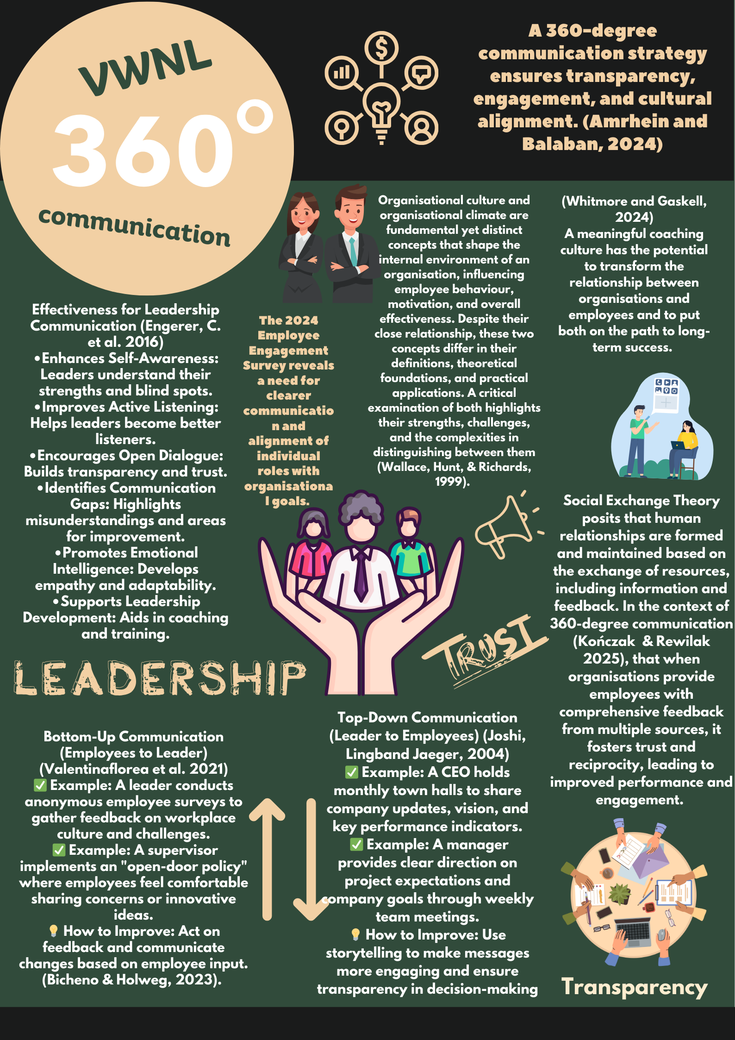

Implementing 360-Degree Communication for Organisational Alignment
To address issues from the 2024 Employee Engagement Survey, a 360-degree communication strategy and Leadership Development Program was recommended. The survey revealed that unclear communication and role misalignment contribute to low engagement and productivity (Drew, 2023).
While this strategy can help, its success depends on organisational readiness, manager engagement, and employee participation in feedback mechanisms. Leadership communication must align with the organisation’s core values of trust, autonomy, and transparency to improve motivation and performance (Wallace, Hunt, & Richards, 1999).
Social Exchange Theory supports this approach, as multi-source feedback fosters trust and collaboration (Danilwan & Dirhamsyah, 2022). However, leadership and managers must actively act on feedback to prevent it from becoming superficial or ineffective.
Rationale for Implementation
The 360-degree communication strategy addresses inconsistent leadership communication and misalignment with company values identified in the survey. Miscommunication leads to disengagement, where employees feel disconnected from larger objectives and uncertain about their roles (Barney, 1986: Arsawan et al., 2022). While this strategy holds promise, a key consideration is its feasibility and impact on various organizational levels. Top-down communication might improve clarity at the leadership level, but it can fail to reach frontline employees effectively unless managers actively engage in the feedback loop. Furthermore, bottom-up communication, although essential for fostering engagement, can be easily dismissed if employees perceive that leadership isn’t genuinely listening or acting on their concerns.
The strategy includes key mechanisms to enhance communication at all levels. Top-down communication will be strengthened through monthly Town Halls and weekly team meetings, ensuring employees receive regular updates on performance and initiatives. A structured communication plan will promote consistency across the organisation (Joshi, Ling & Jaeger, 2004). However, mechanisms must be in place to assess whether employees are truly engaging with the information or experiencing information overload.
Bottom-up communication will be improved through anonymous surveys, open-door policies, and one-on-one check-ins. Feedback will be escalated to leadership for continuous improvement (Valentinaflorea et al., 2021). However, this will only be effective if employees trust that their input leads to meaningful change, requiring a clear feedback loop to demonstrate tangible outcomes.
Digital tools like Culture Amp will track engagement and identify communication gaps, fostering a culture of improvement (Kończak & Rewilak, 2025). However, their success depends on seamless integration and proper manager training to interpret and act on insights.
Strategic Communication Days will provide leadership updates on company performance and goals, helping employees align their roles with the organisation’s mission (Alankarage et al., 2024). To avoid one-way communication, interactive elements like Q&A sessions and focus groups will encourage meaningful dialogue.
The Leadership Development Program will equip managers with skills in ethical decision-making, emotional intelligence, and inclusive communication to foster trust and transparency (Whitmore & Gaskell, 2024; Bates et al., 2025). However, ongoing development and organisational support are necessary to sustain its impact over time.
The Manager’s Role and Its Importance
Managers play a crucial role in the success of the 360-degree communication strategy. They are responsible for clear and active communication, ensuring employees feel heard and informed. Strong leadership communication has been linked to higher employee engagement and retention (Engerer et al., 2016).
However, it is important to recognize that managers themselves face challenges in effectively executing this strategy. For instance, lack of managerial training or reluctance to implement transparent feedback mechanisms may hinder the strategy's success. Furthermore, managers must navigate competing priorities, which might make it difficult for them to dedicate sufficient time and resources to communication initiatives.
By fulfilling these roles, managers help drive engagement, align teams with company objectives, and contribute to a positive organisational culture. But their success depends on the continuous support and commitment from leadership to reinforce these efforts.
The poster will be designed to communicate the 360-degree communication strategy while emphasizing the crucial role of managers in its success. It will serve not only as an informative tool but also as a motivational one, reinforcing the significance of managers in shaping the organization’s culture and climate. The design will highlight the key elements of the strategy, with a particular focus on the managers' responsibilities in communication and engagement. By providing a visual summary of the communication framework, the poster will make it easier for employees to understand how the strategy impacts their daily work.
In addition to this, the poster will emphasise the responsibility of managers to foster transparent communication. By reinforcing this message, the poster will act as a constant reminder for managers of their role in ensuring engagement and building trust within their teams (Rusu & Avasilcai, 2014). Furthermore, the Leadership Development Program will be prominently featured, showcasing its key components, such as ethical decision-making, emotional intelligence, and inclusive communication. This will reassure employees that the organization is committed to developing strong leadership capabilities (Bates et al., 2025).
The poster will also encourage employees to actively participate in feedback mechanisms, such as surveys and open-door policies. By emphasizing the importance of employee input, the poster will reinforce the idea that communication is a two-way process, fostering a culture of inclusivity and continuous improvement. It will further link the communication strategy to the organization's core values of trust, autonomy, and transparency, helping employees understand how their work contributes to broader goals and promoting a unified culture (Hofstede, 1998).
Finally, positioned in key areas, the poster will serve as a regular reminder of the organization’s commitment to improving communication and engagement. It will help integrate the strategy into the everyday operations of the company, ultimately creating a culture of accountability and continuous improvement (Koskinen, 2024).
The 360-degree communication strategy and Leadership Development Program address gaps in leadership communication and engagement. Strengthening top-down and bottom-up communication, equipping managers with necessary skills, and utilizing digital tools and strategic events will help align employees with organizational goals.
However, success depends on manager engagement, clear feedback loops, and leadership support. The poster will reinforce key messages, empowering managers to drive change and support long-term organisational success (Koskinen, 2024).

References
Abdelwahed, N.A.A., Doghan, M.A., Saraih, U.N., & Soomro, B.A. (2025) Unleashing potential: Islamic leadership’s influence on employee performance via Islamic organizational values, organizational culture and work motivation. International Journal of Law and Management, 67(2), 165–190. DOI:10.1108/IJLMA-01-2024-0019
Adewuyi, O. (2024) Beyond Competency and Charisma: Redefining Effective Leadership Qualities for the Modern Era. SSRN 4731886. http://dx.doi.org/10.2139/ssrn.4731886
Alankarage, S., Chileshe, N., Samaraweera, A., Rameezdeen, R., & Edwards, D.J. (2024) Diagnosing Organizational BIM Culture: A Qualitative Case Study Using Schein’s Model. Journal of Management in Engineering, 40(3), p.05024005. https://doi.org/10.1061/JMENEA.MEENG-5672
Amrhein, C., & Balaban, D., (2024) The effectiveness of 360° videos for environmental communication. Exploring the impact of different types of storytelling. Computers in Human Behavior Reports. 13. DOI:10.1016/j.chbr.2024.100368
Arsawan, I.W.E., Koval, V., Rajiani, I., Rustiarini, N.W., Supartha, W.G. and Suryantini, N.P.S., (2022) Leveraging knowledge sharing and innovation culture into SMEs sustainable competitive advantage. International journal of productivity and performance management, 71(2), pp.405-428. https://doi.org/10.1108/IJPPM-04-2020-0192
Barney, J. B. (1986) Organizational culture: Can it be a source of sustained competitive advantage? Academy of Management Review, 11(3), 656-665. https://doi.org/10.2307/258317
Bates, J., Beus, J.M., & Parkinson, S. (2025) Contextualizing Ethical Climate: Examining Contextual Moderators of the Connection Between Ethical Climate Perceptions and Ethical Behavior. Journal of Business Ethics, 196, 129–148. https://doi.org/10.1007/s10551-024-05698-9
Bates, J., Beus, J.M., & Parkinson, S. (2025) Contextualizing ethical climate: Examining contextual moderators of the connection between ethical climate perceptions and ethical behavior. Journal of Business Ethics, 196(1), pp. 129–148. DOI:10.1007/s10551-024-05698-9
Bicheno, J., & Holweg, M. (2023) The Lean Toolbox: A Sourcebook for Process Improvement. Buckingham, England: Production and Inventory Control, Systems and Industrial Engineering PICSIE Books.
Danilwan, Y., & Dirhamsyah, I.P. (2022) The impact of the human resource practices on the organizational performance: does ethical climate matter?. Journal of Positive School Psychology, 6(3), pp.1-16. Available at: https://mail.journalppw.com/index.php/jpsp/article/view/1062/558
Deshpande, S., Bhanot, A., & Maknikar, S. (2015) Assessing the influence of a 360-degree marketing communications campaign with 360-degree feedback. Social Marketing Quarterly, 21(3), 142-151. https://doi.org/10.1177/1524500415599528
Drew, H. (2023) Employee engagement. London: Henry Stewart Talks Ltd.
Dundon, T., Martinez Lucio, M., Howcroft, D., Hughes, E., Keizer, A., & Walden, R. (2017) Power dynamics in work and employment relationships: the capacity for employee influence. Part 1 – thematic literature review. London: Chartered Institute of Personnel and Development. Available at: https://www.cipd.co.uk/knowledge/work/job-qualityvalue-creation/power-employee-influence
Engerer, C., Berberat, P.O., Dinkel, A., et al. (2016) Integrating 360° behavior-orientated feedback in communication skills training for medical undergraduates: Concept, acceptance and students’ self-ratings of communication competence. BMC Med Educ, 16, 271. https://doi.org/10.1186/s12909-016-0792-0
Greve, H.R., & Argote, L. (2015a) Behavioral Theories of Organization. In: J.D. Wright, ed, International Encyclopedia of the Social & Behavioral Sciences (Second Edition). Oxford: Elsevier, pp. 481–486. doi/10.1016/B978-0-08-097086-8.73121-7
Greve, H.R., & Argote, L. (2015b) Behavioral Theories of Organization. In: J.D. Wright, ed, International Encyclopedia of the Social & Behavioral Sciences (Second Edition). Oxford: Elsevier, pp. 481–486. doi/10.1016/B978-0-08-097086-8.73121-7
Hatch, M.J. (1993) The dynamics of organizational culture. The Academy of Management Review, 18(4), 657. https://doi.org/10.2307/258594
Hofstede, G. (1998) Attitudes, values and organisational culture: Disentangling the concepts. Organisation Studies, 19(3), 477-493. https://doi.org/10.1177/017084069801900305
House, R.J., Wright, N.S., & Aditya, R.N. (1997) Cross-cultural research on organizational leadership: A critical analysis and a proposed theory: pp. 535–625. The New Lexington Press/Jossey-Bass Publishers. San Francisco, CA, US
Joshi, R.M.S., Ling, F.W., & Jaeger, J. (2004) Assessment of a 360-degree instrument to evaluate residents’ competency in interpersonal and communication skills. Academic Medicine, 79(5), 458-463. DOI: 10.1097/00001888-200405000-00017
Katuu, S. (2013) The utility of maturity models: The ECM maturity model within a South African context. Paper presented at IPRES 2013 Capability Assessment and Improvement Workshop. DOI:10.13140/RG.2.2.17853.74722
Katuu, S., & Katuu, S.A. (2019) Diverse applications and transferability of maturity models. Hershey, PA: IGI Global. DOI:10.4018/978-1-5225-7080-6
Kończak, I., & Rewilak, P. (2025) Digital Tools for Performance Management: A Review of Recent Trends. Journal of Organizational Development, 29(2), pp. 22–35.
Rusu, G., & Avasilcai, S. (2014) Linking human resources motivation to organizational climate. Procedia-Social and Behavioral Sciences, 124, 51–58. https://doi.org/10.1016/j.sbspro.2014.02.459
Schein, E.H. (1999) What is corporate culture built on? In E. H. Schein. The corporate culture survival guide: Sense and nonsense about culture change. California: Jossey-Bass Inc.
Wallace, J., Hunt, J., & Richards, C. (1999) The relationship between organisational culture, organisational climate and managerial values. International Journal of Public Sector Management, 12(7), pp. 548–564. DOI:10.1108/09513559910305339
Whitmore, J., & Gaskell, T. (2024) Coaching for Performance: The Principles and Practice of Coaching and Leadership. Philadelphia, PA: John Murray Business.

