Search
AI and Machine Learning (ACCA6011)
February 26, 2020
Matthew Lewington
BSc Software engineering
UWTSD School of Applied Computing
Contents
1 Introduction 1
2 Maze Solver 2
2.1 Algorithms 2
2.2 Data Structures 2
2.3 Structure 2
2.3.1 Menu 2
2.3.2 File Handling 3
2.3.3 Maze 3
2.4 User Guide 3
2.5 Testing 3
3 8-Tile Puzzle Solver 4
3.1 Algorithms 4
3.1.1 Hill Climbing 4
3.2 Data Structures 6
3.3 Structure 6
3.3.1 Menu 6
3.3.2 Puzzle Solver 6
3.4 User Guide 7
3.5 Testing 7
4 Conclusion 8
5 References 9
6 Appendix A – Maze Main Menu 10
7 Appendix B – Maze File Reader 11
8 Appendix C – Maze Solver 12
9 Appendix D – Maze User Manual 13
10 Appendix E – Maze Testing 20
11 Appendix F – Eight Tile Main Menu 52
12 Appendix G – Eight Tile Solver 53
13 Appendix H – Eight Tile User Manual 54
14 Appendix I – Eight Tile Testing 62
15 Appendix J – Maze Code 87
15.1 Maze.h 87
15.2 Maze.cpp 88
15.3 Node.h 96
15.4 FileHandler.h 97
15.5 FileHandler.cpp 98
15.6 Menu.h 101
15.7 Menu.cpp 102
15.8 Source.cpp 103
16 Appendix I – Eight Tile Code 105
16.1 Board.h 105
16.2 Board.cpp 106
16.3 Menu.h 113
16.4 Menu.cpp 114
16.5 RNG.h 115
16.6 RNG.cpp 116
16.7 Source.cpp 117

Introduction
This report has been produced to accompany the two applications created for the Artificial Intelligence / Machine Learning module. Contained herein is the information regarding both the maze solver and 8-tile puzzle solvers including algorithms and data structures used, program structures, user guides and test information (both of which are included in the appendices) for both applications. A discussion on hill climbing and example algorithms also supplied are within the 8-tile puzzle solver section.

Maze Solver
The maze solver allows users to either pass their own .txt maze files in (following a character protocol for walls, objects, start and finish), or use the included maze files and the program will be able to execute a depth first search to find the end of the maze.

Algorithms
The search algorithm used for the maze solver was a depth first search. Due to the potential size and style of the maze provided, an algorithm that can explore “deeper” into a graph is a key strategy. Though it may not visit every node, it will eventually find the target node as long as there are no nodes that loop [1].

Data Structures
A stack was used to keep a track of the visited nodes. If it cannot move in any direction, it will pop a node off the top of the stack and go back to the previous node.
A vector was used for the maze itself as it allows dynamic memory allocation, allowing the user to pass in any size maze they want to.

Structure
The application contains three object files; menu system, file handler and the maze itself.

Menu
A menu object is created and displays a menu for the user while they have not selected a maze file.
If the user pauses the maze solver by pressing any keyboard button, a Menu object is instantiated and displays the pause menu. The user has the option to continue the maze solver, return to the main menu, or exit the program.
A flowchart is provided in Appendix A.

File Handling
If the user selects to load a file, the user is shown the mazefiles directory. The choice is passed to a FileHandler class to make sure the file is valid, read it in, and pass it back to the main program as a vector. The file is read in as a vector rather than having fixed height/width values, as this is dynamic and allows the user to try their own maze files without having to change the code.
Once the file is returned, the user has the option to load a new file, or to start the maze solver with or without a “step through”, in the case that it may solve the maze too quickly and the user wants to watch it be solved step-by-step.
A flowchart is provided in Appendix B.

Maze
A maze file is created, then the solver will find the starting node and push this to the stack. While the end node has not been found, it will then check up, right, down and left to see if there are suitable spaces to move to. If so, it will move there, update the node to “visited” and push the new node to the stack, then it re-sets the process.
If the node contains an object (depicted as an ‘o’), it will update the object counter to count how many items it has found whilst traversing the maze.
Upon completion, the FileHandler will display it’s found objects vs. the number of objects in the maze and output to a Path.txt file to show the path taken for the maze.
A flowchart is provided in Appendix C.

User Guide
See Appendix D.

Testing
See Appendix E.

8-Tile Puzzle Solver
An 8-tile puzzle solver has been developed to solve the provided puzzle. It can either automatically solve the given puzzle utilising hill climbing, or randomly generate a puzzle for a user to test their puzzle solving skills.

Algorithms
The algorithm used was the hill climbing algorithm and will be described within the following subsection.

Hill Climbing
The hill climbing algorithm is a local search based heuristic which is limited to local optima and is widely used in artificial intelligence to solve optimisation problems for example the travelling salesman and the 8 tile puzzle game [2]. It works by accepting a better neighbouring solution than the current one [3], hence the term hill climbing, and is used if a reliable heuristic is available to evaluate the state. The current position is taken as the centre, and the surrounding positions are measured against the current value. If they increase the value, then the two points are swapped.

Hill Climbing Algorithm
The hill climbing algorithm can be explained by the following steps [4]:
- Initial state is evaluated against the goal state. If it is the same, the process stops as it is successful. If it is not the same, the process continues by making the initial state the current state.
- Search for a neighbour value that has not been used in the current state and create a new state
- Evaluate new state
  - If the new state is the goal state, stop as it is successful.
  - If the new state is not the goal state, but it is better than the current state, then set the current state to the new state
  - If the new state is no better than the current state, repeat steps 2 onwards.

Hill Climbing Example
An example provided for completion of the assignment is shown (Figure 3-1).
The current h value is defined as the number of tiles in the correct place.
The next h value is defined as the potential number of tiles in the correct place, depending on which move is made (up, right, down or left). The move made is defined by whether the new state is better than the current state.

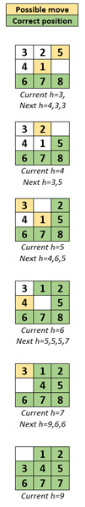
Figure 3-1 Illustration of given puzzle

Data Structures
As the problem is only for an 8-tile maze, a simple 3d array was used to store each of the integers in a 3x3 matrix.

Structure
Like the maze solver there is a menu and the puzzle solver itself. Due to the 8-tile puzzle being limited, no file handler was implemented.

Menu
The menu object is created and displays a menu for the user where they have the option to automatically solve the given puzzle, or to generate and try solving a puzzle themselves.
A flowchart has been provided in Appendix F.

Puzzle Solver
Upon the user selecting for the automatic solving, or to manually play the solver, a board object is created which contains the solution, or goal state (g) along with two other arrays; one with the initial state and one temporary array which is used for the “new” state.

$$g= \left[\begin{matrix}0 & 1 & 2 \\ 3 & 4 & 5 \\ 6 & 7 & 8\end{matrix}\right]$$

If the user selects to automatically solve the given puzzle (p), it will initialize the temporary array, then whilst unsolved it will apply the hill climbing algorithm to work toward achieving the goal state.

$$p= \left[\begin{matrix}3 & 2 & 5 \\ 4 & 1 & 0 \\ 6 & 7 & 8\end{matrix}\right]$$

If the user selects to manually solve a random puzzle, it will initialize only the solution and current arrays. It will then randomise the board based on the specified amount of turns, then request the user enter a move.
Each method runs until the current array is equal to the solution array and will exit to the menu once complete.
A flowchart has been provided in Appendix G.

User Guide
See appendix H.

Testing
See appendix I.

Conclusion
There are a number of different algorithms that can be applied to many different scenarios. Some more fit for purpose than others. A delve into the depth first search and hill climbing algorithms both show their potential use cases and how they can work differently.
As part of machine learning, if implemented correctly, these searches can be powerful tools.

References
[1] A. S. Hidayatullah, A. N. Jati, and C. Setianingsih, “Realization of depth first search algorithm on line maze solver robot,” in 2017 International Conference on Control, Electronics, Renewable Energy and Communications (ICCREC), 2017, pp. 247–251.
[2] T. G. Tan, J. Teo, and P. Anthony, “Uniform versus Gaussian mutators in automatic generation of game AI in Ms. Pac-man using hill-climbing,” in 2010 International Conference on Information Retrieval & Knowledge Management (CAMP), 2010, pp. 282–286.
[3] M. A. Al-Betar, M. A. Awadallah, A. L. Bolaji, and B. O. Alijla, “β-Hill Climbing Algorithm for Sudoku Game,” in 2017 Palestinian International Conference on Information and Communication Technology (PICICT), 2017, pp. 84–88.
[4] Y. Sazaki, H. Satria, A. Primanita, and R. Apriliansyah, “Application of the Steepest Ascent Hill Climbing Algorithm in the Preparation of the Crossword Puzzle Board,” in 2018 4th International Conference on Wireless and Telematics (ICWT), 2018, pp. 1–6.

Appendix A – Maze Main Menu

Appendix B – Maze File Reader

Appendix C – Maze Solver

Appendix D – Maze User Manual
Maze File Installation
The maze solver comes with 8 mazes currently pre-set. The user has the option to install their own maze.txt file by navigating to the /AIMaze/mazefiles/ directory [Figure 1-1], here the user can place their own files [Figure 1-2].
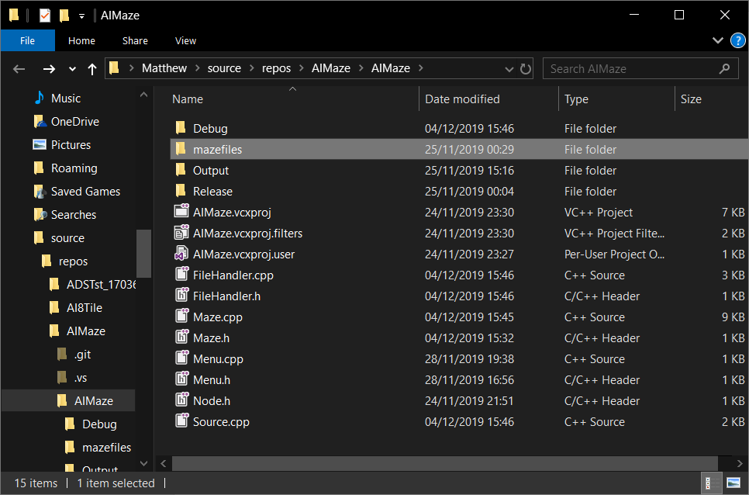
Figure 1-1 /AIMaze/ directory

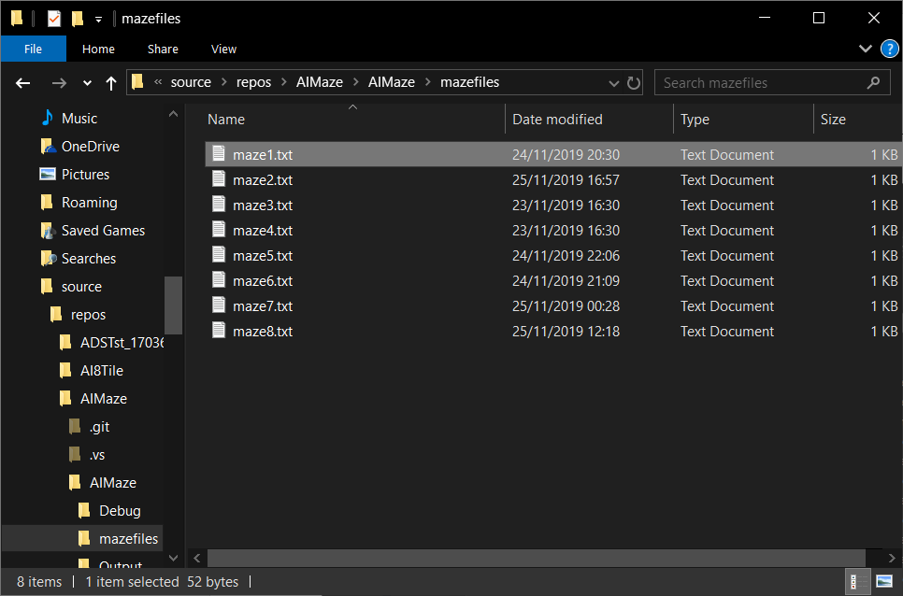
Figure 1-2 /AIMaze/mazefiles directory

Loading Maze File
The user will need to first load a maze file into the program by entering option 1 [Figure 2-1].

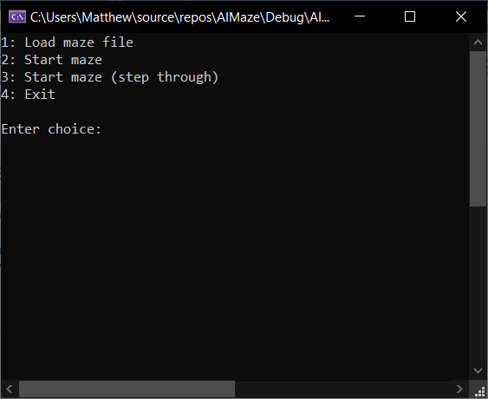
Figure 2-1 Main menu and choice selection

Maze Selection
The program will query the /AIMaze/mazefiles/ directory and display any files it has found. The user then enters the name of the file they wish to load [Figure 2-2] – this allows the user to easily place their own maze .txt file into the program directory for the maze solver.

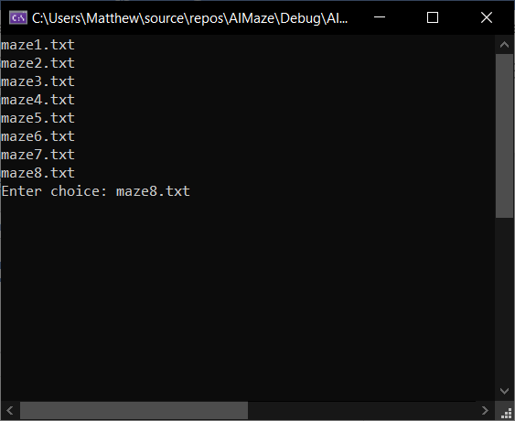
Figure 2-2 Maze selection output and user input

The user has three more options; to start solving the maze, to start solving the maze allowing the user to control the pace (step through the process), or to exit.
Solving
This is maze8.txt before the maze solver begins. We can see there are 4 objects to find [Figure 3-1].
‘s’: Start
‘f’: Finish
‘o’: Object
‘*’: Wall

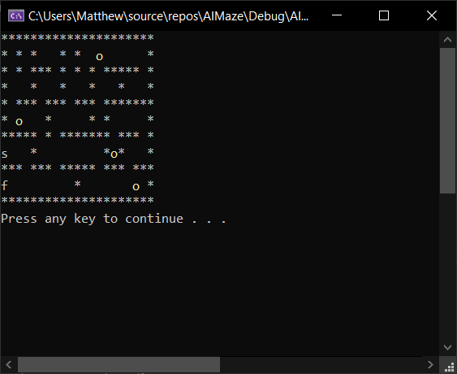
Figure 3-1 maze8.txt before maze solving begins

The maze solver will begin solving the maze by checking first up, then right, then down, then left of its current position. If the checked space is free, it will move to it then re-start the checks. The previously visited space will be marked with an ‘x’.
If the maze solver runs into a dead-end, it will mark its current position as ‘-‘ to show that it has had to retract a step, then re-visit its last position. The checks then re-start.
At any time, a keyboard press can be made to bring up the pause menu [Figure 3-2].
‘.’: Current position
‘x’: Path taken
‘-‘: Step back
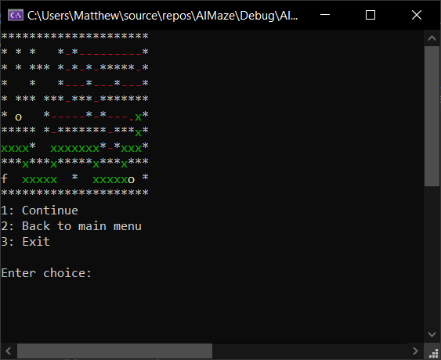
Figure 3-2 Pause screen on maze8.txt while being solved

The maze solver will continue until the user selects to exit, or until it reaches the finish of the maze.
Solving (Step Through)
Included is an option to “step through” the maze. This will take the maze file loaded by the user and allow the user to press a keyboard button to step through the maze. It allows the maze to show where the agent is and waits for user keyboard input, in the case that it might run too quickly for the user to see and track the agent [Figures 4-1 – 4-2].

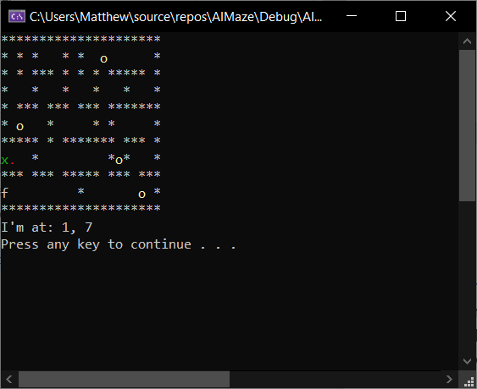
Figure 4-1 Stepping through maze solver

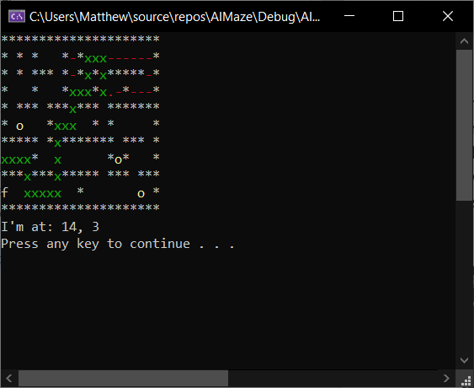
Figure 4-2 Stepping through maze solver

Results
Once the maze solver has completed the maze, it will output how many objects it has found based on how many were in the maze on load [Figure 5-1], and it outputs the path taken to a path.txt file.

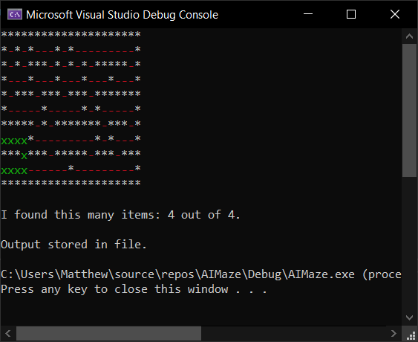
Figure 5-1 maze8.txt completion

Results File
If the user navigates to /AIMaze/Output [Figure 5-2], there will be a Path.txt file that the user can open which shows the path that the maze solver has taken.

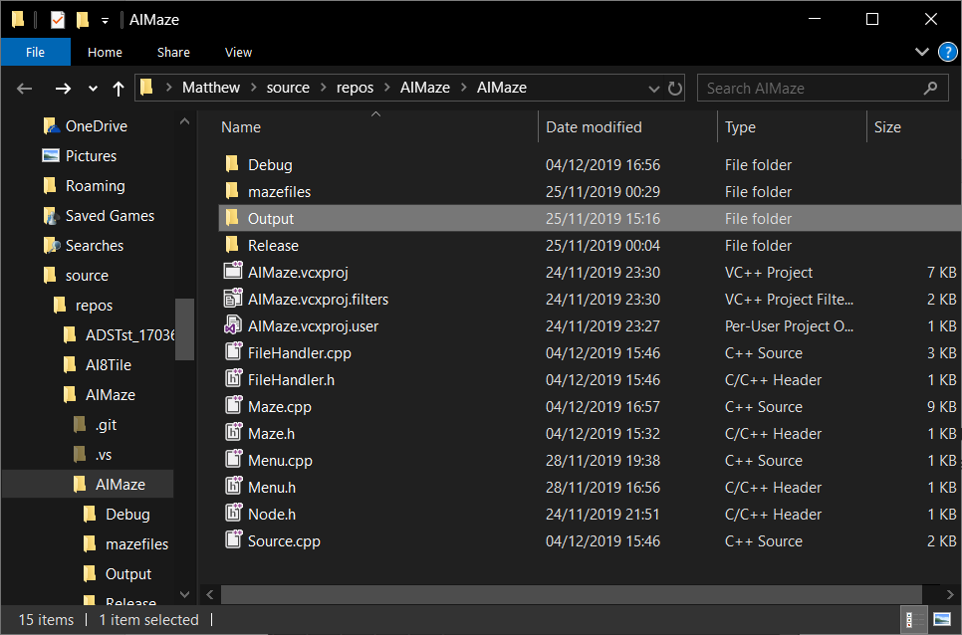
Figure 5-2 /AIMaze/ directory highlighting Output folder
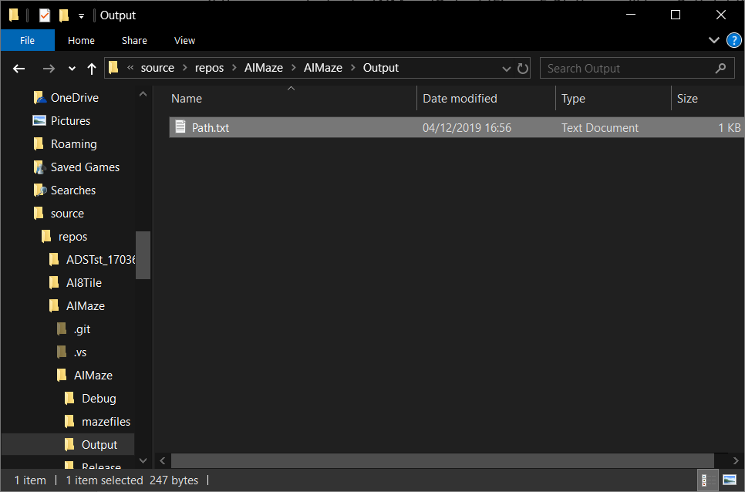
Figure 5-3 /AIMaze/Output directory showing Path.txt file

Appendix E – Maze Testing
MZ_MainMenu_1a
Test Case ID | MZ_MainMenu_1a
Test Title | Start maze without file
Description | Check if the maze solver runs without a file

Pre-conditions | No file to be loaded

Step | Test Step | Test Data | Expected Result | Actual Result | Status (Pass/Fail) | Notes
1 | Enter option to start maze | Option = 2 | Re-load main menu | Crash | Fail

Screenshot (if applicable)
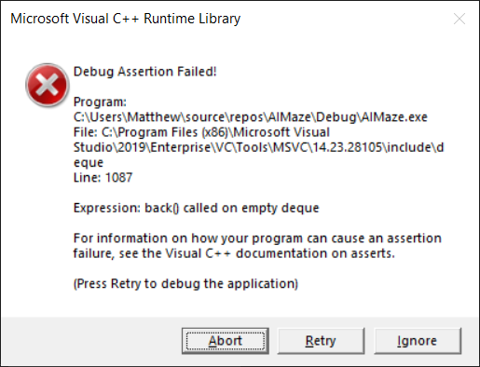

MZ_MainMenu_1b
Test Case ID | MZ_MainMenu_1b
Test Title | Start maze without file
Description | Check if the maze solver runs without a file

Pre-conditions | No file to be loaded

Step | Test Step | Test Data | Expected Result | Actual Result | Status (Pass/Fail) | Notes
1 | Enter option to start maze | Option = 2 | Re-load main menu with error | Re-load main menu with error | Pass | Issue with object handling. Needed to check that the file was actually available (implemented file name length check), and developed method to “clear” file, rather than delete it as this was pointing to invalid memory.

Screenshot (if applicable)
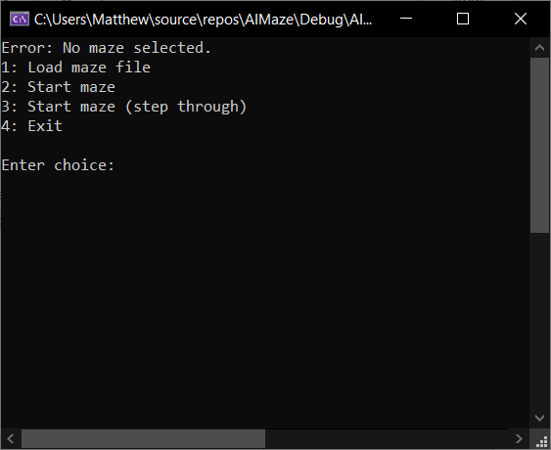

MZ_FileLoad_1a
Test Case ID | MZ_Fileload_1a
Test Title | Load invalid file
Description | Check if it will load an incorrect file - no file extension, and invalid filename

Pre-conditions | No file to be loaded

Step | Test Step | Test Data | Expected Result | Actual Result | Status (Pass/Fail) | Notes
1 | Enter option to load file | Option = 1 | Go to file load screen | Go to file load screen | Pass
2 | Enter invalid filename | Filename = a | Display error  Re-load file list | Display error  Re-load file list | Pass

Screenshot (if applicable)
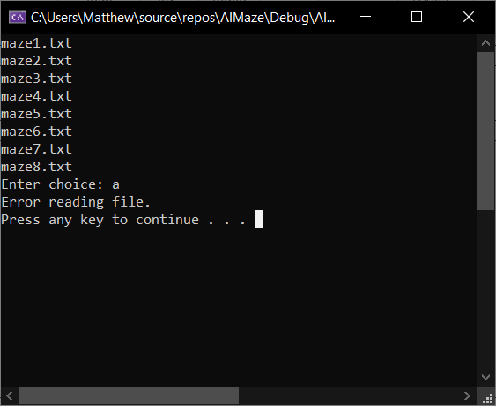

MZ_FileLoad_2a
Test Case ID | MZ_Fileload_2a
Test Title | Load invalid file
Description | Check if it will load an incorrect file - no file present called maze99.txt

Pre-conditions | No file to be loaded

Step | Test Step | Test Data | Expected Result | Actual Result | Status (Pass/Fail) | Notes
1 | Enter option to load file | Option = 1 | Go to file load screen | Go to file load screen | Pass
2 | Enter invalid filename | Filename = maze99.txt | Display error  Re-load file list | Display error  Re-load file list | Pass

Screenshot (if applicable)
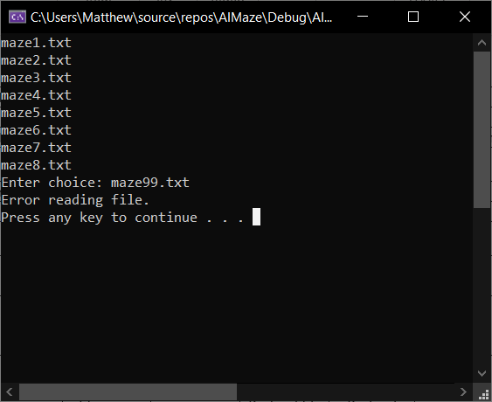

MZ_FileLoad_3a
Test Case ID | MZ_Fileload_3a
Test Title | Load invalid file
Description | Check if it will load an incorrect file - incorrect file extension

Pre-conditions | No file to be loaded

Step | Test Step | Test Data | Expected Result | Actual Result | Status (Pass/Fail) | Notes
1 | Enter option to load file | Option = 1 | Go to file load screen | Go to file load screen | Pass
2 | Enter invalid filename | Filename = maze1.txtd | Display error  Re-load file list | Display error  Re-load file list | Pass

Screenshot (if applicable)
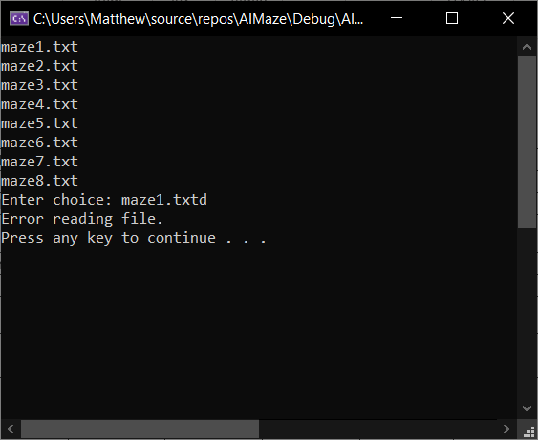

MZ_FileLoad_4a
Test Case ID | MZ_Fileload_4a
Test Title | Load invalid file
Description | Check if it will load an incorrect file - no file extension

Pre-conditions | No file to be loaded

Step | Test Step | Test Data | Expected Result | Actual Result | Status (Pass/Fail) | Notes
1 | Enter option to load file | Option = 1 | Go to file load screen | Go to file load screen | Pass
2 | Enter invalid filename | Filename = maze5 | Display error  Re-load file list | Display error  Re-load file list | Pass | Could be implemented where it auto adds .txt to the end

Screenshot (if applicable)
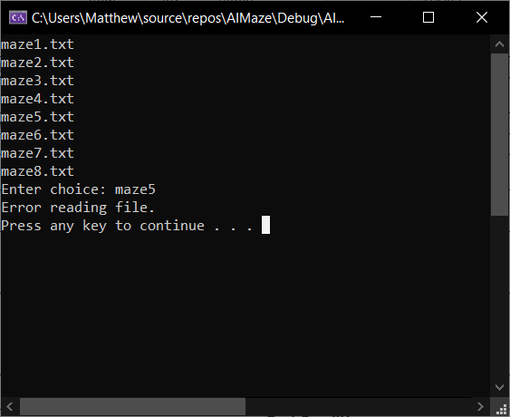

MZ_FileLoad_5a
Test Case ID | MZ_Fileload_5a
Test Title | Load correct file
Description | Check if it will load a correct file

Pre-conditions | No file to be loaded

Step | Test Step | Test Data | Expected Result | Actual Result | Status (Pass/Fail) | Notes
1 | Enter option to load file | Option = 1 | Go to file load screen | Go to file load screen | Pass
2 | Enter valid filename | Filename = maze8.txt | Go to main menu | Go to main menu | Pass

Screenshot (if applicable)
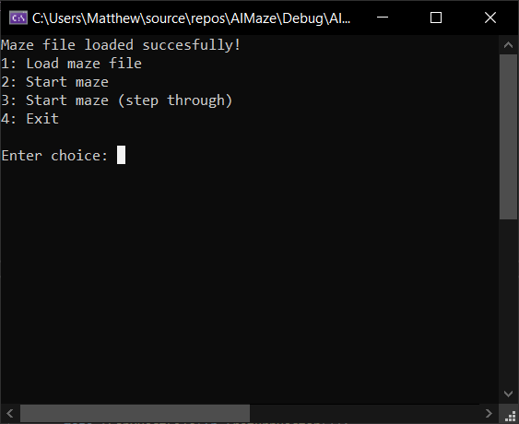

MZ_FileLoad_6a
Test Case ID | MZ_Fileload_6a
Test Title | Re-load new file
Description | Check if it will load a file while one is already present

Pre-conditions | File already loaded

Step | Test Step | Test Data | Expected Result | Actual Result | Status (Pass/Fail) | Notes
1 | Enter option to load file | Option = 1 | Go to file load screen | Go to file load screen | Pass
2 | Enter valid filename | Filename = maze8.txt |  |  | Pass
3 | Start maze solve | Option = 2 | Solve maze | Solve multiple mazes | Fail

Screenshot (if applicable)
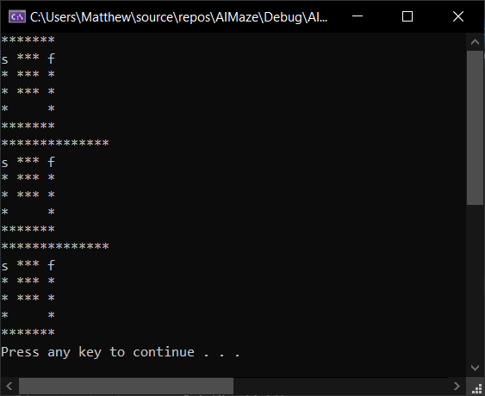

MZ_FileLoad_6b
Test Case ID | MZ_Fileload_6b
Test Title | Re-load new file
Description | Check if it will load a file while one is already present

Pre-conditions | File already loaded

Step | Test Step | Test Data | Expected Result | Actual Result | Status (Pass/Fail) | Notes
1 | Enter option to load file | Option = 1 | Go to file load screen | Go to file load screen | Pass
2 | Enter valid filename | Filename = maze8.txt | Go to main menu | Go to main menu | Pass
3 | Start maze solve | Option = 2 | Solve maze | Solve maze | Pass | Deleted file object as it was duplicating

Screenshot (if applicable)
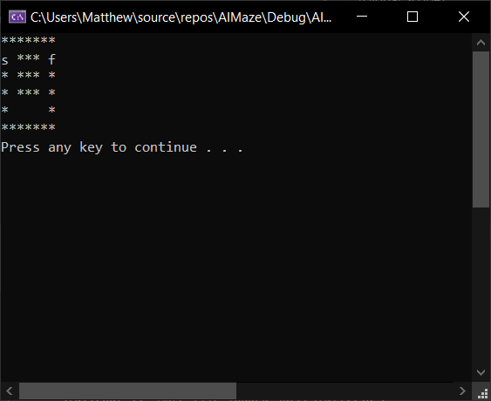

MZ_FileLoad_7a
Test Case ID | MZ_Fileload_7a
Test Title | Loading different size maze files
Description | Check if it will load in different size (height/width) maze files

Pre-conditions | No file loaded  Different size maze files available in mazefiles folder

Step | Test Step | Test Data | Expected Result | Actual Result | Status (Pass/Fail) | Notes
1 | Enter option to load file | Option = 1 | Go to file load screen | Go to file load screen | Pass
2 | Enter valid filename | Filename = maze1.txt | Go to main menu | Go to main menu | Pass
3 | Start maze solve | Option = 2 | Solve maze | Solve maze | Pass | Maze1.txt is 7x6

Screenshot (if applicable)

MZ_FileLoad_8a
Test Case ID | MZ_Fileload_8a
Test Title | Loading different size maze files
Description | Check if it will load in different size (height/width) maze files

Pre-conditions | No file loaded  Different size maze files available in mazefiles folder

Step | Test Step | Test Data | Expected Result | Actual Result | Status (Pass/Fail) | Notes
1 | Enter option to load file | Option = 1 | Go to file load screen | Go to file load screen | Pass
2 | Enter valid filename | Filename = maze2.txt | Go to main menu | Go to main menu | Pass
3 | Start maze solve | Option = 2 | Solve maze | Solve maze | Pass | Maze2.txt is 16x16

Screenshot (if applicable)
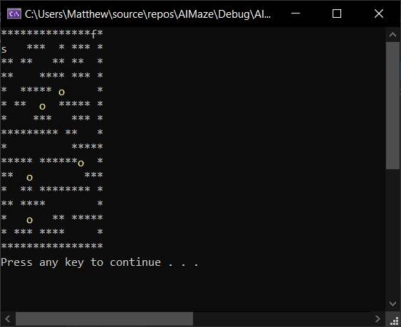

MZ_FileLoad_9a
Test Case ID | MZ_Fileload_9a
Test Title | Loading different size maze files
Description | Check if it will load in different size (height/width) maze files

Pre-conditions | No file loaded  Different size maze files available in mazefiles folder

Step | Test Step | Test Data | Expected Result | Actual Result | Status (Pass/Fail) | Notes
1 | Enter option to load file | Option = 1 | Go to file load screen | Go to file load screen | Pass
2 | Enter valid filename | Filename = maze3.txt | Go to main menu | Go to main menu | Pass
3 | Start maze solve | Option = 2 | Solve maze | Solve maze | Pass | Maze3.txt is 8x8

Screenshot (if applicable)
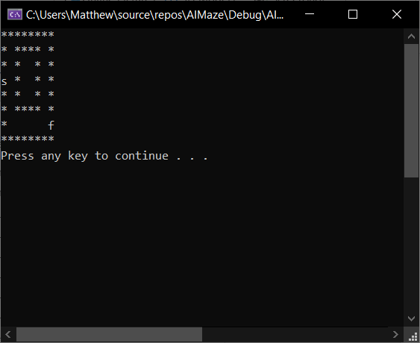

MZ_FileLoad_10a
Test Case ID | MZ_Fileload_10a
Test Title | Loading different size maze files
Description | Check if it will load in different size (height/width) maze files

Pre-conditions | No file loaded  Different size maze files available in mazefiles folder

Step | Test Step | Test Data | Expected Result | Actual Result | Status (Pass/Fail) | Notes
1 | Enter option to load file | Option = 1 | Go to file load screen | Go to file load screen | Pass
2 | Enter valid filename | Filename = maze5.txt | Go to main menu | Go to main menu | Pass
3 | Start maze solve | Option = 2 | Solve maze | Solve maze | Pass | Maze5.txt is 10x10

Screenshot (if applicable)
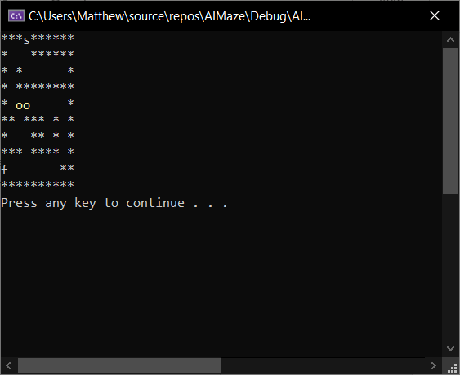

MZ_PauseMenu_1a
Test Case ID | MZ_PauseMenu_1a
Test Title | Pause menu load
Description | Check if pause menu loads

Pre-conditions | File loaded

Step | Test Step | Test Data | Expected Result | Actual Result | Status (Pass/Fail) | Notes
1 | Start maze solve | Option = 2 | Solve maze | Solve maze | Pass
2 | Press pause button | Button = spacebar | Pause menu underneath maze | Pause menu underneath maze | Pass

Screenshot (if applicable)
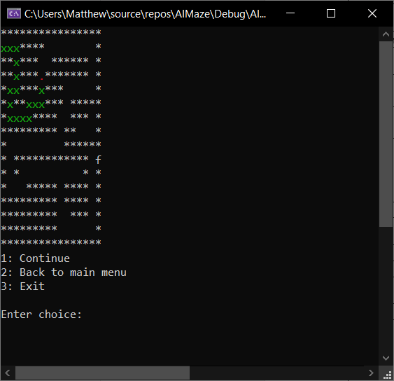

MZ_PauseOptions_1a
Test Case ID | MZ_PauseOptions_1a
Test Title | Pause menu options
Description | Check if pause menu options work correctly - continue solving maze

Pre-conditions | File loaded  Maze solver paused

Step | Test Step | Test Data | Expected Result | Actual Result | Status (Pass/Fail) | Notes
1 | Continue maze solver | Option = 1 | Solve maze | Solve maze | Pass

Screenshot (if applicable)
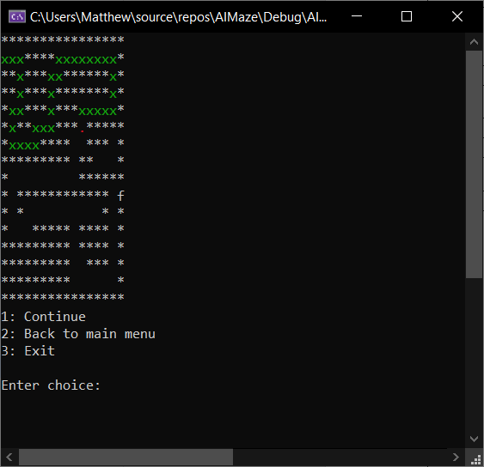
NB – had to pause again for screen shot

MZ_PauseOptions_2a
Test Case ID | MZ_PauseOptions_2a
Test Title | Pause menu options
Description | Check if pause menu options work correctly – return to main menu

Pre-conditions | File loaded  Maze solver paused

Step | Test Step | Test Data | Expected Result | Actual Result | Status (Pass/Fail) | Notes
1 | Return to main menu | Option = 2 | Main menu display | Main menu display | Pass

Screenshot (if applicable)
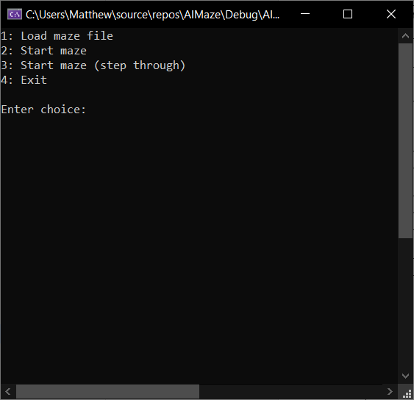

MZ_PauseOptions_3a
Test Case ID | MZ_PauseOptions_3a
Test Title | Pause menu options
Description | Check if pause menu options work correctly – exit

Pre-conditions | File loaded  Maze solver paused

Step | Test Step | Test Data | Expected Result | Actual Result | Status (Pass/Fail) | Notes
1 | Exit | Option = 3 | Exit | Exit | Pass

Screenshot (if applicable)
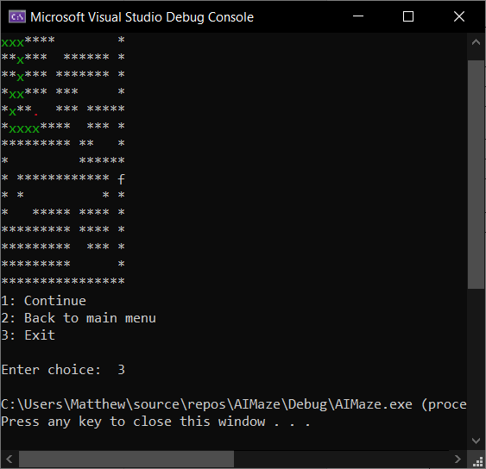

MZ_MazeSolve_1a
Test Case ID | MZ_MazeSolve_1a
Test Title | Maze solving
Description | Check if it can solve a small simple maze with one path

Pre-conditions | Maze1.txt file loaded  Main menu

Step | Test Step | Test Data | Expected Result | Actual Result | Status (Pass/Fail) | Notes
1 | Solve maze | Option = 2 | Maze solved | Maze solved | Pass

Screenshot (if applicable)
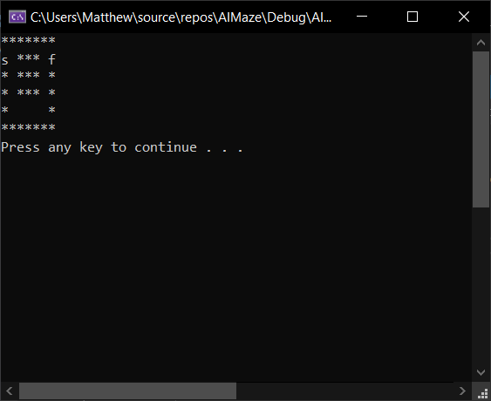

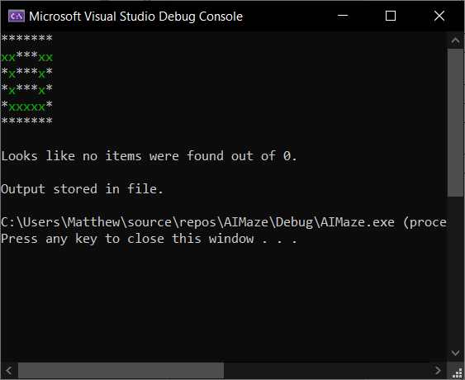

MZ_MazeSolve_2a
Test Case ID | MZ_MazeSolve_2a
Test Title | Maze solving
Description | Check if it can solve a small simple maze with one path

Pre-conditions | Maze3.txt file loaded  Main menu

Step | Test Step | Test Data | Expected Result | Actual Result | Status (Pass/Fail) | Notes
1 | Solve maze | Option = 2 | Maze solved | Maze solved | Pass

Screenshot (if applicable)
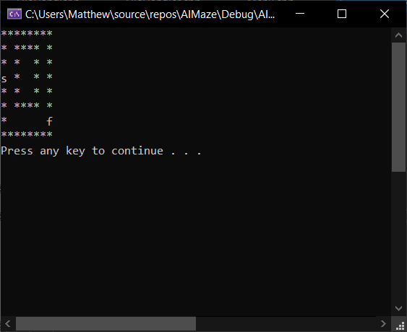

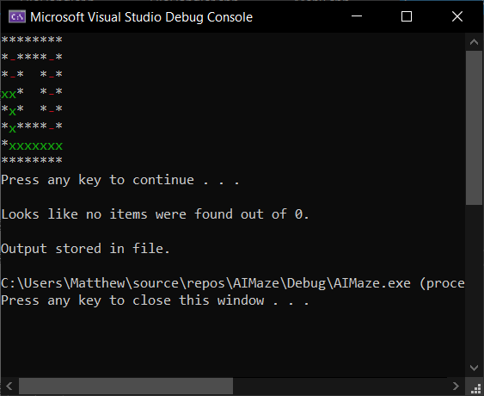

MZ_MazeSolve_3a
Test Case ID | MZ_MazeSolve_3a
Test Title | Maze solving
Description | Check if it can solve a small simple maze with one path, but with the start and finish sides swapped

Pre-conditions | Maze6.txt file loaded  Main menu

Step | Test Step | Test Data | Expected Result | Actual Result | Status (Pass/Fail) | Notes
1 | Solve maze | Option = 2 | Maze solved | Maze solved | Fail

Screenshot (if applicable)
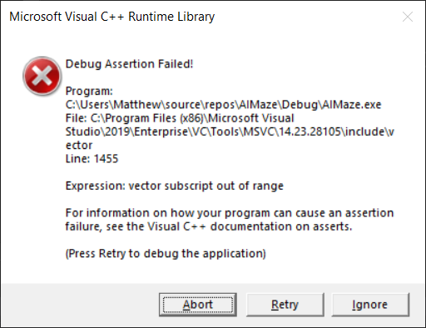

MZ_MazeSolve_3b
Test Case ID | MZ_MazeSolve_3b
Test Title | Maze solving
Description | Check if it can solve a small simple maze with one path, but with the start and finish sides swapped

Pre-conditions | Maze6.txt file loaded  Main menu

Step | Test Step | Test Data | Expected Result | Actual Result | Status (Pass/Fail) | Notes
1 | Solve maze | Option = 2 | Maze solved | Maze solved | Pass | Boundary checks implemented as it checked to the right of the ‘s’

Screenshot (if applicable)
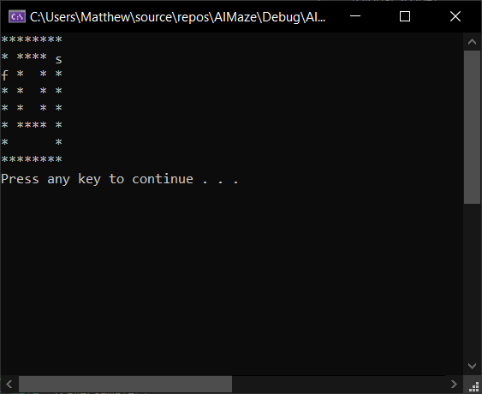

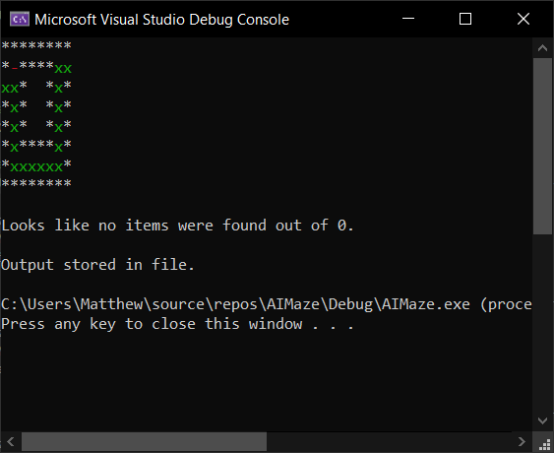

MZ_MazeSolve_4a
Test Case ID | MZ_MazeSolve_4a
Test Title | Maze solving
Description | Check if it can solve a more difficult maze with a false path

Pre-conditions | Maze4.txt file loaded  Main menu

Step | Test Step | Test Data | Expected Result | Actual Result | Status (Pass/Fail) | Notes
1 | Solve maze | Option = 2 | Maze solved | Maze solved | Pass

Screenshot (if applicable)
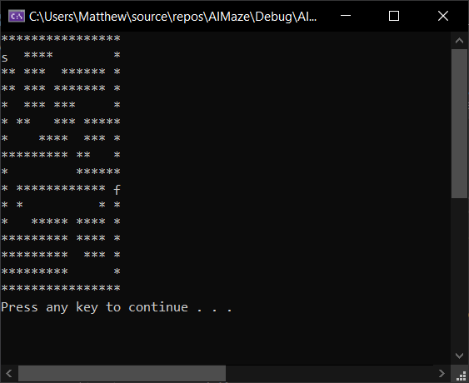

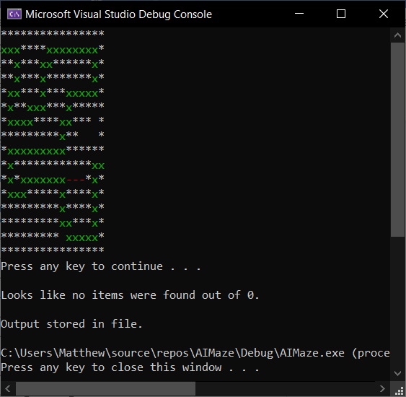

MZ_MazeSolve_5a
Test Case ID | MZ_MazeSolve_5a
Test Title | Maze solving
Description | Check if it can solve a more difficult maze with multiple false paths

Pre-conditions | Maze7.txt file loaded  Main menu

Step | Test Step | Test Data | Expected Result | Actual Result | Status (Pass/Fail) | Notes
1 | Solve maze | Option = 2 | Maze solved | Maze solved | Pass

Screenshot (if applicable)
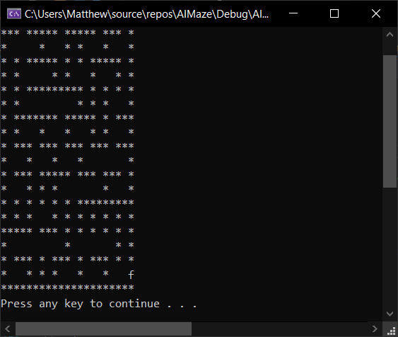

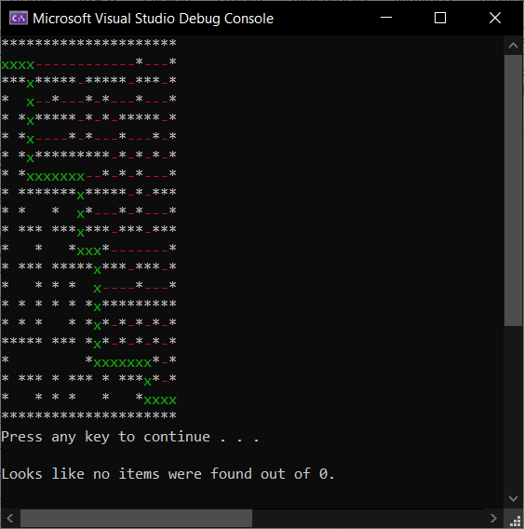

MZ_MazeSolveObject_1a
Test Case ID | MZ_MazeSolveObject_1a
Test Title | Maze solving
Description | Check if it can solve a maze and count objects

Pre-conditions | Maze5.txt file loaded  Main menu

Step | Test Step | Test Data | Expected Result | Actual Result | Status (Pass/Fail) | Notes
1 | Solve maze | Option = 2 | Maze solved, 2 items found | Maze solved, 2 items found | Pass

Screenshot (if applicable)
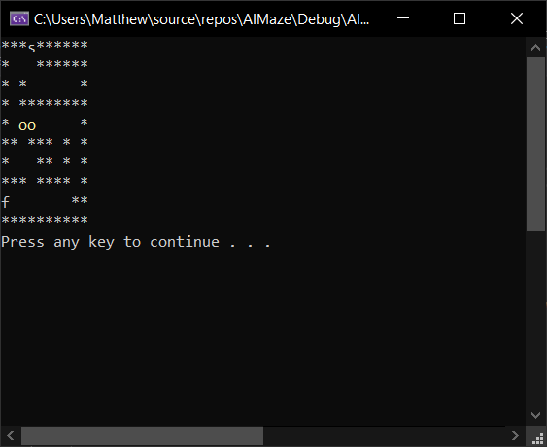

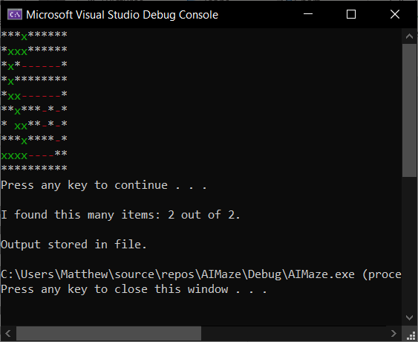

MZ_MazeSolveObject_2a
Test Case ID | MZ_MazeSolveObject_2a
Test Title | Maze solving
Description | Check if it can solve a maze and count objects, this time with more objects than it collects before it gets to the end

Pre-conditions | Maze2.txt file loaded  Main menu

Step | Test Step | Test Data | Expected Result | Actual Result | Status (Pass/Fail) | Notes
1 | Solve maze | Option = 2 | Maze solved, 2 items found | Maze solved, 2 items found | Pass

Screenshot (if applicable)
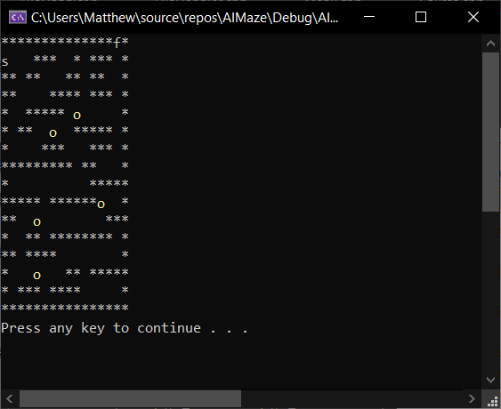

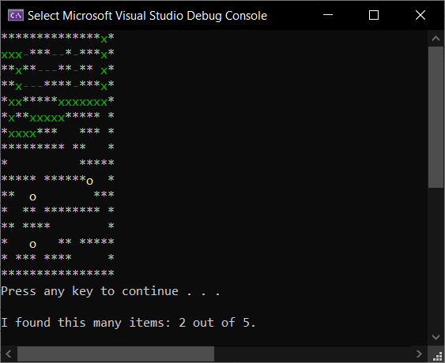

MZ_MazeSolveObject_3a
Test Case ID | MZ_MazeSolveObject_3a
Test Title | Maze solving
Description | Check if it can solve a maze and count objects, slightly larger maze and objects put in an order that they are all going to be picked up

Pre-conditions | Maze8.txt file loaded  Main menu

Step | Test Step | Test Data | Expected Result | Actual Result | Status (Pass/Fail) | Notes
1 | Solve maze | Option = 2 | Maze solved, 4 items found | Maze solved, 4 items found | Pass

Screenshot (if applicable)
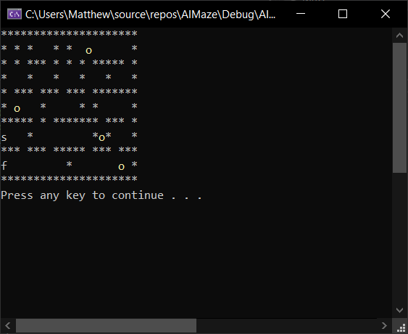

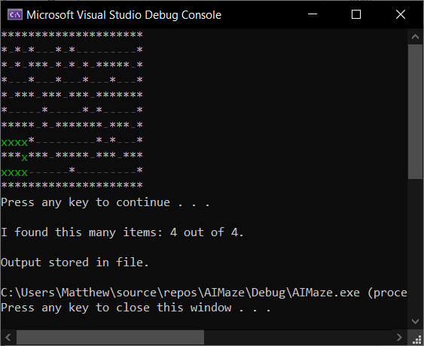

MZ_FileOutput_1a
Test Case ID | MZ_MazeSolveObject_1a
Test Title | File output
Description | Check if it outputs the path taken to the relevant file

Pre-conditions | Maze file loaded  Maze solving completed

Step | Test Step | Test Data | Expected Result | Actual Result | Status (Pass/Fail) | Notes
1 | Navigate to /AIMaze/AIMaze/Output |  | Path.txt file to be displayed | Path.txt file displayed | Pass
2 | Open Path.txt |  | Output from maze of path taken | Output from maze of path taken | Pass

Screenshot (if applicable)
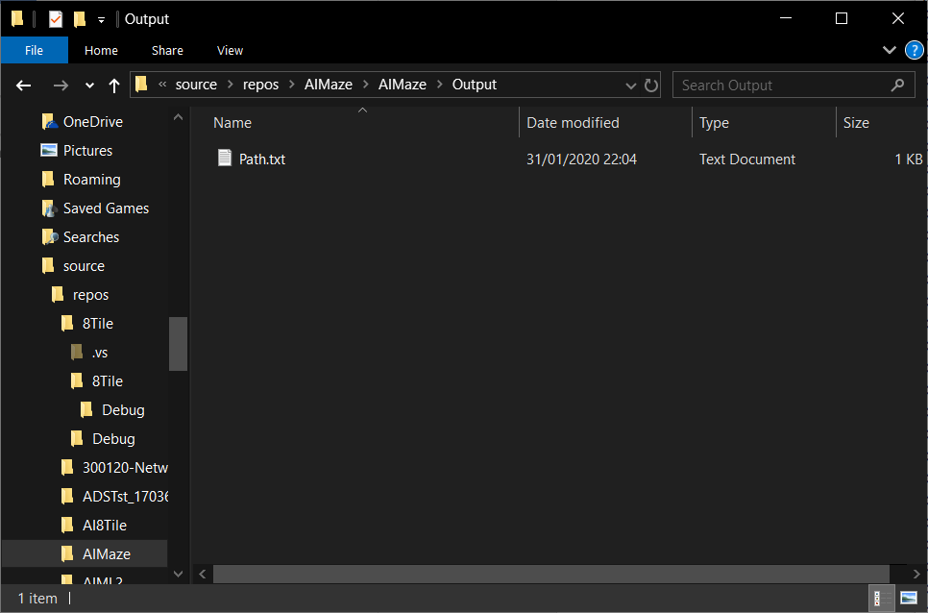

Appendix F – Eight Tile Main Menu
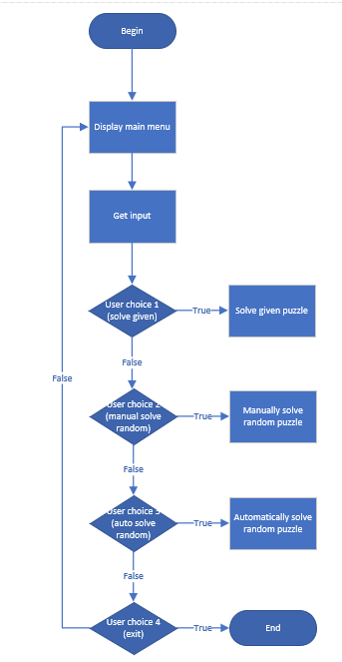

Appendix G – Eight Tile Solver
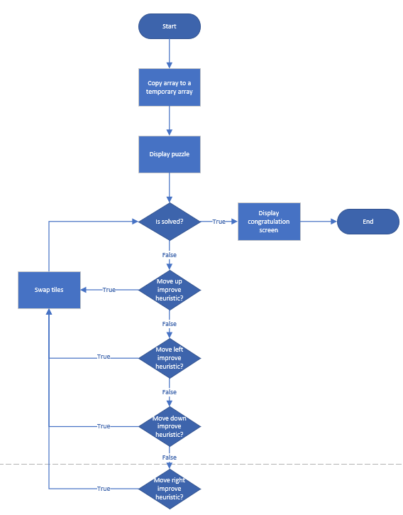

Appendix H – Eight Tile User Manual
Solve Given Puzzle
The given puzzle for the AI/ML module has been hardcoded into the board constructor. The user is presented with a main menu (Figure 1-1) that gives them the option to select to solve the given puzzle, manually attempt to solve a random solvable puzzle, or for the program to generate a random solvable puzzle and solve it itself.

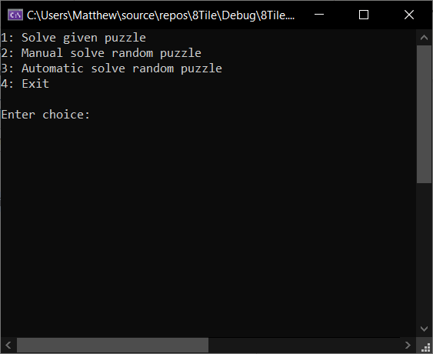
Figure 1-1 Main menu

Option 1 will allow the program to implement the heuristic for tiles in correct place. It will first present the user the given puzzle along with the heuristic (Figure 1-2), then the user presses a key to step through the solving process (Figures 1-3 & Figures 1-4) through until puzzle completion (Figure 1-5).

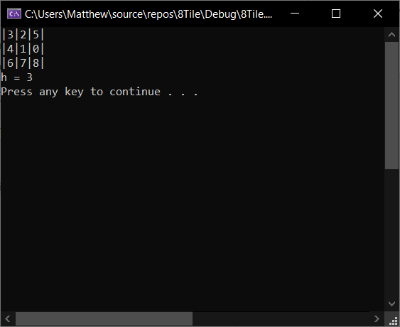
Figure 1-2 Given puzzle original state

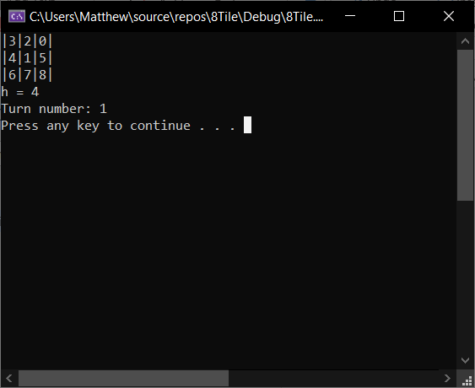
Figure 1-3 Given puzzle step 1
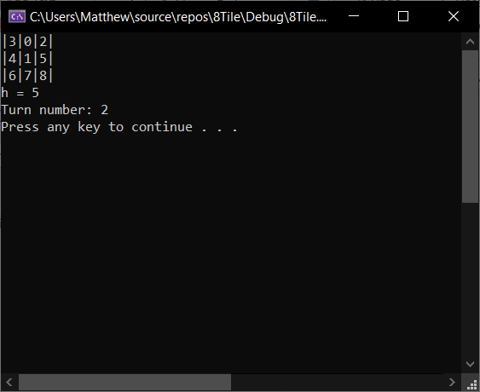
Figure 1-4 Given puzzle step 2

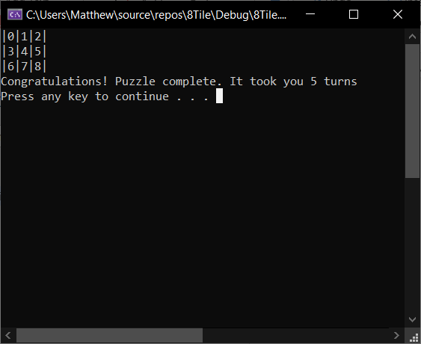
Figure 1-5 Puzzle complete

Manually Solve Random Puzzle
If the user selects option 2, the program will randomise the board for a pre-defined amount of turns and allow the user to move the 0 “tile” using WASD.
It begins by showing them the end goal (Figure 2-1), then randomises the tile positions and allowing the user to enter their turn. This continues until the end goal is achieved (Figure 2-2 – Figure 2-5).

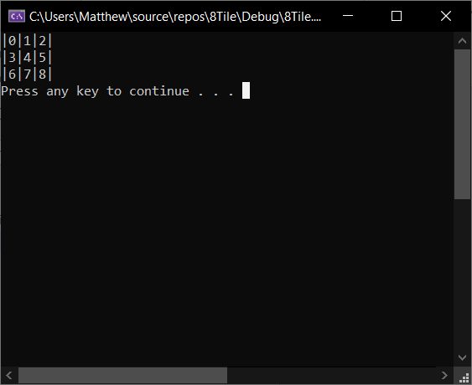
Figure 2-1 Solution

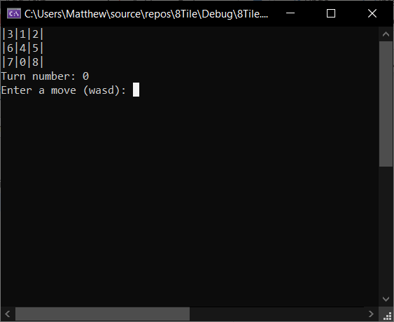
Figure 2-2 Manual solving after randomisation

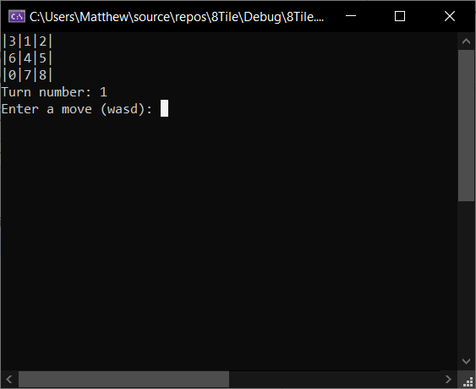
Figure 2-3 Move 1

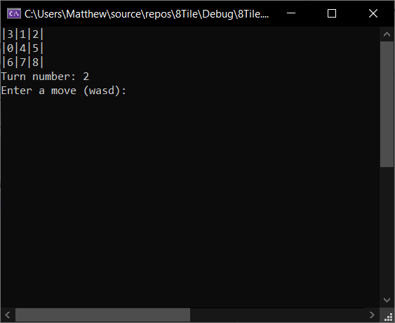
Figure 2-4 Move 2

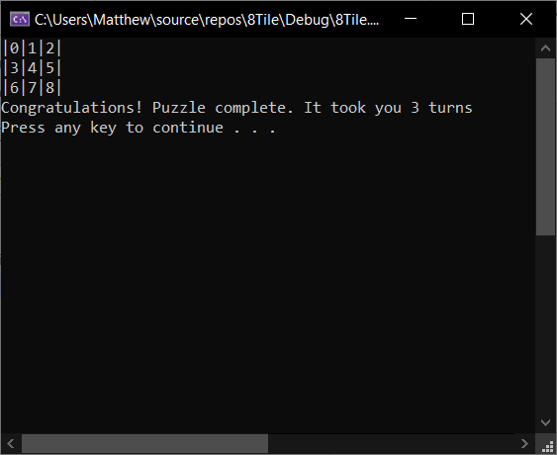
Figure 2-5 Move 3

Automatically Solve Random Puzzle
If the user selects option 3, the program will generate a random puzzle and (attempt to) solve it automatically using the pre-defined heuristic. It runs through the same process of showing the user the original board (Figure 3-1), then randomising it (Figure 3-2), then attempting to auto solve (Figure 3-3 – Figure 3-4).

Figure 3-1 Solution

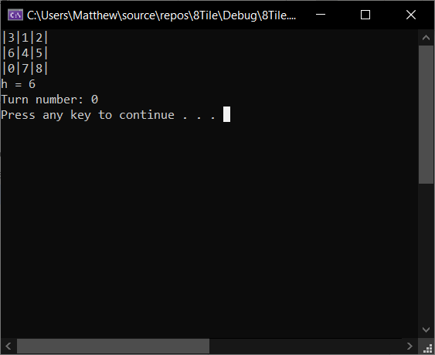
Figure 3-2 Randomised board

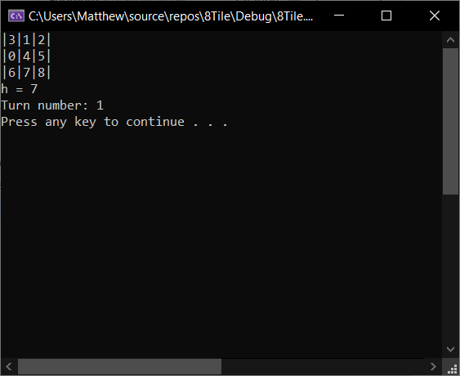
Figure 3-3 Move 1

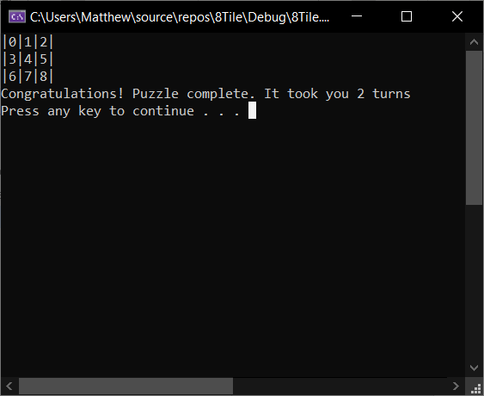
Figure 3-4 Move 2

Appendix I – Eight Tile Testing
ET_AutoSolve_1a
Test Case ID | ET_AutoSolve_1a
Test Title | Auto solving given eight tile problem
Description | Check if the given eight tile problem is resolved

Pre-conditions | Tiles set in code (tiles{ {3,2,5}, {4,1,0}, {6,7,8} })

Step | Test Step | Test Data | Expected Result | Actual Result | Status (Pass/Fail) | Notes
1 | Enter option to start solving problem | Option = 1 | Output tiles, correct heuristic and turn number | Output tiles, correct heuristic and turn number | Pass
2 | Begin solving | Space bar to be pressed | As above but progressing to resolve | As above but progressing to resolve | Pass | Some screenshot steps removed

Screenshot (if applicable)
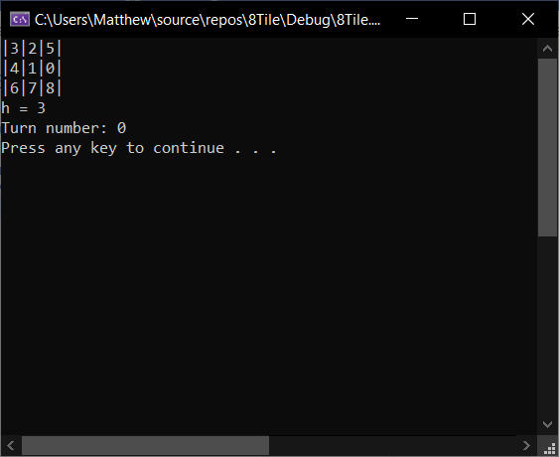

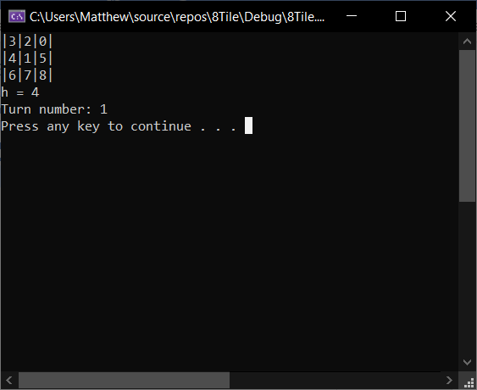

…

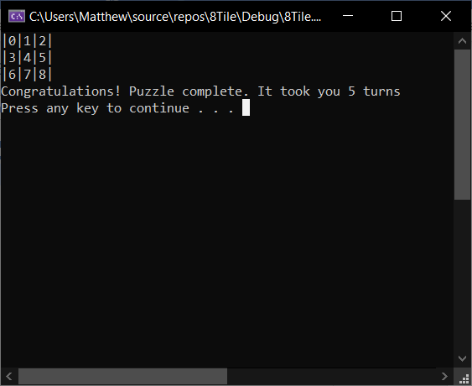

ET_AutoSolve_2a
Test Case ID | ET_AutoSolve_2a
Test Title | Auto solving other eight tile problem (1)
Description | Check if another eight tile problem from appendix is resolved

Pre-conditions | Tiles set in code (tiles{ {1,4,2}, {3,5,8}, {6,0,7} })

Step | Test Step | Test Data | Expected Result | Actual Result | Status (Pass/Fail) | Notes
1 | Enter option to start solving problem | Option = 1 | Output tiles, correct heuristic and turn number | Output tiles, correct heuristic and turn number | Pass
2 | Begin solving | Space bar to be pressed | As above but progressing to resolve | As above but progressing to resolve | Pass | Some screenshot steps removed

Screenshot (if applicable)
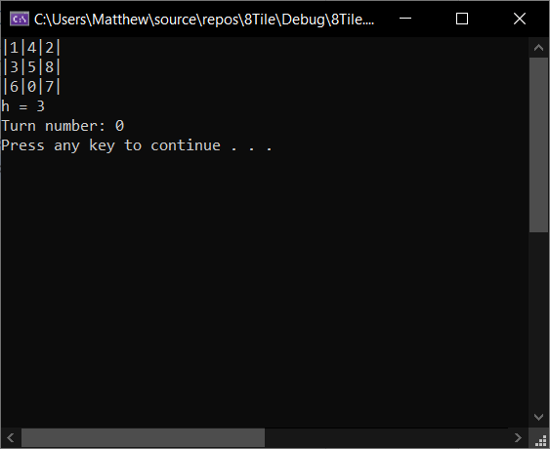

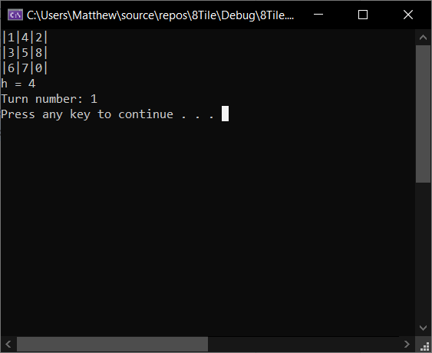

…

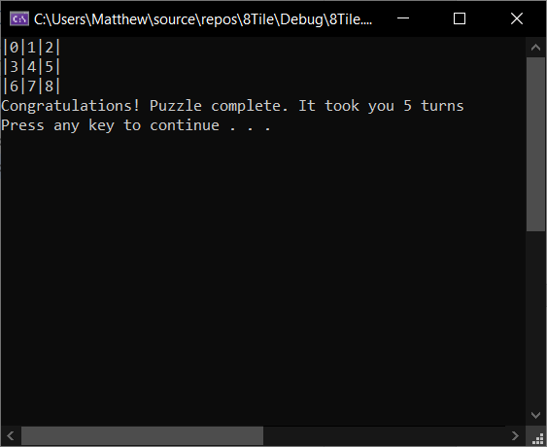

ET_AutoSolve_3a
Test Case ID | ET_AutoSolve_3a
Test Title | Auto solving other eight tile problem (2)
Description | Check if another eight tile problem from appendix is resolved

Pre-conditions | Tiles set in code (tiles{ {1,4,2}, {3,5,8}, {6,0,7} })

Step | Test Step | Test Data | Expected Result | Actual Result | Status (Pass/Fail) | Notes
1 | Enter option to start solving problem | Option = 1 | Output tiles, correct heuristic and turn number | Output tiles, correct heuristic and turn number | Pass
2 | Begin solving | Space bar to be pressed | As above but progressing to resolve | As above but progressing to resolve | Pass | Some screenshot steps removed

Screenshot (if applicable)
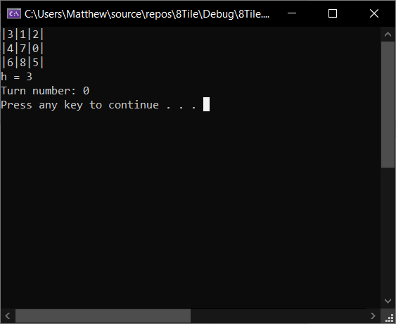

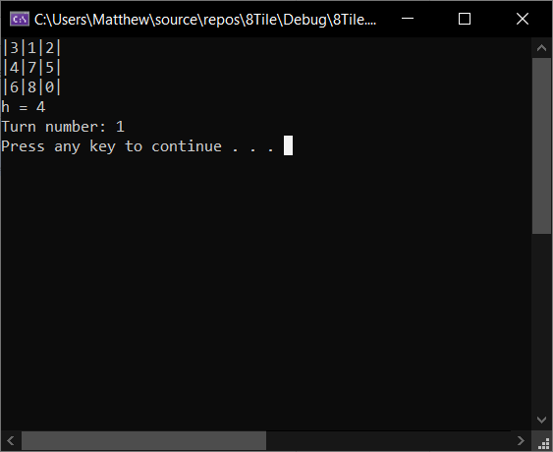

…

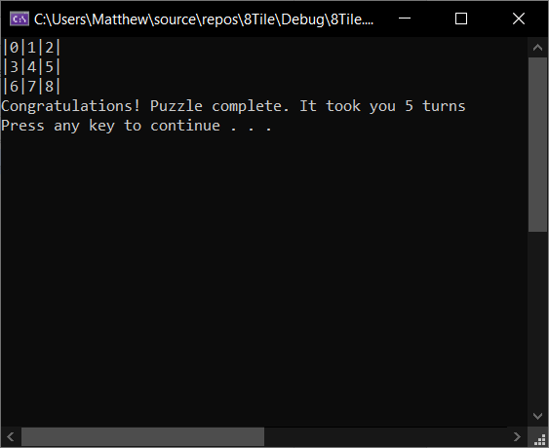

ET_AutoSolve_4a
Test Case ID | ET_AutoSolve_4a
Test Title | Auto solving other eight tile problem (3)
Description | Check if another eight tile problem from appendix is resolved

Pre-conditions | Tiles set in code (tiles{ {3,1,2}, {4,7,0}, {6,8,5} })

Step | Test Step | Test Data | Expected Result | Actual Result | Status (Pass/Fail) | Notes
1 | Enter option to start solving problem | Option = 1 | Output tiles, correct heuristic and turn number | Output tiles, correct heuristic and turn number | Pass
2 | Begin solving | Space bar to be pressed | As above but progressing to resolve | As above but progressing to resolve | Pass | Some screenshot steps removed

Screenshot (if applicable)

…

ET_AutoSolve_5a
Test Case ID | ET_AutoSolve_5a
Test Title | Auto solving other eight tile problem (4)
Description | Check if another eight tile problem from appendix is resolved

Pre-conditions | Tiles set in code (tiles{ {1,4,2}, {0,7,5}, {3,6,8} })

Step | Test Step | Test Data | Expected Result | Actual Result | Status (Pass/Fail) | Notes
1 | Enter option to start solving problem | Option = 1 | Output tiles, correct heuristic and turn number | Output tiles, correct heuristic and turn number | Pass
2 | Begin solving | Space bar to be pressed | As above but progressing to resolve | As above but progressing to resolve | Pass | Some screenshot steps removed

Screenshot (if applicable)
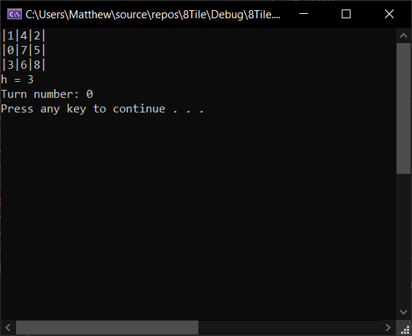

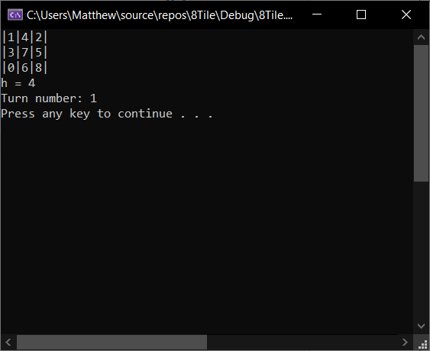

…

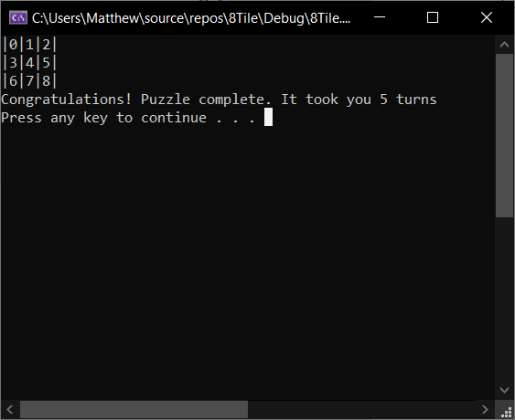

ET_ManualSolve_1a
Test Case ID | ET_ ManualSolve _1a
Test Title | Auto solving other eight tile problem
Description | Check if another eight tile problem from appendix is resolved

Pre-conditions | Tiles set in code (tiles{ {1,4,2}, {0,7,5}, {3,6,8} })

Step | Test Step | Test Data | Expected Result | Actual Result | Status (Pass/Fail) | Notes
1 | Enter option to manually solve problem | Option = 2 | Output tiles in order | Output tiles in order | Pass
2 | Begin shuffling tiles | Space bar to be pressed | Random order of tiles, display turn number, request user input | Random order of tiles, display turn number, request user input | Pass | NB. Tiles are shuffled in random directions, so every puzzle should be solvable (it just may take more turns)
3 | User input (WASD) | WASD | 0 to move places, tiles to re-draw, amount of moves displayed | 0 to move places, tiles to re-draw, amount of moves displayed | Pass | Repeat until completion (Step 4)
4 | User input (WASD) | WASD | Display completion | Display completion | Pass

Screenshot (if applicable)
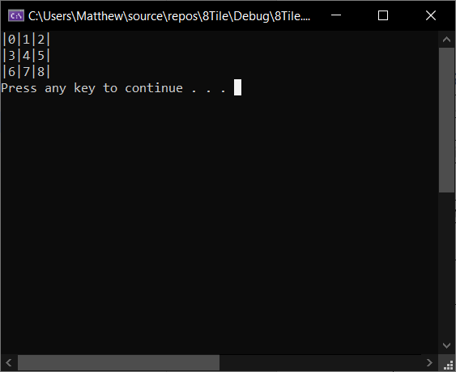

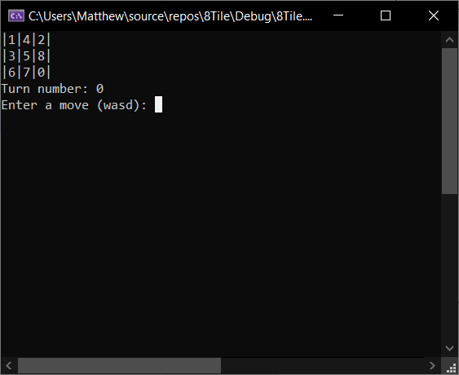

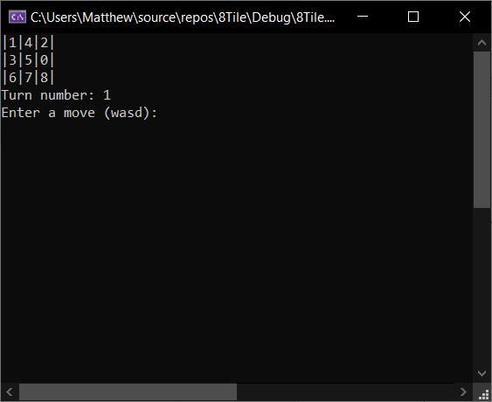

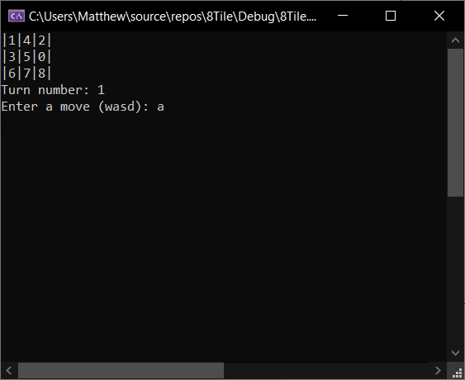

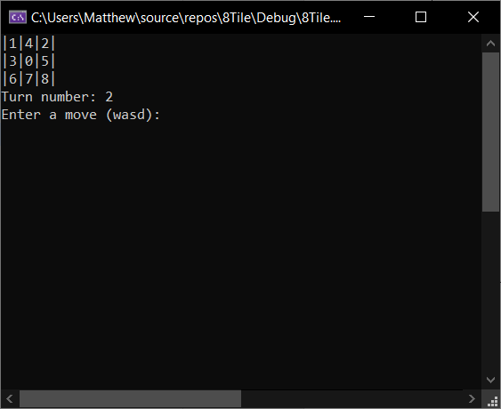

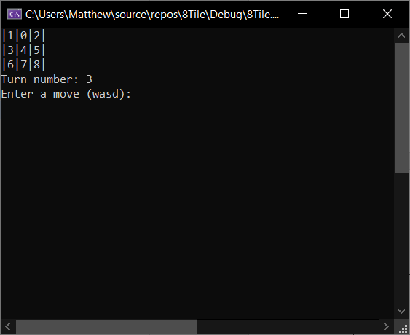

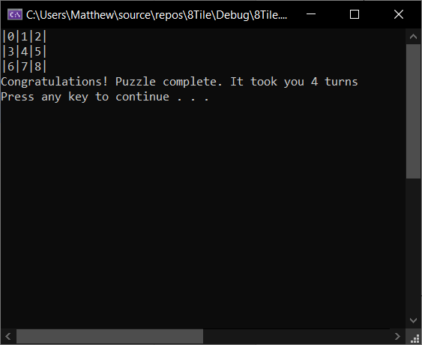

ET_TileShuffle_1a
Test Case ID | ET_ TileShuffle _1a
Test Title | Shuffling the tiles
Description | Shuffling the tiles to allow the user to manually resolve the puzzle

Pre-conditions | Main menu option = 2

Step | Test Step | Test Data | Expected Result | Actual Result | Status (Pass/Fail) | Notes
1 | Begin shuffling tiles | Space bar to be pressed | Random order of tiles, display turn number, request user input | Random order of tiles, display turn number, request user input | Pass | NB. Tiles are shuffled in random directions, so every puzzle should be solvable (Have completed some puzzles in screenshots

Screenshot (if applicable)

ET_TileShuffle_2a
Test Case ID | ET_ TileShuffle _2a
Test Title | Shuffling the tiles
Description | Shuffling the tiles to allow the user to manually resolve the puzzle

Pre-conditions | Main menu option = 2

Step | Test Step | Test Data | Expected Result | Actual Result | Status (Pass/Fail) | Notes
1 | Begin shuffling tiles | Space bar to be pressed | Random order of tiles, display turn number, request user input | Random order of tiles, display turn number, request user input | Pass | NB. Tiles are shuffled in random directions, so every puzzle should be solvable (Have completed some puzzles in screenshots

Screenshot (if applicable)

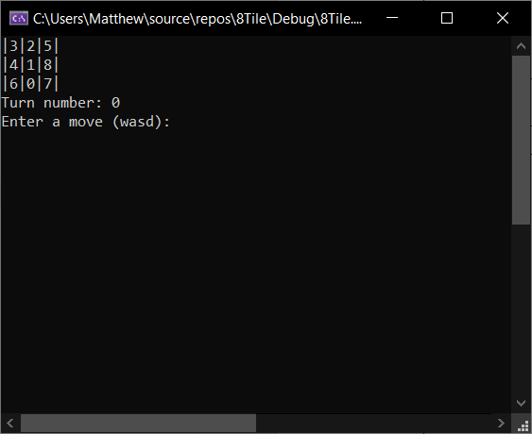

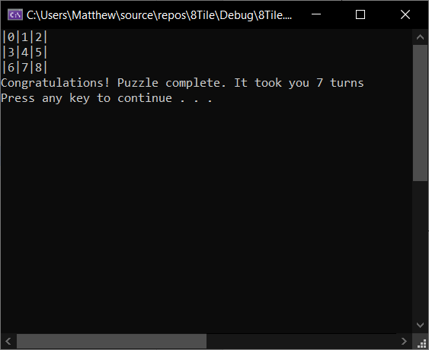

ET_TileShuffle_3a
Test Case ID | ET_ TileShuffle _3a
Test Title | Shuffling the tiles
Description | Shuffling the tiles to allow the user to manually resolve the puzzle

Pre-conditions | Main menu option = 2

Step | Test Step | Test Data | Expected Result | Actual Result | Status (Pass/Fail) | Notes
1 | Begin shuffling tiles | Space bar to be pressed | Random order of tiles, display turn number, request user input | Random order of tiles, display turn number, request user input | Pass | NB. Tiles are shuffled in random directions, so every puzzle should be solvable (Have completed some puzzles in screenshots

Screenshot (if applicable)

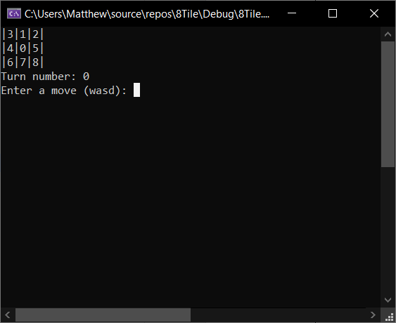

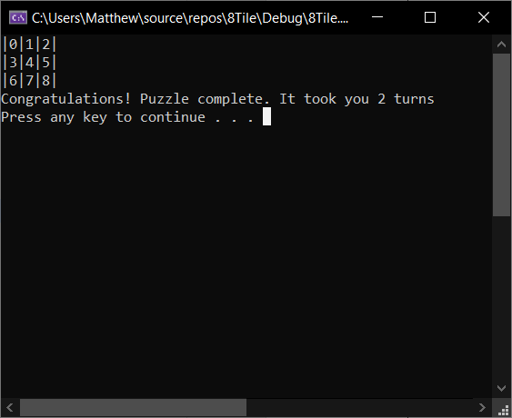

ET_AutoShuffleSolve_1a
Test Case ID | ET_ AutoShuffleSolve _1a
Test Title | Shuffling the tiles
Description | Shuffling the tiles to allow the user to automatically resolve the puzzle

Pre-conditions | Main menu option = 3

Step | Test Step | Test Data | Expected Result | Actual Result | Status (Pass/Fail) | Notes
1 | Begin shuffling tiles | Space bar to be pressed | Random order of tiles, display turn number, request user input | Random order of tiles, display turn number, request user input | Pass | NB. Tiles are shuffled in random directions, so every puzzle should be solvable
2 | Solve puzzle | Space bar to be pressed | 0 to move, heuristic to increase, turn number to increase | 0 to move, heuristic to increase, turn number to increase | Pass

Screenshot (if applicable)

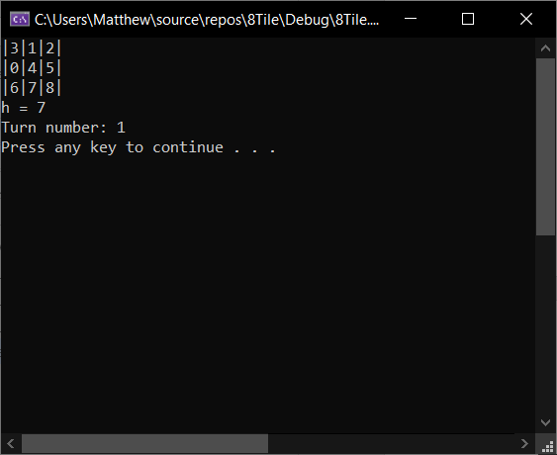

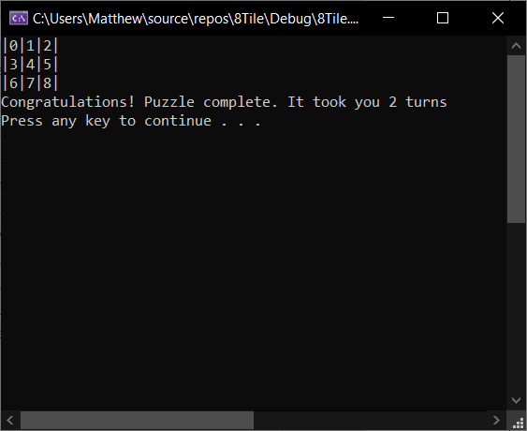

ET_AutoShuffleSolve_2a
Test Case ID | ET_ AutoShuffleSolve _2a
Test Title | Shuffling the tiles
Description | Shuffling the tiles to allow the program to automatically resolve the puzzle

Pre-conditions | Main menu option = 3

Step | Test Step | Test Data | Expected Result | Actual Result | Status (Pass/Fail) | Notes
1 | Begin shuffling tiles | Space bar to be pressed | Random order of tiles, display turn number, request user input | Random order of tiles, display turn number, request user input | Pass | NB. Tiles are shuffled in random directions, so every puzzle should be solvable
2 | Solve puzzle | Space bar to be pressed | 0 to move, heuristic to increase, turn number to increase | 0 to move, heuristic to increase, turn number to increase | Fail | Likely the implemented heuristic is not suitable for a puzzle that has had a lot of moves.

Screenshot (if applicable)

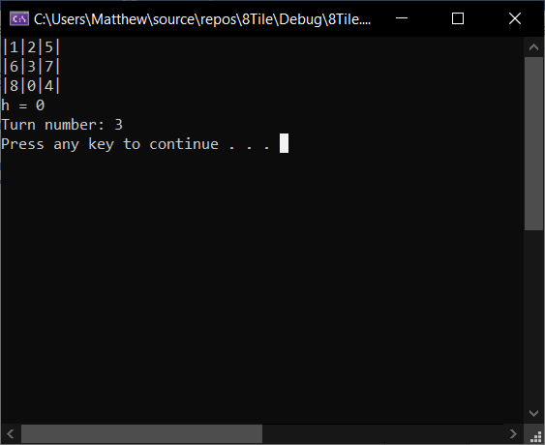

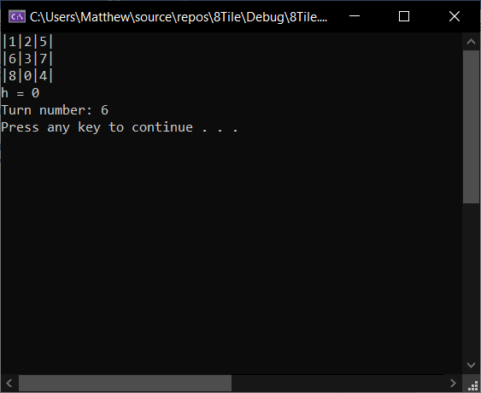

Appendix J – Maze Code

Maze.h
#include <iostream>
#include <stack>
#include <vector>
#include "Node.h"
#include <Windows.h>

class Maze {
// Attributes
private:
bool _pauseTraversal;
bool _nodeAdded;
bool _completed;
std::stack<Node> _stack;
std::vector<char> _col;
std::vector<std::vector<char>> _maze;
int _itemsCollected;
int _itemsInMaze;
HANDLE hConsole;
CONSOLE_CURSOR_INFO info;

// Constructor
public:
Maze();

//Properties
public:
void SetPauseTraversal(bool set);

// Methods
public:
void AddNode(int row, int col, char d);
void FindStart();
void TraverseMaze();
void InitialiseMaze();
void UpdateTrail();
void CheckUp();
void CheckRight();
void CheckDown();
void CheckLeft();
void CheckAdjacentNodes();
void PopStack();
void FinishMaze();
void MazeDisplay();
void PrintItemCount();
void PrintResult();
void CopyVectFile(std::vector<std::vector<char>> in);
void HideCursor();
void ShowCursor();
};

Maze.cpp
#include "Maze.h"
#include "FileHandler.h"
#include "Menu.h"
#include <string>
#include <conio.h>

// Colour definitions for the console handler
#define RED 4
#define GREEN 2
#define GREY 7
#define GOLD 14

// Maze constructor
Maze::Maze()
{
_pauseTraversal = false;
_nodeAdded = false;
_completed = false;

_itemsCollected = 0;
_itemsInMaze = 0;

// This is just for the colours and for the cursor visibility to be used
hConsole = GetStdHandle(STD_OUTPUT_HANDLE);

// Sets cursor to visible
info.bVisible = true;
}

/ Adds a new node to the stack. Depending on the character passed in, it will set bool variables true for start, finish, up, right, down, left
void Maze::AddNode(int row, int col, char d)
{
//If finish
if (d == 'f')
{
Node node{ row, col, 0, 1, 0, 0, 0, 0 };
_stack.push(node);
}

//If start
else if (d == 's')
{
Node node{ row, col, 1, 0, 0, 0, 0, 0 };
_stack.push(node);
}

//If up direction
else if (d == 'u')
{
Node node{ row, col, 0, 0, 1, 0, 0, 0 };
_stack.push(node);
}

//If right direction
else if (d == 'r')
{
Node node{ row, col, 0, 0, 0, 1, 0, 0 };
_stack.push(node);
}

//If down direction
else if (d == 'd')
{
Node node{ row, col, 0, 0, 0, 0, 1, 0 };
_stack.push(node);
}

//If left direction
else if (d == 'l')
{
Node node{ row, col, 0, 0, 0, 0, 0, 1 };
_stack.push(node);
}

_nodeAdded = true;
}

// Find the first node to start
void Maze::FindStart()
{
short int row = 0;
short int col = 0;

for (auto i = _maze.begin(); i < _maze.end(); i++)
{
for (auto j = i->begin(); j < i->end(); j++)
{
// If it's an 's', this is the start so add the first node
if (*j == 's')
{
AddNode(row, col, 's');
}

// If it's an 'o', this is an object so increase the object count
else if (*j == 'o')
{
_itemsInMaze++;
}
col++;
}
row++;
col = 0;
}
}

// While the top of the stack isn't the finish, traverse the maze
void Maze::TraverseMaze()
{
while (!_stack.top()._finish)
{
// If a keyboard button has been hit, bring up a pause menu
if (_kbhit())
{
Menu* menu = new Menu();
menu->PrintPauseMenu();
switch (menu->GetChoiceInt())
{
case 1: // Carry on
break;
case 2: // Return to main menu
system("cls");
delete menu;
return;
case 3: // Exit program
delete menu;
exit(0);
default:
delete menu;
break;
}
}

_nodeAdded = false;

// Update position
UpdateTrail();

// Check nodes again
CheckAdjacentNodes();

// If maze is completed, return to main
if (_completed)
{
return;
}

// Display maze
MazeDisplay();
}
}

// Initialises the maze (hides cursor, displays maze, finds the starting node, traverses maze)
void Maze::InitialiseMaze()
{
HideCursor();
MazeDisplay();
FindStart();
TraverseMaze();
}

// Sets current position to 'x' to leave a breadcrumb trail of the path it has taken so far
void Maze::UpdateTrail()
{
_maze[_stack.top()._row][_stack.top()._col] = 'x';
}

// Checks upward of the current position
void Maze::CheckUp()
{
// Checks if finish first, if it is update position and add to stack
if (_stack.top()._row > 0 && _maze[_stack.top()._row - 1][_stack.top()._col] == 'f')
{
_maze[_stack.top()._row - 1][_stack.top()._col] = '.';
AddNode(_stack.top()._row - 1, _stack.top()._col, 'f');
FinishMaze();
}

// If object, update position and add to stack. Increase items collected.
else if (_stack.top()._row > 0 && _maze[_stack.top()._row - 1][_stack.top()._col] == 'o')
{
_maze[_stack.top()._row - 1][_stack.top()._col] = '.';
AddNode(_stack.top()._row - 1, _stack.top()._col, 'u');
_itemsCollected++;
}

// If empty space, we can move there. Update position, add to stack.
else if (_stack.top()._row > 0 && _maze[_stack.top()._row - 1][_stack.top()._col] == ' ')
{
_maze[_stack.top()._row - 1][_stack.top()._col] = '.';
AddNode(_stack.top()._row - 1, _stack.top()._col, 'u');
}

// Else we can't move there, so set up to false
else
{
_stack.top()._up = false;
}
}

// Checks to the right of current position
void Maze::CheckRight()
{
// Checks if finish first, if it is update position and add to stack
if (_stack.top()._col < _maze[0].size() - 1 && _maze[_stack.top()._row][_stack.top()._col + 1] == 'f')
{
_maze[_stack.top()._row][_stack.top()._col + 1] = '.';
AddNode(_stack.top()._row, _stack.top()._col + 1, 'f');
FinishMaze();
return;
}

// If object, update position and add to stack. Increase items collected.
else if (_stack.top()._col < _maze[0].size() - 1 && _maze[_stack.top()._row][_stack.top()._col + 1] == 'o')
{
_maze[_stack.top()._row][_stack.top()._col + 1] = '.';
AddNode(_stack.top()._row, _stack.top()._col + 1, 'r');
_itemsCollected++;
}

// If empty space, we can move there. Update position, add to stack.
else if (_stack.top()._col < _maze[0].size() - 1 && _maze[_stack.top()._row][_stack.top()._col + 1] == ' ')
{
_maze[_stack.top()._row][_stack.top()._col + 1] = '.';
AddNode(_stack.top()._row, _stack.top()._col + 1, 'r');
}

// Else we can't move there, so set up to false
else
{
_stack.top()._right = false;
}
}

// Checks downward of the current position
void Maze::CheckDown()
{
// Checks if finish first, if it is update position and add to stack
if (_stack.top()._row < _maze.size() && _maze[_stack.top()._row + 1][_stack.top()._col] == 'f')
{
_maze[_stack.top()._row + 1][_stack.top()._col] = '.';
AddNode(_stack.top()._row + 1, _stack.top()._col, 'f');
FinishMaze();
return;
}

// If object, update position and add to stack. Increase items collected.
else if (_stack.top()._row < _maze.size() && _maze[_stack.top()._row + 1][_stack.top()._col] == 'o')
{
_maze[_stack.top()._row + 1][_stack.top()._col] = '.';
AddNode(_stack.top()._row + 1, _stack.top()._col, 'd');
_itemsCollected++;
}

// If empty space, we can move there. Update position, add to stack.
else if (_stack.top()._row < _maze.size() && _maze[_stack.top()._row + 1][_stack.top()._col] == ' ')
{
_maze[_stack.top()._row + 1][_stack.top()._col] = '.';
AddNode(_stack.top()._row + 1, _stack.top()._col, 'd');
}

// Else we can't move there, so set up to false
else
{
_stack.top()._down = false;
}
}

// Checks to the left of current position
void Maze::CheckLeft()
{
// Checks if finish first, if it is update position and add to stack
if (_stack.top()._col > 0 && _maze[_stack.top()._row][_stack.top()._col - 1] == 'f')
{
_maze[_stack.top()._row][_stack.top()._col - 1] = '.';
AddNode(_stack.top()._row, _stack.top()._col - 1, 'f');
FinishMaze();
return;
}

// If object, update position and add to stack. Increase items collected.
else if (_stack.top()._col > 0 && _maze[_stack.top()._row][_stack.top()._col - 1] == 'o')
{
_maze[_stack.top()._row][_stack.top()._col - 1] = '.';
AddNode(_stack.top()._row, _stack.top()._col - 1, 'l');
_itemsCollected++;
}

// If empty space, we can move there. Update position, add to stack.
else if (_stack.top()._col > 0 && _maze[_stack.top()._row][_stack.top()._col - 1] == ' ')
{
_maze[_stack.top()._row][_stack.top()._col - 1] = '.';
AddNode(_stack.top()._row, _stack.top()._col - 1, 'l');
}

// Else we can't move there, so set up to false
else
{
_stack.top()._left = false;
}
}

// Runs main checks
void Maze::CheckAdjacentNodes()
{
if (!_nodeAdded) CheckUp();
if (!_nodeAdded) CheckRight();
if (!_nodeAdded) CheckDown();
if (!_nodeAdded) CheckLeft();

// If the stack is empty, it no longer has the starting node, so it means it has
// completed so we can just return back to our main.
if (_stack.empty())
{
return;
}

// If we can't move in any direction, pop the stack and re-start.
if (!_stack.top()._up && !_stack.top()._right && !_stack.top()._down && !_stack.top()._left)
{
PopStack();
}
}

// Sets current node to '-', pops, then sets new current position to a '.'
void Maze::PopStack()
{
_maze[_stack.top()._row][_stack.top()._col] = '-';
_stack.pop();
_maze[_stack.top()._row][_stack.top()._col] = '.';
}

// Method is called to state the maze is solved, and the path taken is output to a file for the user to see
void Maze::FinishMaze()
{
UpdateTrail();
FileHandler* fp = new FileHandler();
fp->CreateNewFile("Output", "Path", "txt");

// If file creation was succesful, output
if (fp)
{
std::string str;

str += ("(Row, Col)\n\n");

// While stack isn't empty, append to string
while (!_stack.empty())
{
str += ("(");
str += std::to_string(_stack.top()._row);
str += (", ");
str += std::to_string(_stack.top()._col);
str += (")");

// Write to file, pop for next output and clear the string
fp->WriteFile(str);
_stack.pop();
str.clear();
}

delete fp;
MazeDisplay();
PrintItemCount();
PrintResult();
_completed = true;
system("pause");
system("cls");
ShowCursor();
}

else
{
std::cout << "Error storing file\n";
}

return;
exit(0);
}

// Print when maze has completed
void Maze::PrintResult()
{
std::cout << "\nOutput stored in file.\n";
}

// Prints maze and sets colours
void Maze::MazeDisplay()
{
system("cls");

for (auto i = _maze.begin(); i < _maze.end(); i++)
{
for (auto j = i->begin(); j < i->end(); j++)
{
if (*j == 'x')
{
SetConsoleTextAttribute(hConsole, GREEN);
}
else if (*j == '-')
{
SetConsoleTextAttribute(hConsole, RED);
}
else if (*j == 'o')
{
SetConsoleTextAttribute(hConsole, GOLD);
}
else if (*j == '.')
{
SetConsoleTextAttribute(hConsole, RED);
}
else
{
SetConsoleTextAttribute(hConsole, GREY);
}
std::cout << *j;
}
std::cout << std::endl;
}

// If user has selected for a step through, display the current position as a co-ordinate
if (_pauseTraversal)
{
if (!_stack.empty())
{
std::cout << "I'm at: " << _stack.top()._col << ", " << _stack.top()._row << std::endl;
}
system("pause");
}

// Otherwise sleep between refreshes
else
{
Sleep(100);
}
}

// Print the amount of found items
void Maze::PrintItemCount()
{
if (_itemsCollected <= 0)
{
std::cout << "\nLooks like no items were found out of " << _itemsInMaze << "." << std::endl;
}

else
{
std::cout << "\nI found this many items: " << _itemsCollected << " out of " << _itemsInMaze << "." << std::endl;
}
}

// Copies the file to the local maze object
void Maze::CopyVectFile(std::vector<std::vector<char>> in)
{
_maze = in;
}

// If user wants to step through, sets to true
void Maze::SetPauseTraversal(bool set)
{
set ? _pauseTraversal = true : _pauseTraversal = false;
}

// Hides cursor
void Maze::HideCursor()
{
info.dwSize = 100;
info.bVisible = false;
SetConsoleCursorInfo(hConsole, &info);
}

// Shows cursor
void Maze::ShowCursor()
{
info.bVisible = true;
SetConsoleCursorInfo(hConsole, &info);
}

Node.h
struct Node {
int _col;
int _row;
bool _start;
bool _finish;
bool _up;
bool _down;
bool _left;
bool _right;

Node(int row, int col, bool start = false, bool finish = false, bool up = false, bool right = false, bool down = false, bool left = false)
: _row(row), _col(col), _start(start), _finish(finish), _up(up), _right(right), _down(down), _left(left)
{
}
};

FileHandler.h
#include <iostream>
#include <vector>
#include <fstream>

class FileHandler
{
// Attributes
private:
std::ifstream _fileInTemp;
std::ofstream _fileOutTemp;
std::string _fileName;
std::string _filePath;
std::string _fileExtension;
std::vector<char> _col;
std::vector<std::vector<char>> _file;

// Constructor
public:
FileHandler();

// Properties
public:
void SetFileName(std::string name);
void SetFilePath(std::string path);
void SetFileExtension(std::string extension);
std::string GetFileName();
std::string GetFilePath();
std::string GetFileExtension();

// Methods
public:
bool FileOpen(std::string filepath, std::string filename);
bool FileValid(std::ifstream& in);
void ReadFile(std::ifstream& in);
void CreateNewFile(std::string filepath, std::string filename, std::string fileExtension);
void WriteFile(std::string in);
void DisplayFile();
std::vector<std::vector<char>> returnVector();
void Clear();
};

FileHandler.cpp
#include "FileHandler.h"

FileHandler::FileHandler()
{
_fileInTemp.clear();
_fileOutTemp.clear();
_fileName = "";
_filePath = "";
_fileExtension = "";
_col.clear();
_file.clear();
}

// Opens file, if its successful it will read the file in
// and pass the file back as a vector of vectors
bool FileHandler::FileOpen(std::string filepath, std::string filename)
{
std::string str;
str += filepath;
str += "\\";
str += filename;

this->_fileName = filename;

_fileInTemp.open(str.c_str());

if (FileValid(_fileInTemp))
{
ReadFile(_fileInTemp);
returnVector();
_fileInTemp.close();

return true;
}
else
{
std::cout << "Error reading file." << std::endl;
system("pause");
system("cls");
return false;
}
}

// Returns file as a vector
std::vector<std::vector<char>> FileHandler::returnVector()
{
return _file;
}

//If file valid
bool FileHandler::FileValid(std::ifstream& in)
{
if (in.good())
{
return true;
}
else
{
return false;
}
}

// Reads file in while !EOF. Converts chars to lower case.
void FileHandler::ReadFile(std::ifstream& in)
{
char d;

while (in)
{
d = in.get();
isupper(d) ? d = tolower(d) : d;
if (d == EOF)
{
_file.push_back(_col);
break;
}
if (d == '\n')
{
_file.push_back(_col);
_col.clear();
d = in.get();
isupper(d) ? d = tolower(d) : d;
}
_col.push_back(d);
}
}

// Creates a new file with the given values
void FileHandler::CreateNewFile(std::string filepath, std::string filename, std::string fileExtension)
{
SetFileName(filename);
SetFilePath(filepath);
SetFileExtension(fileExtension);

std::string s;

s += _filePath;
s += "\\";
s += _fileName;
s += ".";
s += _fileExtension;

std::ofstream outfile(s);
}

// Writes to current file
void FileHandler::WriteFile(std::string in)
{
std::string file;
file += GetFilePath();
file += "\\";
file += GetFileName();
file += ".";
file += GetFileExtension();

std::ofstream o(file.c_str(), std::fstream::app);

o << in << std::endl;
}

// Displays file
void FileHandler::DisplayFile()
{
for (auto i = _file.begin(); i < _file.end(); i++)
{
for (auto j = i->begin(); j < i->end(); j++)
{
std::cout << *j;
}
std::cout << std::endl;
}
}

void FileHandler::SetFileName(std::string name)
{
this->_fileName = name;
}

void FileHandler::SetFilePath(std::string path)
{
this->_filePath = path;
}

void FileHandler::SetFileExtension(std::string extension)
{
this->_fileExtension = extension;
}

std::string FileHandler::GetFileName()
{
return this->_fileName;
}
std::string FileHandler::GetFilePath()
{
return this->_filePath;
}
std::string FileHandler::GetFileExtension()
{
return this->_fileExtension;
}

// Closes and clears current file attributes
void FileHandler::Clear()
{
this->_fileInTemp.close();
this->_fileOutTemp.close();
this->_file.clear();
this->_col.clear();
this->_fileExtension = "";
this->_fileName = "";
this->_filePath = "";
}

Menu.h
#pragma once
#include <string>
class Menu
{
// Attributes
private:
int choiceInt;
std::string choiceString;

// Constructor
public:
Menu();

// Properties
public:
int GetChoiceInt();
std::string GetChoiceString();

// Methods
public:
void PrintMainMenu();
void PrintPauseMenu();
void PrintMazeList();
void AskChoiceInt();
void AskChoiceString();
};

Menu.cpp
#include "Menu.h"
#include <iostream>
#include <string>

Menu::Menu()
{
choiceInt = 0;
choiceString = "";
}

void Menu::PrintMainMenu()
{
std::cout << "1: Load maze file\n2: Start maze\n3: Start maze (step through)\n4: Exit\n\n";
AskChoiceInt();
}

void Menu::PrintPauseMenu()
{
std::cout << "1: Continue\n2: Back to main menu\n3: Exit\n\n";
AskChoiceInt();
}

void Menu::PrintMazeList()
{
system("cls");
system("dir mazefiles /b /a-d");
AskChoiceString();
}

void Menu::AskChoiceInt()
{
std::cout << "Enter choice: ";
std::cin >> choiceInt;
}

void Menu::AskChoiceString()
{
std::cout << "Enter choice: ";
std::cin >> choiceString;
}

int Menu::GetChoiceInt()
{
return choiceInt;
}

std::string Menu::GetChoiceString()
{
return choiceString;
}

Source.cpp
#include "FileHandler.h"
#include "Maze.h"
#include "Menu.h"
#include <stdio.h>
#include <iostream>

int main(int argc, char** argv)
{
// Menu and file handler objects are created on runtime
Menu* menu = new Menu();
FileHandler* fp = new FileHandler();

// Infinite loop so it can be run constantly until user chooses to exit
while (true)
{
menu->PrintMainMenu();

// Load maze
if (menu->GetChoiceInt() == 1)
{
// if file already exists, clear it so it can be over-written
if (fp)
{
fp->Clear();
}

// Print the current /mazefiles/ list of files
menu->PrintMazeList();

// While the user hasn't selected a correct maze file
while (!fp->FileOpen("mazefiles", menu->GetChoiceString()))
{
menu->PrintMazeList();
}

system("cls");
std::cout << "Maze file loaded succesfully!\n";
}

// If user has selected to solve the maze
if (menu->GetChoiceInt() == 2)
{
// Make sure the filename length is greater than 0, otherwise the file is likely
// not loaded and will fail
if (fp->GetFileName().length() > 0)
{
// Create a new maze, and the file handler will read in the file the user has specified
// then it will pass the file as a vector into the maze solver
Maze* maze = new Maze();
maze->CopyVectFile(fp->returnVector());

// Sets so the maze will just run with no user interaction
maze->SetPauseTraversal(false);

// Initializes the maze
maze->InitialiseMaze();

// Completed, so delete
delete maze;
}

// If no maze has been selected from option 1 display an error
else
{
system("cls");
std::cout << "Error: No maze selected.\n";
}
}

// User selected 3, which is that they have the choice to "step through" the code
// in the case that it may run too quickly and they want to check step-by-step
// that it is correct
if (menu->GetChoiceInt() == 3)
{
// Make sure the filename length is greater than 0, otherwise the file is likely
// not loaded and will fail
if (fp->GetFileName().length() > 0)
{
// Create a new maze, and the file handler will read in the file the user has specified
// then it will pass the file as a vector into the maze solver
Maze* maze = new Maze();
maze->CopyVectFile(fp->returnVector());

// Set so the user controls the speed by pressing a key to step through the maze
maze->SetPauseTraversal(true);

// Initialize the maze
maze->InitialiseMaze();

// Completed, so delete
delete maze;
}

// If no maze has been selected from option 1 display an error
else
{
system("cls");
std::cout << "Error: No maze selected.\n";
}
}

// Exits application and deletes the objects that have been created
if (menu->GetChoiceInt() == 4)
{
delete fp, menu;
exit(0);
}
}

// Deletes objects if it makes it to this point
delete fp, menu;
}

Appendix I – Eight Tile Code

Board.h
#pragma once

class Board
{
// Attributes
private:
int tiles[3][3]; //puzzle now
int temp[3][3];
int solution[3][3];//puzzle at start (solved).
int correctTiles;
int temprow;
int tempcol;
int row;
int col;
int moveNumber;
char move;
char bestMove;
bool tileMoved;

// Constructor
public:
Board(int choice);

// Properties
public:

// Methods
public:
void CopyArray();
void Display(); //draw puzzle
void AutoSolve();
void CalculateCorrectTiles(int arr[3][3]);
void Swap(int arr[3][3]); //swap blank with selected tile
bool IsSolved();
bool IsOKLeft(); //can I move left
bool IsOKRight();//can I move right
bool IsOKUp();//can I move up
bool IsOKDown();//can I move down
void AskMove();
void RandomizeBoard(int maxIterations);
void Congratulations();
void PrintTurns();
void PrintHeuristic();
void IncreaseMoveCount();
};

Board.cpp
#include "Board.h"
#include "RNG.h"
#include <Windows.h>
#include <iostream>

// Sets the tiles to the given puzzle for the assignment unless the user has specified
// the manual/auto random generation
Board::Board(int choice) : solution { {0, 1, 2}, { 3,4,5 }, { 6,7,8 } },
tiles{ {3,2,5}, {4,1,0}, {6,7,8} }

// Additional sets of tiles used for testing
//tiles{ {1,4,2}, {3,5,8}, {6,0,7} }
//tiles{ {3,1,2}, {4,7,0}, {6,8,5} }
//tiles{ {1,4,2}, {0,7,5}, {3,6,8} }
{
// If user specified manual/auto solve with random generation, it will set tiles
// to 0,1,2,3,4,5,6,7,8 to allow for randomization
if (choice == 1)
{
int count = 0;
for (size_t i = 0; i < 3; i++)
{
for (size_t j = 0; j < 3; j++)
{
tiles[i][j] = count;
count++;
}
}
}

// Sets the starting row and col position to where the 0 is.
// Sets temp variables for 2nd array for auto solve
for (size_t i = 0; i < 3; i++)
{
for (size_t j = 0; j < 3; j++)
{
if (tiles[i][j] == 0)
{
temprow = i;
tempcol = j;
row = i;
col = j;
}
}
}

correctTiles = 0;
moveNumber = 0;
}

// Copies given array to a temp array for auto solve
void Board::CopyArray()
{
for (size_t i = 0; i < 3; i++)
{
for (size_t j = 0; j < 3; j++)
{
temp[j][i] = tiles[j][i];
}
}
temprow = row;
tempcol = col;
}

// Displays board
void Board::Display()
{
system("cls");
int count = 0;
for (size_t i = 0; i < 3; i++)
{
for (size_t j = 0; j < 3; j++)
{
std::cout << '|' << tiles[i][j];
if (j == 2)
{
std::cout << '|' << std::endl;
}
}
}
}

// Automatically solves the puzzle
void Board::AutoSolve()
{
int heuristic = correctTiles;

Display();
PrintHeuristic();
PrintTurns();
system("pause");

// Check up. Sets the move to up, swaps it on the temporary array,
// Calculates the correct amount of tiles and if the correct amount of
// tiles is better than the current on the real board, set the best move
// as 'w', then reverts the move to perform other move checks.
move = 'w';
Swap(temp);
CalculateCorrectTiles(temp);
if (correctTiles > heuristic)
{
bestMove = 'w';
}
if (tileMoved)
{
move = 's';
Swap(temp);
tileMoved = false;
}

// Check left
move = 'a';
Swap(temp);
CalculateCorrectTiles(temp);
if (correctTiles > heuristic)
{
bestMove = 'a';
}
if (tileMoved)
{
move = 'd';
Swap(temp);
tileMoved = false;
}

// Check down
move = 's';
Swap(temp);
CalculateCorrectTiles(temp);
if (correctTiles > heuristic)
{
bestMove = 's';
}
if (tileMoved)
{
move = 'w';
Swap(temp);
tileMoved = false;
}

// Check right
move = 'd';
Swap(temp);
CalculateCorrectTiles(temp);
if (correctTiles > heuristic)
{
bestMove = 'd';
}
if (tileMoved)
{
move = 'a';
Swap(temp);
tileMoved = false;
}

// Sets the move to the best move
move = bestMove;

// Actions the move on both arrays
Swap(temp);
row = temprow;
col = tempcol;
Swap(tiles);
temprow = row;
tempcol = col;
tileMoved = false;
IncreaseMoveCount();

Sleep(200);
}

// Count the number of correct tiles
void Board::CalculateCorrectTiles(int arr[3][3])
{
correctTiles = 0;

for (size_t i = 0; i < 3; i++)
{
for (size_t j = 0; j < 3; j++)
{
if (arr[i][j] == solution[i][j])
{
correctTiles++;
}
}
}
}

// Check if board is solved
bool Board::IsSolved()
{
CalculateCorrectTiles(tiles);
if (correctTiles >= 8)
{
return true;
}
else
{
return false;
}
}

// Swap tiles
void Board::Swap(int arr[3][3])
{
int temp;

// If move is 'a' (left), check the boundary, swap tiles and set flag.
if (move == 'a' && IsOKLeft())
{
temp = arr[row][col - 1];
arr[row ][col - 1] = arr[row][col];
arr[row][col] = temp;
col--;
tileMoved = true;
}

// If move is 'd' (right), check the boundary, swap tiles and set flag.
else if (move == 'd' && IsOKRight())
{
temp = arr[row][col + 1];
arr[row][col + 1] = arr[row][col];
arr[row][col] = temp;
col++;
tileMoved = true;
}

// If move is 's' (down), check the boundary, swap tiles and set flag.
else if (move == 's' && IsOKDown())
{
temp = arr[row + 1][col];
arr[row + 1][col] = arr[row][col];
arr[row][col] = temp;
row++;
tileMoved = true;
}

// If move is 'w' (up), check the boundary, swap tiles and set flag.
else if (move == 'w' && IsOKUp())
{
temp = arr[row - 1][col];
arr[row - 1][col] = arr[row][col];
arr[row][col] = temp;
row--;
tileMoved = true;
}
}

bool Board::IsOKLeft()
{
if (col > 0)
{
return true;
}
else
{
return false;
}
}

bool Board::IsOKRight()
{
if (col < 2)
{
return true;
}
else
{
return false;
}
}

bool Board::IsOKUp()
{
if (row > 0)
{
return true;
}
else
{
return false;
}
}

bool Board::IsOKDown()
{
if (row < 2)
{
return true;
}
else
{
return false;
}
}

void Board::AskMove()
{
std::cout << "Enter a move (wasd): ";
std::cin >> move;

IncreaseMoveCount();
Swap(tiles);
}

// Create a Mersenne twister, this iterations for the value passed into function.
// If result collides with border, re-randomizes.
// If result is the completed board, re-randomizes.
void Board::RandomizeBoard(int maxIterations)
{
int num = maxIterations;

RNG* rng = new RNG();

for (size_t i = 0; i < maxIterations; i++)
{
rng->GenerateInt(3);

switch (rng->GetInt())
{
case 0:
if (row <= 0)
{
i = 0;
break;
}
move = 'w';
Swap(tiles);
break;
case 1:
if (col >= 2)
{
i = 0;
break;
}
move = 'd';
Swap(tiles);
break;
case 2:
if (row >= 2)
{
i = 0;
break;
}
move = 's';
Swap(tiles);
break;
case 3:
if (col <= 0)
{
i = 0;
break;
}
move = 'a';
Swap(tiles);
break;
default:
break;
}

// If it resets back to its original state, restart the randomization
if (tiles[0][0] == 0 && tiles[0][1] == 1 && tiles[0][2] == 2
&& tiles[1][0] == 3 && tiles[1][1] == 4 && tiles[1][2] == 5
&& tiles[2][0] == 6 && tiles[2][1] == 7 && tiles[2][2] == 8)
{
i = 0;
}
}
delete rng;
}

void Board::Congratulations()
{
std::cout << "Congratulations! Puzzle complete. It took you " << moveNumber << " turns" << std::endl;
}

void Board::PrintTurns()
{
std::cout << "Turn number: " << moveNumber << std::endl;
}

void Board::PrintHeuristic()
{
std::cout << "h = " << correctTiles << std::endl;
}

void Board::IncreaseMoveCount()
{
moveNumber++;
}

Menu.h
#pragma once
class Menu
{
// Attributes
private:
int choiceInt;

// Constructor
public:
Menu();

// Properties
public:
int GetChoiceInt();

// Methods
public:
void PrintMainMenu();
void AskChoiceInt();
};

Menu.cpp
#include "Menu.h"
#include <iostream>

Menu::Menu()
{
choiceInt = 0;
}

void Menu::PrintMainMenu()
{
std::cout << "1: Solve given puzzle\n2: Manual solve random puzzle\n3: Automatic solve random puzzle\n4: Exit\n\n";
AskChoiceInt();
}

void Menu::AskChoiceInt()
{
std::cout << "Enter choice: ";
std::cin >> choiceInt;
}

int Menu::GetChoiceInt()
{
return choiceInt;
}

RNG.h
#pragma once
class RNG
{
int num;

public:
void GenerateInt(int maxNum);

int GetInt();

};

RNG.cpp
#include "RNG.h"
#include <random>

// Mersenne twister for random number generation
void RNG::GenerateInt(int maxNum)
{
std::random_device random;
std::mt19937 mt(random());
std::uniform_int_distribution<int> dist(0, maxNum);

this->num = dist(mt);
}

int RNG::GetInt()
{
return this->num;
}

Source.cpp
#include <iostream>
#include "Board.h"
#include "Menu.h"

int main()
{
// Menu object created for main menu
Menu* menu = new Menu();

// Infinite loop so user can keep playing until exit
while (true)
{
system("cls");

menu->PrintMainMenu();

// Solve given maze for assignment
if (menu->GetChoiceInt() == 1)
{
Board* board = new Board(0);
system("cls");

board->CopyArray();

while (!board->IsSolved())
{
board->AutoSolve();
}
if (board->IsSolved())
{
board->Display();
board->Congratulations();
system("pause");
}
delete board;
}

// Generate random maze and let user complete it
if (menu->GetChoiceInt() == 2)
{
Board* board = new Board(1);
board->Display();
system("pause");
board->RandomizeBoard(5);
while (!board->IsSolved())
{
board->Display();
board->PrintTurns();
board->AskMove();
}
if (board->IsSolved())
{
//finish and congratulate user
board->Display();
board->Congratulations();
system("pause");
}
delete board;
}

// Generate random maze and automatically solve it
if (menu->GetChoiceInt() == 3)
{
Board* board = new Board(1);
board->Display();
system("pause");
board->RandomizeBoard(6);
board->CopyArray();
while (!board->IsSolved())
{
board->AutoSolve();
}
if (board->IsSolved())
{
board->Display();
board->Congratulations();
system("pause");
}
delete board;
}

// Exit
if (menu->GetChoiceInt() == 4)
{
delete menu;
exit(0);
}
}
delete menu;
}

