Student Name: Jessie Allerton
P Number: 1104564
Programme of Study: BA Music Technology
Module: M4X01560

Tasks in the order I received them:
Task One: Semiotic Analysis (Ryan task) = 501 words
Task Two: Manifesto (Julia Task) = 512 words
Task Three. (Jon Task) = 478 words

Task 1: Semiotic Analysis (Ryan’s Task)
“Language disguises thought.” (Ludwig Wittgenstein, unknown year). This is something that in a modern age we latch onto, language. This means that images are passive, we think more on what we have read rather that a blatant image in front of us, we absorb the glamour and refuse to read between the lines when things seem to be handed to us.
“Politeness and civility are the best capital ever invested in business.” (P.T.Barnum) and as a society we are enticed by politeness, encourages to buy with lack of asking questions, and this is how the business world on Instagram works. A celebrity or ‘Social Media Influencer’ can be payed an enormous amount of money to promote, whether that be clothes, brands, or what I am going to speak about ‘healthy products’.
Influencer marketing is so effective in part because of its near-invisibility. (Jane Solomon. Dictionary.com). And this is true, thus influencer marketing blends in with our day to day life of searching the internet, ‘scrolling through Instagram’. One minute we can be looking at photos of our loved one’s recent holiday then we are hit with these promises of weight loss, no fat food and zero calories.
This is a scary thought because of how easily influenced young people are by celebrities or ‘personalities’. Thanks to the business these influencers are gaining from these posts the companies responsible are thriving.
What we’re not being told though is the truth. There are no medical backing for these products or lifestyles, yet we are being promised lack of bloating and hunger cravings to go away therefore inducing (what they claim to be) weight loss. If there was medical backing for these products then influencer wouldn’t have to promote them, we would be recommended to use them and be given them by doctors and dieticians, but we are not, and that shows that these ‘miracle’ products aren’t affective and leads me to question if they are indeed good for us.
My key example of this is ‘The only way is Essex’ (ITV2) star Lauren Goodger and her shamelessness in promoting these type of products when majority of her fanbase are 16-30 year old women. 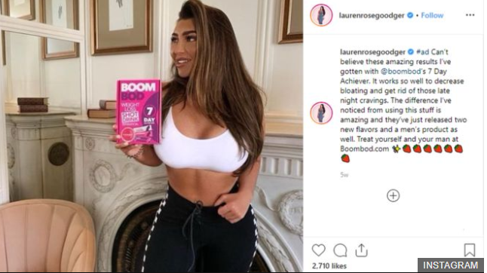
Lauren Goodger, with her clearly hard worked for body, is claiming that this product had reduced bloating and late-night cravings. The clear problem here is she has not actually told her audience what the product is, therefore leading individuals to explore this product on their own website and make purchases. She has made it clear that this is a payed advertisement through the use of ‘#ad’ (Legal requirement from Instagram), made is clear the ‘so call’ affects this product has had on her yet completely avoided telling her audience what the physical product is.
Bibliography
@laurengoodger – Instagram
Kate Solomon, Dictionary.com. The meteoric rise of the word ‘influencer’, https://www.dictionary.com/e/influencer/
https://www.bbc.co.uk/news/technology-50124719

Task two: Manifesto (Julia’s task)
1. Lack of response to the arts is also a valid response, cut down forcing responses from an individual
2. A musician to have more legal say in where their royalties for their product are distributed and to whom
3. Any person involved in the arts to be entitled to a free course focusing on marketing and promotion.
4. Each city to have at least one venue which would cater for homeless musicians/buskers to enable them to earn extra money or potential funding and cut down on the homelessness crisis
5. Arts students (Media, photography, art, fine art, music and music technology) to be entitled to more government funding towards their course due to equipment being expensive
6. Christian musicians to be offered free placement from local churches
7. Mainstream companies (BBC, ITV) to have a set programs for arts students to offer opportunities to reduce risk of students struggling to find jobs post-graduate
8. Social media to play less a factor in promoting and marketing.

Key words and images
Homelessness crisis

Los Angeles, Skid Row, Homelessness Crisis.
4. Each city to have at least one venue which would cater for homeless musicians/buskers to enable them to earn extra money or potential funding and cut down on the homelessness crisis
“Today the only way you can ignore homelessness in the UK is by averting your eyes.” (The guardian, 2019) this is how as a society, and even in Britain we view homelessness and the homelessness crisis, we walk down a street and share no guilt in ignoring a plead for money or food and would sooner avert our eyes. ‘It cannot be right in the 21st century that people are homeless or having to sleep on our streets’ (Boris Johnson. 2019) after promising the UK to invest more money in funding and helping homeless people relocate to sufficient housing. But, as everything else, this is a promise, was it a promise to gain votes or something that is going to change? The only way of knowing is if the topic is pushed, supported and the promise carried through.

Social Media
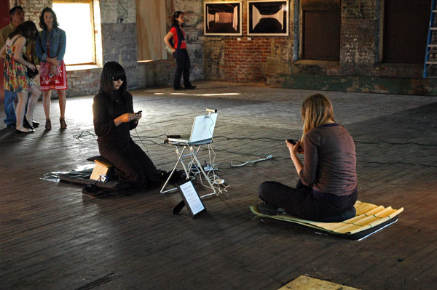
‘The Artist is kinda present’ by An Xiao
8. Social media to play less a factor in promoting and marketing.
The Cambridge English Dictionary defines ‘Social Media’ as ‘websites and computer programs that allow people to communicate and share information on the internet using a computer or mobile phone’. This is obvious as we know, but it’s missing the true meaning of social media and how it plays a enormous part in a persons every day life, it misses how consumed we can become in it and how we rely on social media to almost survive. This comes into a business sense as well. Companies, or in my sense of speaking, people of the Arts rely so much on social media for marketing and promotion. Its how we gain a following, how we distribute a product and get people talking about that it is we do. We promote music, art, live events and rely on social media for this.
‘One of the best reasons for your small business to be marketing through social media is that your customers are spending time on these channels.’ (Keran Smith, August 12th 2019). Keran Smith is correct, majority of a customer base is online. But, due to social media essentially taking over the world it had destroyed newspaper advertisements, people going out and promoting through flyers and posters, which realistically speaking, was the only way of promoting at a certain time before social media. Newspapers and posters will evidentially become obsolete due to social media, everyone is fixed on screens.
Valid response
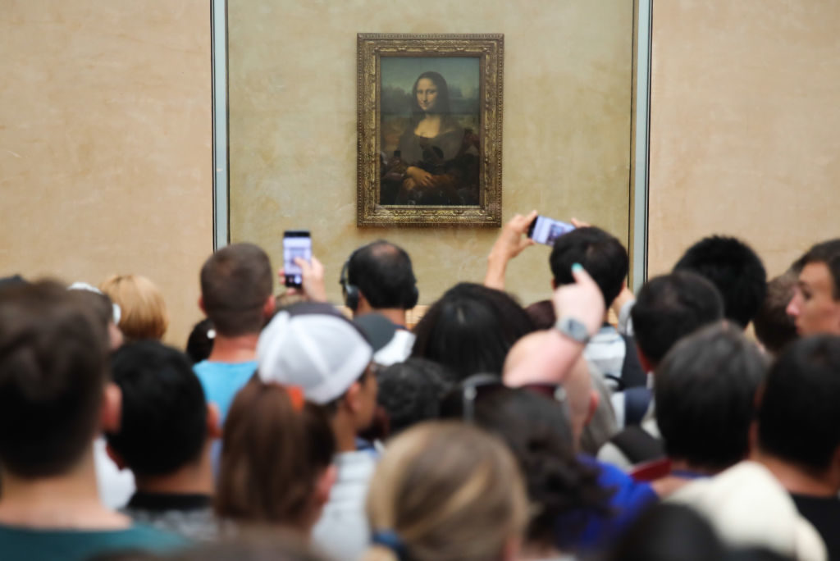
The Mona Lisa being viewed, Louvre Museum, France.
1. Lack of response to the arts is also a valid response, cut down forcing responses from an individual
Any response to absolutely anything should be valid, especially a lack of response. As a society we thrive off validation from people, whether that’s our work, clothes, appearance. But, people of the Arts need (or feel like they need) responses of people, which can be good or bad responses as any response ands feedback is welcomed. The problem lies within an artist who pushes and forces responses out of people, what if someone doesn’t have an opinion or doesn’t respond in the way in which you wanted? Then there seems to be a problem. So, society needs to learn to accept that not everybody you come across will have an opinion on everything you do, a lot of people could simply be indifferent.
“Approval is a lover who will always break your heart.”- (SAMMY RHODES, This Is Awkward)
Bibliography:
musiciansagainsthomelessness.net
The guardian https://www.theguardian.com/society/2019/nov/19/rage-and-responsibility-nine-months-of-reporting-homeless-deaths-why-isnt-it-election-priority
Article: Spiked https://www.spiked-online.com/2020/01/03/the-homelessness-crisis-demands-radical-solutions/
Cambridge English dictionary: Social Media
Lyfe Marketing https://www.lyfemarketing.com/blog/marketing-through-social-media/
Task three: Reflective writing (Jon’s task)
A practical reflection of Walt Disney’s Snow White and the Seven Dwarfs (1937 film)
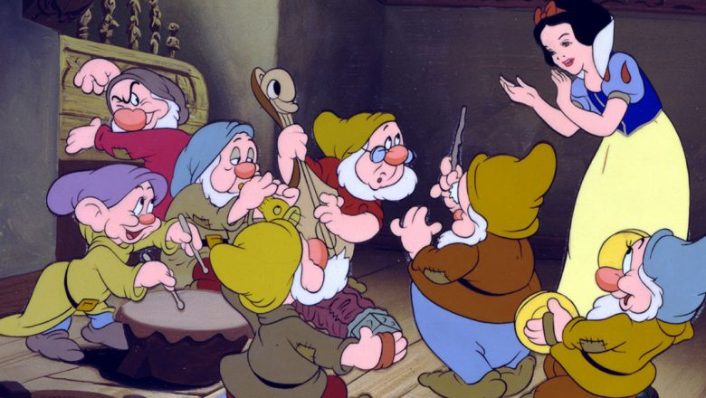
When thinking back on Snow white and the seven dwarfs I can’t not help but feel a wave of nostalgia, being 5 years old and having been gifted a VHS tape of the film, being completely oblivious of the true extent of this film as well as being unaware of just how old the film was.
This film paved the way for animated full length feature films, without Walt Disney’s snow which there would have been no ‘The Wizard of Oz’ and no other Disney films to follow due to this film being a risk. Walt Disney’s snow white was the first ever full-length feature animated film in colour and due to it’s success and popularity back in 1937/1938 (Released December 1937) it created decade upon decade of animated feature length films.
If it wasn’t for this film back in 1937 there would be no Frozen 2 today which already has it’s own merits.
In a reflective sense I remember thinking, due to the evil Queen story line (The Queen wanting to kill snow white because of her beauty which resulted in the death of the Queen herself) I learned at a young age, which I’m sure many other young girls and now grown women would agree, that envy is a very dangerous trait to behold. ‘Grudges get heavier, the longer they are carried.’ (P.K Thomajan).
Realistically speaking, without Walt Disney’s Snow White and the Seven Dwarfs, animated films/cartoons would be very different now, not far off 100 years on. Not only for being brave and breaking the boundaries of animated films but for also influencing the world of movie soundtracks (Music), Snow White was not only the first full length animated feature in colour but also the first full length feature with a soundtrack released alongside it. This influenced not only future Disney movies but every other movie as it gave confidence at the time that these tools to make a film would work.
Although there is so much positivity that can be said about this movie it does have it’s flaws, as an adult I realise this, it’s the film that started the stereotyping (and the films that followed) of a woman needing a husband to achieve in life, personally this influence didn’t affect me growing up but it is understandable how this can influence quite easily a younger generation of children watching, girls and boys, boys especially because they could feel like they have to be an equivalent to a prince and have to ‘save’ a females life and be this role model for them and be this ‘hero’. Parents these days tend to want to teach there children to be independent, but also want them to watch all of these old Disney films which says the exact opposite of that, maybe their thinking is the same as mine and it comes down to nostalgia.

