
Skills for the Workplace
Module Assignment Submission
Student Name: | Tracey Hughes
Student Number: | 2008698
Module No: | BMSK4004
Module Title: | Problem Solving and Decision Making

Statement of Confirmation of Authenticity
By the act of making this submission, the student declares that this is the work of the student named above. The work has not, in whole or in part, been knowingly presented elsewhere for assessment, or where assessment has been built on a previous assessment, this has been identified. Where materials have been used from other sources it has been properly acknowledged. If this statement is untrue, the student acknowledges that an assessment offence has been committed.
Attention is drawn to the plagiarism and unfair practice policies of UWTSD.

Table of Contents
Define a complex problem in the workplace, including its scope and impact 3
Analyse information on the identified problem, to help inform the decision making process 3
Propose a range of alternative solutions to the problem 4
Using a decision making technique, evaluate a range of solutions to identify the most appropriate option 4
Develop a detailed plan for implementing the solution 5
Communicate the plan to relevant stakeholders 6
Assess appropriate monitoring and review techniques to ensure successful implementation of solution 6
References 7
Appendix 1 7
Appendix 2................................................................................................................................
Appendix 3..................................................................................................................................
Appendix 4............................................................................................................................
Appendix 5.................................................................................................................................
Appendix 6...................................................................................................................................

Define a complex problem in the workplace, including its scope and impact

This report will explain a problem that was encountered whilst working for a company called ‘Village Home Care services,’ which was based locally in the town The basis of the company was an Adult social Care Services for the elderly and disabled in their own homes in a 20-mile locality of the office. The company was run for twenty years and was started by two local ladies and when their clients base grew too large for them to manage, they decided to sell.
The byer an exceptionally large organisation called Mitie (Mitie.com) bought the business for £111 million and capitalised on the outsourcing of community care from councils to private operators and outsourcing its home care service to a larger population and a larger geographical area. (MIHomecare.com)
The problem started to arise when after the sale, the local office was closed, and the existing management and care staff were placed in new premises in a different town, which was over 10 miles from most staff’s homes. The original office was a hub for teams of carers to meet up before their shift, pick up rotas, hand in time sheets etc. And to be more cost effective we would car share and take one car to service users homes, since the move and being unable to park on new premises and being a distance away this now meant that we would have to drive to our calls together in separate cars. This meant added petrol costs which took up to two wks. to get credited back to staff
Once the company was up and running, the care staff were given new clients in different geographical areas, new rotas, and new routes, which sometimes were unmanageable for a lot of staff and staff retention became a problem.
One of the routes, was over 60 miles away in a very rural part of the country and was given to four care givers, two females and two males, one male one female in each team to work opposite shifts of a total of 250/300 miles every day, the day begun with the first call at 6 a.m. and not finishing the last call till 10 p.m. These calls were back-to-back resulting in no breaks been taken in this time. Also added is the hour and a half drive home, these shifts were twice a week and two half days again starting at 6a.m and finishing at 3p.m where the opposite team would work the afternoon shift and vice versa the following day. We were also responsible for any sickness and holidays had to be covered by ourselves.
This situation needed to change, there needed to be enough time given to the service user to receive the care they need with dignity and respect they deserve and to be knowledgeable in the times we will arrive. Also needed to be improved was holiday and sickness cover or if we were caught up in an accident, The lack of reception and internet connection is a great problem with communication.
This problem needed to be explained to the management and planning team to figure out a new way of working that was in the best interest of its staff and service users.
After a few weeks, the care givers and the service user's wellbeing started to change dramatically, fatigue began to show due to lack of breaks, long hours, and not having enough personal time between shifts. The service users were getting more confused and vulnerable, this was a complete disregard to service users not receiving the support and care that was needed.
This problem was becoming a significant issue and was only a matter of time before something serious was going to happen, fortunately most on our rota did not live alone but some did have family that were not able to give them personal care and medications, they might need an unforeseen accident, being left on the floor, medications not given on time , service users going hungry , their toilet needs not being met resulting in their lack of self-dignity and respect .

Analyse information on the identified problem, to help inform the decision-making process

After using techniques such as mind mapping ( appendix 1 ) and the 5 whys method ( appendix 2 ) to gather as much information as possible , each member of the team contributed their own perspective on the issues we were facing .
The main priority was service users were not getting the care they deserved , and late calls were making them vulnerable , and not receiving medication on time , their toilets needs weren’t met resulting in the service users losing their dignity and respect , it was also the time it was taking to get to their homes was longer than the carer givers were given time for which resulted in sometimes driving too fast , this was also dangerous as the roads that were travelled were not A roads but country lanes with one way traffic at a time , so driving faster was not a solution as it could cause unforeseen accidents , and especially at night when there were no street lights. Added to this issue was lack of communication, should there be an unforeseen issue such as an accident, car breakdown, there was no way to call for help or let the ser4vice user know we were going to be later, so were leaving ourselves and our service users very vulnerable and anxious
It also became apparent that besides petrol costs, wear and tear on the vehicles being used was an issue as most of the rds. were dirt tracks leading to service users homes , without proper lighting if there was an accident there was no way the office or on call planner could be notified as phone signals were non-existent in most areas which had an effect on both teams , without being able to call for help or get a message to service users to explain what had happened and why the team hadn’t turned up for their call , this would leave service users very vulnerable .
Using a cause and effect technique such as Ishikawa ( fishbone analysis )( appendix 3 ) we were able to identify the root causes of the problem which was ineffective care and narrow it down to being a logistical issue , as you can see by the diagram , there was not enough time to travel to calls safely , this resulted in a range of issues not enough time if an emergency situation arose , not enough manpower to cover the large area we were expected to cover in the time given which again resulted in inconsistent call times and not meeting the service user's needs . This put a strain on the care givers who were responsible for the care been given which was unsatisfactory at best.

Also in the allocated time frames it was extremely important that on every visit the care plans were adhered to these were in written form and needed to be more accurate and up to date , but again time was against you .
This problem was also affecting the care givers as the calls were back-to-back and no time was given for breaks, so we are expected to work 15 hour shifts without any breaks and no stop off to be able to eat unless whilst driving.
Another big issue was there was no paid travelling so if a call lasted 30 mins and then it took you 30 mins to get to the next call you would only get paid for duration of the call. This seemed very unfair to cate givers who were in work 15 hours, only getting paid for 7/8.
We used a swot analysis graph(appendix 4) to show where our weakness and strengths lay and how it could be managed in a more efficient way.

Propose a range of alternative solutions to the problem

The team worked together to produce a range of solutions to the problem that was being faced every shift we undertook.

One solution was to change the route, not only to cover less mileage, but it would also mean less petrol costs, but time would be saved. As it stood now the team travelled 60 miles to their first call of the morning, having passed very nearby to two service users' homes, the care givers then would travel back to the first nearest house then would pass the second service users' home to go to another call which was 30 miles in the opposite directions, these were due to the call times been given by the planning team.

Another solution would be to change call times of the service users .

There were 6 service users in total, with 4 visits daily, during the morning calls, care givers were expected to get the service user out of bed, washed, dressed, and fed, given meds, reports written and made comfortable in 30 mins, this was totally unacceptable, and everything was rushed which caused stress to cate givers and service users, mistakes could easily be made to the detriment of the service user and their health. Changing call times would be necessary to follow the new routes.

Travelling times was a big issue so needed to be addressed, and routes needed to be calculated properly to make sure that safety on the roads were adhered to avoid accidents. Most of these rds. were in rural locations so mostly lanes and unkept rds. and dirt tracks. It was extremely dangerous to drive fast as tractors were encountered most routes in a daily basis. By the time the care giver reached their destination they were almost always late and then calls needed to be cut short to travel to next call.

Working in unfamiliar territory and having to work with the weather was also a factor, it snowed, and rds. were untreated so would be very icy and unsafe, the solution of having 4x 4 to give the care givers more confidence in being able to drive in extreme weather conditions.

This added with a petrol card would be beneficial to staff as their own vehicles would not be used daily causing wear and tear and also having to pay upfront petrol costs before being reimbursed later. Making the care giver short on money, and no petrol we were unable to do our job.

The idea of additional staff would be a workable solution but would not offer an immediate Solution as staff would need to be employed and trained up so the solution could be to employ care staff in the geographical area this would be at a cost to the company but would save petrol costs.

.

Using a decision-making technique, evaluate a range of solutions to identify the most appropriate option

Using a grid analysis (appendix 5 factoring a range of factors that the team had produced including the wellbeing of service users and wellbeing of staff, to the cost of petrol and wear and tear on our own personal vehicles and giving the seven solutions we had produced and marking them from 0- being poor to 3 being an excellent option. When calculating a second grid analysis which ranged from 1- being the least important to 6 being the most. It became apparent that the solution would be to change routes from closer to home and working our way back to home at the end of shift, this would save time, with the added bonus of less petrol costs for us and also the company, .to add to this decision call times would need to be changed with the nearest service user to our home being the first, and then the next service user and so on.

As a team we also suggested by changing our rotas to coincide with our route change, that instead of working two full days and two half days we would cover each other's half shift so we were working three full days instead, which would give you time to recover and have more time personally, this suggestion had been made previously but discounted. We also added this again to our range of solution as it was the wellbeing of care givers was important to be able to give proper care to service users.

Also being discussed was a tracker system this would be at a cost to the company but was detrimental to the safety of care givers and would always give the team leader our location, it could also send out an SOS to our team leader if something unforeseen happened and be able to let the service user know we could be late

Added to this tracker system would be our calls times so it would log us into the service users' home when we arrived, we were able to electronically write our care plans, so notes were not being lost we had all the updated information we needed to do our job to the best of our ability. It would also be able to track the distance between calls and help in the changing of the routes and call time.

Another way we wanted to show management was with a pest analysis (appendix) to show exactly where we were failing as a company and show just how much it was affecting our ability to do our jobs.

Develop a detailed plan for implementing the solution

When we had all the information to back up our plan, we spoke to our team leader and organised a meeting with management to speak about our solution to the problems we were facing. we spoke to service users to see if they would be happy with a new arrangement, it might mean their call times we would change but they could be more confident in the fact we would be there when we said we would. All service users were happy with the solution.
We used a Gantt chart (appendix 6) ( teamgantt,com) to make a detailed plan for implementing our solution in the best way possible and started from speaking to the team and service users to management who were able to see what procedures needed to be taken to get the solution executed as cleanly and as efficiently as possible.

Communicate the plan to relevant stakeholders

Assess appropriate monitoring and review techniques to ensure successful implementation of solution

Again, using the Gantt chart (appendix 6) and being in touch with the team leaders every day we were able to find out exactly how the plan was being implemented, the shift patterns were changed almost immediately, and the planning department had been on the routes themselves to calculate the distance between calls and a more manageable allocated time given. Our office was quick to take our concerns seriously and started to make arrangements to change rotas and routes as quickly as possible.
In the meantime .it became apparent that this was a concern in other rural areas which were taken over by MIHomecare (mitie.com). Two other members of staff has given their concerns on feeling very vulnerable at night and had contacted an outside union representative TUC general secretary Frances O’Grady said “it was criminal that care workers were not being paid their full entitlement “(tuc.org.uk). Both women also worked for the formally known’ village home care’ company. They took it one step further and contacted BBC news Wales (bbc.co.uk) as they had found out that our local office had changed their way of working for our team. MIHomecare said in a statement to the press they would investigate the allegations as some serious concerns were raised. The women only known as Clare and Emma told BBC radio 4, that the long hours, stress, and clipping calls to be able to reach next client had led to them both resigning from their jobs. (bbc.co.uk/radio 4)
A report by the Care and Social Services Inspectorate Wales raised their concerns about working hours and stress among employees and recommended reviewing travel times between calls depending on location. (“Ex-carers had 'too little travel time' between jobs - BBC News”)
Due to the media intervention, MIHomecare was examined by HM revenue and customs after an internal review was conducted found workers for the company were effectively not being paid minimum wage for time spent travelling between calls. (HM Revenue & Customs)
A reporter Zoe Conway of BBC radio 4 today stated that MIHome care examined the pay of 44 workers in south Wales and found that the collectively owned up to £80,000 for time spent travelling to calls.
It was then leaked to the investigative organisation corporate watch (corporatewatch.com) that minimum wage was not being given. They gave MI homecare a chance to rectify the situation.
MIHomecare issued a statement said they were “rectifying systemic errors and did value their staff. And when it had completed a comprehensive review of all payments for all its care workers, to be absolutely certain that they are treated fairly and that we comply with a wage legislation, we have found some errors in calculating travel time and have decided to make a one-off payment to all affected people “
An email was sent to all staff including our team and stated “we are in discussions with HRMC to better understand how travel time should be accounted for across our business so we are both compliant and consistent, also on conclusion to discussions rates of pay will change so staff are paid travelling time. (. MIHomecare.com)
The problem our team faced was bigger than we anticipated and thankfully our office was ready to listen to our solution and make the appropriate changes, what we did not anticipate was the cheque we received in the post for £2000 pounds for inconvenience and suffering and a thank you to our support and bringing up a situation that needed to be rectified and a payback for lost wages.

References

Conway Z BBC Radio 4 today,’ MIhomecare staff paid less than minimum wage, [online] at: https://www.bbc.co.uk/news/business-31869447
MIHomecare [online]at: https://mihomecare.com

HM Revenue and Customs, available at: https://www.gov.uk/goverment/organisations/hm-revenue-customs/contact
‘Gantt charts’ available at: https://teamgantt.com/h
‘Mind mapping tools’ available at: https://www.lucidchart.com/pages

Appendix 1
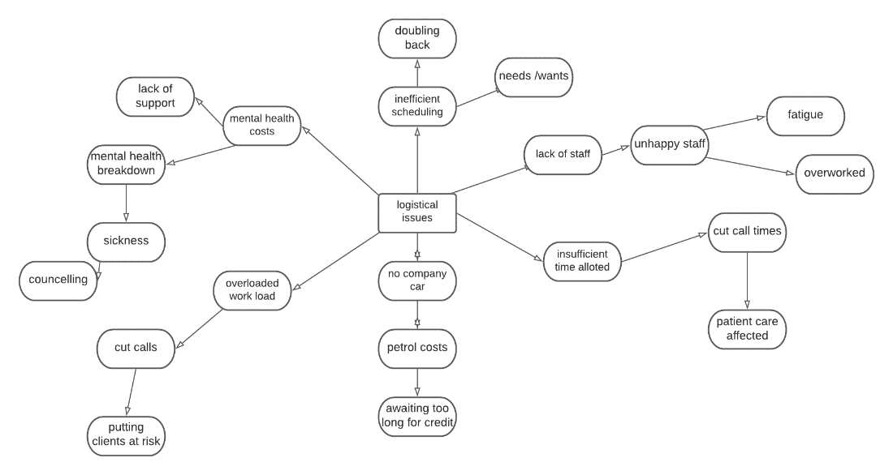
Appendix 2

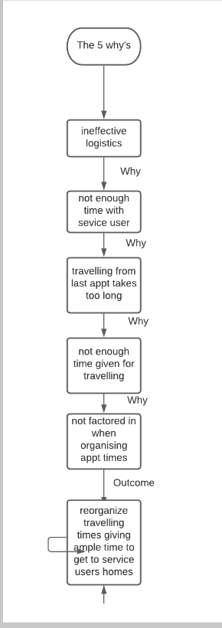
Appendix 3

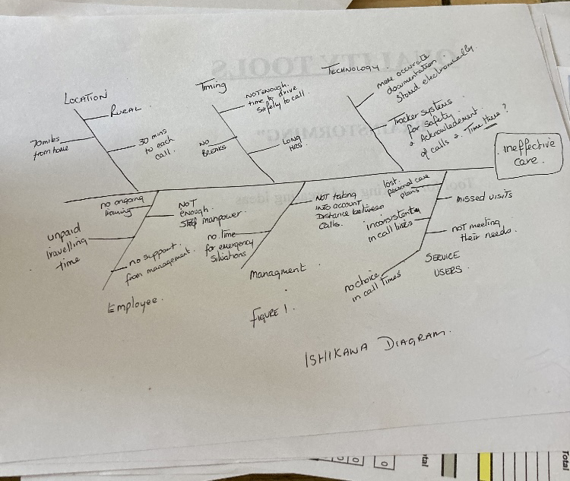

Appendix 4

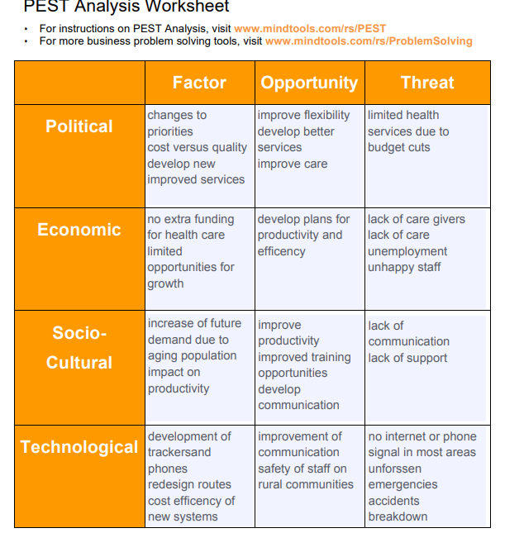

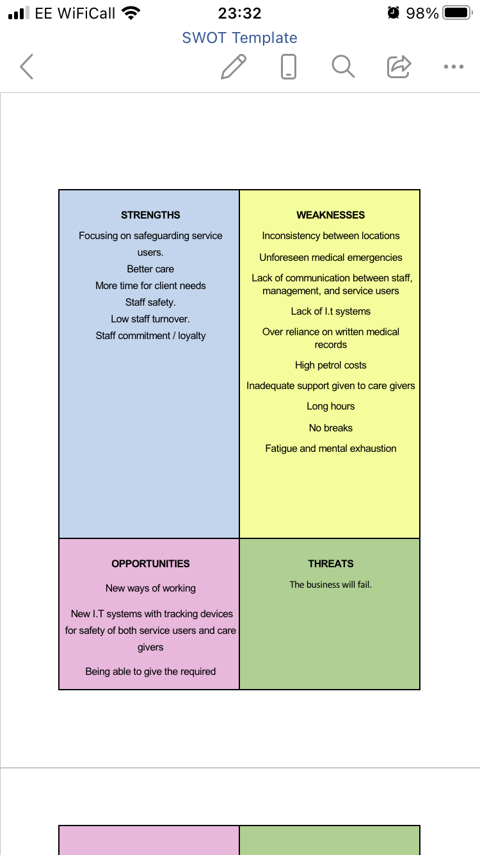

Appendix 5a

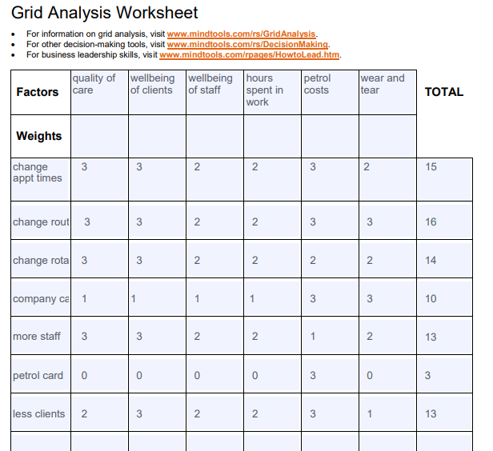

Appendix 5 b
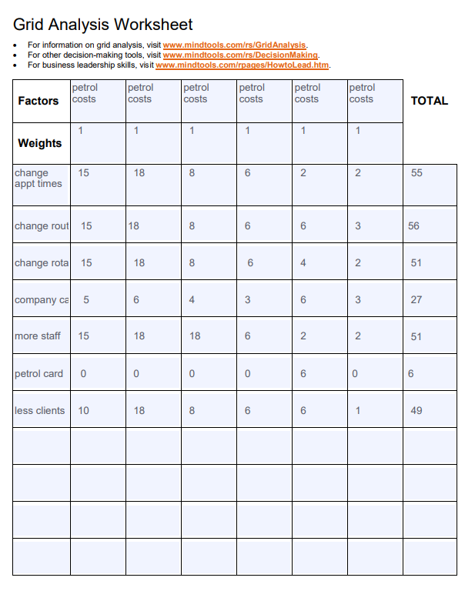

Appendix 6


