Building Surveys


Digital Surveying & Highway Design
Osian Rhys Davies

Contents
Introduction
Objectives and Scope
- Why are Building Surveys Important?
Digital Tools & Technology
- Drones
- LiDAR (Light Detection and Ranging
- Building Information Modelling (BIM)
Planning a Survey
- Pre Survey Plan & Preparation
- Survey Execution
- Data Integration
Challenges of Surveying
- Site Access
- Building Preservation
- Environment
- Structure of the Building

- Conclusion
- References

Introduction
Building surveys are essential for the upkeep, enhancement, and restoration of historic structures globally. They offer crucial information regarding the condition, structural soundness, and safety of these buildings, enabling informed decisions that help to conserve their integrity. Such surveys are instrumental in safeguarding the history and architectural significance of noteworthy sites for future generations.
Recently, advancements in digital technology have greatly influenced the process of conducting building surveys. Continuous development of new tools has made these assessments safer for engineers. Innovations such as drones, 3D scanning, and Building Information Modelling (BIM) enable professionals to gather highly precise data regarding a structure's condition, often without needing to physically enter the building.
In this project, I will develop a detailed digital survey plan for the Dylan Thomas Centre located in Swansea City Centre. This Grade II listed structure was originally constructed in 1829 as the Swansea Guild Hall. It underwent renovations in 1995 to transform into the Dylan Thomas Centre and has since served as a venue for numerous literary events and exhibitions open to the public.


GPSmyCity. (2025). Dylan Thomas Centre. [online] Available at: https://www.gpsmycity.com/attractions/dylan-thomas-centre-41324.html [Accessed 31 Jul. 2025].
Objectives and Scope
As part of my assessment of the Dylan Thomas Centre, several aspects can be evaluated. These include the external condition of the structure, the roof and its framework, as well as the building's structural soundness and environmental performance. This information will contribute to a comprehensive report intended to assist workers in future renovation efforts.
During a recent site visit, it became evident from the accompanying image that the building's exterior has deteriorated over time, revealing exposed stonework and numerous cracks around the pillars. To prevent further degradation that could jeopardize the building's structural integrity, maintenance is necessary. Conducting these assessments will allow for a more thorough analysis of the building’s exterior and facilitate long-term maintenance planning.
Additionally, all conducted surveys will aid in creating a digital archive of the building, establishing a lasting digital record through 3D imaging and photography. This resource will serve educational purposes and highlight its historical significance.
The building is situated in Swansea City Centre's Maritime Quarter and exhibits Neo-Classical architecture. Its brick construction features numerous arched windows and structural columns; therefore, regular upkeep is essential to ensure its preservation for future generations.
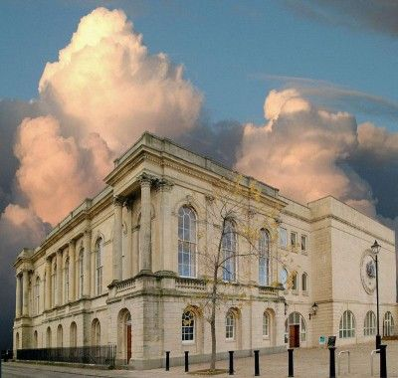
Glass, A. (2013). Dylan Thomas Under Milk Wood. [online] Pinterest. Available at: https://uk.pinterest.com/pin/dylan-thomas-centre-swansea--541065342703218718/ [Accessed 31 Jul. 2025].

Digital Tools & Technologies
To conduct the necessary surveys on the Dylan Thomas Centre, I will require a range of tools and digital technologies to ensure accurate reporting on the structure. In this section, I will outline several of these technologies and discuss their significance in building surveying.
Drones
In recent years, drones have become increasingly vital in the field of building surveying. They are particularly useful for obtaining views of hard-to-reach areas, such as rooftops, without needing to erect scaffolding. Equipped with cameras, drones can capture video footage or photographs from an aerial perspective and can also be utilized to access hazardous parts of a building while keeping human operators safe from potential risks.
Data obtained from drones can generate 2D or 3D scans of structures, and in some instances, it is possible to capture thermal imaging as well. This data can assist in compiling a report on the thermal efficiency of buildings and identify areas for potential enhancements. This technology will be essential for my assessment of the roof condition at the Dylan Thomas Centre.


Allain, R. (2017). The Physics of How Drones Fly. [online] WIRED. Available at: https://www.wired.com/2017/05/the-physics-of-drones/ [Accessed 31 Jul. 2025].
Laser Scanning (LiDAR)
LiDAR, which stands for Light Detection and Ranging, is a commonly utilized instrument in building surveying that enables the digital mapping of structures in three dimensions. It accomplishes this by measuring distances between various objects and features within a given environment. LiDAR creates a virtual 3D map by emitting short light pulses into the surroundings; when these pulses bounce off objects, a sensor records the time it takes for them to return. When combined with GPS data, this information forms a Point Cloud that accurately represents its location on Earth. Subsequently, this data can be uploaded to a computer to produce the 3D virtual map.

In the case of the Dylan Thomas Centre, LiDAR can effectively document the building's intricate external façade and outline internal floor plans without any physical contact with the structure, making it ideal for capturing the detailed architectural features of the building.
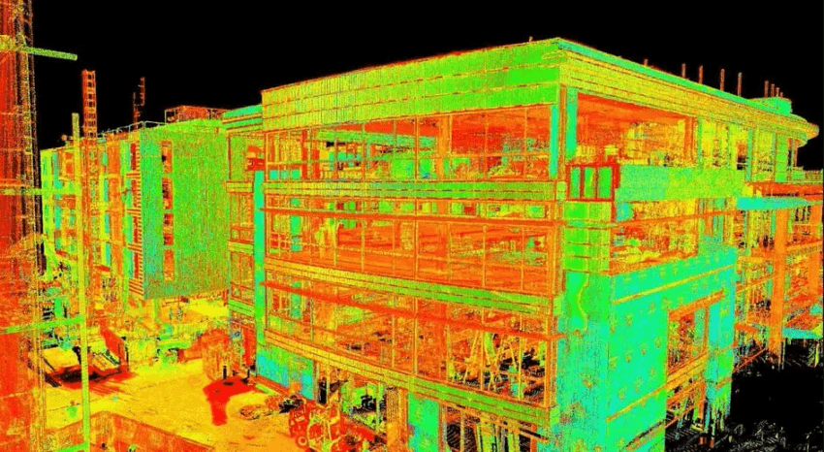
Virtualbuildingstudio.com. (2024). Virtual Building Studio. [online] Available at: https://www.virtualbuildingstudio.com/blog/lidar-scanning-and-bim-a-perfect-combination/ [Accessed 31 Jul. 2025].

Building Information Modelling (BIM)
Building Information Modelling (BIM) is a software tool that facilitates the creation of 3D building models derived from surveys, such as those conducted using LiDAR technology. BIM has become a well-established technology within the construction sector, enabling the integration of various aspects including building data, design, construction processes, and operational management. The software is capable of storing information regarding structural components and existing conditions while assisting in the planning of maintenance and repair tasks for buildings. Following the completion of surveys at the Dylan Thomas Centre, all gathered data will be processed through BIM, allowing for comprehensive digitization.
Additionally, BIM software enables the generation of a digital twin for a building. This functionality ensures that if any part of the building's interior or exterior deteriorates, it provides a reference point for creating an accurate replica of the original structure. This capability also aids in preserving historical elements present in the building.
Planning a Survey
To conduct my surveys at the Dylan Thomas Centre effectively, I will need to formulate a detailed survey plan to ensure safety throughout the process.
Pre-Survey Planning and Preparation
As I prepare for the upcoming surveys at the Dylan Thomas Centre, an extensive desktop survey will be conducted to gather insights into its architectural details. Subsequently, I will hold a pre-survey meeting with the facility's managers to obtain essential information such as site permissions and access routes. This discussion will help clarify the full scope of necessary surveys and objectives to be met. Once this stage is complete, I can assess which equipment is required for conducting the surveys while ensuring it is safe, calibrated correctly, and properly licensed. I will also coordinate logistics, including transport and storage of equipment, and confirm that all team members are adequately trained for their specific roles. Communication protocols will be established to ensure effective collaboration and rapid response to any on-site issues that may arise. In addition, I will review health and safety requirements, ensuring all risk assessments are up-to-date and compliant with current legislation. This thorough preparation will allow the surveying process to proceed efficiently and with minimal disruption to the site's operations.
Survey Execution
When performing external building surveys—especially those involving drone usage—it's crucial to avoid any obstacles within the surveyed area. A valid license is mandatory for drone operations, and all operators must adhere to regulations set forth by the UK Civil Aviation Authority regarding drone flight protocols. To maintain accuracy during these external assessments, it's advisable to conduct them under dry weather conditions.
Internal surveys should aim to minimize disruptions while still capturing all pertinent information needed from each assessment. These internal evaluations are best scheduled during off-peak hours or when the facility is closed to mitigate interference. Surveyors must also maintain clear communication with on-site staff to coordinate access and avoid interrupting essential operations. Utilizing non-invasive techniques and efficient data collection methods will help streamline the process. Attention should be given to sensitive areas or historically significant features to prevent damage. Additionally, accurate documentation through sketches, photographs, and notes will support the final report and ensure that no critical details are overlooked during analysis.

Data Integration
Upon completing all surveys, results will be integrated into BIM to construct necessary 3D models required for structural evaluations and compliance documentation. Data collected from equipment can be transferred onto computers before being imported into BIM software to generate these models. After incorporating all relevant information into these models, they can be presented for review; subsequently leading to recommendations aimed at enhancing building performance. All stakeholders involved in these surveys will have full access to collected data allowing them to analyse findings and annotate within the system.
The cumulative data gathered will provide a comprehensive understanding of the extent of work needed on the building while also aiding in compliance verification and forecasting future maintenance requirements.

Challenges of Surveying
Conducting a building survey presents numerous challenges that can influence the methodology employed during the process.
Site Access
The ability to access a site significantly impacts the effectiveness of a building survey. However, advancements such as drone technology enable surveyors to reach difficult areas without relying on scaffolding, thereby minimizing risks for both the surveyor and the public. In buildings that are currently occupied, it is crucial to perform surveys in a manner that minimizes disruption to ongoing activities, workers, and visitors. At times, obtaining special permission for access or postponing the survey may be necessary to achieve this goal.
Building Preservation
When surveying historically significant structures, preserving their integrity is paramount. This necessitates avoiding any invasive procedures during the assessment. Techniques like LiDAR and thermal imaging can assist in maintaining the building's features while gathering necessary data. These non-destructive technologies allow for accurate mapping of surfaces and detection of hidden structural issues without physical contact. Additionally, detailed photographic documentation and measured surveys provide essential references for conservation planning. It is also important to consult with conservation officers or heritage professionals to ensure all methods comply with preservation guidelines. By employing careful, respectful strategies, surveyors contribute to the long-term protection and understanding of the building’s historical value.

Environment
Weather-related factors can also impact how surveys are executed and may affect their outcomes. Ideally, surveys should be conducted under optimal weather conditions to decrease the likelihood of accidents and equipment damage while ensuring accurate results. For buildings located near coastal areas, considerations regarding repair methods and material choices may arise due to exposure to salty air.

Structure of the Building
If a structure is in disrepair or considered unsafe, it poses significant challenges for conducting safe surveys. Utilizing drones and digital technologies mitigates risks by reducing the need for physical human access. These approaches are less intrusive since they do not require scaffolding or any alterations to the building itself.
Conclusion
In summary, implementing a thorough building survey at the Dylan Thomas Centre would significantly contribute to preserving this historic site for Swansea. This report outlines a methodical approach to conducting various types of surveys while discussing their respective advantages and disadvantages.
The recommended surveys will integrate 3D laser scanning, photogrammetry, and BIM technology—essential tools for future maintenance or renovations of the structure. Conducted by skilled surveyors adhering to high standards, these assessments will protect all historical aspects of the building.
Given that its condition has slightly deteriorated over recent years, comprehensive surveys could help prevent further decay and facilitate monitoring changes so that repairs remain non-invasive and cost-effective. As this building holds substantial historical significance for Swansea, it is imperative that it be preserved for future generations.

References
admin (2024). Common Challenges in Conducting Measured Building Surveys. [online] Survey2Plan. Available at: https://survey2plan.com/challenges-in-conducting-measured-building-surveys/ [Accessed 31 Jul. 2025].

DylanThomas.com. (n.d.). History of the Dylan Thomas Centre. [online] Available at: http://www.dylanthomas.com/dylan-thomas-centre/history-dylan-thomas-centre/ [Accessed 31 Jul. 2025].

Intersectsurveys.co.uk. (2024). Common Challenges In Conducting Measured Building Surveys. [online] Available at: https://intersectsurveys.co.uk/blog/common-challenges-conducting-measured-building-surveys [Accessed 31 Jul. 2025].

onekeyresources.milwaukeetool.com. (n.d.). How Is BIM Used in Surveying? Construction Technology Topics. [online] Available at: https://onekeyresources.milwaukeetool.com/en/bim-in-surveying [Accessed 31 Jul. 2025].

uk.milwaukeetool.eu. (n.d.). One KeyTM Resources | Anti Theft Tool Tracker | Milwaukee Tools UK. [online] Available at: https://uk.milwaukeetool.eu/systems/one-key/resources/what-is-lidar-and-how-can-we-use-it-in-constructio/ [Accessed 31 Jul. 2025].

www.designingbuildings.co.uk. (n.d.). Building survey. [online] Available at: https://www.designingbuildings.co.uk/wiki/Building_survey [Accessed 31 Jul. 2025].

