Student Name: Ioana Mirela Bumbu
Student Id number: 2227453
Module: Marketing Essentials BMIH4005
Lecture’s name: Christopher Wilkin
Word count: 1275

Introduction
Based on the research of Baltes (2015), the marketing plan's purpose is to identify the business's target audience. A marketing plan is regarded an advertising plan that a business integrates to retail its products and services. A marketing plan assists in reaching and identifying the target marketing of the organization. This marketing plan report will highlight London Hilton on Park Lane. This hotel offers every delight and is also located in one of the prestige places in London (Hilton, 2023). According to Kilburn (2019), The hotel is pleased to have helped reinvent the United Kingdom's event business, which is now valued at an estimated £18.1 billion. The hotel's economic impact on the London economy was projected to be around £7 million when it opened in 1963.The various models that will further be highlighted in this marketing strategy report are 5Cs for situation analysis, Marketing Mix, USP for control, Bowmans watch and many others.

Situation Analysis

5Cs
Company
According to CIPD (2021), A SWOT analysis is a planning method that identifies the project's or organization's Strengths, Weaknesses, Opportunities, and Threats. It is a framework for aligning an organization's objectives, programmes, and capabilities with its operating environment. A Swot Analysis was made for London Hilton on Park Lane, (See figure 2).

Collaborators
London Hilton Hotel works with various partners to ensure that they are providing good quality services to their guests. The business maintains a positive association with franchises and other organization and also offer full responsibility to partners for maintaining the requirements of the business. In 2021, the business developed an association with Bluestone Lane to generate a comprehensive beverage and food program (Hilton, 2021).

Customers: Segmentation and Targeting
According to Similar Web (See figure 3), the hotel is focusing the attention on the age categories 25-34 around 26.04%, followed by 35-44 within 20.29. The segmentation is to target people who are visiting London, both female and male, family travelers and business travelers. Mostly targeting people who love creativity, design and comfort. The target are individuals who want comfort at good prices and a good positive and comfortable environment. The hotel is offering these services which attracts this type of customers for a higher budget.

Competitors:
According to Comparably 2023, Hilton Hotel has as competitors: Marriot Hotel, Holiday Inn, Loews Hotels, IHG, Hyatt Hotels and many others.
The Perceptual map (see figure 4), Hilton is considered as having high-quality services for high price compared to others.

Climate: PESTLE (Macro Analysis)
Many variables influence the performance and expansion of the hotel sector. Governmental changes, high-stakes rivals, and uncontrollable weather are all impediments to the hospitality and tourism industry (Frue,2019). London Hilton Hotel was affected as well, from a political point of view because the government imposed a 12,5 decreased VAT on the hotel’s activities. (Government of UK, 2023). According to BBC 2020, the unemployment rate has been increased. As a result, the hotels lost an increased number of staff. The consumer preferences are changing and because of that the social media is contributing by introducing new trends in the industry (CIHMS OFFICIAL 2022). Also, technological new concepts are appearing and Iot, AI, and Smart technology are positively changing the hospitality sector (Ruel and Njoku,2021). As a Legal factor, this sector is complying with the Copyright, Design and Patent Act 1988 (Bakvis et al., 2016). For the Environmental factor, sustainability has become fundamental for hotel industry (Legrand et al., 2022).

Objectives

- To enhance guest engagement on social media platforms by 20% by the mid of 2023.
- To market sustainable programs that are occupied by the hotel to develop a brand reputation and improve sales by 20% by the end of 2023.
- To improve website interaction for London Hilton Hotel by 20% by utilising SEO marketing by the end of 2023.

Strategy
London Hilton Hotel's focus is on enhancing guest service. The hotel offers a positive and comfortable experience to the guest. Hilton Hotel further offers quality and high-class services to guests so that they can live and work in a good environment (Hilton, 2023b). From the strategy of Bowman's (See Figure 1), it is identified that Hilton Hotel in London is focusing on Focused differentiation, which is number 5. By focusing on this strategy, the business will offer high-perceived values with high prices. The consumer of the hotel is mostly loyal consumers from the high class who can easily afford their services. Management teams and the analyst community utilise the Ansoff Matrix to plan and assess growth efforts. The instrument assists stakeholders in conceptualising the risk associated with various growth strategies (Peterdy, 2023). (See figure 6).

Tactics

Marketing Mix

Product
London Hilton Hotel is classified as a hotel that offers full services. The business offer range of services involving banquet and wedding facilities, special event services, beverages and food services, swimming pools and many others (Hilton, 2023c). The products of the hotel are divided into three levels which are facilitation, supporting and core products.

Place (Distribution)
London Hilton Hotel is located in a prestige location in London. The hotel depends on the internet and information technology. The hotel website serves as an active platform and offers various capabilities and features. Guests can easily attain information from its websites and schedule meetings, book rooms or plan for weddings and events (Buhalis and Leung, 2018).

Price
Hilton Hotel follows a premium pricing strategy. The business charges high prices for its products and services so that it can offer quality services. The hotel offers four and five-star rooms (Knowles, 2017). The business further offers various benefits, including high status, luxury and a sense of achievement.

Promotion
Hilton Hotel in London focuses on various channels for promoting its products and services. The business also focuses on engaging with the guest so that they can attain high guest satisfaction, which contributes to attaining a good image in the hospitality sector. The business, to improve its marketing plan, need to utilize RACE. This model will aid in transforming the marketing strategy (Shuen, 2018). The business would be able to improve its focus, increasing its awareness and improving website visits.

Action
The success of a marketing strategy it is required that appropriate planning is done, which would aid in the successful implementation of the marketing plan. Prioritising, management and staff, effective time management, and attention to detail will lead towards positive outcomes. The Gantt that has been provided will aid in assessing the marketing activities that have been scheduled for Hilton Hotel (see chart 1). The marketing channels or platforms that businesses will utilise include Facebook and Instagram due to improving usage by the guest. The business will further focus on influencer marketing so that it can improve its image.

Control
The unique selling point of Hilton Hotel's offer is offering the best quality services. The business aims to offer similar services to other known hotels. The business has managed to deliver integrated IT systems, focusing on guest satisfaction and service standardization. The company further focus on providing high-quality service to business and leisure guest. The hotel is situated in London. The business provides high-quality services at high prices. The business aims to reduce its waste by 50% by 2030. The business is working on recycling, food upcycling, donation and waste prevention so that they can become more sustainable (Hilton, 2023d).

Conclusion
In a nutshell, it can be summarized that the marketing plan for London Hilton Hotel will be able to improve their marketing strategies which will aid in driving good sales and attaining a competitive advantage. The business will face challenges in terms of competition. Through an effective marketing strategy, the business would be able to improve its engagement and improve website interaction.

References
Arshad, A. and Yazdanifard, R., 2017. Investigative synopsis of Sony Inc.’s strategic management issues/failures and how to overcome them. International Journal of Management, Accounting and Economics, 4(9), pp.917-936.
Bakvis, H., Rhodes, R.A.W. and Weller, P. eds., 2016. The hollow crown: countervailing trends in core executives. Springer.
Baltes, L.P., 2015. Content marketing-the fundamental tool of digital marketing. Bulletin of the Transilvania University of Brasov. Economic Sciences. Series V, 8(2), p.111.
BBC 2020. Hospitality worst-hit as unemployment rises again. [Online] Available at https://www.bbc.com/news/business-55313752 [Accessed on 6 March 2023]
Buhalis, D. and Leung, R., 2018. Smart hospitality—Interconnectivity and interoperability towards an ecosystem. International Journal of Hospitality Management, 71, pp.41-50.
CIHMS OFFICIAL 2022. Social networks trends impact the hospitality industry: The holdbacks of influencer marketing. [. Online] Available at:
https://www.cihms.com/en/social-networks-trends-impact-the-hospitality-industry/ [Accessed on 5 March 2023]
CIPD 2021. SWOT analysis. [Online] Available at
https://www.cipd.co.uk/knowledge/strategy/organisational-development/swot-analysis-factsheet#gref [Accessed on 5 March 2023]
Comparably 2023 Hilton Competitors [Online]. Available at:
https://www.comparably.com/companies/hilton/competitors [Accessed on 6 March 2023]
Frue, K., 2019. PESTLE Analysis for Hotel Industry. [ Online] Available at
https://pestleanalysis.com/pestle-analysis-for-hotel-industry/ [Accessed on 6 March 2023]
Government of UK 2023. VAT: reduced rate for hospitality, holiday accommodation and attractions. [Online] Available at https://www.gov.uk/guidance/vat-reduced-rate-for-hospitality-holiday-accommodation-and-attractions [Accessed on 6 March 2023]
Hilton 2021. Hilton & Bluestone Lane Brew Up New Food and Beverage Offerings to Meet the Evolving Needs of Travelers. [Online] Available at https://stories.hilton.com/releases/hilton-brews-up-new-food-and-beverage-offerings [Accessed on 6 March 2023]
Hilton 2023. London Hilton on Park Lane. [Online] Available at https://www.hilton.com/en/hotels/lonhitw-london-hilton-on-park-lane/ [Accessed on 6 March 2023]
Hilton 2023b. Rooms. [Online] Available at https://www.hilton.com/en/hotels/lonhitw-london-hilton-on-park-lane/rooms/ [Accessed on 6 March 2023]
Hilton 2023c. Events. [Online] Available at https://www.hilton.com/en/hotels/lonhitw-london-hilton-on-park-lane/events/ [Accessed on 6 March 2023]
Hilton 2023d. OUR JOURNEY TOWARD 2030. [Online] Available at https://esg.hilton.com/toward2030/ [Accessed on 6 March 2023]
Knowles, C., 2017. Walking plutocratic London: exploring erotic, phantasmagoric Mayfair. Social Semiotics, 27(3), pp.299-309.
Kilburn, H., 2019. 100 Years of Hilton exhibitions opens in London. [Online] Available at https://hoteldesigns.net/industry-news/100-years-of-hilton-exhibition-opens-in-london/ [Accessed on 5 March 2023]
Legrand, W., Chen, J.S. and Laeis, G.C., 2022. Sustainability in the hospitality industry: Principles of sustainable operations. Routledge.
Peterdy, K., 2023 Ansoff Matrix. What is the Ansoff Matrix. [ Online] Available at
https://corporatefinanceinstitute.com/resources/management/ansoff-matrix/ [Accessed on 6March 2023]
Ruel, H. and Njoku, E., 2021. AI redefining the hospitality industry. Journal of Tourism Futures, 7(1), pp.53-66.
Similar Web 2023. Hilton. [Online] Available at https://www.similarweb.com/website/hilton.com/#demographics [Accessed on 6 March 2023]
Shuen, A., 2018. Web 2.0: A Strategy Guide: Business thinking and strategies behind successful Web 2.0 implementations. O'Reilly Media.

Appendix
Figure 1: Bowman's Strategy Clock
Source: Arshad and Yazdanifard, 2017
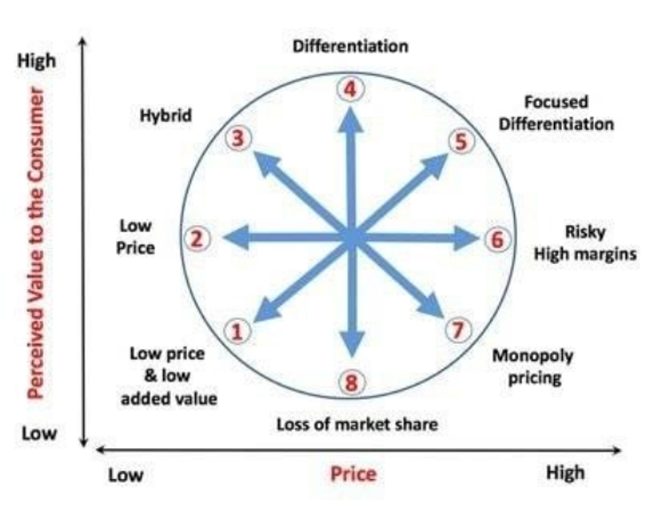

Figure 2
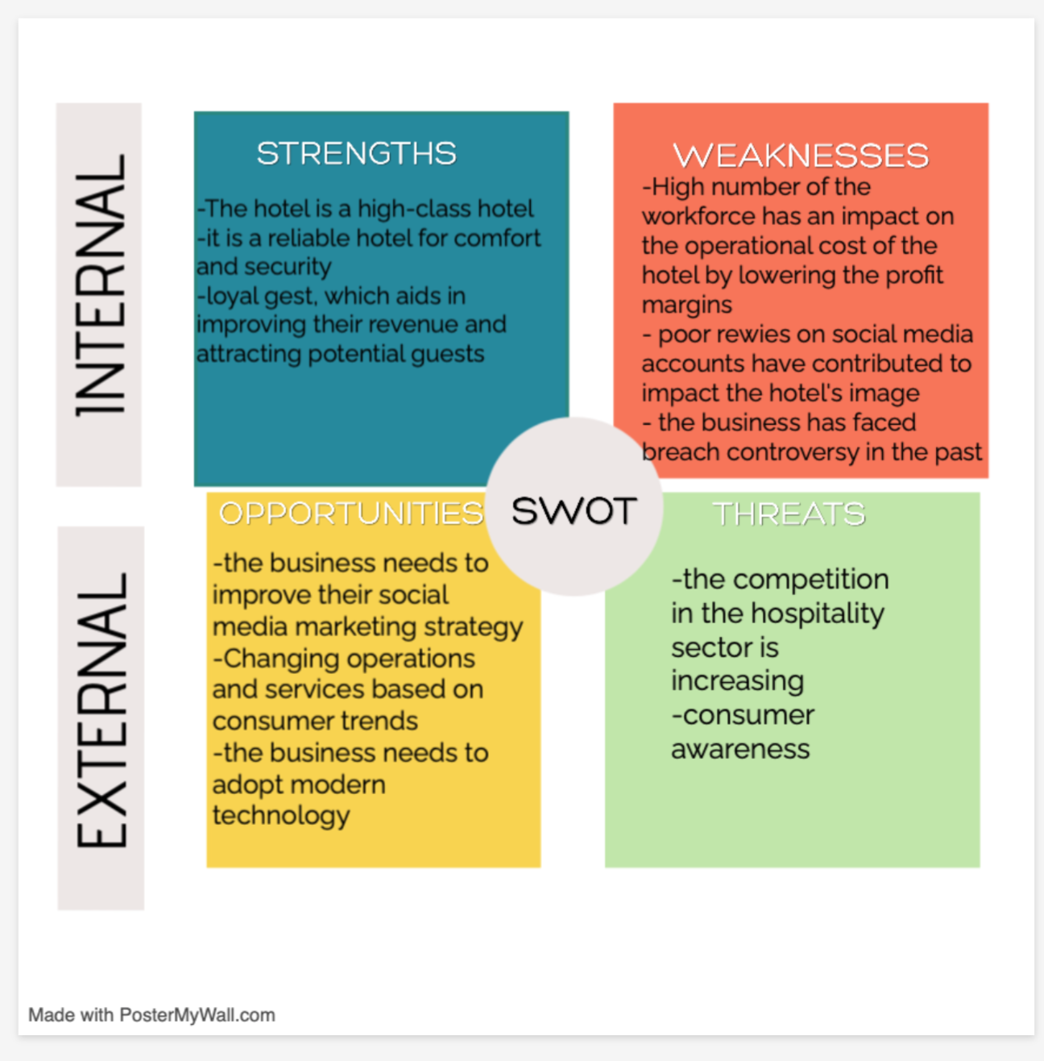

Figure 3

Target Audience
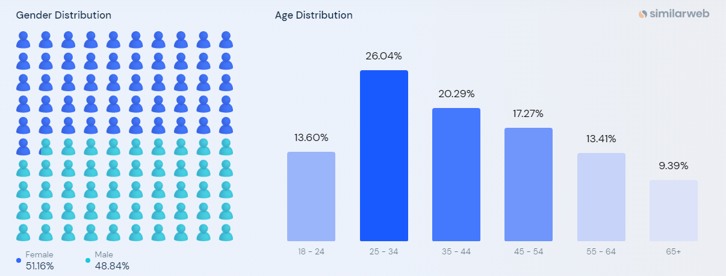

Figure 4
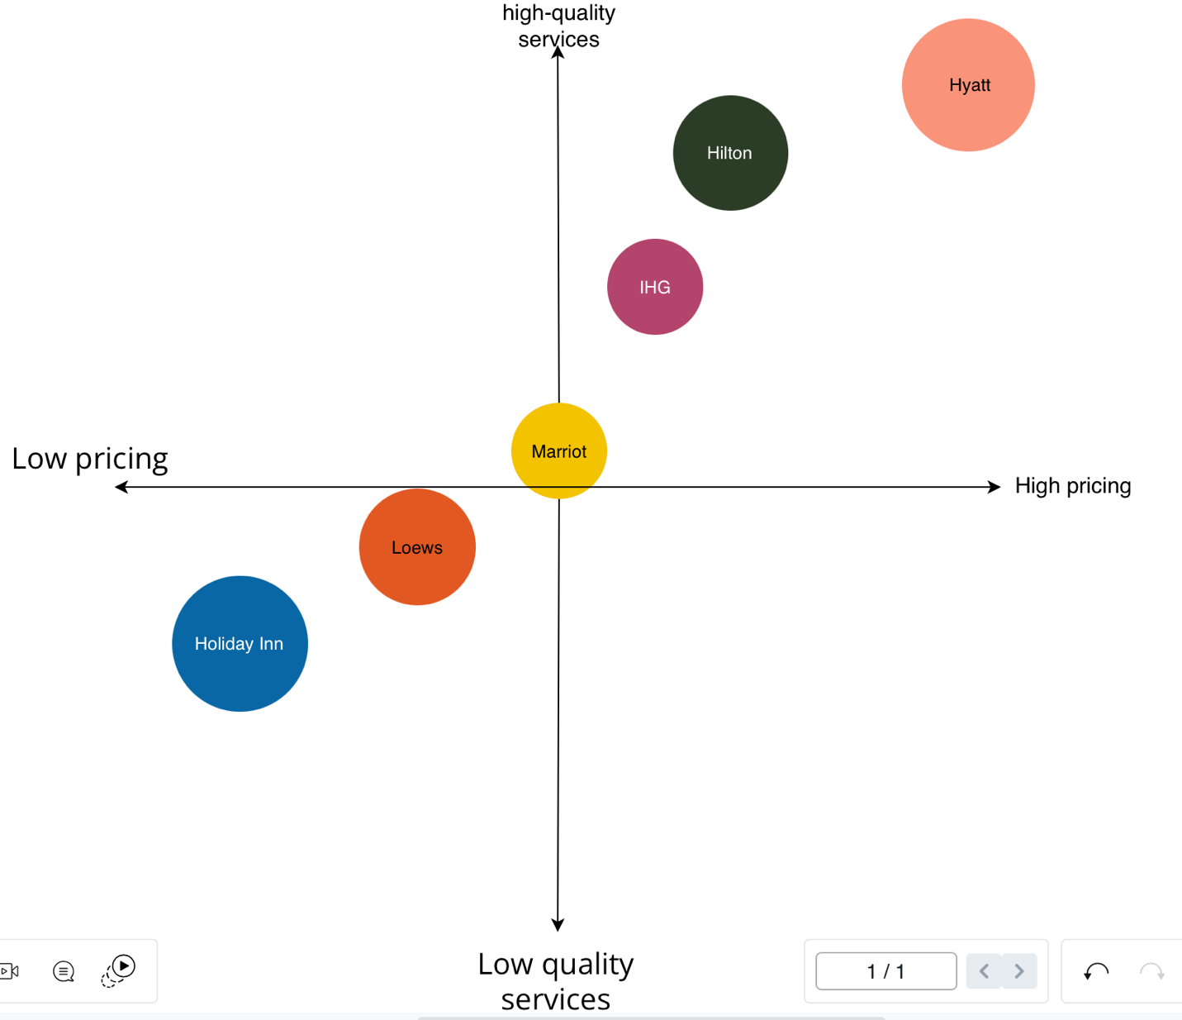

Figure 5
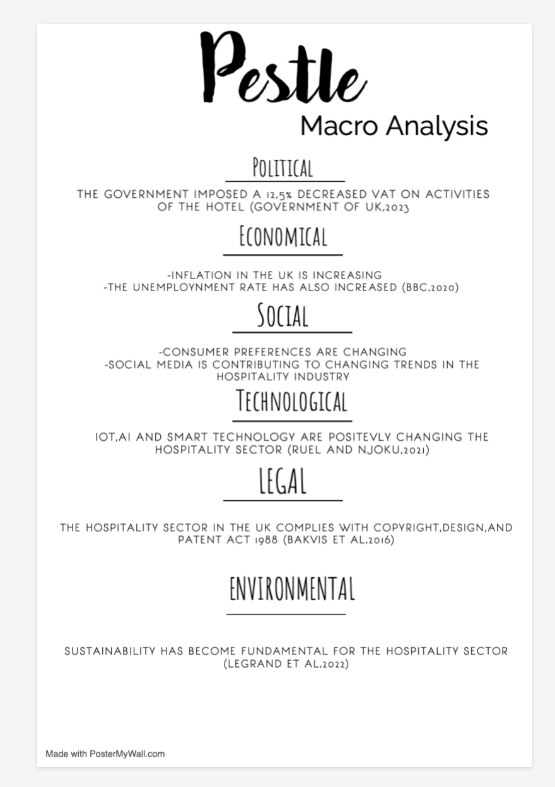

Figure 6
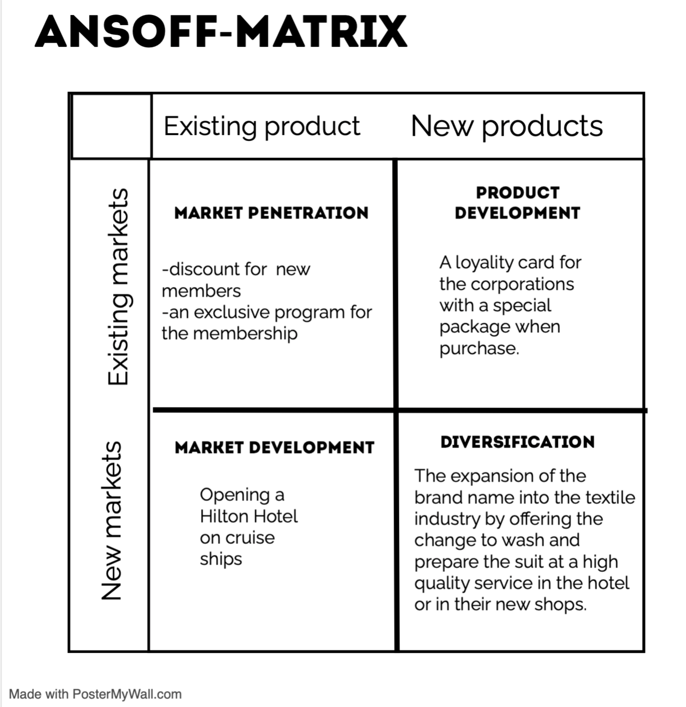

Chart 1

Gantt Chart
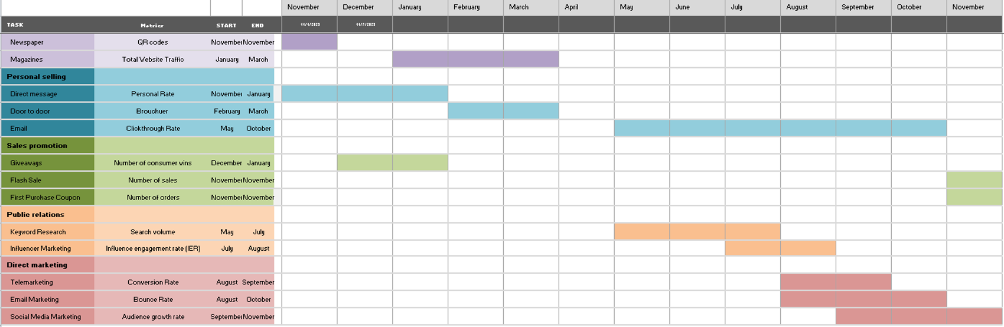

Component B: Presentation


