University of Wales Trinity Saint David



Modelling of Shaped Charges
Advanced Physics for OME (ACDB 5015)

Adam Mayo

2112088

25.10.2023

Lecturer: Prof. Kelvin Donne

Contents
Table of Figures 3
List of Equations 3
List of Tables 3
Abstract 5
1.0 Introduction 6
1.1 Aims 6
1.2 Objectives 6
2.0 Background Information 7
2.1 Shaped Charges Progression 7
2.2 Types of Software 10
2.3 Mesh Overview 11
2.4 Material Models 12
3.0 Methodology 17
3.1 Geometry 17
3.2 Mesh 18
3.3 Simulation parameters 20
4.0 Results & Analysis 22
4.1 2D-simulation 22
4.2 3D-simulation 26
4.3 Recommendations 28
5.0 Conclusion 29
6.0 Reference List 30
7.0 Appendix 34
Appendix A 34

Table of Figures
Figure 1, Illustration of (a) hollow cavity and (b) lined cavity [2]. 7
Figure 2, Variable thickness bell liner [6]. 8
Figure 3, Collapse process of the liner and formation of the jet [4]. 8
Figure 4, illustration of Lagrangian, Eulerian, ALE mesh and particle motion. [21] 12
Figure 5, Shaped charge diagram [2]. 18
Figure 6, Comparison of the shaped charge sketches in 2D and 3D in Abaqus. 18
Figure 7, 3D mesh overview of the full shaped charge and the liner. 19
Figure 8, 2D mesh overview of the full shaped charge and the liner. 20
Figure 9, 2D and 3D Shaped charge Boundary Conditions. 21
Figure 10, Max Principal scaling key. 22
Figure 11, Progression of the 2D shaped charge at a given time interval. 25
Figure 12, Velocity results for the 2D-simulation with the node selection in the right-hand image. 25
Figure 13, 2D-simulation extruded through 180° at 0µs and 24µs. 26
Figure 14, 3D liner results 24µs and an enhanced image of the failure region. 27
Figure 15, Velocity results for the 3D-simulation with the node selection in the right-hand image. 27

List of Equations
Equation 1, Mie-Grüneisen EOS [24]. 12
Equation 2, Johnson-Cook Plastic equation [25]. 13
Equation 3, Johnson-Cook Damage equation [25]. 13
Equation 4, JWL EOS equation [24]. 15

List of Tables
Table 1, Explosive properties [15]. 10
Table 2, Copper material data. 14
Table 3, PE-4 Material data. 15
Table 4, Aluminium Material data. 16

Abstract
This report discusses shaped charge formations and the various methods that are employed to simulate them. Shaped charge geometries were discussed, which led to a design to be chosen for this report. Two simulations were conducted in this report using the chosen shaped charge design (2D axisymmetric model and 3D model). The mathematical material models that are implemented within the simulations were discussed and explored to identify a what was needed to be modelled and to what extent, for an accurate simulation.

The simulations were setup within a finite element analysis software called Abaqus. The sources of the material data for each simulation was gathered using creditable literature or trusted websites. The simulations were found to simulate the formation process of a shaped charge, with the 2D-simulation being less accurate and the 3D-simulation being the most accurate. The 3D-simulaiton can be accredited for being more accurate due to the more complex mathematics it uses, as it is modelling more node interactions taking place. Overall, the report suggested the application of each simulation. However, future simulation work should coincide with experimental trials to confirm or disapprove simulation results to be more confident in their accuracy.

1.0 Introduction
Shaped charge finite element analysis has developed over recent years and made progressions that make it vital when investigating differing geometries and materials. Simulations are employed on shaped charges to explore a wide range of scenarios, whilst providing in-depth insights into interactions and behaviours that may be difficult to study in real-world experiments. Simulation work can then be used in conjunction with experimental work to confirm what is expected to occur. However, simulation work does have its limitations, which are discussed in this report.

The shape charge simulations in this report will be a two-dimensional (2D) and a three-dimensional (3D) study of the same shape charge geometry and will have identical material models associated with them. The data produced by the above simulations will be discussed and compared using academic and trusted sources. These discussions will explain how the 2D and 3D models compare and perform against each other.

1.1 Aims
This report sets out to model one shaped charge design within a finite element analysis software (Abaqus), using two modelling techniques to achieve this. The discrepancies between the two modelling methods will highlight the importance of using the correct modelling approach for experimental simulations, as the two approaches incorporate different mathematical processes.

1.2 Objectives
- Conduct and analyse a 2D Lagrangian finite element analysis of a shaped charge.
- Conduct and analyse a 3D Lagrangian finite element analysis of a shaped charge.
- Explore the benefits and limitations of each of the simulation methods listed above.

2.0 Background Information

2.1 Shaped Charges Progression
Shape charge developments started in 1792 in the mining industry, where it was found that by having a hollow section in the explosive its energy can be focused [1]. This is shown in Figure 1, where the effect is demonstrated, as (a) is an unlined explosive and (b) represents a metal-lined explosive. This addition of the metal liner increased the penetration capabilities of the explosive. This effect is more commonly known as the Munroe effect in the USA, from the well-documented experiments during the year 1888 [2], conducted by Charles Monroe. However, in Europe, it is known as the Vonfoster or Neumann effect [1].

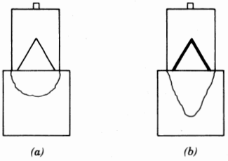
Figure 1, Illustration of (a) hollow cavity and (b) lined cavity [2].

Furthermore, Monroe discovered that by adding a copper conical liner (Figure 1 (b)) in contact with the explosive, the depth of penetration was increased as a result of the creation of a skinny jet of copper [3]. The research of shaped charges was enhanced during the Second World War era, between 1935 and 1950, for military applications [2], such as defeating tank armour [3].

The development of this phenomenon has been made possible by the discovery of blasting caps (Detonators) by Alfred Nobel in 1867 which allowed the high explosive (HE) to detonate and produce the desired effect without the use of confinement.

Modern-shaped charges consist of a liner in contact with an explosive, the liner can be any axisymmetric shape, but conical liners are most common, some other geometries include tulip, trumpet or hemisphere. However, these are less researched and used, as it was found that hemispherical-shaped charges produce shallow craters with large diameters [4] in comparison to conical geometries. The apex angle of the liner dictates the penetration characteristics, with small angles leading to long skinny jets. Therefore, as the apex angle increases the jet becomes shorter and less penetrative [5].

The ideal thickness for the liner has been found experimentally to be 2% of the cone diameter [5]. Additional research has been conducted into variable thickness bell liners (Figure 2), which leads to a greater surface area of the liner. This improved surface area increases the energy absorption of the detonation energy and increases the collapse velocity of the liner. However, this liner geometry falls outside of this report’s aims.
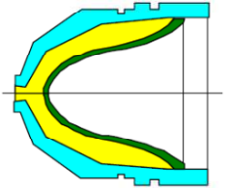
Figure 2, Variable thickness bell liner [6].

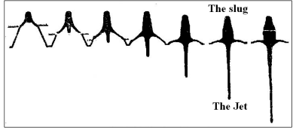
Figure 3, Collapse process of the liner and formation of the jet [4].
The geometry of the shaped charge causes the gaseous products formed from the detonation wave to focus the energy into a considerable localized force [2]. This detonation wave occurs at speeds of ≈ 8kms⁻¹, this generation of gaseous products is superimposed on the liner causing broad hydrodynamic pressures [2] at around 3x10¹⁰Pa [3], allowing the solid liner to have such high energy it can behave hydrodynamically as if it were a liquid [5]. This leads to the liner violently distorting over a short period, at strain rates of 10⁴ - 10⁷ [2], pushing the liner to flow like a jet, travelling at speeds near 10kms⁻¹ [7] at the tip (front) and around 2 kms⁻¹ at the slug [4] (rear). Due to this present velocity gradient, the jet is stretched until it breaks apart into a string of particles [2], which is illustrated in Figure 3. The formation process of a shaped charge should take 50µs - 100µs depending on the geometry and materials used [8] [9].

During shaped charge formation Birkhoff originally stated the following assumptions [10]:
- The magnitude of pressure exerted on the liner by the explosive is so great that the material strength can be neglected, thus the liner will behave hydrodynamically.
- Metal flow is incompressible and non-viscous.
- The pressure on the collapsing liner does not increase the length of any portion of the liner.
- The impulse from the detonation wave acts immediately so that the acceleration of the liner can be neglected.
- Each element of the liner collapses with a constant velocity, which is independent of its original position.

Following these assumptions a shaped charge will have a velocity gradient [11], as the tip is travelling much faster than the tail, causing the jet to stretch and break up in the process [12]. Birkhoff theory also predicts steady-state jet and slug velocities, but further theories replace this as they include more variables like Visco-Plastic behaviour and strain rate dependence of the liner [2].

The Per theory assumes a variable collapse velocity for the conical liner, improving the steady-state results [2]. For this theory, the collapse velocity will decrease from the apex to the base of the liner [2]. The Per model was later modified by Carleone in 1987 to allow variations from a conical liner which excludes hemispherical liners [2]. However, this report will not utilise these techniques due to time constraints but simply outline the theory surrounding shaped charge formations.

In conjunction with formation theories advanced hydrocodes are written to model the behaviour of the liner acting as a fluid. Many organisations develop their own codes as they have differing applications in military or commercial shaped charges. However, some examples of common codes would be Cheetah [13] or EXPLO5 [14], which predict the intricacies of fluid dynamics and shockwave interactions associated with a detonation event. These codes are generally proprietary information of each organisation.

Generally, more energetic explosives produce faster jets and greater penetrations are witnessed [2]. The energy obtained from the explosive is related to its Gurney velocity [4], which relates to the energy released from the explosive and how it performs work on the liner. Gurney velocity increases with detonation velocity or detonation pressure of the explosive, resulting in a faster jet. It is expected that HMX-shaped charges would perform the best as a result of their high Gurney velocity [15], as shown in Table 1.

Table 1, Explosive properties [15].
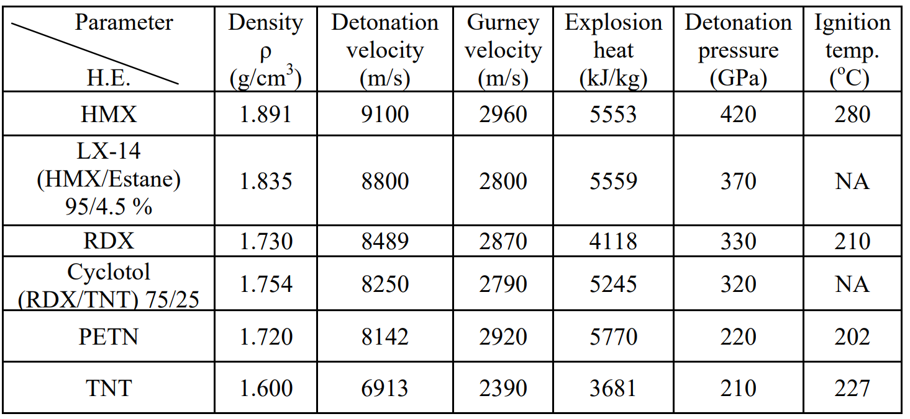

2.2 Types of Software
For the modelling of the complex physics needed for shaped charge analysis, two main approaches are taken which are finite element analysis (FEA) [16] and computational fluid dynamics (CFD). These two methods replace analytical solutions for complicated geometries and material properties.

FEA works by allowing an element discretization, which reduces the problem to elements (Nodes). This method will be used by the report to model the shaped charge problem. However, there are wide range of software available, that all have their benefits and limitations, but Abaqus will be used in this report due to the resources available. Abaqus is good at modelling shaped charges due to its explicit dynamic analysis, which performs a large number of small-time steps efficiently [17]. This analysis is good for large models with short dynamic responses, and sporadic events that involve large deformations.

Additional examples of the software available are below:
- LS-DYNA [18]
- ANSYS Autodyn-2D [19]
- ABAQUS [18]

2.3 Mesh Overview
For any given simulation, the spatial discretization can be either represented by a Eulerian or Lagrangian mesh. The Lagrangian mesh is a gird within the material, where each node is associated with a material particle. This mesh distorts and aids the review of deformation occurring [20], but it cannot easily follow large deformations without the incorporation of adaptive meshing techniques.

Whereas, in the Eulerian scheme the grid is fixed in space and allows mass to pass through it. For Eulerian meshes large deformations can be processed more easily than Lagrangian, but they do suffer from generalised resolution of the material flow interface definitions [21].
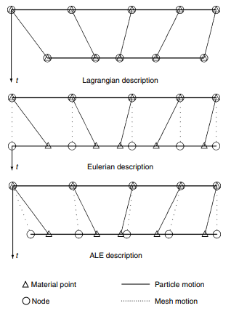
Figure 4, illustration of Lagrangian, Eulerian, ALE mesh and particle motion. [21]
Both the above mesh types offer unique advantages and disadvantages, and the industry tends to combine the two into a technique called Arbitrary Lagrangian-Eulerian (ALE) description [21]. Figure 4 demonstrates how the ALE gives a continuous rezoning ability, which allows greater distortions to be calculated than just the pure Lagrangian mesh, at a better resolution than a pure Eluerian mesh.

2.4 Material Models
For the simulations in this report, the material models were selected to accurately model each part of the shaped charge. The most important aspects to model were the liner and high explosive (HE).

For the liner the Mie–Grüneisen (Us-Up) equation of state (EOS) was used to model thermodynamic behaviour, such as shockwaves within compressed materials [22]. This EOS assumes the pressure is non-linearly related to the density but linear energy relative to the Hugoniot reference curve [23], as shown by Equation 1.
Equation 1, Mie-Grüneisen EOS [24].
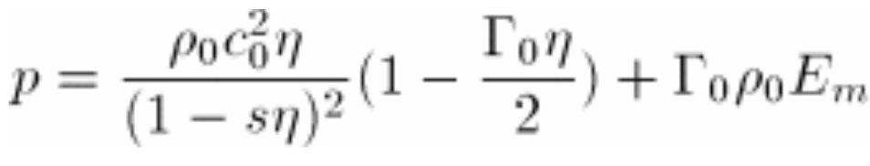
Where is the equivalent to the elastic bulk modulus, ₀ is the Grüneisen ratio, and & s, define the linear relationship between the linear shock velocity, and the particle velocity

This will enable the simulation to describe the hydrodynamic nature of the shaped charge jet. The EOS relates to the temperature, pressure, volume and specific heat of a given material. Which enables materials to be described as gases, fluids and solids.

The use of Johnson-Cook plastic and damage models was utilised. The Johnson-Cook plastic model is suitable for high-strain rate deformation of metals in dynamic simulations [25] and is represented by Equation 2. Whereas the Johnson-Cook Damage model will allow the progressive degradation of the material and the removal of damaged elements from the mesh [25]. This is shown by Equation 3.

Equation 2, Johnson-Cook Plastic equation [25].
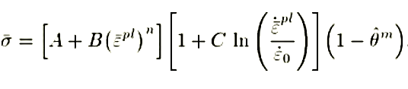
Equation 3, Johnson-Cook Damage equation [25].
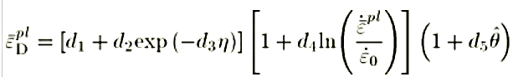
Where A, B, C, n and m are the Johnson-Cook material behaviour coefficients, is the equivalent plastic strain rate, is the yield stress at non-zero strain rate, is the non-dimensional temperature, is the strain at failure, is the dimensionless pressure- deviatoric stress ratio, where p is the pressure stress and q is the mises stress, d₁-d₅ are the failure parameters measured at the transition temperature.

This report will use copper as the liner material, as this is the most researched liner material. Copper is ideal as it is a dense material that flows easily into a jet due to ductile behaviour [5]. The literature surrounding copper liners will help identify if the model is behaving as expected [2]. The material data used for the copper within this report is shown in Table 2.

Table 2, Copper material data.
Parameter |  | Copper
Johnson-Cook Damage [26] | d1 | 0.54
Johnson-Cook Damage [26] | d2 | 4.39
Johnson-Cook Damage [26] | d3 | 3.03
Johnson-Cook Damage [26] | d4 | 0.015
Johnson-Cook Damage [26] | d5 | 1.12
Johnson-Cook Damage [26] | Melting Temperature (K) | 1356
Johnson-Cook Damage [26] | Transition Temperature (K) | 293
Johnson-Cook Damage [26] | Reference Strain Rate | 1
Johnson-Cook Damage [26] | Fracture Energy (J/m²) | 1300000000
Density [27] | Mass Density (kg/m³) | 8935
Elastic Shear [28] | Shear Modulus (GPa) | 56
EOS Us-Up [29] | c0 (ms⁻¹) | 3940
EOS Us-Up [29] | s | 1.489
EOS Us-Up [29] | Gamma0 | 2.02
Plastic Johnson-Cook [30] | A (MPa) | 90
Plastic Johnson-Cook [30] | B (MPa) | 292
Plastic Johnson-Cook [30] | n | 0.31
Plastic Johnson-Cook [30] | m | 1.09
Plastic Johnson-Cook [30] | Melting Temperature (K) | 1356.15
Plastic Johnson-Cook [30] | Transition Temperature (K) | 293
Plastic Johnson-Cook [30] | C | 0.025
Plastic Johnson-Cook [30] | Epsilon dot zero | 1

The EOS for the HE relates the pressure, density and temperature of the explosive products [31] and the Jones-Wilkins-Lee (JWL) EOS is most commonly used within the industry [22]. Initiation time is determined by the geometric progression of the detonation wave speed within the HE, and not from shock within the HE [24]. However, to better model this, a definition of the ignition and growth equation of state could be used which would better model the propagation of the detonation wave within the explosive and the associated shock to the unreacted HE. This is because the HE is being modelled as a mixture of a solid and the gaseous reacted products [24].
Equation 4, JWL EOS equation [24].
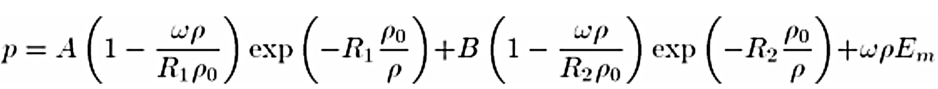
Where A, B, R₁, R₂ and ω are user-defined material constants, p₀ is the density of the explosive, p is the density of the detonation products and E_{m} is the initial energy per unit mass.

Hydrocodes can be used to calculate the JWL EOS from the isentrope created at the Chapman-Jouguet (CJ) point. However, the heating and re-shock behaviour over a wide thermodynamic range requires considerable knowledge of the material properties that might not be widely available [32], so this report does not implement the use of hydrocodes.

The explosive for this report should have a fast velocity of detonation of ≈ 8 km/s. The velocity of detonation needs to be fast for good shape charge formation as previously discussed in 2.1 Shaped Charges Progression. However, HMX was not used, instead, PE-4 was chosen due to availability of data. PE-4 is an RDX-based plastic explosive that produces a velocity of detonation of ≈ 8 km/s at a density of 1.59 mg/m³, which is suitable for this report. The material data used for the PE-4 within this report is shown in Table 3.

Table 3, PE-4 Material data.
Parameter |  | PE-4
Density [33] | Mass Density (kg/m³) | 1600
EOS JWL [34] | Detonation Wave Speed (m/s) | 7550
EOS JWL [34] | A (GPa) | 1800
EOS JWL [34] | B (GPa) | 10.153
EOS JWL [34] | omega | 0.2
EOS JWL [34] | R1 | 6.271
EOS JWL [34] | R2 | 1.05
EOS JWL [34] | Detonation Energy Density (J/m³) | 6596
EOS JWL [34] | Pre-deton Bulk Modulus | 0
EOS JWL [34] | X (m) | 0
EOS JWL [34] | Y (m) | 0.18
EOS JWL [34] | Z (m) | 0
EOS JWL [34] | Detonation Delay Time (seconds) | 0

For the case, a simple damage evolution model was used to allow element deletion, to ensure the simulations ran smoothly, whilst also providing a realistic interaction of the explosive. Additionally, this would contain the explosives at a given density and a degree of confinement [4], which is an important feature to simulate. The case was made from aluminium which is used in many shaped charge designs [35], the material data for this is shown in Table 4.

Table 4, Aluminium Material data.
Parameter |  | Aluminium
Density [36] | Mass Density | 2698.9
Elastic – isotropic [36] | Youngs Modulus (MPa) | 68
Elastic – isotropic [36] | Poisson’s Ratio | 0.36

3.0 Methodology
This report will simulate a shaped charge design using 2D and 3D methods within the Abaqus simulation software, the design has stemmed from previously discussed literature. Although using a hemispherical was considered, less work surrounds them as they produce shallow caters with large diameters [4] in comparison to conical designs with greater penetrative abilities.

During the iterative process of the simulations in this report, a lot of simulations were set up using various geometry and mesh assignments. Often the biggest downfall of each simulation was the mesh distorting too early, which required several attempts to get the right size mesh that would achieve the best run time of the simulation. The attempts of each simulation were around fifteen simulations to find the best size mesh.

3.1 Geometry
The shaped charges are most commonly a conical shape, with an apex angle of 42° [2]. As a result of this, the design shown in Figure 5 was used to base this report's geometry of the shaped charge. Other geometries were considered but it was found in 2.1 Shaped Charges Progression that a conical design would have the best jet formation for this simulation.
This geometry was then created within the Abaqus software using drawing tools such as geometry constraints to ensure dimensions were the same as represented in Figure 6 and Figure 5. In both designs, the liner was 1.905mm thick so the liner was 2% of the cone diameter (81.3mm).

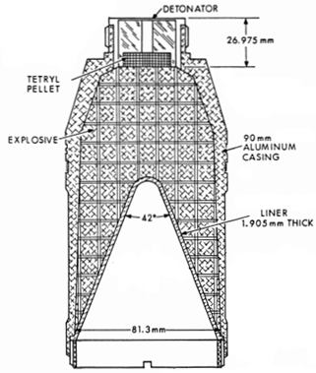
Figure 5, Shaped charge diagram [2].
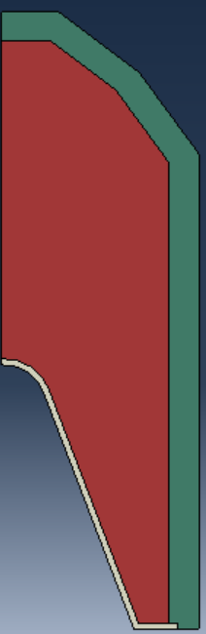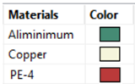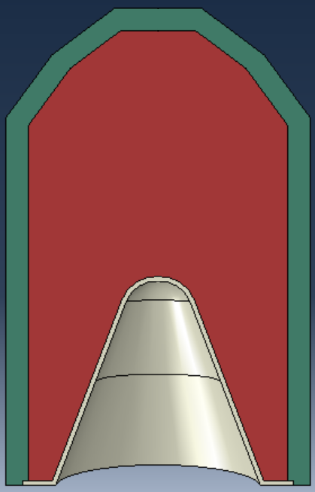
Figure 6, Comparison of the shaped charge sketches in 2D and 3D in Abaqus.

3.2 Mesh
The mesh of these two simulations went through several iterations of fine and course mesh assignments. But a limiting factor was the number of nodes allowed by the software as this was limited to 250,000 which set a maximum limit to define how fine the mesh could be. However, when a mesh was used that was close to this limit, it struggled with often shorter simulation times as more mathematical errors would accumulate and cause excessive distortion of some elements, which is shown in Appendix A. To prioritise areas of interest the mesh was denser in the liner and interaction zone between HE and the liner, this was achieved by using tools to allow a variable mesh to be assigned.

Furthermore, this report utilises a Lagrangian system as this was the best option due to the time constraints of this report (Figure 7 and Figure 8). The geometry of the mesh was also considered for compromises in computational efficiency or solution accuracy. Therefore, a linear tetrahedral mesh was used instead of a quadratic tetrahedral as it has fewer nodes, which reduces the number of calculations needed to be performed. The linear mesh has four nodes on each vertex of the tetrahedron and a quadratic has ten nodes, as there are additional nodes at the midpoints of the edges.

By having fewer nodes, the numerical errors that the simulations encountered were decreased, due to there being fewer calculations and less carryover of any numerical errors. This can lead to a greater simulation time. However additional improvements could incorporate the ALE techniques described in 2.3 Mesh Overview if more time was available for this report.

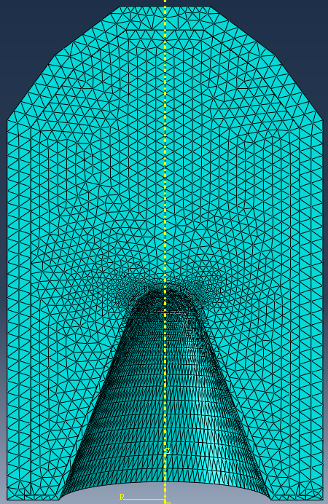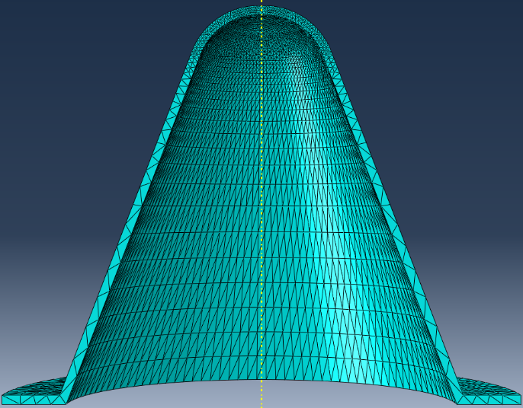
Figure 7, 3D mesh overview of the full shaped charge and the liner.
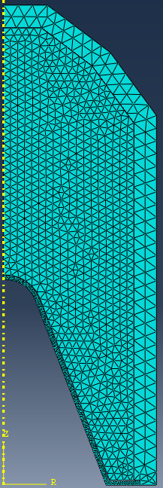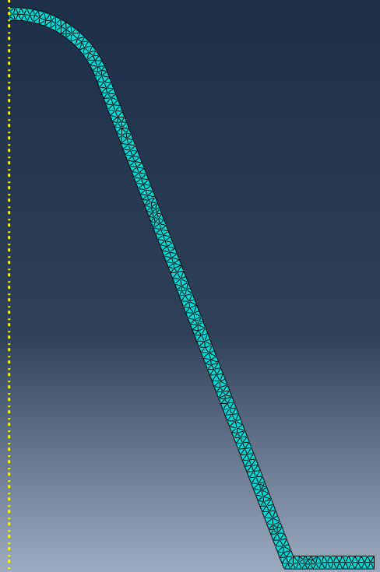
Figure 8, 2D mesh overview of the full shaped charge and the liner.

3.3 Simulation parameters
The simulations will use the explicit dynamic analysis within Abaqus, but during the first iterations of the simulations, there were relatively large time jumps between each step of the simulation as the total simulation time was only 0.0009 seconds long. To combat this, the frequency interval of the steps was changed from 1 to a range of values (10, 100, 1000 and 10,000) and it was found that a frequency of 1000 gave a good time resolution between each step without exhausting computational resources.

Boundary conditions within the Abaqus software allowed the 2D-simulation to act as a segment of the shaped charge. Only acting in the X and Y plane and not exceeding the centreline as this would be interacting with other parts of the shape charge which were not simulated. This is illustrated in Figure 9.

The 3D-simulation did not use the same boundary conditions as the 2D. However, as it was important to see the formation process only 180° was simulated allowing a more in-depth analysis of the simulation without going into cross-section views that Abaqus does offer. This also improves the computational speed of the simulation and the mesh density. This boundary condition stops any elements from crossing the Z-axis in one direction, as shown in Figure 9. This still allows distortion in all three planes.

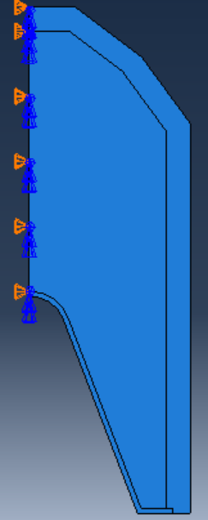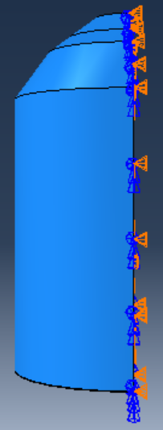
Figure 9, 2D and 3D Shaped charge Boundary Conditions.

4.0 Results & Analysis
For the analysis of the simulations Max Principal stress was analysed as Von-Mises is not suitable when the liner is dealing with compression. The same scaling will be applied to all images relating to the shaped charge, with the more compressive forces being shown in blue as in Figure 10.

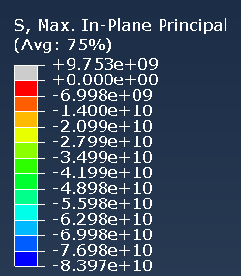
Figure 10, Max Principal scaling key.

4.1 2D-simulation
The 2D-simulation provided detail covering the formation of the shaped charge fully over a 90µs period, which is the supported time duration by the findings in 2.1 Shaped Charges Progression.

At 15µs the explosive is starting to first interact with the liner which is to be expected, and confirms the explosive was modelled to a degree of accuracy by the simulation. By 20µs the liner is starting to witness the enormous compressive force of the detonation pressure of the explosive. The tip is being stretched as a result, and most likely experiencing the largest compressive force, however this is not easily identifiable by the image below as it is not zoomed in close enough to confirm this. However, elements in the formation process are displaying compressive forces. The overall simulation is behaving in agreeance with the literature as it is with the formation of a slug and jet which are moving at differing velocities, as shown in Figure 11.

The jet velocities were analysed in Figure 12, which represents a general overview of the jet velocity. It can be inferred that this shaped charge has a velocity of approximately 4km/s. with some erroneous nodes traveling much faster but may not be accurate to confirm for definite. On the other hand, there was likely to be a velocity gradient, but the node selection did not analyse this fully to confirm this.

However, Abaqus allowed the 2D model to be extruded through 180°, to give the impression of a 3D visual effect as it can display contour plots of the 2D elements, this is presented in Figure 13. However, it is simply duplicating the results around and not incorporating additional interactions within the liner that a 3D model would have. These interactions would require additional maths that the 2D model does not consider. A direct comparison of the 2D extruded simulation to the 3D-simulation shows the 2D-simulation is forming quicker, but it is most likely that the 3D-simulation is displaying a more accurate formation process, due to factors stated in 4.2 3D-simulation.

In general, the 2D-simulation did model the hydro-dynamic state of the liner under the large pressures created by the explosive filling. Which led to a large stretching of the nodes in the simulation, from the large pressures modelled by the explosive. Lastly, this method of shaped charge analysis allows a rudimentary method of confirming possible variations of a shaped charge design, this is quick and requires relatively low resources to conduct.

t₂ = 20µs
t₁ = 15µs

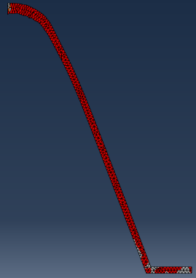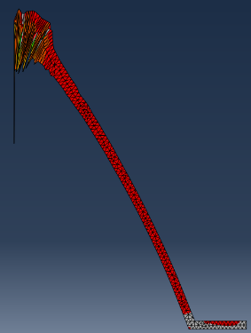
t₃ = 24µs
t₄ = 30µs

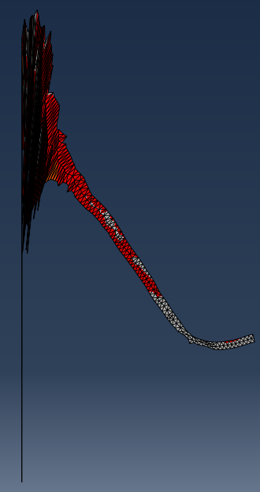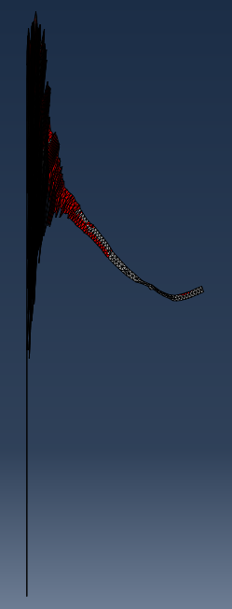

t₁₀ = 90µs
t₉ = 80µs
t₈ = 70µs
t₇ = 60µs
t₆ = 50µs
t₅ = 40µs
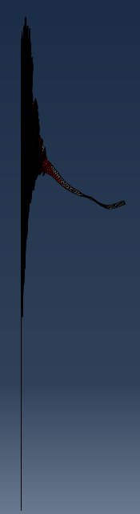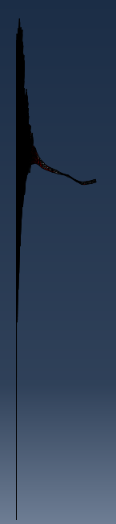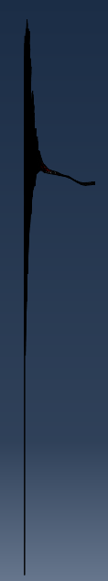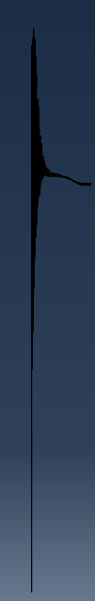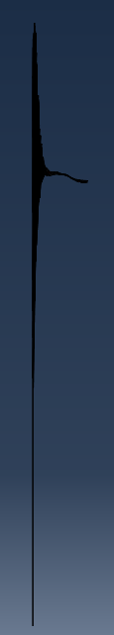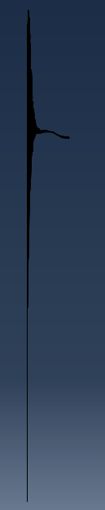
Figure 11, Progression of the 2D shaped charge at a given time interval.

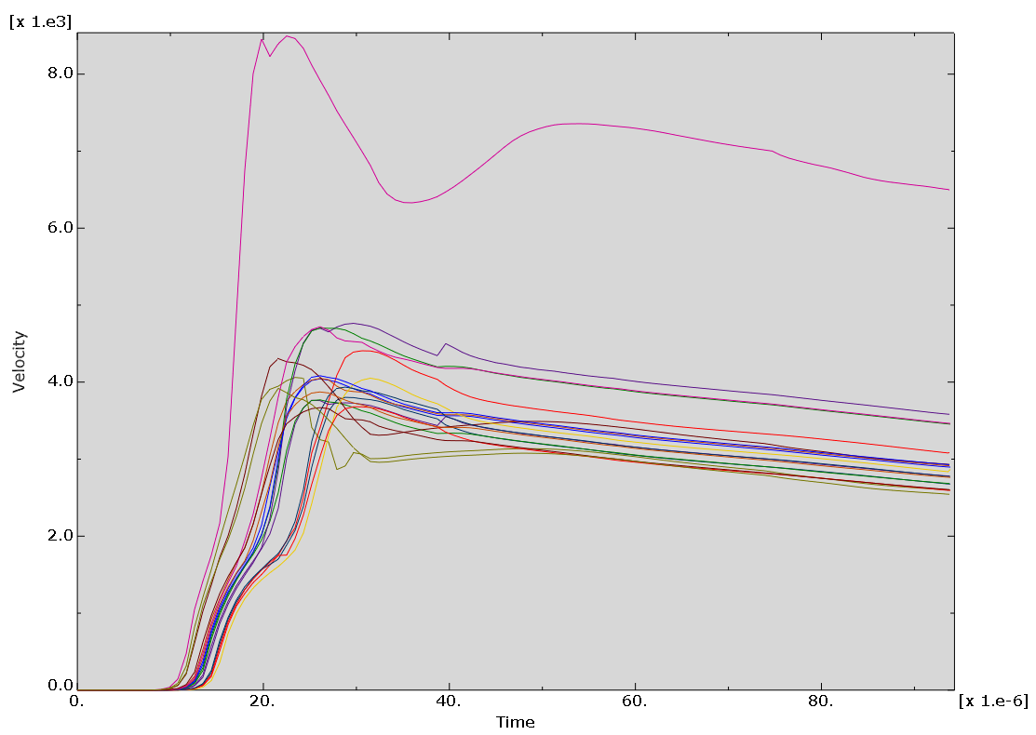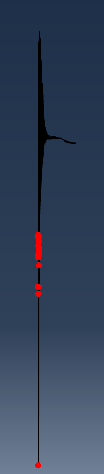
Figure 12, Velocity results for the 2D-simulation with the node selection in the right-hand image.

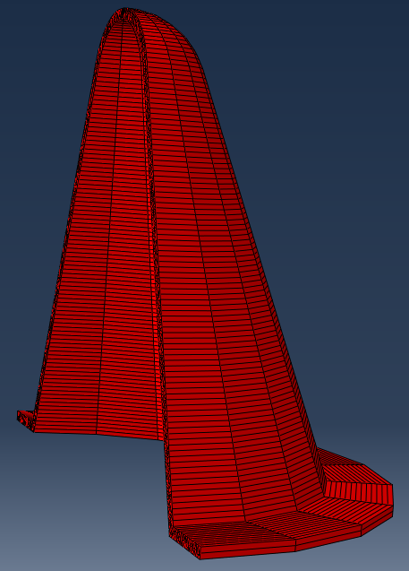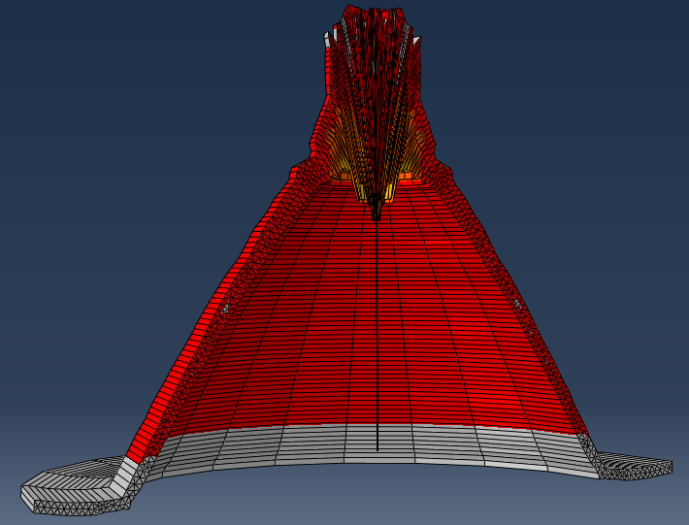
Figure 13, 2D-simulation extruded through 180° at 0µs and 24µs.

4.2 3D-simulation
The 3D-simulation has a shorter jet, compared to the same time increment in the 2D-simulation, shown by Figure 14, which implies the jet is travelling slower in the 3D-simulation. This is as more nodes are incorporated in the maths which now is in three planes, causing more complex interactions which use up more energy which is not converted to a velocity in the liner fully. This may be a more accurate representation of what should occur. This slower velocity is also confirmed by the velocity trace shown in Figure 15, it is around 3.5km/s on average. Additionally, in this velocity trace, there is evidence of a velocity gradient present in the shaped charge which is supported by previous research.

The 3D-simulation in total only ran for 24µs before some numerical errors occurred causing the excessive stretching of elements which is shown in Figure 14. The possible reason for the numerical errors could stem from the more complex interactions between nodes in a 3D-simulation. The point of failure is shown in Figure 14 as well, and this displays high compressive stresses, that lead to the simulation’s failure. This indicates that the simulation is correctly modelling the high pressure generated by the explosive on the liner, causing it to act in a hydrodynamic state.

The liner edge is stretching in this simulation before any detonation event has interacted with it because of a weld assignment, which was given to this point which is pinning it to the explosive. This was needed as issues occurred with the liner becoming disconnected from the explosive upon detonation.

However, the 3D-simulation was in agreeance with research found in 2.0 Background Information, which confirms that the shaped charge is being modelled to a degree of accuracy compared to the 2D-simulation. It achieved this by modelling the interactions of the shaped charge liner through 180°, which led to the accuracy of results being produced. Therefore, it is valid to assume the 3D-simulation is a better representation of the shaped charge formation. Therefore, it is recommended that the 3D-simulation should be used for more in-depth analysis of shaped charge geometries over 2D-simulations.
t₁ = 24µs

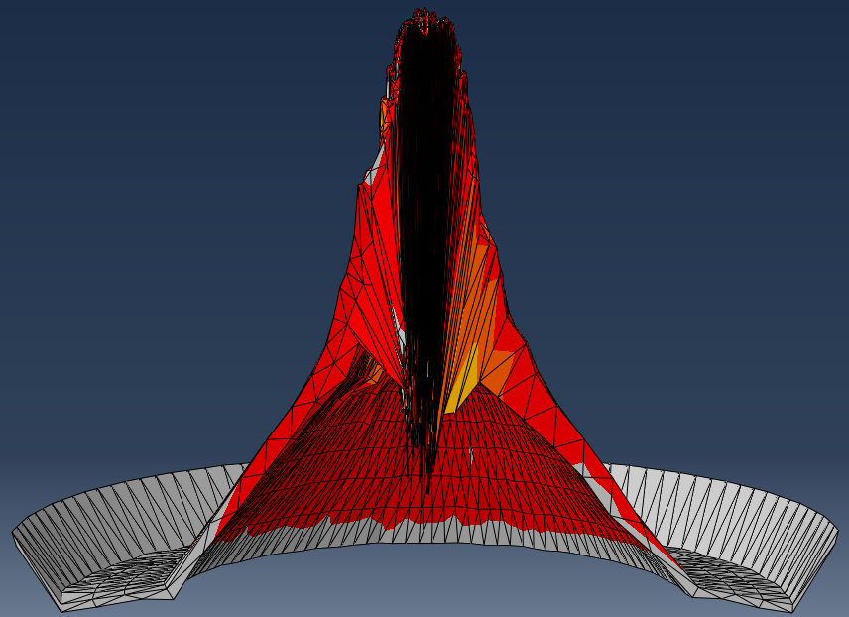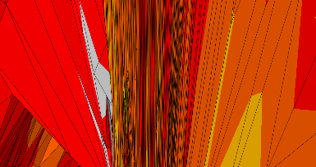
Figure 14, 3D liner results 24µs and an enhanced image of the failure region.

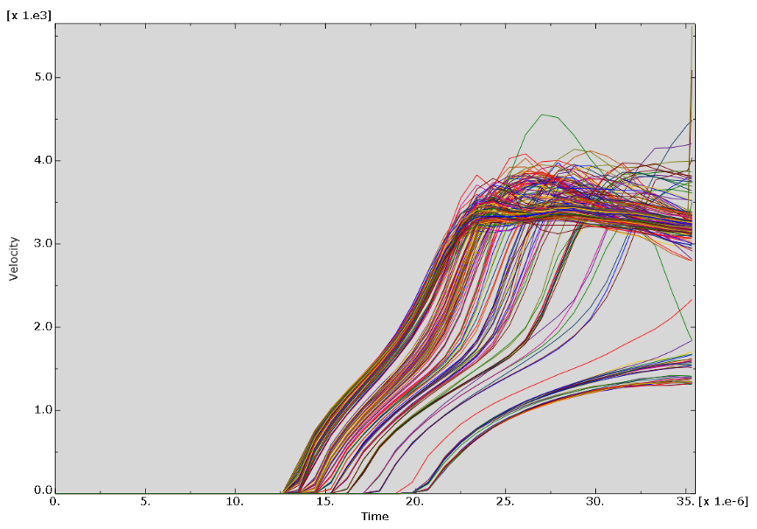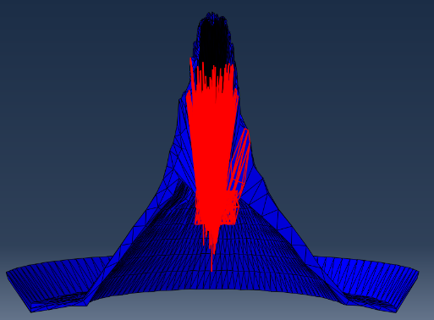
Figure 15, Velocity results for the 3D-simulation with the node selection in the right-hand image.

4.3 Recommendations
Despite these promising results further research is needed to better understand if the simulations are representative of an experimental shaped charge with identical geometry. This trial would ideally provide X-rays at sensible steps during the formation process of the shaped charge, which can be directly compared to the simulations in this report.

Additionally, the incorporation of more efficient material models would not only improve the efficiency of the simulation but generate more representative results. This could be achieved using hydrocodes or more material parameters being modelled.

In order to combat the mesh distortions seen in 4.1 2D-simulation an improved ALE mesh could be used which would better handle large distortions seen in the mesh. As well as, improving the mesh density in key areas of interest, such as the apex of the liner. This would increase the accuracy but increase the computational cost of the simulation.

Future studies may also investigate the compressive forces that the liner is subjected by the explosive in more detail. This review of the pressures seen here would help validate the simulations if the values were nominal or supported by other literature.

5.0 Conclusion
This report set out to model one shaped charge design with a finite element analysis software. This was achieved by utilizing two modelling techniques. The research shown within this report has discussed how shaped charges are formed and shown the various methods used to simulate them. As a result, a 2D Lagrangian finite element analysis was simulated, which did achieve sensible results that coincided with the discussed literature surrounding the formation of the shaped charge.

However, when the 3D Lagrangian finite element analysis was conducted, a greater level of detail was added due to the additional interactions taking place and being modelled. This resulted in a slightly lower velocity seen in the 3D-simultaion velocity. However, the two methods were compared, and it can be concluded that 2D-simulations should be used for rough shaped charge design validation and 3D-simulation should be used for in-depth analysis of a given shaped charge design.

In order to validate to what extend the modelling of the simulations was correct, an experimental trial is recommended to confirm or disprove the simulation results.

6.0 Reference List

[1] | W. P. Walters, “The Shaped Charge Concept Part II. The Histroy of Shaped Charges,” U.S. Army Laboratory Command, MaryLand, 1990.
[2] | W. Walters and J. Zukas, Fundamentals Of Shaped Charges, John Wiley & Sons, Inc., 1989, pp. 11 - 14, 72 - 78.
[3] | C. Poole, “Penetration of a Shaped Charge,” 2005.
[4] | t. Abd and E. Elshenawy, “Criteria of Desgin Improvement of Shaped Charges Used as Oil Well Perforators,” The Faculty of Engineering and Physical Sciences, 2012.
[5] | P. R. Courtney-Green, Ammunition For The Land Battle, vol. 4, Shrivenham, UK: Brassey's, 1991, pp. 122-130.
[6] | D. Davison and D. Pratt, “A Hydrocode-Designed Well Perforator with Excepitonal Performance,” 17th International Symposium on Ballistics, 1998.
[7] | A. J. Ruys, “Chapter 8 - Glass-Bonded SiC (GBSC),” in Silicon Carbide Ceramics, Sydney, Australia, 2023, pp. P 435-489.
[8] | D. Pyka, K. Jamroziak, M. Bocian and e. a. Kurzawa, “Numerical and Experimental Studies of the ŁK Type Shaped Charge,” Applied Sciences 10, 2020.
[9] | M. J. Szuck, “Simulation of Micro-Shaped Charge Experiment and Analysis of Shock States for a Hyper-Elastic Solid,” 2011.
[10] | D. A. Jones, “A Review of One Dimensional Shaped Charge Theory Part 1 - Jet Formation,” 1984.
[11] | M. L. Lampson, “The influence of convergence velcocity gradients on the formation of shaped-charge jets,” US Army ballistic research laboratory, 1987.
[12] | P. C. Chou, J. Carleone, C. A. Tanzio and R. D. Cicarelli, “Shaped Charge Jet Breakup Studies Using Radiograph Measurement and Surface Instability Calculations,” Dyna East Coportation, 1965.
[13] | L. E. Fried, W. M. Howards and P. C. Souers, “Kinetic modeling of non-ideal explosives with CHEETAH,” 1998.
[14] | M. Suceska, “Evaluation of Detonation Energy from EXPLO5 Computer Code Results,” 1999.
[15] | M. H. Keshavarz and S. Abolfazl, “The simplest method for calculating energy output and Gurney velocity of explosives,” Journal of Hazardous materials, pp. 1-5, 2005.
[16] | V. JAGOTA, A. P. S. SETHI and K. KUMAR, “Finite Element Method: An Overview,” Walalak Journal, 2013.
[17] | Dassault Systèmes, “ABAQUS Analysis User's Manual - 6.3.3 Explicit dynamic analysis,” [Online]. Available: https://classes.engineering.wustl.edu/2009/spring/mase5513/abaqus/docs/v6.6/books/usb/default.htm?startat=pt03ch06s03at07.html. [Accessed 28 12 2023].
[18] | G.-S. Yeom, “Numerical Simulation of Conical and Linear-Shaped Charges Using an Eulerian Elasto-Plastic Multi-Material Multi-Phase Flow Model with Detonation,” 2022.
[19] | E. E. El-Sayed, T. A. Elshenawy, M. A. Shaker and A. M. Riad, “Influence of different shaped charge parameters on jet penetration into metallic target”.
[20] | B. Zhuming, “Applications - Multiphysics Systems,” in Finite Element Analysis Applications, Academic Press, 2018, pp. 407 - 453.
[21] | J. Donea, A. Huerta, -P. J and A. Rodriguez-Ferran, “Arbitary Lagrangian - Eluerian Mehtods,” in The Encylopedia of Computational Mechanics, vol. 1, Wiley, 2004, pp. 413-437.
[22] | R. Saurel, A. Chiapolino and F. Fraysse, “Relaxation Method For Mie–Grüneisen Type Equations Of State,” Physics of Fluids, 13 November 2023.
[23] | A. C. Robinson, “The Mie-Grüneisen Power Equation of State,” Sandia National Laboratories, California, 2019.
[24] | Dassault Systèmes, “Abaqus Analysis User's Manual - 24.2.1 Equation of State,” [Online]. Available: http://130.149.89.49:2080/v6.11/books/usb/default.htm?startat=pt05ch24s02abm49.html. [Accessed 22 12 2023].
[25] | Dassault Systèmes, “ABAQUS Analysis User's Manual - 18.2.7 Johnson-Cook plasticity,” [Online]. Available: https://classes.engineering.wustl.edu/2009/spring/mase5513/abaqus/docs/v6.6/books/usb/default.htm?startat=pt05ch18s02abm21.html. [Accessed 02 01 2024].
[26] | H. Liu, J. Zhang, X. Xu, Y. Qi, Z. Liu and W. Zhao, “Effects of Dislocation Density Evolution on Mechanical Behavior of OFHC Copper during High-Speed Machining,” 24 July 2019.
[27] | AZO Materials, “An Introduction to Copper”.
[28] | MatWeb, “Copper, Cu; Annealed,” [Online]. Available: https://matweb.com/search/DataSheet.aspx?MatGUID=9aebe83845c04c1db5126fada6f76f7e&ckck=1. [Accessed 08 12 2023].
[29] | M. K. Mohd Nor, C. S. Ho, N. Ma'at and M. Karmarulzaman, “Modelling Shock Waves In Composite Materials Using Genralised Orthotropic Pressure,” Continnuum Mech, 2019.
[30] | D. M. Lordache and e. al, “Determination of Johnson-Cook material constants for Copper using traction tests and inverse identification,” Materials Science and Engineering, 2021.
[31] | J. A. Zukas, “Introduction to Energetic Materials,” in High Velocity Impact Dynamics, Wiley-Interscience, 1990, pp. 715-729.
[32] | L. Neron, R. Saurel, A. Chiapolino and F. Fraysse, “Relaxation method for Mie–Grüneisen type equations of state,” Physics of fluids, 2023.
[33] | M. Chick and L. Learmonth, “Determination of Shock Initation and Detonation Charateristics of PE4 in Proof Test Geometries,” 1985.
[34] | H. Bornstein, V. Kuznetsov, J.-P. Lu, S. Stojko and J. Freundt, “Characterisation and validation of the JWL equation of state parameters for PE4,” International Journal of Impact Engineering, 2022.
[35] | N. T. Sy, S. Beer, P. Konecny and V. V. Bien, “Simulation Study of Shaped Charge Collapse Process and Optimal Standoff Determination,” ICMT, may 2019.
[36] | MatWeb, “Aluminum, Al,” [Online]. Available: https://www.matweb.com/search/datasheet.aspx?bassnum=AMEAL00#:~:text=Aluminum%20is%20a%20silver%2Dcolored,to%20corrosion%20under%20most%20circumstances.. [Accessed 08 12 2023].

7.0 Appendix

Appendix A


