

University of Wales Trinity Saint David

Wales Institute of Science and Art

Integrating Project Report (ACHA4008)

MAD HATTERS
Siobhan Aspland (1901059),
Jamie Woodberry (2007714),
Badrakh Nyamsuren (2011093),
Dale Smart (2005183),
Loxton Baker (2013483)

Content's page

Contents
1. Content's page 1
2. Introduction 2
3. Parts 3
4. Final designs 4
5. Suitability and quality 5
6. Calculations 6
7. Future possible changes and improvements 7

Introduction

This report is to showcase what we have accomplished during this project regarding our final designs and an evaluation of the process we took to design this vehicle. The quality and sustainability of this design will be addressed as well as positives and negatives or anything that could be changed or improved upon. Also, in this part of the project we will be using computer aided design skills to create a 3D module of soapbox and the parts that’ll will be used on it on solid works software

Parts
This section shows the parts of the kart we have designed, using solidworks. Below we have designed a body for the kart, which is made up of three sections, a seat, wheels and tyres, as well as a chassis.

Body
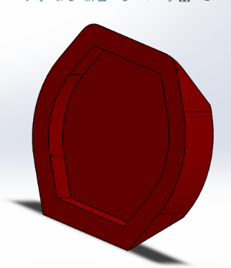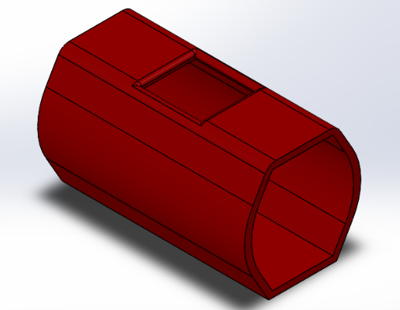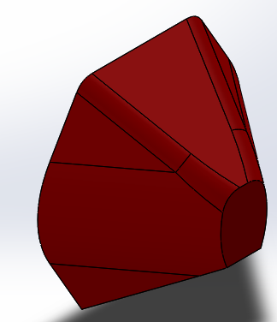

Seat
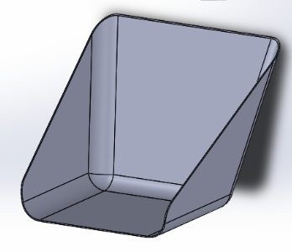

Chassis
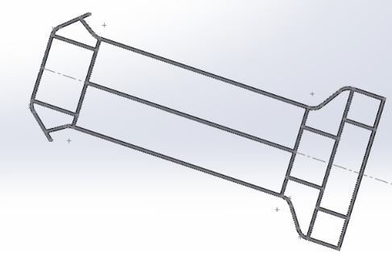

Wheel and Tyre
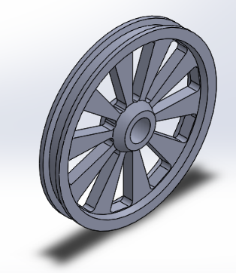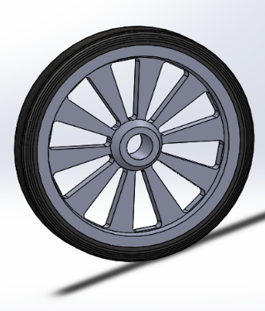

Kart
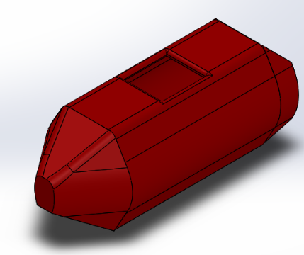

Final designs

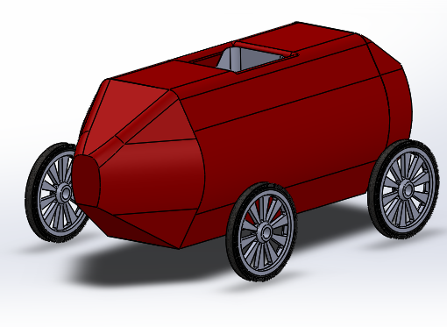
This is what the final design looks like.

Suitability and quality

From making different designs within this project, we believe that this final design is the most suitable and durable for the course. We have met all the requirements that were asked for and with a budget we designed a soapbox that was the most suitable for the course. We made the final design so that it was lightweight and strong. Therefore, we used heavy duty wheels so that the soapbox can withstand any bumps it goes over, and we also put in suspension so that there isn’t much for being applied to the chassis and the body which will lower the chances of the kart having problems and breaking.

Calculations

Important details for the calculations:
- Length of the course is 550m and the decent of it is 50m
- Weight of the soapbox including the driver 158kg
- Gravity=9.81m/s²

The equations that will be used are as shown:
Kinetic Energy= ½ X mass X velocity²
Gravitational potential energy= mass X gravity X height
$velocity=√2g∆h$
We will be working out the calculations for the top on the bottom of the course

50m

Bottom
550m

Top
GPE= Mx g x h
GPE= 158 x 9.81 x 0=
= 0j
$$v=√2g∆h$$
$$v=\sqrt{2x9.81x\left(50-0\right)}=$$
V= 31.32m/s
KE= ½ x m x v²
KE= ½ x 158 x 31.32²
KE= 77494.45 j

GPE= M x g x h
GPE= 158 x 9.81 x 50=
=77499 j
KE= ½ x m x v²
As the soap box hasn’t yet moved from the top the velocity will =0m/s
KE= ½ x 158 x 0²
KE= 0 j

Analysis

As we were only given the decent and length of the course, we could only do a certain number of calculations. From looking at photos of the course you can clearly see that the course isn’t just straight decent, some parts of the course are steeper than others therefore the velocity that we worked out isn’t going to be accurate for what the soapbox will perform on it. For example, the soapbox will be going faster in some places rather than others because parts are steeper, and this will affect the final velocity. We also take into consideration of friction; wind resistance is a factor but that can just depend on how windy it is on the day. From the information that we were given we worked out that the velocity will be 31.32m/s.

Further possible changes and improvements

On the whole this project on making a soapbox went pretty from the feedback from our group. With the pandemic we lost out on facilities that we could’ve used within the university such as the workshop. The workshop would’ve benefited us much more as we would’ve had the access to many materials and could’ve seen what would’ve been best for the soapbox. Not only this for could’ve had face to face conversations with lectures in the university.

Although there could’ve been many improvements that could’ve been made for the soapbox and also the build-up to designing it. With the communication part of this project there was many complications because of coronavirus as we couldn’t see each other in person and go over the project, if this did happen maybe the outcome of the project would’ve been better structured, and the soapbox could’ve been designed better and a bit more aesthetically pleasing.

