上海园景万豪酒店
Marriott Shanghai Parkview

自 助 早 餐
BUFFET BREAKFAST
每人13元
早餐供应时间为: 7:00 - 9:00
Breakfast Served From: 7:00 – 9:00

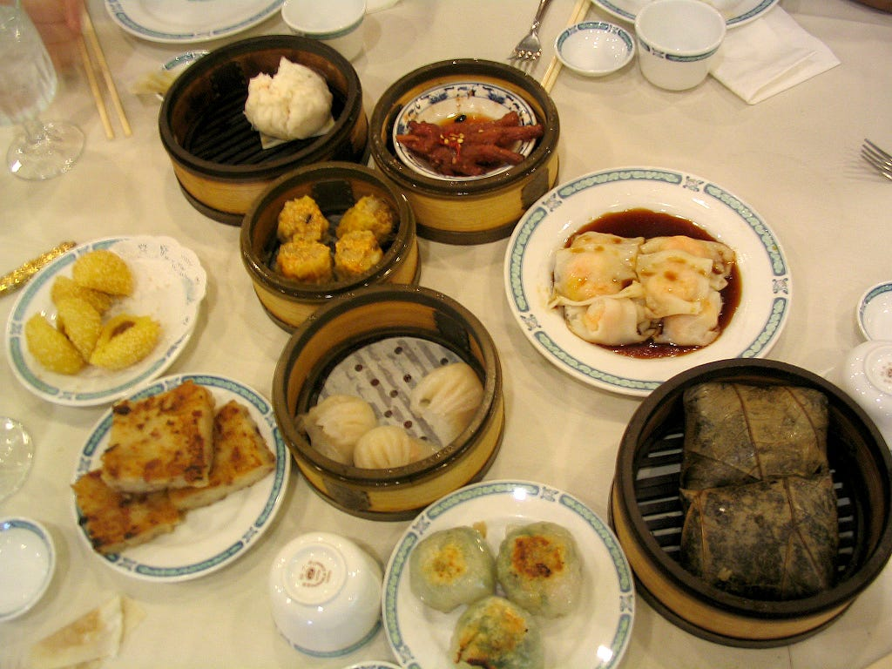

Title: Chinese Breakfast Information Board (Assignment 5)
Module: M5X01923
Tutor: Wei Wang
Student: Rohan Dubrey (1905715)

