Implementation and Analysis of NBFM Jamming Techniques and RTL-SDR Receiver Design Using GNU Radio

Joshua J Port 2114468

BEng Embedded Electronic Systems

University of Wales Trinity St David’s

Advanced Digital Signal Processing

(ACDA6002)

Word Count: 2750

Contents
Figures 3
Equations 4
Introduction 5
Background Research 5
Frequency Modulation 5
Anti-Jamming Backgrounds / Capabilities 5
Current FM Communications 5
Task 1 6
FM Equation and Calculations 6
NBFM Transmission Index: 6
NBFM Transmission Calculations: 6
NBFM Modulation and Demodulation 7
NBFM Modulation 7
NBFM with a Gaussian Jammer 9
NBFM with FHSS Anti-Jamming Capabilities 11
NBFM Demodulation with Tx and Rx Analysis 13
Task 2 15
RTL-SDR Setup and Design 15
Wide Band Frequency Modulation (SDR) 16
WBFM LPF Index: 16
WBFM LPF: 16
WBFM Re-Sampler Index: 16
WBFM Re-Sampler: 17
WBFM Receiver Index: 17
WBFM Receiver: 17
Signal Analysis and Visualisation 17
Ethical Considerations and Impacts 19
Conclusion 20
References 21

Figures
Figure 1 - NBFM Block Architecture [4] 7
Figure 2 - NBFM Modulation Block Diagram 8
Figure 3 - NBFM Audio Signal in the Time Domain 8
Figure 4 - NBFM Carrier Signal in the Time Domain 8
Figure 5 - NBFM Modulation Block Diagram with a Jammer 9
Figure 6 - NBFM Modulation without Noise 9
Figure 7 - NBFM Frequency Spectrum Modulation with No Noise 10
Figure 8 - NBFM Modulation without Noise (Waterfall Diagram) 10
Figure 9 - NBFM Modulation with Noise 10
Figure 10 - NBFM Frequency Spectrum Modulation with Noise 10
Figure 11 - NBFM Modulation with Noise (Waterfall Diagram) 11
Figure 12 - NBFM Modulation + Noise Phase Constellation Diagram 11
Figure 13 - NFBM Modulation Block Diagram with Jamming and FHSS Anti-Jamming 11
Figure 14 - FHSS Anti-Jamming Channel Select 12
Figure 15 - FHSS Anti-Jamming Waterfall Diagram 12
Figure 16 - NBFM Full System with Demodulation 13
Figure 17 - Receiver FM Signal Demod 13
Figure 18 - NBFM Demodulation Waterfall Model 13
Figure 19 - NBFM Frequency Spectrum Demodulation 14
Figure 20 - RTL-SDR GNU Radio Set-Up 15
Figure 21 - RTL-SDR Block Diagram 16
Figure 22 - Modulation and Demodulation of the FM Broadcast Signal 17
Figure 23 - Modulation and Demodulation of the FM Broadcast Signal (Out of the Carrier) 18
Figure 24 - Modulated BBC Solent FM Signal 18
Figure 25 - RTL-SDR Time and Frequency Demodulation Graphs 19

Equations
Equation 1 - Phase Angle 6
Equation 2 - Message Signal 6
Equation 3 - Phase angle and Message Signal 6
Equation 4 - Modulated Signal 6
Equation 5 - Modulated Signal with the Phase and Message 6
Equation 6 - Integration of the Combined Signal 6
Equation 7 - Frequency of the Modulated Signal 7
Equation 8 - Final Modulated Signal 7
Equation 9 - Final Modulated Signal After Cancelling 7
Equation 10 - RTL-SDR Equation 15
Equation 11 - New Sample Rate > 2 * Cutoff Frequency 16
Equation 12 - New Sample Rate 16
Equation 13 - New Sample Rate with Figures 16
Equation 14 - New Sample Rate Calculation Refined 16
Equation 15 - Final New Sample Rate 16
Equation 16 - Sample Rate Output 17
Equation 17 - Sample Rate Output with Figures 17
Equation 18 - Final Sample Frequency Output 17
Equation 19 - Audio Output Sample Rate Equation 17
Equation 20 - Audio Output Sample Rate with Figures 17
Equation 21 - Final Audio Output Sample Rate 17

Introduction
The start of this project shows the use and design of a regular Wide Band Frequency Modulation (WBFM) technique used it multiple everyday applications. Following from this there were two main objectives which required the use of the simulation software GNU radio. The first task was to generate and simulate a form of Narrow Band Frequency Modulation (NBFM) and implement a form of gaussian jamming and use Frequency Hoping Spread Spectrum (FHSS) anti-jamming to clear the signal. The system could then be analysed using multiple channels to assess what will happen to the message signal throughout this process. To confirm the signal has been received in, the audio file set up, will be played through the computer’s speakers.
The secondary task was to fully design an RTL-SDR receive diagram and observe the signal changes at multiple points. This would involve obtaining a signal capture of a randomised FM radio broadcast and explain the process in which this signal is being modulated, demodulated and then received by the Software Defined Radio.

Background Research

Frequency Modulation
Frequency Modulation is the combination of both the message and the carrier signal which is utilised by encoding the message required within the carrier and adjusting the frequency to give the output signal, in accordance with the varying amplitude of the message wave [1]. This allows the signal to have a greater chance of being transmitted and not being affected by the outside environment before reaching the receiver location.
In FM both the phase and the amplitude doesn’t change allowing only the frequency to be altered to create the transmission signal. The main use of FM is communication audio links. This is because, FM is, unlike other modulations, very wide band. This wide band aspect can be tuned to a specified frequency which is known as NBFM. Another version of FM is Wide Band Frequency Modulation (WBFM), used for wider band frequency transmission over the air.

Anti-Jamming Backgrounds / Capabilities
At current there are several ways in which Frequency Modulation can be achieved as well as, ways that ant-jamming can be used to disrupt or block the required signal from reaching it receive location. The main use for jamming frequencies is in broad military applications using Electro-Magnetic (EM) waves as a means to disrupt, deter or inevitably control the outcome within the battle environment [2]. Some of these applications include missile warning systems, radar detection, radio reconnaissance, anti-drone and cellular capabilities [2].

Current FM Communications
The current forms of FM communications consist of areas such as point to point radio transmit and receive, Radar communications, satcom communications. FM is currently used in these capabilities for the simple reason that it is far less susceptible to many types of interference and noise due to its multiplication with the carrier wave which is an off shoot of the main message signal [3].

Task 1

FM Equation and Calculations
To create an FM signal which can be modulated and demodulated, a series of calculations need to be undertaken. There are multiple aspects of FM that are required in order to allow the signal to be clear at the receiver module. The finalised transmission signal is a combination of the phase angle, required frequency, the carrier frequency and carrier amplitude, as well as the modulation index.

NBFM Transmission Index:
$$θ_{i}\left(t\right)→Phase Angle$$
$$f_{c}→Frequency of the Carrier Signal$$
$$A_{c}→Amplitude of the Carrier Signal$$
$$k_{f}→Sensitivity of the Frequency Modulation$$
$$m\left(t\right)→Modulating Signal$$
$$A_{m}→Amplitude of the Modulating Signal$$
$$f_{m}→Frequency of the Modulating Signal$$
$$β→Frequency of the Modulating Signal$$
$$∆f→Frequency Deviation$$

NBFM Transmission Calculations:
$$θ_{i}\left(t\right)=2π \int{\left[f_{c}+ k_{f}m\left(t\right)\right]dt}$$
Equation 1 - Phase Angle
$$m\left(t\right)= A_{m}cos2πf_{m}t$$
Equation 2 - Message Signal
$$θ_{i}\left(t\right)=2π \int{\left[f_{c}+ k_{f}(A_{m}cos2πf_{m}t\right]dt}$$
Equation 3 - Phase angle and Message Signal
$$s\left(t\right)= A_{c}cosθ_{i}(t)$$
Equation 4 - Modulated Signal
$$s\left(t\right)= A_{c}cos⁡[2πf_{c}t+ 2πk_{f} \int{A_{m}cos2πf_{m}t dt]}$$
Equation 5 - Modulated Signal with the Phase and Message
$$\int{\cos\left(2πf_{m}t\right)dt}= \frac{1}{2πf_{m}}sin2πf_{m}t$$
Equation 6 - Integration of the Combined Signal
$$β= \frac{A_{m}k_{f}}{f_{m}}= \frac{∆f}{f_{m}}$$
Equation 7 - Frequency of the Modulated Signal
$$s\left(t\right)= A_{c}cos⁡[2πf_{c}t+ 2π \frac{A_{m}k_{f}}{2πf_{m}} sin2πf_{m}t$$
Equation 8 - Final Modulated Signal
$s\left(t\right)= A_{c}cos⁡[2πf_{c}t+ β sin2πf_{m}t$ (2ϖ cancels)
Equation 9 - Final Modulated Signal After Cancelling
The above calculation has been used in this report to build the FM transmitter. The FM system in figure 1 follows this calculation to create the modulated message signal.
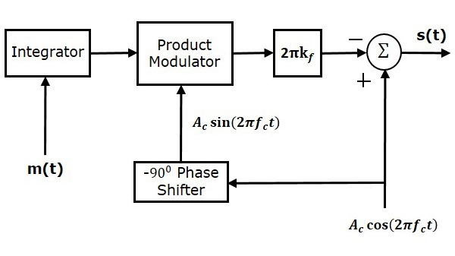
Figure 1 - NBFM Block Architecture [4]

NBFM Modulation and Demodulation

NBFM Modulation
Shown below is a simple system, set out in GNU radio to display and simulate the modulation of an FM message audio signal using the FM transmission calculations. The wav file at a sample rate of 48k and frequency of 2 KHz is multiplied by the modulation index of 0.5 and put through a phase modulation of 1. This signal is then multiplied with the carrier signal to produce the finalised FM transmission signal.
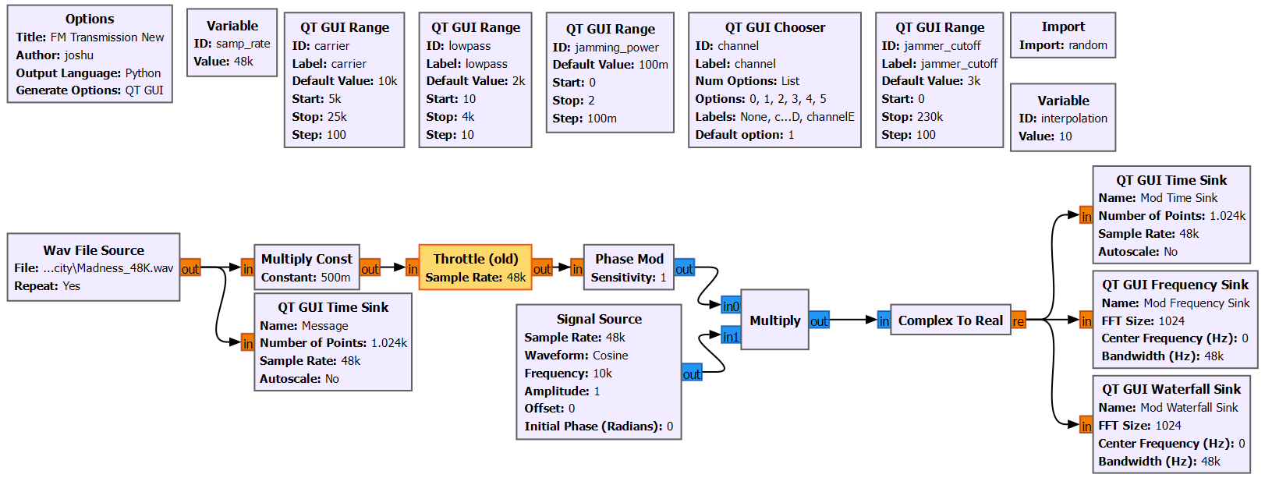
Figure 2 - NBFM Modulation Block Diagram
Shown below is the message signal input for the NBFM system. This signal is produced by using audacity to make an audio recording at a sample rate of 48k which is the desired sample rate of this specific FM system. It can be seen that the audio signal has a fluctuating amplitude between -1 and 1. Using this, boundaries can be set out for the carrier signal which it will be multiplied by.
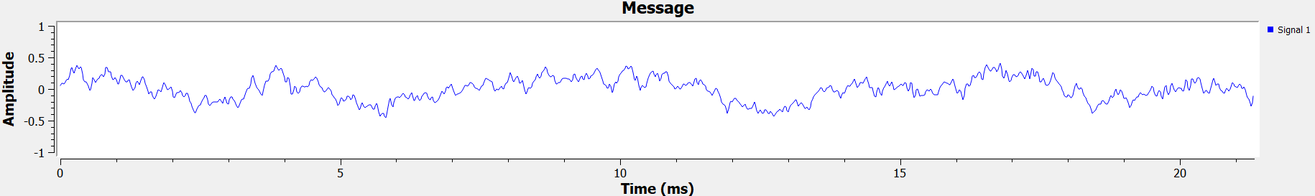
Figure 3 - NBFM Audio Signal in the Time Domain
After the signal is multiplied by the modulation index and the phase, the carrier signal is multiplied in. The carrier signal is used within FM to allocate the frequency required for the signal to be modulated in order for it to be transmitter over the air (OTA). Fm is used in this way as it is he least susceptible of the modulation schemes to outside noise making it perfect for point to point transmission. Shown below is the carrier signal which is a constant cosine wave with the frequency of 10 KHz.
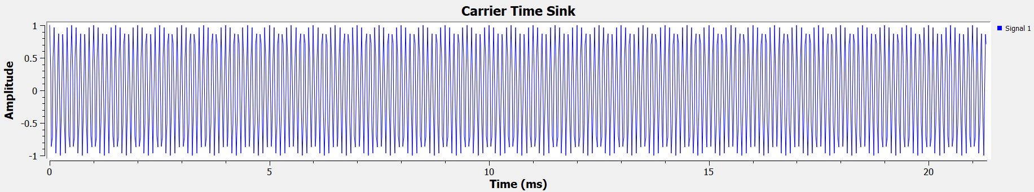
Figure 4 - NBFM Carrier Signal in the Time Domain

NBFM with a Gaussian Jammer
The gaussian jammer set up in this system is done so in such a way that the jamming can be increased or decreased to observe the differences in the signals transmission and receive capabilities. When the jammer is added the noise signal gets considerably distorted due to a change in the frequency outside of the carrier frequencies range. Although similar to the carrier frequency, it can be observed that without jamming, the signal is able to be modulated and can be received normally.
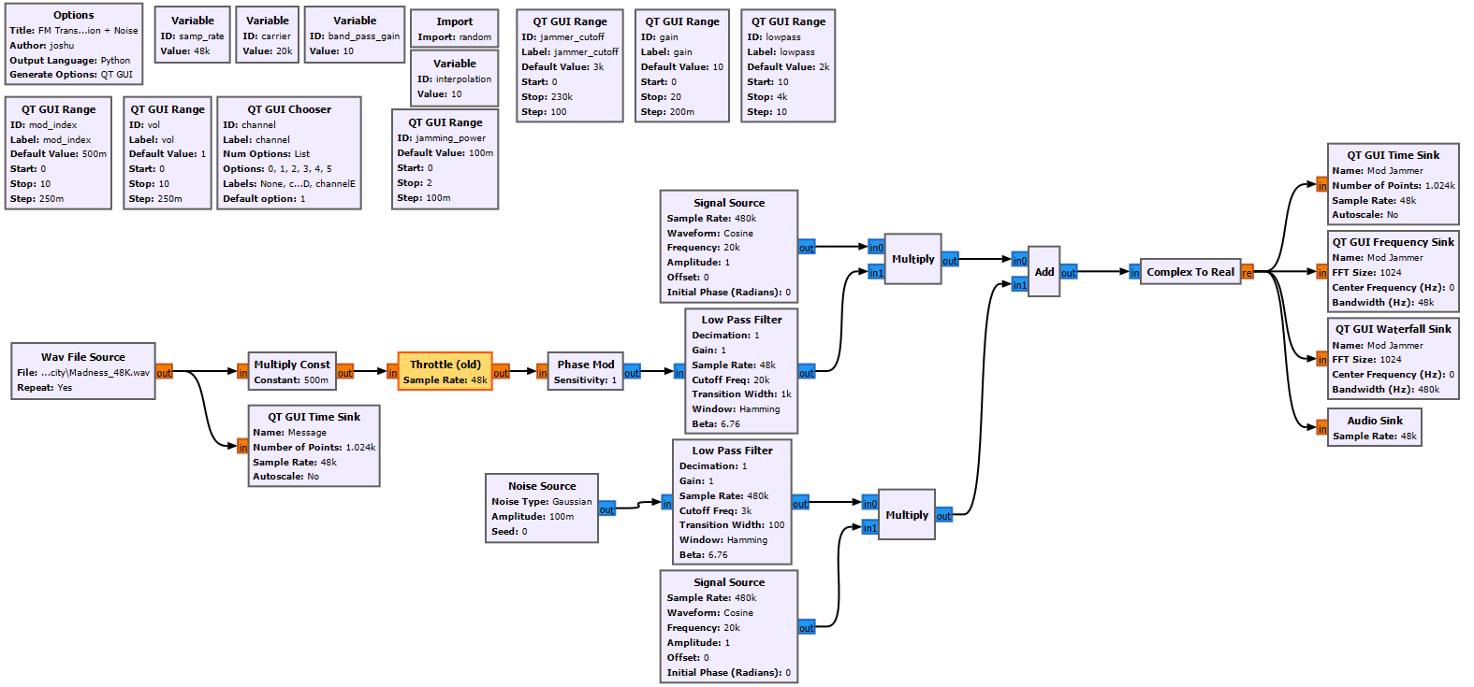
Figure 5 - NBFM Modulation Block Diagram with a Jammer
Figure 5 shows the regular Modulation scheme used before whilst also adding a jammer. This system can mimic a jammer which would be used to intercept over the air transmissions. The system uses a white gaussian input combined with the carrier frequency and added to the main signal. This gives the effect of randomised noise when transmitting that would require filtering before the receiver can obtain the original message signal.
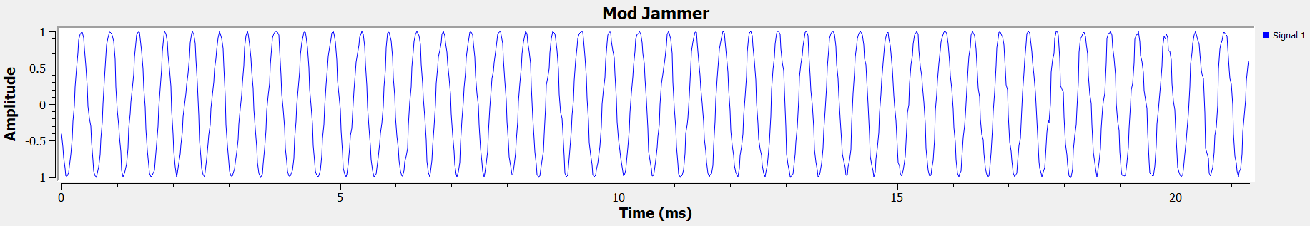
Figure 6 - NBFM Modulation without Noise
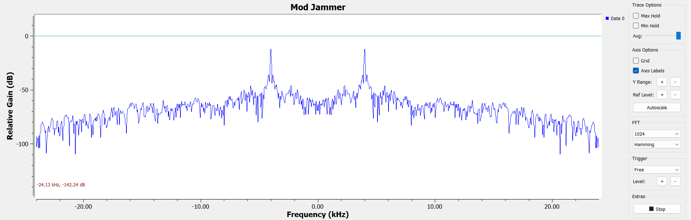
Figure 7 - NBFM Frequency Spectrum Modulation with No Noise
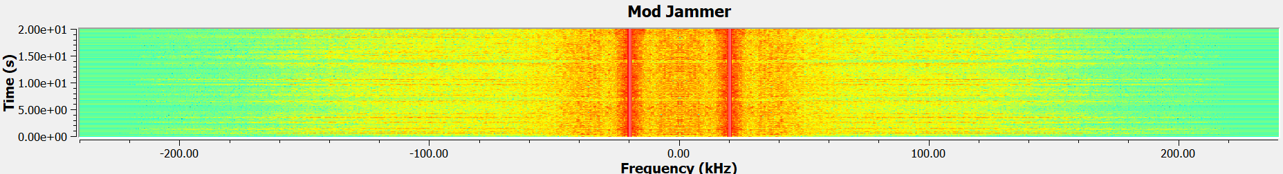
Figure 8 - NBFM Modulation without Noise (Waterfall Diagram)
The spectrum and waterfall here show the two carrier side lobes with the main frequency between the bands. This noise between the bands is just the modulated signal, however it could not yet be received in this format due to the frequency being muddled with that of the carrier frequency.
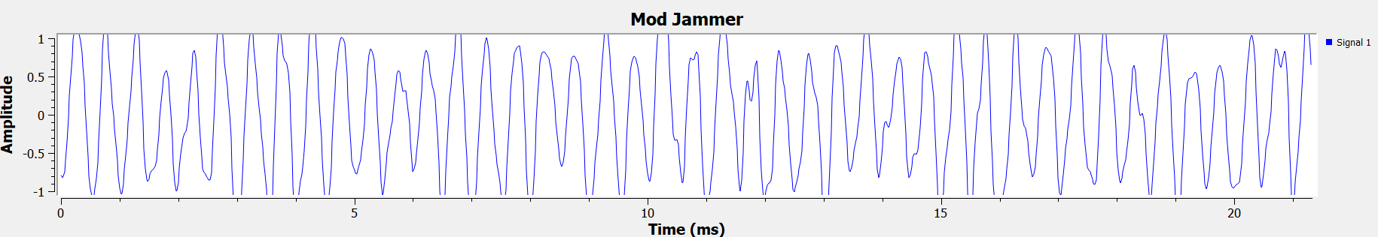
Figure 9 - NBFM Modulation with Noise
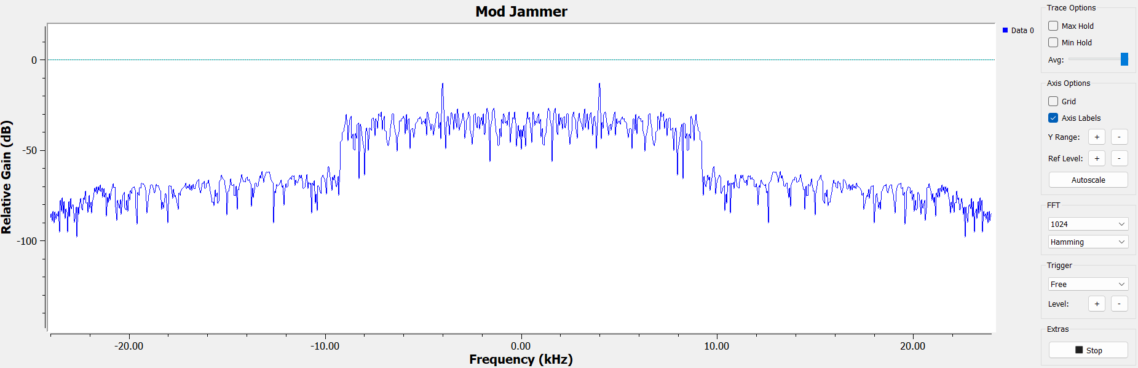
Figure 10 - NBFM Frequency Spectrum Modulation with Noise
As shown here, there message signal can clearly be shown half inside and half outside of the side bands of the carrier frequency. This means that the jammer power is high, and the signal cannot be transmitted without noise. This jamming is shown with the fluctuation in figure 9 when noise has been added.
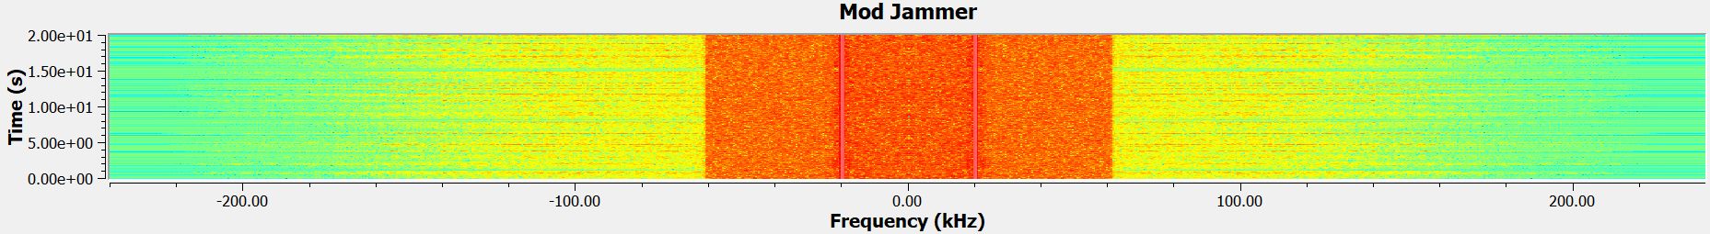
Figure 11 - NBFM Modulation with Noise (Waterfall Diagram)
The waterfall diagram in figure 11 shows the jammer when the power is increased, distorting the signal. This can be shown by the massive orange band proceeding outside of the carrier frequency set at 20 KHz.
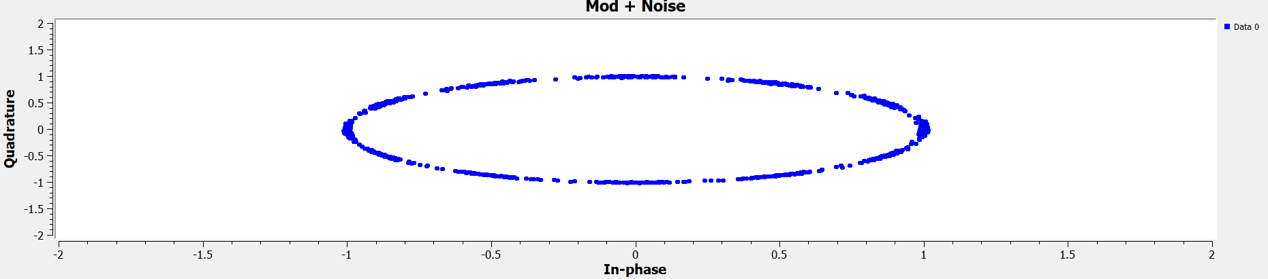
Figure 12 - NBFM Modulation + Noise Phase Constellation Diagram
Figure 12 shows the phase of the modulation and noise in the frequency modulation system. This image shows the phase between 1 and -1 depending on the phase of the sensitivity used.

NBFM with FHSS Anti-Jamming Capabilities
Figure 13 - NFBM Modulation Block Diagram with Jamming and FHSS Anti-Jamming
Frequency Hopping Spread Spectrum (FHSS), is utilised by multiplying the carrier signal by a randomised channel which can be user altered if required. FHSS in simple terms is the changing of the channel used, altering the frequency to avoid any noise or incoming jamming from another external source [5]. The signal source multiplied by the low pass filter carries this capability and allows the user to change the channel, thus changing the carrier frequency, which increases the spectrum range. This allows the required message to be filtered from the jammer properly before it is received. This anti-jamming capability is widely used in encrypted end to end communications to allow the signal to hop onto other channels to still relay the required high level messages as seen below.
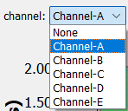
Figure 14 - FHSS Anti-Jamming Channel Select
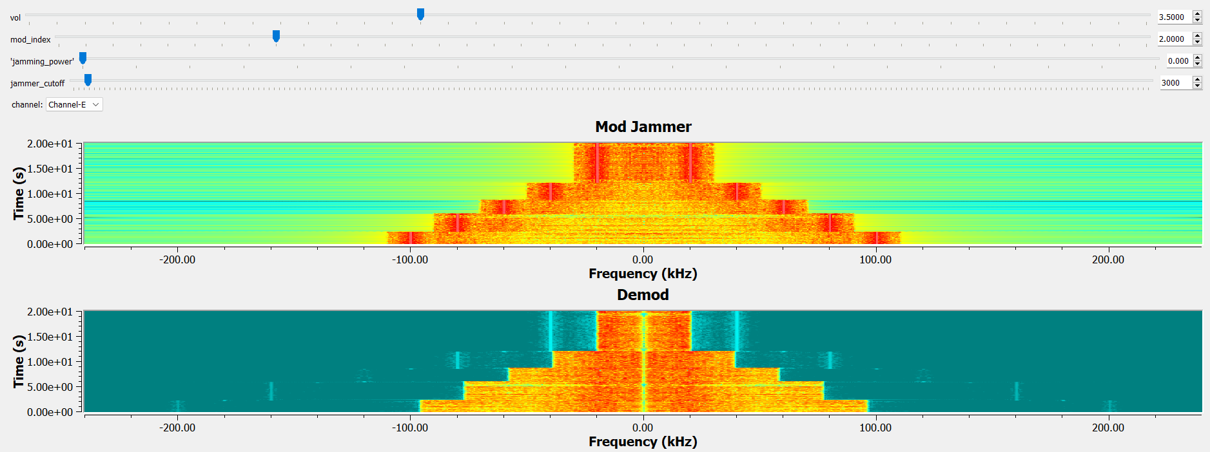
Figure 15 - FHSS Anti-Jamming Waterfall Diagram
The first waterfall diagram in figure 15 above shows the message signal when it is multiplied by the carrier frequency across all 5 channels. As displayed, the modulated signal is altered with each channel which has been chosen due to the signal source carrier frequency being multiplied with the channel number. Channel A is 1, channel B is 2 and so forth. This means that the frequency of the message can change to allow the message to still be passed over the air with the surrounding noise.
The second waterfall diagram shows how the message signal has been demodulated to give the clear audio signal. Like the modulated signal, the demodulated signal adapts the frequency in accordance with the channel selected to allow the signal to be received.

NBFM Demodulation with Tx and Rx Analysis
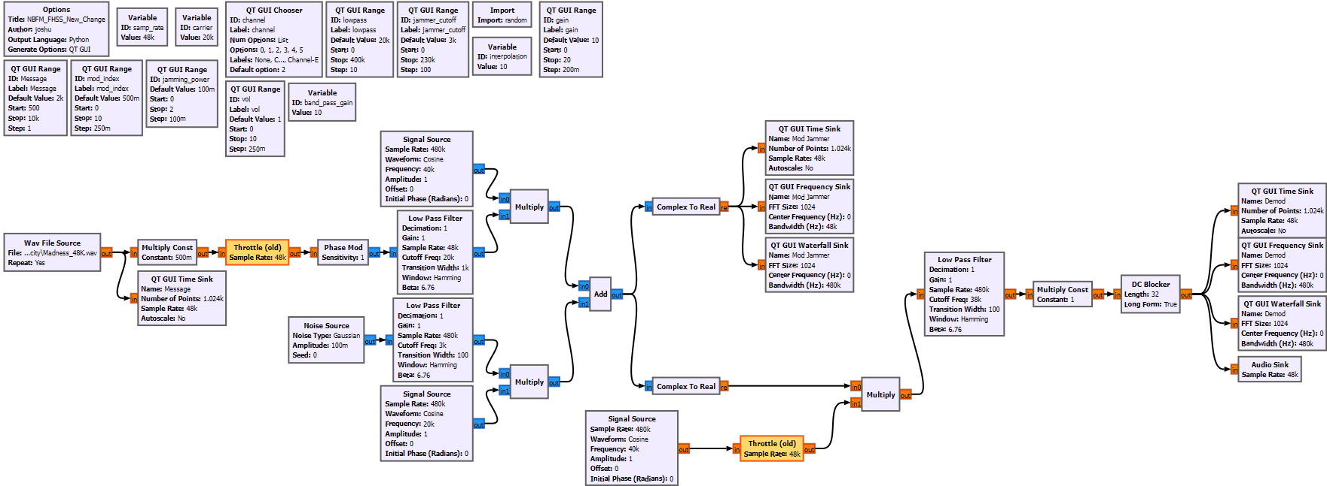
Figure 16 - NBFM Full System with Demodulation
Figure 16 shows the full FM GNU radio system which included FM modulation, gaussian jamming, FHSS anti-jamming and FM demodulation. The message signal is received by demodulating the over the air noisy signal, so the message can clearly be heard. Demodulation is done by multiplying the noisy signal again by the carrier signal multiplied by the user selected channel range. This method allows the carrier signal to be cancelled out from the previous multiplication during the modulation process. The result of this is the original message signal without any noise addition. When transmitting the lowpass filter cut off can be adjusted to help widen the range of the frequencies which the signal can be sent on. This allows multiple different signals at many different frequencies to be transmitted and received with clarity.
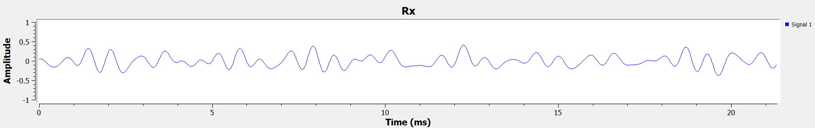
Figure 17 - Receiver FM Signal Demod
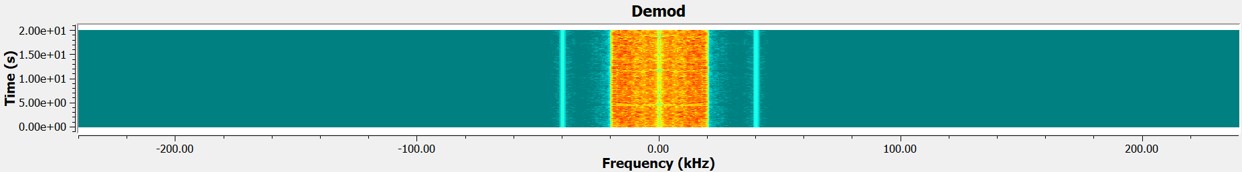
Figure 18 - NBFM Demodulation Waterfall Model
Figure 17 and18 shows the fully demodulated signal of the FM wav file transmission. The signal can clearly be shown as centred around 0 KHz and well within the 40 MHz frequency carrier band. This means that the signal is being received properly and is able to be played and / or read.
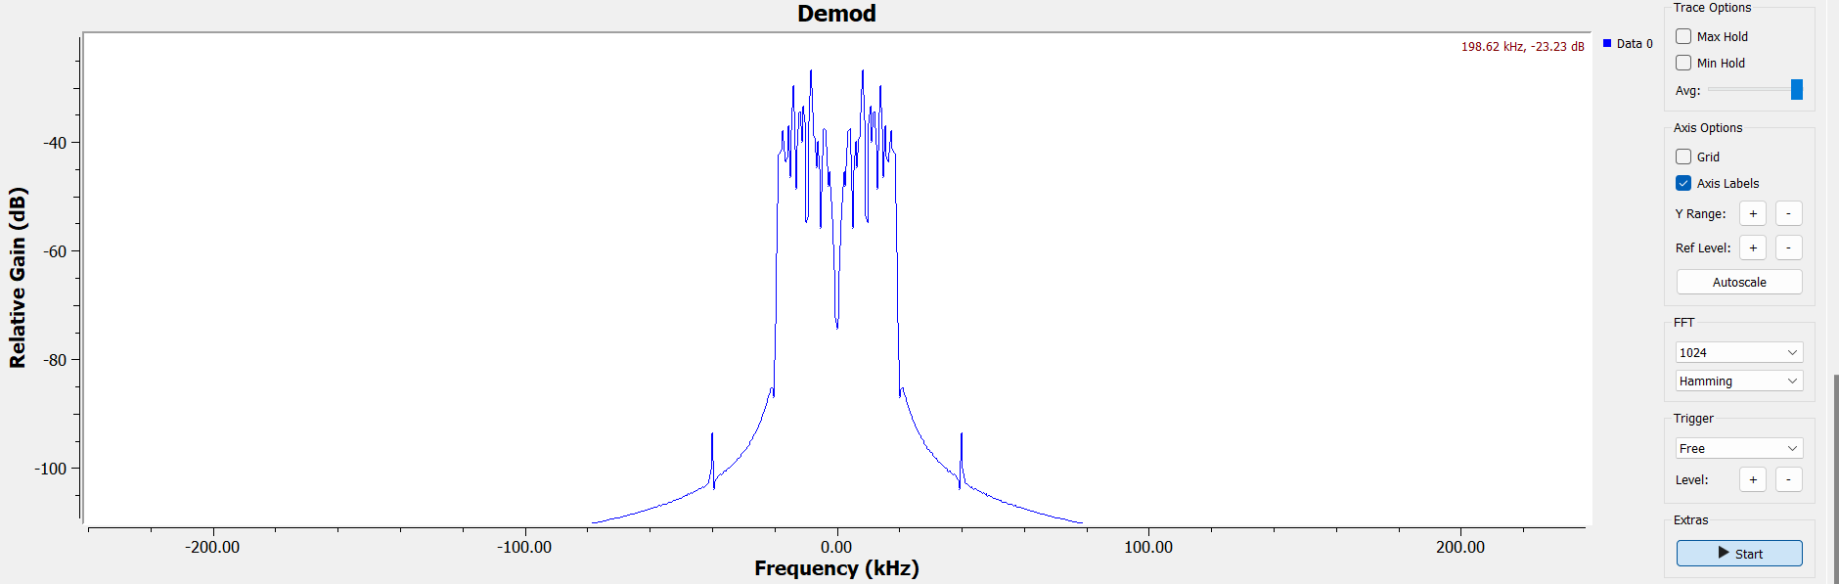
Figure 19 - NBFM Frequency Spectrum Demodulation
The frequency spectrum shown above displays all of the message signal within the carrier frequency bands, to receive a clear signal either side of the central frequency.

Task 2

RTL-SDR Setup and Design
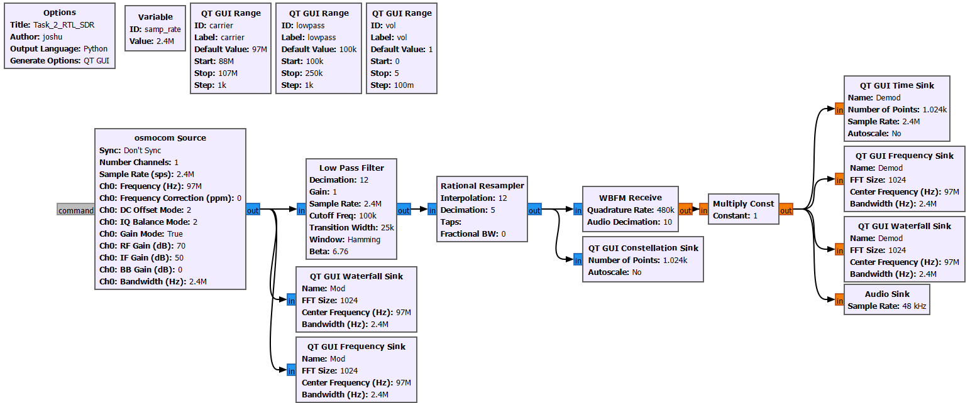
Figure 20 - RTL-SDR GNU Radio Set-Up
$$s\left(t\right)=I\left(t\right)+jQ(t)$$
Equation 10 - RTL-SDR Equation
The equation above represents the real and imaginary parts of the FM modulator and demodulator for IQ sampling. The real and imaginary parts are split and combined with the carrier frequency to then be passed through the low pass filter. The lowpass filter (LPF) on both the I and Q parts is used strictly for focusing on one particular channel which has been selected to transmit on. The LPF then filters off all of the other channels around this frequency to only allow the transmitted signal to be received.
The decimation factor within the LPF is used as a sample sizer for the incoming signal. The decimation allows the specific number of samples taken from the original signal to be whittled down to a manageable sample size. In this case the sample rate was set at 2.4M samples every second which is a huge file when captured. The decimation factor has been set to 12, meaning that the overall sample size per second is divided by 12 to 200K samples per second. This allows the low pass filter to work at a more manageable rate. Every channel within FM operates with a bandwidth of 200 KHz making the samples now equal the bandwidth [6].
The frequency transition width also had to be adjusted to facilitate the sample rate and frequency change. The transition width correlates directly to the size of the frequency band. The bigger the width, the wider the frequency band. After the LPF a rational resampled is used to keep the samples at the same rate ready to be demodulated. These samples then go into the Wide Band Frequency Modulation (WBFM) Block. This WBFM block is used to alter the audio size to be in correct alignment with the 48 KHz needed to represent the inbound FM transmission. This is done by dividing the quadrature rate of 480 K by a decimation factor of 10. The multiply constant at the end of the system is used to increase the volume of the signal so it can be here when received.
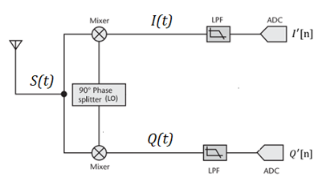
Figure 21 - RTL-SDR Block Diagram
Above is the block diagram which will be followed to create the FM capture.

Wide Band Frequency Modulation (SDR)

WBFM LPF Index:
$$m→ Decimation Factor=12$$
$$f_{max}→Cutoff Frequency=100 K Hz$$
$$f_{sample}→Sample Rate=2.4 M$$
$$f_{sampleNew}→New Sample Rate=200 K Hz$$

WBFM LPF:
$$f_{sampleNew}≥2* f_{max}$$
Equation 11 - New Sample Rate > 2 * Cutoff Frequency
$$f_{sampleNew}= \frac{f_{sample}}{m}$$
Equation 12 - New Sample Rate
$$f_{sampleNew}≥ \frac{2.4 M}{12}=200 K$$
Equation 13 - New Sample Rate with Figures
$$200 K ≥2*100 K$$
Equation 14 - New Sample Rate Calculation Refined
$$200 K ≥200 K$$
Equation 15 - Final New Sample Rate

WBFM Re-Sampler Index:
$$m→ Decimation Factor=5$$
$$int→ Interpolation=12$$
$$f_{sampleNew}→New Sample Rate=200 K$$
$$f_{sampleOutput}→Output Sample Rate=480 K$$

WBFM Re-Sampler:
$$f_{sampleOutput}= f_{sampleNew}* \frac{int}{m}$$
Equation 16 - Sample Rate Output
$$f_{sampleOutput}= 200 K* \frac{12}{5}$$
Equation 17 - Sample Rate Output with Figures
$$f_{sampleOutput}= 480 K$$
Equation 18 - Final Sample Frequency Output

WBFM Receiver Index:
$$m→ Decimation Factor=10$$
$$f_{sampleOutput}→Output Sample Rate=480 K$$
$$f_{audioOutput}→Output Audio Sample Rate=48 K$$

WBFM Receiver:
$$f_{audioOutput}= \frac{f_{sampleOutput}}{m}$$
Equation 19 - Audio Output Sample Rate Equation
$$f_{audioOutput}= \frac{480 K}{10}$$
Equation 20 - Audio Output Sample Rate with Figures
$$f_{audioOutput}=48 K$$
Equation 21 - Final Audio Output Sample Rate

Signal Analysis and Visualisation
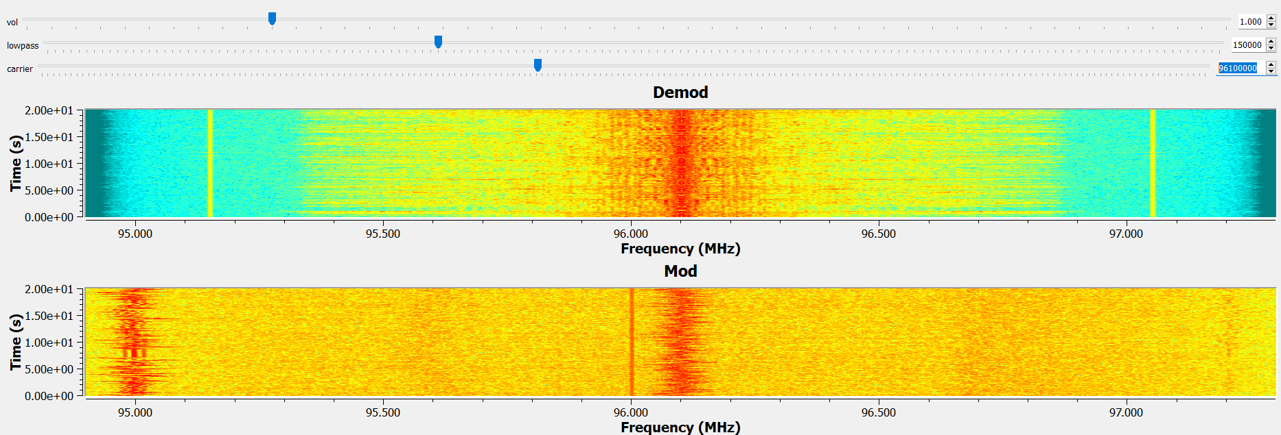
Figure 22 - Modulation and Demodulation of the FM Broadcast Signal
The frequency displayed here in figure 21 is of BBC radio Solent which operates on a frequency of 96.1 MHz. It can be seen that the modulation at 96.1 has a distinct red line where the radio station is transmitting. The modulation here is displayed with general noise from the atmosphere and other frequencies. This noise is effectively a natural jammer for communication systems.
The demodulated signal at the top of figure 21 shows the two side bands of the carrier frequency and the signal along the central frequency of 96.1 MHz. The clear indication that it is a clean signal is most of the transmitted demodulated signal is within this 1.9 MHz frequency band. It can also be seen that there is another frequency channel centring and operating around 95 MHz. Using the carrier frequency slider at the top of the page, the frequency can be adjusted to be able to receive this lower frequency radio station (Fiesta FM).
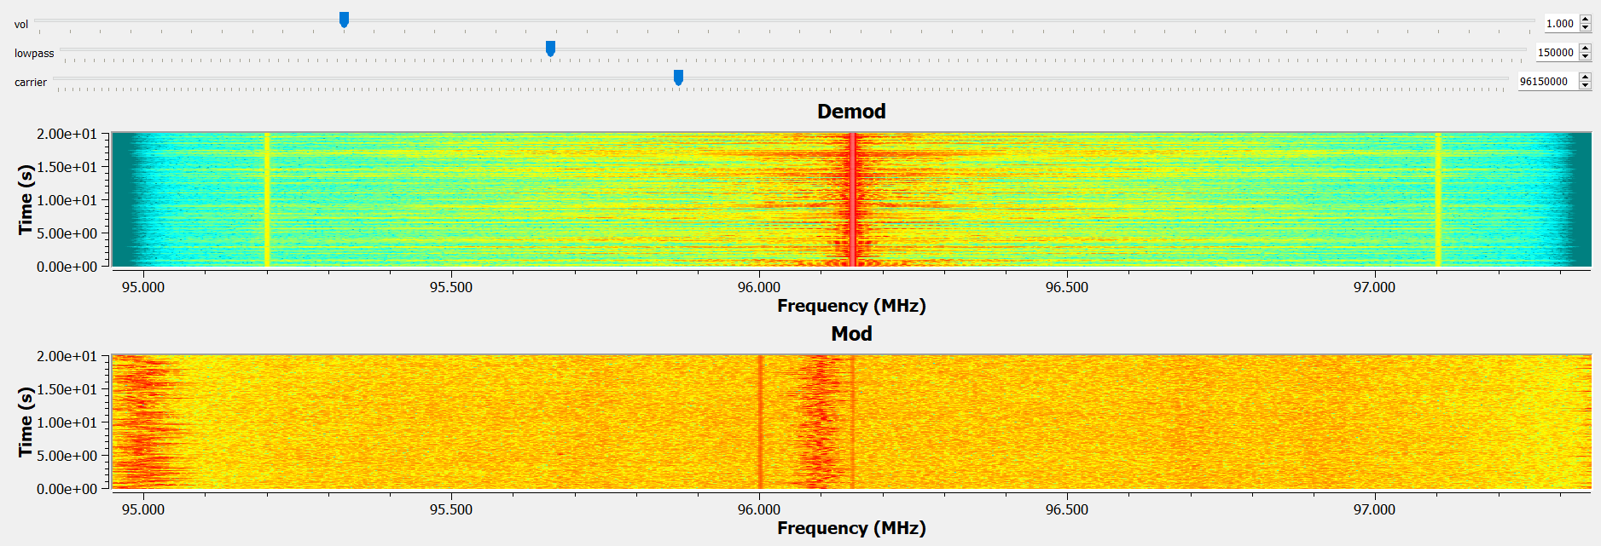
Figure 23 - Modulation and Demodulation of the FM Broadcast Signal (Out of the Carrier)
Figure 22 shows the same frequency section used but shifted 0.05 MHz higher. As shown in the demodulation before (figure 21) the frequency still centres around 96.1 MHz as expected however, now there is a shift the message signal now pushes outside of the carrier bands creating mass distortion of the radio broadcast. Most of the FM channel bandwidths are around 0.2 MHz wide with the centre being half of this, meaning that the band can be 0.1 MHz higher or lower than the central frequency [7].
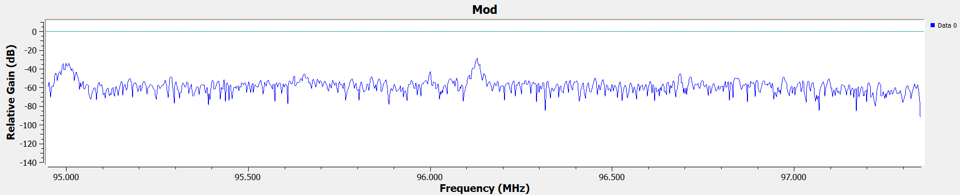
Figure 24 - Modulated BBC Solent FM Signal
The modulated signal above shows the signal after its has been through the lowpass filter. The centre is along 96.1. The noise along the other frequencies is the unfiltered over the air transmission noise. This is shown to be significantly lower that the higher signal spikes at both 95 and 96.1 MHz.
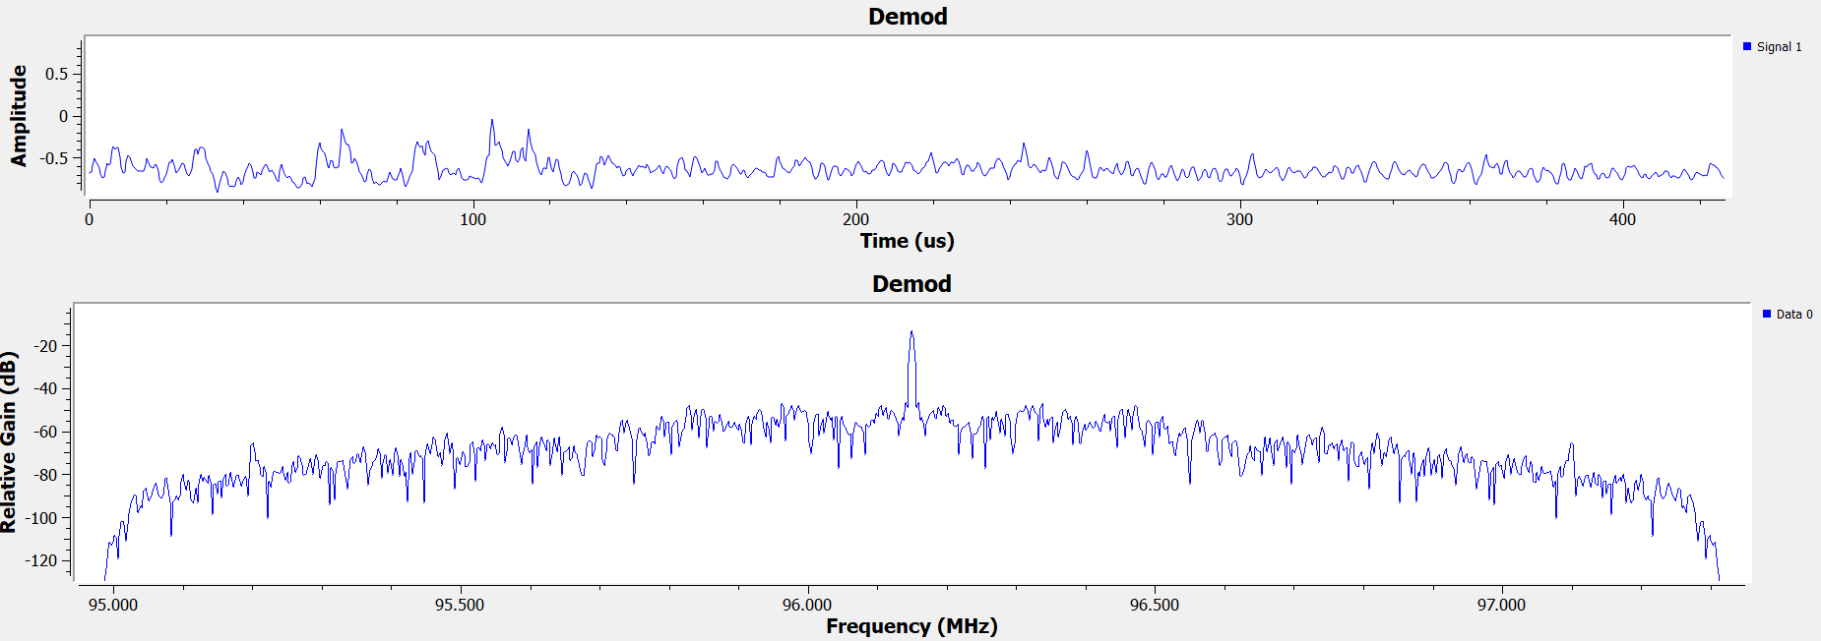
Figure 25 - RTL-SDR Time and Frequency Demodulation Graphs
Figure 24 shows the fully demodulated signal of the FM radio broadcast BBC Solent at 96.1 MHz. The signal is clearly identified in the frequency domain with the spike being centred on the required transmission and receiver frequency.

Ethical Considerations and Impacts
The use of radio frequency within the United Kingdoms domain is controlled, operated and authorised by the Office for Communications (OFCOM). If a required frequency is to be used, OFCOM must be notified to either deny or allow access of the frequency band used as well as, if you’re planning to block any channels. This is due to the possibility of accidently or purposefully jamming a widely used channel such as radio or television. Jamming or restricting these types of channels is highly illegal.
Although jamming is highly restricted and usually illegal, however there are applications where it is necessary to carry out blocking of channels. One main area is for military point to point encrypted radio communication. The jamming is important as military comms, both friendly and enemy, are incredibly classified. This means with the right jamming and filters; the enemies communications could be blocked whilst friendly signals can pass through. Secure communications are generally highly encrypted to isolate and contain highly classified information and it is against the law to use these practices to listen into encrypted or secure radio and satellite communications.
If communications in and around the UK are not regulated, there could be mass panic or dangerous incidences like attacks or no telephone usage due to unrestricted jamming or secure comms leaks.

Conclusion
After reviewing NFBM and FHSS, it can be found that the introduction of a filter and frequency hopping can be used to avoid jamming capabilities. By using FHSS the user can hop between multiple channels in order to avoid the singular channel which is being blocked to disrupt data communications between two parties. This anti jamming, in this capacity, is extremely effective however, in real world applications this method may not be the best way to avoid signal blocking. This is due to the simulation within this report having a refined amount of noise as opposed to real world noise or jamming. Although the concept may be the same, when transmitting over the air, there are many more complications with an amassed amount of noise to filter off. This is shown by the volume of noise within the WBFM SDR testing in figure 22.
Considering the factors stated above, an improvement for the next iteration of this work would be to add more lowpass or band pass filters could help with restricting wider band frequencies when radiating. This would help to filter away more unwanted noise surrounding ir attempting to block the signal from reaching the receiver.
Overall, the project shows that there is a capability for anti-jamming technic=ques such as FHSS and WBFM. Factors such as the frequencies being used can be adapted to solidify the data within this report and establish advances which can be made to the systems to increase their adaptability to different levels of jamming techniques.

References

[1] | M. Plonus, “Digital Systems,” in Electronics and Communications for Scientists and Engineers, Academic Press, 2001, pp. 327-403.
[2] | Army Technology, “Electronic Warfare Equipment and Jamming Systems (Land EW) for the Defence industry,” Army Technology, 2024. [Online]. Available: https://www.army-technology.com/buyers-guide/electronic-warfare-jamming-systems/. [Accessed 01 January 2025].
[3] | M. Brodowicz, “Frequency Modulation, Its Applications and Future,” 22 March 2024. [Online]. Available: https://aithor.com/essay-examples/frequency-modulation-its-applications-and-future#21-fm-radio-broadcasting. [Accessed 1 January 2025].
[4] | TutorialsPoint, “Generation of NBFM,” TutorialsPoint, 2025. [Online]. Available: https://www.tutorialspoint.com/analog_communication/analog_communication_fm_modulators.htm. [Accessed 13 January 2025].
[5] | X. L. K. A. Y. L. G. Z. Yuxin Shi, “Efficient Index-Modulation-Based FHSS: A Unified Anti-Jamming Perspective,” IEEE Internet Of Things Journal, vol. XI, no. 2, p. 3458, 2024.
[6] | M. Mustaqim, “GnuRadio Tutorial | FM Receiver using RTL-SDR | Step by Step Explanation,” Youtube, 2023.
[7] | Federal Communications Commision, “Why do FM Frequencies End in an Odd Decimal?,” Federal Communications Commision , 1 September 2021. [Online]. Available: https://www.fcc.gov/media/radio/fm-frequencies-end-odd-decimal#:~:text=The%20FM%20broadcast%20in%20the,lower%20end%20of%20the%20channel.. [Accessed 10 January 2025].

