UNIVERSITY OF WALES
BA BUSINESS MANAGEMENT

MARKETING FUNDAMENTALS ANALYSIS AND EVALUATION



McDonald’s – Marketing Analysis
-ASSESSMENT II-

Student: Cristian Ghiburcea (1916923)
Lecturer: Tushara Balendran

Contents

Introduction: 3
1. Processes and stages of marketing including the role of the marketing mix according to McDonalds: 4
SWOT 6
PORTER'S FIVE FORCES 8
Marketing SEGMENTATION, TARGETING and POSITIONING PROCESS: 12
2. Stakeholder engagement and their impact on the marketing activities of McDonalds Company: 18
CONCLUSION: 20
RECOMMENDATIONS: 21
REFERENCES: 22

Introduction:
Marketing represents one of the main activities in every successful business. Together with other activities such as production or accounting, marketing has a crucial role in the evolution of a company. Through marketing, a company can accomplish a sort of connection between their products and their potential customers, as well as a connection between these and the company itself. In fact, the aim of marketing is to help the customer identify and be satisfied by the product.
During the years, there has been many different ways of defining this term. To keep it short, marketing is a process of showing your potential customers the price of a product of service, with the aim of selling it. It could be an important function or a list of processes that could begin with the study of the market, and then an analysis of the customer's desires, followed by offering them products or services that will satisfy their needs. Thereby, the company's profits will be assured, as expected (Gundlach, Wilkie. 2009).
In this report, I will be doing an analysis of the globally known company, McDonalds, one of the largest fast-food chains in the world. Created in 1948, California, by the McDonalds brothers, it had a massive success, quickly becoming one of best known fast food brands. This success is shown in the 35 000 opened shops as of now, in more than 120 countries. McDonalds is daily serving over 50 million customers, which gives them an annual profit of approximately 15 billion dollars (Ahmed, 2016).

There are many strategies that make it possible for McDonalds to be the fast food company with the most revenue in the world. One of these can be: a process of continuous improvement of the company, through different social activities or sponsors. Also, due to the cultural and social differences, they have been forced to adapt their products in order to fit in the restrictions of different countries. Hence, in order to also satisfy customer's needs in different geographical places, they produce and sell different types of products, at different prices, for example prices in Asia compared to prices in the US or Europe.

1. Processes and stages of marketing including the role of the marketing mix according to McDonalds:
Marketing Process:
Down below, there is a list and a figure of the process of marketing:
SITUATION ANALYSIS: - based of studying the current position, attracting customers that could be interested in the offered products / services as well as maintaining a good relationship with these;
OBJECTIVES: - objective description of existing capacities, achieving a relationship with the competition and establishing the target;
OPTIMIZING SOLUTION: - making strategic changes to maximize the number of interested people in the business;
CONTROL: - this step of the process is reached when the company claimed all their objectives; which mean that the marketing strategy used offers the customers satisfaction, respectively the profit;

Fig.1: Marketing process steps

Furthermore, I will be thoroughly explaining these 5 steps, in regards to McDonalds:
SITUATION ANALYSIS:
This type of analysis helps the leaders of the company find their own advantages and disadvantages. This will examine their own resources and offer suggestions for the development of the brand's capacities. After all the important points are being taken into account, they can develop an efficient system called 'marketing plan'. Examples of situation analysis are SWOT, PESTEL or Porter's Five Forces, each being useful depending on the desired analysis. In order words, in this report there will be a thorough analysis of these (SWOT and Porter's).

SWOT: - SWOT analysis is a framework which is aimed to identify and analyze an organization's strengths, weaknesses, opportunities and threats - which actually form up the acronym 'SWOT'. The gained information can help a company make use of their strengths, in order to minimize risks and maximize profits. Down below, there will be a SWOT analysis of McDonalds:
-STRENGTHS:
McDonalds is an example of a successful business, which has proven to be extremely profitable over a long term. This represents a big advantage keeping in mind that we live in a period of time where we have less and less spare time; therefore people choose to eat at a fast-food restaurant such as McDonalds, in order to save this precious time. McDonalds offer good quality products and keep their customers close by offering them acceptable prices and a quick serving time, which makes them be chosen over any other fast food chain.
McDonalds has a strong global presence, which is why they are considered a leader in the catering industry. Any other fast food chain will need a considerable amount of time to reach McDonalds' level, which represents one of their biggest strengths. They have gained a lot of integrity over the years, with their iconic slogan: "I'm Lovin' it', which is known all over the world. Therefore, brand recognition can represent another one of their strengths, as it allows them to gain more market share at new restaurant openings or expansions.
Another strength is the strong cash flows. This gives the company flexibility to invest in development plans, which offers them continuous evolution in the industry. Therefore, the big budget can be used for renovations, new location openings or advertisement projects whose results can be seen in the future.
-WEAKNESSES:
One of McDonalds' weak points, which they will not get rid of, soon, is the amount of unhealthy food on the menu. A large range of burgers, French fries and fizzy drinks are only a few of the unhealthy items sold every day. However, McDonalds is trying to address this weakness, by introducing less calories products such as salads.
Another major weakness is the high employee turnover. The low salaries for the high amount of working hours, the large number of everyday customers and most importantly, the stress in the working place, are only a few factors which do not allow employees continuity. Therefore, this factor leads to more money being wasted on new employees' training, as they cannot allow low quality services that a new, non-experienced staff will provide.
-OPPORTUNITIES:
McDonalds has expanded their presence in many European capital cities, US or Chinese metropolises or cities. However, there are many regions where they intend to open new restaurants, in order to continue growing the business and have assured profits. This will nonetheless need a variety of new products that will fit customer's preferences and attract them into one of their restaurants.
Aside from this, another opportunity which can represent an important percent of the outcome in the future is their service of home delivery. Even though home delivery can cost more and decrease the quality of the food, it has been one of the most profitable services in the past year, due to many reasons, such as the pandemic. However, all delivery companies and the large number of clients could bring considerable amounts of profit in the future.
-THREATS
The high number of new successful fast food brands is a threat that McDonalds is facing. In other words, keeping in mind that the main McDonalds product is the burger and in the previous year’s many new companies based on the same concept have been created, there is a risk that some customers might choose to have their meal at another restaurant, due to things like: price, quality of products and nutritional value of the products. This competition could have negative effects on McDonalds in the near future.
The company is also accused of some food safety and other regulations regarding the way the products are manufactured, their marketing strategy and the distribution of their products all around the world. The brand's failure in complying with these regulations could lead to fines or a decrease in reputation, which could impact the business.
PORTER'S FIVE FORCES: it is a simple technique, but extremely useful in understanding the competition in the business environment, and to identify potential strategies of another company. This is necessary because when you understand the strengths in the brand's environment, you can create an appropriate strategy, which will take advantage of the strong points, and try to improve on the weak points in order to avoid future issues. There are 5 main factors, (shown in figure 2), such as: Threats of New Entrants, Threat of Substitutes, Bargaining Power of Suppliers, Rivalry among Existing Competitors and Bargaining Power of Buyers (Kapoor, 2018).
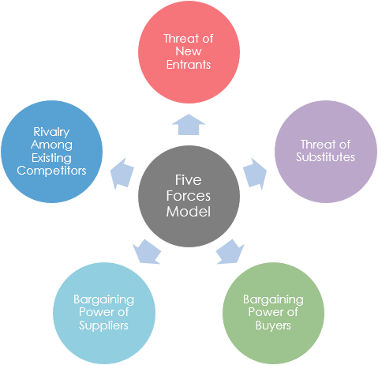
Fig. 2: Porter’s 5 Forces
(Source: https://www.visual-paradigm.com/tutorials/five-forces-analysis-tutorial/)

THREAT OF NEW ENFRANTS IS MODERATE. Considering the fact that these days, the opening of a new fast-food restaurant does not require a large investment, it means that this could be a threat to McDonald’s on a long term. Furthermore, there is a possibility that a new branch could offer new products, different prices and to represent an attraction to loyal McDonald’s customers. On the other hand, a small company would need an extreme amount of money in order to represent a competition to McDonalds, which has a history of many decades and is expanded over the majority of Earth. Also, this market of fast-food products is extremely crowded at the moment, which could represent a barrier for new investors. In conclusion, these external factors show that new entrants could be a threat which needs to be taken into account by McDonalds, but at the same time, not as important and dangerous as others.
THREAT OF SUBSTITUTES IS STRONG. Potential substitutes are a significant concern for McDonalds Corporation. These could be the many other fast-food chains such as: KFC, Subway, Burger-King, as well as bakeries, or simple sandwiches bought from supermarkets. For any customer, the move from McDonalds to any other substitute is very easy. This decision could be impacted by simply a desire in reducing their budget, or a past experience that made them unhappy. Therefore, this element of Porter's Five Forces represents a major strategic concern which requires different approaches, such as an improvement in the quality of products or a better permanent relationship with their customers.
BARGAINING POWER OF BUYERS IS HUGE. From this point of view, customers could make a permanent choice in another fast-food brand aside from McDonalds, as they could have higher and higher requirements due to the large amount of fast-food chains. Hence, these customers must be always treated as the most important part in the business. The offered services must be of the highest quality, as well as the waiting time which has an important role. The customers must be drawn in at all times, through advertisement or different offers and discounts.
BARGAINING POWER OF SUPPLIERS IS LOW. Over the years, McDonalds has ended partnerships with well-known companies such as Coca Cola Company or Dr. Pepper Snapple Group Inc., hence only good quality products are sold in their restaurants. A possible negotiation as well as a change of suppliers could generate in the future a negative change in terms of products and therefore dissatisfaction from customers. Therefore, this element of Porter's Five Forces analysis represents a small threat in the strategy of McDonalds.

RIVALRY AMONG EXISTING COMPETITORS IS STRONG. As seen in figure 3, at the beginning of 2020, McDonalds has kept their position as the leader in regards to the value of the brands, in comparison to their competition. Their main advantages that offer them this position are the large number of restaurants scattered around the world, as well as their reputation as the most known fast food chain around the world. This industry of fast food chains is in a continuous state of changes through the new created companies that seek to bring new products on the market that could launch them as a successful business. This element of the analysis shows that their competitors represent one of the most significant threats; much must be taken into their consideration (Dudovskiy, 2016).
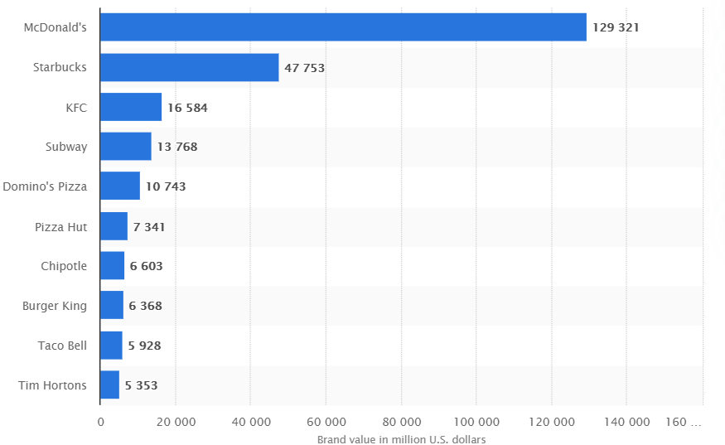
Fig. 3: Brand value of the 10 most valuable quick service restaurant brands worldwide in 2020
Source: https://www.statista.com/statistics/273057/value-of-the-most-valuable-fast-food-brands-worldwide/

Marketing SEGMENTATION, TARGETING and POSITIONING PROCESS:

Fig. 4: The STP Marketing’s steps

STP Marketing contains three steps shown in the previous figure, being crucial tools in advertising products. When using this technique, the market is divided into more parts, so they can focus on the most important ones. Afterwards, the product will be positioned in the right location in order to reach their target. One frequent mistake of most companies is to think that they can please the whole market with one product. This approach will make it difficult to sell the product as many potential customers will not find it suitable for their needs.

I. SEGMENTATION:
McDonalds uses different types of segmentation to adapt to their different types of customers:
- Geographic Segmentation - this divided the markets depending on the geographic region, for example: America, Europe, Asia, or other countries. Due to this division, McDonalds makes their menus depending on the regional tastes or needs. Some examples of these adaptations could be: McAloo Tiki and McVeggie, products available in India, McArabia Chicken and Beef Burger, available in Arabic countries or McRice which is available and limited to Indonesia. These deviations from the original menus are used in order to fit under the regional restrictions (for example beef is banned in India), and in order to keep up their total percentage of loyal customers all around the world (Khan M., Khan M. 2013).
- Demographic Segmentation - this firstly contains a division between age groups. For example, McDonalds has created menus for children as well as menus aimed for adults. Beside these, there is also a division between the total outcomes of their customers as some menus cost more than others, for the people that wish to spend less money.
- Psychographic Segmentation - this includes a segmentation of customers, based on their life styles, as there are more and more customers that are vegetarian or desire drinks with no sugar. Due to this, McDonalds continues to make different products such as salads or pies that can replace other unhealthy old products.

II. TARGETING:
After an appropriate segmentation, the company must establish an efficient strategy. The company must also have to choose the segments of the market that they wish to focus on.
Customer-wise, McDonalds focuses on children, and to attract as many of these as possible. McDonalds constantly creates ads that contain toys, festive meals or desserts, factors which lure children into their restaurants. Majority of these restaurants include external playgrounds where children can consume their energy in between classic meals, such as the Happy Meal. Also, there are games that include prizes, gifts, and not to forget the well-known mascot, Ronald McDonalds.

III. POSITIONING:
This step is about the decisions that must be taken regarding the way of advertising themselves on the market. In order to position the products correctly, McDonalds uses statistics about their customer's preferences, which they use to create a profile of positioning for every product. Therefore, through an appropriate positioning, they will try to satisfy all classes of customers that enter their restaurants; from children to older people and from people that are willing to spend more than others.

OBJECTIVES:
The most important objectives of the company McDonalds are maintaining their superior position in the fast-food industry as well as continuing their process of development by opening as many restaurants as possible. These two objectives are achievable only by keeping up the high number of customers compared to their competition, which can be maintained through the quick serving time, quality of products, as well as the low prices. Beside from these, a good, clean and friendly environment will make customers happily come back to the McDonalds restaurants.
STRATEGY:
After an analysis of the market and the establishment of the main objectives, McDonald’s must create a strong plan for the development of the business. For this, 5P’s marketing strategy will include: the product, place, price, advertisement and involved people.
- Products:
A significant advantage of McDonalds is represented by the varied menu in comparison to other fast food chains. Offering the customer the possibility to choose from a long list of products means that they will be likely more satisfied by the product. However, in order to assure this satisfaction, they monitor and use their customers' preferences, and introducing new products after a short while.
The main attraction from the McDonalds menu is the beef, chicken or fish burgers such as: Big Mac, Cheeseburger, Hamburger, Quarter Pounder with Cheese, Filet O Fish, Chicken Legend or the Mayo Chicken. Beside from these, there are also only chicken based products such as McNuggets or Chicken Strips, all served along French fries and drinks. Recently introduced products can include salads, shakes, desserts, pies or Mc Cafe products.
- Place:
This part represents the place where the products can be purchased from by the customers. At McDonalds, restaurants represent the main locations of distribution. However, in the last couple of years, virtual locations have also been used more and more. These virtual locations include mobile phone applications such as Uber-Eats, Deliveroo or Just Eat! as well as their official website.
Furthermore, McDonalds duty is to serve as many customers as possible, which is why they are aggressively expanding the company by establishing the location of new restaurants in urban environments; locations such as malls, airports, highways or crowded areas.
- Price:
At McDonald’s, they use a competitive strategy in establishing the prices of products, this meaning that they keep in mind other fast food chains' prices Another strategy is giving new products that might be a new attraction to customers, a high initial price, in order to benefit from the large amounts of these selling on their first days. The rest of the old products have standard prices, so they can be accessible to all classes of customers. Furthermore, the company offers different prices depending on the economical situations of different countries.

- Promotion:
The main purpose of this element is to is to present a product or service to people to make them feel eager to test it inside the restaurant. This focuses on communicating with these through advertisement, sales promotion or direct marketing. The first one is the most used tactic, through TV, online media or newspapers ads. The second category is used to make customers attend the restaurants, through coupons or free goods.
- People:
In this part there are two categories of people: consumers and employees. The leaders must understand the true connection between these two categories, meaning that only a full working team of employees can satisfy and serve customers in an appropriate way. It is very important that these employees are being respected and have a relaxed working environment. A client must be treated with a professional attitude when they enter the restaurant, which will make it likely that they will come back again.
IMPLEMENTATION:
The implementation plan in a company consists of decisions after establishing the strategy, which are aimed to produce improving changes. For example, regarding McDonalds, they had to make a change that would let them adapt to the customers' desires of healthier food. In order to satisfy these customers, they implemented more and more products with a lower quantity of sugar and fats.

CONTROL:
Marketing control represents an important step in the strategic marketing process as it consists of a review in order to identify problems, opportunities and modify the plan to improve the performance of the organization. This review is necessary because it allows the company to avoid bad decision making in the future, reducing the risk of repeated errors (Iyad, 2017).

2. Stakeholder engagement and their impact on the marketing activities of McDonalds Company:

A stakeholder is a person, group or organization that is interested in something. These stakeholder can be affected or have an effect on the organization (Gaur, 2013). Examples of stakeholders can be: a customer, a supplier or an employee. There are two types of stakeholders: internal and external.
- Market Stakeholders - represents the internal stakeholders, they are the ones that are involved in the economic transactions.
The employees of McDonalds represent the most important part of the business, which is why they are encouraged to work hard and improve their careers. Besides, the company itself knows that they offer low salaries, the bare legal minimum, and that there are too many working hours.
- Non-Market Stakeholders - external stakeholders that are not involved in economic transactions, however they are affected by them, some examples include suppliers, communities and customers)

Customers represent the people that bring the profits in restaurants, which is why the company must ensure that they are in a good mood after they decide to leave. McDonalds tries every time to complete this task, furthermore, they offer discounts or free meals to help this.
The suppliers are considered external stakeholders as they are directly involved in contracts with the company. McDonalds works with many suppliers in order to produce all their products on the menu. These suppliers are a crucial part because if they do not provide the restaurants with ingredients, the McDonalds employees will not be able to deliver the food, or make profit.
The communities are also external stakeholders because they can benefit from things such as working places, as well as fast-food products through McDonalds. The company puts a lot of price on the community's opinion because the business won't develop without offering good quality products.

How McDonald's communicates with their stakeholders:
INTERNAL STAKEHOLDERS | EXTERNAL STAKEHOLDERS
Meetings, Conferences | TV, Online advertising
Video Calls | Direct Marketing
E-mails | Newsletters

CONCLUSION:

In conclusion, the marketing strategy at McDonalds is based on the utilization of individual elements of the marketing communication mix. Their objective is to attract as many customers as possible, as well as offering these satisfying products and service.
From the SWOT analysis above, we can see that the most important strengths of McDonalds are their global presence, the strong brand or big cash flow. However, there are some things that are affecting their business negatively, such as: the big amount of unhealthy products offered to the clients or the continuous change of staff.
Porter's Five Forces analysis highlighted 3 main factors which could represent a long-term threat; bargaining power of buyers, threat of substitutes and rivalry among existing competitors.
McDonalds has different stakeholders, internal or external, each having a well-established objective for the company. The communication with these has an important role because it's the way they can achieve these objectives. Furthermore, all the McDonalds restaurants around the world face new threats such as: training the employees for a correct preparation process, gathering the necessary ingredients from the suppliers and a fair and friendly service.
Over the years, McDonalds has tried to modernize their logo, design, menu and the marketing strategy, which led to their fresh and friendly image.

RECOMMENDATIONS:

- Market Extension: keeping in mind the amount of new fast-food chains in the industry, all around the world, as well as the fact that McDonalds owns enough for a potential expansion, their development around the market is a strategy that should be taken into consideration, from large cities such as European capital cities, to less populated ones.
- Against Obesity: considering the desire of healthier food as well as the number of obese children, McDonalds will have to consider a different responsible approach, by introducing as many healthy products as they can. These threats have determined many people to question their chosen products as McDonalds, which could have an impact on the total number of served people in the future if no actions are being taken.
- Quality Service: given the new modifications introduced by government regarding the pandemic, many restaurants have less-employees than usual, which have to deal with a larger number of customers than usual. Due to this, these employees need to avoid a crowded building through a professional way of serving food.

REFERENCES:

- Ahmed R. R. (2016) ‘Strategic Marketing plan for McDonald’s 2016’. University Karachi Pakistan
- Dudovskiy J. (2016) ‘McDonalds’ Porter’s Five Forces Analysis’
- Gaur V. (2013) ‘Understand your stakeholders’ International Journal of Advancements in Research & Technology, Volume 2, Issue1, January-2013
- Gerhardt S., Hazen S., Lewis S. (2014) ‘Small Business Marketing Strategy Based on McDonald’s’ Vol. 21, No. 1, 271-278.
- Gundlach G., Wilkie W. (2009) ‘The American Marketing Association’s new definition of marketing: Perspective and Commentary on the 2007 Revision’. Journal of Public Policy & Marketing, Vol. 28 (2). Fall 2009, 259-264.
- Iyad A. (2017) ‘Impact of Applying the Marketing Control on the Competitive Position for Dairt Companies in Saudi Arabia’ Journal of Business & Economic Policy, School of Advertising and Marketing Communication KSA, Vol. 4, No. 2, 79-96.
- Jing H. (2008) ‘The Business Strategy of McDonald’s’ International Journal of Business and Management, Vol. 3, No. 11, 72-74.
- Khan M., Khan M. M., (2013). ‘I’m lovin’it around the world: A case study of McDonald’s glocalization’. In SAGE Business Cases. SAGE Publications. Ltd.
- Kapoor S. (2018) ‘Analysis and Critical evaluation of Strategy followed by McDonald’s India’ MBA. International Business.
- Nawaz S. (2011) ‘Employee motivation: A study on some selected McDonalds in the UK’. Department of Management, Islamic University, Bangladesh.
- Vrontis D., Thrassou A. (2006) ‘Situation Analysis and Strategic Planning: An empirical case study in the UK beverage industry’. University of Nicosia.

