ABOUT MY POSTER

02/05/2024

Digital Technologies

Anamaria-Cristina Finta Tutor:Mark Huntly

In my poster, I wrote some information about Digital Technologies, The definition of it, Big Data and Real-time Analytics, and other many useful things like the Internet of Things.

I added a few pictures and illustrations, along with some specific graphics.

 | I hope this would convince young people to join us a big Data Analiytics in real time as a future job. | 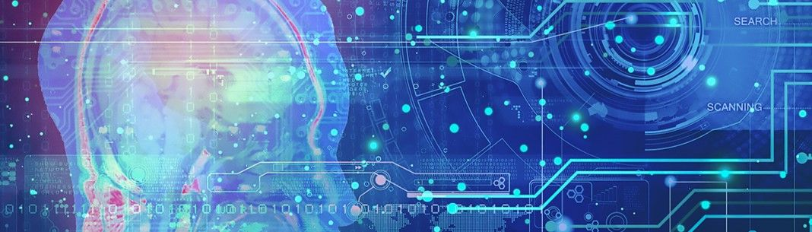

References

Definition of Digital Technology [01]
https://www.studysmarter.co.uk/explanations/business-studies/business-development/digital-technology/

Big Data and Real-Time Analytics & Internet of Things (IoT) [02]
https://www.glueup.com/blog/digital-transformation-technologies
One of the most common Internet of Things examples is smartwatches. Wearable IoT technology like Fitbits and Apple Watches connect to other devices (like your smartphone) to share data. They typically also connect to the internet to track GPS locations.

What is IoT? [03]
One of the most common Internet of Things examples is smartwatches. Wearable IoT technology like Fitbits and Apple Watches connect to other devices (like your smartphone) to share data. They typically also connect to the internet to track GPS locations.

Conclusion [04]
https://digitialtechforeducation.weebly.com/conclusion.html

