Problem Solving and Decision Making
(BMSK4014)
Nicola Jones
2431355

Table of contents

Introduction | 1
Information Analysis | 2
Alternative Solutions | 5
Plan For Implementing the Solution | 8
Communication To Stakeholders | 10
Reflection | 15
Reference’s | 16

Introduction
The availability and punctuality of clinical staff is very important for the smooth running of daily schedules in any dental practice. When an associate dentist calls in sick at the last minute, it can be a problem that cannot be ignored. (McLean, 2023) This situation could put a lot of stress on the practice's operations, finances, and reputation. Looking at a problem that came up out of the blue: an associate dentist was unwell and had to miss work, and the practice needs to figure out how to best handle and fix the situation in a timely manner.
To find the best solution looking at many possible plans and then use analytical tools like Mind Mapping, 5 Whys, and Root Cause Analysis to evaluate them. With these tools, you can break down the problem, find its root causes, and come up with both defensive and proactive steps that can be taken to avoid future problems.
Scope: The office manager, the front desk staff, other dentists, dental nurses, and, most importantly, the patients are the first people who will be affected. This can cause patients to be annoyed and unhappy, appointments to be rescheduled, and extra work for the staff. Other dentists may have to take on extra work in some cases, which would put extra strain on an already busy schedule.
Effects: In the short run, there will be less money coming in, unhappy patients, and more stress among staff. There could be long-term effects if this isn't dealt with well, such as damage to the practice's image, loss of patients, and staff burnout. Knowing how big and bad this problem really is will help figure out how to deal with similar situations more effectively in the future.
Using structured brainstorming and problem-solving methods to look at different possible solutions and come up with a useful, well-thought-out way to handle an associate dentist absence from the practice.
AI was only used to help with research (finding references, summarising, and comparing materials), to help structure the work (writing argument flow and headings), and to proofread.

1

Information Analysis
Brainstorming is a good way to effectively analyse information, (He et al., 2024) it leads to new ideas and deeper insights. Looking at things from new views and finding hidden connections in the data by sharing their ideas without immediately judging them. This encourages creativity, uncovers overlooked details, and tests assumptions. One person's idea can spark another person's, which speeds up the process of fixing a problem. Brainstorming can also help you find information gaps, set goals, and come up with several ideas before deciding on one. This leads to a more complete analysis that combines critical thought with creativity. This makes it more likely that accurate, useful, and new solutions will be found.

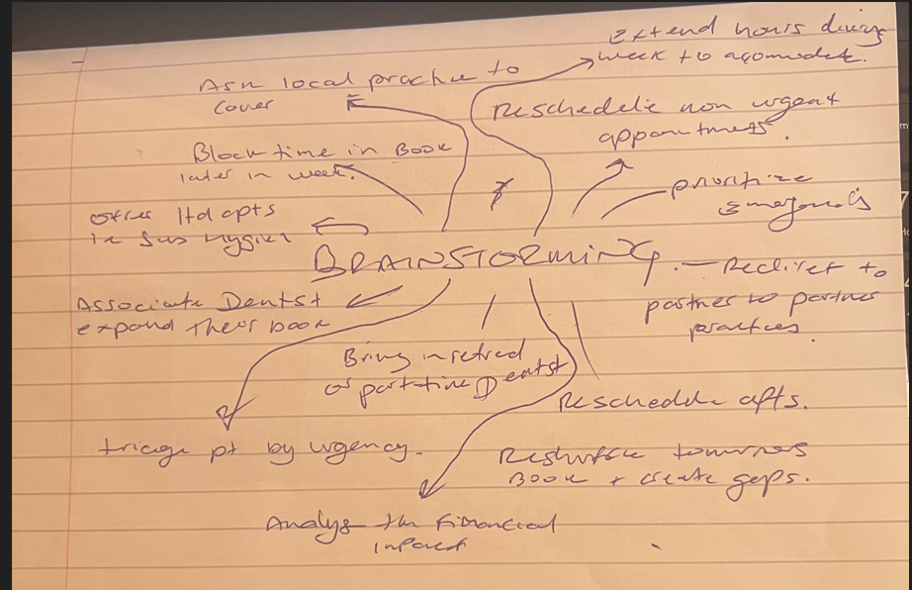

Above are brainstorming ideas for the problem of an associate dentist calling in sick and how to resolve the issue.

Because mind mapping visually arranges potential solutions, including rescheduling appointments, transferring workload, or bringing in temporary assistance, it can be helpful in resolving an associate dentist's sick-day issue. (Benedikt, 2024) It is simpler to recognise priorities, dependencies, and innovative solutions when options and their impacts are presented in a clear, connected way. This approach guarantees that no crucial element is missed and encourages quick, organised thinking.

2

Staff Process
Reallocate patients to other dentists Prioritize urgent cases
Use dental hygienists for certain treatments Reschedule non-urgent
Bring in locum/temporary dentist Use cancellation list to rebook later
Extend hours for remaining staff Streamline procedures to save time
Adjust breaks to cover peak times Adjust breaks to cover peak times
Work later though the week

BRIANSTORMING
MIND MAP

Communication
Notify patients quickly via calls/texts
Update online booking system
Inform all staff of changes immediately
Provide clear scripts for reception staff
Post updates on practice social media

Above is a Mind Map of ideas to solve the problem of an associate dentist calling in sick, it is a beneficial step to solve the issue.

The 5 Whys method is helpful because it enables you to look past visible signs of an issue to determine its true cause. Asking "Why?" five times or more helps you find deeper problems that could otherwise go unnoticed. (Five Whys, n.d.) This helps you find long-term answers rather than stick a plaster on it treatments that just address the issue. It is easy to use, requires no specialised equipment, and may be applied to a variety of challenges, including process failures and staffing shortages.
3

- Why did this disrupt the practice?
Because list of patient appointments could not be covered as planned.

- Why couldn’t the appointments be covered?
Because there was no immediate backup dentist available.

- Why was there no backup dentist available?
Because no formal locum or cover arrangement had been arranged.

- Why was no arrangement in place?
Because contingency planning for sudden staff absence had not been developed or documented.

- Why had contingency planning not been developed?
Because the practice had been relying on ad-hoc solutions rather than a structured approach to staffing emergencies.

A 5 Whys technique used above to show why this problem occurred and how they can resolve this for the future. (McLean, 2023)
An Ishikawa (fishbone) diagram can help you figure out why. (Wong, 2011) This is because it clearly divides the problem into groups, like equipment, environment, people and material, so you can see all the possible causes at once. This organised method helps find the real reasons behind problems, not just their short-term effects, and makes sure that no aspect is missed. By making a map of the links, the team can find weak spots, come up with specific ways to fix them, and get ready for future absences more effectively.
4
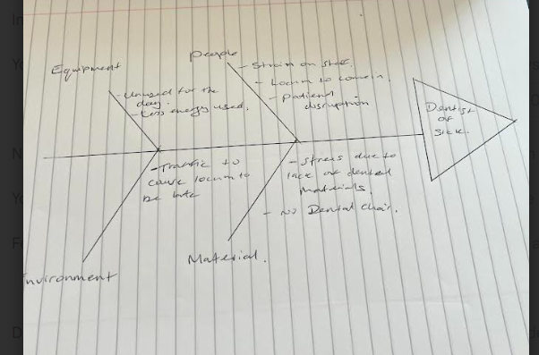
Above is a simple fishbone diagram regarding the problem of the dentist calling in sick.

Alternative solutions
There are various practical answers to the dilemma of an associate dentist calling in sick at short notice using existing resources.
Rearranging appointments among the remaining dentists prioritising urgent cases. This ensures continuity without overloading clinicians.
A locum dentist can also provide professional cover and allow the practice to continue its full range of services.
The practise could collaborate with a nearby dental practise to cover certain locum appointments if none are available.
The practice might also extend working hours later in the week to clear the absence backlog. Flexible scheduling reduces cancellations and patient discontent by seeing patients quickly.
Rearranging patients, finding locum support, extending hours, and seeking help from
5
local clinics helps the practice manage unforeseen personnel shortages while preserving patient care and minimising inconvenience.

Resolving the problem of a dentist calling in sick can be greatly aided by the application of well-known decision-making techniques such as grid analysis (Decision making techniques – criteria grid, n.d.)and cost-benefit analysis (Hwang, 2015) .
Through comparison of variables like cost, practicality, influence on patient care, and staff effort, grid analysis enables the practice to logically assess several options, including rearranging patients, hiring a locum, extending hours, or seeking assistance from a nearby practice. By evaluating each choice in light of these standards, the practice may quickly and efficiently determine which options provide the greatest overall benefits.
Similar to this, a cost-benefit analysis compares the expenses of each option with the advantages—like preserving patient satisfaction, reducing staff burnout, and preventing appointment cancellations. This makes it possible to make sure that resources are used effectively and that the solution selected offers the most benefit at the lowest possible cost.
When combined, these methods offer a logical, organised approach to evaluating possibilities, eliminating uncertainty and ensuring that the practice reacts to unplanned staff absences successfully. Both the dental team and the patients benefit from this.

Factors | Time | Cost | Patient reactions | Result
Weights | 5 | 4 | 3
Rearrange | 4 – 20 | 2 – 8 | 0 -0 | 6 - 28
Locum | 2 – 10 | 2 – 8 | 4 – 12 | 7 – 30
Work Later | 2 – 10 | 3 – 12 | 2 – 6 | 7 – 28
Local Practice | 2 - 10 | 1 - 4 | 2 - 6 | 5 - 20

Above is a Grid Analysis showing the scoring suggesting the option to arrange a locum dentist would be the best solution.
6
A cost-benefit analysis would be beneficial also as it allows the dental practice to weigh the financial and functional impact of the dentist's absence like lost patient revenue, rescheduling costs, patient dissatisfaction, against the costs of potential solutions (e.g., hiring a locum dentist, paying overtime, rearranging schedules).
By assessing these possibilities, the practice can choose the one that reduces total losses while keeping operations running as smoothly as possible.
Option | 1 | 2 | 3 | 4 | 5
Locum charge | 1000 | 1000 | 1000 | 1000 | 1000
Extra Reception | 100 | 100 | 100 | 100 | 100
Net cost | 1100 | 1100 | 1100 | 1100 | 1100
Loss – patients not wanting to change | 300 | 300 | 200 | 200 | 200
Total | 1400 | 1400 | 1300 | 1300 | 1300

= £6700 cost for associate dentist calling in sick 5 times.
Above is a cost benefit analysis over a 5-month period if the dentist calls in sick once a month over a 5-month period. As an associate they would not be paid as they would be self-employed, so no extra payment is taken for them.

List of benefits table –
 | 1 | 2 | 3 | 4 | 5
Patients attending | 500 | 500 | 600 | 600 | 700
Associate off sick | 900 | 900 | 900 | 900 | 900
Total | 1400 | 1400 | 1500 | 1500 | 1600

This list of benefits table shows the total calculation over 5 months to be £7400.
7

7400 $÷$6700 =1.1
1400-1400 = 0
7400 – 6700 = 140
These calculations show the benefit over 5 months to be a plus of £140.

Over the course of five months, the cost–benefit analysis shows that the associate dentist calling in sick once a month costs the practice a total of £6,700. This includes the locum fee, extra costs for the reception staff, and lost revenue from customers who don't want to change their appointment. During the same time period, the rewards add up to £7,400, which is a net gain of £140.
This small financial gain may not seem like much, but the real benefit is keeping up high patient attendance—700 in the best month—along with consistent service and patient happiness. Keeping patients helps protect the practice's long-term income and image, which aren't fully reflected in short-term costs.
The study shows that getting in a locum, even if the prices stay the same every month, keeps things running smoothly and reduces downtime. The main goal shouldn't just be to save money, but also to get the best mix of making money, keeping patients, and keeping the business running smoothly every day.

Plan for implementing the solution
A Gantt chart shows activities or jobs on a timeline and is a visual tool for managing projects. It shows what needs to be done, when it needs to be done, and who is responsible for it. (Ramachandran & Karthick, 2019). The bars show how long each job takes.
A Gantt chart can help when an associate dentist calls in sick because it
makes it clear which jobs need to be covered, by whom and when they happen.
Assisting the practice in rescheduling or reassigning tasks in a way that keeps patient care uninterrupted.
8

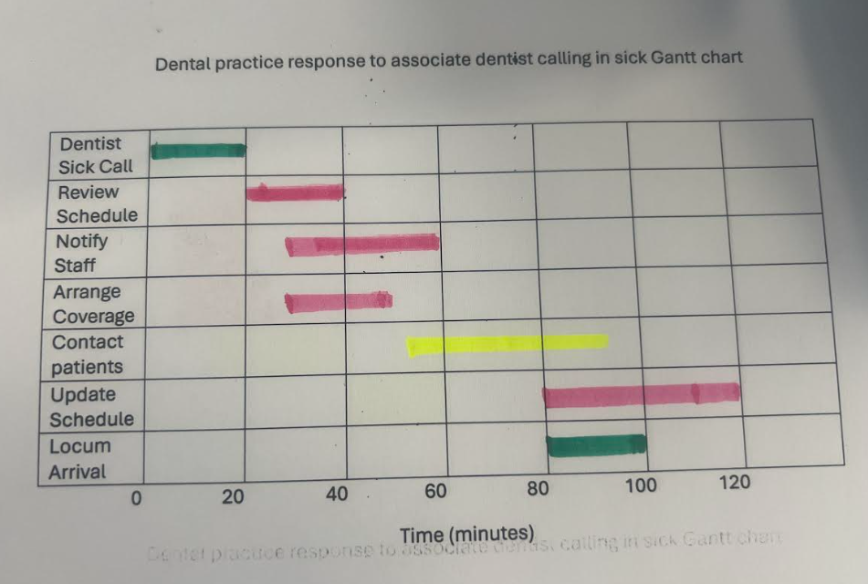
Green – Clinician
Pink – Practice manager
Yellow – Reception staff

Above is a Gantt chart showing who needs to do what and at what time.
Based on the colour coding in the Gantt chart, here is a list of jobs and what they are responsible for:
Green: Dentist
Calling in sick as a dentist (0–20 minutes): The dentist starts the process by calling in sick.
Locum Arrival (80–100 minutes): Later, the dentist comes to work to cover the shift.
Pink: Manager of the practice
9
Over the course of 20 to 40 minutes, the practice manager looks over the day's
appointments to see how the dentist's absence will affect things.
Notify Staff (30–50 minutes): The practice manager tells the rest of the team what's going on.
Arrange Coverage (30–50 minutes): They also work together to find a locum dentist to cover.
Update Schedule (80–120 minutes): Once changes and coverage are confirmed, the meeting schedule is changed to reflect those changes and coverage.
Yellow: Reception staff
Contact Patients (50–90 minutes): The receptionist calls patients to let them know about changes, reschedule appointments, or confirm that the locum dentist will be coming.
The Flow:
Dentist is sick and calls in (Green).
The practice manager quickly looks over the day's plans and lets the staff know (Pink).
They make plans for covering (Pink).
The receptionist tells the patients (Yellow).
Schedule has been changed (Pink).
The temporary dentist shows up (Green).

Communication to Stakeholders
If an associate dentist calls in sick, the stakeholders would be:
1. The associate dentist who called in sick
They are important to the situation and their absence starts the reaction process.
Needs to let people know when they're available and any important information about the patient or care.
10
2. The practice manager is in charge of the operational reaction.
Sets up covering, keeps staff informed, and changes the day's work flow.
3. The receptionist or front desk team talks to patients, changes appointments, and keeps notes up to date.
4. A locum dentist takes over to care for the patient.
Has to be kept up to date on the plan, patient needs, and practice rules on a regular basis.
5. Dental hygienists and Dental nurses
Might have to switch appointments to accommodate, set up rooms in a different way, and help a different clinician.
6. Patients who were scheduled for that day will be directly affected; they need to be told about any changes to their appointments, delays, or new treatment providers.
7. The practice owner – Principal Dentist needs to know about any problems with operations, how they affect income, and how to keep services running.

Stakeholder | Influence | Interest | Why kept informed | Communication method
Practice manager | High | High | Coordinates coverage, oversees work flow, and makes sure activities run smoothly. | Direct and immediate updates; a say in all decisions.
Receptionist | Medium | High | Talks to patients keeps the schedule up to date, and handles appointments. | Clear directions and quick notification after the manager is told.
Locum | High | High | Offers continuity of care; needs information about the patient and their plan before arriving. | Get in touch early with full case and process information.
Hygienist/Nurse | Medium | Medium | Change their responsibilities, get rooms ready, help a locum, or get used to the new situation. | Update when the covering plan is set in stone.
Patients in that day | Low | High | Need to know about cancellations, rescheduling, or new provider. | Communication that is on time, clear, and caring.
Principal Dentist | High | Medium | Oversees business, finances, and making sure patients are happy. | Update with a summary after service is set up.
Associate Dentist | High | Medium | Must say when they are available and record information about patients and treatments. | The first message to start the process, plus any follow-ups if the absence lasts longer.

High Influence / High Interest - practice manager – locum dentist
High Influence / Medium Interest – principal dentist – associate dentist
Medium influence / High Interest – receptionist – dental nurse
Low influence / High Interest – patients 12

Level of Influence
When an associate dentist calls in sick, this is the influence–interest matrix for the people who matter:
Top-right (High Influence, High Interest): Practice Manager and Locum Dentist—need information right away and to be involved.
Principal Dentist and associate dentist (high influence, medium interest): keep them informed for planning and control.
Middle-right (Medium Influence, High Interest): Receptionists and dental nurse—let them know right away when the plan is set in stone.
Bottom-right (Low Influence, High Interest): Patients should be told about changes in a clear and caring way.

A communication plan specifies who needs information, what they need, how, when, and by whom. (Galli, 2022)
13
It helps solve difficulties because it clarifies roles and responsibilities so everyone understands who to contact and what to communicate.
Misunderstandings are avoided by consistent, truthful messaging.
Informs stakeholders so they can act fast.
Decisions can be made faster when information flows reliably and predictably.
It helps everyone stay on track in the team.

Communication plan
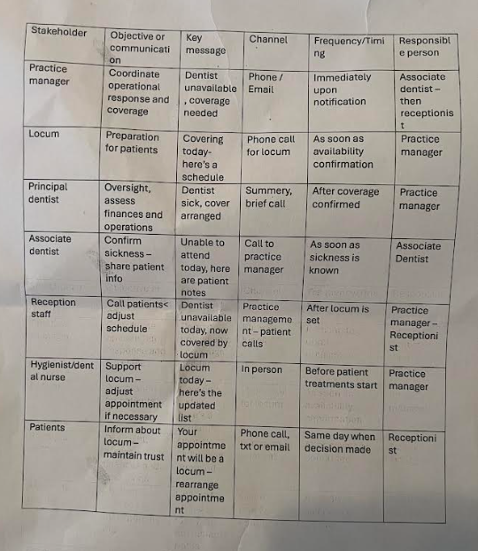
Above is a communication plan showing who does what, when and how.

14

Reflection
This shows how important it is to have a clear, structured communication plan for when problems arise out of the blue in a dental practice. When an associate dentist calls in sick without warning, it can affect the business's operations, finances, and patients' happiness. A well-thought-out communication plan makes sure that the right people get the right information quickly, which cuts down on confusion and lets people move quickly.

Right away, there is clarity, everyone involved, from the office manager to the receptionist, knows their part, what they need to say, and when they need to say it. This keeps people from getting messages that aren't consistent, are done twice, or are missed. Trust in the practice is kept up even when things are bad by making sure that patients are told quickly and with compassion.

Problem-solving techniques like Mind Mapping, 5 Whys, and Root Cause Analysis can help with the communication plan by showing both short-term fixes and long-term ways to avoid problems. Mind mapping can help you picture choices like moving patients around, finding a locum, or staying open later. The 5 Whys show where the problems really are, like not having a written backup plan. These problems can then be fixed for the future.

When used with structured brainstorming, these help people come up with creative, useful ideas. They make sure that decisions aren't just based on gut feelings, but on both operational goals and patient needs. A communication plan also helps people make decisions faster by ensuring that information moves in a predictable way. This means that things like rescheduling or hiring a locum can be done without any unnecessary delays.

This report shows that clinical skill is important for the success of a dental practice, but being able to communicate well during problems is just as important. Communication that is clear, on time, and consistent not only lessens the effects of staff absences right away, but it also protects the practice's image, staff morale, and patient loyalty.

15
References

Benedikt, J. (2024, June 22). Does brainstorming work? What does the data research say? Jiří Benedikt. https://www.jiribenedikt.com/brainstorming/?utm
British Dental Association. (n.d.). Sickness absence. Retrieved August 16, 2025, from https://www.bda.org/advice/employment-law/pay-leave-and-rewards/sickness-absence/?utm
Decision making techniques – criteria grid. (n.d.). University of Minnesota Extension. Retrieved August 16, 2025, from https://extension.umn.edu/leadership-and-civic-engagement/decision-making-techniques-criteria-grid?utm
Five Whys. (n.d.). Taylor & Francis Knowledge. Retrieved August 16, 2025, from https://www.taylorandfrancis.com/knowledge/Engineering_and_technology/Engineering_support_and_special_topics/Five_Whys/?utm
Galli, B. J. (2022). The role of communication in project planning and executing. International Journal of Applied Management Sciences and Engineering, 9(1), 1–20. https://doi.org/10.4018/IJAMSE.302902
He, J., Wu, B., Zhong, H., Zhan, J., Zhu, L., Zhang, J., Zeng, Y., … & Li, Z. (2024). Implementing mind mapping in small-group learning to promote student engagement in the medical diagnostic curriculum: A pilot study. BMC Medical Education, 24, Article 336. https://doi.org/10.1186/s12909-024-05318-0
Hwang, K. (2015). Cost-benefit analysis: Its usage and critiques. Journal of Public Affairs, 16(1), 75–80. https://doi.org/10.1002/pa.1565
McLean, I. (2023, June 5). Partnerships: Continuity and contingency planning. BDJ In Practice, 36, 33. https://doi.org/10.1038/s41404-023-2011-0
Ramachandran, K. K., & Karthick, K. K. (2019, May). Gantt chart: An important tool of management. International Journal of Innovative Technology and Exploring Engineering, 8(7C), 2278–3075. Retrieved from ResearchGate
Wong, K. C. (2011, March 29). Using an Ishikawa diagram as a tool to assist memory and retrieval of relevant medical cases from the medical literature. Journal of Medical Case Reports, 5, 120. https://doi.org/10.1186/1752-1947-5-120

16

