Learning in the digital era
Assignment 2
Personal Development Plan Video
Karen Windsor (1918576)
Course BSc Computing Data and Information Systems
1918576@student.uwtsd.ac.uk
30/12/2020
Contents

1. Accessing Video 2
1.1. Website link 2
1.2. Page Link 2
1.3 Shared Document 3
2.Screen Shoots of PowerPoint Presentation 4
3. PowerPoint Presentation 5

1. Accessing Video

There are 3 methods of linking to the Personal Development Plan video

1.1. Website link
https://1918576.wixsite.com/website
Once you have clicked on the website (above)
You will need to choose the Assignment 2 page – see below
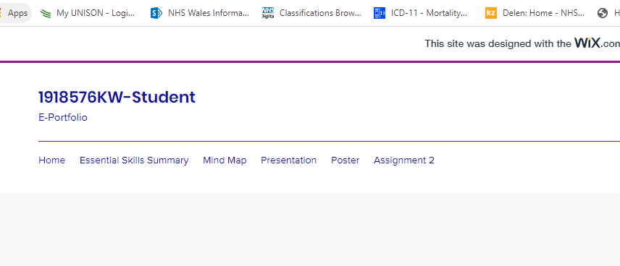

1.2. Page Link
https://1918576.wixsite.com/website/blank-page-4
The above link will take you straight to the web page hosting the video
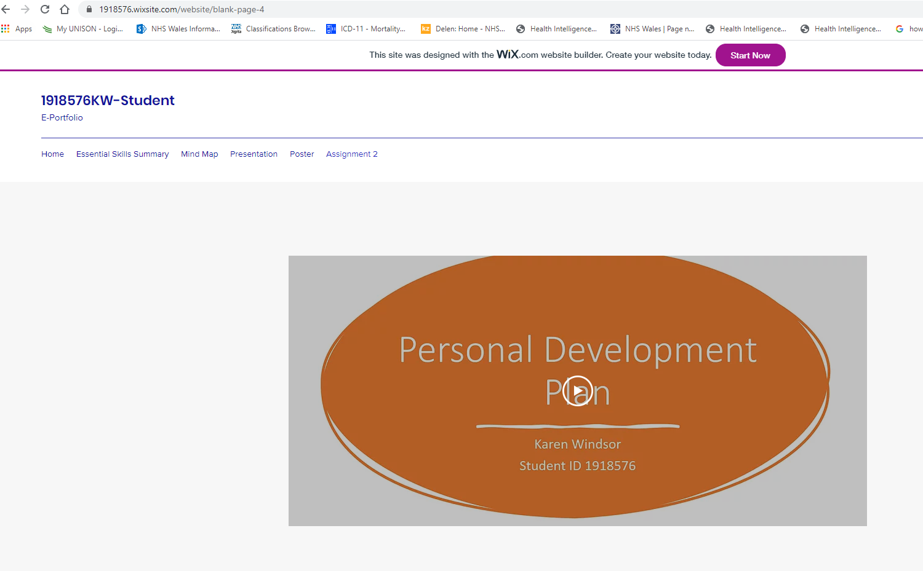

1.3 Shared Document

Below is a link to the video which is saved in my ‘ONE DRIVE’

https://uowtsd-my.sharepoint.com/:v:/g/personal/1918576_student_uwtsd_ac_uk/EfNN0wshTDZDtJAd-0kh2YEBb0I5LACLi_BhXv5QVjLLFA?e=ceNvG6

2.Screen Shoots of PowerPoint Presentation

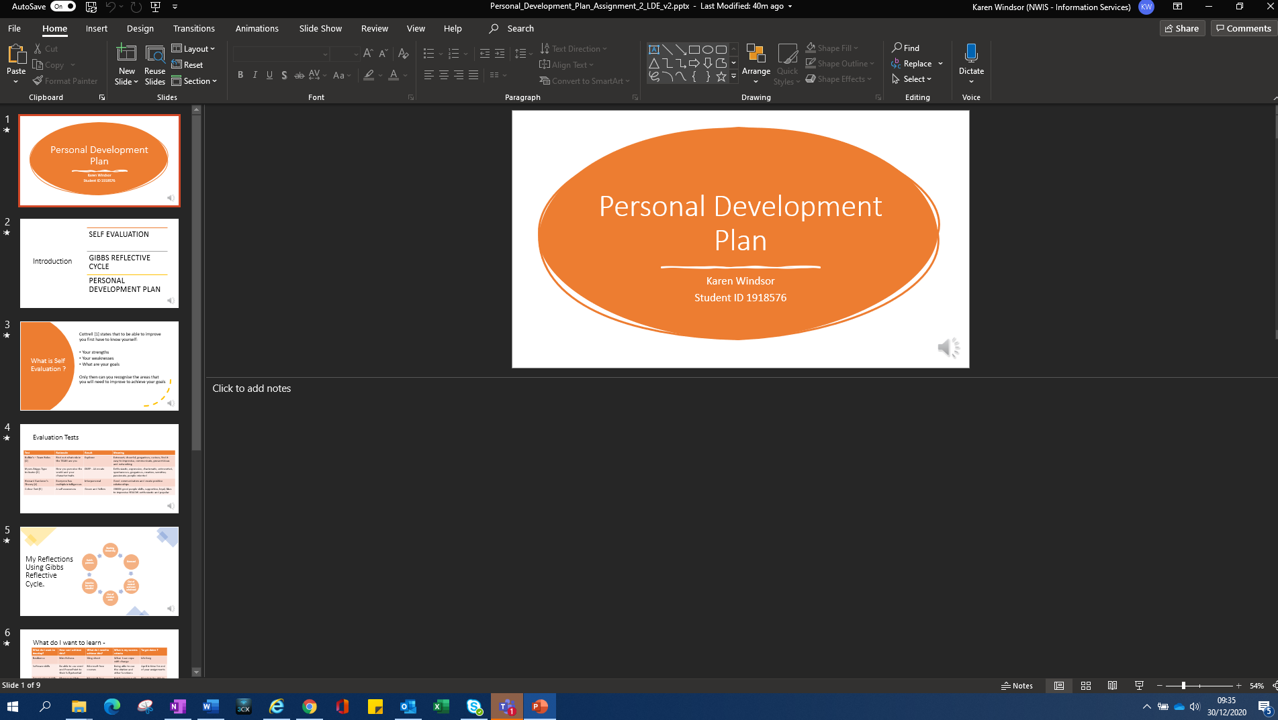
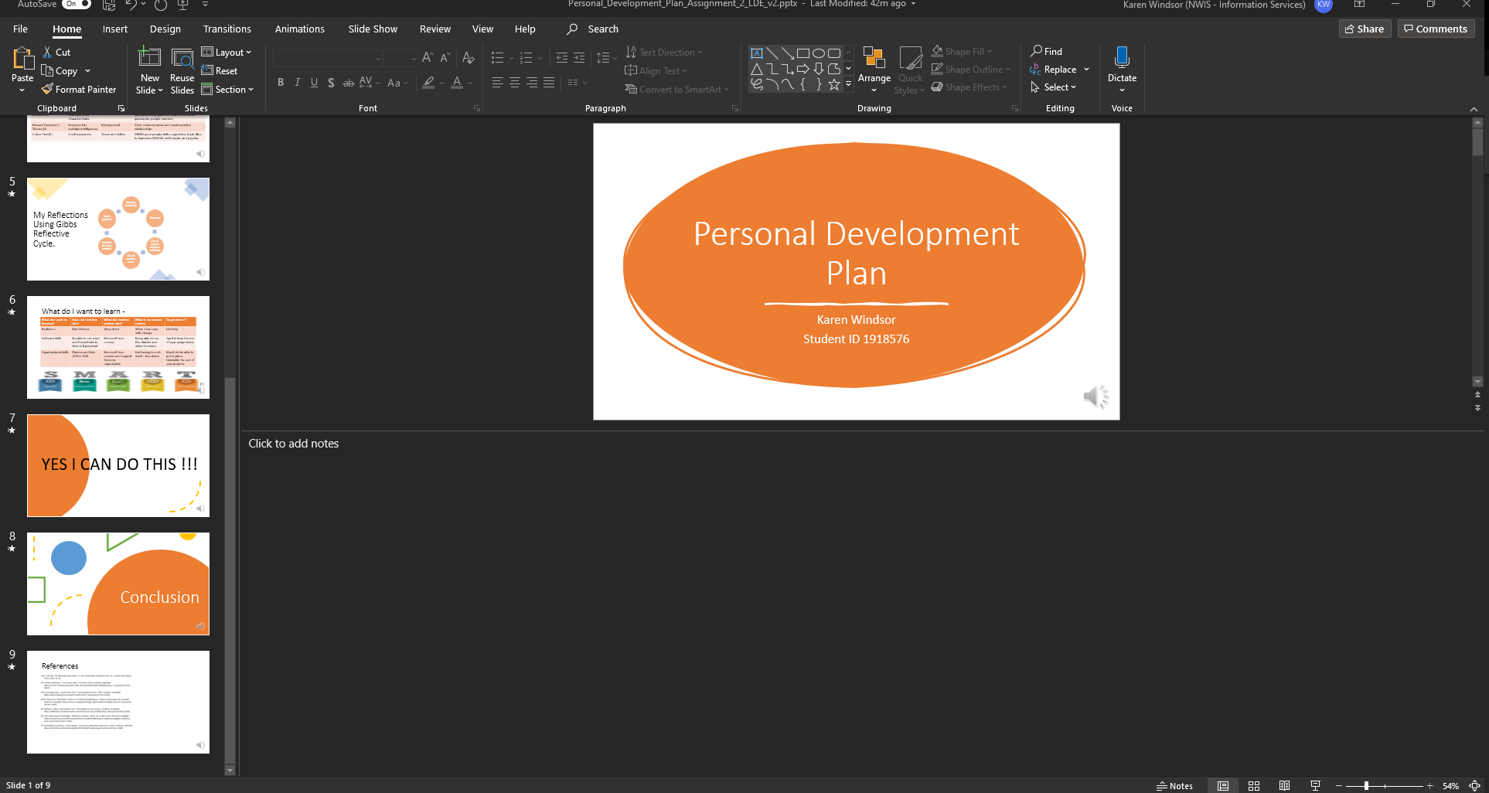

3. PowerPoint Presentation

