Knowledge and Information Management Skills for the Workplace
BMSW-5106 T2G1
Shamima Akther Supa -1916787
Lecturer-Yajesh Kumar

Table of Content
Task-1
Introduction............................................................................................................................3
Significance of effective creation, storing, application and integration of information for good knowledge management development practice.....................................................................4
Evaluation of the identified scenario of Amazon....................................................................5
Different knowledge management theories and models applied...........................................6
Nonaka and Takeuchi model of knowledge management.....................................................7
Choo Sense making knowledge management model............................................................8
Wiig model of building and using knowledge.........................................................................8
Effectiveness of knowledge and information management culture to create knowledge asset and to maintain effective customer relationship management...............................................9
Amazon’s potential knowledge management challenges.....................................................10
Recommendations to strengthen their knowledge management practices from the knowledge acquisition-retention-transfer perspectives........................................................11
Conclusion...........................................................................................................................13
Task-2...................................................................................................................................13
References..........................................................................................................................14

Task-1

Introduction
Amazon is one of the renowned Information Technology Organisation in America which deals with different kinds of products and services. E-Commerce is one of the renowned and most profit-generating segments for Amazon. The company has achieved significant recognition and customer base in the e-commerce atmosphere due to the convenience and low-cost leadership that it provides its customers (Amazom, 2021). The company has a large but diversified workforce around the world that is in place to build successful relationships with customers. The pandemic situation has reshaped the structure of the organisation and the nature of the way it deals with its customers and suppliers (Sadq et al., 2018). The frequent lockdown has shifted off-line trading to online trading, and Amazon has grabbed that opportunity by investing much more in their e-commerce platform. By investing in e-commerce projects, Amazon has been able to attract more and more customers only during that period. It has also hired many more employees to answer then create a customer base. Finally, it has created an employee-friendly workplace and invested much more to ensure the safety of its employees. This organisation also emphasized knowledge management principles so that it can build successful and sustainable relationships with their customers by providing real-time information to the customers; this report focuses on the different models and theories of knowledge management used by Amazon to develop a successful relationship with their customers through collection, dissemination, storing and applications of knowledge. Nonaka and Takeuchi model, Choo Sensemaking knowledge management model, and Wiig model of building and using knowledge have been related to the case of Amazon as they are relevant to the case of the company (Venkatesan, 2017).

Significance of effective creation, storing, sharing, application, and integration of information for good knowledge management development practices
KM is defined by the generation and development of knowledge. Any organization's survival depends on its ability to create knowledge. Knowledge generation is a process that occurs in everyday life, whether at the workplace or in social settings. Knowledge is created in a variety of ways, including humanitarian activities (such as formal training or interacting with individuals who have similar passions) and technical procedures (data mining activities through computer programs). Knowledge creation is mainly a human activity; technology can help, but it cannot substitute for it. In Amazon, knowledge is created through interaction with the customers through either face-to-face interaction or customer machine interaction (Alavi and Leidner, 2021).
Information is stored for further use or retrieval in computerized systems in Amazon. Information storing creates value for the organization as it has significant valence for the company to generate insights. The stored information is then shared across the organization through organizational mechanisms. Sharing and dissemination of information make information meaningful and useful. If information and knowledge are used to make data-driven decisions through instruction and routines, this is known as knowledge application. Routines entail applying knowledge encoded in protocols, standards, values, and processes to direct future behavior (Alavi and Leidner, 2021).
The above functions are significantly useful in Amazon or any other organization to capture information and process it for its meaningful use. To ensure effective information and knowledge creation, dissemination, application, and integration following best practices are essential for knowledge management development:
Insights on organizational culture:
It is critical to examine company culture before choosing a knowledge management system because it controls how workers act and accomplish their responsibilities. It's also vital to remember the people who run the system, not the pricey or costly systems, are the main driver behind an effective knowledge management system. The capabilities of a company's employees are an important component of the institution's business demands, and they must be considered while developing a knowledge management system business case. Purchasing a costly and complicated system that does not match business objectives would be detrimental if the company's employees had only computer skills.

Cautious implementation of systems:
It's critical to take your time when implementing KMS for the first time. This is due to the fact that individuals do not generally react well to rapid changes and will most likely avoid adopting a foreign system that they are unfamiliar with. Managing change will be easier if the system is implemented in small, gradual phases. It also allows the company to assess user uptake, make minor adjustments, and learn from the past in order to enhance the company's KMS (Calvo-Mora et al., 2016).
Engagement and empowerment of staff to KM:
Most KM systems fail because of the long-held belief that by suppressing essential information, an employee becomes a fundamental component of the company who cannot be fired because of his or her high position. Powerful motivational incentives, such as an incentive, an employee perk, or even simple expressions of gratitude and acknowledgment, can be used to modify this type of behavior (Berryman, 2005).
Assurance of knowledge ownership practice:
For a variety of reasons, this is an excellent strategy to keep a firm's Knowledge management systems up to date. Workers are motivated to follow KM guidelines and deliver well-organized, reliable, and proper information if their names are attached to the knowledge they supply. The performance appraisal would be simple to implement in this manner, and good information suppliers would be able to take ownership of work (Calvo-Mora et al., 2016). Workers would be held accountable for their own expertise, making KM management much easier. Knowledge consumers can also ask expertise owners for corrections or justifications if they find the content difficult to understand.

Evaluation of the identified scenario of Amazon
Amazon has a number of product lines; E-Commerce is one of the most profitable segments for the company. For the segment, the company especially follows the convenience and low price strategy to provide their customers with personalized service. During the coronavirus crisis, most of the retail chains have been out of business. But Amazon has been able to increase its sales revenue ever more than normal. The secret of being so successful in sales revenue during the coronavirus crisis is that the company has been able to build a one-to-one relationship with their customers during the panoramic situation. While most of the organisation was laying off employees due to compressed business activities, Amazon hired much more employees to keep the wheel of business moving (Gibbert et al., 2020). The company has increased the number of warehouses to serve the over health orders of the customers and also hired 36400 new employees within a three months duration. Amazon has been ever through tremendous active success in direct change due to its investment in knowledge management systems and customer relationship management. Through knowledge management systems, that company has been able to provide customized and personalized Service Delivery to their customers, which has a positive impact on their experience. Amazon believes that information and knowledge are the most precious and valuable resources for an organisation to know better about the customers and their expectations (Gibbert et al., 2020). Therefore the organisation is trying to enhance the value of knowledge generated by their knowledge management system. Knowledge management is a computerized system that captures, creates, stores, shares, and applies knowledge across the organization. The knowledge management system of Amazon is as follows:
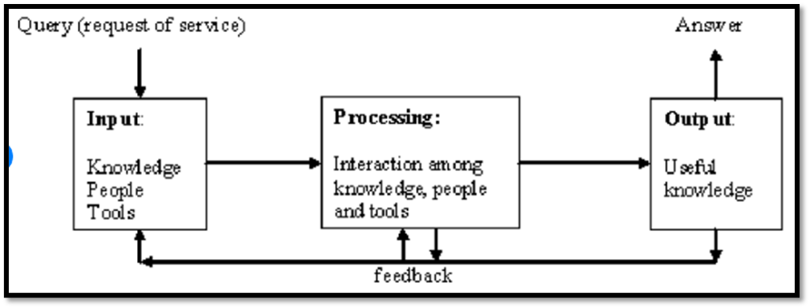

Figure: knowledge management system of Amazon (Du Plessis, 2007)
Customers request service from Amazon, which is then considered as input of information. People and tools are the input agents who contribute to feeding the system necessary inputs. The collected information is integrated to produce insightful information. The generated information is then applied in the organizational context for decision making, which is the output for the knowledge management system. Unlike other information systems, a knowledge management system has a significant role in building a sustainable relationships with customers across the world.

Different knowledge management theories and models applied
Practically there are different knowledge management theories and models that are utilized by different organisations to benefit from the knowledge management systems implemented in the organizational setting. The most commonly used knowledge management theories are as follows:
- Nonaka and Takeuchi model of knowledge management,
- Choo Sensemaking knowledge management model and
- Wiig model of building and using knowledge (Jennex and Olfman, 2014)
Nonaka and Takeuchi model of knowledge management
The Nonaka and Takeuchi KM methodology is based on a holistic paradigm of knowledge creation and serendipity' management. Companies will benefit from the model's insight into organizational learning and how to successfully mix explicit and tacit information to develop new information for a competitive advantage. According to this model, there are two dimensions of the model. They are the epistemological dimension and ontological dimension. On the basis of the epistemological dimension, knowledge can be of different types. There are two sorts of knowledge: explicit information, which can be found in books and protocols, and tacit knowledge, which can only be learned by experience and expressed through symbolism and comparison. On the other hand, the ontological dimension dictates that there are three levels for knowledge creation and sharing. They are individual, group, and organization (Hoe, 2006). For Example expertise of an individual employee on a particular issue is the individual level tacit knowledge, while if it is coded or documented, it will be explicit knowledge. Group norms and protocols of group work contribute to new knowledge creation. And finally, organizational level knowledge has a broad spectrum impact on the other two levels.
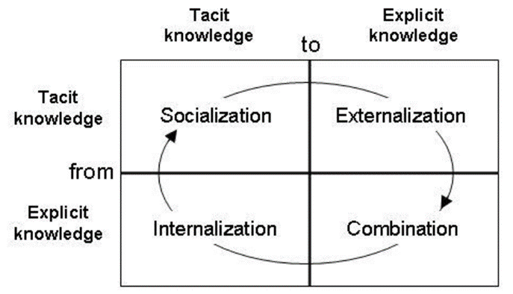

Figure: Nonaka and Takeuchi model of KM (Hoe, 2006)

Choo Sensemaking knowledge management model
Sensemaking, knowledge generation, and decision-making are all emphasized in this model According to this model; organizations use information or knowledge in three areas: (a) sensemaking, (b) knowledge development, and (c) decision making. These three intricately linked activities are critical to the realization of the organization's knowledge vision, its capacity for knowledge creation, and its commitment to maximizing knowledge creation's impact (Choo, 2002).
The final goal of sense-making is to ensure that the company could indeed adapt and thrive in a volatile business environment by conducting exploration and explanation activities that help in analyzing changes, trends, and scenarios about customers, suppliers, rivals, and other macro-environmental actors. Knowledge creation is a method for an entity to construct knowledge by acquiring, organizing, and processing data. The firm must select the best alternative from among those who might be plausible and provided and follow it in accordance with the company's strategy (Choo, 2002). The rational choice concept constrains the decision-making process in organizations.

Wiig model of building and using knowledge
The model of Wiig emphasizes on following principle: knowledge must be structured in order to make it meaningful and significant. Based on how the data will be used, it should be structured accordingly. The Wings KM model has some helpful dimensions. They are completeness, interconnectedness, consistency, as well as perspective and purpose (Wiig, 2003). The amount of specific knowledge obtainable from a particular source is referred to as completeness. Intelligent beings and information sources are examples of sources such as tactics or explicit knowledge. One must first establish that knowledge exists; knowledge is complete if all evidence available on the issue is accessible. Clear and complete relationships between the various knowledge objects are referred to as connectedness. The relationship between various knowledge bases leads to creating valuable information. When all of the facts, ideas, viewpoints, ethics, assessments, and relational ties between the objects are consistent, the knowledge base is said to be congruent (Wiig, 2003). The vast majority of knowledge content will fall short of such expectations. Perspective and purpose refer to the phenomenon of knowing something from a given point of view for a specified reason. We use the dual system to arrange a lot of our knowledge.
Wiig stresses four-stage cycles of knowledge building and using. They are Building knowledge through formal education training and experiences, holding the knowledge in the form of explicit knowledge or implicit knowledge, pooling knowledge from different entities of the organization through brainstorming and other systems, and using knowledge in several work contexts (Wiig, 2003).
The above-mentioned theories are applicable to Amazon to create an effective knowledge management system that supports the organization's ineffective decision-making. Among them, Nonaka and Takeuchi's model is used to determine the significance of tacit knowledge and explicit knowledge. Mostly skilled employees are the basic sources of tacit knowledge in Amazon who are an asset to the company. The long tenure of the job in Amazon provided them with the insights to handle the organization-specific situation with the customers. Besides, such skills and experiences are not coded anywhere. On the other hand, this model dictates transforming implicit knowledge into explicit in the forms of policies, standard operating procedures in the organization to provide unified guidance to everyone.

Another model which could be adopted by Amazon in making sense, developing knowledge, and making knowledge have a significant implication in Amazon. Knowledge workers make sense of and capture valuable information from internal or external sources of information. Then the information is used for meaningful knowledge criterion by applying it in an organizational context. After those valuable decisions are made with respect to serving customers regarding what they want, how they want, and when they want (Wiig, 2003), Wiig model of building and using knowledge provides guidance Relevant alternative academic theories must be identified and evaluated to check the effectiveness of knowledge and information management culture within the given organisation in terms of creating knowledge asset and maintaining effective customer relationship management. These alternative models facilitate knowledge creation and application in Amazon.

Effectiveness of knowledge and information management culture to create knowledge asset and to maintain effective customer relationship management
Customer relationship management emphasizes managing a sustainable and profitable relationship with the customers through proper management of the interaction with the customers. Therefore, organizations like Amazon need to take care of information generating customer touchpoints like website, from the desk, and so on. Direct interaction with the customers provides significant insight into the knowledge management system (Rigby and Ledingham, 2004). Evaluation of alternative academic models of knowledge management focuses on following knowledge management principles to develop an effective knowledge and information culture for Amazon:
Treating knowledge as a valuable resource
Like physical resources, human resources, and financial resources, information or knowledge is a significantly essential asset for the company, which must be treated properly. The staff responsible for the management of knowledge must have the accountability to ensure a proper knowledge culture in Amazon. Commitment from top management to manage knowledge and information will lead to an effective knowledge management culture in the organization.
Storing in a central repository
To reap a better benefit from an organizational knowledge management system, information and knowledge should be stored in a central repository that must be accessed by everyone. The use of a central repository for data storage reduces the chance of malfunction of the knowledge management system (Mertins et al., 2001).

Ensuring knowledge authorship and quality of knowledge
In Amazon, to ensure the quality of knowledge created and captured, the authorship of the knowledge must be assured. It will ensure that the knowledge created is accurate and authentic. Moreover, authorship ensures the completeness and connectedness of data as the author is wholly responsible for the knowledge (Mertins et al., 2003).
Sustainability
Sustainability is another principle of the knowledge management system. To ensure sustainability Amazon ensures the minimal space consumption of the knowledge in the central reforest as new and new knowledge and information are being created and generated.
Sharing and dissemination: Sharing and dissemination is another principle for Amazon's knowledge management system. Knowledge created and stored must be shared with proper users so that they can be able to make decisions. To ensure organization-wide sharing of knowledge, Amazon uses an ERP system which makes it possible to make information available at the point of consumption (Mertins et al., 2003).
Socialization and confidentiality of the knowledge and system
The knowledge that is stored on a stack is worthless. Knowledge's worth is determined by communication and interaction. Knowledge generation, appraisal, improvement, and application are largely social processes.
When information is acquired by a large number of people, it becomes more useful. Most firms are unable to share all information due to privacy and confidentiality concerns. However, it's critical to establish the understanding that access restrictions must be justified. Accessibility also refers to how people with impairments or special needs can gain access to information (Mertins et al., 2003).
The above discussion and evaluation of models used, principles and practices support Amazon to create effective knowledge management systems to maintain a supportive customer relationship management. Initially, the principles create a knowledge management culture in Amazon that contributes to information and knowledge asset creation and maintenance.

Amazon's potential knowledge management challenges
Although Amazon is an information technology company having its dealings in various segments, it maintains a good knowledge management system to generate knowledge and information for on-time decision making. This knowledge management system of Amazon supported the company significantly during the pandemic crisis to build a relationship with the customers. Still, Amazon faces the following knowledge management challenges:
Maintaining consistent employee motivation
Employees are the key resource to create, store and disseminate information and knowledge across the organizations. Motivated employees ensure the accuracy, completeness, connectedness, and authenticity of information and knowledge. But mainlining employee motivation is a challenge for the company as the workforce is quite large. Moreover, during pandemic situations, employees face a critical period that has a negative impact on organization performance (Oppong et al., 2005).
Measuring Contribution to Knowledge
Since it is formed from personal interactions and expertise, knowledge is significantly more complicated than it can be easily quantified. When it comes to knowledge contribution, the shared objective should take precedence over outcomes or efforts (Malhotra, 2020).
Safety and security
It is critical (in most technical endeavors) to offer the appropriate level of security for data, and organizational learning is no exception. As Amazon has a vast repository of knowledge and is decentralized across the organization, it is quite challenging for the company to ensure the safety and security of the information and knowledge (Malhotra, 2020).
Adapting to Constantly Evolving Technology
When it concerns the technologies organization use, revisions and improvements are becoming much more frequent. Despite the fact that the technology Amazon use is constantly changing, the company nevertheless feels a sense of urgency to stay up. Remember that while changes and improvements to technology can be inconvenient at first, they usually lead to new possibilities and the ability to do more stuff for us in exchange (Oppong et al., 2005).
The above challenges jeopardize the knowledge management culture of Amazon. They create threats and lead to either increasing expense or reducing profit. Therefore, these challenges must be overcome.
Recommendations to strengthen their knowledge management practices from the knowledge acquisition-retention-transfer perspectives
To strengthen the knowledge management practices of Amazon following recommendations are useful:
Authorization of knowledge
Although it is a general guideline for all kinds of organizations adopting knowledge management, Amazon should ensure authorization of knowledge management to ensure its accuracy. Use authorization and system security to ensure that different types of information are exchanged in the appropriate channels and with the appropriate persons (Hota et al., 2015).
Ensuring employee motivation
As employees are the key asset to knowledge management in Amazon, they should be kept motivated and satisfied. For this, top management can design an attractive incentive plan to provide rewards to employees to can contribute to creating knowledge creation.
Selecting key performance indicators (KPI) and measuring success against KPI
To measure the success of the knowledge management system in Amazon, the company should select proper key performance indicators (KPI) and periodically measure the success against these KPIs. Such KPI and performance measurements ensure the success of the company and maintain its customer relationship management (Ferraris et al., 2019).
Maintaining consistency between the knowledge management and company culture
Understanding culture in the designing system and maintaining the system to ensure benefit from knowledge acquisition, knowledge transfer, and knowledge application. Relevancy in culture and knowledge management leads to creating and generating valuable knowledge (Ferraris et al., 2019).
The above suggestions strengthen the knowledge management practices in Amazon and make it more convenient to serve customers in a customized and personalized way.

Conclusion
Organizations use various kinds of information systems to automate and redesign their operations to provide convenience and ease in transitions. The knowledge management system is one of the prominent systems used in Amazon to maintain customer relationship management which made it a giant and market leader like Exxon. In maintaining the knowledge management system, the company faces several challenges like lack of employee motivation, lack of security and safety, measuring contribution, and so on. To overcome these obstacles, the company should adopt a few comprehensive steps.
Task-2
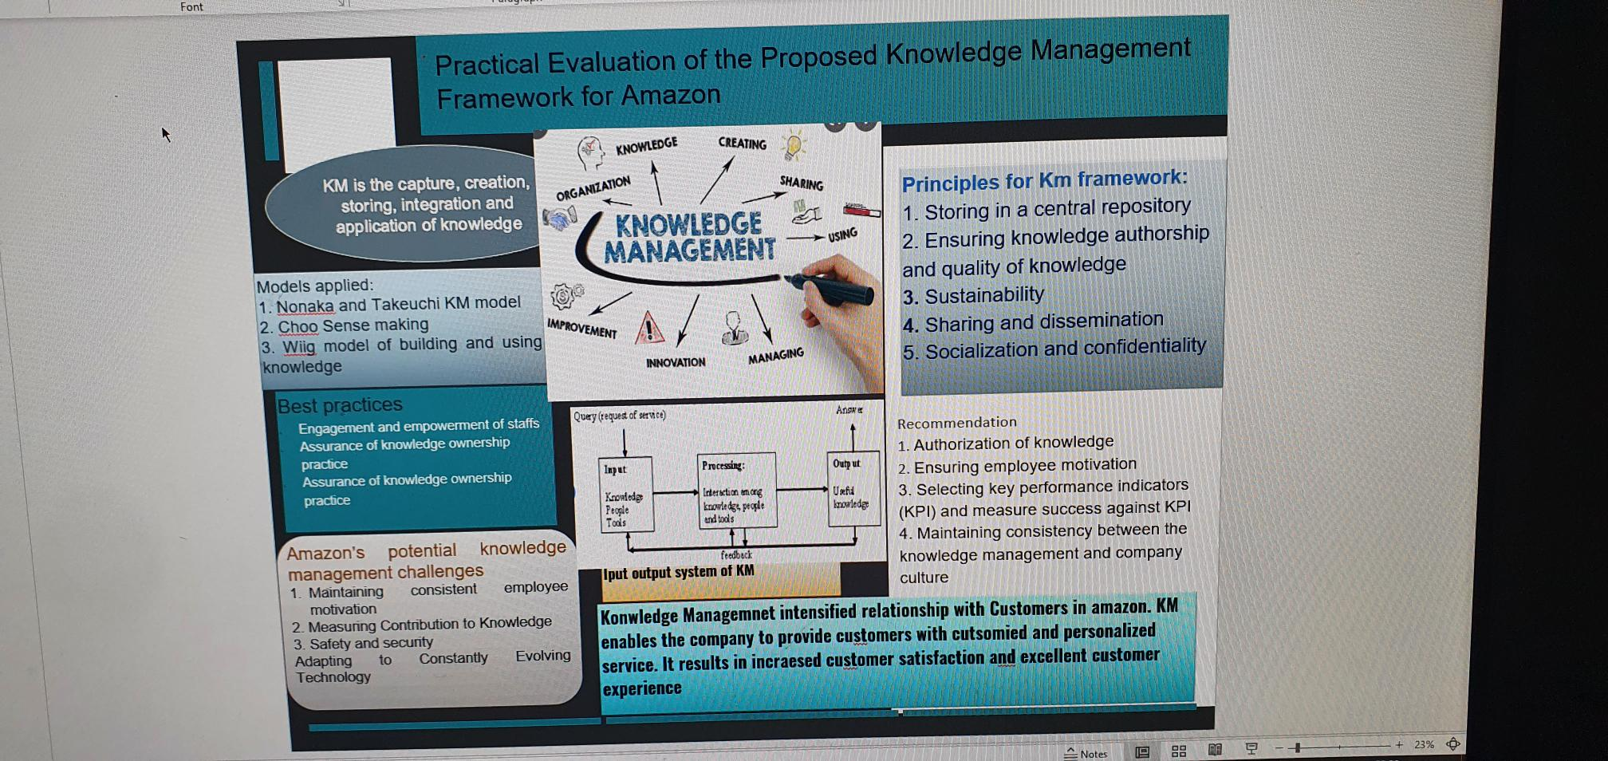

Reference
Alavi, M. and Leidner, D.E., 2021. Knowledge management and knowledge management systems: Conceptual foundations and research issues. MIS quarterly, pp.107-136.
Amazom, 2021. Available at https://www.amazon.com/
Berryman, R., 2005. Knowledge management in virtual organizations: A study of a best practices knowledge transfer model. University of North Texas.
Calvo-Mora, A., Navarro-García, A., Rey-Moreno, M. and Periañez-Cristobal, R., 2016. Excellence management practices, knowledge management and key business results in large organisations and SMEs: A multi-group analysis. European Management Journal, 34(6), pp.661-673.
Choo, C.W., 2002. Sensemaking, knowledge creation, and decision making. The strategic management of intellectual capital and organizational knowledge, pp.79-88.
Du Plessis, M., 2007. The role of knowledge management in innovation. Journal of knowledge management.
Ferraris, A., Mazzoleni, A., Devalle, A. and Couturier, J., 2019. Big data analytics capabilities and knowledge management: impact on firm performance. Management Decision.
Gibbert, M., Leibold, M. and Probst, G., 2020. Five styles of customer knowledge management, and how smart companies use them to create value. European management journal, 20(5), pp.459-469.
Hoe, SL, 2006. Tacit knowledge, Nonaka and Takeuchi SECI model and informal knowledge processes. International Journal of Organization Theory & Behavior.
Hota, C., Upadhyaya, S. and Al-Karaki, J.N., 2015. Advances in secure knowledge management in the big data era. Information Systems Frontiers, 17(5), pp.983-986.
Jennex, M.E. and Olfman, L., 2014, January. Assessing knowledge management success/effectiveness models. In 37th Annual Hawaii International Conference on System Sciences, 2004. Proceedings of the (pp. 10-pp). IEEE.
Malhotra, Y., 2020. Knowledge management for e-business performance: advancing information strategy to "internet time". Information Strategy: The Executive's Journal, 16(4), pp.5-16.
Mertins, K., Heisig, P. and Vorbeck, J. eds., 2003. Knowledge management: concepts and best practices. Springer Science & Business Media.
Mertins, K., Heisig, P., Mertins, K., Heisig, P. and Vorbeck, J., 2001. Knowledge management: Best practices in Europe.
Oppong, S.A., Yen, D.C. and Merhout, J.W., 2005. A new strategy for harnessing knowledge management in e-commerce. Technology in society, 27(3), pp.413-435.
Rigby, D.K. and Ledingham, D., 2004. CRM done right. Harvard business review, 82(11), pp.118-130.
Sadq, Z.M., Sabir, H.N. and Saeed, V.S.H., 2018. Analyzing the Amazon success strategies. Journal of process management. New Technologies, 6(4).
Venkatesan, R., 2017. Executing on a customer engagement strategy.
Wiig, K.M., 2003. A knowledge model for situation‐handling. Journal of knowledge management.

