
A Critical Evaluation of How the Role of The Senior Investigation Officer (SIO) Has Evolved and The Impact of Technology on Homicide Investigations
Gareth Thomas Morgan - 2112544
BSc (Hons) Professional Investigations
25th October 2022

Word Count: 8037

Declaration
This work has not previously been accepted in substance for any degree and is not being concurrently submitted in candidature for any degree.
Signed: GTMorgan
Date: 25/10/22

Statement 1:
This dissertation is being submitted in partial fulfilment of the requirements for the degree of BSc Professional Investigation.
Signed: GTMorgan
Date: 25/10/22

Statement 2:
This dissertation is the result of my own independent work/investigation, except where otherwise stated.
Other sources are acknowledged by footnotes giving explicit references. A bibliography is appended.
Signed: GTMorgan
Date: 25/10/22

Statement 3:
I hereby give consent for my dissertation, if accepted, to be available for photocopying and for interlibrary loan, and for the title and summary to be made available to outside organisations.
Signed: GTMorgan
Date: 25/10/22

Statement 4:
I hereby give consent for my dissertation, if accepted, to be available on the university’s IT system to those who have consent to use the system.
Signed: GTMorgan
Date: 25/10/22
Acknowledgments
I would like to thank my Supervisor, Alison Cooke, for her patience, time, and support throughout the course of this degree, particularly during the dissertation process.
I would also like to thank Trish, Evelyn, and Molly for giving me the inspiration and support to undertake this process. I could not have balanced work, family, and study without them.

Abstract
The aim of this dissertation was to evaluate how the role of the Senior Investigating Officer (SIO) has evolved over many years whilst exploring how technology has also changed and impacted criminal investigations, with a particular focus on homicide. The research considered the profile, skills, and experience of those undertaking the role, the training programmes, and the perception of the role by the police and public.
The researcher carried out a critical analysis of relevant and existing academic literature surrounding the role of the SIO, and examined the potential impact technology has had, both positive and negative.
To assist in understanding the evolution of the role as well as discovering the role technology has had on investigations, questionnaires were conducted with a cadre of retired and serving SIOs. This enabled a greater understanding of the experiences of those that have undertaken the role in different eras, with the analysis of literature providing the basis for the questionnaires.
The findings of the project support the literature analysed. The themes established within this project are centred around the strong influence of training on the evolution of the role and profile of the SIO, the value technology has added to homicide investigations, and the challenges around the collection and management of digital evidence. It also identifies a perception that technology negatively impacts the skills of the modern detective.
Following the completion of key milestones throughout the project, the dissertation achieved its aim by outlining how the role of the SIO has evolved and exploring the impact technology has had on homicide investigations, with the outcomes supported by the views of both the SIO’s surveyed and the existing academic literature.

Table of Contents
__________________________________________________________________________________
Chapter 1 - Introduction 10
1.1 Background 10
1.2 Research Rationale 11
1.3 Aims and Objectives 11
1.4 Structure 11
1.5 Conclusion 12
__________________________________________________________________________________
Chapter 2 - Literature Review 13
2.0 Introduction 13
2.1 The SIO 13
2.2 Training Developments 15
2.3 Impact of Technology on Homicide Investigations 19
2.4 Conclusion 20
__________________________________________________________________________________
Chapter 3 - Methodology 22
3.0 Introduction 22
3.1 The Research Onion 23
3.1.1 Research Philosophy 23
3.1.2 Research Approach 24
3.1.3 Research Strategy and Choice 25
3.1.4 Time Horizon 25
3.1.5 Techniques: Data Collection and Analysis 26
3.1.5.1 Data Collection 26
3.1.5.2 Sampling - Interview Design and Matrix Analysis 26
3.1.5.3 Data Analysis 26
3.2 Reliability and Validity 26
3.3 Limitations 26
3.4 Ethical Considerations 27
3.5 Conclusion 27
__________________________________________________________________________________
Chapter 4 - Data Analysis and Findings 28
4.0 Introduction 28
4.1 Data Analysis 28
4.2 Method for Analysis 28
4.3 Analysis of Qualitative Data Gathered from Interviews 28
4.4 Theme One: 28
4.5 Theme Two: 29
4.6 Theme Three: 29
4.7 Result of Findings 30
4.8 Conclusion 31
__________________________________________________________________________________
Chapter 5 - Conclusion and Recommendations 32
5.0 Introduction 32
5.1 Completion and Achievement of Objectives 32
5.2 Main Findings 32
5.3 Recommendations 33
5.4 Limitations 34
5.5 Future Research 34
5.6 Conclusion 34
__________________________________________________________________________________
Bibliography……………………………………………………………………………….35
__________________________________________________________________________________
Appendices 44
Appendix A - Blank Questionnaire Sheet 44
Appendix B - Questionnaire Transcripts 47
Appendix C - Questionnaire Analysis workings 48
__________________________________________________________________________________

List of Figures
Figure 2.2.1 – PIP Courses aligned to crime seriousness……………………………………17
Figure 2.2.2 – PIP Career Pathway……………………………………………………………..18
Figure 3.1 – The Research Onion……………………………………………………………….23
Figure 3.1.1 – Positivism v Interpretivism……………………………………………………….24
Figure 3.1.2 – Deductive and Inductive Approaches to the Relationship Between Theory and Research……………………………………………………………………………………………25

List of Abbreviations
UK - United Kingdom
SIO – Senior Investigating Officer
COP – College of Policing
UWTSD - University of Wales Trinity Saint David
HM Government - Her Majesty's Government
PIP – Professionalising the Investigation Process
PACE – Police and Criminal Evidence Act (1984)
NPCC – National Police Chiefs Council
HOLMES – Home Office Large Major Enquiry System
ACPO – Association of Chief Police Officer
MIM – Murder Investigation Manual
MCIM – Major Crime Investigation Manual
MIR – Major Incident Room
MIRSAP – Major Incident Room Standard Administrative Procedures
HMIC - Her Majesty’s Inspectorate of Constabulary
HMICFRS - Her Majesty’s Inspectorate of Constabulary and Fire & Rescue Service
CPD – Continuing Professional Development

Chapter 1 - Introduction
This dissertation seeks to evaluate how the role of the SIO has evolved over many years whilst considering how the development of technology has impacted homicide investigations.

1.1 Background
The SIO has been prominent in homicide and serious crime investigations for decades. Throughout the history of major crime investigations, the SIO has been the lead person and is synonymous with the manner and conduct of the investigation. The SIO sets the direction of the investigation, and their management has a significant impact on the outcome (NPCC, 2021).
SIOs are responsible for the most serious and high-profile investigations. Investigations that have a significant impact on communities and, which can also have a profound effect on the SIO (Blackstones, 2014). Traditionally, the SIO was nominated as they were the most senior and experienced detective, often head of the force Major Crime Investigations Team (MCIT) and usually at Superintendent rank (Roycroft & Roach, 2019, p. 107).
The ACPO Murder Investigation Manual (MIM) (2006) was first published in 1998 with the aim of providing a framework for senior investigators, this was updated to the Major Crime Investigation Manual (MCIM) in 2021 (NPCC, 2021).
The Professionalising Investigation Process (PIP) was implemented in 2003. One of the reasons for implementation was to develop SIOs and ensure there was a consistent standard of professional, ethical investigation across the UK (College Of Policing, 2018). The College of Policing (COP) has invested heavily in investigative training at all levels. There is however a national shortage of detectives (HMIC, 2017) and some police forces have implemented fast-track detective schemes as a response (Police:Now, 2022).
There is little research on how the role of the SIO has developed, and the research will aim to explore how this role has evolved over the years and evaluate the differences, pre and post PIP. The research will also consider the ‘traditional’ skills of the detective and discuss whether they are still recognised and valid (Westera, et al., 2016).
This dissertation will explore if it is viable for a police force to parachute people into the role with no experience and look to turn them in to credible and competent SIOs via training courses, without giving them the prior experience that was once deemed a necessity (Donnelly & West, 2019). The developments of training programmes and processes will also be reviewed to consider how this has impacted the conduct of the investigations and the profile and perception of the SIO.
The research will further examine how technology has impacted the manner and extent of criminal investigations, focusing on homicide. The study will further explore whether the police are over-reliant on the use of technology.
It should be noted that the author will not seek to compare the quality of SIOs from different eras. It is accepted that there are outstanding individuals that have undertaken the role throughout the history of criminal investigations.

1.2 Research Rationale
There is a public perception of the SIO that will not match the reality of the role (O'Neill, 2018). Over many years there has been a change in the profile of the SIO, influenced by the introduction of the Home Office Large Major Enquiry System (HOLMES), developments in technology, and the PIP accreditation process.
Evolution is a concept that has relevance across all kinds of disciplines. The author wanted to explore how SIOs have developed and responded to things such as changing technologies and training programmes, as well as social and economic changes, the additional scrutiny, and increased accountability.
As an accredited SIO coming to the end of his career, the author wanted to assess, evaluate, and document the evolution of the role and outline the impact technology has had on homicide investigations and subsequently, how this impacts the capability of the detective.

1.3 Aims and Objectives
The aim of this research project is:
- To explore the evolution of the SIO role and consider how it has been professionalised.
- To better understand the impact of technology on homicide investigations.
These aims will be achieved by completing the following objectives:
- To critically research and analyse past and present academic literature surrounding the role of the SIO and the development and impact of technology on homicide investigation.
- To identify the most suitable research method required to appropriately conduct the research project.
- To conduct primary research and analyse the data collected to expand the understanding of any themes that are identified.
- To provide recommendations regarding any key issues identified that are relevant to the research project.

1.4 Structure
Chapters will be dedicated to ensuring each objective is completed. Chapter two of the dissertation will analyse previous and current academic understanding of the role of the SIO and the developments and use of technology in homicide investigations.
Chapter three will seek to identify the most appropriate research technique and methodology to successfully conduct the research project.
Chapter four will analyse the data that has been collected from the proposed method presented in chapter three and will look to identify common themes or opinions drawn from data analysis.
And finally, chapter five will bring the dissertation to a close and achieve the final objective by identifying the key issues and providing conclusions and recommendations based on the observations derived from the dissertation.

1.5 Conclusion
This first chapter has now successfully presented the background surrounding the research topic, outlining the project aim and objectives.

Chapter 2 - Literature Review

2.0 Introduction
This chapter seeks to achieve aim one of the dissertation - To critically research and analyse past and present academic literature surrounding the role of the SIO and the development and impact of technology on homicide investigation.
This objective will be achieved by examining literature acquired from the UWTSD e-learning online library database, The COP Library, The National Police Library and Google Scholar, which presents data from verified academic and scholarly sources, such as academic journals, professional textbooks, government publications, and other sources authorised and qualified to publish relevant information.
The author has also personally contacted the COP to identify relevant sources of literature that are not online but may be available.

2.1 The SIO
It can be argued that decades ago, the traditional SIO was usually the head of CID, male, white, long in service with a protracted background in criminal investigation. These officers were autocratic leaders, professionally feared, and it was essential for them to have the ‘loyalty’ of their staff. Historically, it was considered that the quality of an investigator relied on their ability to ‘build a chain of informants’ and to be as devious as the criminals they investigated (Donnelly & West, 2019). There was a perception that the SIO was single-minded and sometimes directed the investigation towards their preferred suspects.
Smith and Flanagan (2000), outline that, to maintain and evolve the role of the SIO, there needs to be a plan in place which includes the selection of the right individuals at the right time of their career. They highlight the importance of the formal identification and development of future SIOs, ensuring that there is the correct balance between training and appropriate experience.
Their research suggested that the effective SIO is dependent upon an amalgamation of management skill, investigative ability, and relevant knowledge across the entire investigative process, from golden hour enquiries through to post-charge case management (Fahsing, et al., 2008).
Westera et al (2016), suggest that scientific and technological developments have impacted the efficacy of the SIO. If the SIO does not evolve and adapt to the changes, the outcome may be flawed investigations and prosecutions, with the potential for miscarriages of justice (Gross, et al., 2005), with an enduring impact on public confidence (Innes, 2010; Shipton, 2022).
As alluded to by Stelfox (2016), during the period from the 1970s up to the millennium, there was a series of high-profile failures in the investigation of homicide which significantly impacted public confidence. These failures initiated a series of legislative and procedural changes which, together with key developments across the investigative arena, such as PIP and the development of digital and forensic science, transformed criminal investigation.
These past experiences helped inform future investigative strategies and supported the evolution of the SIO role by outlining best practice and identifying risks to investigations (Roycroft, 2019). Byford (1981), Macpherson (1999) and Horwell (2017) are all examples of formal reviews that identified significant failings in criminal investigations, resulting in changes to policy, procedures and even the culture of police forces. It cannot be enough to simply detect the crime, it must be done legally and ethically and stand scrutiny long term (Stelfox, 2016).
The Home Office report 25/04 (Nicol, et al., 2004, pp. 13-15) noted that ‘many of the serious failures that occurred in modern, complex enquires needed to be understood at a systematic level’. The report suggested that police culture was focused on the ‘positive result’ which glossed over poor practice and flaws.
Fahsing (2019) explains that the role of the SIO in the UK evolved with the implementation of professional accreditation and system support. The MCIM (NPCC, 2021) and Major Incident Room Standard Administrative Procedures (MIRSAP) (NPCC, 2021), together with PIP (College Of Policing, 2018), which utilises the hydra assimilation suite (University of South Wales, 2022) and subsequent accreditation to develop the knowledge, experience and decision-making skills of SIOs are examples of this.
Also supporting the evolution of the SIO, were a range of legislative measures aimed at ensuring good practice. These included, the Police and Criminal Evidence Act (PACE) 1984 (Home Office, 2020) , Criminal Procedure and Investigations Act (CPIA) 1996 (Ministry Of Justice, 2020) and the Regulation of Investigatory Powers Act (RIPA) (2000), all of which provided tighter guidelines for the investigation process. Other changes included the establishment of the Crown Prosecution Service (CPS) to provide independence to the prosecution process (Glidewell, 1998; Director of Public Prosecutions, 2020), the formation of what is now the Independent Office for Police Conduct and the additional scrutiny from agencies such as the Criminal Case Review Commission, HMICFRS, and more recently, Police and Crime Commissioners (Roycroft, 2019).
Parallel to these changes, the role of crime analysts, interview advisors, digital media investigators and others became highly specialised roles, available for use by the SIO. Forensic science evolved, from the traditional examination of crime scenes to CCTV recovery, telecommunications data, and internet traffic. An improved focus on victim needs and community safety also saw the development of roles such as Family Liaison Officers and the management of community impact as a key strategic aim of homicide investigations (Stelfox, 2016).
In 1989, ACPO implemented a homicide review policy aimed at developing and disseminating good practice (Nicol, et al., 2004). The reviews outline good practice and provide both individual and organisational learning which are crucial to the evolution of the SIO (NPCC, 2021, pp. 142-153).
Stelfox (2016) suggests that, despite the changes, the selection, training, and development of SIOs, remained consistent until the introduction of PIP. PIP level 3 focused specifically on homicide investigation and thoroughly revised the selection, training, and development of SIOs to ensure that they had the skills and knowledge they needed to develop and thrive. When implemented, PIP transformed the system of homicide investigation from a largely ad-hoc and regionally insular affair to one which was common throughout the UK (College Of Policing, 2018).
Advancement in technology, forensic science and a move towards information-driven investigative practices has increased the complexity of the role of the SIO (Williamson, et al., 2007). There are some key changes between the MIM (ACPO, 2006) and the MCIM (NPCC, 2021), with the later having a greater focus on digital evidence. The 2021 document is far more aligned to a team approach when investigating homicide, describing the SIO as a’ team leader’ who amongst other things, is responsible ‘for motivating the team’. There is also a dedicated section on the role of the PIP 4 Strategic Investigator, which itself evidences the evolution of the role.
PIP 4 was created following the murder of Rhys Jones in Liverpool in 2017. It was recognised that the scale and profile of the investigation required strategic support for the SIO (Fulwood, 2019). Their purpose is to provide strategic management, oversight, and support to the investigation (NPCC, 2021,pp. 17-19; College of Policing, 2022).
Whilst SIOs are ultimately responsible for decisions made, the current SIO places a great deal of reliance upon their staff (Smith & Flanagan, 2000). The team are crucial to the success of the investigation and the SIO needs to create an atmosphere where team members have confidence to thrive and contribute ideas and theories (College of Policing, 2020; NPCC, 2021).
Roycroft (2019) talks about the ‘collective brain of the team’ and alludes to modern SIOs being aware of the limitations of cognitive bias and avoiding futile lines of enquiry. This is a relevant point and something that should be eliminated to truly evolve and learn the lessons of the past.

2.2 Training Developments
In the early years of homicide investigation, very little was recorded that allowed best practice to be identified and shared, and the ‘craft’ appeared to be passed down from generation to generation. The old methods of learning on the job meant that there was a recurring pattern whereby detectives would learn, make mistakes, improve, and retire. (O'Neill, 2018).
Donnelly and West (2019) report that ‘the primary source of SIO knowledge twenty-five years ago remained essentially experiential’. SIO training courses mainly focused on case studies, and it was argued that the values about what seemed to make a good detective were passed down through ‘war stories and storytelling' (Innes, 2003).
In 1987 National Police Training designed a 14-week detective training course which was dominated by law and not the methods of criminal investigation and detective skills. At that time, the police service had little perception of what attributes or skills were required by detectives and the training therefore never addressed this issue (O'Neill, 2018).
HMIC (2017) expressed concerned about the supervision of criminal investigations. Poor or inconsistent supervision means that too many cases are not progressed professionally, and investigators are not learning their trade. There is also an awareness that ‘those who lack appropriate skills and experience’ may be leading homicide investigations (Donnelly & West, 2019).
Westera, et al (2016) identified some common challenges to ensuring that detectives are effective in the future – which included technology, training, and ongoing development and accountability. In the fall out from the Yorkshire Ripper investigation, Byford (1981, pp. 371-372) had asserted that the traditional qualities of the senior detective including, ‘professional expertise, a sound knowledge of the criminal law and practice and a capacity for assembling evidence’ were not enough and that a different skill set was required (Donnelly & West, 2019). The Royal Commission on Criminal Justice recommended that those conducting investigations must be properly trained and supervised and have access to the necessary scientific aids (Runciman, 1993, p. 9).
The Police Reform Act (2002) and the Police Reform White Paper (Home Office, 2001), highlighted the need for the police service in England and Wales to professionalise all aspects of police investigations to address issues such as inconsistent standards of investigation, failing community confidence in the police, high attrition rates, and the lack of benchmarked standards in policing (Shears, 2014).
In response to this, PIP was implemented in 2003 with the strategic aim of improving the professional competence of all police officers and staff who are tasked with conducting investigations (College Of Policing, 2018).
Through the PIP process an individual must achieve the experience, skills, and accreditation at each stage before being able to progress to the next level; ‘arranging attendance by an individual on a training course does not give them the knowledge, understanding nor skills to be an investigator’ (College Of Policing, 2018). PIP provides a focus on CPD via a wide range of activities, combining training with experience in the field (Shears, 2014; Smith & Flanagan, 2000).

Figure 2.2.1 PIP Courses aligned to crime seriousness (O'Neill, 2018, p. 54).
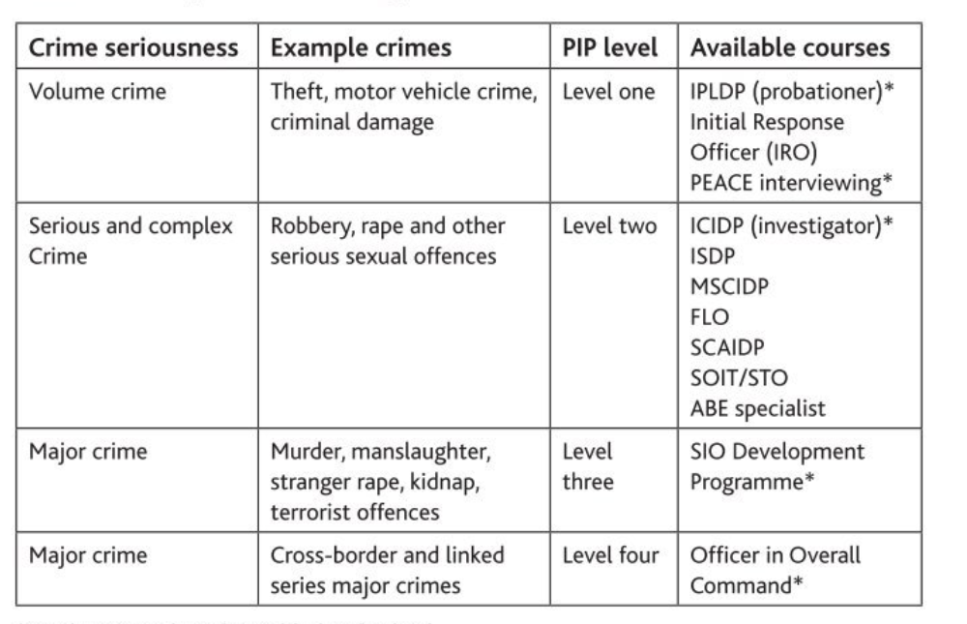* Mandatory to be qualified at that level
The PIP process is aimed at ensuring professionalisation of investigations at all levels and shows a commitment to continuing professional development (CPD) which ensures that there is evolvement of SIOs. By providing a career pathway for detectives, it should attract SIOs with a depth of experience in investigations and balance the requirement for a sound knowledge base with the on-the-job exposure that is required to become an effective SIO, as outlined by Smith and Flanagan (2000). This process should also provide forces with credible SIOs who have the respect of their staff and are able to motivate and lead them, providing them with the confidence to carry out their role effectively.

To obtain accreditation as a senior investigator, the career pathway is:
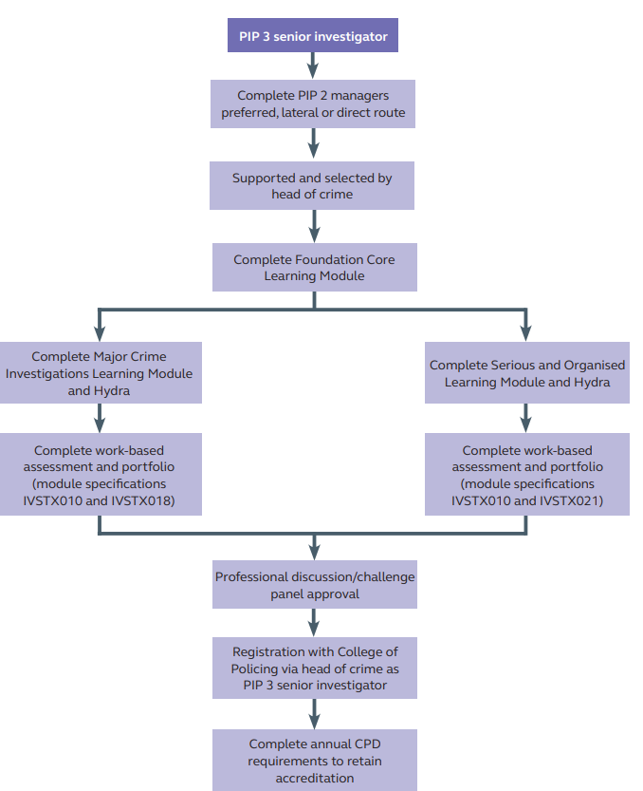
Figure 2.2.2 PIP Career Pathway (College Of Policing, 2018, p. 24)
Stelfox (2011) argues that there is an assumption within the police service that those promoted will be competent investigators and that they will remain so after promotion. He raised concerns that police forces were focusing on the management potential of candidates rather than their competence in specific areas of professional practice. This may have led to officers being parachuted into the role of the SIO without the appropriate skills and experience.
The police acknowledge that in the changing climate, some talented individuals will progress without following the traditional career detective route. Direct entry and fast track detectives have become more common place as a response to the detective shortage (HMIC, 2017), however it is vital that they evidence appropriate competency. Any flexibility should not detract from the necessity for all investigators of serious and complex crime, to demonstrate competence against the requisite standards. This should mitigate the risk that that newly appointed SIOs, with little investigative experience, will feel that their attendance on a training course will “magically” qualify them as an SIO (Shears, 2014; Smith & Flanagan, 2000).

2.3 Impact of Technology on Criminal Investigations
‘Technology is increasingly part of our daily lives. It poses an increasing crime threat but also an investigative opportunity’ (HMIC, 2017).
There were significant advances in the contribution of forensic science from the mid-1990s onwards, with DNA in particular impacting homicide investigations (O'Neill, 2018). Add this to the explosion of the digital age and opportunities such as live facial recognition, and the significant evolution of investigative tactics that are now available to SIOs becomes clear (NPCC, 2020; College of Policing, 2022).
‘By providing hard evidence, forensic science has led to a much more reliable understanding of where when, how and by whom crimes have been committed’ (Government Office for Science, 2015). Science can help provide proof in investigations. It can also be used to eliminate suspects (O'Neill, 2018). DNA and other methods also allow for miscarriages to be identified – cases such as Colin Pitchfork where DNA exonerated a person who falsely confessed to a rape and murder (Elvidge, 2022).
Technology is increasingly an integral part of our lives. However, HMIC (2017) remains concerned that police forces are not keeping pace with how technology impacts daily life and changes the publics experience of crime. As alluded to by Wilson-Kovacs (2021), digital evidence is now more frequently used than any other type of evidence. Several lines of enquiry that were once not applicable are now key areas of criminal investigations (NPCC, 2020).
As criminals develop, so too must the technology, investigative skills, and effectiveness of investigations (O'Neill, 2018). With the rapid increase in technology and changes in legislation, SIOs can ‘become fairly rusty, fairly quickly’ (Smith & Flanagan, 2000). There is a challenge for the SIO to keep up to date with technology. Technology increases evidential opportunities via methods such as CCTV, ANPR, communications data, and vehicle telematics (College Of Policing, 2021). Family liaison and community impact issues have expanded and are impacted by the phenomenon of social media, which also magnifies the scrutiny and accountability of the SIO. Operational security is one area of vulnerability which has increased with technology, as evidenced by the abhorrent behaviour of officers who shared images of homicide victims Bibba Henry and Nicole Smallman (BBC News, 2021).
The development of technology has also played a key role in how evidence is secured and presented. Digital photographs, 360-degree imagery, significant witness interviews and video evidence in chief for example, were all devised to ensure the integrity of the process and to avoid potential miscarriages linked to the issue, as highlighted in the review of the murder of Lynette White (Horwell, 2017; Ministry of Justice, 2022).
As alluded to by O’Neill (2018), scientific advancements in the field of fingerprints and DNA have significantly improved the capacity of the police to solve crimes. They can provide key proof of guilt, and there are many cases that would never be solved without the development of scientific methods. However, the evidence is often circumstantial and presented in conjunction with other evidence to aid the prosecution case. There are also cases that do not yield forensic evidence at all. Innes (2010) points out that science does not solve cases on its own and is only one of many strategies utilised in homicide investigation.
Gill (2019) identifies that there are risks in depending on technology in isolation without focusing on the wider evidence gathering process to build a complete picture. This is particularly true regarding the Post Office ‘Horizon scandal’ which resulted in significant numbers of unreliable convictions that were reliant on the evidence provided by a computer system (Peachey, 2022).
The Yorkshire Ripper review led to the introduction of HOLMES which improved the management of data to support more efficient and effective investigations (Dorset Police, 2022). In his review of the investigation, Byford (1981) identified that the manual indexing system negatively impacted the investigation, and recommended technology and standardisation of procedures as a solution (Harland, 2019).
Eck and Rossmo (2019) claim, that despite significant technological advances in forensics and technology, the investigation process itself has not progressed. There is concern that detectives look for the ‘quick fix’, and rely on technical solutions, such as CCTV of the crime, positive DNA, or other forensic evidence to solve the crime. If this fails, detectives may look to finalise the investigation. Westera, et al (2016) also expressed concern that some detectives defer to electronic information instead of conducting face-to-face enquiries. This brings a risk that detectives lose, or never develop the core skill of talking to people and developing evidence. Harland (2019) suggests that the successful application of biometric material, particularly in homicide investigations, has diluted the understanding of the basic activity of investigation.
In contrast, technology certainly improves the efficiency of investigations (Lum, et al., 2017). Eck and Rossmo (2019) infer that police effectiveness occurred for many reasons, including greater use of data and analysis. The ability to remotely brief teams, the use of laptops, hand-held electronic smart devices, and the capability to stream CCTV to the MIR are examples of this (Westera, et al., 2016).

2.4 Conclusion
Critically evaluating the literature, the author feels that it presents a well-balanced view of the SIO and outlines the changes that have supported the evolution of the role, with the focus now on leadership and teamwork and a duty to manage efficient and proportionate investigations.
PIP has been successful in professionalising the role and identifies the need to balance experience with knowledge with ongoing CPD providing balance. The detective shortage will mean that less experienced officers are being put forward for detective training at all levels, simply to fill the gaps so it is vital that this continues, to mitigate the lack of experience.
The developments in technology and science have significantly impacted the manner and extent of homicide investigation, from an evidential and efficiency perspective, with an understanding that it is only part of the evidence gathering process.
This chapter has now achieved objective one: To critically research and analyse past and present academic literature surrounding the role of the SIO and the development and impact of technology on homicide investigations.
There are some clear themes that come from the review of the literature, and I will focus on three that are key to answering the research question:
- The profile of the SIO has certainly changed. SIOs now commence at Detective Inspector level, following the completion of the relevant PIP training, and there is a greater emphasis on wider managerial and leadership skills, focusing on the ‘team’ ethos to solve crimes.
- The lessons of the past were painful for the police service and the PIP process has been key to professionalising the role, with consistent training which balances knowledge with skills, experience, and CPD.
- Technology has been crucial to developing homicide investigations, HOLMES, and digital forensics. There is however an acceptance that these must be utilised in conjunction with other investigative methods and not be relied upon in isolation.

Chapter 3 - Methodology

3.0 Introduction
This chapter seeks to achieve objective two of the dissertation, which is: To identify the most suitable research method required to appropriately conduct the research project.
The research will be balanced between qualitative data gathered from literature review and the gathering of empirical data via questionnaires.
Research is the method of developing your awareness and knowledge of a particular topic (Saunders, et al., 2019) with Bryman (2016) recording that there are generally two main types of research: primary and secondary. Primary research is described as information personally collected by an individual and gathered for an individual or specific purpose or intention. It can be obtained through the process of direct observation or explicit questioning of people. Secondary research is information obtained from previous studies conducted by someone else and may include published or unpublished works (Rabianski, 2003; Bryman, 2016).
As there is an academic gap regarding the specific research question relating to the evolution of the role of the SIO, both primary and secondary research was required to assist in answering the questions posed by the author.
The data was obtained by reviewing journals, books and material held electronically by several sources including the UWTSD library, Google Scholar, The COP, and The National Police Chiefs Council to understand and compare how training and investigations were managed over several decades. Historical cases were compared with modern cases and key differences critically analysed to establish if the developments in investigative training and technology have professionalised the manner and extent of investigations.
A cohort of retired and current South Wales SIO’s were interviewed using a prepared questionnaire. The questions explored their own experiences around managing investigations, their training and development, their access to, and use of technology.
On receipt of the data, I undertook a content analysis with a focus on answering the research questions. Notes were made, and coding was utilised to highlight key areas and examine what was said by the participants. This enabled the identification of common themes, enabled critical analysis, and supported the author in making informed conclusions (Bennett, et al., 2019).

3.1 The Research Onion
"The Research Onion" (Saunders, et al., 2019), is a common tool used in academic writing to identify and develop research techniques.
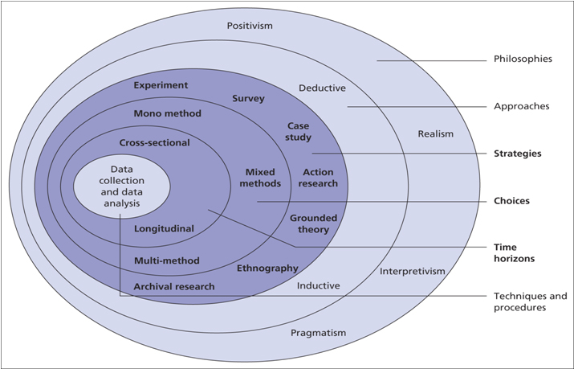
Figure 3.1 - The Research Onion (Source: (Saunders, et al., 2019, p. 130)

3.1.1 Research Philosophy
The outer layer or "Research Philosophies" refers to a system of beliefs and assumptions that the research author may have about a specific field of study. Reflecting and understanding this philosophy supports the author in deciding the method and strategy for their research (Saunders, et al., 2019). This research looked at the words and explanations given by the participants to find patterns or ‘themes’ which could then be presented for inspection (Maykut & Morehouse, 1994).
"Interpretive" is the philosophical approach that will be taken for this research project as Saunders et al (2019) emphasise the influence that social and cultural factors can have on an individual. This research seeks to provide an objective view of the experiences of SIOs and develop a new academic understanding. It will interpret these views and opinions and not focus on rigid, inflexible statistics that may be seen in positivism or quantitative designs (Maykut & Morehouse, 1994; Saunders, et al., 2019).
The below figure outlines the differences between positivism and interpretivism

Figure 3.1.1 . (Revise Sociology, 2022)
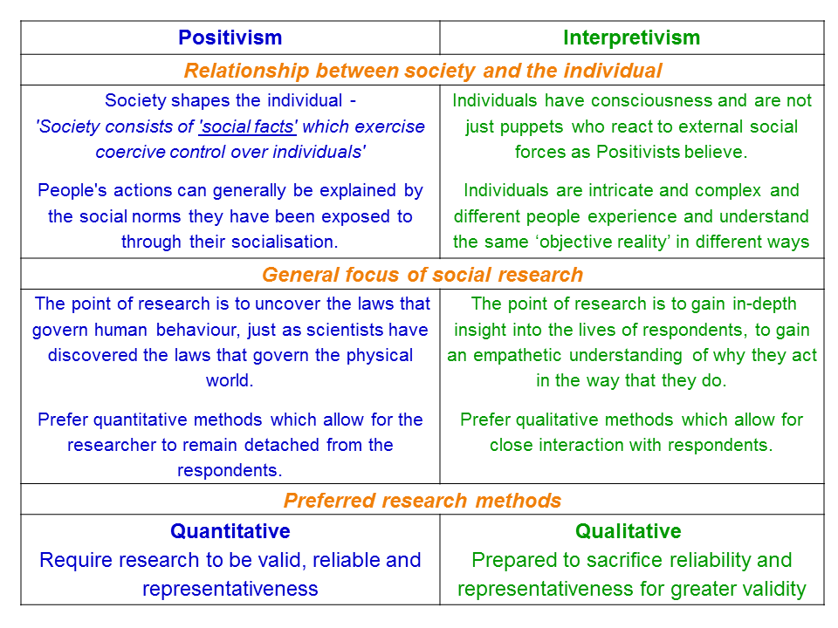

3.1.2 Research Approach
As evidenced in Figure 3.1 by Saunders, et al (2019) there are two types of "Research Approaches" that are often used in academic writing. Bryman (2016) demonstrates the main differences between these approaches, explaining that a deductive study begins with a theory, with the researcher’s seeking to either prove or disprove this theory or hypothesis. However, an inductive study is principally the opposite, where the researcher identifies findings and then sets out to collect data and potentially conclude why such circumstances exist.

Figure 3.1.2 by Bryman (2016) demonstrates the differences between deductive and inductive approaches.
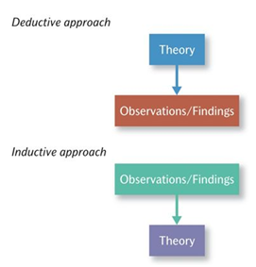
Figure 3.1.2 - Deductive and Inductive Approaches to the Relationship Between Theory and Research (Bryman, 2016)
Given the authors history and experience as a SIO, there was already an informed view/theory around the evolution of the role and the impact technology has had on homicide investigations. Deductive thematic analysis was therefore the chosen approach for this research project (Bennett, et al., 2019).

3.1.3 Research Strategy and Choice
As alluded to, the author conducted qualitative research from both primary (surveys) and secondary (literature) sources, this is described as ‘Mono’ data by Saunders, et.al (2019). By conducting questionnaires with various individuals who have a wide span of SIO experience ranging over 40 years, information could be obtained from variable viewpoints and allow different perspectives to inform the research project when analysing findings or coming to a research conclusion. The participants of these interviews were a mixture of retired former SIOs, as well as current SIOs still undertaking the role.

3.1.4 Time Horizon
The final facet of the research onion is "Time Horizons" which explains how long research collection can take (Saunders, et al., 2019). The personal and professional commitments of the author did limit the extent and scale of the research. A timeline was prepared but deadlines passed due to live work commitments. These limitations meant that "Cross-sectional" was the most appropriate time horizon as it enabled the author to collect data from a number of individuals at a single point in time.

3.1.5 Techniques: Data Collection and Analysis

3.1.5.1 Data Collection
The data collection regarding the qualitative interviews took place in the form of a questionnaire sheet sent to participants with pre-written questions. This method did mitigate the opportunity for any bias whilst allowing descriptive research to take place (Saunders, et al., 2019). A blank copy of the questionnaire sheet can be viewed in Appendix A of the dissertation. The questions were ‘open’ questions with the aim of exploring the participants experiences and opinions from their time as SIOs. The questions were designed to encourage information relating to the research questions.

3.1.5.2 Sampling - Interview Design and Matrix Analysis
The researcher conducted 10 questionnaires as part of the research collection, each participant was individually chosen due to their expertise and experience with the subject matter, demonstrating a non-probability or non-random sample of participants.

3.1.5.3 Data Analysis
The data obtained from the primary research gathered by the interviews was analysed by the author using a basic coding system. Colour codes were used to identify themes from the answers.

3.2 Reliability and Validity
Saunders, et al (2019) explain that reliability of data is observed when results are consistently obtained using the same method of gathering information. This is authenticated when the data collected is in fact valid, accurate, and academically agreed upon. Similar principles are used in assessments, namely ‘VARCS’ which is an acronym for Valid; Authentic; Reliable; Current; Sufficient (Gravells, 2022).
Bryman (2016) outlines that the validity of a project is crucial in ensuring the integrity of the conclusions made in a study. He alludes that the important features of qualitative data are: ‘credibility, transferability, dependability, and confirmability’.
I am satisfied that the profile of the participants ensured compliance with these aspects, whilst bearing in mind that there may be some unconscious bias in their answers, given their association to me and my organisation.

3.3 Limitations
Due to time constraints on the author, caused by his personal and professional circumstances, follow up interviews with the participants were not completed. On reflection, this would have been beneficial as there was feedback from some participants that the questionnaire was restrictive. The author also felt there was a need to explore the answers in more detail which would have allowed more in-depth analysis.

3.4 Ethical Considerations
When conducting this research project, ethical considerations are of utmost importance to minimise risk to the participants, author, and the project. An ethics form was completed prior to the start of the project to ensure integrity was maintained throughout the project. Prior to any form of participation, the author ensured transparency, informing respondents of the purpose of the research, explaining the intended use of any data recovered and analysed. As stated within the approved ethics form from UWTSD, participation was voluntary and the right to withdraw or reject participation at any time was sustained throughout the project. Confidentiality and the right of anonymity was preserved to ensure the privacy of individuals engaged in the research. All personal information was kept private and anonymised as well as stored on a password protected device with VPN security, managed in compliance with GPDR.
All participants were either current or retired police officers and either are or were governed by the code of ethics (College of Policing, 2014) or similar policy which reiterates the policing principles and standards of behaviour. This includes honest, integrity, respect, courtesy, and confidentiality.

3.5 Conclusion
This chapter has successfully identified and demonstrated the most suitable and appropriate form of methodology used for the dissertation. The next chapter will present and analyse the data gathered during the collection phase of the research project.

Chapter 4 - Data Analysis and Findings

4.0 Introduction
This chapter will seek to achieve objective three of the dissertation which is: To conduct primary research and analyse the data collected to expand the understanding of any themes that are identified.
As outlined, an unanswered, blank copy of the questionnaire sheet can be found in Appendix A and presents the questions asked in the interview, as well as who the targeted participants of the interview were and their experience as SIO’s, both retired and serving.
The questionnaire was e-mailed to ten different individuals, with participants selected because of their experience as SIOs. This SIO experience ranged between 1985 to present day. The author felt that ten participants would be sufficient to obtain enough varied data to review and analyse.

4.1 Data Analysis
Data analysis can be described as the process of reviewing, organising, and abstracting information from a large quantity of data that has been gathered, to allow any patterns or themes to become apparent. Consistent themes are likely to provide answers to the research question. The data analysis throughout this chapter will repeatedly aim to address the research question that is central to this project: "How has the role of the SIO evolved, and what impact has the development of technology had on homicide investigations?”

4.2 Method for Analysis
Due to the data being qualitative in nature, a method of analysis that could identify themes and similar answers when sifting through the data was required. As the data was collected via an electronic questionnaire, a transcript of answers from participants was easily collected and compiled utilising the Microsoft forms software, with everyone given a ‘R’ or ‘Respondent’ number to support analysis. Colour coding was then used to identify similar answers and themes.

4.3 Analysis of Qualitative Data Gathered from Interviews
To assist with the analysis of the large quantity of information present in the ten total transcripts, the author reviewed the information and highlighted common trends within the answers provided. By reviewing the dates that the SIOs were in role, the author was able to differentiate and separate the respondents into two categories (retired and serving). This helped to identify themes and outline an overall view of the participants regarding the questions raised. From the analysis, several themes were identified but the author focused on three that were central to answering the research questions posed. The completed questionnaires can be found in Appendix B, with the workings of the analysis in Appendix C.

4.4 Theme One:
Early in the questionnaire every participant was asked to state what experience they had prior to taking up the SIO role.
Following a review of all the responses, a clear theme emerges. Whilst all could be classed as career detectives, over half of the participants (retired) took on the role with no formal SIO training. There is reference to them being career detectives and it is experience that is clearly perceived as the grounding that enabled them to take on the role. All except one of the serving SIOs had received formal SIO training prior to taking up their role and this group outline their development via the PIP programme and bespoke CPD.
It was also apparent that the retired SIOs saw evolution occurring via training and the change in status of the SIO whilst the serving SIOs cited complexity and scale of investigations.

4.5 Theme Two:
It was commonly identified that technology brings significant investigative opportunities and has greatly aided the professionalism, efficiency, and effectiveness of homicide investigations over the decades. The retired SIOs all outline HOLMES and the development of DNA as significant technological developments during their tenure, whilst the serving SIOs refer to CCTV and digital evidence. When outlining the most common investigative methods used by them as SIOs, there was a clear split, in that the retired officers described enquiries such as scene management and house to house and refer to ‘tried and tested methods that were passed down’, whilst the serving SIOs all focus on CCTV and digital evidence. It could be argued that this is clear evidence of evolution.
When asked if there were any cases that they investigated that would have benefited from today’s technological advances, there was a common theme that technology and the advances in DNA would certainly have brought benefits.

4.6 Theme Three:
There was a common view across all SIOs that the biggest change witnessed between the start and end of their tenure as a SIO related to technology and the opportunities it presents. This included technology that improves administrative functions and makes the management of the MIR more efficient and effective. There is a common reference to the concerns that relying on technology can impact the skill set of the investigator with the perception that they may become ‘lazy’ and lose the communication skills required to develop evidence from witnesses. The majority also expressed concerns regarding the volume of material that may be gathered because of these developments.
Examples are provided below:
R2 ‘…. there is a risk that we have become over reliant on the science and may have lost the trade craft of basic detective skills to. Are we now less curious? Are we asking the right questions could we promote tidally (sic) be missing vital clues and pieces of information. Could it make us lazy’.

R5 ‘…. lot of SIOs tend to rely on quick wins via technology. When this doesn’t work the investigation falters when the basics have not been followed’.

R10: ‘There is also the risk that an overreliance on the abundance of electrical information /communication instead of face-to-face communication could lead to detectives loosing (sic) or never developing the skill to talk to people’.

4.7 Result of Findings
As a result of analysing the qualitative interview’s, key themes have emerged that directly correlate with similar findings discovered in chapter two of the research project:
There has been an evolution of the role, driven by the introduction of PIP and the advancements in technology. The profile of the SIO has changed with SIOs commencing at Inspector level and not head of profession as was the case many years ago.
The role of the SIO has been professionalised because of the PIP programme. CPD is now a key part of the development of SIOs and there is a balanced, professional programme as opposed to simply learning on the job.
Technology has had a significant impact on how SIOs identify key lines of enquiry and manage investigations. However, whilst bringing significant opportunities, there is an element of risk due the volume of material and required skills to utilise it effectively. There is also a perception that it may negatively impact the skills of the modern detective.
When critically evaluating the information provided from the literature review and questionnaires, the author makes the following observations:
The information gathered outlines that there has been a change in profile and perception of the SIO which displays evidence of evolution. It is now commonplace for SIOs to undertake the role at Detective Inspector level and there is a far greater emphasis on leadership and the role of the team when managing homicide investigations. Whilst it could be argued that this may sometimes mean that the SIO has a lack of experience that was synonymous with SIOs of the past, it does appear to be a sign of progress and provides mitigation to the possibility of SIOs driving the investigation into the wrong areas with no likelihood of challenge or scrutiny.
PIP has been a key element in evolving the role of the SIO alongside other areas outlined. There has been a willingness to embrace professionalism with a focus on the building blocks, ethics, policy writing and the use of hydra to balance the practical with the theoretical. SIOs are encouraged to keep an open mind to avoid the miscarriages of justice that blighted the past. SIOs are now focused on ensuring a thorough search for evidence and a recording and disclosure of it, even if it may exonerate a suspect.
The need for CPD and a balance of knowledge and investigative skills with professional know how have been addressed via PIP and the implementation of ‘hydra’ training. Whilst it could be argued that the SIOs of the past had more ‘on the job’ experience and may often have been far more seasoned detectives, it is suggested that there was a narrow perspective with little opportunity for objective peer review, challenge, and professional development. The author therefore concludes that the PIP process has made a positive impact regarding the professionalism and development of SIOs.
Technology has clearly played a significant role in the evolution of the SIO. The introduction of HOLMES revolutionised the way homicides were managed and alongside MIRSAP and other process changes, greatly improved the administration of such investigations. Developments in DNA and digital forensics has meant that the SIO has had to adapt, enhance their knowledge, and accept experts into their inner sanctum. Something that may not have been easy many years ago in the world of the autocratic, single-minded SIO who had the privileges of rank and a perceived stubbornness that was not akin to taking advice.
As alluded to throughout the research, technology has also brought challenges. Investigators need to be able to have the skills to understand and utilise technology, investment is needed to keep up to date and there are real concerns that investigators are over reliant on such technology to the point they no longer have the traditional skills when required, such as the ability to conduct face to face enquiries and obtain quality witness statements. These are skills that investigators of the past prided themselves on. In contrast to that however, we must remember that the past was littered with serious miscarriages of justice, often caused by unethical behaviour when dealing with witnesses and gathering evidence. Technology does provide SIOs with the ability to mitigate and prevent such behaviour and subsequently ‘achieve best evidence’ that stands scrutiny.
Whilst the research has identified that there is a fear that investigators may not possess the traditional skills or ability to gather evidence that is not easily available via science and technology but there is no evidence to support this perception.

4.8 Conclusion
This chapter has successfully presented the findings of the research project derived from the primary data collection in the form of qualitative expert interviews. This chapter has also completed objective three of the dissertation by identifying the key themes and considerations surrounding the evolution of the role of the SIO and the impact of technology on homicide investigations, by analysing the responses of expert participants.

Chapter 5 - Data Analysis and Findings

5.0 Introduction
Whilst previous chapters have outlined the structure and methods of the project, this chapter will seek to achieve the final objective of the dissertation; To provide recommendations surrounding the discovered key issues identified relevant to the research project.
This chapter will also provide a conclusion surrounding the research question of; “How has the role of the SIO evolved and what impact has technology had on homicide investigations?’ As well as highlight the limitations of this project and any potential routes for future academic research in this area.

5.1 Completion and Achievement of Objectives
1. To critically research and analyse past and present academic literature surrounding the role of the SIO and the development and impact of technology on homicide investigation.
An analysis of existing literature was successfully carried out within chapter two.
2. To identify the most suitable research method required to appropriately conduct the research project.
This was achieved in chapter three of the dissertation, with qualitative questionnaires being the most appropriate method.
3. To conduct primary research and analyse the data collected to expand the understanding of any themes that are identified.
Objective three was achieved in chapter four following an analysis of data and the discovery of three key themes.
4. To provide recommendations regarding any key issues identified that are relevant to the research project.
This final objective will be achieved within this chapter five.

5.2 Main Findings
As mentioned in chapter four, many of the findings of the project support the established findings highlighted in the literature analysed in chapter two. The findings are also in line with what the author expected at the commencement of the research.
The environment within which SIOs operate continues to go through a process of change and having completed this research, the author is satisfied that there has been a steady evolution of the role of the SIO. They are no longer seen as the autocratic ‘loner’ who keeps their cards close to their chest. The SIO is now perceived as approachable, with an open-door policy and a commitment to team-work and utilising specialist support. The scale and scope of material gathered means that the SIO cannot possibly scrutinise every aspect of the investigation, so there is a greater understanding and acceptance that this approach is the best way to run an efficient, effective, and successful investigation.
The research indicates that the evolution of the role was significant in the late 1980’s and through the 1990’s, engineered in many ways by learning the lessons of the past and the changes in legislation, policy, and procedure.
The evolution has become more subtle since the turn of the century. A combination of external and internal factors has contributed to this. The research identifies that the role of the SIO has certainly become more strategic, with a focus on leadership and management of investigations. SIOs need to have the ability to inspire those below them. In a time where there are less experienced detectives conducting the actions, the personal leadership of the SIO will help forge the team and motivate them to gather the evidence. The research outlines that PIP alone will not make an effective SIO and there is wider CPD, and leadership training required to continue evolution.
The research shows that as the evolvement of the SIO has coincided with the evolvement of technology and its use in criminal investigations. Developments in science and technology are certainly seen as the stand-out influencers to the evolution of the role, from the implementation of HOLMES to the development of DNA and digital forensics. These developments, alongside the implementation of the PIP process, have pushed the SIO into a new era, with a variety of investigative opportunities and a programme that enhances professionalism and encourages them to amend their thought processes.
Technology and science have greatly impacted homicide investigations and whilst there are some risks, the positives clearly outweigh the negatives. There are clear concerns identified through the research regarding the over reliance on technology and whether this will result in ‘lazy’ investigations and a lack of ability to conduct effective ‘face to face’ enquiries. This is a real issue and will require monitoring as most investigations are still likely to be solved when there is a professional response, effective golden hour enquiries, but also, good face to face detective work that contributes to identifying evidential opportunities.
Whilst the research outlines that evolution has seen a shift from the focus on traditional skills towards technology and science, what is evident is that there is a part for both in criminal investigations. Forensic science is not a substitute for good investigation or for good prosecution. The skills of the detective, coupled with the advancements in science and technology can be a formidable team, but one without the other leaves a real risk for error which, as outlined throughout the research, can have significant consequences for individuals, communities, and the police service.
It should also be noted that no SIO is infallible and the developments in training, science and technology do not remove the possibility of errors occurring.

5.3 Recommendations
There are clear concerns highlighted regarding a national shortage of detectives and the subsequent skills required to be effective investigators. If police forces are to evolve and have capacity and capability at SIO level in the future, then they need to clearly understand what skills are required and ensure they expose their officers to the relevant experience and training that will enable them to succeed.
The author feels that there may be benefit in some further joint academic and police research to evaluate and understand the current risks around detective numbers, skills, and abilities which will allow them to shape the future SIO cadre and ensure that they remain fit for purpose when it comes to investigating homicide and serious crime.

5.4 Limitations
The biggest limitation surrounding this research project has been management of time, which has been caused by the authors ongoing work commitments. The author felt that there were many paths the project could have explored, such as gender, rank, and service, as well as the quality of investigations and the link to miscarriages of justice, but there was not the time for more in-depth research.
Also on reflection, whilst it was incredibly beneficial to secure the participation of the individuals who supported the research, more in depth conversations/interviews with the cadre of SIOs may have offered greater insight and detail to support the conclusions.

5.5 Future Research
If an opportunity arose to conduct longitudinal studies in this area, it may be suggested that, with an ever-changing cohort of SIOs and continued development of training and technology, the role of the SIO and the impact of technology on investigations could be a worthy area for academic study. An input from forensic experts and crown prosecutors may add value to such research.

5.6 Conclusion
This research project has successfully achieved the research aims and objectives by outlining how the role of the SIO has evolved and informing the reader how technology has impacted homicide investigation.

Bibliography
ACPO, (2005). ACPO 2005 Practice Advice on Core Investigative Doctrine. [Online]
Available at: https://library.college.police.uk/docs/acpo/Core-Investigative-Doctrine.pdf
[Accessed 7 October 2022].
ACPO, (2006). Murder Investigation Manual. [Online]
Available at: https://library.college.police.uk/docs/APPREF/murder-investigation-manual-redacted.pdf
[Accessed 7 October 2022].
BBC News, (2011). Levi Bellfield guilty of Milly Dowler murder. [Online]
Available at: https://www.bbc.co.uk/news/uk-england-13875507
[Accessed 11 October 2022].
BBC News, (2021). Bibba Henry and Nicole Smallman: Met PCs jailed for crime scene images. [Online]
Available at: https://www.bbc.co.uk/news/uk-england-london-59474472
[Accessed 16 October 2022].
Bell, E., Bryman, A. & Harley, B., (2022). Business Research Methods. Sixth ed. Oxford: Oxford University Press.
Bennett, D., Barrett, A. & Helmich, E., (2019). How to...analyse qualitative data in different ways. The Clinical Teacher, 16(1), pp. 7-12.
Blackstones, (2014). Senior Investigating Officers' Handbook. 3 ed. Oxford: Oxford University Press.
Bryman, A., (2016). Social Research Methods. 5th ed. Oxford: Oxford University Press.
Byford, L., (1981). The Yorkshire Ripper Case, London: Home Office.
College of Policing, (2014). Code of Ethics. [Online]
Available at: https://assets.college.police.uk/s3fs-public/2021-02/code_of_ethics.pdf
[Accessed 1 May 2022].
College Of Policing, (2018). Professional Investigations Programme. [Online]
Available at: https://assets.college.police.uk/s3fs-public/c831i0118_pip_policy_document_130218.pdf
[Accessed March 2022].
College of Policing, (2018). Professionalising Investigations Programme. [Online]
Available at: https://assets.college.police.uk/s3fs-public/c831i0118_pip_policy_document_130218.pdf
[Accessed 6 October 2022].
College Of Policing, (2020). Briefing and Debriefing. [Online]
Available at: https://www.app.college.police.uk/app-content/operations/briefing-and-debriefing/
[Accessed 29 Dec 2021].
College Of Policing, (2021). College Of Policing, Digital Forensics. [Online]
Available at: https://www.app.college.police.uk/app-content/investigations/forensics/#digital-forensics
[Accessed 15 January 2022].
College of Policing, (2021). Investigation Process. [Online]
Available at: https://www.app.college.police.uk/app-content/investigations/investigation-process/
[Accessed 14 January 2022].
College of Policing, (2021). Investigations, Golden Hour. [Online]
Available at: https://www.app.college.police.uk/app-content/investigations/investigation-process/
[Accessed 14 Jan 2022].
College of Policing, (2021). Policing violence against women and girls. National framework for delivery: Year 1. [Online]
Available at: https://www.npcc.police.uk/documents/VAWG/Policing%20VAWG%20national%20framework%20for%20delivery.pdf
[Accessed 5 October 2022].
College of Policing, (2022). Live Facial Recognition. [Online]
Available at: https://www.college.police.uk/app/live-facial-recognition/live-facial-recognition
[Accessed 17 October 2022].
College of Policing, (2022). Senior Investigator PIP 3. [Online]
Available at: https://profdev.college.police.uk/professional-profile/senior-investigator-pip3-2/
[Accessed 6 October 2022].
College of Policing, (2022). Strategic Investigator PIP 4. [Online]
Available at: https://profdev.college.police.uk/professional-profile/strategic-investigator-pip4/
[Accessed 6 October 2022].
Director of Public Prosecutions, (2020). Charging (The Director's Guidance) - sixth edition. [Online]
Available at: https://www.cps.gov.uk/legal-guidance/charging-directors-guidance-sixth-edition-december-2020
[Accessed 14 Jan 2022].
Donnelly, D., (2020). An Examination of Explicit and Tacit Knowledge in the Decision Making of Senior Investigating Officers in Stranger Homicide. [Online]
Available at: https://library.college.police.uk/docs/theses/Donnelly-Decision-making-senior-investigating-officer-stranger-homicide.pdf
Donnelly, D. & West, A., (2019). The Task Is Greater Than The Title: Professionalising The Role of The Senior Investigating Officer in Homicide Investigations. In: M. Roycroft & J. Roach, eds. Decision Making in Police Enquiries and Critical Incidents : What Really Works?. UK: Palgrave Macmillan, pp. 107-128.
Dorset Police, (2022). Major Crime Investigation Team & Major Incident Room HOLMES. [Online]
Available at: https://www.dorset.police.uk/news-information/about-dorset-police/departments-sections/cid/major-crime/
[Accessed 30 March 2022].
Eck, J. & Rossmo, K., (2019). The New Detective, Rethinking Criminal Investigations. Criminology and Public Policy, 18(3), pp. 601-622.
Elvidge, S., (2022). Forensic Cases: Colin Pitchfork, First Exoneration Through DNA. [Online]
Available at: https://www.exploreforensics.co.uk/forenisc-cases-colin-pitchfork-first-exoneration-through-dna.html
[Accessed 12 October 2022].
Fahsing, I., (2019). The Making of an Expert Detective - A Eurpean Perspective: Comparing Decision Making in Norway and UK. In: M. Roycroft & J. Roach, eds. Decision making In Police Enquiries and Critical Incidents: What Really Works?. UK: Palgrave Macmillan, pp. 83-106.
Fahsing, I., Glomseth, R. & Gottschalk, P., (2008). Characteristics of effective SIOs: a content analysis for management in police investigations. International Journal Management and Enterprise Development, 5(6), pp. 708-722.
Fulwood, P., (2019). The role of the PIP4 Strategic Investigator. UK, NPCC.
Geddes, L., (2015). The troubling flaws in forensic science. [Online]
Available at: https://www.bbc.com/future/article/20150512-can-we-trust-forensic-science
[Accessed 11 October 2022].
Gill, P., (2019). DNA evidence and miscarriages of justice. Forensic Science International (Online), Volume 294, pp. 1-3.
Glidewell, I., (1998). The Review of the Crown Prosecution Service. Summary of the Main Report with the Conclusions and Recommendations. [Online]
Available at: https://assets.publishing.service.gov.uk/government/uploads/system/uploads/attachment_data/file/259808/3972.pdf
[Accessed 2 October 2022].
Government Office for Science, (2015). Forensic Science And Beyond, Authenticity, Provenance and Assurance. [Online]
Available at: https://assets.publishing.service.gov.uk/government/uploads/system/uploads/attachment_data/file/506462/gs-15-37b-forensic-science-beyond-evidence.pdf
[Accessed 11 October 2022].
Gravells, A., (2022). Ann Gravells - Education and training author: Assessment. [Online]
Available at: https://www.anngravells.com/information/assessment
[Accessed 17 October 2022].
Gross, S. et al., (2005). Exonerations in the United States 1989 through 2003. Journal of Criminal Law & Criminology, Volume 95, pp. 523-560.
Harland, A., (2019). How a Major Incident Room Operates and the Management of Critical Incidents Ex DCI Harland N Yorks Police. In: M. Roycroft & J. Roach, eds. Decision making in Police Enquiries and Critical Incidents: What Really Works?. UK: Palgrave Macmillan, pp. 69-81.
Harrison, P. & Wilson, D., (2021). Hunting Evil: Inside The Ipswich Serial Murders. Hachette, UK: Sphere.
HMIC, (2017). PEEL: Police Effectiveness 2016. [Online]
Available at: https://www.justiceinspectorates.gov.uk/hmicfrs/wp-content/uploads/peel-police-effectiveness-2016.pdf
[Accessed 2 October 2022].
Home Office, (2001). Policing A New Century: A Blueprint For Reform. [Online]
Available at: https://assets.publishing.service.gov.uk/government/uploads/system/uploads/attachment_data/file/250905/policing_survey.pdf
[Accessed 11 October 2022].
Home Office, (2020). Police and Criminal Evidence Act 1984 Code C. [Online]
Available at: https://www.gov.uk/government/publications/pace-code-c-2019/pace-code-c-2019-accessible
[Accessed 2 May 2022].
Horwell, R., (2017). Mouncher Investigation Report. [Online]
Available at: https://www.gov.uk/government/publications/mouncher-investigation-report
[Accessed 14 Jan 2022].
Innes, M., (2003). Investigating murder: Detective work and the police response to criminal homicide. Oxford: Oxford University Press.
Innes, M., (2010). Criminal Legacies: Community Impact Assessments and Defining "Success" and "Harm" in Police Homicide Investigations. Journal of Contemporary Criminal Justice, Volume 26, pp. 367-381.
Lum, C., Koper, C. & Willis, J., (2017). Understanding the Limits of Technology's on Police Effectiveness. Police Quarterly, Volume 20, pp. 135-163.
Macpherson, W., (1999). The Stephen Lawrence Inquiry. [Online]
Available at: https://assets.publishing.service.gov.uk/government/uploads/system/uploads/attachment_data/file/277111/4262.pdf
[Accessed 29 March 2022].
Maykut, P. & Morehouse, R., (1994). Beginning Qualitative Research: A Philosophical and Practical Guide. London: Routledge (The Falmer Press Teachers' Library).
Ministry Of Justice, (2020). Criminal Procedure and Investigations Act 1996. [Online]
Available at: https://assets.publishing.service.gov.uk/government/uploads/system/uploads/attachment_data/file/931173/Criminal-procedure-and-investigations-act-1996.pdf
[Accessed 16 January 2022].
Ministry of Justice, (2022). Achieving Best Evidence In Criminal Proceedings. [Online]
Available at: https://assets.publishing.service.gov.uk/government/uploads/system/uploads/attachment_data/file/1051269/achieving-best-evidence-criminal-proceedings.pdf
[Accessed 30 April 2022].
Nicol, C., Innes, M., Gee, D. & Feist, A., (2004). Reviewing murder investigations: an analysis of progress reviews from six police forces. Online report 25/04. [Online]
Available at: https://www.politieacademie.nl/kennisenonderzoek/kennis/mediatheek/PDF/4106.pdf
[Accessed 19 October 2022].
NPCC, (2020). Digital Forensic Science Strategy. [Online]
Available at: https://www.npcc.police.uk/Digital%20Forensic%20Science%20Strategy%202020.pdf
[Accessed 28 March 2022].
NPCC, (2021). Major Crime Investigation Manual. [Online]
Available at: https://library.college.police.uk/docs/NPCC/Major-Crime-Investigation-Manual-Nov-2021.pdf
[Accessed 11 October 2022].
NPCC, (2021). Major Incident Room Standardised Administrative Procedures (MIRSAP 2021). [Online]
Available at: https://library.college.police.uk/docs/NPCC/MIRSAP_V1_Nov_2021.pdf
[Accessed 5 May 2022].
O'Neill, M., (2018). Key challenges in criminal investigation. Bristol: The Policy Press.
Peachey, K., (2022)(. Post Office scandal: What the Horizon saga is all about. [Online]
Available at: https://www.bbc.co.uk/news/business-56718036
[Accessed 9 October 2022].
Police Reform Act, (2002). legislation.gov.uk. [Online]
Available at: https://www.legislation.gov.uk/ukpga/2002/30/contents
[Accessed 11 October 2022].
Police:Now, (2022). Police:Now National Detective Programme. [Online]
Available at: policenow.org.uk
[Accessed 30 March 2022].
Rabianski, J., (2003). Primary and secondary data: Concepts, concerns, errors, and issues. The Appraisal Journal, 71(1), pp. 43-55.
Regulation of Investigatory Powers Act 2000, (2000). legislation.gov.uk. [Online]
Available at: https://www.legislation.gov.uk/ukpga/2000/23/contents
[Accessed 22 May 2022].
Revise Sociology, (2022). Positivism and Interpretivism in Social Research. [Online]
Available at: https://revisesociology.com/2015/05/18/positivism-interpretivism-sociology/
[Accessed 18 October 2022].
Robertson, J., (2012). Forensic science, an enabler or dis-abler for criminal investigation?. Australian Journal of Forensic Sciences, pp. 83-91.
Roycroft, M., (2019). Conclusions. In: M. Roycroft & J. Roach, eds. Decision Making in Police Enquiries and Critical Incidents: What Really Works. UK: Palgrave Macmillan, pp. 151-156.
Roycroft, M., (2019). History of Decision-Making. In: M. Roycroft & J. Roach, eds. Decision Making in Police Enquiries and Critical Incidents: What Really Works?. UK: Palgrave-Macmillan, pp. 15-34.
Roycroft, M. & Roach, J., (2019). Decision Making in Police Enquiries and Critical Incidents: What Really Works?. UK: Palgrave Macmillan .
Runciman, V., (1993). The Royal Commission of Criminal Justice. [Online]
Available at: https://assets.publishing.service.gov.uk/government/uploads/system/uploads/attachment_data/file/271971/2263.pdf
[Accessed 11 October 2022].
Saunders, M., Lewis, P. & Thornhill, A., (2019). Research Methods For Business Students. Eighth ed. Harlow: Pearson.
Shears, H., (2014). PIP Review Recommendation Report, UK: College of Policing.
Shipton, M., (2022). Miscarriage of Justice Campaigners call for an independent inquiry into South Wales Police Failures. [Online]
Available at: https://www.msn.com/en-gb/news/world/miscarriage-of-justice-campaigners-call-for-an-independent-inquiry-into-south-wales-police-failures/ar-AA12Uc3L
[Accessed 14 October 2022].
Smith, N. & Flanagan, C., (2000). The Effective Detective: Identifying the skills of an effective SIO, London: Crown Copyright.
Stelfox, P., (2011). Criminal Investigation: Filling the Skills Gap in Leadership, Manangement and Supervision. Policing: a journal of policy and practice, 5(1), pp. 15-22.
Stelfox, P., (2016). The Evolution of Homicide Investigation in the UK. Journal of Homicide and Major Incident Investigation, 10(2), pp. 92-111.
University of South Wales, (2022). Hydra Simulation Centre. [Online]
Available at: https://police.research.southwales.ac.uk/policing-directorate/work-us/hydra-simulation-centre/
[Accessed 22 October 2022].
Wattis, L., (2017). Revisiting the Yorkshire Ripper Murders: Interrogating Gender Violence, Sex Work, and Justice. Feminist Criminology, 12(1), pp. 3-21.
West, A. & Alison, L., (2013). Conclusions: personal reflections on the last decade. In: he forensic psychologists casebook, profiling and criminal investigation. UK: Routledge, p. 285.
Westera, J., Kebbell, M. & Green, T., (2016). Towards a more effective detective. Policing & Society, 26(1), pp. 1-17.
Westera, N., Kebbell, M., Milne & Green, T., (2016). The prospective detective: developing the effective detective of the future. Policing and Society, pp. 197-209.
Williamson, T., Newburn, T. & Wright.A, (2007). The Future of Investigation. In: T. Williamson & A. Wright, eds. Handbook of Criminal Investigation. Devon: Willan Publishing, pp. 652-656.
Wilson-Kovacs, D., (2021). Digital media investigators: challenges and opportunities in the use of digital forensics in police investigations in England and Wales. Policing,Bradford, 44(4), pp. 669-682.

Appendices

Appendix A - Blank Questionnaire Sheet
SIO Survey to support dissertation of Gareth Morgan

My name is Gareth Morgan and I am completing a BSC in Professional Investigations at the University of Wales, Trinity St David. This questionnaire will ask for your views and opinions on areas focusing on the role of the Senior Investigating Officer (SIO) and the impact of technology on criminal investigations. Your answers will be confidential and presented with anonymity.
To take part in this survey you must be aged 18 or over and consent to your responses being used for this study. The data that is sourced will be stored securely until it is destroyed at the conclusion of the dissertation. As a voluntary respondent, you are free to withdraw from this study at any time and are under no obligation to participate. The study will take between 20-30 minutes to complete.

*Required

1. The data collected from this questionnaire will be confidential and presented with anonymity. Please state if you give consent for your results to be used within my research project. *

- I agree
- I disagree

2. Have you undertaken the role of the SIO on homicide investigations? *
- Yes
- No

3. If yes, between what years? *

4. What experience did you have prior to taking up the role? (may include specialist training)

5. How did the role evolve during your time as a SIO?

6. What development opportunities were you exposed to during your time as a SIO?

7. What were the most common investigative methods when you were the SIO?

8. What were the main developments in technology during your time as a SIO?

9. How do you think technology has impacted the role of the SIO?

10. Is there an over-reliance on the use of technology in investigations? Please explain answer.

11. What impact do you think technology has had on the skills of the Detective?

12. Were there any cases you investigated that you feel would have benefited from today's technological advances?
- Yes
- No

13. If yes, please expand.

14. What were the biggest changes you witnessed between the start and end of your tenure as a SIO?

Appendix B – Completed Questionnaires

Appendix C – Questionnaire Analysis Workings (Originals are available to view)

