SCRIPTING AND PROGRAMMING ASSESSMENT
Code: ACCA5036_BIRM
Module: Scripting and Programming Concepts
Date 20/03/2026
Lecture name: Dr Mobolanle Bello
My name: Daunte Barchan
Number: 2412948
Scripting-Programming/Assignment at main · DaunteDB/Scripting-Programming



Table of Contents
1.0 INTRODUCTION (200 WORDS) 3
2.0 requirements analysis 3
3.0 SOFTWARE DESIGN AND DEVELOPMENT 5
3.1 Design 6
3.1.1 Flowchart 6
Purpose of the Flowchart and Flowchart Logic 8
IPO Table 8
3.1.2 Pseudocode (500 words) 10
Pseudocode purpose and importance 10
3.2 Implementation Decision 21
3.2.1 Data Structures (500 words): 21
Definition of Variables 21
VARIABLES TABLE 22
3.2.2 Programming Constructs 23
3.2.3 Python Modules and Libraries 24
ROLES AND TESTING 25
4.0 Role of Testing in a Software Environment 25
4.2 Types of Errors in Programming 26
Syntax Errors 27
Logical Error 28
Runtime Errors 29
4.3 Example of Test Cases 30
5.0 EVALUATION (800WORDS) 35
Future Improvements 35
Self-Reflection 36
REFERENCES 36

1.0 INTRODUCTION
DDB’s Academic equipment booking system currently manages classroom equipment bookings using a paper-based system, this can cause issues like double bookings, lost information, and confusion among tutors and student’s bookings and reservations and returns.
Bookings will require a log in details of student or tutor and with making a booking or reservation will require a name and department being used within the building and time and date of the booking or reservation and also keeping a log of when the item is returned.

2.0 requirements analysis
Requirements analysis is a fundamental phase in software development that identifies what a system must do and the constraints under which it must operate [1]. Its primary purpose is to gather, define, and document the functional and non-functional requirements of a project [2]. By understanding the needs of users, stakeholders, and the organization, developers can create a solution that meets expectations, reduces misunderstandings, and minimizes costly errors later in the development process[3].
The importance of performing a thorough requirements analysis lies in its ability to provide clarity and direction for the design and implementation phases. It helps prioritize features, such as through MoSCoW analysis, ensuring that critical functions are delivered first. Proper analysis reduces the risk of project failure by avoiding scope creep and misaligned objectives. It also provides a reference for validation and testing, ensuring that the final system satisfies all defined requirements efficiently and effectively.

Must Have | Should Have | Could Have | Won’t Have
User login with predefined roles (admin, tutor, student). | Equipment search functionality. | Overdue fine calculation (late fine rate applied). | Web-based interface.
Role-based booking limits. | Late return detection with warning message. |  | Payment processing system.
Role-based loan durations (due date calculation). | Admin ability to view all bookings. |  | Real-time multi-user access.
View available equipment by category. | Admin ability to add equipment.
Book equipment if available. | Admin ability to remove equipment.
Attach department and name to each booking. | Admin ability to remove bookings.
Return equipment.
Persistent data storage using JSON file.

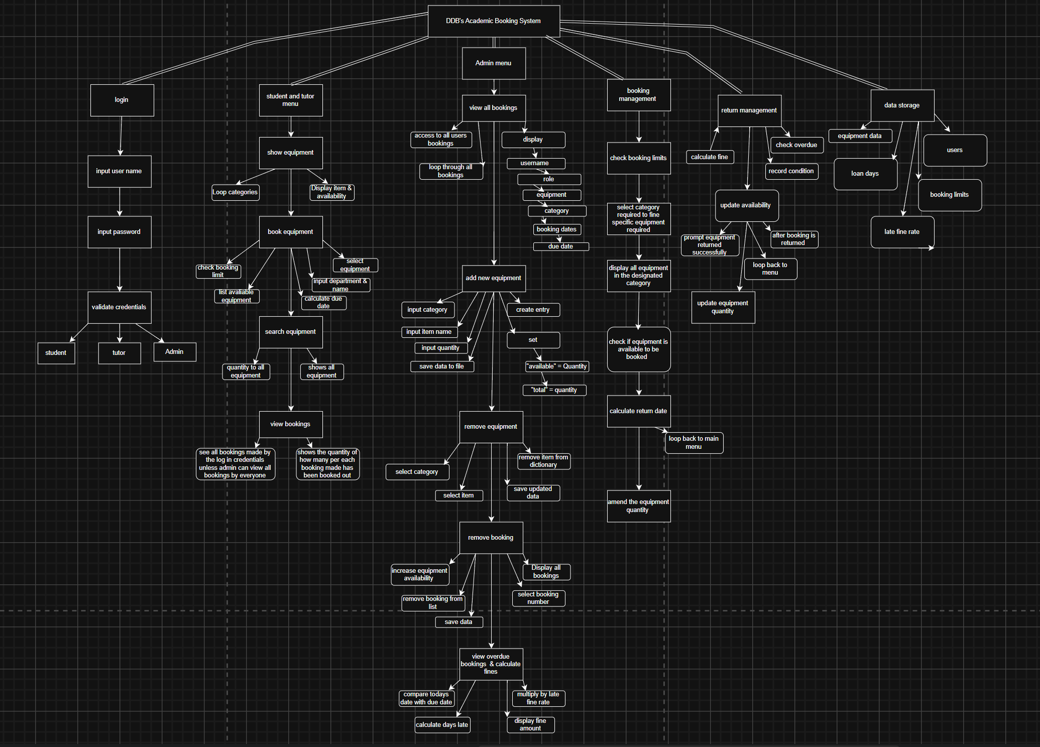

3.0 SOFTWARE DESIGN AND DEVELOPMENT
It is important that the development of the system is functional so that it performs its intended tasks accurately and reliably. A functional system ensures that equipment bookings are saved correctly, displayed clearly and updated in real time in order to prevent issues such as double bookings or missing information[4].
If the system does not function properly, it could cause more confusion than the paper-based method it is meant to replace. Ensuring the program works as expected allows staff to trust the system, rely on it for daily operations, and use it confidently to manage equipment bookings efficiently [5].
This section focuses and explains the design and development of DDB’s Academic Booking System, including the planning tools, flowcharts, pseudocode, programming constructs, implementation decisions and the python modules and libraries needed to be used to build the final solution. These design activities ensure the system is logically structured to be easy to maintain and capable of meeting the functional requirements for managing equipment bookings effectively.

3.1 Design

3.1.1 Flowchart

Flowchart Screenshot
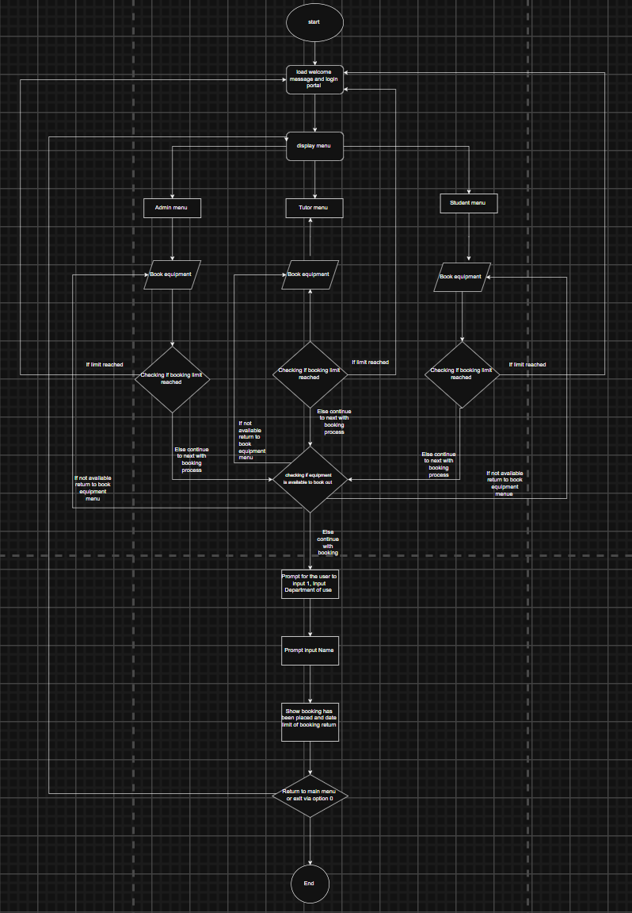

A flowchart is a visual diagram that represents the sequence of steps, decisions, and processes within a system [6]. It uses standard symbols such as rectangles for processes, diamonds for decisions, and arrows to show the direction of flow. Flowcharts help developers understand the logic of a system before implementation[7]

The flowchart for DDB’s academic booking system illustrates the full booking process from the moment a user logs in to the final confirmation of a booking. It shows how different user roles (Admin, Tutor, Student) access the system, how the booking menu is reached, and how the system checks booking limits and equipment availability before allowing a booking to proceed. The diagram also includes user inputs such as department and name, and shows the final step where the system confirms the booking and returns the user to the main menu. This flowchart ensured that the booking logic was clear, structured, and free from logical gaps before coding began.

Purpose of the Flowchart and Flowchart Logic
The flowchart illustrates the full logic of the DDB’s academic booking system by showing how user inputs are processed and transformed into system outputs. It begins with the system loading persistent data and prompting the user to enter login credentials which are validated against stored records.
If the credentials are incorrect the system outputs an error message and loops back to the login stage. Once authenticated the user is presented with a role-specific menu and selecting the booking option triggers a series of decision processes. These include checking whether the user has reached their booking limit and verifying equipment availability.
If both conditions are satisfied, the system collects additional inputs such as department and name calculates the due date, updates equipment quantities, and generates a booking confirmation. This logic directly aligns with the IPO table, where each stage of the flowchart corresponds to a clear set of inputs (e.g., username, menu choice, equipment selection), processes (e.g., validation, availability checks, data updates), and outputs (e.g., login success, booking confirmation, error messages). By mapping these steps visually the flowchart ensures that the program’s behavior matches the structured input process output model used throughout the system.

IPO Table
Input | Process | Output
Username and password | System validates credentials against users dictionary | Successful login and access to menu, or "invalid login" message
Menu selection (1–6, 0) | System displays options based on role | Menu showing view equipment, book, return, search, view bookings made, admin (if admin), logout
View equipment request | System reads data.json and retrieves equipment data | List of equipment with available with total quantities
Search keyword | System searches data.json for matching equipment names | Matching equipment items with available quantity, or prompt "no matches found"
Equipment selection | System checks availability, user booking count, and booking limit | Booking confirmed, due date calculated using loan days, equipment availability updated, data saved to data.json, or error if unavailable
Department and name | System records department and user name with booking details | Booking stored with username, role, name, department, category, date, and due date in data.json
Return selection | System validates booking, prompts for condition (G/D), updates availability, calculates overdue fine if late | Booking removed, equipment availability updated in data.json, fine displayed if overdue, message if damaged, then prompt "returned successfully"
Admin menu option | System validates admin role and displays admin options | Admin menu with: 1. View bookings 2. Add equipment 3. Remove equipment 4. Remove bookings
View all bookings | System reads all bookings from data.json | List of all current bookings and details attached to each booking such as username, equipment, due date etc
New equipment details (category, item, quantity) | System adds equipment to data.json | Confirmation message prompts “Added", equipment available for booking and quantity amended
Equipment removal details (category, item) | System removes equipment from data.json | Confirmation message prompts “Removed", equipment no longer available and updates quantity

3.1.2 Pseudocode

Pseudocode purpose and importance
Pseudocode is a high-level, informal representation of a computer program’s logic that uses structured language resembling code but without strict syntax [8]. Its primary purpose is to plan and communicate the flow of a program before actual coding begins. By outlining the sequence of steps, decisions, and iterations in an understandable format, pseudocode helps developers and stakeholders visualize the logic without being distracted by programming language syntax[9].
Pseudocode builds directly on the logic established in the flowchart by translating each stage of the design into clear, structured steps that can be implemented in Python. While the flowchart provides a visual overview of the system’s decision pathways such as login validation, menu navigation, booking checks, and data updates.
The pseudocode expresses this same logic in a written language independent format, this makes the behavior of each function easier to understand, refine, and verify before coding begins. By breaking the system into smaller modular procedures, pseudocode supports decomposition and ensures that complex processes like booking validation, availability checks, and data handling follow a consistent and error-free sequence.
It also acts as a blueprint for implementation helping maintain clarity and reducing logical errors, while allowing developers or reviewers with different levels of programming experience to follow and evaluate the intended system behavior.

START PROGRAM

SET BASE_DIR to script directory
SET DATA_FILE = BASE_DIR + "/data.json"

IF DATA_FILE does not exist THEN
CREATE default equipment list
CREATE empty bookings list
SAVE data to file
ELSE
LOAD data from file
END IF

DEFINE USERS (username, password, role)
DEFINE BOOKING_LIMITS
DEFINE LOAN_DAYS
DEFINE LATE_FINE_RATE

FUNCTION login()
ASK for username and password
IF username exists AND password matches THEN
RETURN username and role
ELSE
DISPLAY "Invalid login"
RETURN None
END IF
END FUNCTION

FUNCTION show_equipment()
FOR each category
DISPLAY category name
FOR each item
DISPLAY item name and availability
END FOR
END FOR
END FUNCTION

FUNCTION search_equipment()
ASK for keyword
SET found = false
FOR each category and item
IF keyword is in item name THEN
DISPLAY item and availability
found = true
END IF
END FOR
IF found = false THEN DISPLAY "No matches found"
END FUNCTION

FUNCTION view_my_bookings(username)
GET all bookings for username
IF none THEN DISPLAY "No bookings"
ELSE DISPLAY each booking with due date
END FUNCTION

FUNCTION book_equipment(username, role)
GET user’s current bookings
IF total booked >= limit THEN
DISPLAY "Booking limit reached"
RETURN
END IF

DISPLAY categories
ASK user to choose category

DISPLAY available items in category
ASK user to choose item

ASK for quantity
IF quantity > available THEN STOP

ASK for department and name

CALCULATE due_date = today + LOAN_DAYS[role]

REDUCE available stock
ADD booking record with all details
SAVE data

DISPLAY confirmation
END FUNCTION

FUNCTION return_equipment(username)
GET user’s bookings
IF none THEN DISPLAY "No bookings to return"

DISPLAY bookings
ASK user to choose booking
ASK how many to return

CALCULATE days_late = today - due_date
IF days_late > 0 THEN
CALCULATE fine = days_late * LATE_FINE_RATE
DISPLAY fine
END IF

ASK for condition (Good/Damaged)

INCREASE stock by returned amount

IF full amount returned THEN
REMOVE booking
ELSE
REDUCE booking quantity
END IF

SAVE data
DISPLAY "Returned successfully"
END FUNCTION

FUNCTION view_overdue_bookings()
SET found = false
FOR each booking
IF due_date < today THEN
CALCULATE days_late and fine
DISPLAY booking and fine
found = true
END IF
END FOR
IF found = false THEN DISPLAY "No overdue bookings"
END FUNCTION

FUNCTION admin_menu()
DISPLAY:
1. View all bookings
2. Add equipment
3. Remove equipment
4. Remove booking
5. View overdue bookings

ASK for choice

IF 1 THEN DISPLAY all bookings
IF 2 THEN ASK for new item details, add to data, save
IF 3 THEN ASK for item, remove from data, save
IF 4 THEN ASK for booking, restore stock, remove booking, save
IF 5 THEN CALL view_overdue_bookings()
END FUNCTION

FUNCTION student_menu(username, role)
REPEAT
DISPLAY:
1. View equipment
2. Book equipment
3. Return equipment
4. Search equipment
5. View my bookings
0. Logout

ASK for choice
CALL the matching function
UNTIL choice = 0
END FUNCTION

FUNCTION tutor_menu(username, role)
SAME OPTIONS AS student_menu
END FUNCTION

DISPLAY "DDB’s Academic Equipment Booking System"

REPEAT
CALL login() until successful
SET username and role

IF role = student THEN CALL student_menu
IF role = tutor THEN CALL tutor_menu
IF role = admin THEN
REPEAT
CALL admin_menu
ASK "Return to admin menu?"
UNTIL answer != "y"
END IF

UNTIL user exits

END PROGRAM

Login System
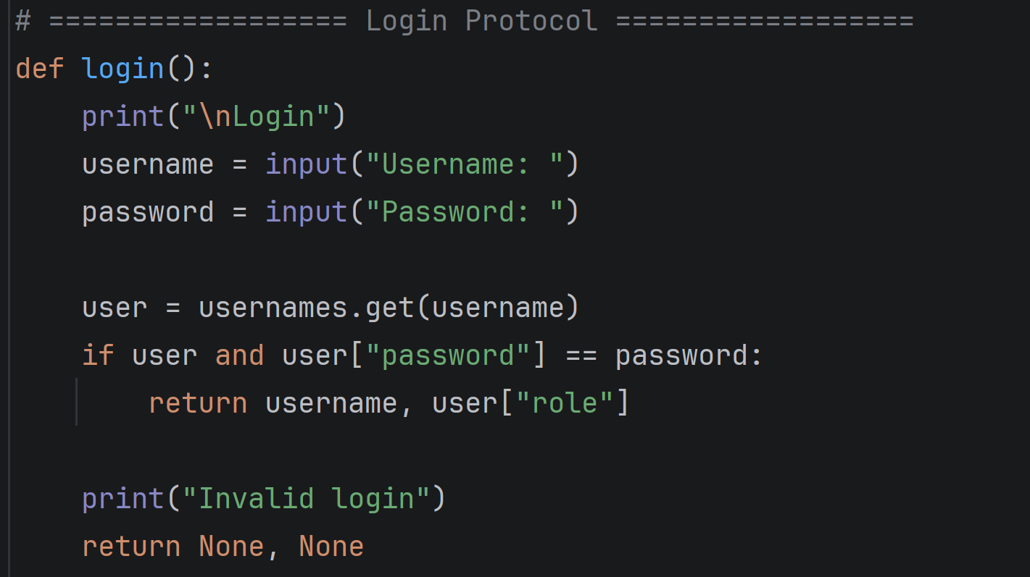
The login system demonstrates modularity and decomposition by isolating authentication into the login() function. It interacts with the system’s data loaded from data.json, which is safely created or reset if missing or corrupted.
This function abstracts the process of verifying a username and password against the users dictionary, keeping the main program focused on menu operations. Selection ensures that only valid credentials permit access, displaying "Invalid login" otherwise. Iteration occurs in the main loop, repeatedly prompting the user until a correct login is provided. This separation of responsibilities improves robustness, as changes to authentication logic can be made within this function without affecting other parts of the system.

Main program protocol
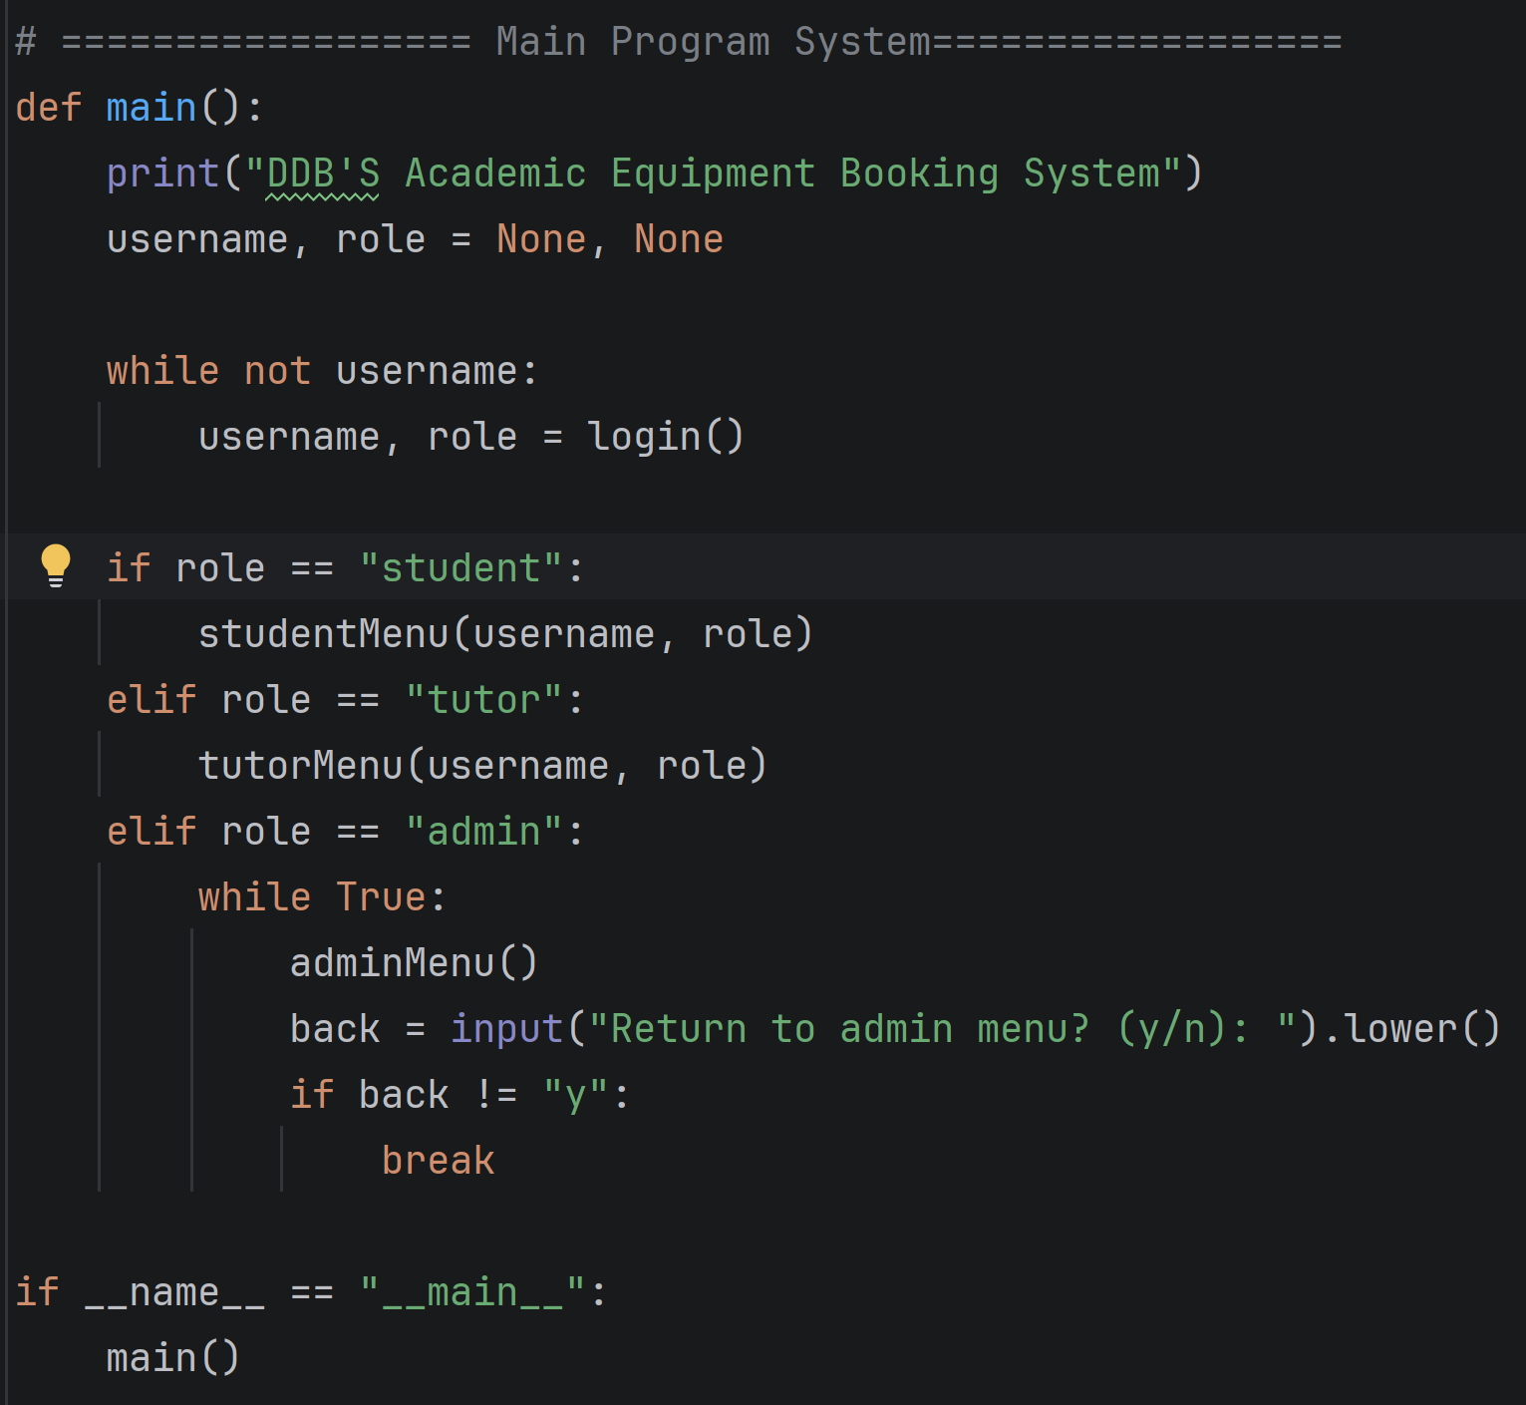
The program now decomposes user interaction into three separate menus: student_menu(), tutor_menu(), and admin_menu(). Each menu directs the user to dedicated functions such as showEquipment(), bookEquipment(), returnEquipment(), searchEquipment(), and viewMyBookings(). Iteration is used inside each menu loop, allowing continuous interaction until logout. Selection ensures that each role only sees the options appropriate to them, improving security and modularity.

Search Equipment protocol
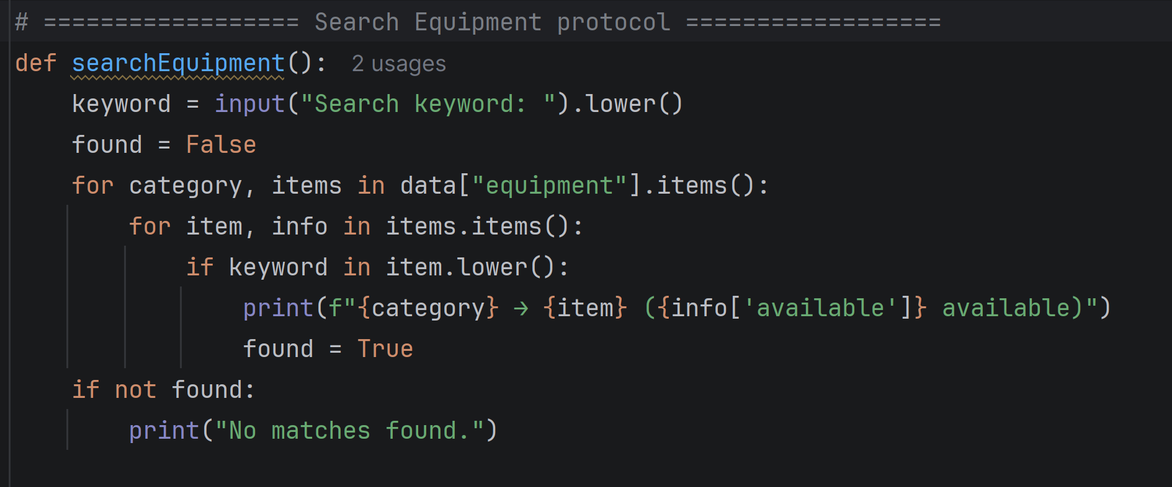
The searchEquipment() function demonstrates iteration and abstraction by scanning through all categories and items in the equipment dictionary to find matches based on a user-entered keyword. Selection is used to determine whether each item name contains the keyword, and matching results are displayed with their availability. This modular approach isolates search logic from other parts of the system, improving clarity and allowing new items or categories to be added without modifying the search function.

Book Equipment
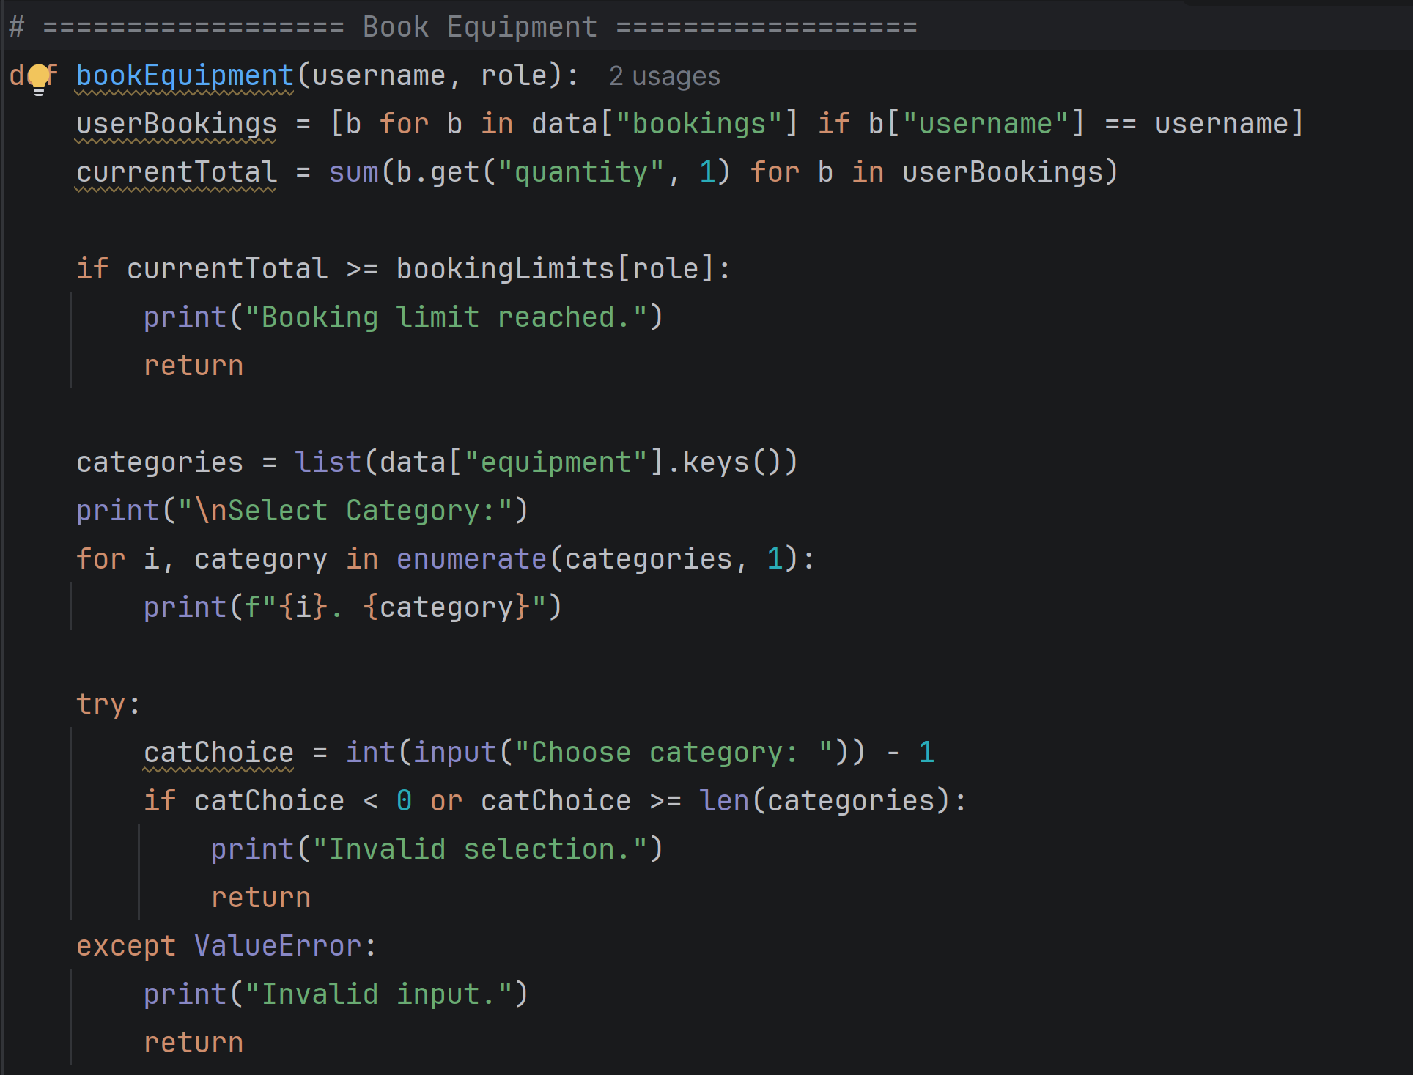
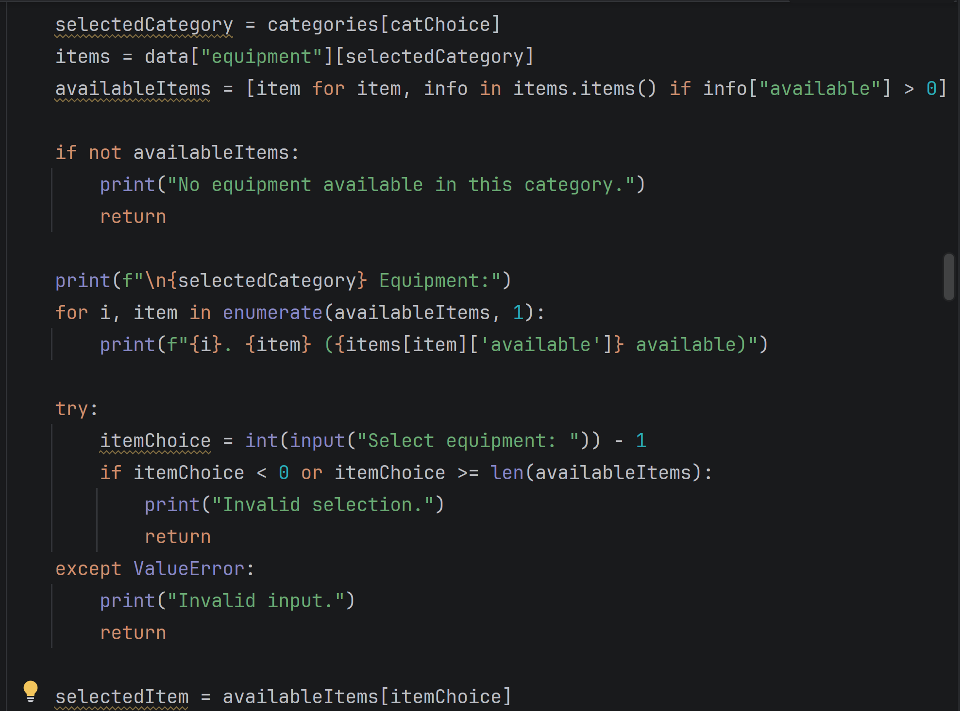
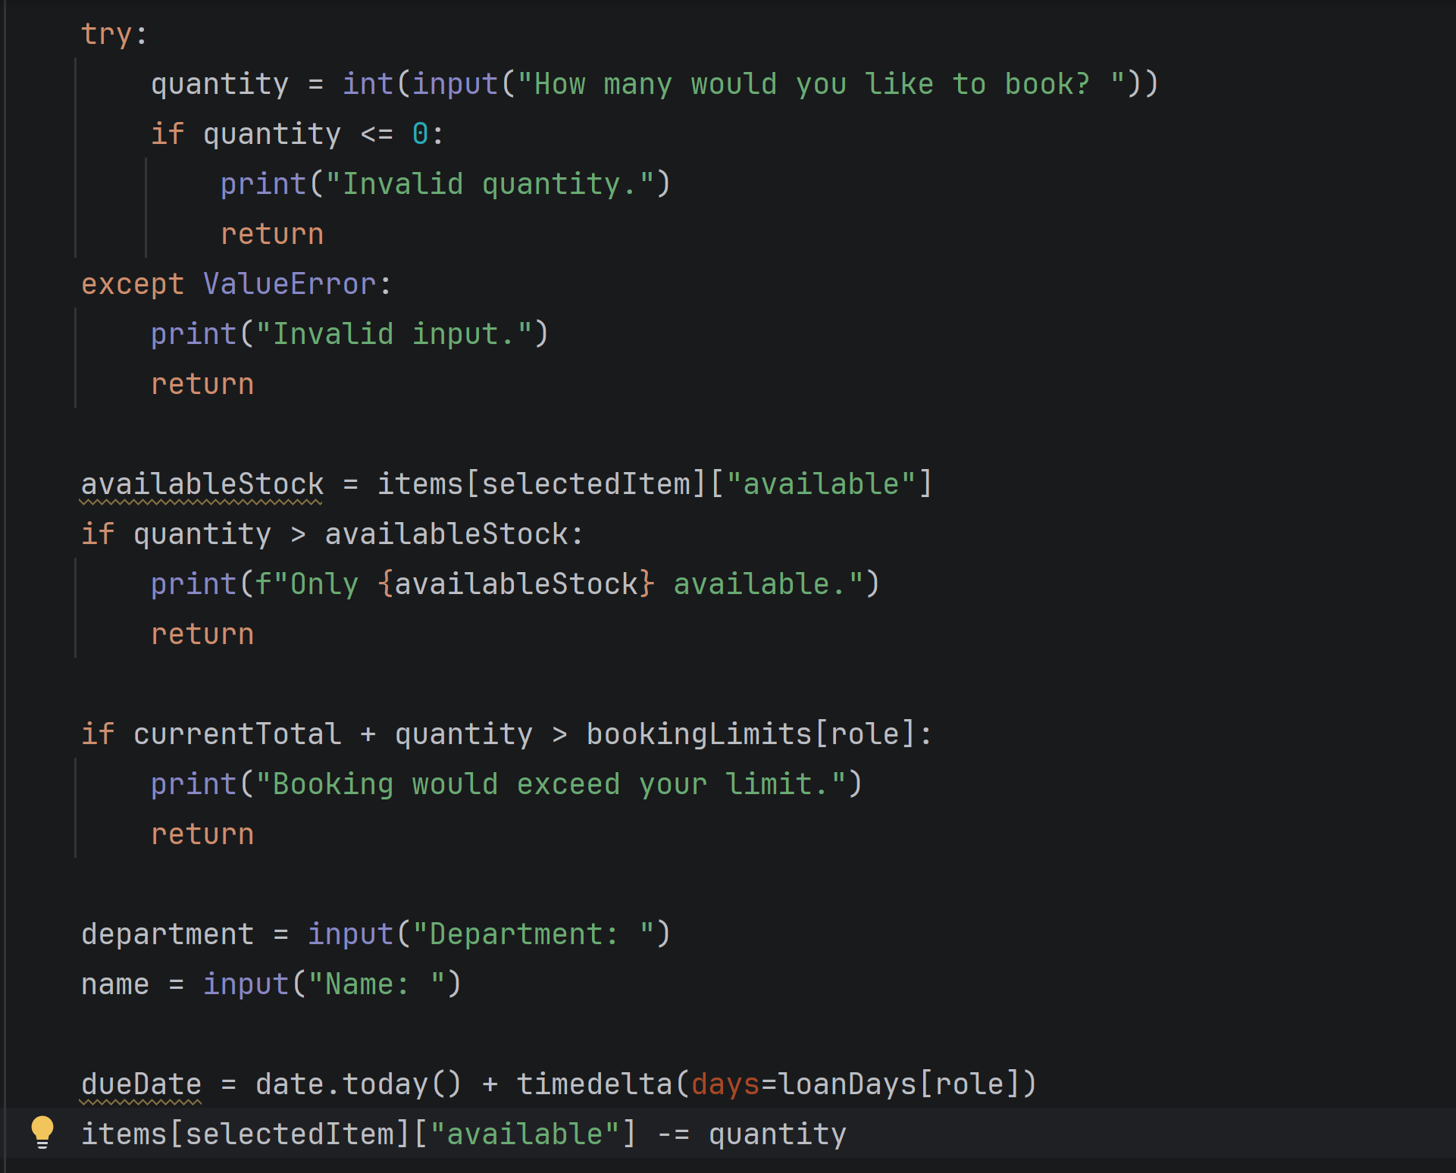
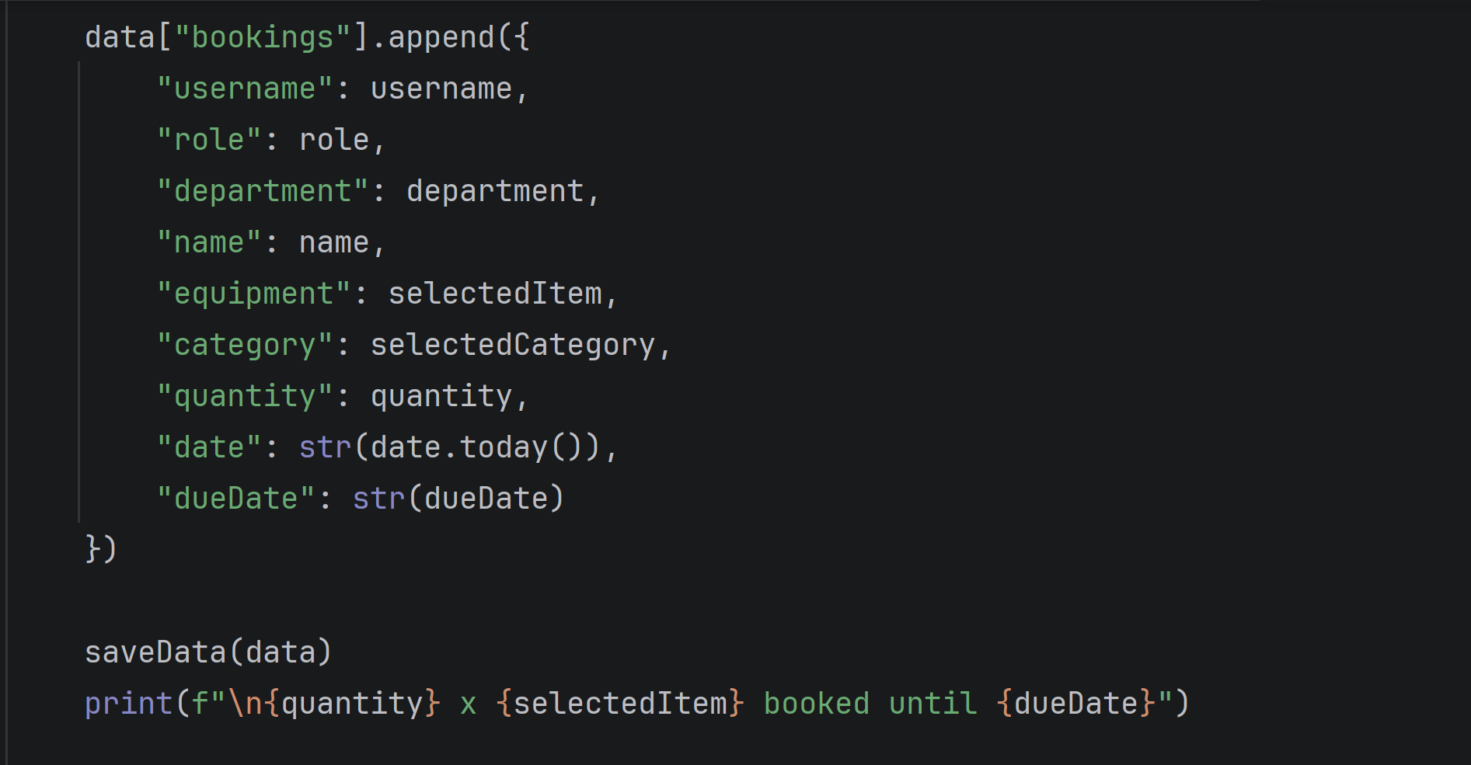
The bookEquipment(username, role) function manages equipment reservations while enforcing role-based limits. It iterates through all categories and items to create a dynamic list of available equipment, then uses selection to validate user input and prevent overbooking. The function decomposes the process into steps: verifying booking limits, prompting for department and name, calculating due dates according to role, updating equipment availability, and saving data to data.json. By abstracting these steps, the system ensures robustness, accurate records, and modularity, allowing future changes to booking rules without affecting other components.

Return Equipment
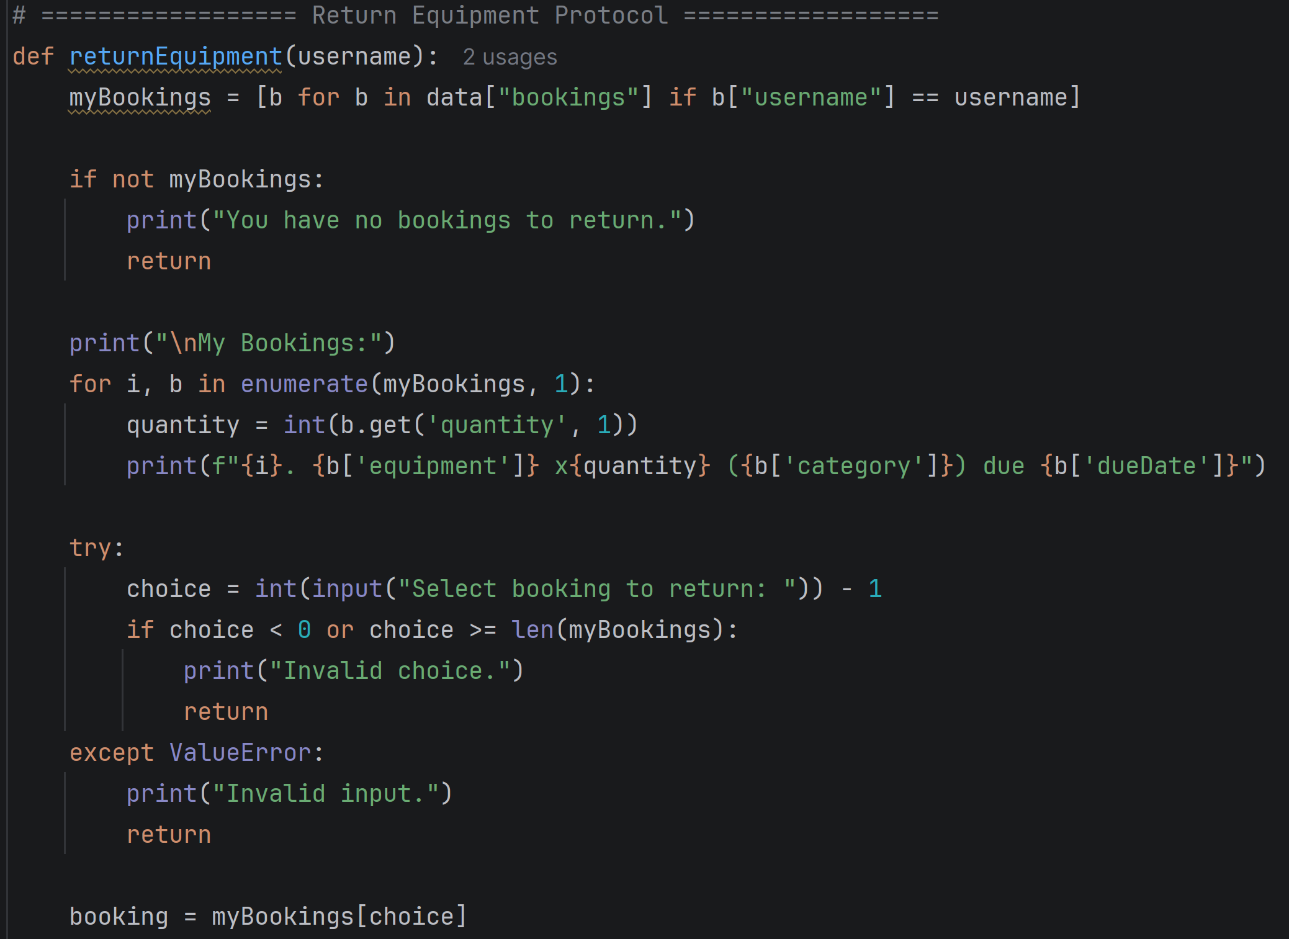
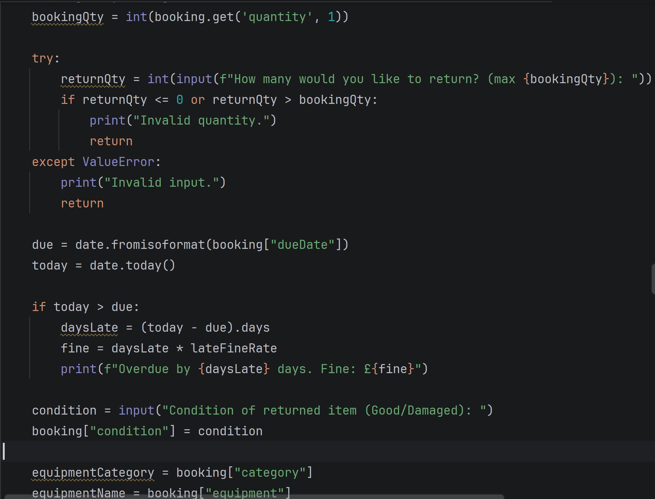
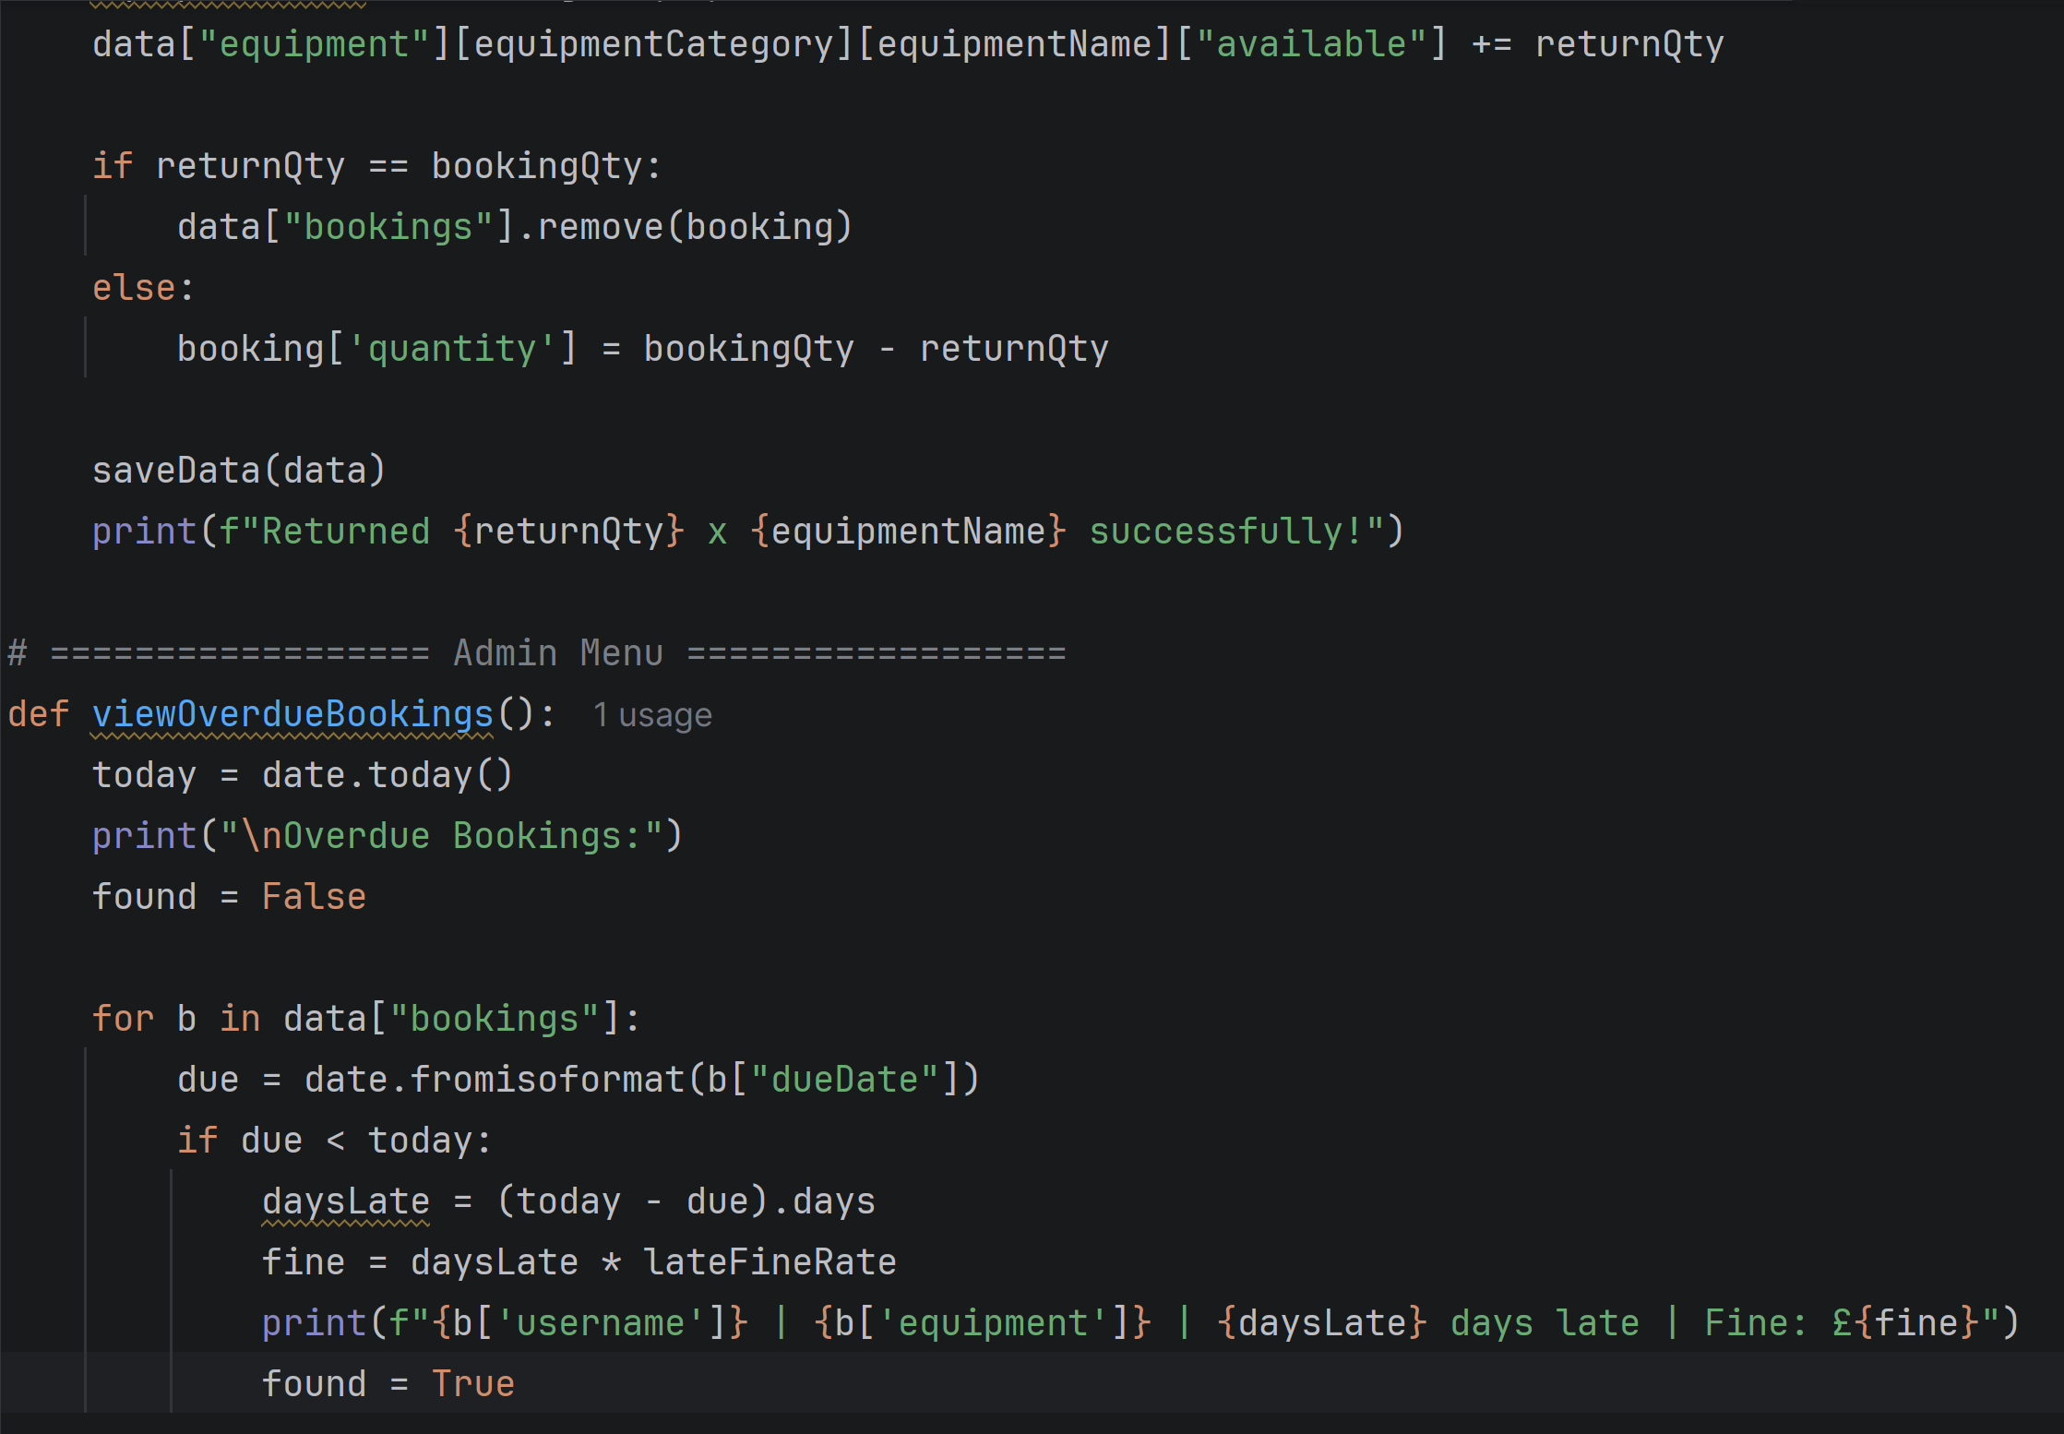
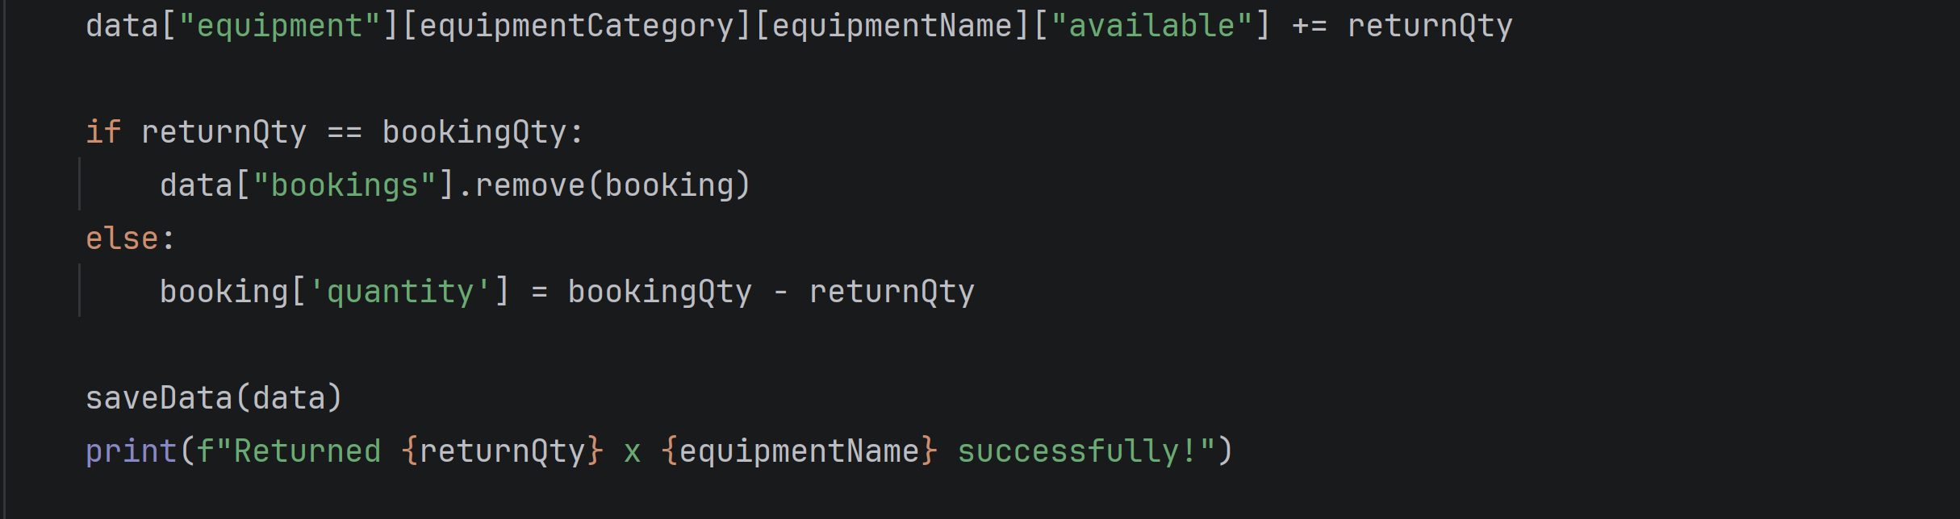
The ReturnEquipment function manages the full return process by first listing all bookings belonging to the user and allowing them to select which item to return. Iteration is used to display each booking, and selection ensures that only valid choices proceed. The function checks whether the item is overdue by comparing the current date with the due date and calculates a fine based on the number of late days. It also records the condition of the returned equipment (Good or Damaged) for tracking purposes. Once confirmed, the system restores the equipment’s availability by increasing the stock count and removes the booking from the system. All updates are saved to data.json, ensuring data integrity. This encapsulated approach demonstrates modularity, abstraction, and robustness by keeping all return-related logic within a single, well-structured function.

Admin Menu
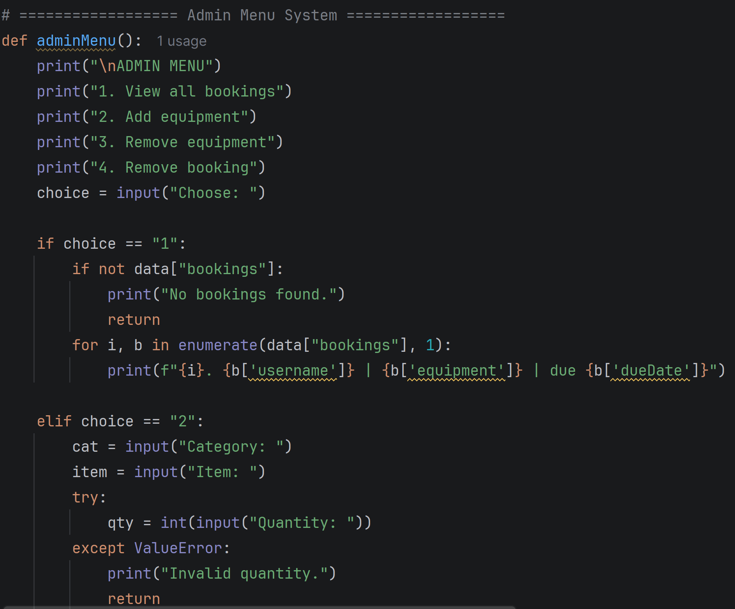
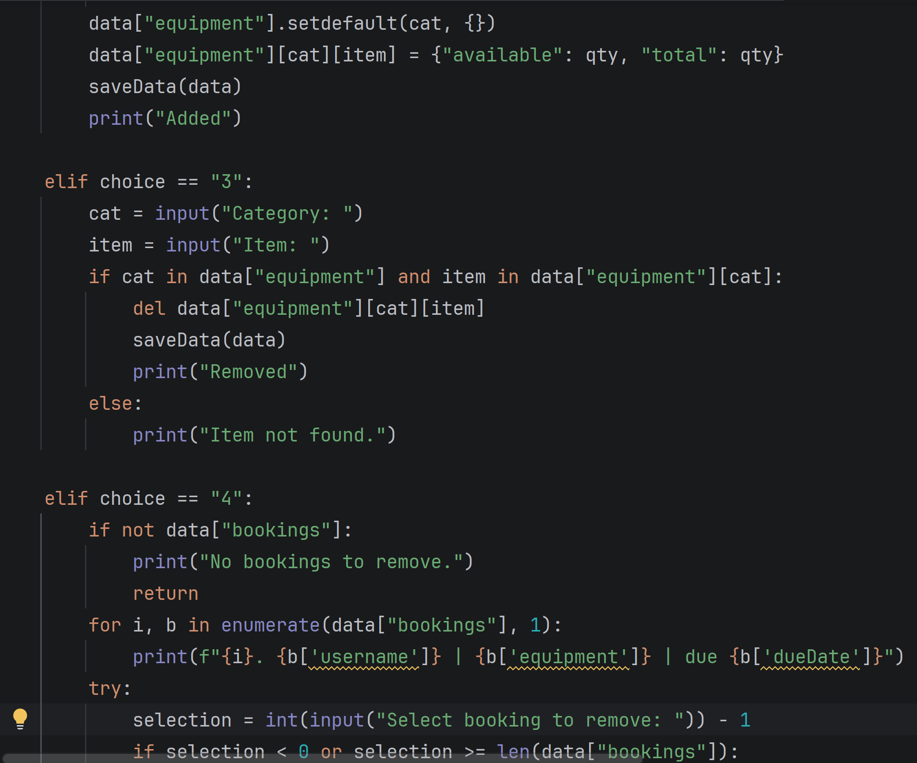
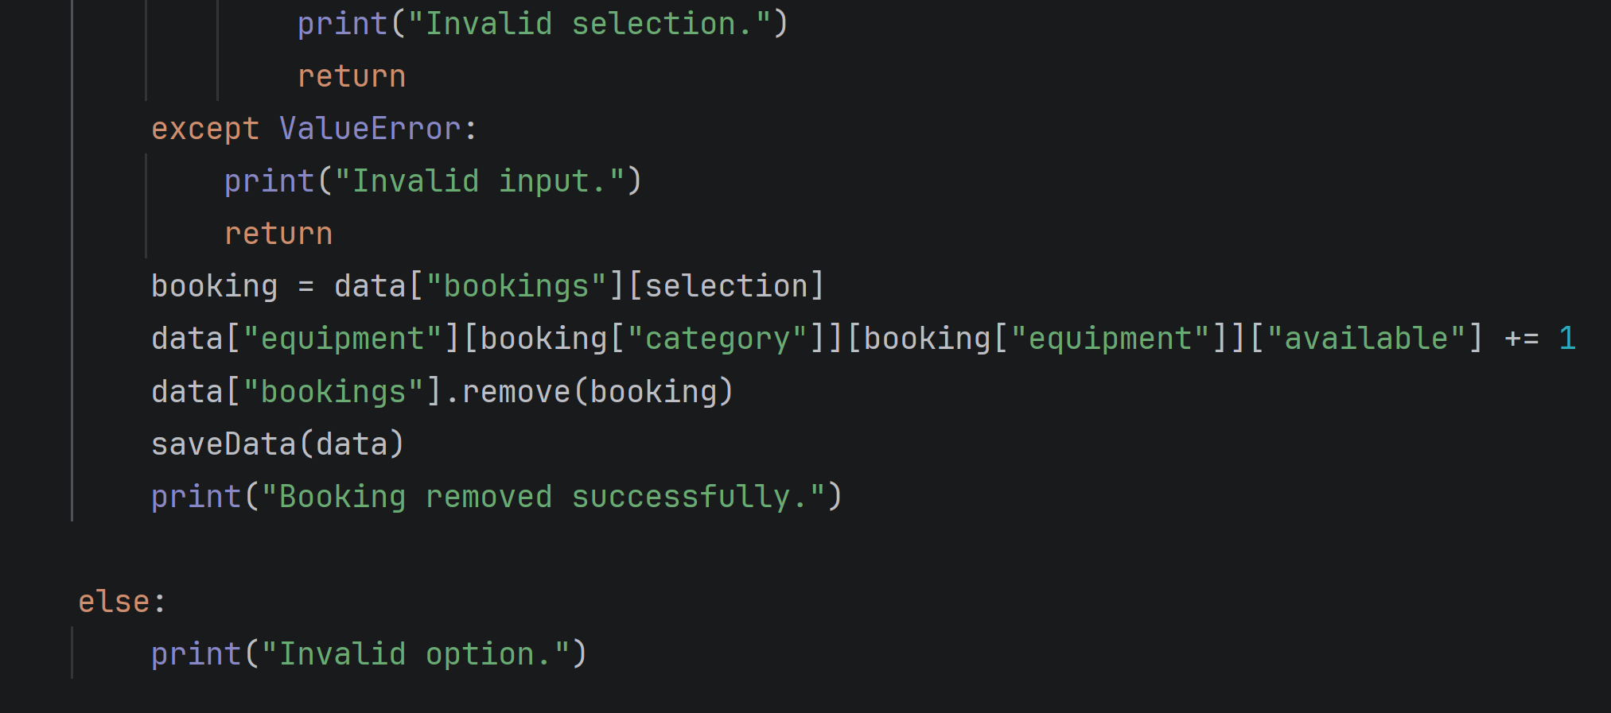
The admin_menu() function applies decomposition, modularity, and selection. Each admin task—viewing bookings, adding equipment, removing equipment, and removing bookings—is implemented as a separate branch, decomposing complex administrative operations into manageable components. Selection ensures that only valid options execute the corresponding task, while abstraction allows high-level interaction without exposing internal data structures. Using setdefault() when adding new categories supports dynamic expansion, maintaining robustness. By separating administrative functions into a dedicated module, the system is easier to maintain, extend, and debug, reflecting careful alignment with the original pseudocode.

3.2 Implementation Decision

3.2.1 Data Structures
In programming, a data structure is an organised way of storing, managing, and accessing data so that it can be used efficiently within a system [10]. Different structures such as lists, dictionaries, and files are chosen based on how the program needs to retrieve, update, or organise information [11].

DDB’s Academic Equipment Booking System uses a combination of dictionaries, lists, and JSON files as its core data structures, each selected to support the system’s functional and design requirements. Dictionaries provide fast, key-based access to essential information, which is crucial for tasks such as validating login credentials and applying role-specific booking rules. For example, the USERS dictionary maps usernames to their passwords and roles, allowing the login process to authenticate users instantly and determine whether they are a student, tutor, or admin. Additional dictionaries, such as BOOKING_LIMITS and LOAN_DAYS, enforce borrowing restrictions and loan durations for each user type, ensuring the system behaves consistently with institutional policies. Equipment data is stored using nested dictionaries, where each category contains items with fields for total quantity and availability. This structure mirrors real-world inventory management and allows the system to update availability dynamically whenever items are booked or returned.
Lists complement these dictionaries by storing collections of data that grow or shrink during program execution. All booking records are held in a list, with each booking represented as a dictionary containing details such as the user, equipment, department, category, and due date. This approach allows the system to iterate through bookings efficiently, filter them by username, and remove them when items are returned. It also supports the seamless addition of new bookings without requiring structural changes to the program, improving maintainability and modularity. Finally, JSON files are used for persistent storage of both dictionaries and lists, ensuring that all user, equipment, and booking data is saved between sessions. This prevents data loss, maintains system integrity, and allows the program to reload structured information reliably whenever it is launched.

Definition of Variables
Variables are named storage locations used to hold data that the program needs to access, update, or manipulate during execution [12]. They allow the system to track user inputs, system states, and operational values as the booking process progresses [13].

In the DDB’s academic booking system, variables play a central role in controlling program flow and managing user interactions. Each variable stores a specific type of information such as usernames, roles, selected equipment, quantities, or booking details which allows functions like book_equipment(), search_records(), and return_equipment() to operate consistently and accurately.
For example, variables such as username, role, and password support the login process while variables like category, item, department and due_date capture user inputs during the booking workflow. Boolean variables such as found and overdue help the system make decisions, such as whether a search was successful or whether a fine should be applied.
Although the system uses dictionaries to store structured data such as equipment categories and booking limits, the variables listed in the table act as the active components that retrieve, update and pass this information between functions. This ensures that the program can dynamically respond to user actions, update availability, calculate fines, and maintain accurate records. The variables table summarises each variable’s data type and purpose showing how they collectively support reliable program behaviour and maintainability.

VARIABLES TABLE

Variable name | Data type | Description
Data | String | Stores all equipment and booking information loaded from data.json
Data_file | String | File path for reading/writing data.json
Username | String | Stores the logged-in user's username
Password | String | Stores the entered password
User | String | Stores the selected user’s data (password and role)
Role | String | Stores the user’s role (admin, tutor, student)
Category | String | Stores the name of an equipment category
Items | String | Stores items within a specific category
Item | String | Stores the name of an equipment item
Info | String | Stores availability and total quantity of an item
Keyword | String | Stores the user’s search input
Found | Boolean | Indicates if a search match was found
User_bookings | String | Stores bookings belonging to the logged-in user
Available | String | Stores list of equipment currently available
I | Integer | Counter used for numbering menu or equipment options
Choice | Integer | Stores numeric menu or equipment selection
Department | String | Stores the department entered during booking
Name | String | Stores the name entered during booking
Due_date | String | Stores the calculated return date (as string)
Booking | String | Stores a selected booking entry for return
Overdue | Boolean | Indicates if equipment was returned late
Condition | Character | Stores the equipment condition input (g or d)
Days_late | Integer | Stores number of days equipment was returned late
Fine_amount | Real | Stores calculated fine for late return
Cat | String | Temporary variable for category name during booking/return
Qty | Integer | Stores quantity entered when adding equipment in admin menu

3.2.2 Programming Constructs

A programming construct refers to the structured way a program controls the order, flow, and behaviour of its execution using sequence, selection, iteration, and modular design [14]. These constructs form the foundation of the system’s logic and ensure that each process—such as logging in, booking equipment, or returning items—follows a predictable and reliable pathway [15].

The booking system makes use of the three fundamental programming constructs—sequence, selection, and iteration—to control the flow of execution and ensure that each process behaves predictably. Sequence is used throughout the program, as most functions follow a clear step-by-step order, such as loading data, displaying menus, collecting user inputs, and updating booking records. This linear structure ensures that each action occurs in the correct order and prevents logical inconsistencies. Selection is implemented through extensive use of if, elif, and else statements, which allow the system to make decisions based on user input and system conditions. These conditional checks are essential for validating login credentials, enforcing booking limits, verifying equipment availability, and determining whether an item is overdue or damaged during the return process. Iteration is also a key construct within the system, with for loops used to display lists of equipment and bookings, and while loops used to keep the main menu active until the user chooses to exit. These loops support efficient navigation and allow the system to handle multiple records dynamically.

The program also adopts a modular design through the use of functions, with each major task separated into its own dedicated procedure. Functions such as book_equipment(), search_records(), return_equipment(), and view_bookings() encapsulate specific behaviours, making the system easier to read, maintain, and extend. This modularity aligns with the structure defined in the flowchart and pseudocode, ensuring that each component of the system performs a single, well-defined role. By passing variables and data between functions, the program maintains consistency and avoids unnecessary repetition, improving both clarity and maintainability.

3.2.3 Python Modules and Libraries

Python modules and libraries are pre-built collections of functions and tools that extend the capabilities of a program without requiring developers to write everything from scratch [16]. They support abstraction, reduce complexity, and improve reliability by providing tested, reusable components for tasks such as file handling, data storage, and date processing [17,18].
The booking system utilizes several of Python’s built-in modules to support data persistence, file management, and time-based calculations. The json module is used to store and retrieve structured data, allowing equipment records and booking information to be written to and loaded from a JSON file. This preserves nested lists and dictionaries between program executions, ensuring persistent storage and maintaining data integrity while abstracting complex data structures into a readable, portable format.
The os module is used to manage file-related operations, particularly to check whether the data file exists and to construct file paths dynamically. This ensures the system runs consistently across different devices and directories, reducing the risk of runtime errors caused by missing files or incorrect paths. Its use enhances robustness and supports platform-independent execution.
The system also imports date and timedelta from Python’s datetime module. These tools are essential for calculating booking dates, determining due dates based on user roles, and identifying overdue returns. By relying on built-in date arithmetic rather than manual calculations, the program ensures accuracy, prevents logical errors, and maintains reliability in all time-based operations.

ROLES AND TESTING

4.0 Role of Testing in a Software Environment
Testing plays a critical role in software development because it verifies that the system behaves as intended and meets the functional requirements defined during the design stage [19]. It ensures that each feature such as logging in, booking equipment, returning items, and updating availability operates correctly under normal and unexpected conditions [20].
By systematically checking inputs, outputs, and system responses, testing helps identify defects early, preventing issues that could compromise reliability, data accuracy or user trust.
Testing is also essential for confirming how the system handles edge cases, such as invalid menu selections, unavailable equipment, exceeded booking limits, or overdue returns. These tests demonstrate whether the program can recover gracefully from errors without crashing or corrupting data. Through this process, developers can validate that error handling, decision logic, and data updates work consistently across different scenarios.

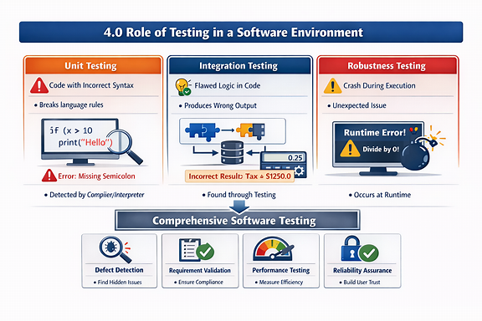
Figure 1 shows the different types of issues that you may face when testing the roles with the script written[21]. (A. Alghamdi and M. Alzahrani, “A CASE Tool for JAVA Programs Logical Errors Detection: Static and Dynamic Analysis,” 2022 3rd International Confere)

4.2 Types of Errors in Programming
Programming errors are generally classified into syntax errors, logical errors, and runtime errors. Understanding these categories is essential for producing reliable and maintainable software systems [22].
To reduce this risk, programmers use input validation and exception handling techniques to ensure the system responds appropriately to unexpected conditions.
Recognising and managing these error types supports systematic problem-solving and improves overall software reliability [23].

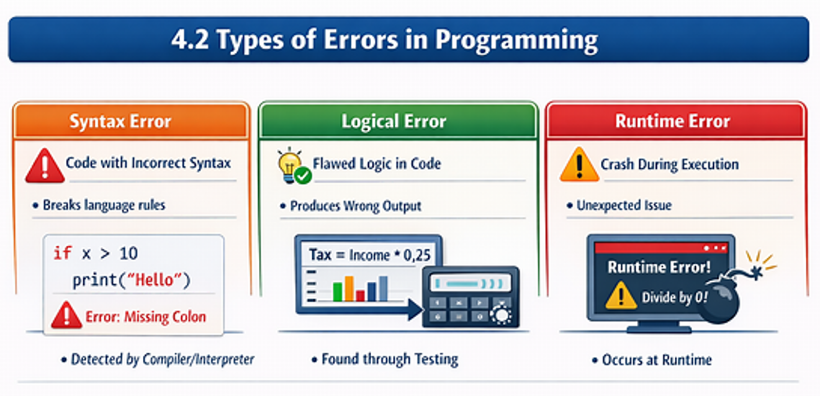
Figure 2 show the types of errors that can arise within script writing [24].

Syntax Errors
Syntax errors occur when code breaks the grammatical rules of a programming language, such as incorrect indentation, missing symbols, or improperly structured statements. These errors are usually detected immediately by the interpreter or compiler and prevent the program from running until corrected [25].
Example 1
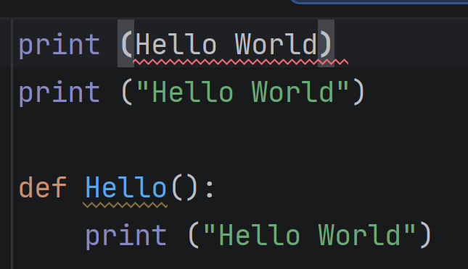
Figure 3 shows the incorrect syntax error and correctly underneath it with a example on how i would use this in script code.
Example 2
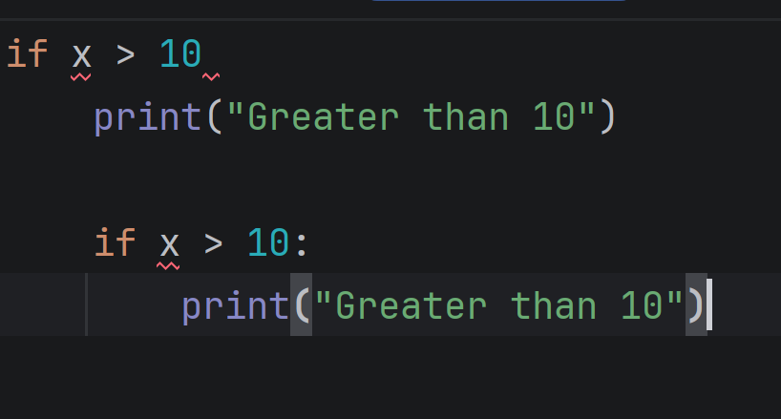
Figure 4 shows a error in the syntax missing in the above statement and correctly in the one underneath it.

Example 3
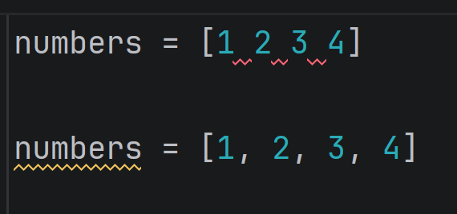
Figure 5 show the error of the missing syntax between the numbers.

Logical Error
Logical errors occur when a program executes successfully but produces incorrect or unintended results. These errors typically arise from flawed algorithms, incorrect conditions, or inaccurate calculations. Logical errors can be difficult to identify because the program appears to function normally, making careful testing and validation essential [26].
Example 1
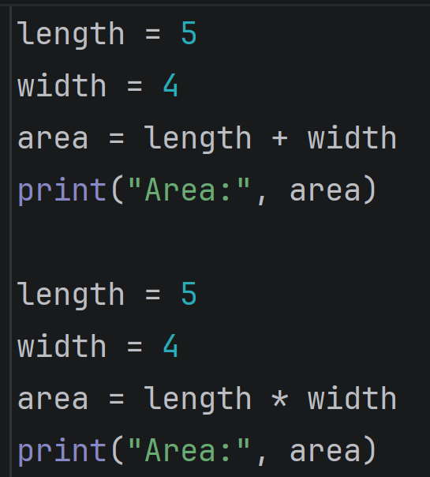
Figure 6 shows the incorrect syntax being used as area of a rectangle should be multiplication not addition which will cause logical errors when running the code.
Example 2
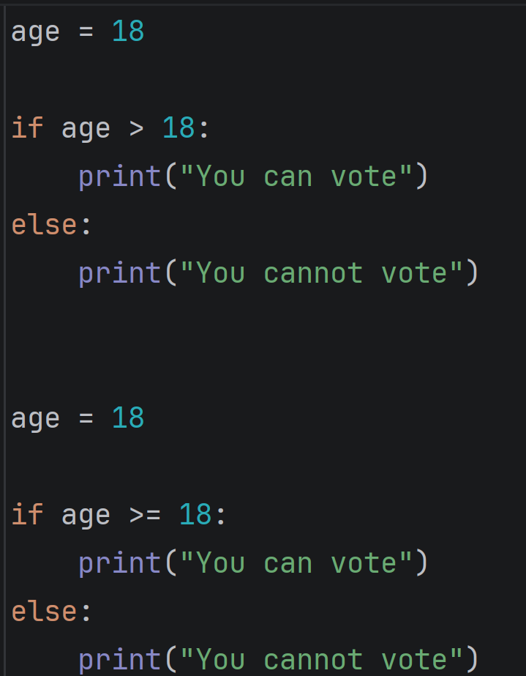
Figure 7 shows the missing syntax in the message as a person 18 years old should be allowed to vote but > excludes 18 with this missing syntax it will cause logical errors when running the code.
Example 3
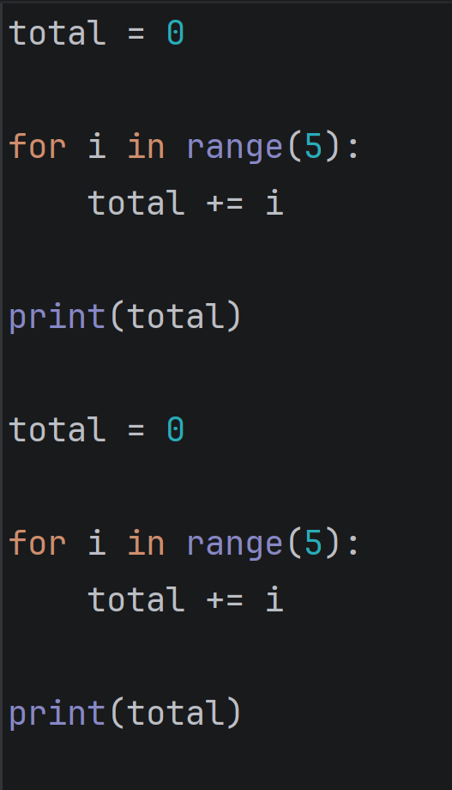
Figure 8 show the missing syntax as this replaces the value instead of adding numbers and will cause logical errors in the running of the script.

Runtime Errors
Runtime errors happen during execution and are often caused by unexpected situations such as invalid input, division by zero, or attempting to access unavailable resources. If not handled correctly, runtime errors can cause a system to crash [27].

Example 1
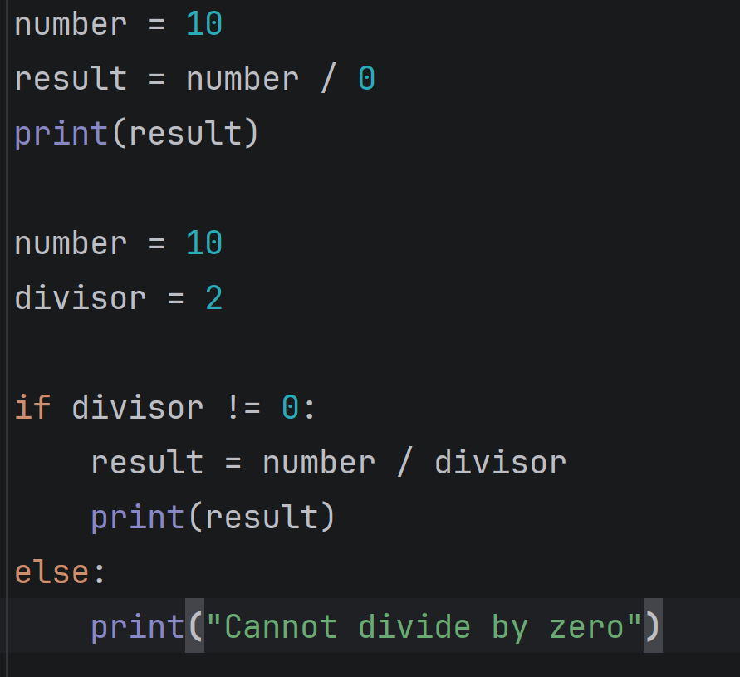
Figure 9 shows the error in the above code of that is division by zero which is not allowed and will give run time errors.

Example 2
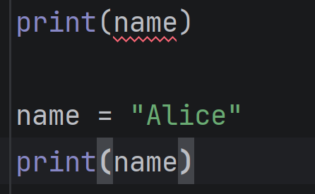
Figure 10 shows the error in the missing name value being defined and will cause a runtime error.

Example 3
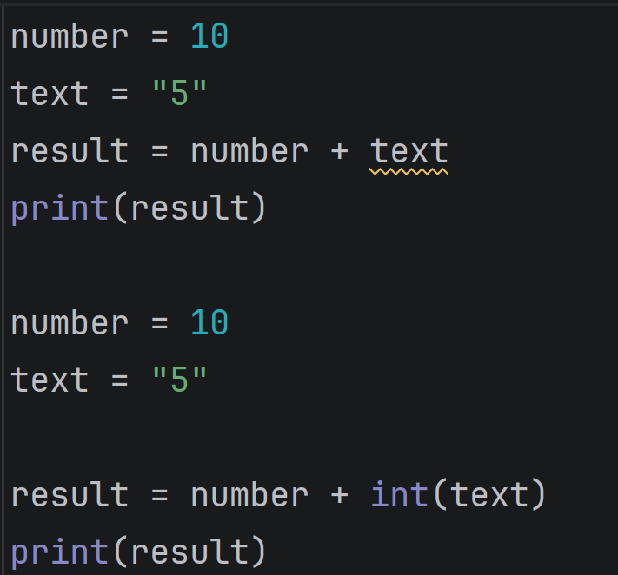
Figure 11 shows the error of trying to add a integer and a string together incorrectly as you cannot add a integer and string together which will give a runtime error.

4.3 Example of Test Cases
During development, test cases confirmed that the system performs all operations reliably [28]. Functional tests validated that selection rules, such as booking limits, are enforced and that overdue fines are calculated accurately. Iteration tests ensured that loops over bookings and equipment categories correctly process all records. Modular testing confirmed that each function operates independently and updates persistent data correctly. Edge cases, including empty bookings or unavailable equipment, were tested to verify robustness. The system demonstrated consistent and accurate behaviour while applying computational thinking to ensure reliability and maintainability and scalability [29].

Test ID | Test title | Objective | preconditions | Test steps | Test data | data | Pass/Fail | Comments
TC01 | Valid admin login | Checking if login is working correctly | The system runs and logs in to the admin section of the booking system | Using user name and password to log into system | Admin menu appears | Admin menu displayed | Pass | Photo below
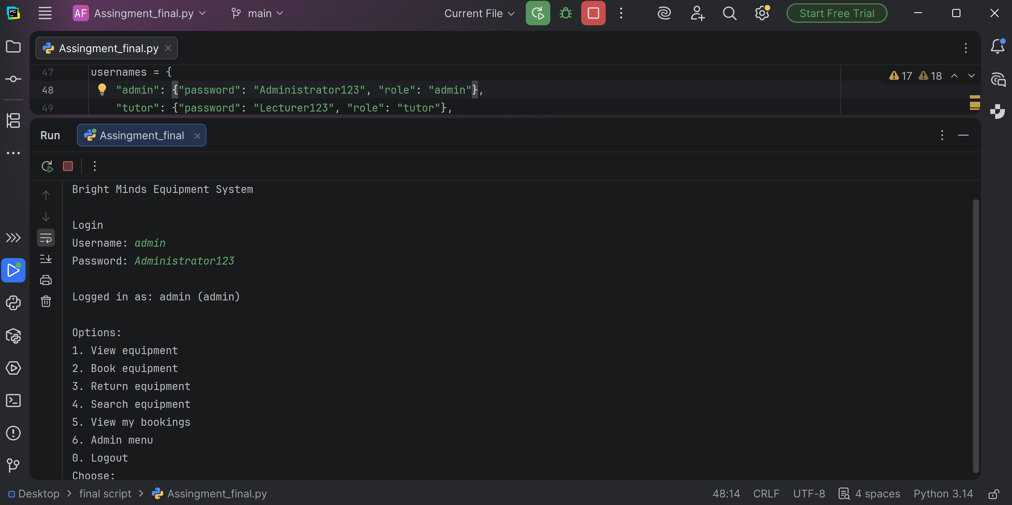

Test ID | Test title | objective | Test steps | Test data | preconditions | Data | Pass/Fail | comments
TC02 | Booking limit works | Book out 20 then try to book 21 when limit is 20 | Book items with the student until limit is reached at 20 bookings | Booking limit reached | System runs bookings until limit reaches then prompts not available to book as limit reached | Booking would exceed your limit and returned to menu | Pass | Photo below
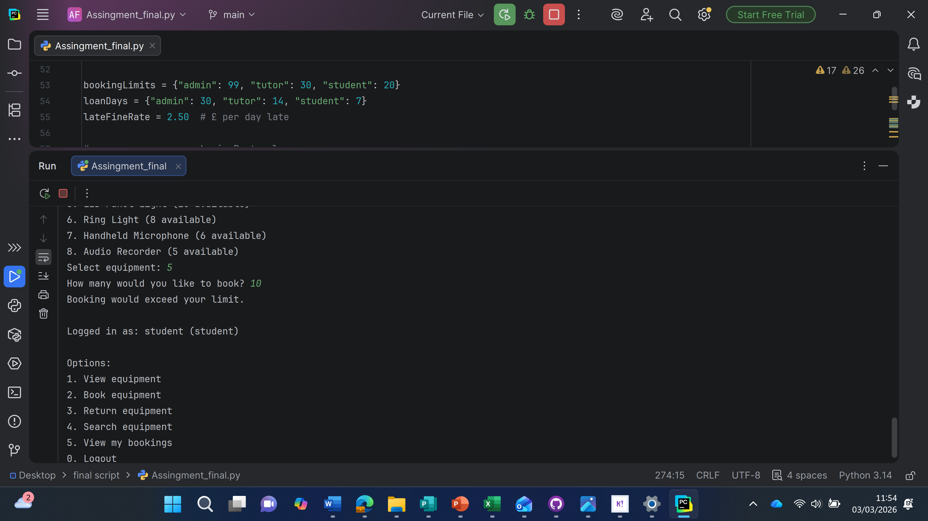

Test ID | Test title | Objective | Preconditions | Test steps | Test Data | Data | Pass/Fail | Comment
TC03 | Return equipment | Return items booked out and at quantity | System runs the process to find the bookings list and then prompt which number selection to return | Select Return equipment then prompt number of booking to return then state booking return successfully | The booking should be returned with print message to confirm this | Returned (equipment name) successfully! | Pass | photo added below
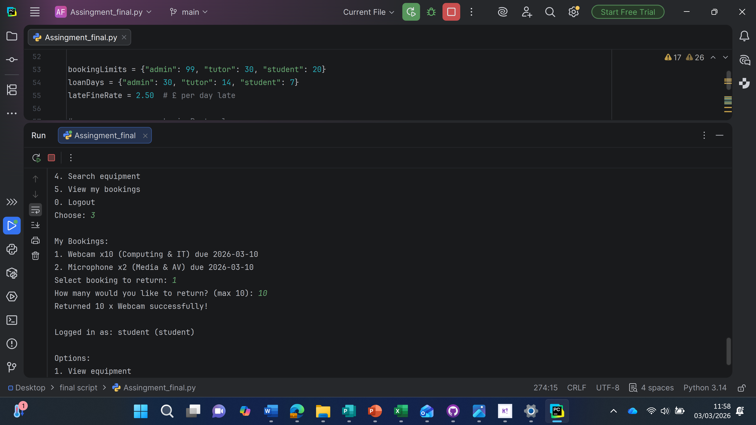

Test ID | Test title | Objective | preconditions | Test steps | Test data | Pass/Fail | comment
TC01 | Book equipment | Book an equipment out without issues | System runs and prompts equipment section selection and then equipment selection and then name input and department input | Booking Equipment process | With prompts of equipment selection and then quantity and department then lastly name to secure booking with return date stamp | Pass | Photo added below
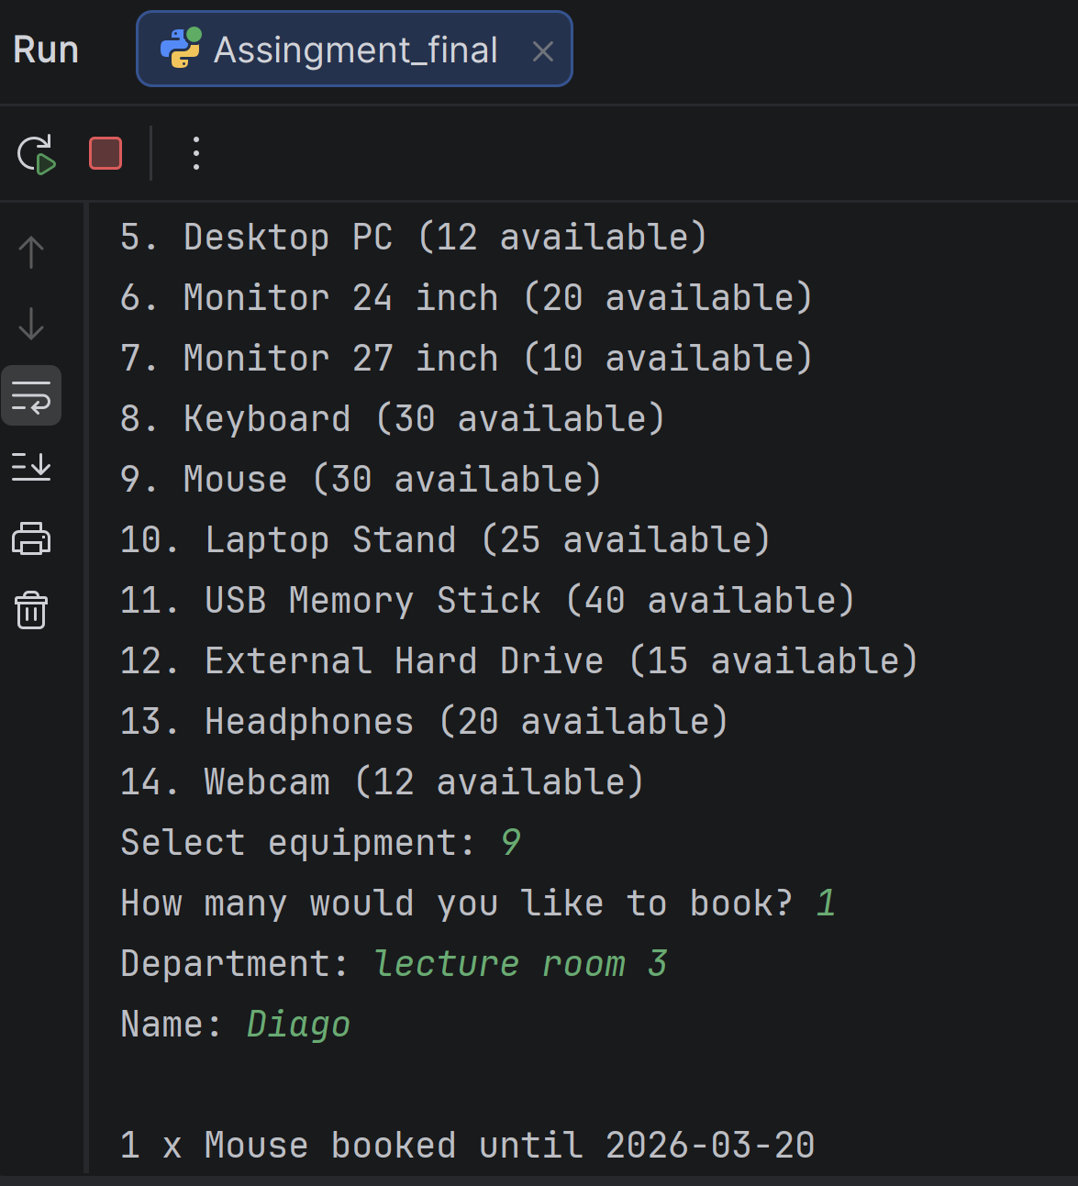

5.0 EVALUATION
When I started working on the DDB’s Academic Equipment Booking System, I ran into a lot of challenges, mainly because I hadn’t done any proper scripting for a few years. At the very beginning, I struggled a lot with getting the syntax right and making the script flow properly. Even the flowchart felt harder than it should have. It took me some time to get used to indenting things correctly, writing functions in the right structure, and remembering how Python handles different operations. But once I slowly got back into the rhythm of coding, things began to make more sense again.
As I worked through the project, I actually started to enjoy the challenge. It reminded me how much I like scripting and solving problems. Every time something went wrong, instead of feeling annoyed, I felt more determined to fix it. Working with different data types like dates for due dates, floats for fines, and strings for equipment names—felt like solving small puzzles. I enjoyed testing different parts of the code and seeing how each change affected the output.
Another challenge was making sure the system handled mistakes properly, like stopping users from returning items they didn’t borrow or booking more than they were allowed. I had to think more like a real user and less like a developer, which pushed me to write clearer error messages and stronger validation checks.
Even though I struggled at first these challenges helped me rebuild my skills and reminded me why I enjoy scripting so much. It helped me regain confidence and showed me that I can still grow and improve, even after taking a break from coding.

Future Improvements
Now that working on this project has helped me get my passion for scripting back, I can see a lot of ways I want to improve and expand the system. One of the biggest things I want to do is upgrade the interface. Turning the script into a PowerShell popup was really fun, and seeing it run like a small app gave me a confidence boost. Then I went further and created a basic Streamlit version that opened in a web browser. That made the system look and feel much more modern, and it really motivated me to eventually build a full web-based version with proper buttons and a smoother layout.
Another improvement I want to make is upgrading the way the system stores data. JSON works fine for now, but moving to a real database would make the system more reliable and able to handle more users. A database like SQLite or a cloud storage option would be a great next step. I also want to add features like email reminders for overdue items, clearer admin tools, and automatic notifications when stock gets low.
This project also reminded me how much I enjoy creating small but useful tools. Making the two QR codes for Student Voice was a great example of that. Even though it wasn’t a huge task, I really enjoyed the process, and seeing them actually work made me feel proud. It’s exactly the kind of thing that makes scripting enjoyable for me.
Personally i want to keep growing the project and keep practising to keep challenging myself. My passion for scripting is definitely back and I’m excited to keep improving both the system and my skills.

Self-Reflection
Working on this project has honestly brought my passion for scripting back. At first, I felt unsure of myself because it had been so long since I last wrote any proper code. But once I pushed through the slow start, things began to click again, and I remembered why I enjoyed scripting in the first place. I liked figuring out problems, fixing errors, and watching the system slowly come to life.
What really reignited my interest was going further than the assignment required. Making the PowerShell popup version felt like a big achievement, and then experimenting with Streamlit made me excited about creating more web-based apps in the future. It showed me that scripting can be creative, not just technical.
I also felt proud when I made the two QR codes for Student Voice. Even though it was a small task, it reminded me how much I enjoy building useful things that people can actually use.
This project helped me grow as a developer and as a person. It reminded me that I’m capable of learning new things, improving old skills, and pushing myself past my comfort zone. Most importantly, it helped me rediscover how much I enjoy scripting.

REFERENCES
- P. Jalote, Software Requirements Analysis and Specification, in A Concise Introduction to Software Engineering. Cham, Switzerland: Springer, 2025, pp. 49–74. [developershaurya.com]
- IEEE Computer Society, IEEE Recommended Practice for Software Requirements Specifications, IEEE Std. 830-1998, 1998. [ibm.com]
- BrowserStack, “What is Requirement Analysis in Software Development?,” BrowserStack, Jan. 2025. [Online]. Available: https://www.browserstack.com/guide/requirement-analysis
[browserstack.com]
- IEEE, “System Requirements Definition,” IEEE Xplore, 2023. [mimo.org]
- T. DeMarco, “Structured Analysis for Requirements Definition,” IEEE Trans. Softw. Eng., vol. SE-3, no. 1, 1977.
[en.wikipedia.org]
- “Flowchart,” Wikipedia, 2026.
[dev.to]
- GeeksforGeeks, “Introduction to Flowcharts,” GeeksforGeeks, Feb. 2026. [geeksforgeeks.org]
- GeeksforGeeks, “What is Pseudocode?,” GeeksforGeeks, Feb. 2026. [geeksforgeeks.org]
- “Pseudocode,” Wikipedia, 2026. [w3schools.com]
- GeeksforGeeks, “What is Data Structure?,” Feb. 2026.
[Programmin...Folder101]
- W3Schools, “DSA Introduction – Data Structures,” 2026. [datasciencemilan.org]
- GeeksforGeeks, “Variable in Programming,” Jul. 2025.
[programguru.org]
- W3Schools, “What is a Variable?,” 2026.
[geeksforgeeks.org]
- Folder101, “Programming Constructs,” 2026. [ieeexplore.ieee.org]
- M. Grassi, “What Is a Construct in Computer Science,” datasciencemilan.org, Mar. 2025.
[ranger.uta.edu]
- Python Software Foundation, “Modules — Python 3.14 Documentation,” 2026.
[geeksforgeeks.org]
- GeeksforGeeks, “Libraries in Python,” Nov. 2025. [en.wikipedia.org]
- Talreja, “Requirement Analysis in SDLC: Steps & Techniques,” TeachingAgile, Dec. 2025.
[teachingagile.com]
- GeeksforGeeks, “What is Software Testing?,” Mar. 2026.
[docs.python.org]
- Testscenario, “Roles and Responsibilities of a Software Tester,” DEV Community, May 2024.
[geeksforgeeks.org]
- Author, “Types of Errors in Programming,” Author-generated figure created using Copilot, 2026.
- IEEE Computer Society, “The Importance of Software Testing,” computer.org, 2026.
[learnpython.com]
- Desai, “What Is the Role of Software Testing in SDLC?,” C# Corner, 2026. [w3schools.com]
- Author, “Role of Testing in a Software Environment,” Author-generated figure created using Copilot, 2026.
- ProgramGuru, “Types of Programming Errors – Syntax, Runtime, Logic,” 2026.
[geeksforgeeks.org]
- GeeksforGeeks, “Types of Issues and Errors in Programming/Coding,” Jul. 2025. [en.wikipedia.org]
- Khan Academy, “Syntax, Runtime, and Logic Errors,” 2026. [mimo.org]
- T. Osbourn, “Most Common Programming Errors,” TextExpander, Mar. 2026. [freecodecamp.org]

J. Woodhouse, “Types of Errors (GCSE Computer Science),” Save My Exams, Aug. 2024. [codecademy.com]

