Qualification: CIPD Diploma in Applied Human Resources

Module Name: Developing Professional Practice in Human Resources

Activity 6

Word Count: 636

Student Name: Maria Mellen Jimenez
Student Number: 2005457
CIPD Membership Number: 57501591

By signing below, I confirm that the work/evidence presented is my own, unaided work. I understand the regulations pertaining to candidate malpractice and the action that may be taken as a result.

Signed: 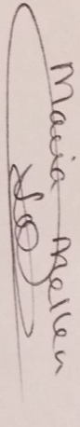
Date: 25/03/22.

ACTIVITY 6: ONGOING WRITTEN UPDATES/ADDITIONS TO PERSONAL DEVELOPMENT PLAN

Introduction
In this activity, I have analysed my progress towards the goals set on my Personal Development Plan, devised in December 2020. I also have taken a new skills assessment based on the New CIPD Profession Map, to identify further development needs, which are added on my Personal Development Plan.
Since setting up my goals, I was promoted to Deputy Store Manager, acting also as General Manager for a few months, at the multinational high street fashion retailer based in Swansea. However, since January 2022 I have been working as part of the Recruitment Taskforce Department in the Neath Port Talbot Council.

Development plan

NAME: | Maria Mellen Jimenez | MEMBERSHIP NUMBER: | 57501591
COVERING THE PERIOD FROM: | January 2021 | TO: | July 2022

Planned outcome

Where do I want to be by the end of this period? What do I want to be doing? (This may be evolutionary or “more of the same”.)

What do I want/need to learn? | What will I do to achieve this? | What resources or support will I need? | What will my success criteria be? | Target dates for review and completion
- Insights, Strategy and Solutions: Where to access legal information if required | - Consult with HR manager about sources of information  - CIPD learning resources  - Attending workshop  - Core texts | HR manager  HR Managers not willing to support in this matter  Lecturer | To be able to find the legal information for the relevant issue | May 2021  Completed
- Performance and Reward: The different elements of a reward package | - Consult with Reward Specialist about the reward packages in our company  - CIPD learning resources  - Attending workshop  - Core texts | HR manager  HR manager denied access to any information  Lecturer  No workshop but independent reading being done | To be able to identify the different components of a reward package and be part of the team who reviews and improve them. | February 2022  Ongoing
- Skilled Influencer: To learn effective negotiation skills | - Complete an influencing styles questionnaire  - Negotiation skills course  - Books on negotiation skills | Line manager | To develop skills to be a successful negotiator | July 2021  Completed
- Curious: Finding out about the connections between wider organisational issues and own role | - Discuss with line manager or HR manager the current issues for my store and how my role impacts these | Line manager  HR manager | To be able to detect any issues and what I can do from my position to solve them | September 2021  Completed
- People Practice: | - CIPD Course on Strategic Workforce Planning  - Resourcing and Talent Planning module workshop | CIPD website  Lecturer | To be able to understand the stages of workforce planning, including analysis, needs, gaps and action plan. | June 2022
- Technology and People | - CIPD Factsheet and other resources on technology and the future of work  - CIPD report on how workplace technology impacts employee experience | CIPD website | To understand which technology is available and how it can improve the employee experience.  To review the impact of technology on roles and people | September 2022
- Valuing People | - CIPD online course on valuing people  - CIPD factsheet and resources on employee wellbeing | CIPD website | To achieve positive outcomes  To reflect on how to incorporate wellbeing practices into the workplace more effectively. | November 2022
- Commercial Drive | - CIPD online course on commercial drive  - Research on the meaning of being ‘commercially aware’ | CIPD website | To achieve positive outcomes  To understand customers’ needs and improving their experiences by engaging with them  To be aware of the operational and financial implications of my choices | January 2023

Development record

NAME: | Maria Mellen Jimenez | MEMBERSHIP NUMBER: | 57501591
COVERING THE PERIOD FROM: | January 2021 | TO: | March 2022

Key dates | What did you do? | Why? | What did you learn from this? | How have/will you use this?  Any further action?
1. February and March 21 | Attended University Workshops  Read Core Textbook  Accessed different websites (ACAS, legislation.gov.uk) | To find out where to access legislation related to Human Resources, specifically discrimination and fairness. | Before making any decisions, it is important to check all legislation, company policies and code of conduct.  Discrimination claims may be filed in an Employment Tribunal as a result of unfairness during the recruitment process. | I was the main point of contact in the store when HR issues arose, and the HR Business Partner was not available.  I have advertised jobs with restrictions such as age and have checked the legal documentation and enclosed it to the advert to avoid a discrimination claim.
2. July 21  February 22 | Read the chapter on Reward Management by Perkins and Woodham (2016) and the CIPD Factsheet on Strategic Reward and Total Reward (2021).  Read the Job Evaluation Documentation for Neath Port Talbot Council. | To understand better how reward packages are drawn up and to ensure that the strategic decisions are having the desired effect by assessing the impact of reward management.  To get a better understanding of the Job Evaluation process. | I learnt that reward packages are not just based on financial compensation, but also on other benefits such as development and career opportunities, or hybrid working practices to provide a better work-life balance.  In order to establish a specific salary for each job there are a number of areas that need to be assessed, such as number of staff in charge of, working hours, etc. | I have not used it on my professional experience at the moment, but since I started working within the HR department for Neath Port Talbot Council, I have been introduced to some of practices, for instance job evaluation and grade and pay structures. I have learnt why each job belongs to a determined grade and pay structure, and the evaluation process which must be carried out to decide the grade.
3. June 21  January 22 | Meeting with HR and Commercial Managers to agree on a Change Management initiative for the store.  Completed the Mindtools Influencing Skills Questionnaire. Scored 68 out of 80 (Strong Influencer and Investigator) | To gain buy-in from the regional team or senior management in management of change.  To find out if my personal style is more aligned to a push or pull approach. | I learnt the importance of highlighting the plan’s strengths to convince colleagues by using logic and emotion, demonstrating its positive aspects and the negative aspects of alternatives.  I was also able to communicate well at different levels, using the right language depending on the audience.  The results showed that I am an Investigator, according to Baker’s Four Strategies of Influence (Mindtools, 2022), which may be classed as direct and logical style. The ‘chunking’ technique seems very useful to obtain approval for projects. | While working as Deputy Store Manager, I identified an issue in the store and took the opportunity to make it a change management initiative. I created both a change plan and communication plan, distinguishing the communication channels, key audiences and messages.  I communicated with various stakeholders at different levels, from sales assistants to senior management.  Generally, when creating a presentation, I use bullet point and keep paragraph shorts, or tables, as I have found it is the best way of retaining information. In future, I will be using the chunking method to ensure the audience remembers it easily.
4. May 22 – July 22 | Discussed with my Store Manager and the Regional Managers (HR and Commercial) the issues we had in store to find a way to solve them. | To learn about the changes and initiatives I could put into place in the store to achieve better results, from my position as Deputy Store Manager. | I realised that by analysing KPI’s and costs I could draw up a plan to implement changes and present it to my senior managers for approval. | As explained above, I devised a change plan, along with a communications plan, to present it to my regional team, allowing me to put in place a training program, creating development opportunities to promote the company values.

Reflective statement
The purpose of reflection is to deepen our learning. By reflecting, we can understand what we have learned, the reasons why we did it and how the learning happened. (CIPD, 2018). As a result of reflection, learning is incorporated, made part of our knowledge, and adapted to ourselves. Reflection is also associated to our ethics and social identity, and it is also physical and emotional. Assumptions and established behaviours are challenged by observing issues from different perspectives, and new ways of seeing are developed.
To reflect on my professional learning, I have applied the Gibbs Reflective cycle (Mindtools, 2022a), a model which may be used not only for us, but to help other people understand what they did well and what they can do better next time.
Generally, the course has been very challenging, as I was not allowed to attend lessons or do any of the coursework during working hours, particularly working 40 hours per week, being responsible for two children and being English my second language. This, however, has helped me to expand my time management skills, being able to submit all the assignments before the deadline. Conversely, it has been a very positive experience, as I have learnt to communicate more professionally and expand my vocabulary and knowledge across different topics, being one of the most important ones the focus on an evidence-based practice (CIPD, 2021a).
Looking at the original objectives set, and considering some negative work experiences along the way, I am very pleased with having achieved three out of four. My first objective referred to Insights, Strategy and Solutions, specifically where to access legal information if required. Although I did not get any support from my HR manager, the workshops I attended, plus the additional reading recommended by the lecturer, has helped to find resources with no trouble and I have been able to use my knowledge by being the main point of contact in the store for any HR issues, and also, as a Recruitment Officer, I have applied it when advertising positions which has age restrictions.
My second objective was learning about the different elements of a reward package. Once again, my HR manager did not support me, and I did not have a workshop which covered the rewards systems per se, so I did some independent research on the CIPD website (2021b) and the core textbook (Taylor and Woodhams, 2016). This is still ongoing as I have not used it in my professional experience. However, I have been given access to documentation on the Job Evaluation process within the Council, and I am willing to try to get involved in it.
The third objective was to improve my influencing skills. This involved a lot of work, as I had to devise a change plan and communication plan to gain buy-in from my regional managers. After some modifications on the original plan, I was able to manage the project and communicate with the stakeholders at different levels, adapting my language to the audience. I also completed a questionnaire on Mindtools (2022b), which has shown me new techniques to gain approval for projects.
My last objective, finding out about the connection between organisational issues and my own role, was completed too. Related to the change management initiative above, I detected some issues in the store; after speaking to my Store Manager and my HR manager, they helped me identify the tools I had, and how I could use them to improve the situation, promoting the company values (personal development) at the same time.
I have now taken an assessment based on the CIPD’s New Profession Map, concentrating on two core behaviours and two core knowledge, added on the original Personal Development Plan, which are:
- People Practice
- Technology and People
- Valuing People
- Commercial Drive
Screenshots of the assessment results are below:

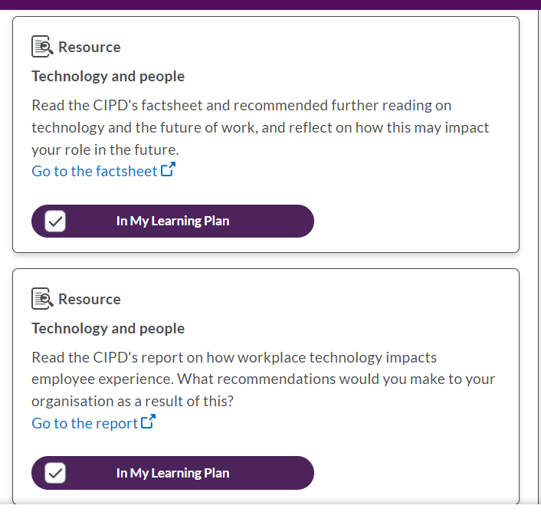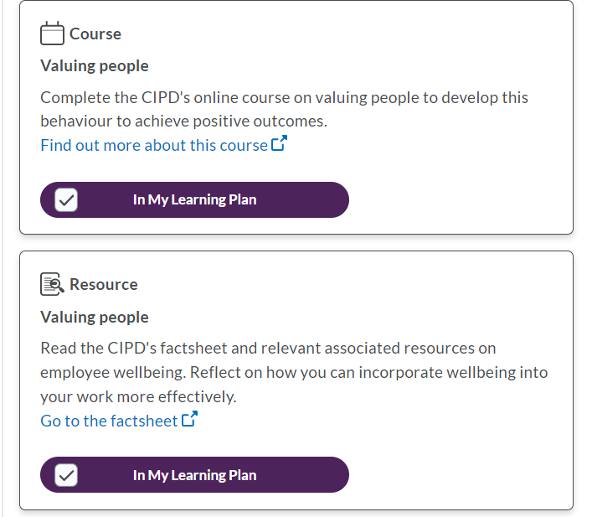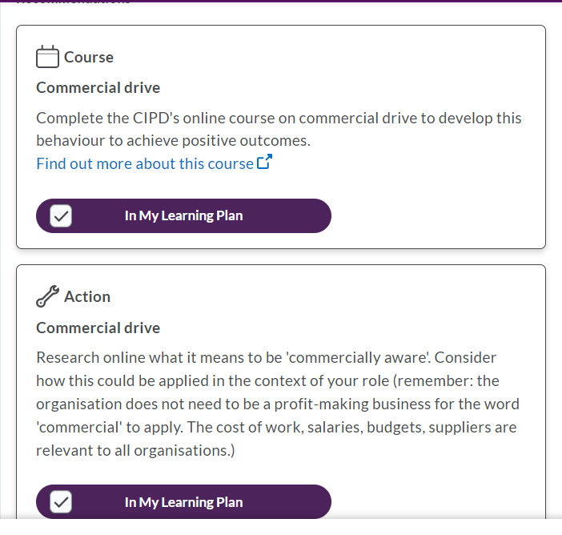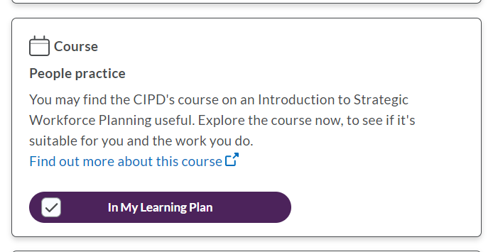

Reference list
CIPD (2018) Reflective Practice Guide. Available at: https://beta.cipduat.co.uk/Images/reflective-practice-guide_tcm18-12524.pdf. Accessed on 21/03/22.
CIPD (2021a) Evidence – based practice for effective decision – making. Available at: https://www.cipd.co.uk/knowledge/strategy/analytics/evidence-based-practice-factsheet. Accessed on 22/03/22.
CIPD (2021b) Strategic reward and total reward. Available at: https://www.cipd.co.uk/knowledge/strategy/reward/strategic-total-factsheet. Accessed on 25/07/21.
Mindtools (2022a) Gibbs’ Reflective Cycle. Available at: https://www.mindtools.com/pages/article/reflective-cycle.htm#:~:text=Professor%20Graham%20Gibbs%20published%20his,these%20don't%20go%20well. Accessed on 22/03/22.
Mindtools (2022b) How strong are your influencing skills. Available at: https://www.mindtools.com/pages/article/influencing-skills-quiz.htm. Accessed on 18/02/22.
Taylor, S. and Woodhams, C. (2016) Human Resource Management: People and Organisations. 2nd edition. London: CIPD. Accessed on 24/07/21.

