Module Name: Sustainable Hospitality & Tourism Management
Module Code: BMIH5006
Assignment Title: Report
Lecturer name: Thomas Huw
Assignment Type: Report
Student Name: Maria Hurmuzache
Student ID:2125468

Executive summary
Sustainable practices within the tourism and hospitality industry are studied in this report. A case study has been performed on a leading UK-based tour operator, Jet2Holidays. Becoming a leading firm within the same industry has become possible because of their enthusiasm for sustainability. The analysis has identified that firms can avoid greenwashing as the regulatory authorities of the UK and EU continually monitor, the ethical and sustainable practices of all firms within the same industry. Reduction of carbon emissions, eliminating single-use plastics and setting a goal of being a Net Zero carbon footprint firm have helped them to become one of the most substantial companies. However, firms can incorporate ‘Green technologies’ by collaborating with other corporations and government bodies who help big firms in adjusting their waste.

Table of Contents
Introduction 5
Literature review 6
Understanding of Sustainability 6
Historical aspects of tourism and hospitality 6
Sustainable development 6
Analysis 8
The practice of sustainable goods in Jet2holidays 8
How self-regulatory codes, market and environmental regulations are influencing Jet2holidays 8
Self-evaluation and the use of Green Technology 9
Discussion 10
Conclusion 13
References 14

Introduction
Sustainable hospitality and tourism management is the process of managing, planning, building and implementing activities within the hospitality industry. The developed plan must reduce the negative impacts on society, and the environment, while promoting sustainability. This report will focus on identifying and understanding the need to practice sustainability within the hospitality industry. This report will also focus on evaluating sustainability within a specific firm. If the firm is ensuring the proper regulations regarding sustainable practices or not this will be identified in this report. Firms within the tourism industry focus on serving their people while meeting at least the minimal requirement of practising sustainability (Inkson and Minnaert, 2018). Moreover, firms within the hospitality industry encourage their visitors to adopt healthy travel practices by minimizing waste. This report will identify ‘best practices’ within the industry by evaluating an appropriate case study within a specific organisation. A specific overview of sustainability and its applications among organisations will be given in this report. Also the concept of ‘Sustainable good practices’ will be analysed within the transport sector. A critical understanding of issues related to sustainable practices will be drawn which could further help in determining a more effective strategy for managers.

Literature review

Understanding of sustainability
Sustainability is the ability of a process that ensures meeting current needs without interrupting or compromising the ability of future generations to meet their needs. Sustainability is a complex concept, it consists of social, environmental and economic factors (Ruggerio, 2021). These three principles of sustainability signify the use of resources that do not damage the environment. Social sustainability ensures that every people has access to resources and economic sustainability highlights the creation of an economy that is prosperous. Tourism can have both positive and negative impacts on the environment, economy and society (Cooper, 2021). It can damage the environment through pollution and can lead to inflation. The demand for tourism continually increases, putting pressure on the environment and resources. Increasing tourism supply is also causing competition among destinations.

Historical aspects of tourism and hospitality
The hospitality and tourism industry has a long history from the ancient days. In the early days, hospitality was only considered as a way of providing food and shelter to the travellers. Over time, through evolution within the hospitality industry, it is not only bound to provide food and shelter to the travellers, but they provide entertainment, transportation and recreation (Haski-Leventhal, 2018). Contemporary growth in the hospitality industry depends upon factors, such as increased disposable income, changing lifestyles of consumers, and improved transportation. As people become richer they need to start spending more money on leisure activities, such as travel. Due to technological advancement transportation has improved and made it more affordable for people who want to travel long distances (Sloan et al., 2017). However, in the past people were mostly interested in traditional vacation destinations, but in recent days people want more authentic and unique experiences.

Sustainable development
Sustainable development encompasses projects, policies, and investments by government bodies, intending to meet the needs without interrupting future generations. Regarding sustainable development, several UK, international and national Wales policies are reviewed and identified. The Sustainable Development Agenda 2030 of the United Nations is an action to reduce poverty and protect the planet. The UK is the second most sustainable country all over the globe, with an EPI score of 77.7 in 2022 (Cohen et al., 2022). The country in recent years has made significant progress in carbon emissions, and increasing the generation of renewable energy. The Wales government in Great Britain has also approached a ‘One Wales, One Planet’ strategy intending to share resources fairly. These policy documents provide a clear road map for the organisations to action.
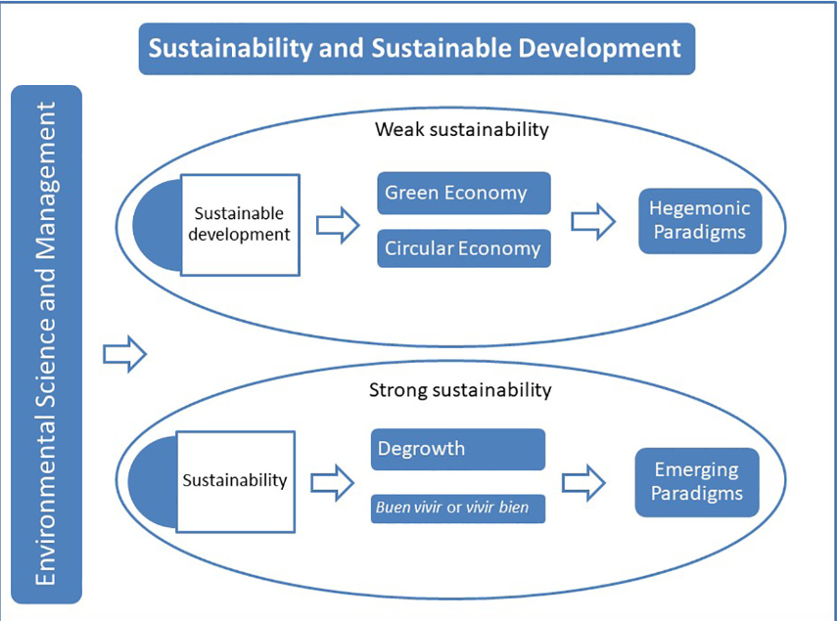
Figure: Sustainable Development
(Source: Ruggerio, 2021)

Analysis

The practice of sustainable goods in Jet2holidays
Jet2holidays is a leading tour operator and package holiday provider in Britain. It is the second-largest tour operator as of 2017 in the UK (Jet2plc, 2024). Several initiatives are taken by the firm to reduce environmental impacts, these include fueling planes from household wastes, investing in new aircraft, and reducing plastic usage. With several new and more efficient aircraft Jet2holidays has invested in, that help in reducing fuel consumption. In some new sustainable aviation fuel plants Jet2holidays has invested, which will produce household waste fuel. This is helping the firm to become more resilient on fossil fuel. The firm has also stopped using millions of plastics on its plane, items such as plastic cups, cutlery and straws have stopped using in Jet2holidays. The firm has a positive impact on regional areas, in urban, rural, and coastal sides. They are working with local farmers and offer local businesses tours and excursions. In coastal areas, the firm supports local conservation projects by reducing plastic use, and in urban areas, the firm is converting equipment for its ground service to electricity.

How self-regulatory codes, market and environmental regulations are influencing Jet2holidays
The ‘Supplier code of conduct’ of Jet2Holidays has minimum supplier expectations and standards. This code highlights their sustainability strategies, that by 2023 their ground service equipment will be powered by electricity by 2023. A series of actions are committed by the firm in reducing the carbon footprint of the company. They want to reduce single-plastic use by 80% by 2023 (Jet2holidays, 2024). In the case of Jet2Holidays environmental regulations are creating a positive impact. They are investing in sustainable plans thus attracting concerned customers. However, the firm in December 2023 has been accused of performing greenwashing (which, 2024). They got unsubstantiated claims, empty promises and use of ambiguous language. The firm has its initiatives in the transport sector also. The firm is investing in new aircraft that help in reducing carbon emissions. Jet2Holidays offers the use of fuel from GSE as a part of its sustainability practices (Jet2plc, 2024). Sustainable aviation fuels are also developed by Jet2Holidays. One area in which the firm is constructed greenwashing is in its use of carbon offsetting. The firm offers its consumers the option to offset the carbon emissions from their flights. However, some critics view that carbon offsetting is not a legitimate way to avoid greenhouse emissions. Thus the firm is greenwashing in their business. With the use of renewable energy, Jet2Holidyas could be constructed as greenwashing in its business. The firm claims to use 100% renewable energy to power the office warehouses. However, there is an argument that the firm is not using enough renewable energy to offset its flight emissions.

Self-evaluation and the use of Green technology
Companies use self-evaluation as a tool to understand their strengths, and sectors for growth. This also helps organisations to plan and set future goals, they try to evaluate their strengths and want to highlight their strengthening business units to their stakeholders. This may increase the brand value of the firm and ultimately help them achieve their core business goals. Though firms are intended to express their authentic operations, in some cases they are accused of greenwashing. Self-evaluation is a good practice for organisations, Jet2Holidays breaks their evaluation which matches the assumptions of their clients. The firm offers ABTA membership and ATOL protection (Jet2holidays, 2024). Customers are allowed to access the company's website to filter the sustainability certification. Jet2Holidays use the ‘Green’ technology, they are committed to using the “Sustainable Aviation Fuel (SAF)” produced by the UK by 2026 (Jet2holidays, 2022). More than 50% of “Ground service types of equipment (GSE)” will be electrically powered, either a hybrid or fully electric. The firm is also committed to using zero-plastic items and replacing them with more sustainable alternatives. The firm also partners with Green Key, which is an independent organisation that helps its hotel partners meet their sustainability standards. The firm has also officially joined the "Global Sustainable Tourism Council (GSTC)" and launched several sustainability programs (GST Council, 2022).

Discussion
Sustainability goals
Jet2Holidays is a firm which believes in growing its business by implementing sustainability. They have reduced emissions and improved the intensity of their emission. Thus the firm is ranked as the fourth lowest airline in the globe for CO2 grams per RPK (Jet2, 2024). The firm has also increased its efficiency by an average of 2.4% per year. This is higher than the global average fuel efficiency goal that is of 2%. The single-use plastic use has also been reduced by the firm. They have reduced almost about 80% of single-use plastic products on their aircraft. All the aircraft are made with sustainable materials, such as recycled plastics and wood. The firm intends to invest in new aircraft, these are more efficient and are used by using sustainable fuel. Almost about $18 million has been invested by the firm in new and in planes with are more fuel efficient, over the past years. The firm has also a scheme for plastic reduction, which also influences their customers to stop using single-use plastic products during their course of travel. Fuelling aircraft from household waste materials has become tremendously innovative for Jet2Holidays which helps to attract travellers who are also concerned about environmental sustainability. The firm offers certified sustainable hotels, they offer a hotel sustainability labelling scheme, that allows their consumers to filter hotels while selecting their preferred travel destinations. Moreover, their GSE electrifying equipment electrification program helps the firm in reducing harmful emissions.
Achieving goals
Jet2Holidays is achieving its goals by targeting to become a net zero carbon footprint firm. Their sustainability strategy includes achieving this goal by 2050. Jet2Holydays offices are powered by renewable energies. Also, more than half of the ground service equipment of the firm is powered by electricity. Offsetting all fuel from GSE is also one of the main goals, and aims to have a carbon-neutral operation by 2022. The firm has an aim to reduce its emissions per passenger by 2030 by about 10%. To achieve these goals the firm has identified the Green Key international certification program as beneficial. The firm pays in other sectors for generating greenhouse gases. This approach is not harming their overall business but rather satisfying their transparent business strategy against all those green housing acquisitions. This also helps the firm attract value-added consumers who trust Jet2Holidays and do not want to harm nature for their leisure activities. The governments of the UK and EU also covered some of their carbon and used carbon emission schemes. Such trading schemes are CORSIA and ETS, however, they also voluntarily pay for other toned emitted carbons. Jet2Holidays have purchased around 98 Airbus A321/A320neo aircraft, which has eventually extended to the number of 146 (Jet2, 2023), highlighting a sign of business growth through achieving sustainable goals.
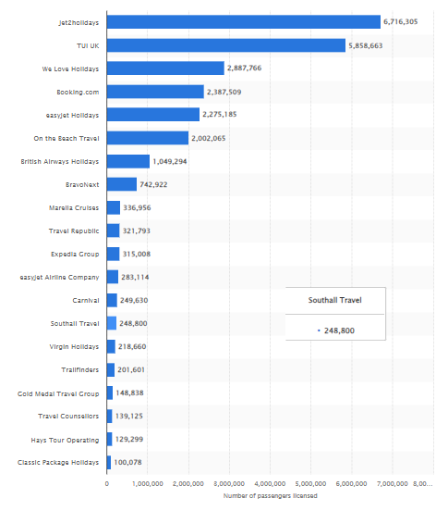
Figure: Top ATOL licensed tour operators in the UK
(Source: (Statista, 2024) )

Self-evaluation and Green technology
Instead of self-evaluating the firm can offer personal travel insurance and assistance. The personal travel insurance plan of the firm covers their consumers while they are on vacation, even if one cannot travel (Jet2, 2024). A consumer can buy a policy from their official site. They can also offer priority check-in, and help their consumers with stairs off and on aircraft. Also, they can offer transport for wheelchairs and increase mobility aids. They can assist travellers with medical equipment and with their luggage. Among other Green technologies that are used by Jet2Holidays, SAF is the most remarkable. The firm plans to use SAF from Fulcrum bioenergy by 2027, and will achieve the EU and UK fuel mix by 2030. With other green technology plans the firm also plans to cover issues regarding sustainability in their hotel supply chain.

Conclusion
The above discussion concludes that there is a major role of ethical and sustainable practice, within an organisational business operation, in achieving their business goal. At first, this report has discussed the concept of sustainability through reviewing the literature. Then the focus was given to the history of tourism and hospitality industry, how it has evolved and what are the current trends within the hospitality industry. This report has also identified that to develop sustainable practices, organisations must follow all the social and environmental regulations proposed by the government. This report has performed a case study on a UK-based leading tourism firm and found that the firm is maintaining a balance in their emission by paying back for another sector to the government. Hence, by analysing the sustainable practices of this firm it has been identified that the use of Green technologies plays an important role in creating a positive brand image. Greenhousing is not proposed to be such a big matter of concern for the firm, although firms within the same industry should avoid greenwashing.

References
Cohen, A.T., Lewis, M., Connor, A., Connolly, S.J., Yue, P., Curnutte, J., Alikhan, R., MacCallum, P., Tan, J. and Green, L., (2022). Thirty‐day mortality with andexanet alfa compared with prothrombin complex concentrate therapy for life‐threatening direct oral anticoagulant‐related bleeding. Journal of the American College of Emergency Physicians Open, 3(2), p.e12655.
Cooper, C. (2021) Essentials of tourism. Third edition. London: SAGE.
gstcouncil, (2022). Jet2 Publishes Sustainability Strategy and Joins GSTC. [Online]Available at: https://www.gstcouncil.org/jet2-publishes-sustainability-strategy-and-joins-gstc/ [Accessed 20 February 2024].
Haski-Leventhal, D. (2018) Strategic corporate social responsibility : tools & theories for responsible management. London: SAGE.
Inkson, C. and Minnaert, L. (2018) Tourism management : an introduction. 2nd ed. London: SAGE.
Jet2, (2023). Article. [Online] Available at: https://www.jet2.com/news/2023/05/Jet2_com_and_Jet2holidays_celebrate_brand_new_Airbus_A321_neo_aircraft_coming_into_operation_ [Accessed 20 February 2024].
Jet2, (2024). Our sustainability strategy. [Online] Available at: https://www.jet2.com/sustainability#:~:text=In%20fact%2C%20we've%20also,revenue%20passenger%20kilometre%20(RPK). [Accessed 20 February 2024].
Jet2, 2024. FAQs. [Online] Available at: https://www.jet2.com/faqs?topic=booking-and-payment-options&category=do-i-need-travel-insurance-when-making-a-booking [Accessed 20 February 2024].
Jet2holidays, (2022). NET ZERO SUSTAINABILITY STRATEGY. [Online] Available at: file:///C:/Users/User/Downloads/Jet2_net_zero_sustainability_strategy.pdf [Accessed 20 February 2024].
Jet2holidays, (2024). ABTA & ATOL protection. [Online] Available at: https://www.jet2holidays.com/atol#:~:text=ABTA%20and%20ATOL%20protection,holiday%20that's%20booked%20with%20us. [Accessed 20 February 2024].
Jet2holidays, (2024). Our sustainability strategy . [Online] Available at: https://www.jet2holidays.com/sustainability [Accessed 20 February 2024].
Jet2plc, (2024). Announcements. [Online] Available at: https://www.jet2plc.com/en/news/announcements?page=78 [Accessed 20 February 2024].
Jet2plc, (2024). Sustainability. [Online] Available at: https://www.jet2plc.com/sustainability [Accessed 20 February 2024].
Ruggerio, C.A., (2021). Sustainability and sustainable development: A review of principles and definitions. Science of the Total Environment, 786, p.147481.
Ryan, M., (2020). The future of transportation: ethical, legal, social and economic impacts of self-driving vehicles in the year 2025. Science and engineering ethics, 26(3), pp.1185-1208.
Sloan, P., Legrand, W. and Chen, J.S. (2017) Sustainability in the hospitality industry : principles of sustainable operations. 3rd ed. London: Butterworth-Heinemann.
Statista, (2024). Leading ATOL-licensed tour operators in the United Kingdom as of February (2024), ranked by number of passengers licensed. [Online] Available at: https://www.statista.com/statistics/932766/leading-atol-tour-operators-by-passengers-licensed-united-kingdom-uk/ [Accessed 20 February 2024].
which, (2024). Which? Travel research uncovers greenwashing from major UK holiday companies. [Online] Available at: https://www.which.co.uk/news/article/which-travel-uncovers-greenwashing-from-major-uk-holiday-companies-aWk7C9s9RLJr#:~:text=We%20then%20analysed%20some%20of%20the%20claims,near%20as%20sustainable%20as%20the%20companies%20that [Accessed 20 February 2024].

