

University of Wales Trinity Saint David
SCHOOL OF ENGINEERING
RECTANGULAR PLATE 2D TEMPETURE DISTRIBUTION
HABTOM GHIRMAY
STUDENT NUMBER- 1810854
L6 MECHANICAL ENGINEERING
27/01/19
MATLAB ADVANCED COMPUTIONAL METHOD (M6X00408)

Table of Contents
1. INTRODUCTION TO THE RECTANGULAR PLATE TEMPETURE DISTBUTION 1
2. THERMAL DIFFUSION EQUATION 1
3. INITIAL AND BOUNDARY CONDITIONS 2
3.1 Tylor series 2
3.2 Explicit Method 2
4. DETAILS OF THE FINITE DIFFERENCE MODEL (Script) 3
5. ANALYSIS OF THE CODE RESULT 4
6. LIMITATION OF THE CODE 6
7. CONCLUSION 6
REFERENCE 7

List of tables
Table 5 1 Grid space varying effect to reach thermal equilibrium
Table 5 2 Time step influence to reach thermal equilibrium
Table 5 3 Plate dimension influence to reach thermal equilibrium
Table 5 4 Convergence characteristic influence to reach thermal equilibrium

List of Figures
Figure 1. temperature distribution over the plate

INTRODUCTION TO THE RECTANGULAR PLATE TEMPETURE DISTBUTION
Two-dimension rectangular plates temperature distribution are commonly used for different application and verification of finite differential equation. Temperature can be distributed to the plate with the effect of the initial and boundary conditions. The distribution would be based on time dependent thermal diffusion equation using finite difference method. So, the finite differential method would calculate the temperature distribution to the rectangular plate with given initial and boundary condition. The temperature distribution modelled with Matlab based on time dependent thermal diffusion equation. The temperature calculated with finite differential equation using the Explicit method.
The 2D rectangular plate was made of Aluminium plate through the time. The mode of heat transfer was conduction throughout the plate in which energy exchanges takes place to the plate due to the internal temperature gradient. The rectangular plate would be taken place with uniform grid which means the grid space is h=Δx=Δy.
Boundary condition to the rectangular plate, the three edges of the plate were perfectly insulated which means there is no heat flow through those edges (those edges are the left (west), right (east) and bottom (south)). The only boundary condition along the North or Top edges temperatures distributed using Gaussian distribution method with minimum temperature 10°C and maximum temperature 60°C. The initial temperature inside the aluminium plate was 0°C throughout the plate.
The model Matlab defined base on the user, the dimension of the rectangular plate in to the two dimensions along the x-axis and y-axis, time step and grid spacing. The grid spacing was based on the dimension of the plate and the temperature calculated at each time step for the plate. The temperature in each node would display at each time step for the rectangular plate and stopped when reached thermal equilibrium.

THERMAL DIFFUSION EQUATION
Heat conduction was defined as a transfer of thermal energy from the more temperature to the less temperature particles. The state of transfer can be taken place in solids, liquids and gases. Conduction happens by direct physical contact between the interacting systems. The heat transfer defined by the amount of the temperature transferred and the direction of the transfer. The conduction transfers between two objects at different temperatures, the higher temperature transfer it heat to the cooler objects until it reaches the same temperature.
The location of the transfer was specified by the coordinates of each point in the contact (x, y) for two dimensions flow. The temperature at a point (x, y) with time t is expressed as T (x, y, t). Two-dimensional, the temperature in the two direction (x, y) are varied, but the temperature variation to third direction was negligible.
Conduction in solids transferred the heat between solid objects, solid conduction heat transfers higher due to the fixed spatial relationships between the atoms which transfer energy by the vibration among them. The vibration helps to migrate the free electrons to the interaction. Conduction for solids described by the following thermal diffusion equation with respect the time,
$\frac{∂^{2}T}{∂x^{2}}+\frac{∂^{2}T}{∂y^{2}}=\frac{1}{α}.\frac{∂T}{∂t}$ (1)
The equation defined thermal diffusion in two dimensions; where the t is the time, T is the temperature, α is the thermal diffusivity (m².s⁻¹), but this equation was without internal heat source.
α = k/ρ. c, k is the thermal conductivity (W.m⁻¹. K⁻¹), ρ is the density (kg.m⁻³) and c is the specific heat capacity (J.kg⁻¹K⁻¹). In this model the material used was Aluminium, so the properties of aluminium k = 143 W.m⁻¹.K⁻¹, ρ = 2800 kg.m⁻³ and c = 795 J.kg⁻¹K⁻¹.
With an internal heat source, Q, the thermal diffusion equation would be:
k.($\frac{∂^{2}T}{∂x^{2}}+\frac{∂^{2}T}{∂y^{2}})+Q=ρ.c.\frac{∂T}{∂t}$ (2)

INITIAL AND BOUNDARY CONDITIONS
The thermal condition on the surface of the medium which with mathematical expression at the boundaries are called boundary conditions. The heat conduction equation is a second order differential equation which would derivatives with respect to the coordinate space variables. The number of the boundary conditions specified in a direction would be equal to the differential equation in that direction. For this model the temperature distribution was in a rectangular plate with two dimensions. The temperature at any point on the plate at a specified time depends on the condition of the rectangular plate at the beginning of the heat conduction process. The initial condition is at the time t=0.
The initial condition can be specified in the below equation in general form
T(x, y, 0) = f(x, y) (3)
Where the function represents the temperature distribution through the plate at initial time.
Boundary conditions would obtain with finite differential equation for each grid on the rectangular plate. The finite differential equations of the boundary calculate each temperature in the grid base on the specified value given.

3.1 Tylor series
Tylor series are calculated derivative functions at a single point for any function. By using the Taylor series for the thermal diffusion equation was calculated by the forward, backward and central difference. The differential equation would be algebraically solve based on the initial and boundary conditions. The method used to calculate the temperature distribution was Explicit Method.

3.2 Explicit Method
The thermal diffusion equation (1) would explain the finite-difference form
At the point P $\frac{∂^{2}T}{∂x^{2}}$=$\frac{T_{O}^{n}-2.T_{P}^{n}+T_{I}^{n}}{h^{2}}$ ; $\frac{∂^{2}T}{∂y^{2}}=\frac{T_{E}^{n}-2.T_{P}^{n}+T_{W}^{n}}{h^{2}}$ (4)
And $\frac{∂T}{∂t}=\frac{T_{P}^{n+1}-T_{P}^{n}}{∆t}$ (5)
F₀ is a Fourier number, with dimensionless
$F_{0}=\frac{α.∆t}{h^{2}}$ (6)
$\frac{1}{F_{0}}T_{P}^{n+1}=T_{O}^{n}+T_{I}^{n}+T_{E}^{n}+T_{W}^{n}-\left(4-\frac{1}{F_{0}}\right).T_{P}^{n}+\frac{h^{2}.Q}{k}$ (7)
The above equation determines the unknown temperature based on the temperature at the previous time step.

DETAILS OF THE FINITE DIFFERENCE MODEL (Script)
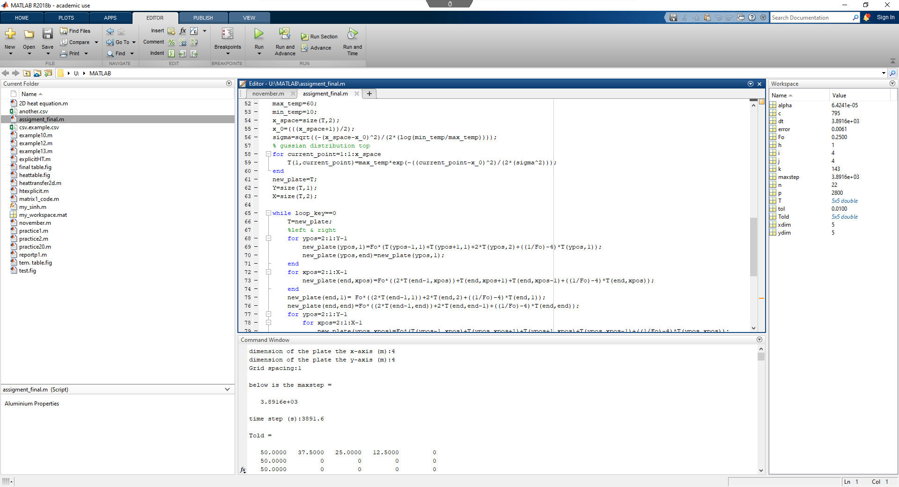
The above code explained the temperature distribution range to the rectangular plate. x_space the dimension to x-axis plate side which gives the temperature to each grid point to x-axis. The full distribution of the temperature points to x-axis (size (T,2)). x_0 is the centre point of the x-axis of the plate. Sigma was explained for the gaussian distribution which was the height of the maximum temperature for the boundary along the North edge. On the top of the plate (north edge) the for loop shows temperature distribution from column one to row one along the x-axis, represented the function of the gaussian along the north edge.
T was the temperature created in the North edge (column one, row one along the x-axis) for that next temperature to the new plate (the new plate had the same temperature) and the temperature showed two-dimensional temperature distribution ((T,1) along the Y and (T,2) along the X). The convergence to the loop close to zero to reach thermal equilibrium. Using the explicit method showed temperature distribution to the new plate. Ypos is the position the second grid from the top y-axis up to one point away the left (Y-1) which was on the left side (west side), because the start boundary was insulated. And the right side of the plate was also the same temperature distribution as the left.
The loop showed the explicit of the temperature along the x_pos (x-axis). The function shows from the end point to the xpos, showed to the top and bottom of the plate.
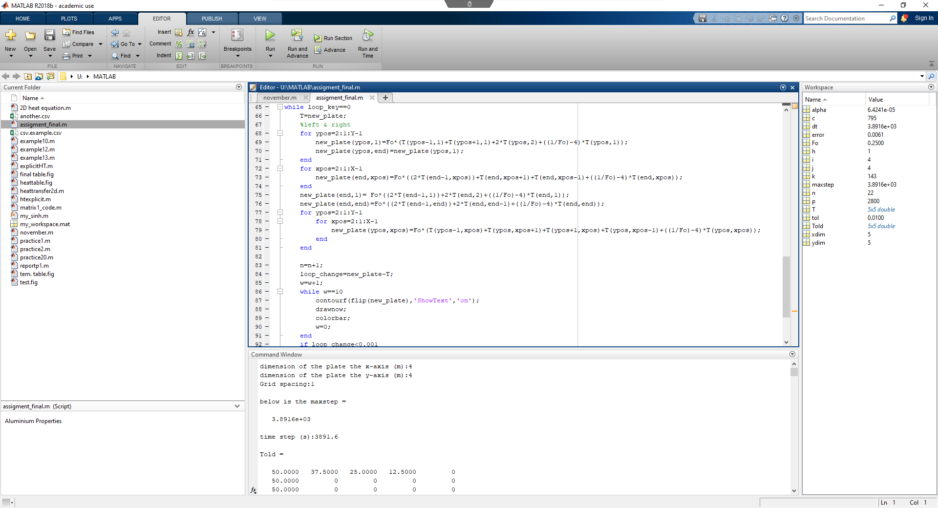
This showed the loop between the x-axis and y-axis along the (left, right) and (bottom and right).

ANALYSIS OF THE CODE RESULT
The analysis determined the result based from the script code, on the table (1) below explained by the varying the grid space with constant plate dimension on X-axis and Y-axis, convergence characteristic and time step based on the result from the grid space. On the analysis as the grid space decreases in size the iteration number increases which means the number of iterations increase to calculate each grid space for the whole rectangular plate and reach thermal equilibrium. But the higher time step was the higher total time to calculate.
X-Axis (m) | Y-Axis (m) | Grid space-h (m) | Time step (s) | Convergence characteristic | Iteration number | Total time (s)
4 | 5 | 1 | 3891.6 | 0.01 | 26 | 101181.6
4 | 5 | 0.5 | 972.9 | 0.01 | 87 | 80727.3
4 | 5 | 0.2 | 155.66 | 0.01 | 367 | 57127.22
4 | 5 | 0.1 | 38.916 | 0.01 | 921 | 35841.636
Table 5 1 Grid space varying effect to reach thermal equilibrium
The below table (2) analysis the code with constant plate dimension (X-axis and Y-axis) for each test, same (grid space (1m) and convergence characteristic) and varying time step. According, the result as the time space was long the number of iterations complete, but to reach the thermal equilibrium the total time increases with the time step.
X-Axis (m) | Y-Axis (m) | Grid space- h (m) | Time step (s) | Convergence characteristic | Iteration number | Total time (time step*iteration number) (s)
4 | 5 | 1 | 3891.6 | 0.01 | 26 | 101181.6
4 | 5 | 1 | 3500 | 0.01 | 29 | 101500
4 | 5 | 1 | 3000 | 0.01 | 33 | 99000
4 | 5 | 1 | 2000 | 0.01 | 47 | 94000

Table 5 2 Time step influence to reach thermal equilibrium
The test on the below table explained as the dimension of the plate varied with constant grid space (1m), constant time step (3891.6 sec.) and same convergence characteristic. As the rectangular plate increase in size proportionally iterations number increases proportional with total time iteration.
X-Axis (m) | Y-Axis (m) | Grid space- h (m) | Time step (s) | Convergence characteristic | Iteration number | Total time (time step*iteration number) (s)
4 | 5 | 1 | 3891.6 | 0.01 | 26 | 101181.6
6 | 7 | 1 | 3891.6 | 0.01 | 51 | 198471.6
8 | 9 | 1 | 3891.6 | 0.01 | 81 | 315219.6
9 | 10 | 1 | 3891.6 | 0.01 | 98 | 381376.8

Table 5 3 Plate dimension influence to reach thermal equilibrium
As the dimension of the rectangular plate (X-axis and Y-axis) kept constant in each step with grid space (1m) and the same time step (3891.6 sec.) but varying the convergence characteristic results affect the iteration number. The iteration number increases as the convergence characteristic value decreases and the total time increases with small convergence characteristic.
X-Axis (m) | Y-Axis (m) | Grid space (m) | Time step (s) | Convergence characteristic | Iteration number | Total time (time step*iteration number) (s)
4 | 5 | 1 | 3891.6 | 0.01 | 26 | 101181.6
4 | 5 | 1 | 3891.6 | 0.001 | 34 | 132314.4
4 | 5 | 1 | 3891.6 | 0.0001 | 42 | 163447.2

Table 5 4 Convergence characteristic influence to reach thermal equilibrium
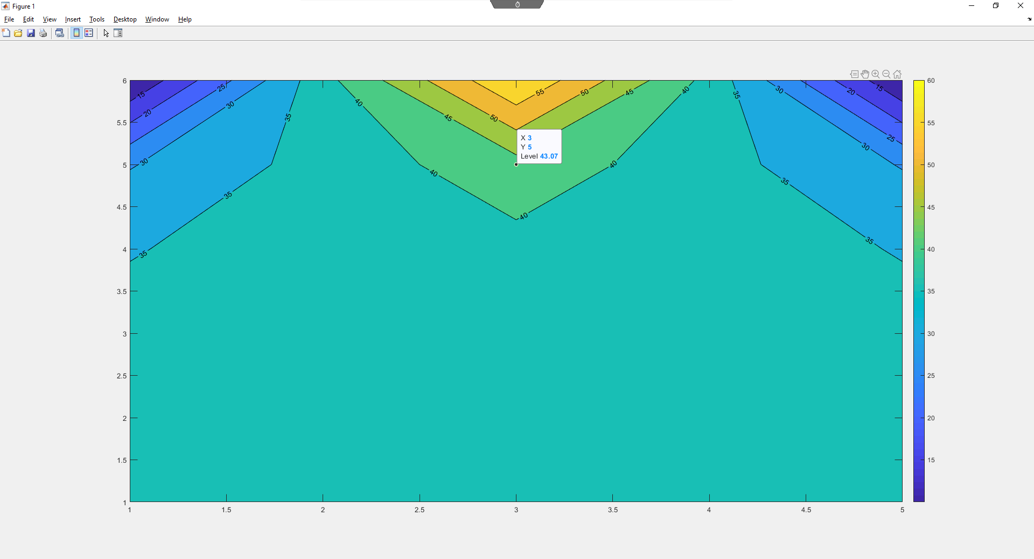
Figure 1. temperature distribution over the plate

LIMITATION OF THE CODE
The limitation of the model was in different points such as the convergence characteristic affect the accuracy of the value to reach thermal equilibrium. The iteration of the result to reach the thermal equilibrium varies, the result varies with a very narrow values but there was a difference. That difference affects for reaching accuracy values.
The duration of the iteration affects to the temperature distribution to reach thermal equilibrium. Iteration time plays massive role to hit the equilibrium, but the value is slightly different.
The Explicit method also one of the limitations to the code in order to reach a very refine temperature distribution to the values.

CONCLUSION
The model was a 2D rectangular plate with aluminium plate, perfectly insulated on the left, right and bottom of the plate. The temperature distribution on the top plate was gaussian distribution. The plate grid points in the to the east, west, north and south with equal difference, so the temperature analysed on each grid point on the plate dimension.
The modelling explained the correlation of the results with varying the grid space, time step, convergence characteristic and plate dimension. The results depend on the user input gives the output. The last result displayed for this model was not the same, result based on the give data.

REFERENCE
- Heat and mass transfer, by Yunus A. Cengel and Afshin J.Ghajar, Fifth edition
- Finite difference Methods in Heat Transfer, Second Edition, by M. Necati Ozisik, Helcio R.B. Orlande, Marcelo Jose Colaco and Renato Machado Cotta

