Pre-Production – Research and Idea Forming
Initial Thoughts
At first, I struggled to come up with an idea that I liked and wanted to work on, mostly thinking with ideas that felt too basic or too obvious. And then it hit me, I wanted to write my own passage of text, that was I could convey the theme and emotion through a style that I wanted to. And so, I chose my favourite Marvel superhero Daredevil as the basis for this idea. I thought, such a complex character with an interesting psychology could make for a very interesting theme to explore when creating my scene. And so, I decided that this is what I wanted to do. I then noted down my initial thoughts about this idea: to create Daredevil’s apartment and include many features and objects within.
The Theme, Feel and Atmosphere
New York – Hell’s Kitchen (The Setting)
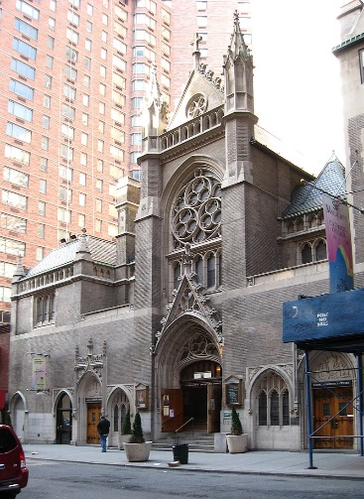
Grunge, constant flux, gritty. According to Wikipedia [1], Hell’s kitchen used to be a bastion of poor, working class Irish Americans, known and famous for its fights and violent history with riots and the like. However, it has recently began to flourish with a lot of LGBTQ+ people and businesses and rent prices have somewhat risen. It has become a home of the entertainment industry as well as being a neighbourhood, featuring heavily on musicians and actors. There are also a large number of catholic churches such as the St. Malachy Roman Catholic Church.
Both precincts that patrol Hell’s Kitchen, both report a lower but persistent crime rate. However, I’ll be focusing on an early 2010s Hell’s Kitchen, so it still features a higher crime rate and a less progressive Hell’s Kitchen. Connecting to the rest of Manhattan via the subway, Hell’s Kitchen also features the massive Port Authority Bus Terminal for a large portion of its public transport.
[1]
Overall, for the atmosphere and theme of the setting, Hell’s kitchen has a gritty, hard atmosphere with the promise of expansion and progression on the horizon. Focuses on grunge, darkness, grit, with some level of light at the end of the tunnel.
The Marvel Comics
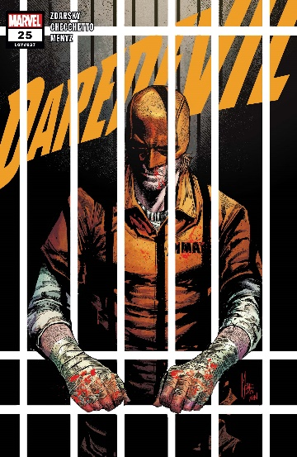
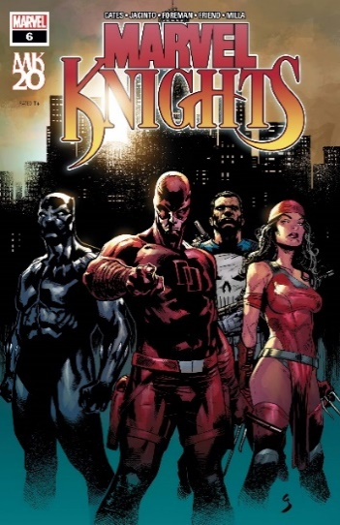
While many artists and writers use a range of different styles, the style I will be focusing hard on is that of the Daredevil, The Punisher, Spider-man noir and Moon Knight comics, from artists such as Marco Checchetto, Chip Zdarsky, Greg Smallwood, and Geoffrey Shaw.
[2]
This art style features very heavy dark shading and a bleak use of colours to give a hard, real, and dark feeling to the images shown.
[3]
The features I will be using from this style will be the heavy shading to truly emphasize the darkness within the apartment, and the contrast between that and the brief shining of light that we get from the lights going past.
Daredevil
The character of Daredevil, featured in the marvel cinematic universe [4] as well as multiple comic book series and crossovers, is my personal favourite of them all. And to understand the direction for some of the themes in my design, I’ll go over briefly the characters story and purpose. First introduced in 1964 in the first Daredevil issue as “The man without fear!” [5] Matt Murdock is the real name of the superhero, is a blind and seemingly normal defense attorney, that grew up and lives in Hell’s Kitchen Manhattan. However, his blindness is not like that of a regular blind person, rather, when he was blinded, he was given the power of heightened other senses. And can use this power to hear the vibrations of sound to perceive things in greater detail than a person with sight could see, provided it made sound. With this power, Matt Murdock became the crime-fighting superhero known as Daredevil and fought to reduce the corruption in Hell’s Kitchen. The trouble that Matt faces, however, is the balance of handling his own normal life as a lawyer with his friends Karen Page and Foggy Nelson, and the balance of his other life as Daredevil. Matt constantly is at flux with trying to keep Daredevil a secret from his friends and trying to do good whilst not crossing the line such as his partner and adversary, The Punisher – as Matt Murdock does not want to kill his opponents, rather he wants to give them chances to change. A sympathy that finds him constantly at odds with his fellow heroes, and within himself. This a great story arc throughout the third season of the Daredevil once Netflix now Disney+ show and it truly explores the duality of the character and serves to truly challenge his convictions. These will be the elements of the character that I will explore within the project.
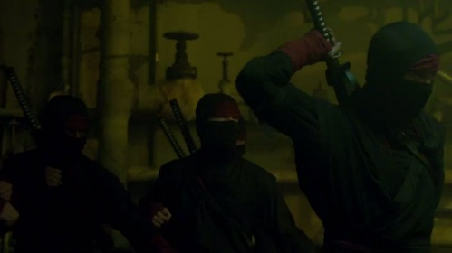
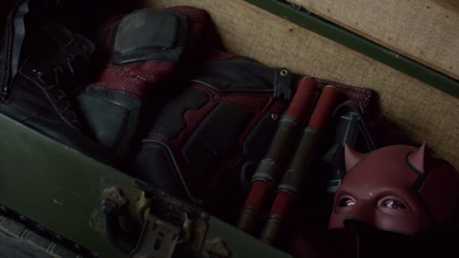
Another thing I will look at incorporating are remnants and scars of Daredevil’s various battles, for example, his fights with the infamous group of assassins and ninja known as the Hand. Since these ninja hunted down Daredevil in his own apartment, I want to have evidence of his hidden away in the scene. As well as the main ending point to the scene: the suit. As the scene concludes, I want to have the camera pan to the closet which opens and reveals the chest, which then opens and reveals the Daredevil costume.
[4]
[4]
Noir Atmosphere
The Noir style of film (French for dark film) is a filmmaking style that mainly features intricate and complex plots, an underlying philosophical theme, cynical heroes, and stark lighting effects [6]. This sort of style blends well with the feeling of grunge and grit of the setting combined with the art style of heavy dark shading and realism of the darker comic book style. Daredevil as a character is certainly a complex one, with the TV show and his comic stories focusing on the moral battle he has within his own head, such as wanting to kill criminals but not actually doing so and balancing that vigilante life with his normal life of a lawyer. These themes combined with the art style and complex plots all feature well for a more noir style, and thus going forward, I will try to blend these styles together to create a noir styled atmosphere.
Style choices and ideas going forward
In terms of the theme of the atmosphere inside the apartment, a lot of my focus will be towards showing the split between the two lives of the character with the noir style as an underlying tone. While for the most part, the apartment is covered in heavy darkness, the constant lights coming from the windows give light to the apartment to show what’s inside in more detail; to show what’s really inside. From two perspectives, it could be the image of a seemingly normal New York apartment, but when light is shone in, you start to notice the hidden elements such as sword scars in the furniture, a shuriken sticking out of the wall, some dried blood stains etc. Or from the other perspective, the darkness itself highlights the dark and gritty second life of the apartment’s owner, with the light shining through the windows signifying the light parts of his normal life, as the lights reveal the details of his life as a lawyer such as the papers on the table or the business coats by the door. Another aspect of duality in this design will be the façade that the character maintains that he is blind. Although featured in the apartment we can see things like his white cane or his glasses, we also notice smaller things in locations that, at first, you would think to be somewhat inconvenient for a blind person, such as wine bottles and knives resting in high places, or the costume hidden away inside a chest located inside a closet. To summarise, the main themes and focuses of my design will be noir and grit, and duality.
The Architecture and Design
New York – Hell’s Kitchen
According to Greenwell [7] The architecture of Hell’s Kitchen is somewhat mixed compared to other areas of Manhattan such as Times Square and West 42nd street, featuring styles such as Late modern buildings combined with the older styles of gothic and late Greek revival. It also features many churches with the medieval and gothic style. “Hell’s Kitchen is known as being one of the few remaining Manhattan neighbourhoods to still feature primarily low-rise architecture.” [8] As for the future of architecture in Hell’s Kitchen, it is said to be “uncertain”, however recently there has been an increase in larger, steel skyscrapers and post-modern buildings.
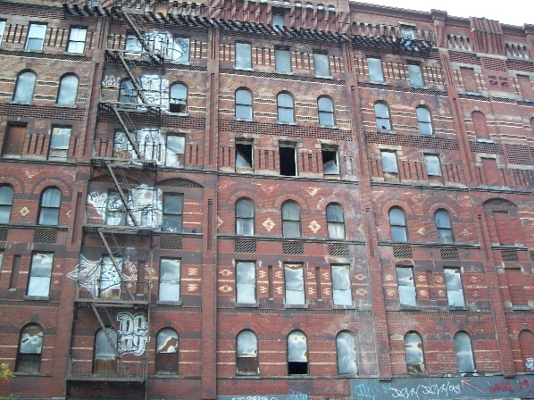
An apartment complex that I am focused on are the Windermere apartments located in Hell’s Kitchen on West 57th Street. Whilst, according to Kennedy [10], currently the Windermere is not in use, its future plans are to turn it into a hotel. But it once was an apartment block, and quite a famous one. The style of this apartment block has an older, low-rise look and features a consistent brick colour and texture. I will use this look and style when creating the apartment.
[9]
American Apartment Features
The type of apartment I will be looking at is that of a loft apartment, according to Wikipedia [11], developed in the 20th century, this type of apartment was developed in a former industrial building. This apartment features more of an industrial design than a normal one, with features such as steel stairs and wooden and metal support beams. It is also typically larger and with a different configuration to a normal apartment. In my design, I plan to feature a slightly slanted roof with a smaller upper level that features a bedroom and an exit to the traditional metal fire escape, often seen on the side of many American city buildings.
Key features of this apartment involve large arch windows, metal radiators, older-dated furniture and walls, metal, and wooden supports.
Sketches, Screenshots and Ideas
After doing the research and finalising my idea, I set out to plan out the scene and to plan my production and postproduction process, including how I wanted the scene to be laid out and what objects I wanted to include inside the scene. The rooms I planned to include were an entrance way, a living area, a kitchen area and an upstairs bedroom. In each room would be basic objects found in an American apartment such as sofas, closets, kitchen appliances and entryway objects such as a coat hangar and a shoe shelf. I also specifically wanted to include radiators as they are not as common in American apartments nowadays, so they really serve to show that it is an older, loft apartment that was once an industrial room.
Since initially I struggled to visualise how I wanted the scene to look and visualised, I created a basic scene in maya and then began creating my initial sketches and thumbnails of the layout. I also used human models to judge scale.
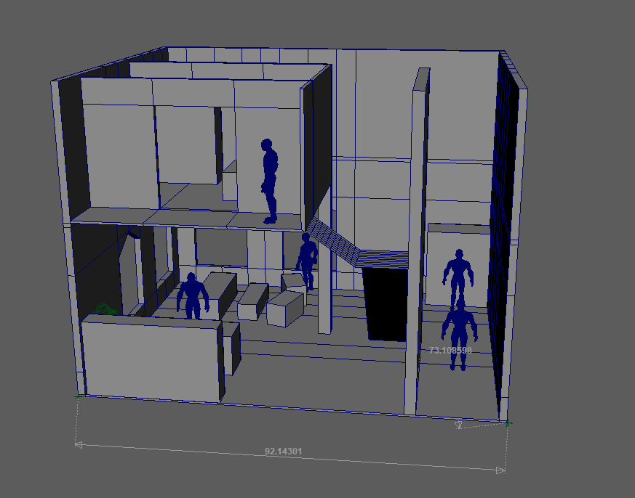

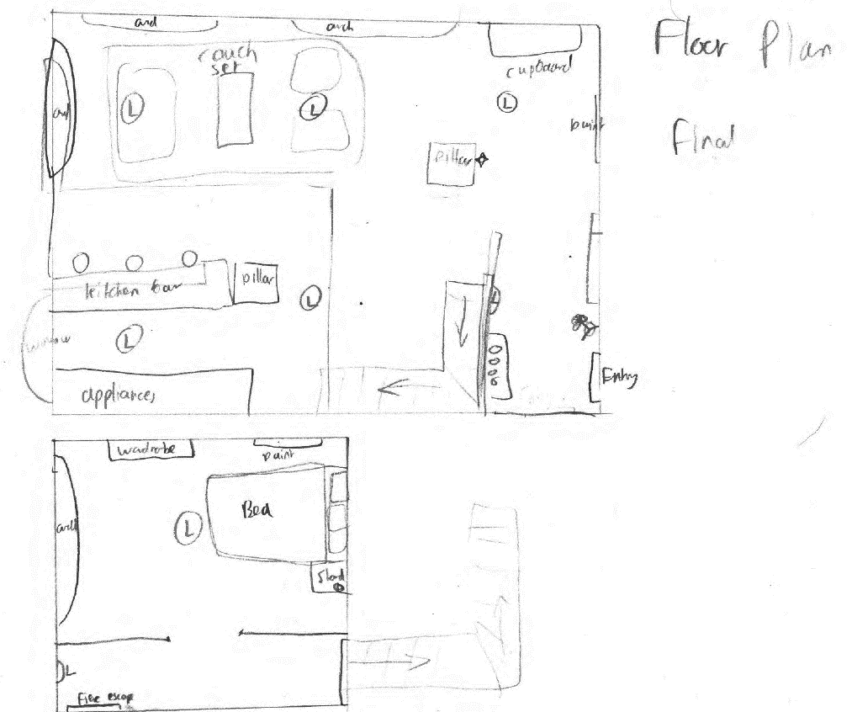

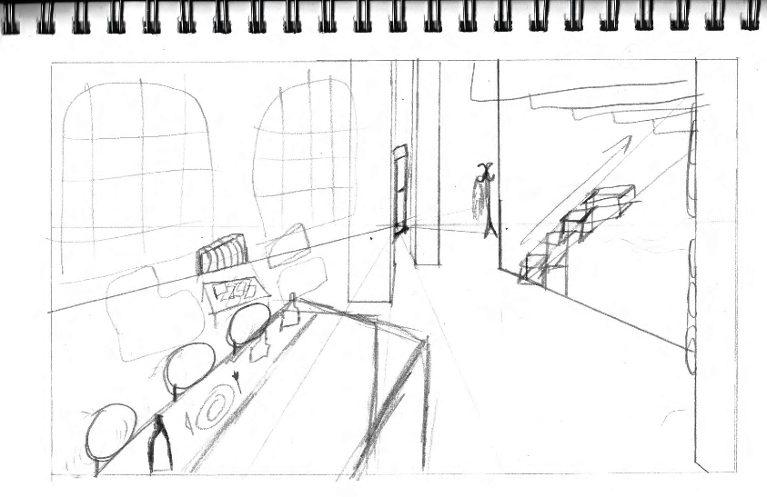
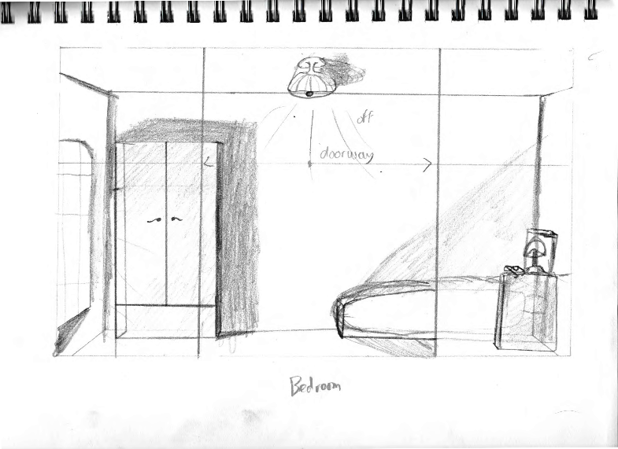
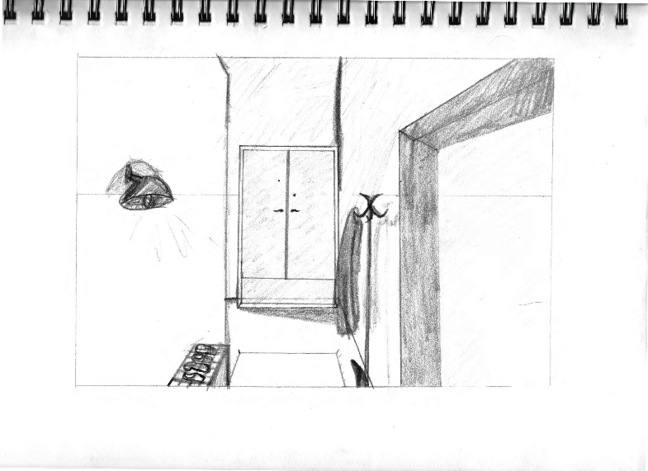

I also created the layout in the game the Sims 4 to help me visualise what is needed in the scene and how the scale of each object should be.
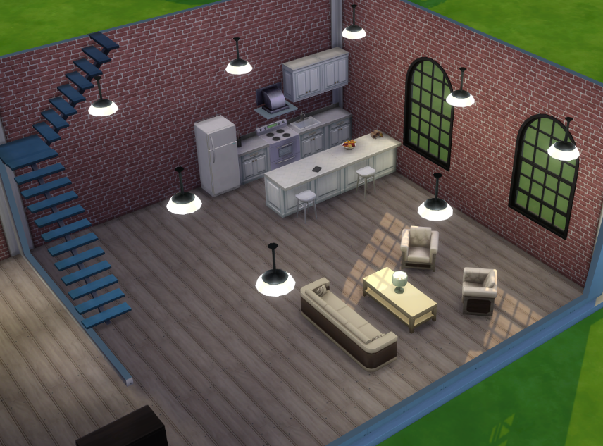

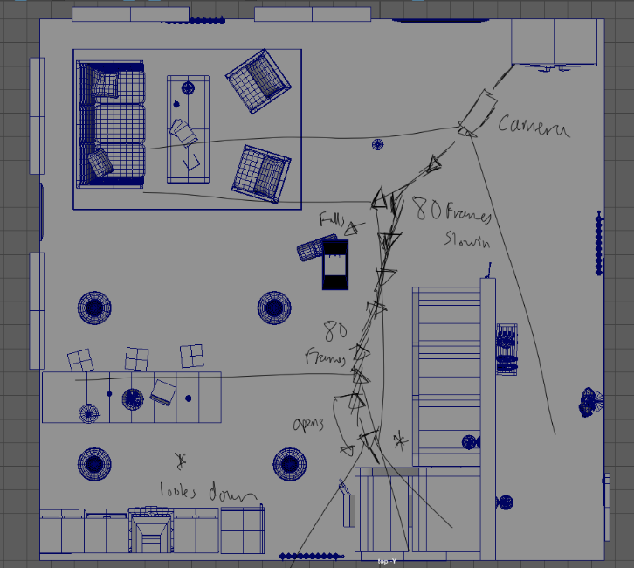
Once settled on a basic look and layout, I then sketched some thumbnails of the objects I wanted to model and include in the scene.
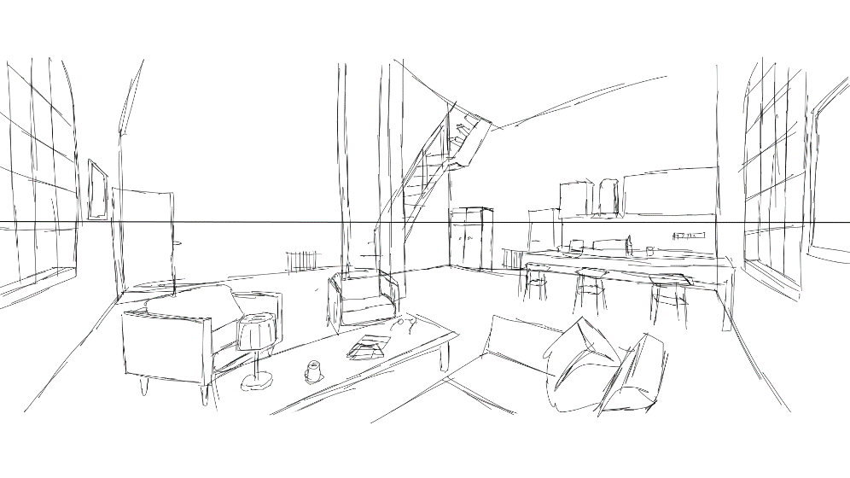

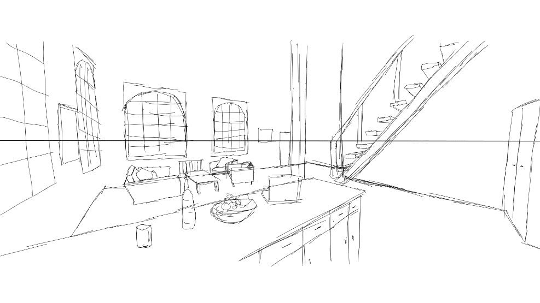

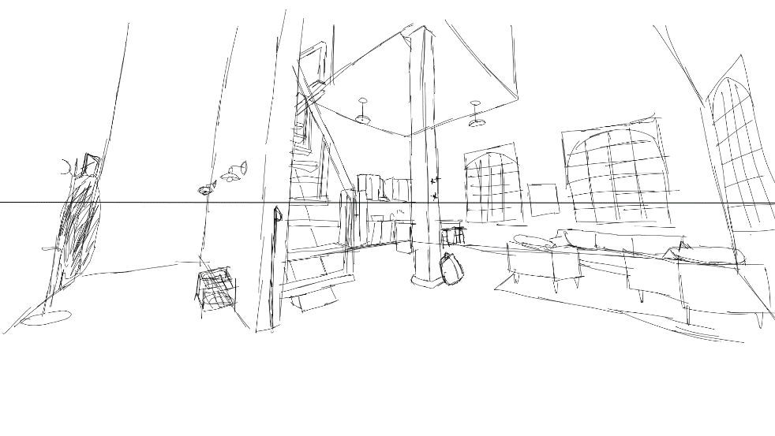

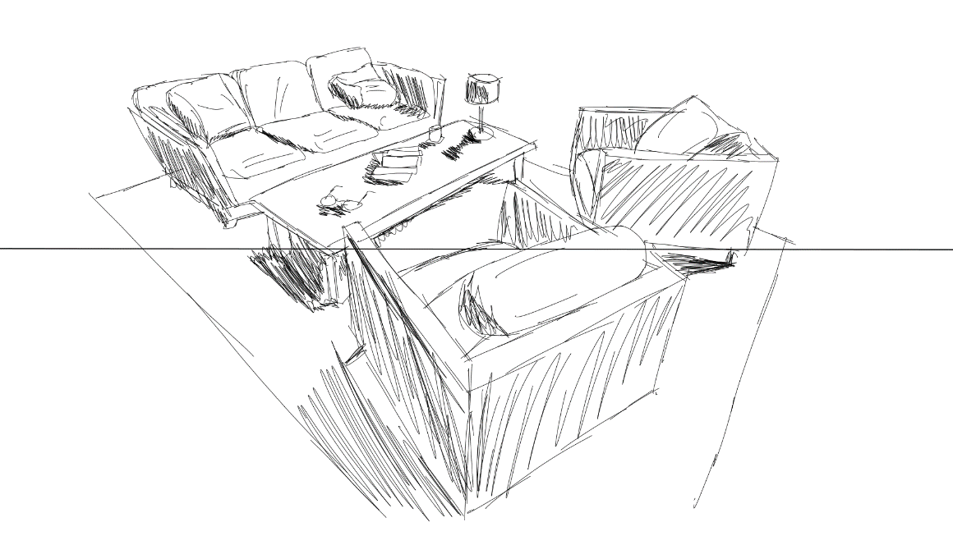

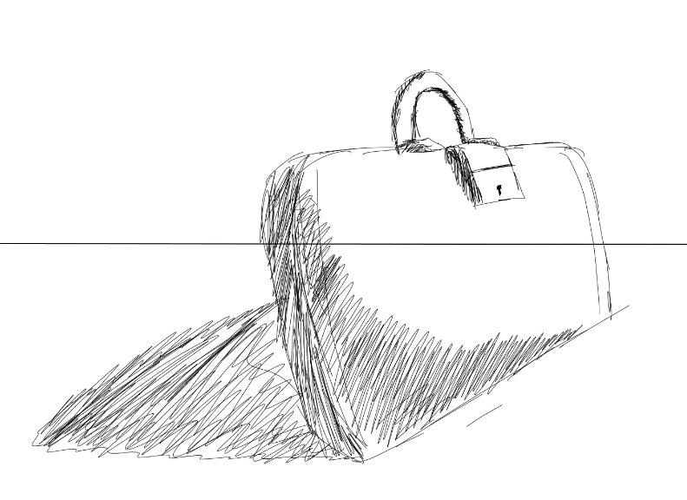
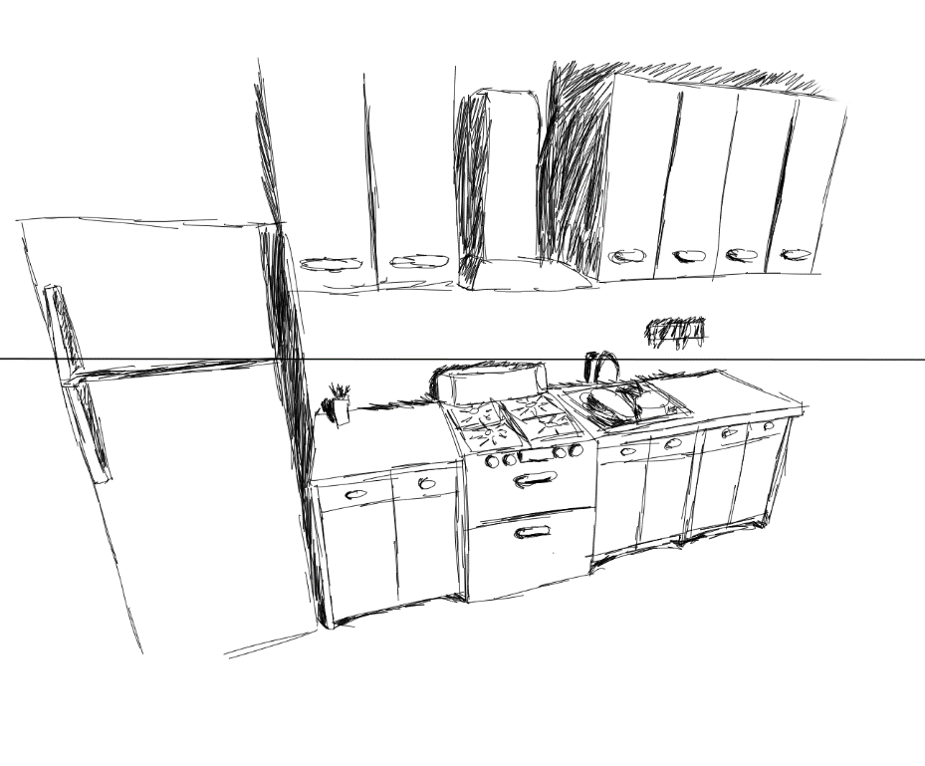

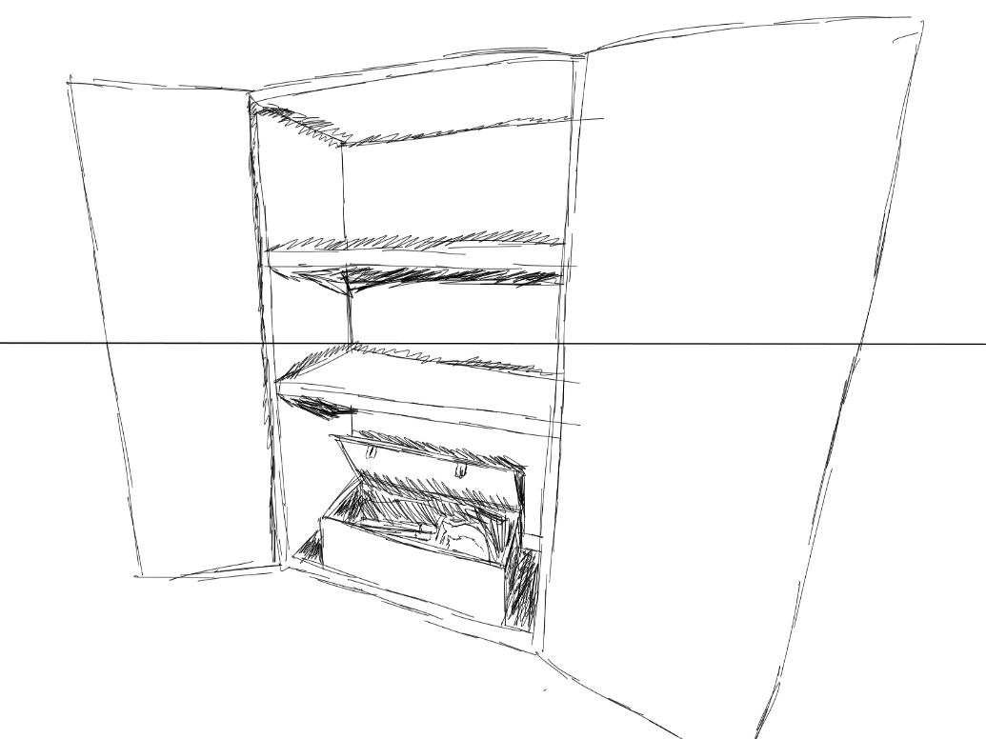
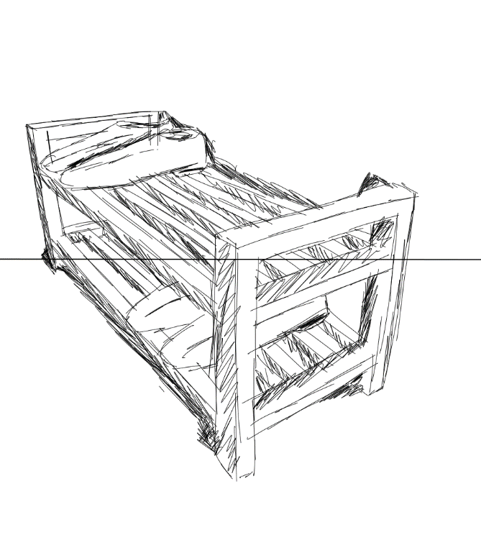

#

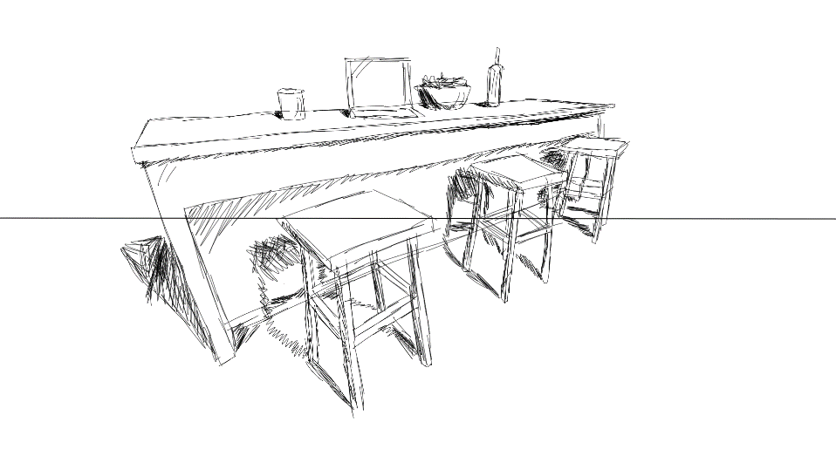
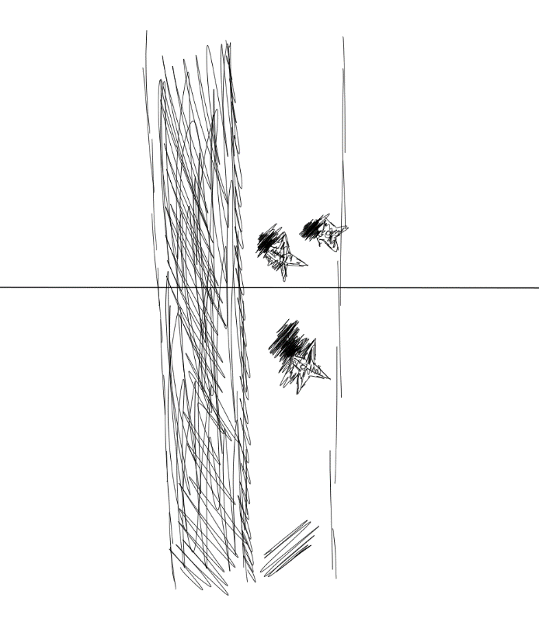

Production – Modelling and Texturing
Modelling the Objects in the Scene
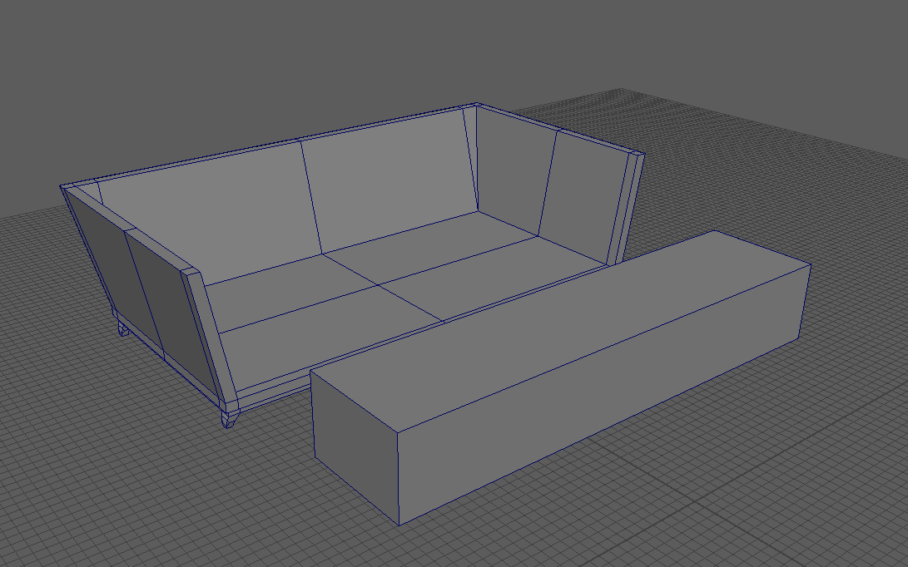
Working from my thumbnail sketches and using other reference images found online and put into a mood board, I began modelling the objects in the scene.
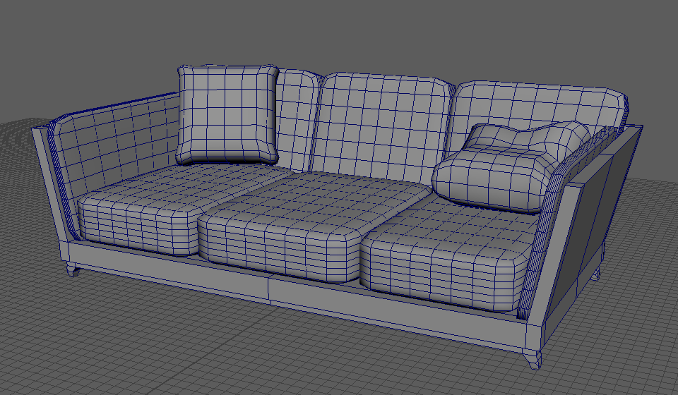

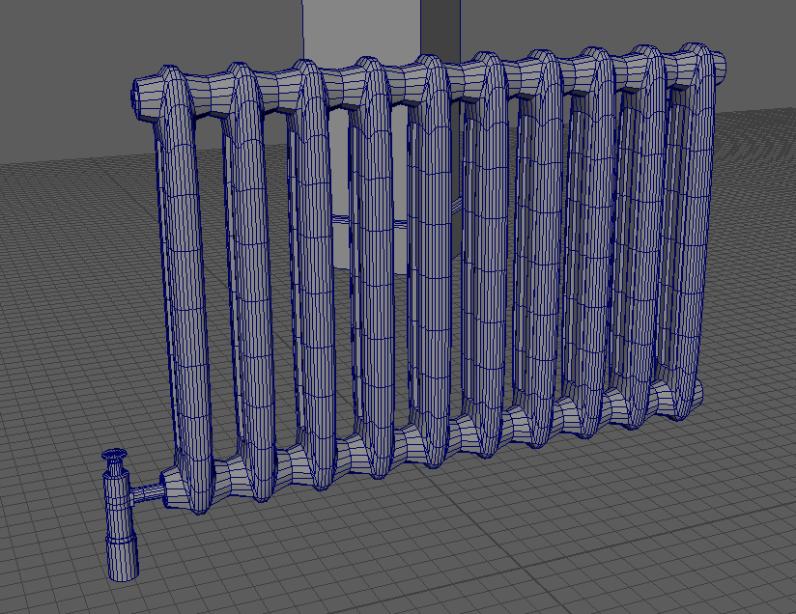
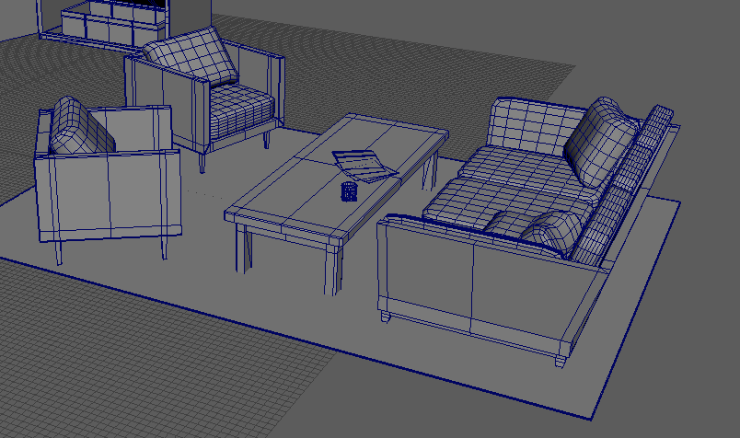

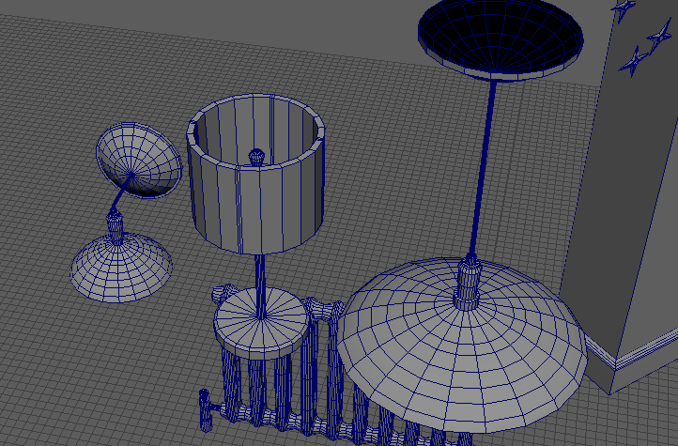
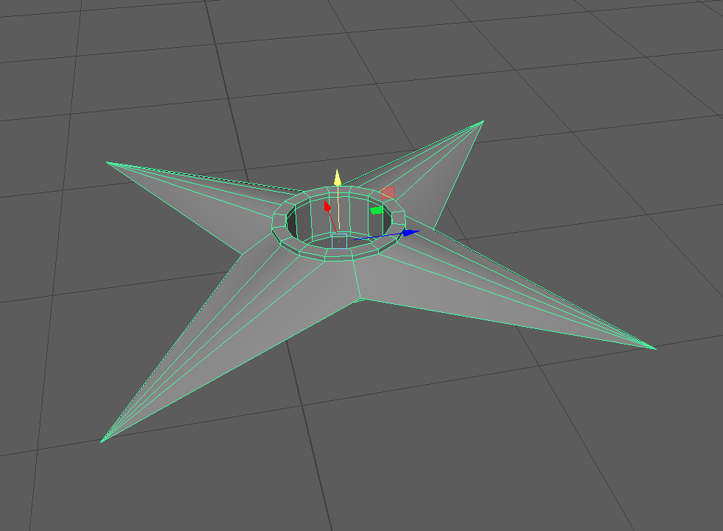

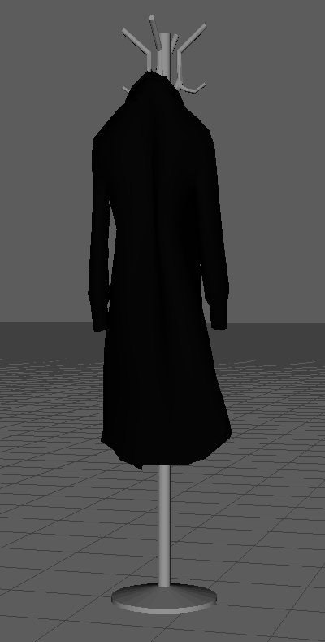
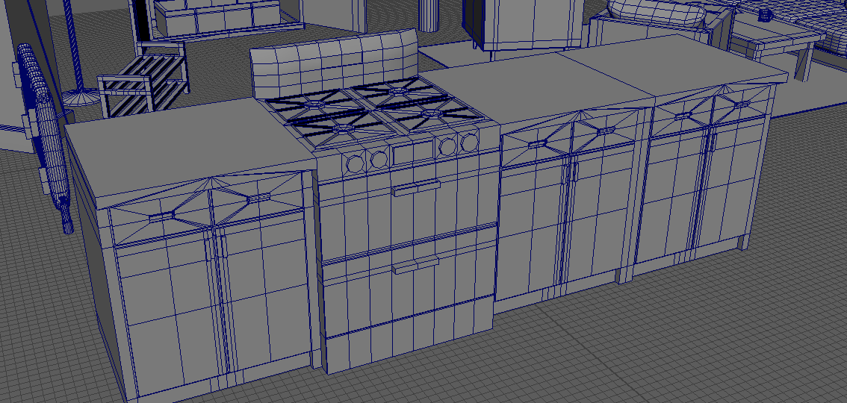

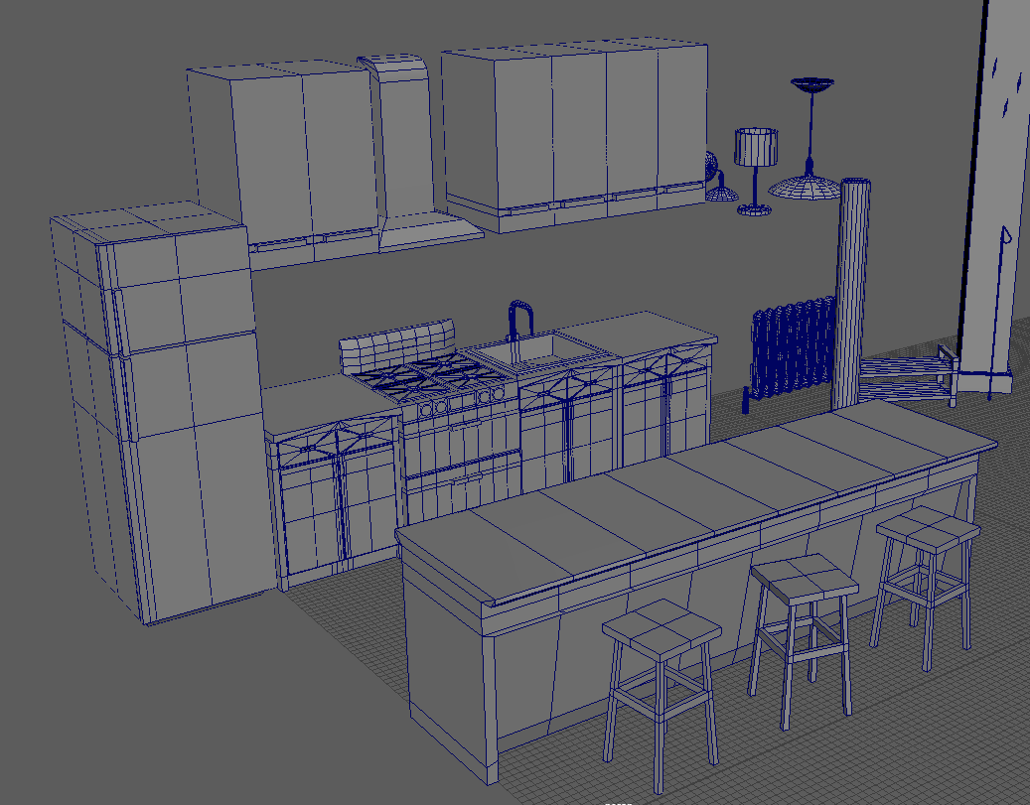
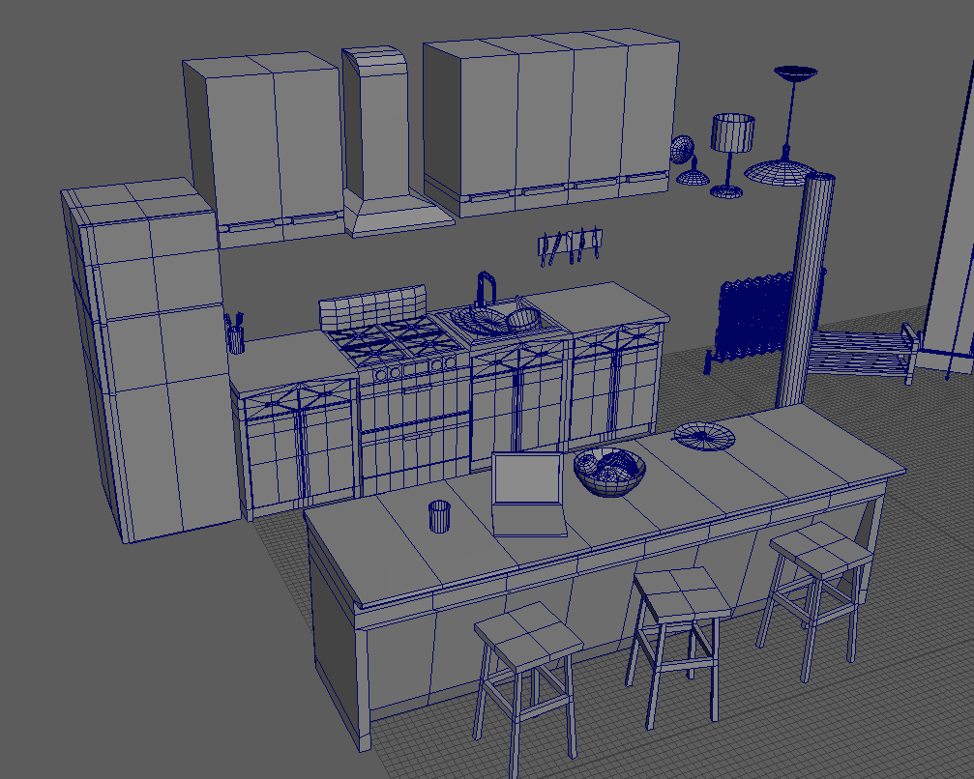

For the coat on the coat hangar, I used ncloth on a model of a coat that I made to simulate it falling around the hangar that it was constrained to. I then deleted the history to get the new model.
When modelling, I had certain things in mind that I thought about and considered: How would the camera see it and from what perspective? How lit will it be? Where in the scene is it located? Will it have visible damage? How large will the object be in the scene? I took into account each of these considerations when modelling each individual object, for example, I modelled each object in the same scene in Maya, this way I could constantly compare the scale of the models to see if it would need any adjustments. When thinking about the camera’s perspective from my original storyboard, I could also delete sections of objects such as faces and edges that the camera wouldn’t see, since this saves on time and resources, and means it requires less work on texturing.
Some techniques that I frequently use when modelling to help me are using the multi-cut tool combined with the target weld and bridge tools to create any geometry I need quickly, as well as using the add divisions and smooth tool to create the less polygonal objects such as the sofa cushions and the kitchen accessories.
While modelling, I decided against including the bedroom and altered my storyboard plan to skip the visit upstairs. I came to the conclusion that for a 10 second animation, it would not be enough time to explore this part of the scene, and it would also save a lot on time and effort.
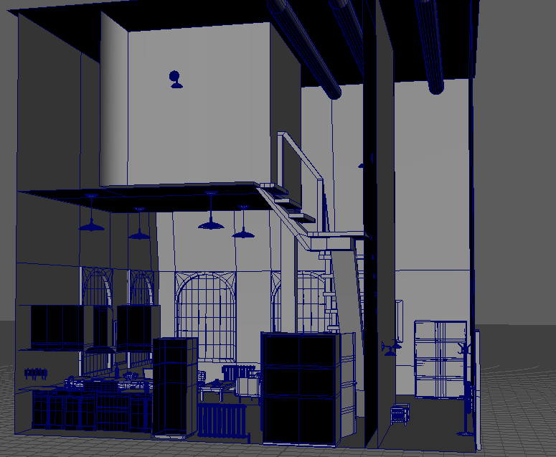
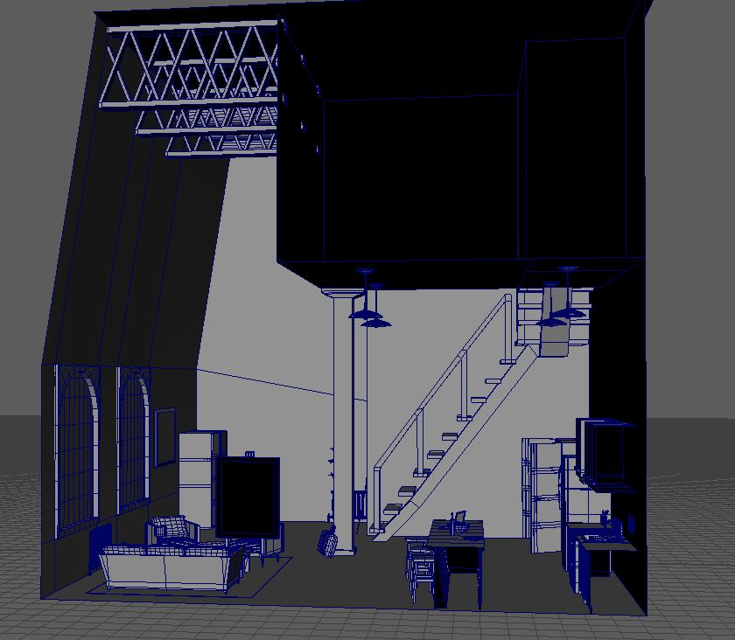

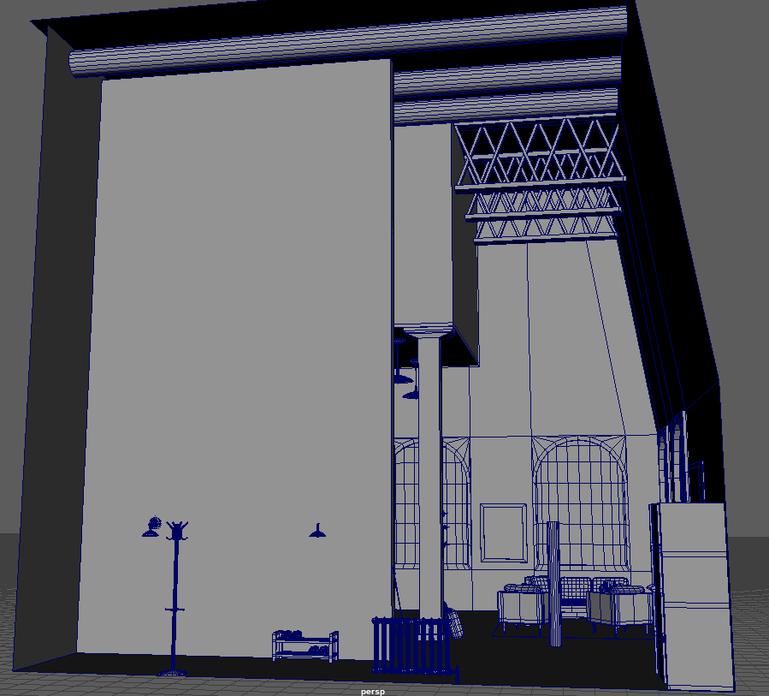
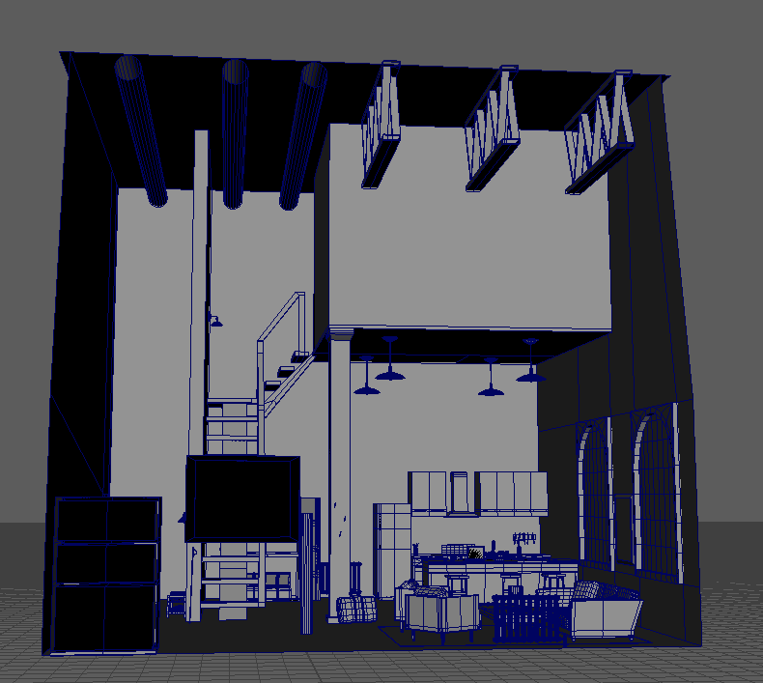

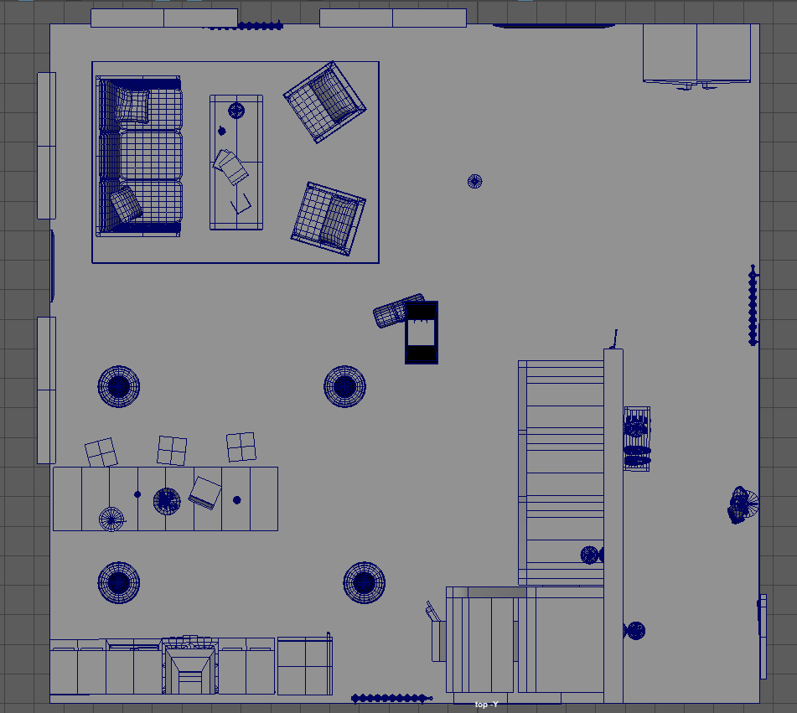
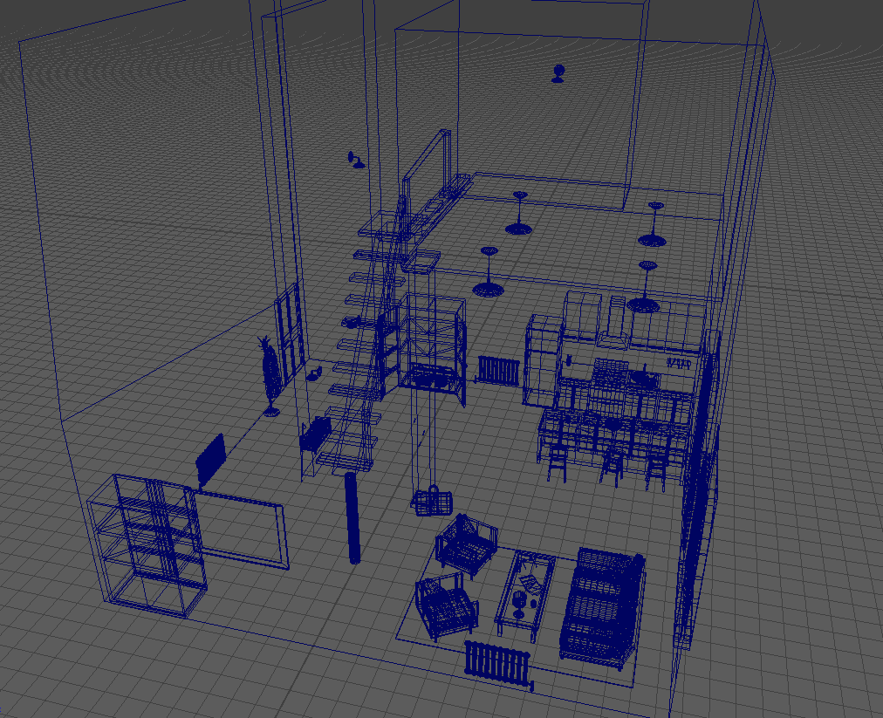

Texturing
After I had modelled each object and was happy with what I included, I then began to UV unwrap them all to prepare for texturing. At first, I started to UV unwrap each model after I had finished modelling it, however, this took up a lot of time and I felt I could do things in a more efficient way. I then decided that if I model everything at once and then afterwards UV unwrapped everything at once, I will become used to the process and workflow instead of constantly switching between them, meaning it would get easier and easier, and would save me a lot of time. This plan worked out well and I then had each model unwrapped and ready to be textured.

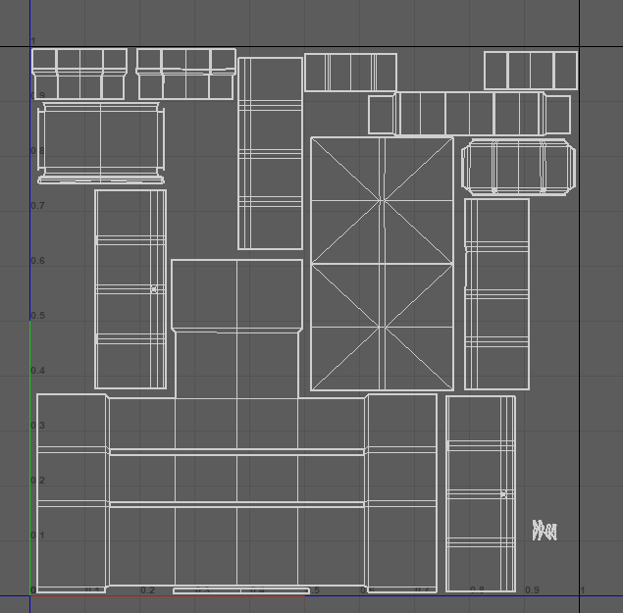
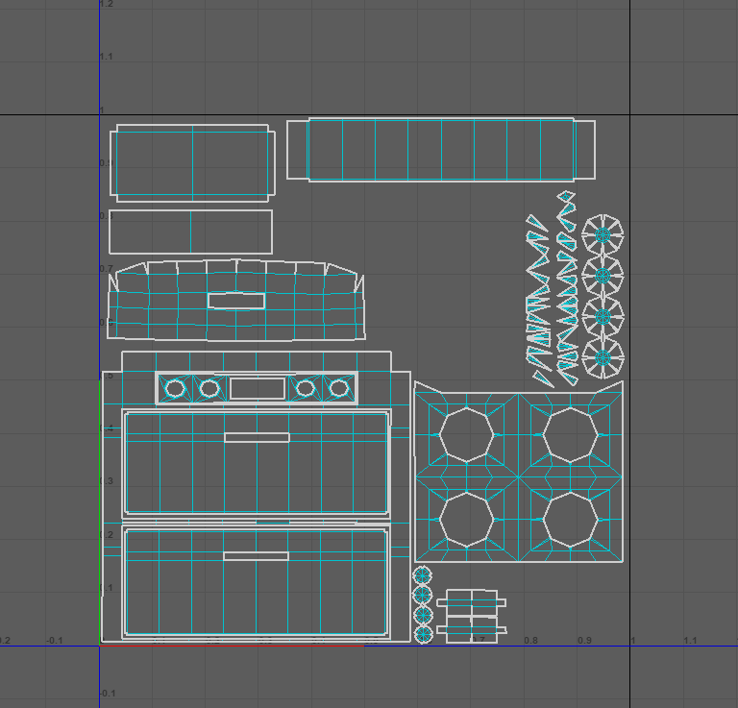

For the look of my models and scene, I wanted the comic book/graphic novel style that I decided on in my initial idea forming stage, and I began researching how I could recreate this in Maya. That’s when I came across the Arnold Toon shader. This shader added contour lines on the objects and combined with tonal colours, made the objects look cell shaded - just like a comic book art style. So, I then began to experiment and play with the settings to get a look that I wanted. After doing some more research into the style of 2D comic book on 3D, I came across two pieces of media that really interested me in terms of art style – the Telltale games [11] and a short film called Paths of Hate [12. The style of these had hand-drawn textures applied to 3D objects with different shading passes to create a very comic book-like look. I loved this idea and I wanted to include this in my scene too. So, after experimenting with one of my objects, I was able to figure out a good method to do this: in the hypershade menu in Maya, I created the toon shader and linked it with the object. I then linked the base colour of the shader to the texture on the object, in this case a basic brown coloured texture; to then improve the lighting and shading on the object, I created a ramp node and connected it to the tonemap of the shader. Turning it off linear, I then had a 3-4 basic colour tonemap of black through white to apply to each of the textures. I was very pleased with this result as it started to look like the style that I had envisioned. The only object without this texture style were the windows on the arches, for which I used a blinn material with complete transparency.
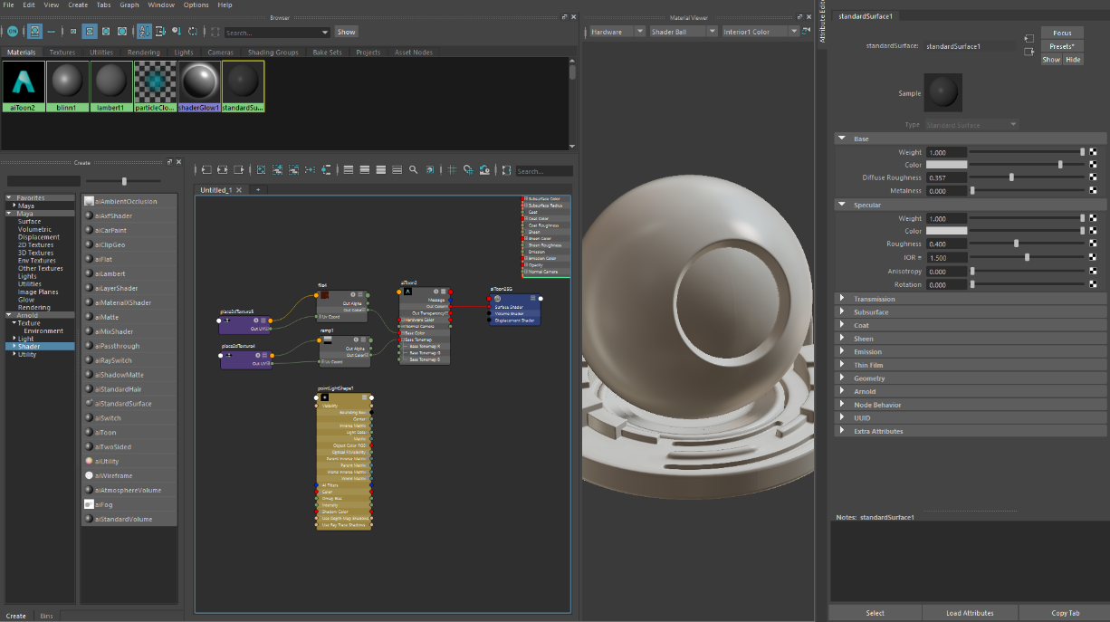

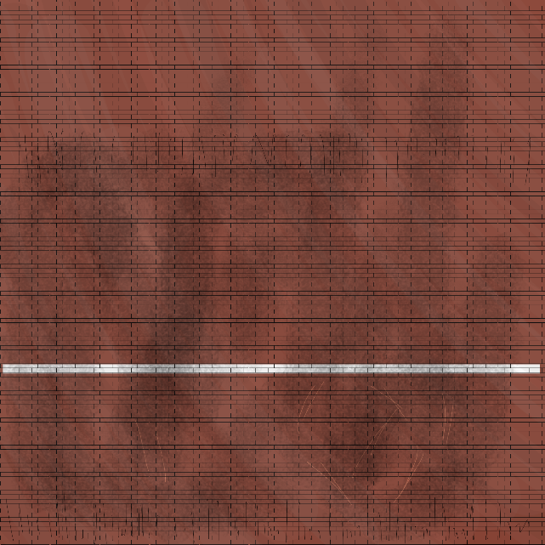
So, with this style and workflow in mind, I then began creating textures for each model in Photoshop, using the brush to hand draw details and grunge to each object depending on the material and colour of the object. For the larger models such as the walls and floor, I created a basic pattern and then repeated that pattern, before adding in any extra details such as sword marks and dirt. After applying these textures combined with the customised toon shader, I had very stylised looking objects that I was extremely happy with. While applying them to each individual object, I was constantly using the render preview combined with temporary lights to check on how the object looks in the scene and compared to the other objects, and I was constantly making adjustments to my textures and shader.
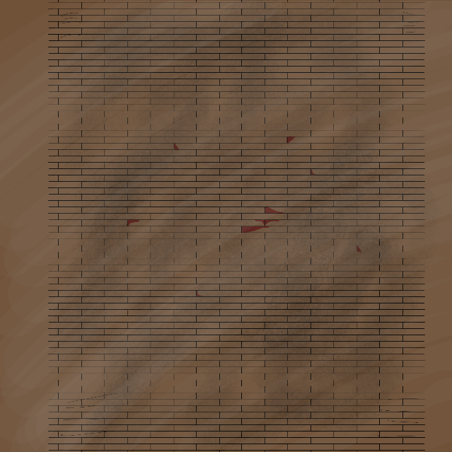

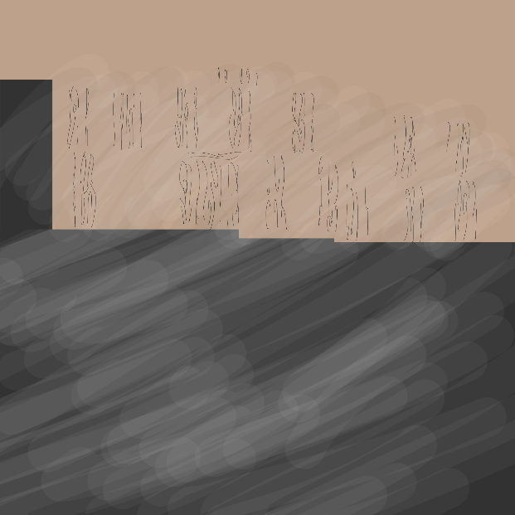
Here is an example of some of my texture maps, I have included hand-drawn details in specific places on the maps related to the locations in the scene

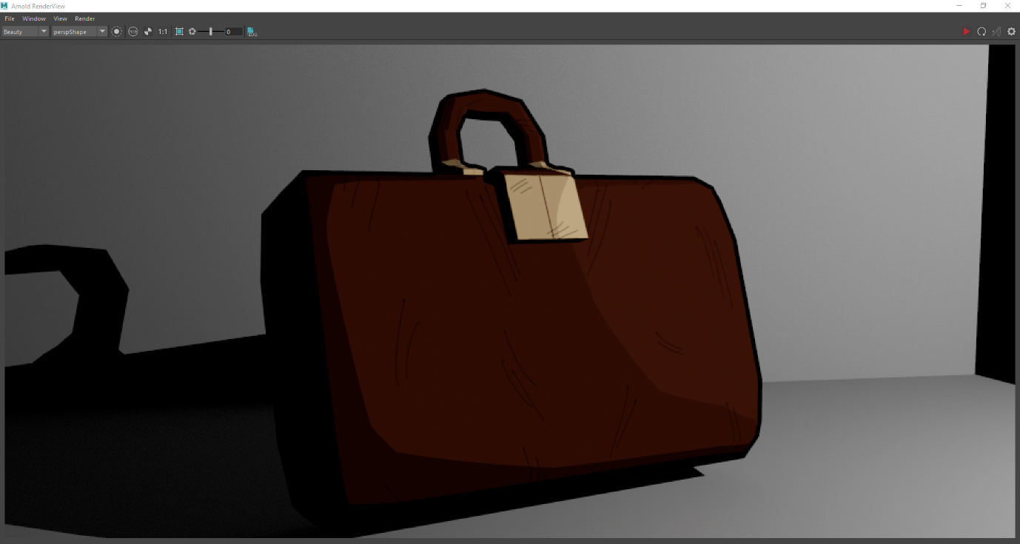

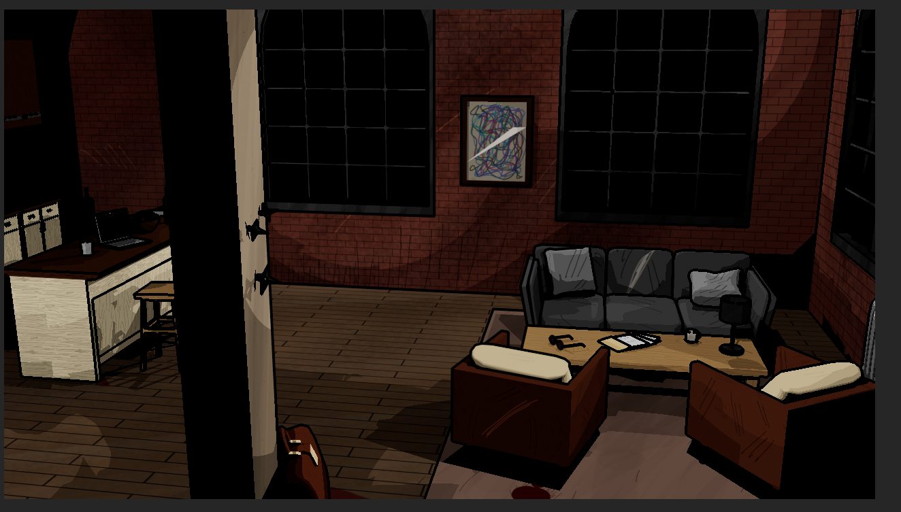

Adding Lights and Animating
The next and final step of the production process was adding in my lights and animating each of the thing I planned to animate.
I started with experimenting with different light types and how I could include them into the scene, my plan was to have some ambient lights on the inside, as well as a general night sky from the city, but with animated lights shining through the windows to replicate car lights driving past.
To achieve this, I first created a sky dome light using Arnold. I originally wanted to have a city night hdri however, I could not find one free online with good enough quality. So instead, I used a flat colour, not unlike the night sky if lit up by thousands of lights from the city. I then created point lights and spotlights to simulate the lights from outside, as well as animating them to simulate the car lights. The first time I rendered using these lights, it came out with glitches from the shadows and so I had to change some of the settings around and re-render it - the second time turned out much better. One issue I had however with using these lights, was that the light colour was not editable for projecting onto the objects with set colours and tones from the toon shader, and so I was not able to get a neon-sign-styled light coming from outside. Although, I was able to edit the other settings such as the exposure and intensity, and this made it easier to create the lighting that matched the style I was looking for. I also decided to include some point lights for the wall lamps located at the entrance as this showed more depth into the environment.
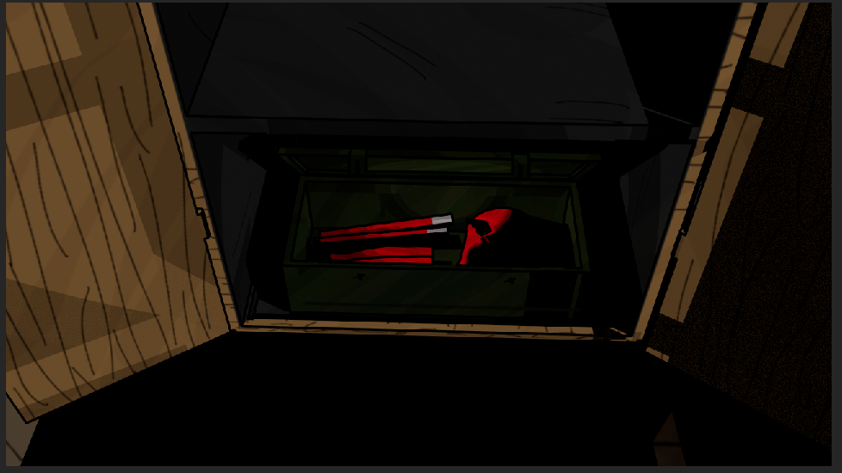
Then came animating. I had planned to animate a few individual objects to suit my scene as well as the camera moving through the shot. For the objects, I had a shuriken sticking out of the wall, fall out as the camera moves past it. I also had the closet and chest housing the Daredevil suit open as if the character was there opening them themself. Using the storyboard, I keyed each of the object’s animations and ironed out the timing of these actions before I was happy. I then animated the camera moving through the scene. I decided to use a panning, far shot to establish the scene and environment before zooming in and becoming a mid range shot on the character as they open up the closet and chest, with the final angle shifting focus from looking over the shoulder of the character, down into the chest. After I was happy with the pacing and movement, I combined each animation together and began to render from my main animated camera.

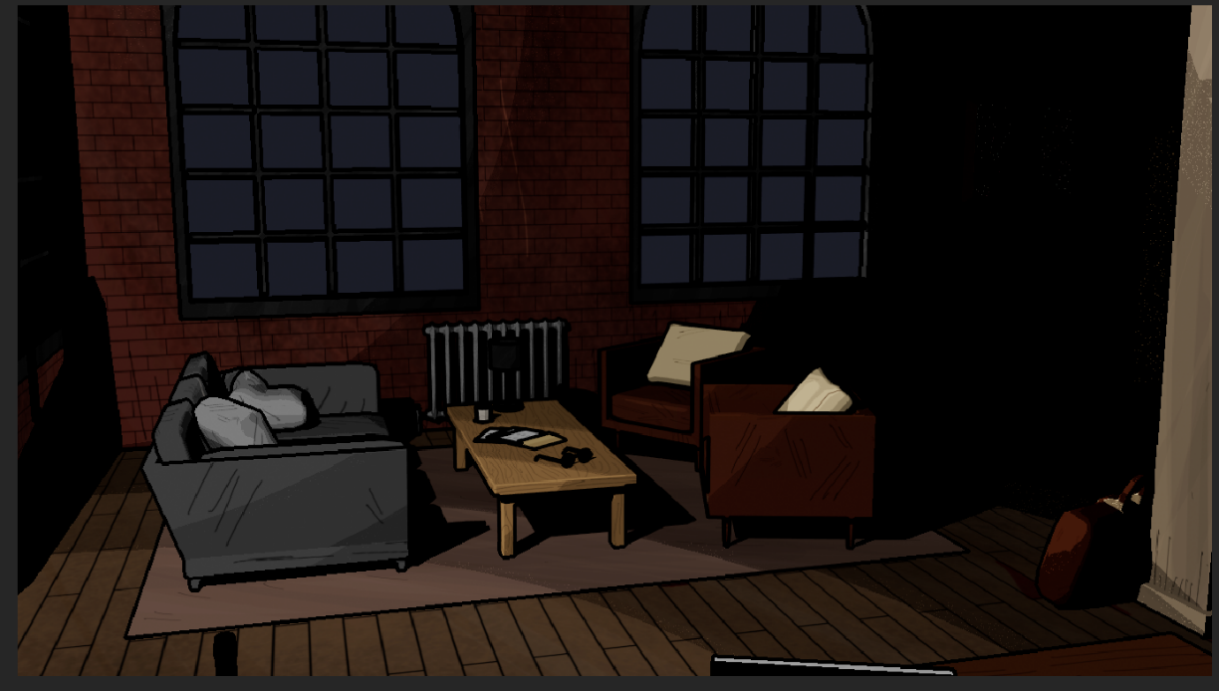

Post-Production and Reflection
Rendering
Before rendering, I made sure all my settings were correct in the render settings menu. I rendered in Arnold using the contour filter to give each edge a hard line to make it look more comic like, and for each object, I selected the angle falloff to decide which edges were to be contoured and such. I then rendered it using the Arnold renderer as a image sequence in png format. After which, I was left with 240 images in a sequence, ready to be compiled.
And so, I brought them into After Effects. One thing I noticed was that it had rendered with a different gamma setting and in After Effects, the scene looked very washed and lacking colour. After doing some research, I found out that I needed to change the gamma settings within After Effects and that then fixed my sequence, I then finally added some royalty free sound to include a little extra detail and then compiled it and rendered it in watchable format.
Reflection
Reflecting on the whole project, as well as being very pleased with how the result turned out, there are some notes I want to talk about here at the end; things to take forward into the future to research and improve.
The main three points I felt I could definitely improve on were project time management, lighting, and animating the camera. For the lighting, as I said before, since I was using the toon shader and the stylized textures, it meant that the lights I used were not nearly as editable and so I struggled to get the final look of the scene that I was hoping for. In future, I want to look more into lighting and to spend more time experimenting with the properties of different shaders to get them to how I want them to look.
For animating the camera, I need to more research on different camera shots and I need to plan out my scene better, as this time I ran into the issue that my idea in my head was too long for a 10 second animation, and so it meant that a lot of the effort I put into modelling specific objects was not di I did not plan with the time accordingly. But knowing this, in the future I feel I can now take into account my issue and plan for it accordingly.
And finally with time management, when working through the project, I feel I was putting off the project a lot of the time and this ultimately meant that my time frame for completing it was much shorter than the original. My issue is that since the time between the deadline and the start date is so long, that if I complete my project way ahead of schedule, I’m left thinking perhaps if I’ve finished so early then what I have done isn’t a good enough standard. After some thought and discussion with my lecturer, I have come up with a plan to handle this mindset in the future, and that is to set myself smaller, shorter-term deadlines for each stage of the project. That way I feel constantly time pressured and would ultimately help me manage my time much more effectively and efficiently.

References:
[1]"Hell's Kitchen, Manhattan - Wikipedia", En.wikipedia.org, 2022. [Online]. Available: https://en.wikipedia.org/wiki/Hell%27s_Kitchen,_Manhattan. [Accessed: 22- Apr- 2022].
[2] C. Zdarsky and M. Checchetto, Daredevil #9 (2019), 9th ed. Marvel Comics, 2020.
[3] D. Cates, G. Shaw, T. Foreman and K. Jacinto, Marvel Knights 20th (2018) #6, 20th ed. Marvel Comics, 2019.
[4] K. Johnston, Marvel's Daredevil. Marvel Television; ABC Studios; DeKnight Productions (season 1); Goddard Textiles (seasons 1–2), 2015.
[5] S. Lee, B. Everett, S. Ditko, S. Brodsky, S. Rosen and J. Kirby, Daredevil Volume 1, 1st ed. Marvel Comics, 1964.
[6] A. Tikkanen, "The golden age of film noir", britannica.com, 2022. [Online]. Available: https://www.britannica.com/art/film-noir. [Accessed: 22- Apr- 2022].
[7] K. Greenwell, "New York Architecture Images- Hell's Kitchen History", Nyc-architecture.com, 2022. [Online]. Available: http://www.nyc-architecture.com/MID/MID-HellsKitchen.htm. [Accessed: 22- Apr- 2022].
[8] G. Soybelman, "The Architecture of Hell's Kitchen", SocioWikiNYC, 2007. [Online]. Available: https://macaulay.cuny.edu/seminars/napoli07/articles/t/h/e/The_Architecture_of_Hell%27s_Kitchen_2537.html#:~:text=Hell's%20Kitchen%20is%20known%20as,feature%20primarily%20low%2Drise%20architecture. [Accessed: 22- Apr- 2022].
[9] M. Minn, "The Windermere", Michaelminn.net, 2022. [Online]. Available: https://michaelminn.net/newyork/urban-renewal/hells-kitchen/the-windermere/index.html. [Accessed: 22- Apr- 2022].
[10] D. Kennedy, "Inside the fight to resurrect NYC's pioneering Windermere building", Nypost.com, 2021. [Online]. Available: https://nypost.com/2021/07/17/inside-the-fight-to-resurrect-nycs-pioneering-windermere-building/. [Accessed: 22- Mar- 2022].
[11] Apartment - Wikipedia", En.wikipedia.org, 2022. [Online]. Available: https://en.wikipedia.org/wiki/Apartment#Facilities. [Accessed: 22- Apr- 2022].
[12] The Wolf Among Us. Telltale Games, 2022.
[13] D. Nenow, Paths of Hate. Poland: Platige Image, 2010.

