Enterprise and Entrepreneurship
John Williams
Autumn Baker (1602733)
University of Wales Trinity of Saint David
John Williams
John Williams
According to The Pembrokeshire Beach Food website John Williams began ‘Café Mor in 2011, after he sensed he needed to back in Pembroke as he missed ‘the sea and the beaches.’ Originally living in Swindon and working in an office Williams craved a more free and expressive lifestyle and moved back to Pembrokeshire. After a summer of working on stalls selling and creating welsh delicacies, Williams decided to create ‘Café Mor.’
May 8th 2011 marked the first day Williams began trading at Café Mor, unlike other entrepreneurs Williams created a business plan which was ‘high risk’, he spent all of his money and savings in ‘equipment hire, catering kit and disposables.’ His first ‘gig’ was at Wye Book Festival where other 250,000 festival-goers attended 10 day festivities. Williams plan proved a success and led to various other local and private gigs. Just after one season of trading Café Mor was shortlisted for the ‘British Street Food Awards.’ With the help of his brother Williams created a Beach Shack out of local drift wood [appendix 1] to wow the judges. Williams had an incredibly successful day and won ‘Best Looking Moblier’, ‘Best Drink’ and ‘Best of the Best 2011.’ Williams described this as a ‘good first year!’ as due to Café Mor winning the ‘Best of the Best 2011’ Williams got the incredible opportunity to cater for the London Olympics in 2012.
2012 marked an even more successful year as due to the ongoing success of the Olympics Café Mor flourished and gained more recognition. Susan Davenport invested into Café Mor and the development of food service and retail, thus creating ‘The Pembrokeshire Beach Food Company’, also known as the ‘travelling beach shack’ which can be found at various festivals and ‘gigs’ whereas Café Mor ‘continues to exist as a mobile food outlet at Freshwater West Beach in Pembrokeshire.’
2013, 2014 and 2016 marked a very inventive year as Williams created various welsh delicacies such as ‘Welshman’s Caviar, ‘Lava bread Pesto’ and ‘Ship’s Biscuits.’ These creative dishes are now sold through various independent retailers in the UK and also led The Pembrokeshire Beach Food Company to the BBV Good Food Winter Show in Birmingham. These creative dishes expanded in 2014 as ‘Mermaid Confetti’ was created. In 2015 they created a new flavour of ‘Ship’s Biscuits’ and in 2016 they launched their Sea Herbs range which consisted of their different products, the ongoing success of this led Williams and his team to Japan where they served their unique dishes in the Hankyu store.
In 2017 Williams made a ‘huge decision’ to stop doing festivals and focus primarily on Café Mor. Williams did one last festival at Wye Book Festival and then continued to focus on the popular Café Mor, Café Mor had had ever-growing national success and had appeared on various TV programs including Escape to the Country and Coast and Country.
In 2018 Williams revamped Café Mor, with the driftwood beach hut going into retirement, Williams used a fishing boat met with solar panels to create the new Café Mor [appendix 2]

Motivation
Dennis [1996] found that there are various factors that can lead an individual to become an entrepreneur, strong evidence has been found that entrepreneurs begin their journey as they find that their ‘skills and abilities’ are wasted in their current employment. Dennis also found that another leading reason is that the individuals crave having ‘greater control’, entrepreneurs are often leaders and intend on being their own ‘boss’ therefore in employment they do not have the ‘greater control’ thus wanting to be self-employed. Dennis finally notes that individuals are motivated to become entrepreneurs as they want to ‘build a business for their family’, some entrepreneurs crave a higher income and a wealthier lifestyle for themselves and their family which is why they intend to build a legacy, to secure this lifestyle for their family.
Dennis theory on motivation matches Williams need to be an entrepreneur as Williams previously said that he ‘didn’t want to be sat in an office’ therefore he wanted to have ‘greater control’ on his life and change his work scenery as well as ensure that his ‘skills and abilities’ were exploited in his new business.
Smeaton [2003] found that a motivating factor for men within the entrepreneurial community is that entrepreneurship allows them to ‘follow on an interest.’ This relates to Williams impeccably as Williams had grown up in Pembrokeshire and also had a key interest in the serenity of the peaceful town. Williams embarked on his career as his currently office role did not meet his expectations and felt he could achieve more, therefore he ‘followed his interest’ as Williams believed it would be the driving force of his success.

Push and Pull in Entrepreneurship
Push and pull are factors that can influence and lead an individual to embark on an entrepreneurial journey. Dawson, C and Henley, A [2011] believe that the ‘push and pull’ factors are the main reasoning behind individuals making the choice to become entrepreneurs – ‘individual self-employment choice is a complex decision based on a combination of pull and push motivation factors.’
Amit, R and Muller, E [2013] define pull factors as ‘those who are lured by their new venture idea and initiate venture activity because of the attractiveness of the business idea and its personal implications.’ Dennis [1996] agrees with this statement as Dennis discovered that ‘people entre self-employment because want to and not because of lack of available alternatives.’ Both statements identity the reasoning behind Williams embarking on the creation of Café Mor and The Pembrokeshire Beach Food Company, as the ‘attractiveness’ of a much more ‘free’ and ‘nature based’ lifestyle is what lured Williams to set up the businesses, Williams did not crave a richer lifestyle he had craved to be in Pembrokeshire.
Amit, R and Muller E [2013] define push factors as ‘those whose dissatisfaction with their positions for the reasons unrelated to their entrepreneurial characteristics pushes them to start a venture.’ Amit, R and Muller, E, also note that push factors can be that potential entrepreneurs want a more ‘flexible lifestyle’, Williams would match with this statement as Williams did not enjoy a typical 9-5 job, Williams wanted a job that combined his passions, catering and food; with his interest’s which were festivals and gigs, Café Mor and The Pembrokeshire Beach Food Company as examples of the lifestyle that Williams preferred. Amit, R and Muller E [2013] identified another factor as income. Savidakis and Storey [2010] agree with this statement as it is reported in their findings that income is found to have a stronger effect on men than women. Women have a stronger interest in socio-economic factors. Williams was not influenced by income, therefore disregarding Amit, R and Muller E’s finding and Savidakis and Story finding. Williams is found to not be dominated by cash flow, Williams admits on his online biography that he spent all his money and savings in 2011 to attend his first festival with Café Mor and that although it proved to be a success, he decided just 7 years later to be more authentic to Café Mor and remain at its prime location in Freshwater West, Pembrokeshire, instead of travelling with his other business The Pembrokeshire Beach Company. Williams relates more to Savidakis and Storey’s finding on the reasoning behind women becoming entrepreneurs, as William’s has built the businesses Café Mor and The Pembrokeshire Beach Food Company to be as sustainable as possible, with his first moblier in 2011 being made entirely of recycled local driftwood, to his current 2018; being a recycled boat with solar panels. Williams relates entirely to Crompton [1979] evidence on push factors, Crompton reports that a reasoning behind entrepreneurship is ‘change of scenery’ and to ‘escape [a] mundane environment.’ Williams began Café Mor because he missed ‘the sea and the beaches’ of Pembrokeshire, and believed his office job in Swindon was holding him back.
Entrepreneur
Onuho [2007:20-32] describes entrepreneurship as the ‘practise of starting new organisations or revitalizing mature organisations, particularly new businesses generally in response to identified opportunities.’ This definition describes entrepreneurship as recognising a ‘gap in the market’ using it to an advantage and either building an existing organisation to meet it or creating a new organisation to match it.
Social Entrepreneur
Gregory Dees, J [1998:4] believes that social entrepreneurs meet the following definitions:
- ‘Adopting a mission to create and sustain social value (not just private value),
- Recognizing and relentlessly pursuing new opportunities to serve that mission,
- Engaging in a process of continuous innovation, adaptation, and learning,
- Acting boldly without being limited by resources currently in hand, and
- Exhibiting a heightened sense of accountability to the constituencies served and for the outcomes created.’
Gregory Dees, J [1998:5] continues to mention that social entrepreneurs are ‘reformers and revolutionaries’ with social mission in mind. Gregory Dees expresses that social entrepreneurs are bold thinkers. They differ from other entrepreneurs as they are not wealth driven. ‘Profit is not the gauge of value creation; nor is customer satisfaction; social impact is the gauge.’ They intend to ‘break new ground’ and are considered the ‘pioneers of new approaches.’
Ecopreneur
Schaltegger [2002:45-58] reports that ecopreneurs are a combition of ‘entrepreneurs’ and ‘ecological.’ Schaltegger mentions that ‘ecopreneurship can thus be defined as ‘entrepreneurship through an environmental lens.’
Wally and Taylor [2002:31-44] note that ecopreneurs can be described as ‘change drivers.’
Günerergin, M and Dr Katrinli, A [2011] report that ecopreneurs main objective is sustainability. ‘Sustainability is based on the principle of consuming resources in such a responsible way.’ They continuously drive to create a more economic business and to motivate and influence other organisations to follow their path.

Intrapreneur
Burgelman [1983]; Burgelman [1984]; MacMillan et. al. [1986] describe intrapreneurs as a combination of ‘corporate entrepreneurship and corporate venturing.’ Intrapreneurs ‘exploit a new opportunity and create economic value.’
Williams, K. D [2013] mentions that employees can be considered as 'intrapreneurs’ as they are not creating their own organisation, but working for the organisation ‘thus the ‘intra’ part.’ Williams, K D, continues to express that although intrapreneurs are aware of the importance of money, it is not their ‘measurement.’ Williams, K D continues that intrapreneurs are risk takers, they do not ‘fear failure,’ they often have an immense amount of confidence and courage as they need that drive to achieve their goal.

John Williams
Johnathon Williams could originally be considered an ‘Intrapreneur’ as in 2010, he worked for the ‘The Really Wild Shop’ at Nant y Coy. Williams created a stall selling various ‘Pembrokeshire’ delicacies to the public, Williams experienced an overwhelming amount of success and continued the stalls for the summer. A year later (2011) Williams embarked on an entrepreneurial adventure and created The Pembrokeshire Beach Company and Café Mor, Williams is very economically driven and intends to be a sustainable as possible, thus being an ‘Ecopreneur.’

Eysneck Personality Traits
Eysenck, H.J. [1973:134] constructed a four-part list on the personality traits of entrepreneurs, Eyseneck notes that the personality traits can be inherited or a psychological trait.
- Sanguine trait, this trait is possessed by ‘stable extraverts.’ Generally, they are outgoing as well as easy going, they have strong social skills, are very talkative. However, they are often carefree.
- Choleric trait, this trait is possessed by ‘unstable extraverts.’ Often those who have the choleric trait are very impulsive, with high energy as they get excited very easily. Unstable extraverts can be restless too.
- Phlegmatic trait, this trait is possessed by ‘stable introverts.’ They have low energy levels, calming to be around and are very peaceful.
- Melancholic trait, this trait is possessed by ‘unstable introverts.’ Individuals with this trait have a more pessimistic attitude, they are seen to be more reclusive and have very low energy levels, they can often be seen as being ‘moody.’
Williams would not be considered to obtain the phlegmatic trait, as though Williams is seen to be easy going and to be very relaxed, stable extraverts tend to lack motivation and therefore can be deemed as ‘unnatural leaders.’ They lack the ability to motivate themselves and their team. Williams is also unlikely to possess the melancholic trait as unstable introverts are hard to work with, they are isolated and lack social skills, this can often effect their workforce as it will not run as smoothly. Williams could be seen to obtain both the choleric trait and the sanguine trait as although he was a very calming personality, he made the decision to create Café Mor on an impulse, Williams has strong social skills and is an active member in the Pembrokeshire community.

Conclusion
John Williams is an incredible entrepreneur, winning various awards such as ‘The Best of the Best’ for the British Street Food Awards, creating various delicacies which are now a part of the ‘Sea Herbs’ range which hold the 11 unique foods and catering for the London Olympics, serving ‘SeaShore Wraps’ in 2012. Williams drive and passion is fuelled by his desire to be around the ‘sea and beaches.’ His authenticity to his brand and to be as sustainable and economic as possible is what leads him to be an impeccable ‘Ecopreneur.’ Various push and pull factors are considered to be the motivation behind his ‘high risk’ business plan which has ultimately lead to his success today, such as ‘change of scenery’ reported by Crompton and ‘socio-economic factors’ which were found by Savidakis and Storey.
Appendix 1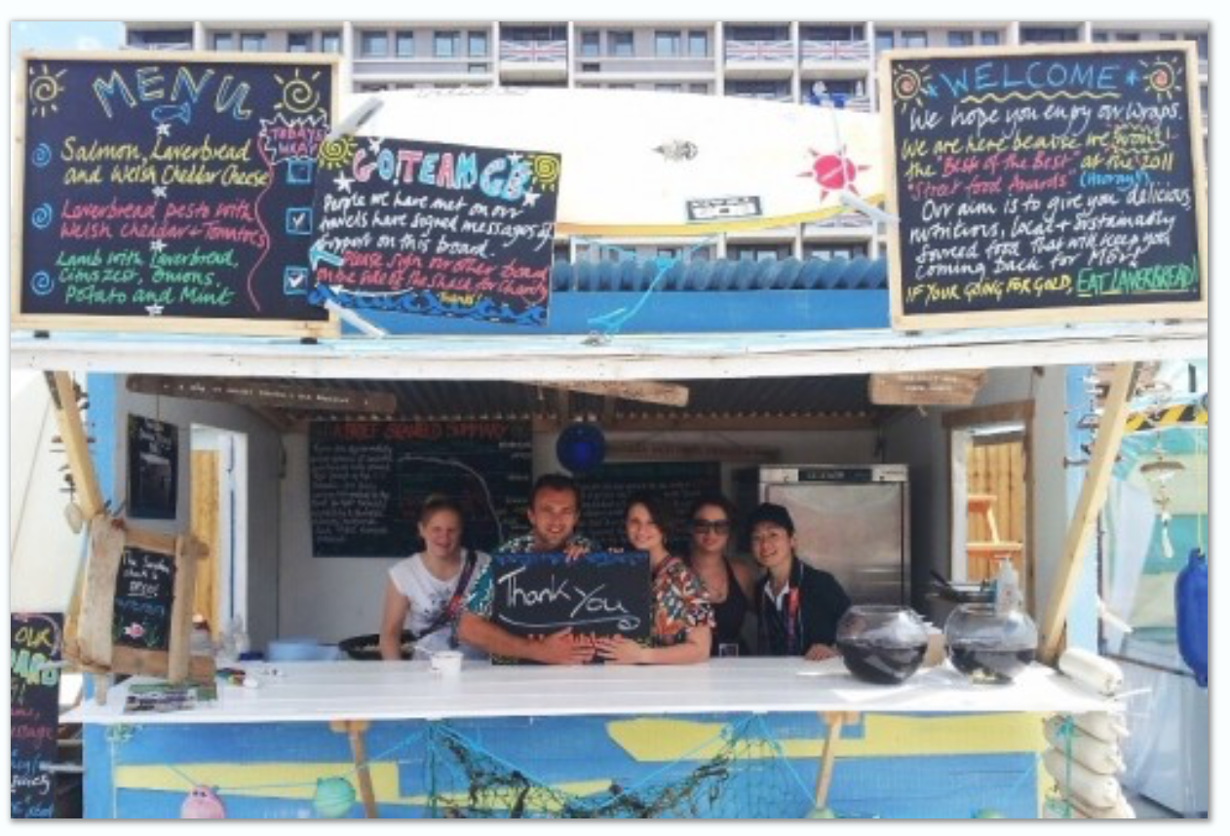
Appendix 2
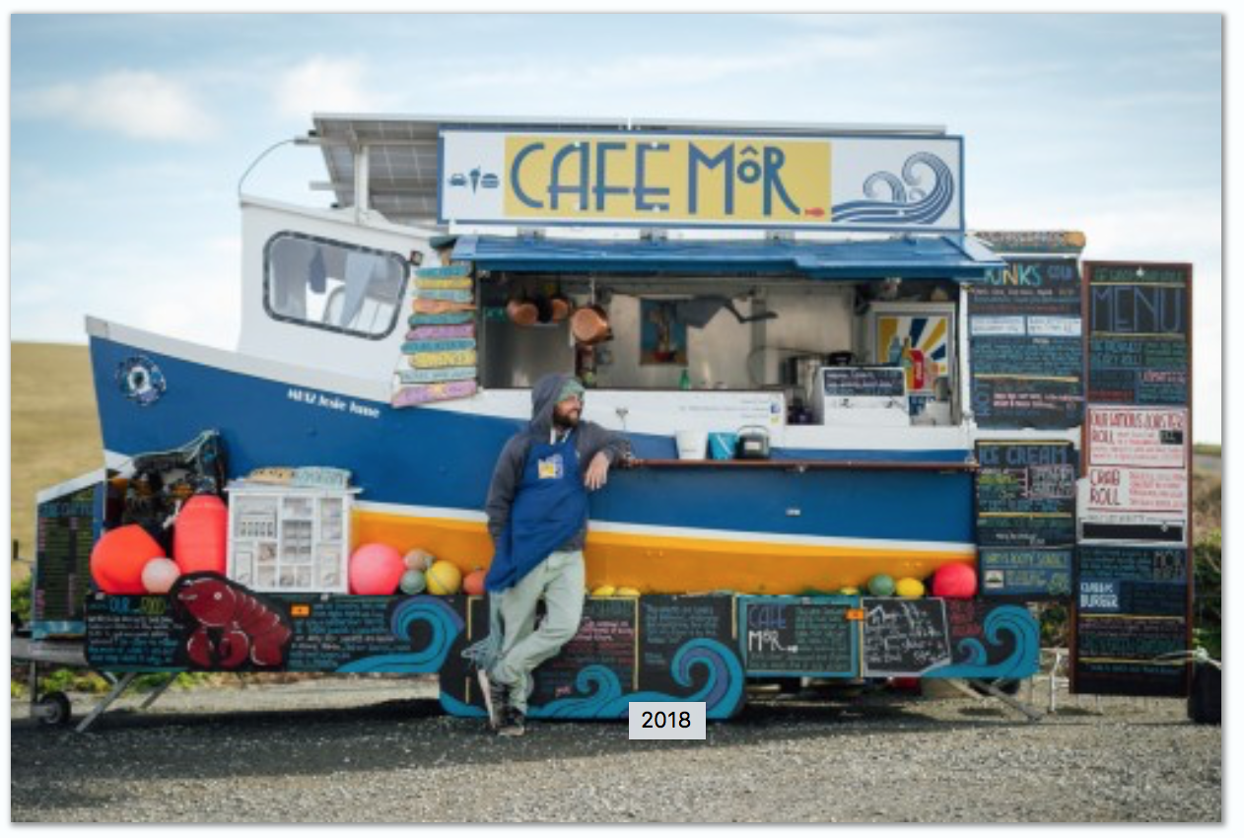

Bibliography
Beach Food (2018) Our Story. [online] available at: https://www.beachfood.co.uk/ourstory.php

Burgelman, R.A. 1983. Corporate entrepreneurship and strategic management: insight from a process study. Man. Sci. 29(12) 1349ñ1365.
Burgelman, R.A. 1984. Designs for corporate entrepreneurship in established firms. California Man. Rev. 26(3) 155 -166.

Çakar23, U., & Alakavuklar24, O. N. (2011). ECOPRENEURSHIP AS AN ETHICAL CHALLENGE. In INTERNATIONAL ENTREPRENEURSHIP CONGRESS 2011(p. 81). Izmir University of Economics.

Crompton, J. L. (1979). How to use SPSS Statistics, 6th Edition, Los Angeles, Pyrczak Publishing.
Dawson, C., & Henley, A. (2012). “Push” versus “pull” entrepreneurship: an ambiguous distinction?. International Journal of Entrepreneurial Behavior & Research, 18(6), 697-719.

Dees, J. G. (2017). 1 The Meaning of Social Entrepreneurship. In Case Studies in Social Entrepreneurship and Sustainability (pp. 34-42). Routledge.

Dennis, J. (1996), “Self-employment: when nothing else is available?”, Journal of Labour Research, Vol. 17 No. 4, pp. 645-61.

Eysenck, H. J. (1973) Eysenck on Extraversion, Crosby Lockwood Staples

MacMillan, I.C., Z. Block, P.N.S. Narashima. 1986. Corporate venturing: alternatives, obstacles encountered, and experience effects. J. Bus. Venturing 1(2) 177ó 191.
Raphael Amit & Eitan Muller (1995) “PUSH” AND “PULL” ENTREPRENEURSHIP, Journal of Small Business & Entrepreneurship, 12:4, 64-80, DOI: 10.1080/08276331.1995.10600505

Saridakis, G. and Storey, D. (2010), “UK self-employment 1973-2007: what have been the main influences on males and females”, conference paper, 33rd ISBE Conference, London, 2-4 November.
Schaltegger, S. (2002). A framework for ecopreneurship. Greener Management International, 2002(38), 45-58.Parker, S. C. (2011). Intrapreneurship or entrepreneurship? Journal of Business Venturing, 26(1), 19-34.
Smeaton, D. (2003), “Self-employed workers: calling the shots or hesitant independents? A consideration of the trends”, Work, Employment & Society, Vol. 17 No. 2, pp. 379-91

Walley, E.E.; Taylor, D.W. Opportunists, Champions, Mavericks . . .? Greener Manag. Int. 2002, 38, 31–44.
Williams, K, D. (2013) The 4 Essential Traits of Intrapreneurs. [online] Available at: https://www.forbes.com/sites/davidkwilliams/2013/10/30/the-4-essential-traits-of-intrapreneurs/#4311394051da

