Module Code: BMIH5005
Module Name: Personnel Resourcing and Development
Lecturer’s name : scott james
Student name in full : Ana Ivascu
Student ID : 2239390

Table of Content
Introduction and Background 3
Discussion/Literature 4
Socio-Economic Analysis (PESTLE Framework) 4
Industrial trends that are influenced by socio-economic factors 6
The emergence of different work models in UK hospitality over the last 5 years 7
Industry examples to manage employees’ performance in different work modes 8
Evaluation and Conclusion 9
Conclusion 9
Recommendation 9
Reference List 11

Project Proposal

Introduction and Background
Implementing different work modes in the hotel and hospitality sector becomes important for companies to foster employee engagement as well as adapting changing trends and also enhance services to meet customers’ requirements (Rabiul and Yean, 2021). Flexible work schedules, remote working, contractual working, job sharing, task-based working, developing hybrid working models and more alternate ways provide opportunities for companies in this sector to obtain overall development accordingly.
Premier Inn Limited is the largest British hotel chain corporation that works with the collaboration of Whitebread Plc in the United Kingdom. This hospitality chain company manages its business activities throughout the country with more than 900 hotels in various regions, totalling over 72,000 rooms (Premierinn, 2023). It is found that the hospitality company expands its service areas mainly in large cities, airport areas and different suburban locations to attract customers from different genres. According to estimates from The Guardian, Premier Inn successfully expectations by reporting £375 million in pre-tax profits in 2021 and 2022. Additionally, it is also identified that through expanded market operations, the company earned £58 million in 2022 which is 34% more than the total earnings of 2020 (Theguardian, 2023).
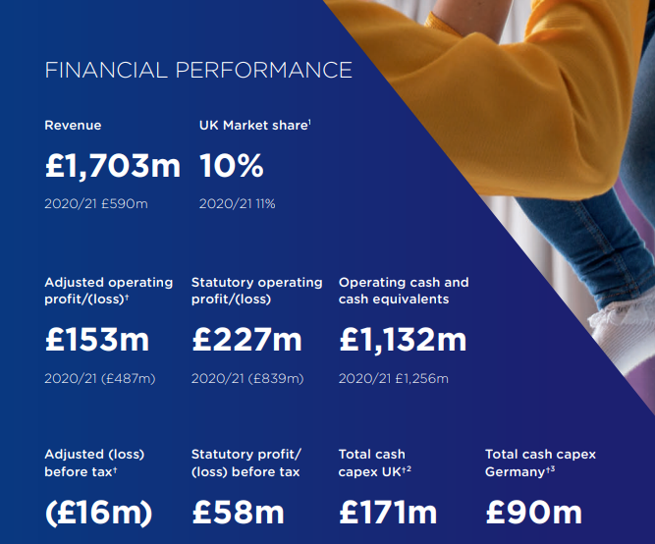
Annual Report of Premier Inn, 2022
(Source: Annualreports, 2022)
Based on the research work of Ntounis et al. (2022), it is identified that in the post-pandemic situation, companies in the global hospitality sector face different HRM issues that directly affect their employee management policies. Employee retention, changed management policies, increasing the popularity of hybrid working modes, touchless services and more factors become troublesome for contemporary hospitality companies. The Brexit and the global pandemic create economic issues for the entire hospitality sector in this current time. This project will analyse different socio-economic factors that affect the company’s growth and successful operations in the competitive environment. It can be mentioned that socioeconomic factors might impact HR management and employee monitoring in different work modes including office work arrangement, hybrid modes and others. This study will also analyse industrial trends at the current time and the emergence of different work modes in the hospitality sector in the last five years.

Discussion/Literature

Socio-Economic Analysis (PESTLE Framework)
According to the research work of Thomas et al. (2021), it is identified that evaluating and identifying socio-economic factors becomes crucial for detecting whether it will be beneficial to enter a targeted market and finding out the best alternate strategies for enhancing ongoing operation tactics in the competitive environment.
Factors | Influences | Effects
Political | The UK has a stable political environment that makes it possible to expand the market successfully. The UK government has already taken advantage of several beneficial opportunities for the tourism and hospitality industry, including free market development, hassle-free promotions, tax rebates, term loans and strategic development to strengthen its position (Thomas et al. 2021). The country maintains diplomatic connections with other countries, providing chances for hospitality companies to attract foreign customers. | Opportunity
Economic | During the global pandemic, the UK economy faced multiple challenges including a drop in per capita income with a deterioration of the public’s buying limits. Thankfully, the country’s economic position and efficiency are stable now with the proper expansion of GDP by 2.7444 trillion US dollars (World Bank, 2023). It is also found that the rate of inflation has increased to 1.94% points which indicates the developing market experiences of the country after the troublesome pandemic and Brexit situations. This situation suggests that UK citizens are now able to increase their buying limits for pricey hospitality services. | Opportunity
Social | Within a given marketplace, social features have a big impact on organisational growth. After the situation of the global pandemic, citizens of the UK market are trying to overcome socio-economic issues by involving in the country’s economic plans. On the other hand, it is also identified that the UK has a large number of educated population which helps the company to get a skilled workforce. Premier Inn, a well-known hotel brand, uses social media marketing initiatives to reach potential customers. However, the labour cost of this market is comparatively higher due to the high literacy rate. | Moderate
Technological | Digital marketing is widely identified as the most efficient and long-lasting marketing strategy for companies that enable an organisation to contact a huge number of viewers seamlessly. It has been shown that over 90% of people in the UK are technologically advanced and utilise a variety of applications in their regular lives. This stage of technological advancement helps companies in creating modern, ethical and sustainable marketing practices. | Opportunity
Legal | Premier Inn is legally required to take into account several governmental regulatory laws as a hotel and hospitality business. These regulatory requirements cover a variety of topics including maintaining fair employment practices, tracking visitor records, and maintaining order. Due to rigorous standards of legal factors, companies face challenges in some specific areas in the UK market. | Threat
Environmental | Premier Inn generates industrial waste each day from its various locations, both connected to tourism and residential use. The government targets to minimise the overall wastage generation by 33% by 2025 (Casañ et al. 2021). The corporation needs to adhere to stringent environmental requirements to meet regulatory targets. | Threat

Industrial trends that are influenced by socio-economic factors
Financial Trends: Based on the research work of Clark et al. (2021), it is identified that the significant contribution that the travel and tourism sector makes to the national economy of the UK. In the same study, it is also identified that before the pandemic time, the tourism sector helped the domestic budget by £234.5 billion. Despite the significant decline in 2020, the criterion showed a positive trend in 2021, even though £131.5 billion was twice before the pandemic time. The national tourist agency aims that the UK tourism industry will be valued at £257 billion by 2025.
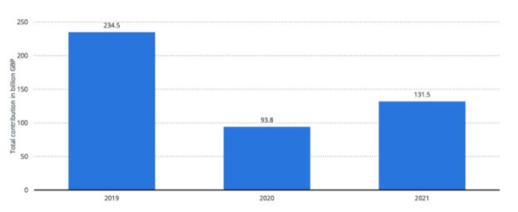
Total contribution of travel and tourism to GDP in the UK in 2019 and 2022
(Source: Statista, 2023)
Retention and Turnover Rate Trends: According to the research work of Statista, it is identified that the turnover rate of the UK tourism sector is very high and it is also identified that nearly 37.6% of employees in this sector leave their jobs each year (Statista, 2023). From the research work of the UK's famous hospitality management organisation Hospitalitynet, it is found that in 2023, after the pandemic turbulence, the employment rates in the hospitality sector in the UK have increased. 46% of hospitality jobs are increased. However, due to complex market situations, 42% of newly joined employees leave their jobs within 90 days (Hospitalitynet, 2023). Currently, the government and individual companies are taking serious steps to minimise the employee turnover rate in this industry by increasing various job opportunities.
Globalisation and Digitalisation: Due to the world's growing interconnectedness, the overall rates of international tourism have increased. Based on the study by Kim (2020), it is found that as more visitors travel across the globe for multiple purposes, the tourism sector has gained from this trend. Different UK-based tourism companies provide multiple offers to individuals which increases the trends of globalisation in the tourism industry. On the other side, due to the development of technologies, many companies take direct support from digital technologies to reach potential customers including social media accounts, internet booking platforms and others.

The emergence of different work models in UK hospitality over the last 5 years
- Flexible Schedules: Due to constant pressures on employee retention rates, companies in the UK hospitality sector are forced to adopt the flexible work schedule strategy and it has become a popular trend in this industry in the last 5 years. Employers in the hospitality industry are implementing more flexible scheduling policies to meet the needs of balancing work-life for their employees (Chung et al. 2021). Along with permanent employment, companies in this sector also focus on part-time, freelancing and seasonal work modes to make employees’ work schedules flexible.
- Remote Working: Although remote working was not familiar to the hospitality industry in the past decade, it became popular after the COVID scenario. Today, most companies allow remote working to some administrative, marketing, finance and business planning employees which was totally not popular in this sector for five years.
- Gig Economy Platforms: Based on the findings of Montgomery and Baglioni (2021), it is identified that the concept of Gig Economy Platforms has become popular in the last five years. Like other sectors, the hospitality industry has witnessed the growth of platforms in the Gig economy that link independent contractors or freelancers with temporary work openings. It is found that these platforms serve both individuals seeking favourable and flexible work arrangements by providing opportunities for workers to select their locations and shifts.

Industry examples to manage employees’ performance in different work modes
The hospitality industry focuses on improving employee performance to develop the quality of guest service and increase communication with potential customers by providing innovative solutions in different work modes. Different renowned hotel brands have focused on improving the efficiency of employees in different work modes including hybrid and remote work in the post-COVID-19 situation. According to Kaushik (2020), in the hospitality sector of the UK, 88% of organisations introduced new methods of employee performance management in hybrid and remote environments. For example, As per the report of Marriott (2020), Marriott has introduced a new digital platform ‘My Marriott Hospitality’ to manage employees in remote and hybrid working harming to control their performance across 8000 global hotel chains. The platform has encouraged around 50% of its managers to improve their virtual performance to improve communication and provide real-time feedback to improve the efficiency of workers (Marriott, 2020).
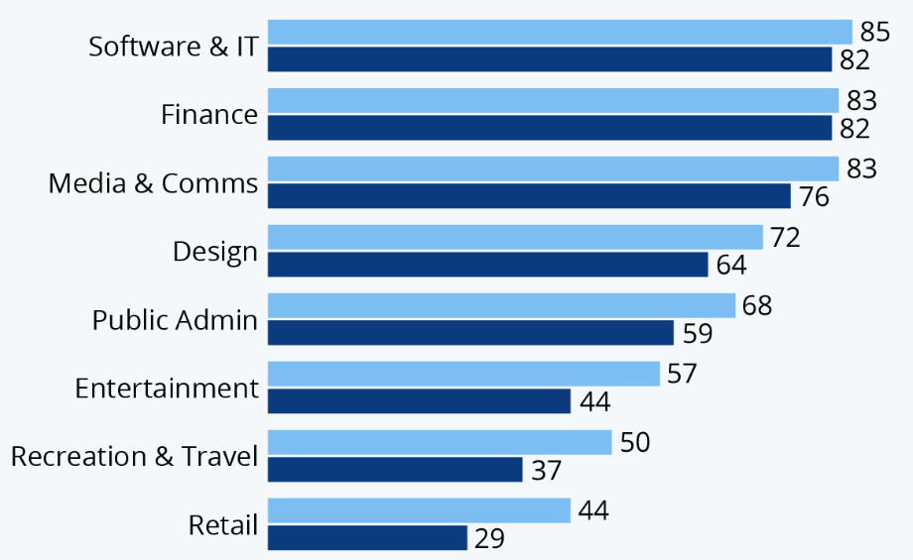
Figure: Infographic: Which Industries Are Best Geared Towards Remote Working?
(Source: Statista, 2020)
On the other hand, as reported by Radisson (2024), the Radisson Hotel Group has developed the ‘Radisson People Pulse’ program to monitor the performance of over 94,000 employees in more than 1100 hotels across the world. This program shows that 20% of employees improve their performance with proper coaching which helps to increase employee engagement by 12% in the hybrid work mode. According to Premier Inn (2024), Another example from the UK hospitality industry is Premier Inn which adopted Microsoft Viva to improve the performance of 47,000 as it introduced a 65% Hybrid work mode to maintain flexibility in the organisation. These digital solutions help to integrate collaboration and productivity of employees in different work notes to improve the reputation of Hotel brands in the competitive market.

Evaluation and Conclusion

Conclusion
From the study, it can be concluded that during the pandemic time, activities of the hospitality sector were totally paused. In current days, overcoming former financial loss becomes challenging. On the other hand, the buying limits of customers are affected by the pandemic scenario. It can be also inferred from the study that due to the changes in the industrial sector, being a large company, Premier Inn also considered different market-wise situations in their activities to develop effective employee engagement strategies that can be supported by socio-economic changes in the external market.

Recommendation
After completing the study, it can be recommended that the company consider the social and technological development of the market and establish effective plans to enhance business operations. By considering digital marketing, and utilisation of automation in customer services and promotions, the company might get socio-economic opportunities because customers in this current situation focus on digital support programs.
It can be also mentioned the company to consider hybrid working models with flexibility for employees. So that they can enjoy their working time and engage in work both from the office and remote locations accordingly. Implementing gig economy platforms will be also beneficial for the company to increase employee engagement rates in changed socio-economic scenarios.
Upskilling along with career progress will be also beneficial for Premier Inn to enhance the working level of employees to face multiple industrial changes. Moreover, it can be also recommended to the firm that it needs to focus on employees’ skill gaps and overcome their lacks through proper training programs.

Reference List

