SWOT Analysis

Introduction
SWOT analysis is a technique used to map out the Strengths, Weaknesses, Opportunities and Threats of a situation. It is often used to assess a business situation and this simple but powerful exercise will help you to build on the strengths of your organisation and to seize opportunities presented.
This exercise first asks you to reflect on things you feel the organisation has achieved. From this you’ll be able to identify some of the organisation’s strengths and weaknesses. To help you think about threats and opportunities, you are asked to describe areas of your workplace where changes are needed or issues need to be addressed.

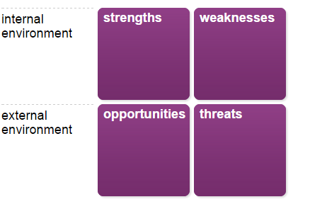

Stage 1 of 7
Organisational achievements and target areas
Before you start, spend some time thinking about your organisation’s achievements over the last two to three years, or longer if that is relevant. Also, think about the future and what aspects of your workplace need to be developed or changed. Your notes here will help you identify strengths and weaknesses in the stages that follow.
Your achievements
Make a note of up to three achievements where you feel the organisation has made important contributions.
Achievement 1

Achievement 2

Achievement 3

Organisational target areas
Describe up to three areas of your workplace where the organisation would like to achieve something, or make a change.

Target area 1

Target area 2

Target area 3

Stage 2 of 7
Guidance
For each achievement ask yourself:
- How did your organisation stand out from the others?
- What skills and knowledge does the organisation demonstrate effectively?

Organisational

strengths

Record specific strengths which enabled the organisation to make a contribution in each situation. You might want to ask others for feedback on what they see as the organisation’s strengths. Focus on the key skills, knowledge and attitudes demonstrated.

Your strengths
Strength 1

Strength 2

Strength 3

Record any other strengths

Are there any other strengths you would like to record?

Stage 3 of 7

Organisational weaknesses
Guidance
For each aspect ask yourself:
- What did the organisation need to do better in this situation?
- What skills and knowledge do you need to improve?
- What weaknesses did others identify in your organisation?

Record any weaknesses you observed in your organisation in each situation or elsewhere. These may be development points identified by yourself or others or feedback you have received.

Your weaknesses
Weakness 1

Weakness 2

Weakness 3

Record any other Weaknesses

What do you avoid doing because you don’t feel confident about the organisation, or because you know they are things the organisation are not good at?

Stage 4 of 7

Your opportunities
Guidance
For each target area ask yourself:
- What changes in your organisation or working environment might create an opportunity in this target area?
- What new trends, services of products are emerging in your field of work which might help you achieve in this target area?
- What changes in your organisational circumstances present an opportunity to achieve in this target area?

Consider the change and development 'target areas' you have selected. Record any opportunities that are emerging in your current situation which could help your organisation achieve or make a change in these areas. Remember to think broadly across the whole of your organisation, sector and life outside work, not just your immediate job and team.

Your opportunities
Opportunity 1

Opportunity 2

Opportunity 3

Record any other Opportunities

Stage 5 of 7

Your threats
Guidance
For each target area ask yourself:
- What changes in your organisation or working environment might prevent you from achieving in this target area?
- What new trends, services of products are emerging in your field of work which might make it more difficult to achieve in this target area?

Now think about barriers or constraints which might prevent you achieving in the 'target areas' you have selected and record them.

Your threats
Threat 1

Threat 2

Threat 3

Record any other threats

Stage 6 of 7

Building on your strengths

Review your strengths, listed earlier. Then note down what you might do to take advantage of the opportunities and confront the threats you have identified, building on the strengths you have. You will have the chance to review your weaknesses later.

Your strategy
- How can you exploit the opportunities you have identified by building on your strengths?
- How can you confront the threats in your environment by using your strengths?

Stage 7 of 7

Minimising your weaknesses

Review your weaknesses identified earlier. Then note down what you might do to minimise their impact when choosing the opportunities and avoiding the threats you have identified.
Your strategy
- How can you ensure these opportunities are not derailed by your weaknesses?
- Which of these threats is biggest, given your weaknesses?

