Project Management Assignment

Christine Woods 1704446

Susan Maw

School of Applied Computing

University of Wales Trinity Saint David

Submission Date – 13.11.18

Declaration by Christine Woods

The work of this report completed under the supervision of Susan Maw. I declare that this report is the product of my own work and is not being submitted for any other degree etc.



Acknowledgments
- Susan Maw – Lecturer University of Wales Trinity St David
- Silvia Settle – Student
- Matthew Stokes – Student
- Lwys Davies – Student

Introduction

In the event of a natural disaster, Health Care is not only over run and unable to deal with the volume of new injuries in emergency departments, but also on-going care is affected [1]. Currently there is no system in place to direct patients to the correct care settings/medicine availability.
Hospital services become over run with patients not knowing where to go or who to contact in the event they need care. The problem is not just about the injuries directly caused by the disaster but ongoing medical needs that also need addressing. Survivors need a centralised database showing availability of resources that is easily accessible.
This will be an aid to the government who will fully fund the project.

Purpose

C.A.L.M.E.R database system will allocate care settings, resources/services and staff where patient care can be continued in the event of a disaster.

Contents
Centralised Alignment of Local Medication and Emergency Resources (C.A.L.M.E.R) Project initiation Document. 6
1.) SMART Objectives: 6
1.1) Database 6
1.2) Drinking Water 6
1.3) Direction for Health Care needs 6
1.4) Stop medication wastage 6
1.5) Health Care staff 6
1.6) Arrange transport 7
2.Scope: 7
2.1) Categories/care setting: 7
2.2) What is not included: 7
3.Assumptions: 8
4.Authority: 8
5.Resources: 8
6.Constraints: 8
7.Project Benefits: 9
8.Options: 9
9.Responsibility: 9
10.Cost and Timescale: 10
11.Cost/Benefit analysis: 10
12. Risk analysis: Identify, assess, respond and control. 10
13. Project plan 10
14. References 11
15. Appendix 12

Centralised Alignment of Local Medication and Emergency Resources (C.A.L.M.E.R) Project initiation Document.

1.) SMART Objectives: [2] (Appendix 2)

) Database

Create a database providing direction for patients to access resources including direction to required care settings. Measurable by keeping count of all the patients that turn up to the care settings and how busy the emergency departments are.

1.2) Drinking Water

Provide direction to clean drinking water. Measured by the amount of water bottles disseminated.

1.3) Direction for Health Care needs

Provide direction to a healthy care setting for patients that need to continue with previous conditions. Measured by the amount of people that visit the care centres for treatment.

1.4) Stop medication wastage

Stop medication being delivered to the wrong areas and being unused. The centralisation of treatment centres will ensure that medicine is delivered and managed in the correct way.

1.5) Health Care staff

Direct professional health care staff to the correct care setting so that areas requiring specialised skills are correctly staffed.

1.6) Arrange transport

Provide information regarding transport (In the event that local transport is not available)

2.Scope:

Set up a database in Tableau using the style of a map that will show filtered categories for a small area with view to enlarging. Users will be able to access this through centralised hubs along with an application on mobile telephone handsets.

Storm/Fire/Earthquake/Volcanoes/Flooding/Hurricanes/Gales/Tidal Waves/Drought or other disaster related emergency injuries – all to be directed to the main emergency departments.

2.1) Categories/care setting:

- GP/Acute triage setting (walking wounded)
- Medication shortages (In the event Pharmacy will not be available)
- Non-functioning home medical equipment (Power outages i.e. ventilators)
- Exacerbation of chronic disease (i.e. diabetes/asthma/oxygen)
- Medication needs (ongoing conditions)
- Vulnerability issues (lower socioeconomic status, pregnancy, aged, mental health, and infants/children, mental health needs)
- Dialysis needs
- Dedicated areas for clean water supplies/hot food/shelter

2.2) What is not included:

- Rotas/Scheduling of staff
- Medical records for patients
- Transport infrastructure for patients and supplies
- Hand held devices (mobile phones will be able to access the application)
- Arrangement of deliveries for medication/resources (although agreements will be made with the forces/relevant suppliers)

3.Assumptions:

- The cloud/internet will be accessible
- Logistics (Care Settings) - pre-arranged with local council
- Staffing arrangements - pre-assigned through local health boards
- Transport - pre-arranged (by local services/forces)
- Medication deliveries - pre-arranged (by local businesses/forces)
- In the event of a large disaster it will be presumed that the government will provide food, water, transport, communications, medication and other necessary survival resources via the forces.

4.Authority:

- Sponsor: Local Authority/Government. Heads of local authority.
- Project Manager: Sue Maw
- Project Organisation Chart/Structure (Appendix 3)
- Stakeholders (Appendix 1)

5.Resources:

- Team members
- Software requirements (Tableau, Microsoft 365)
- Hardware requirements (During design and roll-out)
- Local information (data)
- Agreements (Local Health Boards/Forces)
- Medications/Equipment
- Health care professionals

6.Constraints:

- System updates/key holders
- Power outage/H.A.L.O. access
- Scale of disaster
- Accessibility
- Timescale

7.Project Benefits:

- Accident and Emergency centres will not be over crowded
- Patients will be directed to the correct care setting immediately
- Resources can be directed to the required places
- Staff will be directed to the necessary areas ensuring the availability of service
- Security staff will be minimalised having areas designated to securing certain medicines
- The correct equipment will be in the correct areas saving valuable treatment time
- Patients can see where they need to be and how they are going to get there

8.Options:

- A map showing areas with any major damage
- Details of how to order more supplies
- Inclusion of a database of missing/found persons

9.Responsibility:

- Project Managers – responsible for the overview of the project within the designated areas
- Stakeholders – responsible for data input (Appendix 1)
- Project Team – delivery and usability
- Project Team – updates and functionality

10.Cost and Timescale:

- Initial set up cost would be the hours that the database takes to build along with time for meetings and project management
- Costs ensuring access to Tableau/Server (H.A.L.O)
- Management of system
- System updates

11.Cost/Benefit analysis:

- Freeing up unnecessary patient visits to the emergency areas
- Delivering supplies to all areas rather than a main central drop off
- Dedicated specialist areas allowing for equipment to be utilised fully

12. Risk analysis: Identify, assess, respond and control.

- System failure
- Staffing issues – unable to attend designated areas
- Power outage
- Stakeholders unable to agree on system requirements
- Staff illness
- Resources unavailable
- No backing from the forces
- Technology changes
- Project tasks over running/not being completed/real time performance
- Public awareness of the resources/direction available
- Patients cannot access the system/robustness

See Appendix 4 [3]

13. Project plan

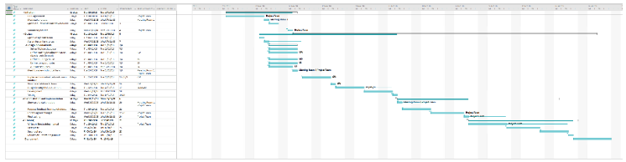

The project plan has been compiled in Microsoft office. The project plan lays out the timeline for all tasks within this project to ensure the project will finish on schedule, define any overlapping activities and show the task dependencies. [4] (Appendix 5 for enlarged versions).

14. References

[1] | K. Joy, “Ripple effect - How hurricanes and other disasters affect hosptial care,” 11 September 2017. [Online]. Available: https://labblog.uofmhealth.org/industry-dx/ripple-effect-how-hurricanes-and-other-disasters-affect-hospital-care. [Accessed 6 September 2018].
[2] | S. Maw, Intoduction Power Point, Swansea: Sue Maw, 2018.
[3] | A. B. Consortium, “MoSCoW Prioritisation,” DSDMAtern Handbook, 2008. [Online]. Available: https://www.agilebusiness.org/content/moscow-prioritisation-0. [Accessed 10 November 2018].
[4] | P. Hub, “How to use Gantt chart to kick start a project like a boss,” 24 July 2018. [Online]. Available: https://www.proofhub.com/articles/uses-of-gantt-chart. [Accessed 10 November 2018].

15. Appendix

Appendix 1. Stakeholder Table

Appendix 2. SMART objectives
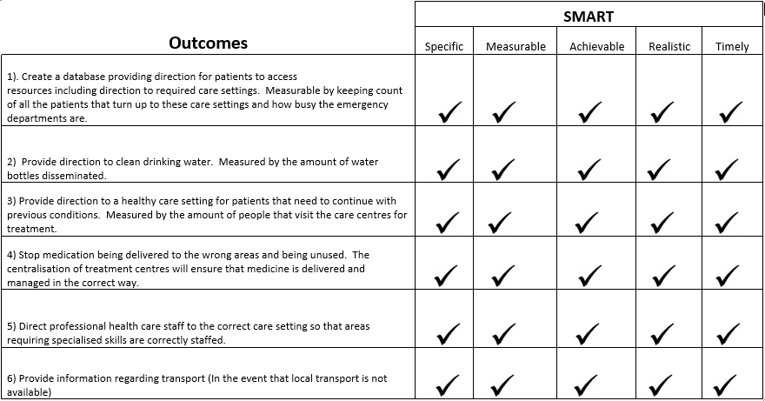

Appendix 3. Project structure

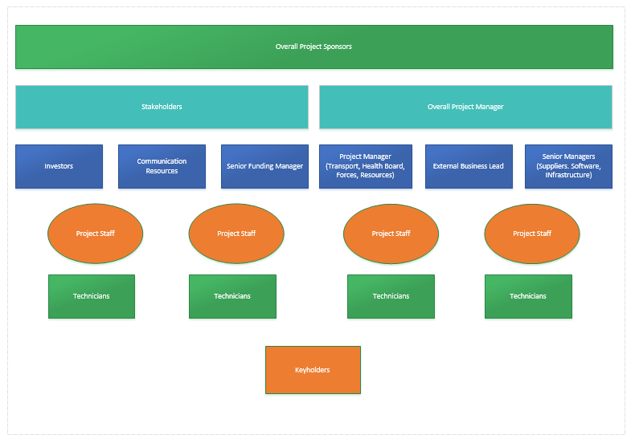

Appendix 4. Risk analysis

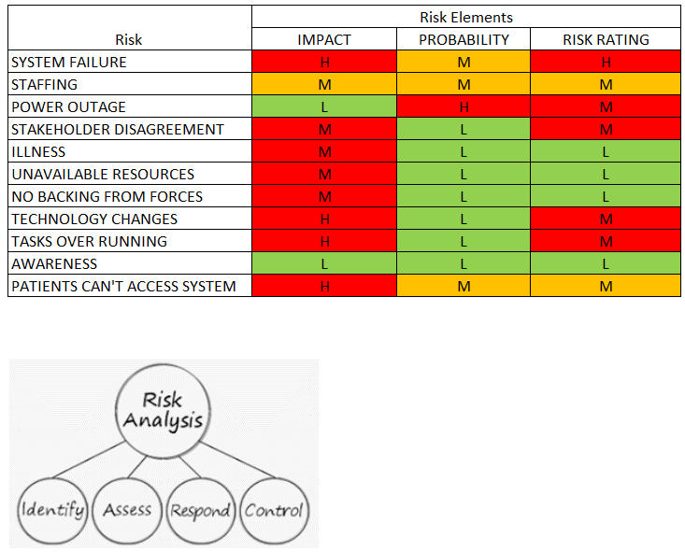

Appendix 5. Project Plan.



