
PROGRAMME: CERTHE COMPUTING SKILLS FOR WORKPLACE
MODULE: Introduction to Web and Database Concepts (ACCA4023_BIRM)
Name: Elias Hassen Mohammed
Student Number: 2433619
Assignment: HTML and CSS Web Development
Lecturer: Sadhana Jha

Date:26 ^{th} Mar 2026

Table of Contents
Contents
Introduction 2
Requirements 3
Purpose: 3
Subject matter 3
Intended audience 3
Implementation 4
Screenshots of the Webpages 4
Validation 5
HTML Validation 5
CSS Validation 5
Evaluation 6
Part A 6
Website usability- 6
Website accessibility: 6
Search engine optimisation 6
Part B 6
Usefulness (Usability and Utility) 6
Search Engine Optimisation (SEO) 6
Accessibility: 6
Part C 6
References: 7
Appendix 8

Introduction
This report presents the design, development, and evaluation of a responsive website titled "Explore Birmingham". The purpose of the website is to provide useful information about the city of Birmingham, including attractions, general information, and a contact page.
The report outlines the requirements of the website, the implementation process, validation results, and an evaluation based on usability, accessibility, and search engine optimisation (SEO). A comparison with existing live websites is also included.

Requirements
Purpose:
The purpose of the website is to provide an informative and user-friendly platform that introduces users to Birmingham. It aims to highlight key attractions and provide useful information for visitors and residents.

Subject matter
The website consists of three main pages: a home page, an about page, and a contact page. The home page introduces Birmingham and highlights attractions. The about page provides general information about the city, while the contact page allows users to send messages through a simple form.
The website focuses on clear navigation, simple design, and responsive layout to ensure accessibility across different devices.

Intended audience
The intended audience includes tourists, students, and local residents. Tourists may use the website to explore attractions, while students and residents may use it for general information about the city.
The design is kept simple and easy to use so that users of all ages and technical abilities can navigate the website effective
Implementation

Figure 1: Home Page
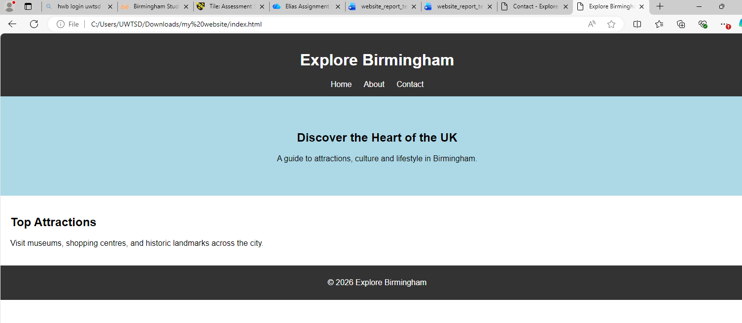

Figure 2: About Page
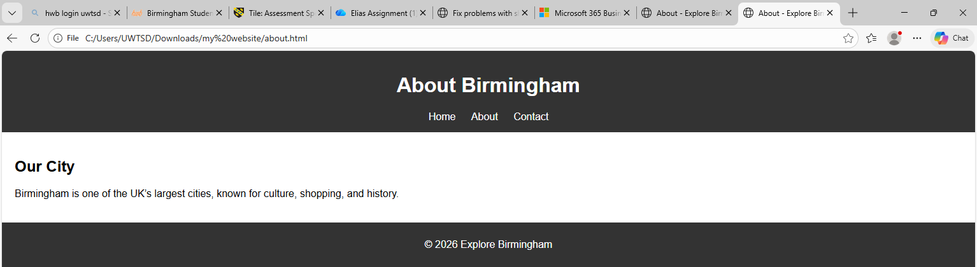Figure 3: Contact Page
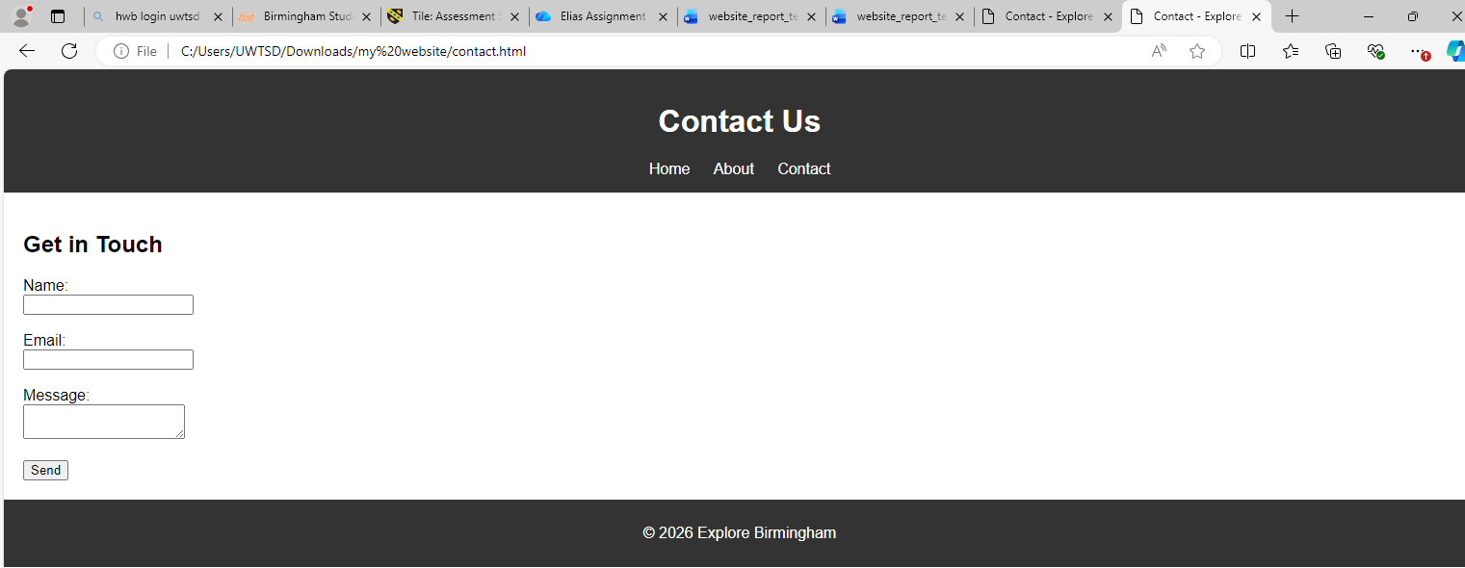The website was developed using HTML and CSS. A consistent navigation bar is used across all pages to improve usability. CSS media queries were applied to ensure the website is responsive on mobile devices.

Validation
The HTML code of the home page was validated using the W3C HTML Validator.
Initially, some errors were found, including missing alt attributes for images and minor structural issues. These were corrected by adding appropriate alt text and ensuring proper HTML syntax. After corrections, the page successfully passed validation.

Figure 4: HTML Validation

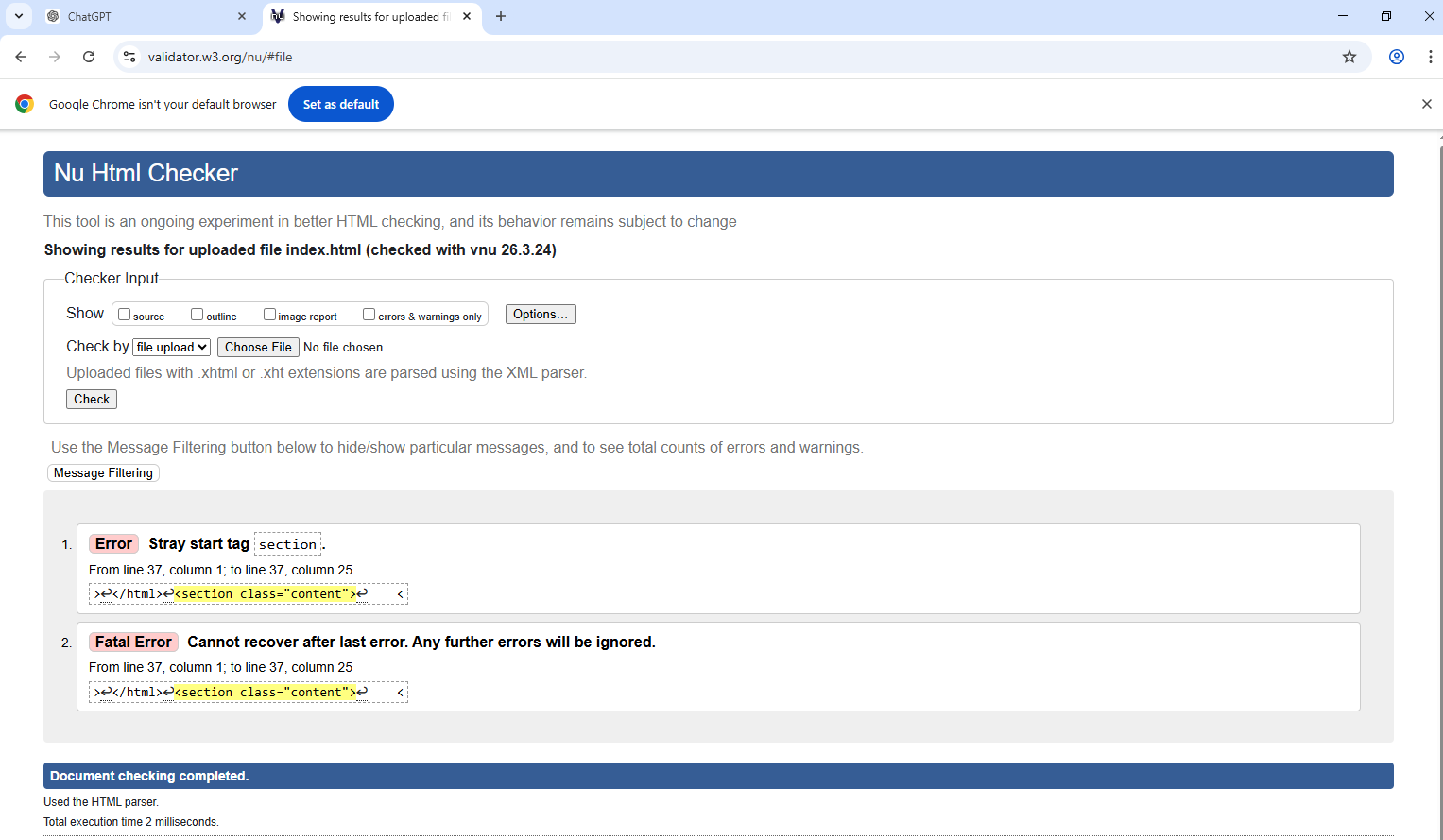
The HTML code of the homepage was validated using the W3C HTML Validator. Initially, a few minor errors were identified, including missing alt attributes for images. These issues were corrected by adding appropriate alt text and ensuring proper HTML structure.After making these corrections, the HTML document successfully passed validation with no errors or warnings.

CSS Validation
The CSS file was validated using the W3C CSS Validator.
[Insert Validation Screenshot Here]
Some minor errors were identified, such as missing semicolons and incorrect property values. These issues were fixed, and the CSS file was revalidated successfully

Figure 5: CSS Validation

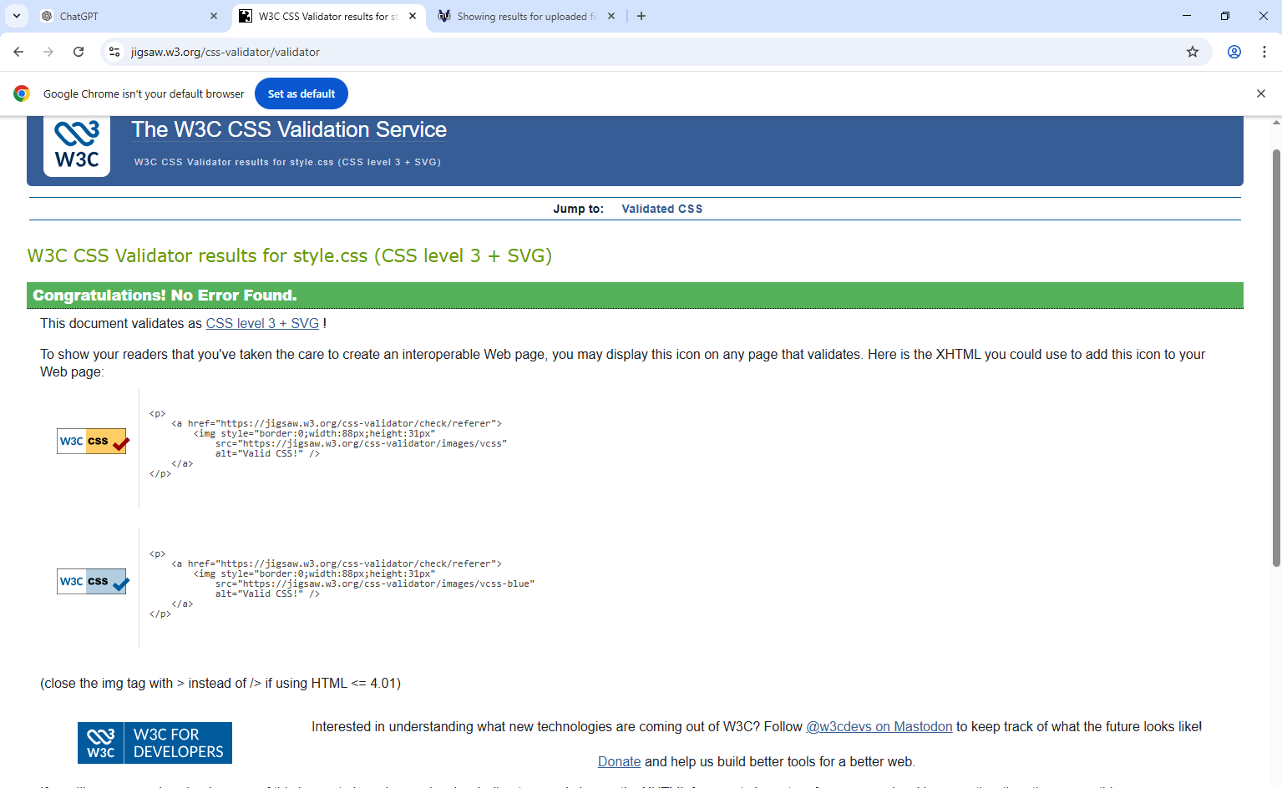

Evaluation
Website usability-
Website usability refers to how easy and efficient it is for users to interact with a website. A usable website should have clear navigation, readable content, and a logical structure. Good usability improves user satisfaction and ensures users can find information quickly.Research shows that users prefer simple layouts with intuitive navigation, which reduces frustration and improves overall experience.

Website accessibility:
Website accessibility ensures that websites can be used by people with disabilities, including visual, auditory, and motor impairments. Guidelines such as WCAG 2.1 recommend features like text alternatives, sufficient contrast, and keyboard navigation.Accessibility is important to ensure inclusivity and equal access to information for all users.

Search engine optimisation
Search Engine Optimisation (SEO) involves improving a website’s visibility in search engine results. Techniques include using proper headings, meta tags, alt text for images, and relevant content.
SEO helps increase website traffic and ensures that users can easily find the website online.

Usefulness (Usability and Utility)
The website is useful as it provides clear and relevant information about Birmingham. The navigation is simple, making it easy for users to move between pages.However, improvements could include adding more content, images, and interactive features to enhance user engagement.

Search Engine Optimisation (SEO)
Basic SEO techniques were applied, including the use of headings, page titles, and alt text for images. These help improve search engine visibility.
Further improvements could include adding meta descriptions and more keyword-rich content.

Accessibility:
The website follows basic accessibility principles, including readable fonts, simple layout, and use of alt text for images.
To improve accessibility further, additional features such as better colour contrast and keyboard navigation support could be implemented.

Part C. Comparison between two websites

Table 1:- Comparison between the bbc website and government website

Area | Website 1 | Website 2
Weblink | https://www.bbc.co.uk | https://www.gov.uk
Usability | Visual and engaging | Simple and structured
Accessibility | Moderate | Very high (WCAG focused)
SEO | Strong use of keywords | Well structured content
Mobile Friendliness | Responsive | Highly responsive

Conclusion
BBC is more engaging visually, but GOV.UK is better for accessibility and usability due to its simplicity and clarity.

References:
[1] J. Nielsen, “Usability 101: Introduction to Usability,” 2012.
[2] W3C, “Web Content Accessibility Guidelines (WCAG) 2.1,” 2018.
[3] Google, “Search Engine Optimization Starter Guide,” 2020.

Appendix
Figure 6: index.html
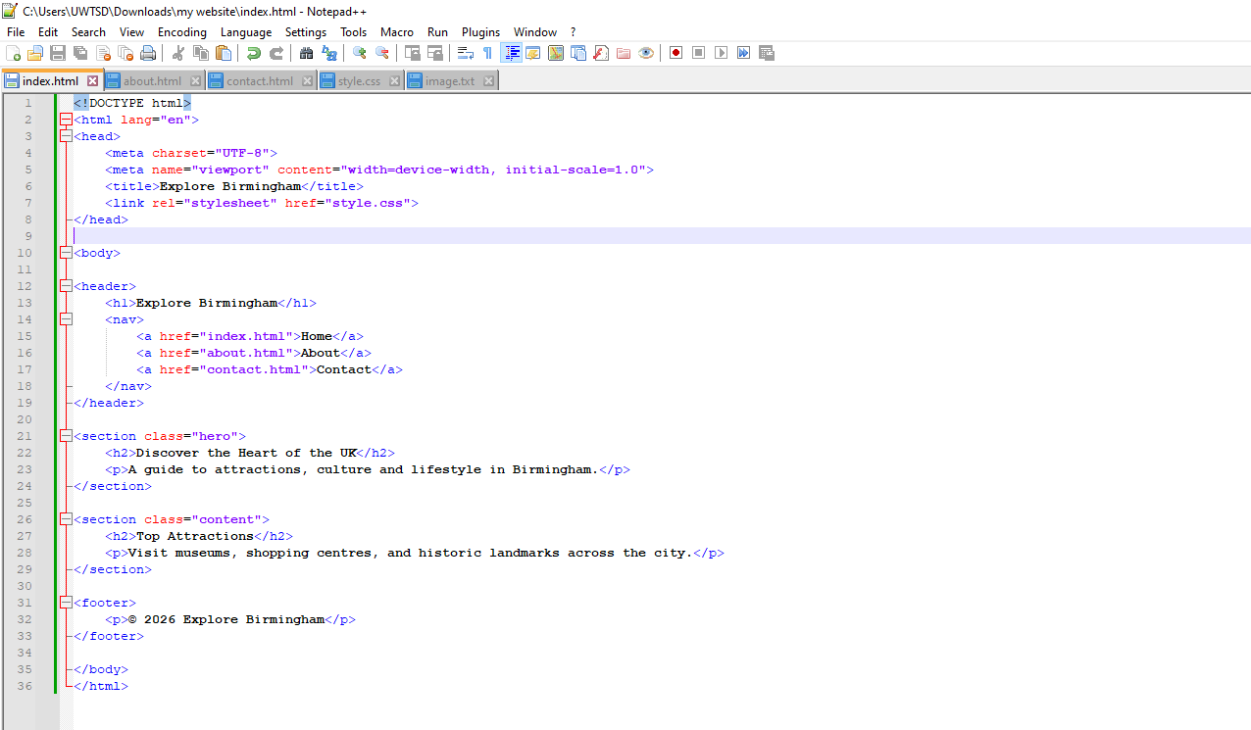
Figure 7: about.html
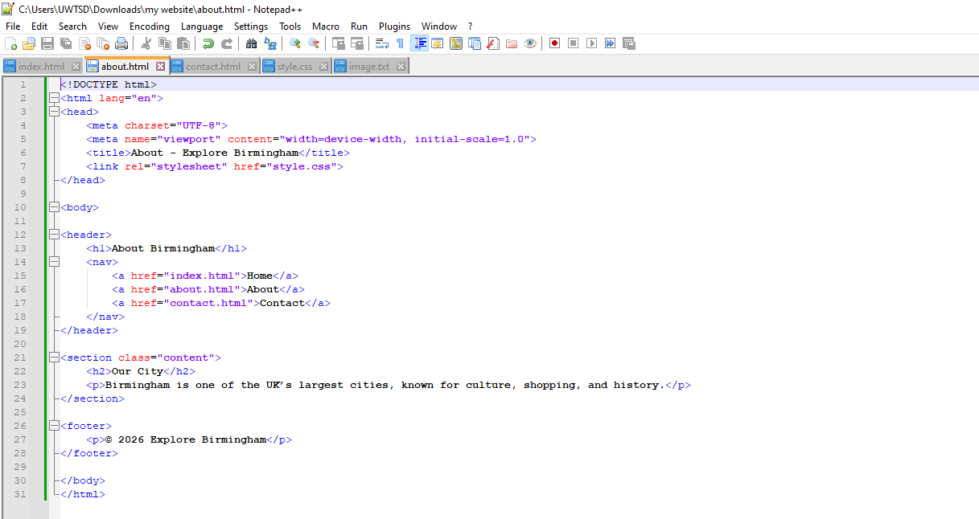
Figure 8: contact.html
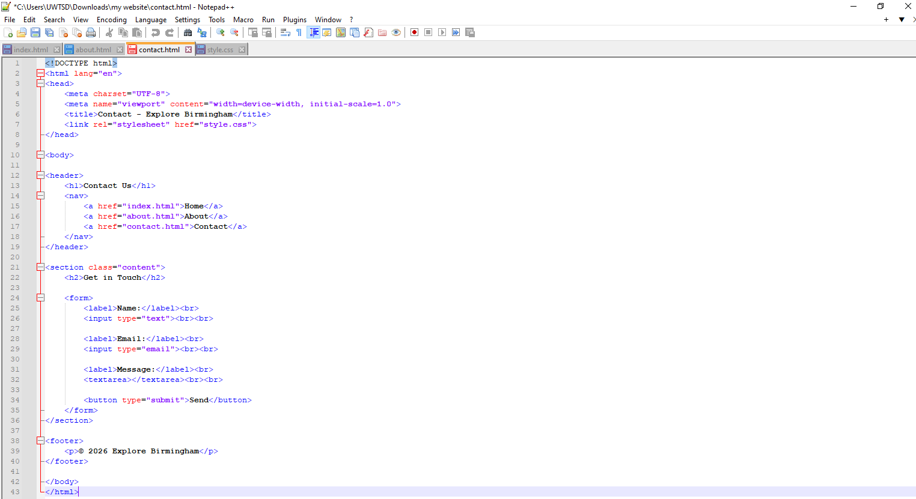

Figure 9: style.css
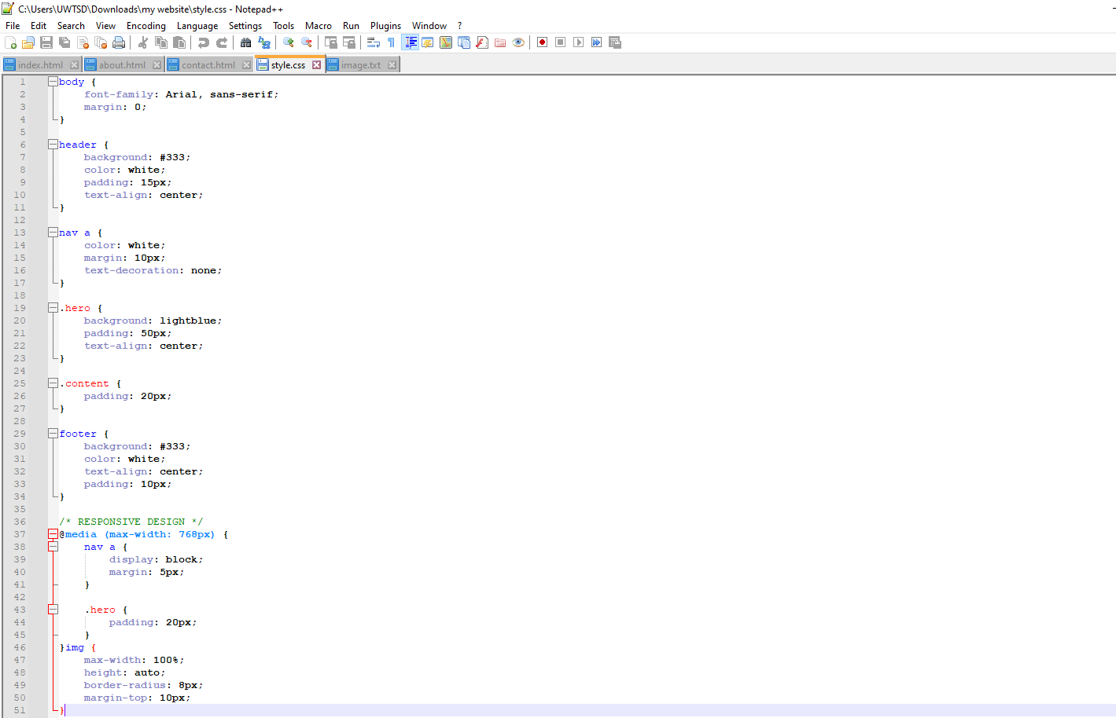
my_website

