
Date: 05 January 2022
Module code: BMHP6006
Student name: Ana Maria Stanciu
Student ID: 1909953
Lecturer: Bianca Sanfilippo
Mental Disorders and Psychopathology
Assessment 2

Table of Contents
Introduction 2
Anxiety 2
Schizophrenia 6
Autism 10
Conclusion 13
Reference list: 14
Appendix 16

Introduction

Mental Health has a negative influence on someone's life making it complicated in many ways. The velocity of the information transmission, gaps between nations and the prospects have increased making it harder for people to cope therefore becoming frustrated (WHO, 2001).
The following report will analyse important elements of anxiety, schizophrenia, and autism spectrum disorders.

Anxiety

The individual's feelings of uncertainty, nervousness, apprehension about something that will occur can be interpreted as anxiety (Anxiety UK, 2012).

From time to time all humans or almost everyone has experienced anxiety when faced with complicated or frightening circumstances and that can be normal and healthy because it can help people prepare for circumstances in time and therefore be more prosperous (Anxiety UK, 2012).
Regardless, anxiety can come to be overwhelming and serious that will impact everyday achievements and life in general making an impact on someone's emotions, feeling nervous most times compared to everyone else around them. At this stage, one is considered to suffer from an anxiety disorder (Anxiety UK, 2012).
There are various classifications of anxiety disorders (general anxiety disorder, phobias, obsessive-compulsive disorder, panic attack, social anxiety disorder) all retaining anxiety signs at their core (Anxiety UK, 2012).

Anxiety can be found in chapter five “Mental and behavioural disorders” (F40-F48) under “Neurotic, stress-related and somatoform disorders” of ICD-10 which is the 2010 version of the multinational disorder statistical model used to evaluate diseases internationally (WHO, 2010).

Furthermore, anxiety is the world-largest mental health disorder that affects approximately 3.6% of the world population with a higher preponderance among women of all ages as can be seen in Figure 1. (4.6 % women 2.6% men) (WHO, 2017). Figure 2. however, illustrates the anxiety preponderance by countries as it can be seen American countries have the highest prevalence of anxiety disorders among people in the world (WHO, 2017).

  - Figure 1. Worldwide preponderance of anxiety.

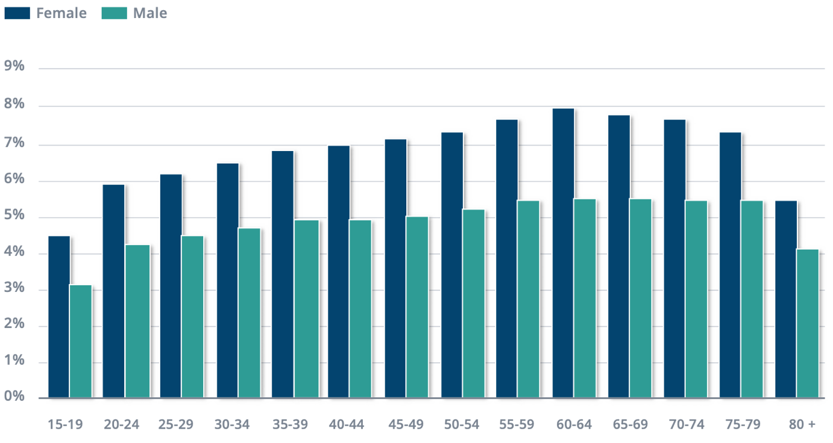
Source: https://apps.who.int/iris/bitstream/handle/10665/254610/WHO-MSD-MER-2017.2-eng.pdf.

  - Figure 2. Preponderance of anxiety by the world regions.

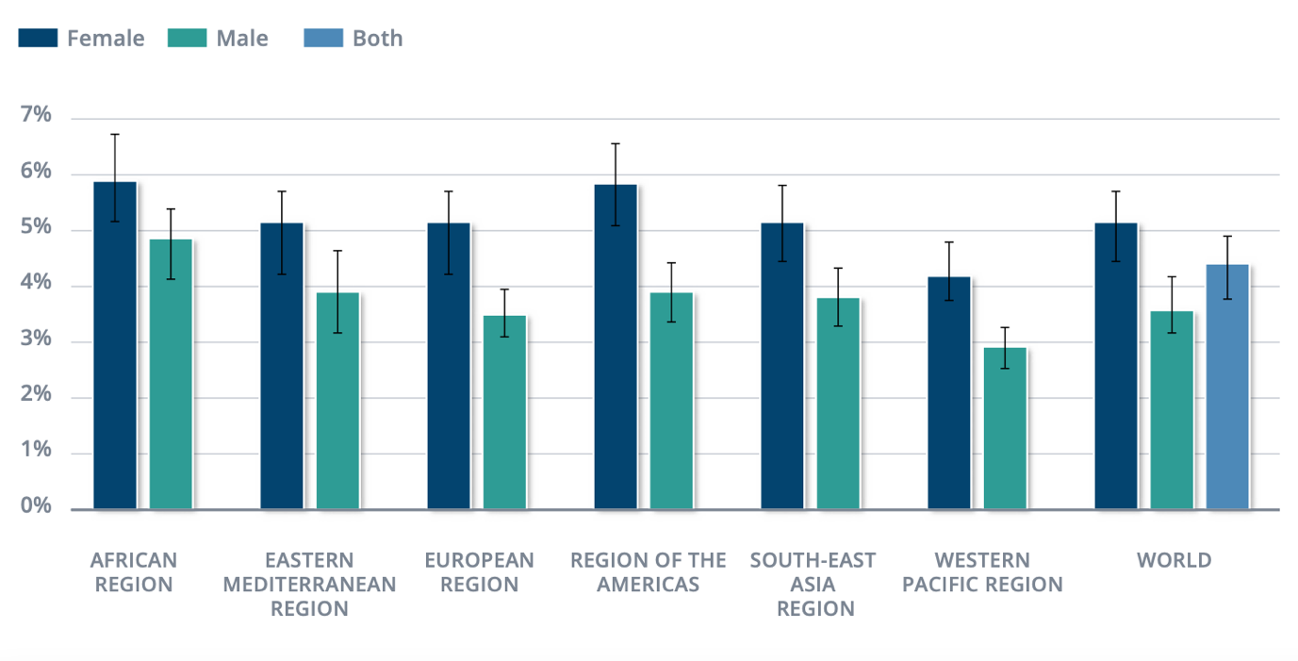
Source: https://apps.who.int/iris/bitstream/handle/10665/254610/WHO-MSD-MER-2017.2-eng.pdf

Yet in the UK, according to Mental Health Awareness (2014) General anxiety disorder accounts for one-third of the patients with mental disorders seen by GP’s which makes the most common type of mental health affecting around 4.7% of the population from where:
- 1.2% are suffering panic disorders
- 1.9% suffering different types of phobias with a higher majority among women
- 1.5-3.5% suffer acrophobia from a mild to severe
- 2.6% mean and 3.3% women suffering from post-traumatic stress illness
- 2-3% obsessive-compulsive illness.

With a higher prevalence among the people of the poor neighbourhoods, anxiety can cause problems with jobs performance as well as with an increase in obesity eating being a form of comfort that people who suffer from anxiety disorder do (Mental Health Awareness, 2014).

Anxiety aetiology can involve stress, comorbidities such as diabetes and depression, genetics, first-degree family members with a general anxiety disorder (GAD) (25%), child abuse and drug abuse. Even if all types of anxieties have similar genetics, they, however, differ. For example, panic attacks disorders come to have a bigger hereditary explanation than others although substantial genes have not been recognised whereas others seem to be influenced by stressful life environments (Adwas, A.A, Jbireal, M.J and Azab, E.A, 2019). In addition, Adwas, A.A, Jbireal, M.J and Azab, E.A, (2019) suggests that anxiety has a higher prevalence among women because they are exposed and get more stressed than man when something happens around them, especially within their families.

As it has been mentioned above anxiety disorder can become problematic mental health that can affect the everyday life of an individual when:
- Their anxious feelings are very intense and last for a long time
- Uncertainty and concerns go out of proportion
- Individuals start avoiding circumstances that make them feel anxious
- Concerns became sceptical and they cannot be controlled
- Symptoms such as agitating stomach, light-headed or dizziness, restlessness, inexplicable body pains, fast breathing, irregularities in heart bits, sleeping difficulties, nauseating and panic attacks

It is also possible that people are suffering from anxiety without any of the above-mentioned signs (Mind, 2021).

Furthermore, patients that suffer from anxiety in the UK are examined by the GP with a set of questions (please see Appendix Figure 1.) and referred to specialists for further examination and eventual treatment (NHS, 2012).

The anxiety current treatment, however, can be medicated as the most common drug being Diazepam also known as Valium and is always a secondary treatment or psychological considered primary care treatment such as supportive psychotherapy and relaxation training which is the most common and effective way of treatment (NICE, 2020).

The progress but also a way of managing and helping patients is the “Adult improving access to Psychological Therapies program” (IAP) which is a program widely used for anxiety disorder. Throughout IAP anxiety duration and recovery is monitored by periodic assessment of rehabilitation done by accredited practitioners over a set period of time that differs from patient to patient (NHS, 2008).

Mind (2020) also suggests that NHS is not yet fully equipped to deliver accurate psychotherapy therefore they usually treat anxiety as primary care prescribing anti depressives which most times are either not working, or patients become addicted to the pills.

  - Case Study 1.

The following story is the perfect example of a patient wrongly diagnosed.
Me. AB was a 21-year-old student who suffered insomnia but after a visit to the GP, he has been prescribed 10mg of Diazepam daily for ten days who has not improved his sleeping at all and more importantly he found himself back to the drugstore claiming that he still cannot sleep (Schifano, F., 2015).

  - Recommendation

In other words, an anxiety disorder can affect the everyday life of an individual consequently those around them, therefore, accurate diagnosis and treatment are crucial, there is no place for misinterpretations as well as wrong treatments. Likewise, the most important recommendation is for NHS practitioners UK National Health should provide an accessible way to educate practitioners in correctly diagnosing and treating anxiety.

Nevertheless, it is also important that practitioners follow a guideline that intends to improve procedures and outcomes of treatments. They can:
- Making recommendations regarding the management of the disorder by providing up to date evidence-based procedures.
- Using set standards in the assessment of health care.
- Possess sufficient education and training.
- Assessing, involving, and correctly informing the service user in their treatment.
- Assuring the best way of communication between service providers and service users.
- Ability to identify the best treatment (NICE, 2020).

Schizophrenia

At the beginning of the current century, the Swiss psychiatrist Bleuler has introduced a new term into the medical terminology “SCHIZOPHRENIA” (WHO, 1998).

Yet because it is a new medical terminology it cannot be defined as anxiety is, however, it is known to be a complicated mental health disparity that relates to psychosis. What is well known is the fact that it affects one in a hundred individuals at some point in their lives (Mind, 2020).
Schizophrenia is undoubtedly an extensively drastic cognitive disorder as well as a greatly economically disastrous for the world responsibility of illness (Ayano, G., 2016).

WHO (2019) suggests that twenty million people suffer from this mental disorder which is not as common as other mental disorders also, it does begin with men from a younger age compared with women.

In the UK however, a survey reported that in 2014 there were 0.7% of people suffering from schizophrenia with is a considerable increase since 2007 when the same survey reported 0.4%, nevertheless, it has not been a significant difference between men and women rates as it can be seen in Figure 3 (Baker, C., 2021).

Same as anxiety, schizophrenia can be found in the ICD-10 manual in chapter five under “Mental and Behavioural Disorders” (F20-F29) (WHO, 2010).

  - Figure 3. Preponderance of Schizophrenia in the UK.

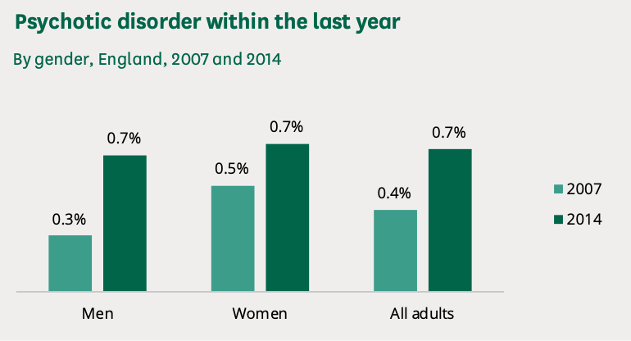

Source: https://researchbriefings.files.parliament.uk/documents/SN06988/SN06988.pdf#page5.

Further, the aspects contributing to the aetiology of the psychotic disorder are:

- Genetics only if first-degree family members suffering from the disorder, the children have a probability of 10% developing schizophrenia
- Perinatal aspects. Mothers that have gestations and labour difficulties such as mothers’ malnutrition or viral infections can deliver infants with a higher risk to develop schizophrenia later in life
- Biochemical aspects. Dopamine, serotonin, norepinephrine, GABA, and glutamate are the main chemicals found to have an impact on schizophrenia development (Ayano, G., 2016)

Moreover, according to Mental Health UK (2021), schizophrenia is manifested in different ways for which reason they are different types:

- Paranoid schizophrenia is the most common type that develops later in life, with patients expressing illusions and misconceptions but does not affect language and feelings
- Hebephrenic schizophrenia usually develops in individuals between 15 and 25 years of age showing symptoms of disorganisation both in their lifestyle as well as language. They may have disorganised speech and not show any type of emotion
- Catatonic schizophrenia is the rarest of all and patients have different, insufficient, and unexpected actions. They can be very active and immediately change to be very still, also copying other languages and actions
- Undifferentiated schizophrenia is the type that patients may have some of the above-mentioned symptoms, but it does not fit into one of them
- Residual schizophrenia relates to the patient's history of psychosis
- Simple schizophrenia is again a very rare type especially in the UK and is diagnosed by identifying symptoms such as slow movement, lack of remembrance, needy hygiene, lack of engagement
- Cenesthopathy schizophrenia shows symptoms of bodily feelings
- Unspecified schizophrenia, patients show general symptoms that meet the requirements but do not conform to any of the above

Diagnosing such mental disorder is not easy, it is extremely difficult because there is no single symptom-specific and no explicit blood test, therefore, diagnosing schizophrenia requires at least six months of symptoms analysis eliminating all possible explanations as well as observing a deterioration of the function level of the patient (Ayano, G., 2016).

On the other hand, the National Institute of Mental Health (2021), suggests that symptoms such as illusions and misconceptions are the most common signs of schizophrenia. Usually, individuals start discerning, scenting, hearing, sense or touching things that do not exist, just in their minds or hear voices that can sometimes drive them to do harmful things to either themselves or people around them (National Institute of Mental Health, 2021).

UK National Health Service provide a series of different ways of treatment for this mental disorder depending on how serious patients are suffering from the disorder (NHS, 2019). Treatment consists of a series of individually custom mixtures of talking treatments and medication decided by a specialized mental health committee after examining the individual cognitive state. The examination programme is formed by four phases, assessing the patient health and social necessities, creating a plan that meets the patient's health and social needs, nominating a social employee or a nurse and regular revision to the plan (NHS, 2019).
Yet sometimes patients with severe disorders need voluntary or mandatory detention because they can be harmful to themselves and others. Patients are retained under the Mental Health Act (2007) and on psychiatric indications. Other treatments are antipsychotics, psychological treatment, cognitive behavioural therapy, family therapy and complementary therapy such as art therapy (NHS, 2019).

Like all mental illnesses, schizophrenia must be measured to find out the mental state of the patient but also to understand if the treatment is working.
“Morningside Rehabilitation Status Scale” (please see Appendix Figure 2) is a scale specially designed for psychiatric rehabilitation that assesses the extent of dependence, how active patients are in doing things and recreation, sociable or solitude, recent symptoms, and deviant behaviours (Affleck, J.W. and McGuire, R.J., 2018).

  - Case Study 2.

Alex was a nurse from Lancashire, England but he was working in New Zealand when he was diagnosed with Paranoid Schizophrenia. He was given medication and assessed from time to time, but he was not advised on what to do work ways since he could not be a nurse anymore. He eventually found a job as a support worker in a horticultural centre, supporting people with mental illnesses beyond recuperation, and that made him feel worse (Together, 2021).

  - Recommendation

As it can be noticed in the above case study there is a lack of knowledge about schizophrenia among everyone or lots of people, therefore, it should be explained and exposed more since it is such a horrific mental illness. People should know about it.

Schizophrenia is indeed a complex mental health issue, therefore, patients along with their careers must be involved in their care plans, their care plans must be delivered in the highest quality and effective procedure, non-discriminatory, easy accessibility, assurance of patients and their careers safety, coordination between careers and agencies, accountability for the public services and offering patients the choice of Independence (NHS, 1999).

Autism

Unlike anxiety and schizophrenia, autism spectrum disorder (ASD) is an illness that affects the communication and behavioural development of an individual and has no cure, however, it can be improved by treatments. It develops at a young age although it can be diagnosed anytime in life (NIH, 2018).

First signs start to be noticed very early in childhood because individuals with ASD have problems communicating and interacting with others as well as repetitive behaviour and very little interest in engaging or doing things (NIH, 2018).

Yet the list below explains signs of autism spectrum disorders, but one may have ASD even if it is not exhibiting any of the following:

Social interaction behaviour

- The absence or inconsistency of eye connection
- The inclination of not listening to others
- Lack of enjoyment of items and actions by referring them to people around them
- Failure to respond when their names are called, or people try to attempt their awareness
- Often, they take particular interest in an object or specific topic without understanding or giving a chance for other people to intervene or comment on it
- Facial attitude, emotions and actions do not always match the conversations topics
- Voice tons are always unique sometimes sounding like they sing or robotic
- Failure to comprehend other people’s points of view and inability to discern their actions

Repetitive behaviour

- Repetitive words or terms
- Showing lengthy interests in specific themes or numbers
- Extensive interest in moving items
- Upsetting behaviour in the littles change in their routine
- High or less sensitive than others to sensory impute

Individuals with autism spectrum disorders may have problems sleeping and they can be easy irritated, but they can also express the ability to learn and memorise information for a long time, be exceptionally good optic and acoustical learners, excel in mathematics, science, music, and crafts (NIH, 2018).

Rowland, D. (2020) suggests that Autism is a word originating from the Greek language and it means “self”, later introduced by the swiss psychiatrist in 1911 Bleuler same psychiatrist who introduced schizophrenia disorder, and referred to it as isolation into one’s internal world.

Ever since researchers have not found much related to the aetiology of ADS, however, Rowland D. (2020) learned that autism results from an inherent neuropsychological abnormality that develops a continual state of serious cognitive attention fixated on one thought structure at the time eliminating everything else. That is called hyper focus and is the only factor that contributes to the withdrawal of an autistic individual into an internal world that is completely cognitive. Yet hyper focus maintains individuals’ awareness entangled in the intelligent left frontal lobe obstructing the accessibility to the right frontal lobe, where feelings and social connectivity are felt (Please see Figure 3 Appendix).

Likewise, autism can be found in ICD-10 in chapter five under “Mental and behavioural disorders” (F80-F89) (WHO, 2010).
Furthermore, according to the ICD-10, there are two types of autism:

- “Childhood autism” normally develops in children under the age of three and it is characterised by abnormalities affecting the functionality of social interaction, communication, and repetitive behaviour
- “Atypical autism” is a disorder that differs from childhood autism either by developing later in life or showing different symptoms

Regarding the prevalence, Autism affects around 1.04% globally, whereas in the UK approximately 700 thousand people are affected by this mental illness and 1.6 % children (UK Parliament, 2020).
In addition, although research cannot say anything precise about the aetiology of the ADS besides being hereditary it has, however, found that men are three times more likely to develop it compared with women (UK Parliament, 2020).
According to the UK Parliament (2020), currently, there is no biological test for ASD nonetheless, NHS (2019) suggests that individuals who are referred by different health institutions or families are evaluated by a series of specialists who will assess the patient following the NICE guidelines of recognition of symptoms that will indicate whether one has ASD and by a tool called “ Autism Diagnostics Observations schedule” which is the first choice of diagnosis but also a way of monitoring the improvement of the treatment (Zander, E. et. All., 2015) (please see Figure 4 Appendix).

After an effective evaluation and an, diagnose of ASD or Asperger disorder are long-life conditions, there is not a specific treatment for it because all individual's reactions are different. Regardless, numerous interventions will help autistic individuals achieve their entire capability of living an individual life (National Autistic Society, 2022).

Treatment is composed of different communication, behavioural and educational strategies such as vocabulary and dialogue therapy, communication by illustrations, social tales, structure, positive, empathy, low arousal and therapy of autistic and transmission handicapped pupils and that are normally adopted to the individual needs (National Autistic Society, 2022). Yet regarding medication, there have not been many medications that worked with autistic people besides nutrition diets, vitamins, hormones interventions and antipsychotic pills that can only be used under strict medical supervision because they can have side effects (National Autistic Society, 2022).

  - Case Study 3.

Unlike the previous case studies that have been collected from public literature, this one is personal.

“E” is a four-year-old girl who has been diagnosed with ASD affecting her speech and emotions. Yet because of her inability to communicate her parents have given her to eat anything and everything fearing that she will be hungry developing obesity and diabetes. The exact weight is unknown, but she's a four-year-old girl who wears clothes of 11-12 years old.

  - Recommendation

As it can be noticed in the case study it is extremely important to educate parents or carers on the importance of keeping a healthy diet for an autistic child who is already dealing with an impairment.

On the other hand, a health care provider should ensure the accessibility to full health, social and cognitive health assistance regardless of the individual's cognitive health circumstances. Services and treatment should be delivered in a non-discriminatory, safe, professional, and knowledgeable way (NICE, 2013). Nevertheless, every health care provider must comply with “The Autism Act (2009) (UK Parliament, 2020).

Conclusion

Ultimately, mental health affects someone's feelings, psychological and social wellbeing that's why awareness should be a reminder of essentiality to oversee, understand, kindness, confidence, healing, and fulfilment for those who are living with mental illness.

Reference list:

Adwas, A.A., Jbireal, M.J. and Azab, E.A. (2019) ‘Anxiety: Insights into Signs, Symptoms, Etiology, Pathophysiology, and Treatment’. The South African journal of medical sciences, 2(10), pp. 80-91.

Affleck, J.W. and McGuire, R.J. (2018) ‘The Measurement of Psychiatric Rehabilitation Status’. Cambridge University Press, 145(5).

Ayano, G. (2016) ‘Schizophrenia: A Concise Overview of Etiology, Epidemiology Diagnosis and Management: Review of literatures’. Journal of Schizophrenia Research, 3(2), pp. 1-7.

- Anxiety UK (2012) Understanding Anxiety. Available at: https://www.anxietyuk.org.uk/wp-content/uploads/2010/06/Understanding-Anxiety-.pdf (Accessed: 27 December 2021).
- Mind (2021) Anxiety and Panic Attacks. Available at: https://www.mind.org.uk/media/7089/anxiety-and-panic-attacks-2021-pdf-version.pdf (Accessed: 28 December 2021).
- Mental Health Awareness (2014) Living with anxiety. Available at: https://www.mentalhealth.org.uk/sites/default/files/living-with-anxiety-report.pdf (Accessed: 28 December 2021).
- Mental Health UK (2021) Types of Schizophrenia. Available at: https://mentalhealth-uk.org/help-and-information/conditions/schizophrenia/types-of-schizophrenia/. (Accessed: 29 December 2021).
- NHS (2012) Health Anxiety. Available at: https://www.nhs.uk/conditions/hypochondria/documents/health%20anxiety%20a4%20%202010.pdf (Accessed: 28 December 2021).
- NHS (2019) Treatment Schizophrenia. Available at: https://www.nhs.uk/mental-health/conditions/schizophrenia/treatment/. (Accessed: 29 December 2021).
- NHS (2008) Adult Improving Access to Psychological Therapies programme. Available at: https://www.england.nhs.uk/mental-health/adults/iapt/. (Accessed: 28 December 2021).
- NHS (1999) Modern standards and services. Available at: https://assets.publishing.service.gov.uk/government/uploads/system/uploads/attachment_data/file/198051/National_Service_Framework_for_Mental_Health.pdf. (Accessed: 29 December 2021).
- NICE (2020) Generalised anxiety disorder in adults. Available at: https://www.nice.org.uk/guidance/cg113/evidence/anxiety-full-guidance-pdf-136340461. (Accessed: 28 December 2021).
- NICE (2020) SOCIAL ANXIETY DISORDER: RECOGNITION, ASSESSMENT AND TREATMENT. Available at: https://www.nice.org.uk/guidance/cg159/evidence/full-guideline-pdf-189895069. (Accessed: 28 December 2021).
- NICE (2013) Autism spectrum disorder in under 19s: support and management. Available at: https://www.nice.org.uk/guidance/cg170/resources/autism-spectrum-disorder-in-under-19s-support-and-management-pdf-35109745515205 (Accessed: 2 January 2022).

- National Autistic Society (2022) Autism Diagnostic Assessment. Available at: https://cchp.nhs.uk/sites/default/files/Clinical%20Guideline%20Autism%20Diagnostic%20Assessment.pdf (Accessed: 3 January 2022).

- National Institute of Mental Health (2021) Schizophrenia. Available at: https://easacommunity.org/files/NIH%20What%20is%20Schizophrenia.pdf. (Accessed 29 December 2021).
- NIH (2018) Autism Spectrum Disorder. Available at: https://www.nimh.nih.gov/sites/default/files/documents/health/publications/autism-spectrum-disorder/19-mh-8084-autismspectrumdisorder.pdf. (Accessed: 29 December 2021).
- Rowland, D. (2020) ‘The Neurophysiological Cause of Autism’. Journal of Neurology & Neurophysiology, 11(5), pp. 001-004.

Schifano, F. (2015) Case study: assessing and counselling a patient with insomnia. Available at: https://pharmaceutical-journal.com/article/ld/case-study-assessing-and-counselling-a-patient-with-insomnia. (Accessed: 28 December 2021).

Together (2021) Alex’s story. Available at: https://www.together-uk.org/mental-health-resources/personal-stories/alex/. (Accessed: 29 December 2021).

UK Parliament (2020) Autism. Available at: https://researchbriefings.files.parliament.uk/documents/POST-PN-0612/POST-PN-0612.pdf (Accessed: 29 December 2021).

WHO (1998) Schizophrenia and public health. Available at: https://www.who.int/mental_health/media/en/55.pdf. (Accessed 29 December 2021).

WHO (2010) ICD-10 Version:2010. Available at: https://icd.who.int/browse10/2010/en#/V (Accessed: 27 December 2021).

WHO (2017) Depression and Other Common Mental Disorders. Available at: https://apps.who.int/iris/bitstream/handle/10665/254610/WHO-MSD-MER-2017.2-eng.pdf (Accessed: 27 December 2021).

WHO (2019) Schizophrenia. Available at: https://www.who.int/news-room/fact-sheets/detail/schizophrenia. (Accessed: 30 December 2021).

(WHO, 2001) WORLD HEALTH REPORT 2001-MENTAL HEALTH. Available at: https://apps.who.int/iris/bitstream/handle/10665/121922/em_rc48_inf_doc_1_en.pdf. (Accessed: 2 January 2022).

Zander, E. et. All. (2015) ‘The objectivity of the Autism Diagnostic Observation Schedule (ADOS) in naturalistic clinical settings’, Eur Child Adolesc Psychiatry, 25, pp. 769-780.

Appendix

Figure 1.

NHS questionnaire for anxiety.

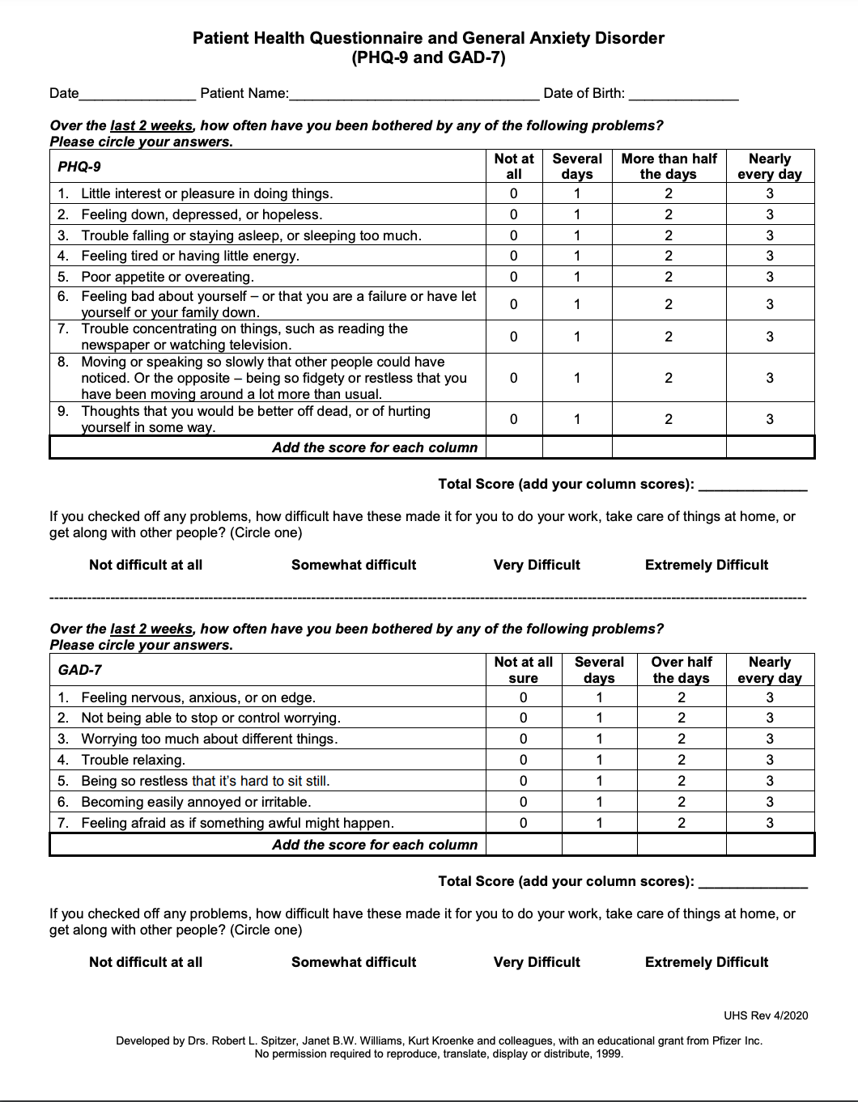

Source: https://uhs.fsu.edu/sites/g/files/upcbnu1651/files/docs/PHQ-9%20and%20GAD-7%20Form_a.pdf

Figure 2.

Rehabilitation scale for schizophrenia
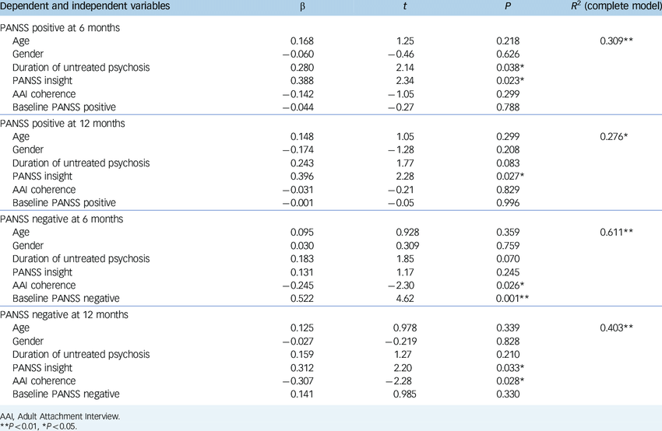

Source: https://www.google.com/search?q=rehabilitation+Scale+for+schizophrenia&tbm=isch&ved=2ahUKEwi41brNoZj1AhVD0oUKHayLAYcQ2-cCegQIABAA&oq=rehabilitation+Scale+for+schizophrenia&gs_lcp=CgNpbWcQAzoHCCMQ7wMQJzoGCAAQBxAeOgYIABAIEB46BAgAEBhQoRhY_1VgpV5oAXAAeACAAaIBiAGyEJIBBDEuMTaYAQCgAQGqAQtnd3Mtd2l6LWltZ8ABAQ&sclient=img&ei=q1PUYfjTCsOklwSsl4a4CA&bih=821&biw=1440&rlz=1C5CHFA_enGB945GB945&hl=en#imgrc=v9p1TeTQB00oCM

Figure 3.

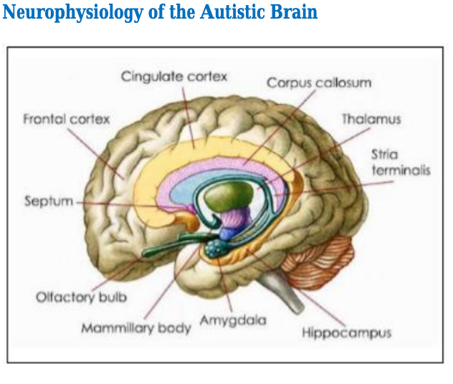

Source: https://www.researchgate.net/publication/342467944_Autism_as_an_Intellectual_Lens

Figure 4.

Autism rehabilitation form
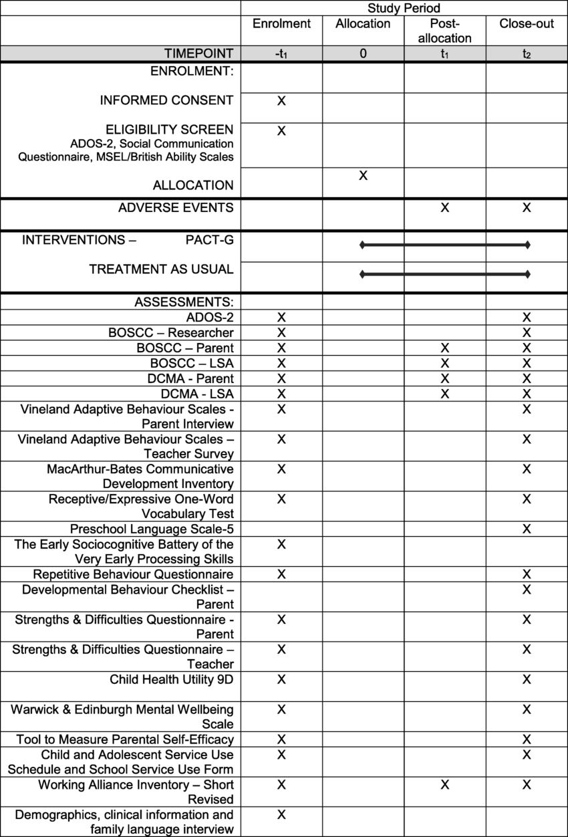

Source: https://www.researchgate.net/figure/Schedule-of-assessments-Key-ADOSAutism-Diagnostic-Observation-Schedule-2-MSELMullen_fig2_327813262

