

LCMB7023 HUMAN CAPITAL MANAGEMENT - Component 1
Assessment component 1: Individual report

Topic: Innovating New Working Practices and Breeding an Environment Where Talent May Grow
Student name : Krish Avadabhai Odedra
student ID : 2603808

Table of Contents
TASK A: Designing Innovative Working Practices 3
A.1 Introduction 3
A.2 Critical Evaluation of Work Design 3
A.2.1 Traditional and Innovative Work Design 3
A.2.2 Key Theories of Innovative Working 3
A.2.3 Challenging Conventional Management 4
A.3 Recommended Innovative Working Practices for NHSX 5
A.3.1 Cross-Functional Agile Collaboration 5
A.3.2 Hybrid and Flexible Working Models 6
A.3.3 Employee Autonomy and Digital Collaboration 6
A.4 Justification for Organisational Performance Improvement 6
A.4.1 Addressing NHSX’s Decision-Making and AI Challenges 6
A.4.2 Innovative Design and Performance Outcomes 7
TASK B: Breeding an Environment Where Talent May Grow 8
B.1 Critical Evaluation of Talent Environments 8
B.1.1 Global Organizations, Talent and Competitive Advantage 8
B.1.2 Learning, Growth Mindset and Psychological Safety Theories 8
B.1.3 Employee Experience, Job Crafting and Motivation 9
B.2 Strategic Talent Ecosystem for NHSX 10
B.2.1 NHSX Talent Growth Strategy 10
B.2.2 Career Growth and Continuous Learning for Retention 10
B.2.3 Employee Wellbeing and High-Performance Management 12
TASK C: Reflective Report (Reflection using Gibbs' Cycle) 13
Introduction 13
C.1 AI as a Strategic Tool in HRM 13
C.2 Reflective Analysis 13
What? 13
So What? 13
Now What? 13
C.3 Personal Action Plan 14
Conclusion 14
References 15

TASK A: Designing Innovative Working Practices

A.1 Introduction
NexSpace Health Systems (NHSX) has to deal with hierarchical decision-making, limited employee creativity, and lower collaboration within hybrid teams, which hampers innovation and organisational agility. NexSpace Health Systems (NHSX) is a fast expanding health care technology provider employing around 600 staff across the UK, India and the UAE. NHS evidence backs up this challenge with 62.65% of staff saying that their teams do not often talk about effectiveness in 2025 (Affina OD, 2026).. This section discusses flexible and participatory working methods that can contribute to faster decision making, a spread of knowledge and to innovation within organisations..

A.2 Critical Evaluation of Work Design

A.2.1 Traditional and Innovative Work Design
Traditional hierarchical structures can help centralise decision-making, although they can also stifle employee autonomy and experimentation. Modern HPWS/HIWS practices are based on shared responsibility, improved participation, and innovation. The increase in the use of, and intention to use, permanent increased homeworking was also highlighted among UK businesses in the private sector, with 20% saying they do or plan to do this in 2026 (Office for National Statistics, 2026a).

A.2.2 Key Theories of Innovative Working
HPWS enhances employee capability via training, performance management and supportive HR practices, while HIWS increases participation, autonomy and shared decision-making. Agile Working undermines hierarchical structures by means of iterative teams and flexible roles and with the aid of fast feedback. To supplement these approaches is Sociotechnical Systems Theory that relates the technological systems to human needs and social structures. Together, these theories urge NHSX to adopt empowerment, collaboration, learning and improvement – a more responsive and innovative approach that will undo the mantle of central control. This shows that 29% of UK businesses used AI in June 2026, underscoring the importance of work designs that effectively incorporate employees with emerging technology (Office for National Statistics, 2026a).

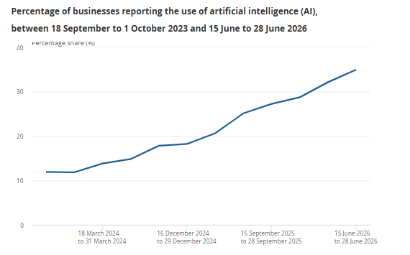
Figure 1: Percentage of UK businesses using at least one AI technology
(Source: Office for National Statistics, 2026c)

A.2.3 Challenging Conventional Management
The inherent logic of HPWS is the ability to align performance with employee development; the inherent logic of HIWS is to give voice and decision-making power to the employee. Agile Working further diminishes hierarchy: via self-organising teams, quick feedback and incremental problem-solving. Sociotechnical Systems Theory is a theory that challenges technology-centric management by applying a design process to both the person and the technology. For NHSX, this is especially significant, with 51.15% of NHS staff in 2025 saying there were opportunities for them to develop their careers within their organisation (Department of Health and Social Care, 2026).

A.3 Recommended Innovative Working Practices for NHSX

A.3.1 Cross-Functional Agile Collaboration
Cross-functional Agile teams should be formed collaboratively between NHSX, representing IT, clinical professionals, HR, data specialists and cybersecurity professionals, and must have shared goals and decision-making powers. Digital collaboration platforms should offer shared workflows and be transparent on the progress of hybrid teams. This is in line with the NHS priorities for increased local empowerment and innovation. National engagement in the NHS rose to 6.47 in Q1 2026/27, compared with 6.46 in Q2 and Q4 2025/26, a sign of the importance of employee engagement and collaborative working (NHS England, 2026a). NHS England's staffing confidence has fallen since 2020 and then ticked up slightly over the following period, but overall has stayed below 40%.
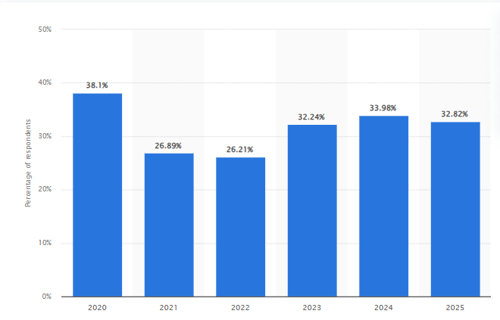
Figure 2: Survey employee engagement
(Source: Statista, 2026)

A.3.2 Hybrid and Flexible Working Models
NHSX should take a hybrid approach for the UK-based team and the Indian and UAE based team, wherein there are two fixed collaboration timings followed by flexible timings. The essential meetings should occur during core hours and all documentation and handovers should take place in an asynchronous manner. This aligns with ONS data that 17% of UK businesses with 10 or more employees identified being affected by worker shortages in February 2026, underscoring the need for flexible approaches in hiring and keeping talent across various locations (Office for National Statistics, 2026a).

A.3.3 Employee Autonomy and Digital Collaboration
Staff should be increasingly empowered within NHSX policies and procedures as regards task allocation, project decisions and working schedules with clear accountability systems. To connect teams in the UK, India and the UAE, video meetings, as well as shared documents and project-management dashboards, should all be part of a digital collaboration platform. This aligns with evidence in the UK in 2026 indicating the prevalence of digitised data and technology-enabled collaborative communication for 86% of businesses (Department for Science, Innovation and Technology, 2026).

A.4 Justification for Organisational Performance Improvement

A.4.1 Addressing NHSX’s Decision-Making and AI Challenges
These recommendations fit within the context of the NHSX's hierarchical decision-making and lack of cross-team working, offering the opportunity to move appropriate decision-making to Agile teams in order to minimise delays to approvals and accelerate the problem-solving process. Structured hybrid working ensures collaboration between the teams in UK, India and UAE, and the digital platforms facilitate the sharing of information and accountability in real time. An employee's autonomy also promotes ownership, creativity and continuous improvement. This is particularly significant given that by June 2026, 49% of businesses with 250 employees or more were utilising at least one AI technology, and the use of AI has been reported as increasing across a wide range of industries throughout the UK (Office for National Statistics, 2026a).

A.4.2 Innovative Design and Performance Outcomes
The effects of innovative work design can be measured by tracing back the connection between employee presence and autonomy, collaboration and innovation in digital working, and productivity and decision speed. Being Agile, teams can minimise delays in the approval process for NHSX and encourage collaboration across functions for knowledge sharing and problem-solving. Measure performance by decision-cycle time, project completion rates, levels of employee engagement, innovation outputs and employee productivity. In the period Q2 2026, output per hour worked in the UK rose by 0.7% compared to Q2 2025 – a value that represents productivity movements in the wider UK economy (Office for National Statistics, 2026b).
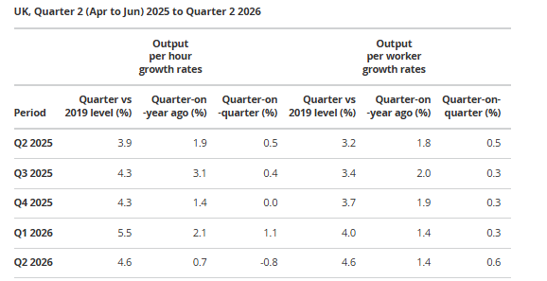
Figure 3: UK output per hour worked growth, Q2 2025–Q2 2026
(Source: Office for National Statistics, 2026b)

TASK B: Breeding an Environment Where Talent May Grow

B.1 Critical Evaluation of Talent Environments

B.1.1 Global Organizations, Talent and Competitive Advantage
Career development, employee empowerment and internal mobility, combined with learning culture, are the ways that leading global organisations foster talent (Abid and Polo, 2025). These practices enhance organisational capability in retaining knowledge and preparing workers for technological change. A talent leader's greatest concern is employee retention, with learning opportunities cited as the top strategy to keep staff from quitting (Wellhub Editorial Team, 2026). Furthermore, in Microsoft's 2026 Work Trend Index report, which includes interviews with 20,000 AI-using workers from 10 countries, the role of human work becomes even more significant as AI shapes the future of work (Microsoft, 2026). For NHSX, these findings underline a culture characterised by constant learning, progression, workforce autonomy, and principled AI use as key factors in retaining talent and ensuring an organisation's competitiveness.

B.1.2 Learning, Growth Mindset and Psychological Safety Theories
Senge's Learning Organisation is a way of continuously learning, thinking in systems and having a shared vision, which will support NHSX's ability to adapt to technological change. Dweck's Growth Mindset sees abilities as something that can be developed (and achieved), and she encourages staff to make mistakes and try difficult things. With Edmondson's psychological safety, people can raise problems, pose questions and try something new without fear, fostering innovation and knowledge exchange. Exposure to learning opportunities alone, without managerial consistency, is insufficient to lead to growth, but these theories are complementary. The health and social work sector in the UK has a strong focus on workforce training, with 80% having completed training in 2026 (Department for Education, 2026).
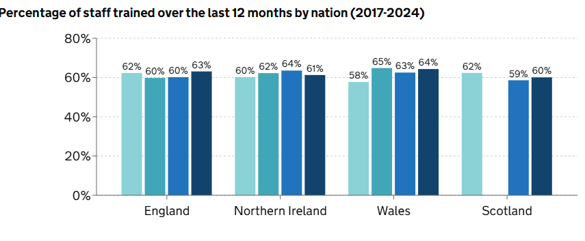
Figure 4: Proportion of staff receiving training by sector, UK, 2024
(Source: Department for Education, 2025)

B.1.3 Employee Experience, Job Crafting and Motivation
Employee Experience (EX) and retention go hand in hand because EX establishes supportive, meaningful and inclusive organisations. Job Crafting Theory allows workers to adjust the roles, relations, and responsibilities to leverage their talents/specialties, thereby improving ownership and level of satisfaction with their work (Dhanpat, 2025). Autonomy, competence and relatedness drive an increase in intrinsic motivation and connectedness, according to Self-Determination Theory. These strategies might stand together for NHSX to help with retention, providing personalised career development, increased autonomy at work, engaging digital initiatives and improved team dynamics. Evidence from CIPD’s 2026 Resourcing and Talent Planning Report shows that 44% of UK employers found talent more difficult to retain, while 45% of organisations introducing retention initiatives increased learning and development opportunities (CIPD, 2026a). Moreover, 34% stated that greater hybrid or remote working had a positive effect on retention, demonstrating flexible EX practices (CIPD, 2026b). The greatest issues with talent retention exist in public and private sectors, where there continues to be workforce strain.
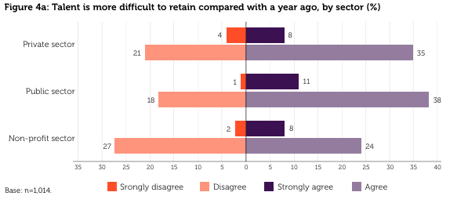
Figure 5: Talent is more difficult to retain compared with a year ago, by sector (%)
(Source: Hogarth and McCartney, 2026)

B.2 Strategic Talent Ecosystem for NHSX

B.2.1 NHSX Talent Growth Strategy
NHSX should build a talent model that will bring about structured career pathways, ongoing digital learning, and internal mobility and mentoring. Individual development plans should focus on leadership, analytical and technical skills, and projects can be cross-functional to provide opportunities to use new skills. Regular career conversations and recognition mechanisms need to be used by managers to enhance motivation and retention (Imran et al., 2025). There is a need for AI and digital-learning programmes for staff to equip them for the new healthcare technologies, combined with learning time. The strategy is especially relevant given that 505,000 NHS clinicians and support staff have been granted access to Microsoft 365 Copilot in June 2026, highlighting the magnitude of technological transformation that necessitates workforce transformation (NHS England, 2026b). Further, 87.78% of NHS staff said that they felt their role was important to the patients, which lays a strong ground for talent development in the profession centered around purpose (NHS England, 2026c).

B.2.2 Career Growth and Continuous Learning for Retention
High-performing individuals need to be retained in NHSX by creating clear career opportunities between technical, clinical, analysis and leadership and aligning these with competency frameworks, mentoring and internal promotion. Funded training certifications and AI training, coaching, and protected learning time should be part of individual development plans. A progression map can help uncover barriers and employee aspirations for progression and link with NHSX future skills requirements for career progression all through quarterly career conversations. This is especially significant as 52% of organisations in the UK said they were facing higher competitive pressures to recruit well-qualified talent in 2026 (CIPD, 2026b). It emphasises the importance for the NHSX of having in place a robust internal career growth and lifelong learning programme to help them to better retain highly qualified staff. NHSX should, therefore, integrate progression and ongoing re-skilling to allow high-performing individuals to be given challenging projects, leadership positions and/or specialist roles in the digital space. These pathways can help enhance work motivation, organisational commitment, and job retention, as well as decrease reliance on external recruitment.

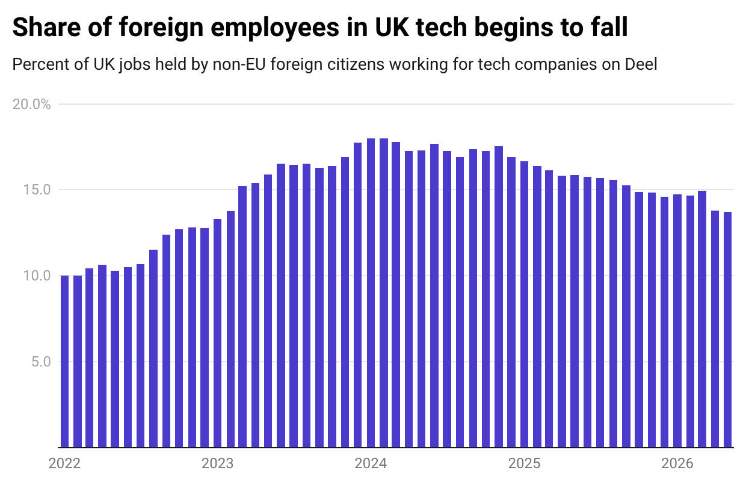
Figure 6: The UK Talent Map
(Source: Thomas, 2026)

UK technology businesses had a high proportion of foreign workers, which increased and subsequently decreased after migration restrictions were introduced.

B.2.3 Employee Wellbeing and High-Performance Management
Taking a high-performance-with-wellbeing approach in which NHSX managers set realistic workloads, plan regular wellbeing check-ins, offer mental health education and include aspects of flexibility. Managers should take the time to review workload and project pressures on a monthly basis, and staff should have access to counselling, occupational-health services and confidential avenues of escalation. Performance goals should focus on the results, not too many hours, so that the emphasis should not be on too much work, burnout and responsibilities. In 2026, 73% of organisations that trained line managers in mental health reported that managers were confident discussing sensitive issues and signposting employees to support, compared with 57% where managers received no such training (CIPD, 2025). Also 36% of employers who have remote workers said they saw a decrease in sickness absences as a result of flexible working, as part of a wider wellbeing strategy (Sinclair and Suff, 2025).

TASK C: Reflective Report (Reflection using Gibbs' Cycle)

Introduction
This reflective report evaluates my experiences of using Artificial Intelligence in HRM, focusing on decision-making, critical thinking and ethical responsibility. Using Driscoll’s “What? So What? Now What?” framework, it reflects on my learning and identifies specific capabilities for future professional development.

C.1 AI as a Strategic Tool in HRM
Artificial Intelligence (AI) can strengthen HR decision-making by analysing workforce data, identifying patterns and supporting recruitment, performance, retention and talent development (Iyer et al., 2026). However, AI recommendations should not replace human judgement because algorithms cannot fully understand employees’ emotions, motivations or circumstances (Shekhar and Saurombe, 2026). This raises an ethical issue in terms of privacy, bias and transparency.

C.2 Reflective Analysis

What?
As I explored and professionalised with AI tools, I have come up with 3 ways AI can be put to use. By first using AI to brainstorm some initial thought and ideas and then structuring my research on innovative working practices, I will have brought some fresh energy to my entire project. Second, I summarised complex concepts with AI such as High performance work systems, Agile working, talent management etc. Third, I utilized artificial intelligence to find suitable statistical evidence and enhance the clarity of an academic writing.

So What?
Self-employment experiences helped to develop my digital skills, research effectiveness, and organization. AI provided different points of view and original insights about HR, tech and performance. But, wrong and incomplete output might hamper critical thinking (Andreas et al., 2026).

Now What?
In the future, I would be using AI as a tool to aid my professional opinion. I will compare and critically evaluate AI-generated recommendations, while also verifying critical facts and information from credible sources. Ethical considerations, such as potential biases, privacy concerns, and the role of AI augmenting, rather than replacing, human decision-making will be taken into account.

C.3 Personal Action Plan
The personal action plan I would create is based on gaining skills and competencies needed for effective and responsible HR practice. My first step will be to gain HR Analytics skills as I will take an online training course and practice data interpretation and Excel and PowerBI for 6 months to enhance my capability to make workforce recommendations supported by solid evidence. Second, I'm going to become AI literate, to take some short courses about generative AI, about responsible AI and HR technology, and to practise and learn how to critically interpret the outputs of AI to assess and evaluate them. Thirdly, my interpersonal and communication skills will be enhanced through representation in presentations, teamwork and professional networking and with feedback received from tutors and colleagues after every activity. Progress will be monitored through a skills checklist and reflective journal, which are to be done quarterly indicating improvement in employability (Ng et al., 2025).

Conclusion
In conclusion, this reflection underscores the role AI can play in augmenting HR decision-making processes, improving research efficiency and professional growth, provided it is leveraged responsibly. Through my experiences, I came to see the critical thinking skills, empathy, and ethical understanding and judgement.

References
Abid, K. and Polo, F. (2025) ‘Talent development through intrapreneurship: a human-capital approach in French SMEs’, European Journal of Training and Development, 49(9), pp. 952–974. Available at: https://www.emerald.com/ejtd/article/doi/10.1108/EJTD-11-2024-0162/1249690
Affina OD (2026) What the NHS staff survey reveals about key aspects of team working. Available at: https://affinaod.com/news/what-the-nhs-staff-survey-reveals-about-key-aspects-of-team-working/
Andreas, O.M., Samosir, E.M. and Saragih, E. (2026) ‘Critical thinking and algorithmic rationality in education: A Habermasian perspective’, Jurnal MEKOM (Media Komunikasi Pendidikan Kejuruan), pp. 1–17. Available at: https://journal.unm.ac.id/index.php/MKPK/article/view/13072
CIPD (2026a) Almost half of employers are upskilling their workers in the wake of labour market and legislative challenges. Available at: https://prod.cipd.org/en/about/press-releases/rtp-2026/
CIPD (2026b) Resourcing and talent planning report. Available at: https://www.cipd.org/uk/knowledge/reports/resourcing-surveys/
CIPD (2026b) Resourcing and talent planning report. Available at: https://www.cipd.org/uk/knowledge/reports/resourcing-surveys/
Department for Education (2025) Employer Skills Survey 2024. Available at: https://explore-education-statistics.service.gov.uk/find-statistics/employer-skills-survey/2024
Department for Science, Innovation and Technology (2026) UK Business Data Survey 2026. Available at: https://www.gov.uk/government/statistics/uk-business-data-survey-2026/uk-business-data-survey-2026
Department of Health and Social Care and NHS England (2026) NHS staff standards: detailed requirements for employers. Available at: https://www.gov.uk/government/publications/nhs-staff-standards/nhs-staff-standards-detailed-requirements-for-employers
Dhanpat, N. (2025) ‘Job crafting agility: a conceptual proposition for rethinking behaviour in organizations’, International Journal of Organization Theory & Behavior, 28(1), pp. 18–33. Available at: https://www.emerald.com/ijotb/article/28/1/18/1243016
Hogarth, A. and McCartney, C. (2026) Resourcing and talent planning report 2026. London: Chartered Institute of Personnel and Development. Available at: https://www.cipd.org/globalassets/media/knowledge/knowledge-hub/reports/2026-pdfs/9218-resource-and-talent-planning-2026-report-web.pdf
Imran, U.D., Ghazwan, M.F. and Firmansyah, F. (2025) ‘The effect of recognition and appreciation on employee motivation and performance’, Economics and Digital Business Review, 6(1), pp. 1–18. Available at: http://ojs.stieamkop.ac.id/index.php/ecotal/article/view/1890
Iyer, S.S., Arora, R., Murugendrappa, D.G., Raji, B., Ganguly, A., Anwar, S., Mahesh, A., Reyes Jr, F.E. and Subramanian, R. (2026) ‘AI-driven talent management: Transforming recruitment, retention, and workforce analytics’, Human Resource Strategy and Practice, 2(1). Available at: https://journals.niepublish.com/index.php/hrsp/article/view/101072
Microsoft (2026) Agents, human agency, and the opportunity for every organization: 2026 Work Trend Index Annual Report. Available at: https://www.microsoft.com/en-us/worklab/work-trend-index/agents-human-agency-and-the-opportunity-for-every-organization
Ng, F.L., Yap, W.H. and Yong, P.V.C. (2025) ‘Evaluating research mobility placements: A skills audit framework for enhancing employability and professional development in higher education’, Cogent Education, 12(1), p. 2554953. Available at: https://www.tandfonline.com/doi/abs/10.1080/2331186X.2025.2554953
NHS England (2026a) Workforce, Training and Education Bulletins. Available at: https://www.england.nhs.uk/london/workforce-training-and-education-bulletins/
NHS England (2026b) 500,000 NHS staff to get new artificial intelligence tools to help free up more time for patients. Available at: https://www.england.nhs.uk/2026/06/500000-nhs-staff-to-get-new-artificial-intelligence-tools-to-help-free-up-more-time-for-patients/
NHS England (2026c) 3-year high in attacks on NHS staff. Available at: https://www.england.nhs.uk/2026/03/3-year-high-in-attacks-on-nhs-staff/
Office for National Statistics (2026a) Business insights and impact on the UK economy: 2 July 2026. Available at: https://www.ons.gov.uk/businessindustryandtrade/business/businessservices/bulletins/businessinsightsandimpactontheukeconomy/2july2026
Office for National Statistics (2026b) Productivity flash estimate and overview, UK: April to June 2026 and January to March 2026. Available at: https://www.ons.gov.uk/employmentandlabourmarket/peopleinwork/labourproductivity/articles/ukproductivityintroduction/latest
Office for National Statistics (2026c) Artificial intelligence in UK businesses: 2023 to 2026. Available at: https://www.ons.gov.uk/businessindustryandtrade/business/businessservices/articles/artificialintelligenceinukbusinesses/2023to2026
Shekhar, A. and Saurombe, M.D. (2026) ‘Algorithmic anxiety: AI, work, and the evolving psychological contract in digital discourse’, Frontiers in Psychology, 17, p. 1745164. Available at: https://www.frontiersin.org/journals/psychology/articles/10.3389/fpsyg.2026.1745164/full
Sinclair, A. and Suff, R. (2025) Health and wellbeing at work. London: Chartered Institute of Personnel and Development. Available at: https://www.cipd.org/globalassets/media/knowledge/knowledge-hub/reports/2025-pdfs/8920-Health-and-wellbeing-report-2025.pdf
Statista (2026) Perceived staff shortage levels NHS England. Available at: https://www.statista.com/statistics/883485/nhs-england-views-on-staffing-levels/
Thomas, L. (2026) The UK talent map: Where high-skilled workers move and what they earn. Deel Works, 3 June. Available at: https://www.deel.com/deel-works/uk-talent-map-2026/
Wellhub Editorial Team (2026) Employee retention: 88% of companies make it a top priority in 2026. Available at: https://wellhub.com/en-uk/blog/talent-acquisition-and-retention/employee-retention-uk/

