Student name: Vasile Daniel Remus Stanica

Student code: 2424143

Module: Employment and Career Development; LCLM4005

Assignment: Mock Interview

Table of Contents
Job Advertisement 3
Curriculum Vitae – CV 4
Cover Letter 6
Reference list 7

Job Advertisement
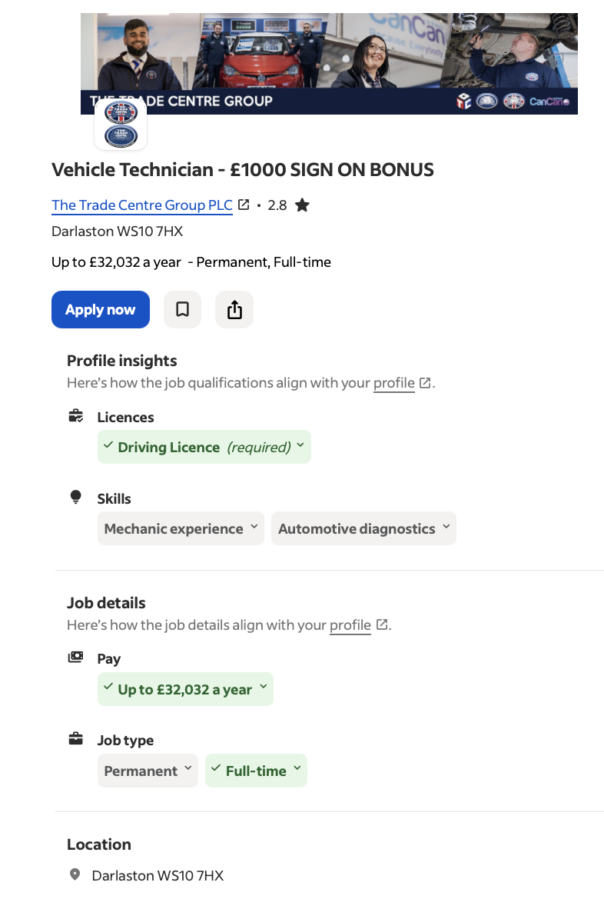

This is the chosen job advertisement that interests me. The reason for this is because this job aligns with my experience and passion as it is my dream to continue working as a mechanic (Indeed, 2026). Considering the job details and person specification, this job directly matches my hands-on experience gained throughout my years of working as a car mechanic and vehicle technician for Duo Rent a Car and at Capital Service Auto. (For full job details please find the job link in the reference section.)

I have also provided a CV and a Cover Letter showing my interest for the job and how this aligns with the job advertisement, company requirements and core values.

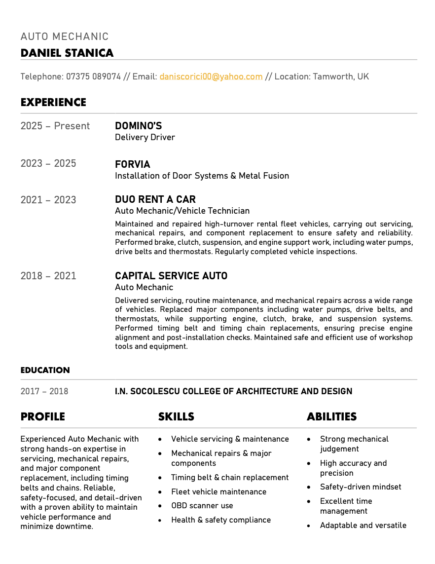
Curriculum Vitae – CV
Thanks to my hands-on experience, the role as a Vehicle Technician at The Trade Centre Group is a perfect match for me. I bring to the team all the required skills of a mechanic, including vehicle servicing and maintenance, repairs and major components, fleet vehicle maintenance, as well as health and safety compliance and strong mechanical judgement (Elite Garages, 2026). I am a quick learner and keen to integrate effective feedback in order to improve performance and achieve only the highest standards of work (LSST, 2022).

Cover Letter

Vasile Daniel Remus Stanica
5 Willow Close, Tamworth
daniscorici00@yahoo.com
07375 089074
23 February 2026
The Trade Centre Group PLC

Dear Hiring Manager,
I am Vasile Daniel Remus Stanica and I am writing you to apply for the position of Vehicle Technician at The Trade Centre Group PLC based in Darlaston. I have strong background in vehicle maintenance and mechanics developed through my hands-on experience in the field.

As an Auto Mechanic at Capital Service Auto I conducted routine maintenance and I developed strong ability to ensure mechanical repairs across a wide range of vehicles, including major components such as water pumps, drive belts and thermostats. I am also experienced in supporting engine works, clutch, brakes, as well as timing belt and timing chain replacements. I am well educated in efficient usage of workshop tools.

During my time as a Vehicle Technician at Duo Rent a Car I maintained and repaired a high-turnover rental fleet vehicles. I developed my skills of component replacement, as well as safely carrying out servicing and mechanical repairs. I am experienced in performing regular inspections and tests to ensure the safety and reliability of the vehicles. In plus, I often acted as an agent to conduct car rentals, especially for foreign-speakers individuals, and accurately managed paperwork.

Besides my hands-on experience of 6 years, I also bring enthusiasm and passion to the team. I am happy to show how my experience aligns with the company’s core values and requirements. Thank you for considering my application!

Yours sincerely,
Vasile.

Reference list

Elite Garage, (2026), ‘’What every car mechanic should know’’, [online] available on: https://www.elitegarages.co.uk/2022/09/top-car-mechanic-skills-and-traits , last accessed on 23 February 2025.

Indeed, (2026), ‘’Vehicle Technician - £1000 sign on bonus’’, [online] available on: https://uk.indeed.com/viewjob?jk=1245b29d080cb1b2&from=appshareios , last accessed on 23 February 2025.

LSST, (2022), ‘’Why effective feedback is important to student wellbeing’’, [online] available on: https://www.lsst.ac/blogs/why-effective-feedback-is-important-to-student-wellbeing/ , last accessed on 23 February 2025.

