Project Initiation Document

Module Title: Project management
Module lecture: Sue Maw

Contents
- 1.1 Introduction
- 1.2 Background
- 2.1 Project definition
- 2.2 Purpose
- 2.3 Objectives
- 2.4 Scope
- 2.5 Deliverables
- 2.6 Constraints
- 2.7 Assumptions
- 3.1 Benefits
- 3.2 Options
- 4.1 Risk analysis
- 4.2 Risk identification
- 4.3 Risk prevention
- 4.4 Risk management
- 4.5 Risk monitoring
- 5.1 Gant chart project planning
- 6.1 Conclusion

1.1 Introduction

This assignment will look to propose a plan for the project that is being put forward. To assess the project the Oscar method will be used. This assignment will cover the objective of the project. so, this will cover the purpose of the product. For example, what is the purpose of the product and what objectives will this project look to cover. After the objectives the next topic is the overall scope of the product then the constraints of the product will be covered. Each topic will hold advantages and disadvantages.

1.2 Background

The project that is being put forward is to create a piece of network equipment that can be placed inside a car and then to have this equipment to be utilised as a find my car system. What this system will look to do is allow the user to find their car in a case of theft.

2.1 Project definition

2.2 Purpose:

The purpose of the find my car system is to allow the owner of the vehicle to locate their car. This can be whether they go shopping and forget where they parked so they can use this system to help them find their car. At the end of this project the end goal is to create a successful project that can be utilised to maximum efficiency and to aid the car owner with their car troubles. This would be the best-case scenario for this project the worst-case scenario would be that this system would get overlooked and underused by the car owners.

2.3 Objectives:
User friendly
It is important that the equipment is user friendly. This is an important objective to aim for because this project is being used to make the car owners life that much easier rather than to make the car owners life a lot harder.

Project efficiency
Another objective that is taken into consideration is the overall efficiency of the project completion. It is important as an objective to make sure the project is run with efficiency.

Product Quality
The next objective is to make sure the project is quality made.

Time management

The final objective is to make sure t hat the product is completed within in the time limit.

2.4 Scope

When design this project boundaries will have to be taken into consideration. A main boundary of this project is the focus on which side to pick to make it software or a hardware item. This is an important factor to make, as this will decide whether it can be an app for the car owners. As well as find my car being an app the hardware see will also be taken into consideration for example would you implement a device that allows you to gain connection to this device, to help the owner find their car. As well as this boundary there is another factor to be brought up and that is what kind of work will this project require. As both the software and hardware side have their own work that will be needed to carry out so it is important to choose between software and hardware. The next boundary that this project is facing would be the client. The clients would have to be car owners as this project is being designed to be implemented into cars systems. So the client side is very limited and is only aiming towards 1 type of client.

2.5 Deliverables

To show progress in this project timescales can be produced to make sure each deadline is met. To go along with time scales reports can be made to measure the progress off the overall project.

2.6 Constraints

The constraints that will need to be taken into consideration. Are the time scales they have to be met and the production of the project? So, by production it will take time to understand how the project will work and what is required to make the project operate efficiently.

2.7 Assumptions

At the start of this project the assumptions that can be made are. For this project to be completed by the deadlines that have been given. Another assumption that can be made is that this project will be completed to the best quality that can be produced and it will also run at high efficiency.

3.1 Benefits

This project is being carried out to deliver a friendly and helpful service to the car owners. This project will look to help car owners with keeping their car secure. This project will also look to help people with a memory problem if they were to forget where they parked their car. So, this project can look to deliver a friendly way to remembering where car owners parked their car. The find my car will also look to prevent vehicle theft by keeping up to date on the location of the car.

3.2 Options

When planning this project, a lot of options were taken into consideration. For example the option that was taken into consideration was how the whole project was going to be carried out. When even considering how this project was going to be carried other important factors had to be considered with in the options of planning. For example the time scaling of the project is a big consideration to take in any project. Another idea that was put forward as an option was similar to find my car but it was called finds my car keys. Which would operate in a very similar way as in to finding my car. Instead of finding my car the project would be to find my car key.

4.1 Risk analysis

4.2 Risk identification

With this project it is important to acknowledge and to recognise some of the risks that may appear during this project. A main risk does not understand the software or hardware required for this project. This is a risk because if the user does not know how to produce this project, then they will be required to learn and understand the project in depth. Another risk that may appear is overworking on the project. So as this project will take time to learn and understand. This could lead to the user working long hours in the days and nights to try and master the project idea and execution. Also a risk that may appear is that the user doesn’t not have the required tools to apply to this project. So this risk will have to be managed and dealt with by acquiring the required tools.

4.3 Risk prevention

To prevent any risks during this project all risk will have to be taken in to account as mentioned above. To manage the risks all risks will look to be dealt with when raised. By dealing with the risks this will allow the project to run accordingly and smoothly. By the project running smoothly this will allow the project to run efficiently and be quality made.

4.4 Risk management

If the risks were to materialise then of course they would have to be dealt with. it is important to deal with any risks that may arise to make the project run smoothly. For example, to manage the overworking risk and the deadline risks. Operating hours could be put into place to manage how much time ach day should be applied to the project and when to take suitable breaks. Another important risk too del with is the lack of required tools. This can be dealt with by acquiring the software or equipment that is required to produce the project. As the project will not be able to complete without the right tools.

4.5 Risk monitoring

To monitor the risks routinely checks will be made on the project to make sure there is no interference with the work that is being produced. By carrying out routine checks then this will help with the risk management. If the checks are successful and no risks or interferences were raised. Then this means that the risk prevention was carried out successfully s no risk were raised. As there was already a risk prevention system in place.

5.1 Gant chart project planning

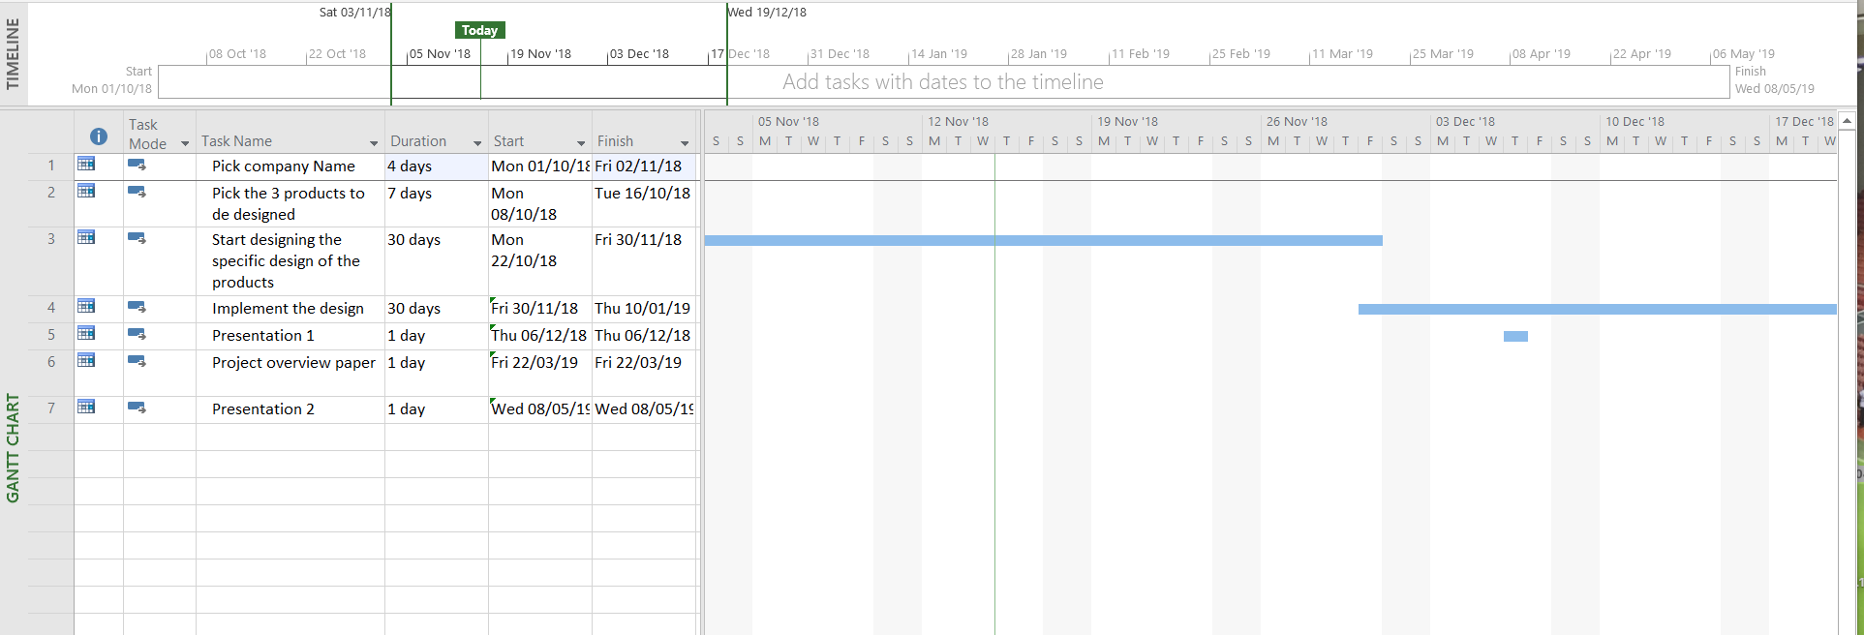
Below is a screen capture from a gant chart that was produced in Microsoft project. This gant chart was created to plan out the development of the project and how the project will look to be assessed. As you can see in the gant chart the main purpose of utilising the gant chart was to make sure that the project meets the deadlines. By placing these deadlines, it will allow the user to be more relaxed when it comes to doing the work on this project as the deadlines have been set.

6.1 Conclusion

In conclusion this document was made to initiate the project design. This assignment was made to look at why the project was created and what Is the purpose of the project that was chosen. By doing the analysis at the start of identifying the objectives, scope, deliverables, constraints and assumptions. Will help with the identification of the project find my car. By identifying all these things, it will give a clear view on how the project is created and when the project should be aimed to be completed by. By placing these deadlines this will identify how the project will be assessed during its course production. Another point that was raised in this assignment to help the development of the project is the risk assessment. This was an important stage in the task. As the risk assessment is where the problems were raised and how the problems should be handles. So, by doing this task it will also decrease the chance in mistakes and or risks being produced when creating the project.

