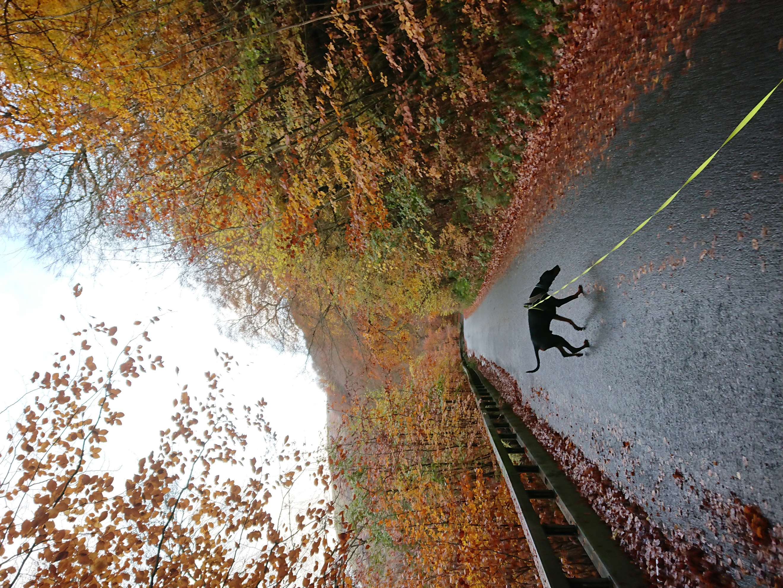 | THE impact and response of wildlife to covid-19  A focus on the effects COVID-19 has had on wildlife and the resulting impact this has had from a governance perspective.  Rebecca Macfarlane  BSc Environmental Conservation

Contents
Contents 1
Introduction 2
Impact and Response 2
Discussion 2
Conclusion 2
References 3

Introduction
This report focuses on the effects of COVID-19 on wildlife and the resulting impact this has had from a governance perspective. Considering the limited amount of research that has taken place during the pandemic period, suggestions will also be made on what should be taken into consideration for new policy decision-making.

Impact and Response
The greatest impact COVID-19 has had on wildlife has mostly been governing responses to virus containment rather than the virus itself. Though it is notable that the virus can affect a variety of species, particularly marine mammals (Alberts, 2020) and can mutate in others (Kesslen, 2020). However these instances have been few when considering the proximity of vast numbers of animals to humans (Kevany, 2020), particularly within agriculture.
A positive direct result from COVID-19 is the global effort to crack down on wet markets and the illegal wildlife trade (Aguirre, et al., 2020); from the origins of the virus being traced back to the pangolin (Winn, 2020), China has taken the lead in working towards a ban on using wildlife food markets (Borzée, et al., 2020).
In addition, a more nature-focused outlook has been experienced by populations in lockdown as they have resorted to spending more time outdoors (Manentia, et al., 2020). This has also led to developments that work in harmony with the local environment being explored (Weston, 2020).
Negative impacts have been varied, both as a result of intervention, such as the mink cull in Denmark (Kevany, 2020) and the heavy use of disinfectants and cleaning materials whilst battling COVID-19 (Nabi, et al., 2020); and indirect action, such as the way in which we process wastewater putting vulnerable species at further risk (Alberts, 2020).

Discussion
Though steps have been taken towards ending wet markets and vulnerable species have been upgraded in status to make illegal trade of them more difficult (National Geographic, 2020), no solid plan to fully eradicate them has been published (Shreedhar & Mourato, 2020). As wet markets primarily exist to act as a source of protein for poorer communities (Melchor, 2020) work needs to be done to show that this will be replaced with easily accessible and affordable food (WWF, 2020).
Further to this, the virus presents the issue of our current practices (PTES, nd) and how they impact wildlife already (Rutz, et al., 2020). With an increased public awareness to environmental issues, policy-makers now need to place a higher value on information gained from research (Roe, et al., 2020).
Similarly, with an increase in people spending time outdoors and exploring the natural world during lockdown, particularly in the UK, more effort needs to be put towards educating people on appropriate interaction and safeguarding to ensure that existing conservation work isn’t damaged (Manentia, et al., 2020).

Conclusion
The impacts felt by wildlife during the COVID-19 pandemic are both direct, as in the case of marine mammals susceptible to the disease, and indirect in terms of governance responses. Most of the impact is currently from the latter as research into how far-reaching the disease is will take considerably longer to determine.
For policy-makers, action plans will need to heavily rely on information from research to determine how to proceed and long-term planning will be more effective than a short-term solution to an individual issue.

References
Aguirre, A. A., Catherina, R., Frye, H. & Shelley, L., 2020. Illicit Wildlife Trade, Wet Markets, and COVID‐19: Preventing Future Pandemics. World Medical & Health Policy, 24 6, 12(3), pp. 256-265.
Alberts, E. C., 2020. Can whales and dolphins catch COVID-19 from wastewater? It’s murky. [Online]
Available at: https://news.mongabay.com/2020/12/could-whales-and-dolphins-get-covid-19-from-wastewater-possibly-study-says/
[Accessed 4 12 2020].
Borzée, A. et al., 2020. COVID-19 Highlights the Need for More Effective Wildlife Trade Legislation. Science Direct, 12, 35(12), pp. 1052-1055.
Kesslen, B., 2020. Here's why Denmark culled 17 million minks and now plans to dig up their buried bodies. The Covid mink crisis, explained. [Online]
Available at: https://www.nbcnews.com/news/animal-news/here-s-why-denmark-culled-17-million-minks-now-plans-n1249610
[Accessed 4 12 2020].
Kevany, S., 2020. Escaped infected Danish mink could spread Covid in wild. [Online]
Available at: https://www.theguardian.com/environment/2020/nov/27/escaped-infected-danish-mink-could-spread-covid-in-wild
[Accessed 4 12 2020].
Manentia, R. et al., 2020. The good, the bad and the ugly of COVID-19 lockdown effects on wildlife conservation: Insights from the first European locked down country. Biological Conservation, 9, 249(n/a), p. n/a.
Melchor, S., 2020. Coronavirus risk grows as animals move through wildlife trade. [Online]
Available at: https://news.mongabay.com/2020/12/coronavirus-risk-grows-as-animals-move-through-wildlife-trade/
[Accessed 4 12 2020].
Nabi, G. et al., 2020. Massive use of disinfectants against COVID-19 poses potential risks to urban wildlife. Environmental Research, 188(n/a), p. n/a.
National Geographic, 2020. 10 good-news stories for wildlife in 2020. [Online]
Available at: https://www.nationalgeographic.com/animals/2020/12/wildlife-wins-good-news-stories-2020/
[Accessed 4 12 2020].
PTES, nd. Press Release: Impact of COVID-19 on Wildlife Conservation. [Online]
Available at: https://ptes.org/press-release-impact-of-covid-19-on-wildlife-conservation/
[Accessed 4 12 2020].
Roe, D. et al., 2020. Beyond banning wildlife trade: COVID-19, conservation and development. World Development, 12, 136(n/a), p. n/a.
Rutz, C. et al., 2020. COVID-19 lockdown allows researchers to quantify the effects of human activity on wildlife. Nature, Ecology & Evolution, 22 6, 4(n/a), pp. 1156-1159.
Shreedhar, G. & Mourato, S., 2020. Linking Human Destruction of Nature to COVID-19 Increases Support for Wildlife Conservation Policies. Environmental and Research Economics, 11 7, 76(n/a), pp. 963-999.
Weston, P., 2020. Going wild? A radical green plan for Nottingham's unloved shopping centre. [Online]
Available at: https://www.theguardian.com/environment/2020/dec/04/going-wild-the-radical-green-plans-for-nottingham-post-covid-regeneration-aoe
[Accessed 4 12 2020].
Winn, P., 2020. Pangolin smuggling: The next coronavirus time bomb?. [Online]
Available at: https://www.pri.org/stories/2020-12-01/pangolin-smuggling-next-coronavirus-time-bomb
[Accessed 4 12 2020].
WWF, 2020. COVID-19 and Wildlife Trade: Perspectives and Proposed Actions. [Online]
Available at: https://www.worldwildlife.org/pages/covid-19-and-wildlife-trade-perspectives-and-proposed-actions
[Accessed 4 12 2020].

