UK Tourism
and
Leisure Industry

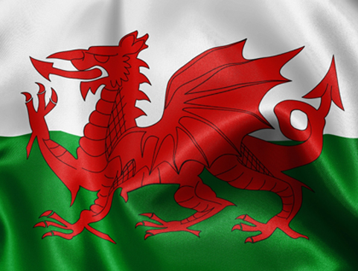

https://www.bing.com/images/search?view=detailV2&ccid=KeqnT1av&id=4B87B87E68BFE4F2EFDE1619679D07371E47507F&thid=OIP.KeqnT1avmHWl6VH_y1cBGgHaFm&mediaurl=https%3A%2F%2Fnathenamin.files.wordpress.com%2F2011%2F11%2Fwelshflag.jpg&exph=364&expw=481&q=wales+flag&simid=608038988723129881&ck=D203FBD0F7F733A301B74CF40696A63C&selectedindex=4&form=IRPRST&ajaxhist=0&vt=0&sim=11

By Chloe Speirs
2000729

Contents
Introduction……………………………………………………………………………………………………………..3
Main Body……………………………………………………………………………………………………………….3-5
Conclusion………………………………………………………………………………………………………………..6
References……………………………………………………………………………………………………………….7-8
Appendix……………………………………………………………………………………………………………………9

Introduction
This essay will be focusing on evaluating the provision of the tourism and leisure industry, the essay will focus on the International tourism market, as well as the inbound tourism. During this essay and will be concentrating on the impacts and effects tourism will have on the individual country, the researcher will be focusing on investigating the impacts and effects the outbound tourism has on Wales. In addition to this will also show how Wales as a country is adapting to the new circumstances that they are faced with; this is including Coronavirus. Furthermore, the researcher will also look in more depth about how the Welsh government and other Welsh tourism organizations have helped with the increase or decrease in tourism throughout Wales. This then will be followed by the researcher investigating if there has been a decline or a rise in the amount of international tourists visiting Wales, over the years and examining why the decline or rise has happened and what effect it has had on the inbound tourism. Besides this we will also be considering and explaining the Maslow’s needs hierarchy.

Wales leisure and tourism sector plays a massive role within the economy of the country. As this is what entices the people into the cities, villages, and towns of Wales. There are numerous cities and villages that attract customers to Wales but the main one is the Capital city which is Cardiff. Cardiff is the home to several major attractions, including museums, castles, and shopping arcades, but the main attractions are the Principality Stadium and St Fagan’s National Museum of History (TripAdvisor. 2020). Cardiff newsroom. (2018) says that in 2017, 20.30 million people visited the city, this was a 5% increase since 2017. On the other hand, statistics from VisitBritain (2019) shows the researcher that 382,000 inbound tourists stayed within Cardiff in 2019, this was an increase from the previous year.
Wales as a country offers numerous tourism and leisure attractions from entertainment parks to museums and art galleries. Wales is also the home to around 600 castles (Wales. 2020), heritage railways, beaches and 3 national parks, that attract both international and British tourists, due to the beautiful scenery (npapa. N.d).
Considering that there are countless attractions within Wales. Dearsley, B. (2019) article shows that the top attractions include Brecon Beacons National Park, Snowdonia National Park, Caernarfon Castle and National Slate Museum.
As well as major attractions, Wales also offers some of the most gorgeous destinations, with amazing scenery. Touropia (2020) shows that Llandudno, Pembrokeshire Coast, Conwy and Cardiff are included amongst these destinations. An article from VisitWales. (2019) shows that Wales was listed in the ‘Rough Guide’s’ most beautiful countries in 2019, and then Castle Beach in Tenby was awarded the Beach of the year by ‘The Sunday Times’. This is good publicity and will attract the international tourists to stay and visit these destinations.

Wales has a range of both international and domestic visitors, but Wales main interest is to entice the international customers, as these are more likely to use other leisure and hospitality facilities. The Welsh Government (2019) shows that the amount of international trips increased by 3.6% in 2019 to 1,023,000, it also shows that the visitor spending in 2019 increased by 18.8% from the same time in 2018, it rose to £515 million.
The Welsh Government (2019) also shows us that there was a decline in domestic tourism, as there was a decrease of 8.8%, which resulted in 87,300,000 tourism day visits.
Linking to appendix 1, the table shows us that there was around a 12.8% decrease from 2017, which resulted in 941,000 trips to Wales from international tourists, on the other hand the international customer expenditure grew to £405 million, this was an increase of 9.7% from 2017. (Welsh Government. 2019) There are several explanations why the international visits were down in 2018, such as Brexit and terror attacks.
The tourism and leisure industry has been hit hard throughout 2020 due to the global pandemic. This has led to nearly all organizations within the Leisure, Travel and Events sector closing, as BBC News.(2020) statistics shows that 97% of business needed to close due to coronavirus, this had major consequences on the economy as there was either a decline in sales or no sales at all. The number of international tourists entering Wales throughout this year has declined massively due to the 5 miles travel restriction placed throughout Wales.
UNWTO. (2020) shows us that within the first 3 months of 2020, international tourists visits had already fallen by 22% and was shown to carry on declining throughout the year. Also, the amount of international tourist entering the United Kingdom declined by 57% due to many countries entering lockdown.
As the above information states that million of international tourists visit Wales a year, this includes all types of visitors, as Wales tourism and leisure sector has something for everyone, including all ages, genders, disability, race, and income. However, according to Welsh Government (2017) Wales attracted more 16 to 34-year-old compared to 2013, whereas the number of 55 plus year old’s visiting Wales had decreased.
For the tourism and leisure industry to attract customers both old and new the organization must make sure that they are meeting all the individual’s needs. According to Maslow’s hierarchy, Pichere, P. (2015) there are five sections of needs, these include, physiological, security, recognition, esteem, and personal accomplishment needs. The employees working within the tourism industry must make sure that the customers’ needs are met from bottom to top, as the customers cannot have self-esteem unless they feel belonginess and loved within a group. Businesses must make sure that you work your way up the hierarchy. See appendix 2, this shows the different levels of needs. The lowest on the hierarchy being physiological, this consists of food, sleep, warmth, and water. This then leads to the second need which is security, if the customers feel safe and relaxed within the environment then there are more likely to return. The third tier is belonging, this is when the customer feels loved and wanted within a group. The fourth level is esteem, this relates to the money and power that defines who we are in today’s society. The final tier, which is the need for personal accomplishment, this is a need that only the individual can achieve by themselves, whereas the others needs you would depend on others.
Within Wales there are numerous stakeholders that make up the tourism and leisure industry, these can be separated into 3 sectors, this includes private, public, and voluntary. The private sector is where most tourism and leisure companies belong, the central objective is to make a profit, an example is the Holiday Inn, Oakwood Theme Park and many more businesses within Wales. The public sector is funded by the national and local government, so Visit Wales, the Welsh Government and Cadar fund the tourism, leisure, and hospitality businesses within Wales. A voluntary organization is usually founded by trusts or charities, these include the National Trust. (Stravelandtourism. N/d)
There are 3 main impact areas that effects this leisure, tourism, and events sector, these include environmental, economic, and social.
There are several social impacts that are positive towards the sector. These include the creation of jobs for local people, it brings communities together and it will give the local community a change to learn and experience new cultures. On the other hand, there are also many negatives such as loss of the local language for example the Welsh language, the erosion of the local community values and it could also lead to clashes between the cultures.
There is a mixture of both positives and negatives for economic impacts within the sector. The positives impact includes the creation of jobs, promotion of the local county and it increases the property values within the place. International tourists create a movement within the foreign currencies into the economy of Wales (Archer, B & Cooper, C & Ruhanen, N.d) (P. 79-82). Although there are many positives there is also several negatives, these incorporates money being drawn out of the local economy, there will also be limited employment, for example seasonal jobs.
The positive impacts that environmental brings to the tourism and leisure industry consists of aesthetic improvements, contributes to preservation area such as open spaces, and enforced regulations. However, there is also many negatives impact that they bring to the sector, some of these are major pollution, habitat loss, physical erosion and both human and vehicle congestion. (Aware Impact. 2019)
There are several impacts that are affecting the tourism and leisure industry, the main one this year being COVID-19, this has had lasting effects on the industry as there was billions of revenue lost throughout organizations within the sector. This has been the worst issue that Wales tourism industry has faced, as for a period of 3 months, the majority of organizations relating to the tourism industry, were shut completely, this meant no sales of income going into the business, the only revenue was what the Government had offered these organizations. The pandemic is still influencing the industry as the international visitors still can not enter Wales or any other country within Great Britain. It is still also affecting the domestic tourism as there are still several travel restrictions in place.
Conclusion
To conclude with the Tourism and Leisure industry will still struggle at the beginning of 2021 with attracting international tourists. This is due to the uncertainty of COVID-19 and whether more national lockdown will be introduced, this could be within the UK or the international country. The researcher also believes that comes winter 2021 there will start to be an incline in the number of international tourists visiting Wales, this will be due to the amount of time they have been stuck within the same city and them wanting to escape and experience new cultures. The author also thinks that both the domestic and international tourist visiting Wales will increase, as the pandemic has made people realize how valuable holidays were and how much visiting other countries impact their everyday lives. So, even though the leisure, events and tourism sector has struggled throughout 2020, the researcher believes that the industry will come out much stronger and will see a major boost in the number of tourists entering Wales.

References
- Cardiff Newsroom. (2018) Cardiff boasts record visitor numbers as industry experts prepare for Cardiff Tourism Summit 2018. Available at: https://www.cardiffnewsroom.co.uk/releases/c25/18168.html#:~:text=%2D%20During%202017%2C%2021.30%20million%20people,more%20than%20the%20year%20before.&text=This%20success%20comes%20as%20some,meet%20at%20Cardiff%20Tourism%20Summit. Accessed on: (27/11/2020)
- Dearsley, B. (2019) 14 Top-Rated Tourist Attractions in Wales. Available at:https://www.planetware.com/tourist-attractions/wales-w.htm#:~:text=Perhaps%20the%20most%20photographic%20of%20Wales%27%20many%20castles%2C,to%20do%20so%20in%20your%20Cardiff%20sightseeing%20itinerary Accessed on: (30/11/2020)
- National Museum Wales. (2020) Cumulative Visitor Figures: 2019-2020. Available on: https://museum.wales/visitor-figures/cumulative-2019-20/. Accessed on: (02/12/2020)
- Npapa. (n.d) National Parks of Wales. Available at: National Parks of Wales (npapa.org.uk) Accessed on: (30/11/2020)
- Pichere, P. (2015) Maslow’s Hierarchy of Needs. Available at: - VleReader Accessed on: (03/12/2020)
- Stravelandtourism. (N/d) Public, Private and Voluntary Sector. Available at: Public, Private and Voluntary sector - Travel and Tourism industry (weebly.com) Accessed on: (03/12/2020)
- Touropia. (2020) 10 Best Places to Visit in Wales. Available at: 10 Best Places to Visit in Wales (with Map & Photos) - Touropia Accessed on: (30/11/2020)
- TripAdvisor. (2020) Things to Do in Cardiff. Available at: https://www.tripadvisor.co.uk/Attractions-g186460-Activities-Cardiff_South_Wales_Wales.html Accessed on: (30/11/2020)
- UNWTO. (2020) International Tourist Numbers Could Fall 60-80% in 2020. Available at: International Tourist Numbers Could Fall 60-80% in 2020, UNWTO Reports | UNWTO Accessed on: (03/12/2020)
- VisitWales. (2019) Award-winning Wales. Available at: Award-winning Wales | Visit Wales. Accessed on: (01/12/2020)
- Wales Government. (2019) Wales Tourism Performance Report January to December 2018. Available on: https://gov.wales/sites/default/files/statistics-and-research/2019-06/wales-tourism-performance-report-january-to-december-2018.pdf. Accessed on: (02/12/2020)
- Wales. (2020) Castle Country. Available at: https://www.wales.com/about/culture/castles Accessed on: (30/11/2020)
- Welsh Government. (2020) Wales Tourism Performance:2019. Available at: Wales tourism performance: 2019 | GOV.WALES Accessed on: (02/12/2020)
- Welsh Government. (2017) Wales Visitor Survey 2016: UK Day Visitors. Available at: Wales Visitor Survey 2016: UK Day Visitors (gov.wales). Accessed on: (04/12/2020)
- VisitBritain. (2019) Inbound Town Data. Available at: Inbound town data | VisitBritain. Accessed on: (04/12/2020)
- Archer, B & Cooper, C & Ruhanen, L. ( N.d) The Positive and Negative Impacts of tourism. P. 79-82. Available at: Global Tourism - Google Books Accessed on: (04/12/2020)
- Aware Impact. (2019) 10 Negative Effect of Tourism You Should Know About. Available at: 10 Negative Effects of Tourism You Should Know About - Aware Impact. Accessed on: (04/12/2020)
- BBC News. (2020) Coronavirus: Lockdown Review Gives Wales Tourism Sector ‘Hope’. Available at: Coronavirus: Lockdown review gives Wales tourism sector 'hope' - BBC News. Accessed on (04/12/2020)

Appendix
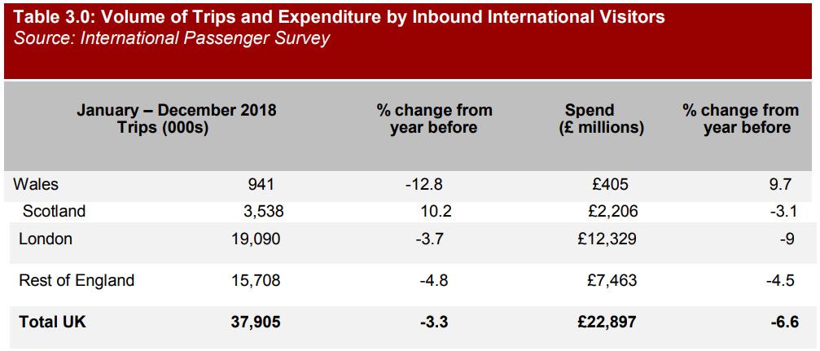
Appendix 1

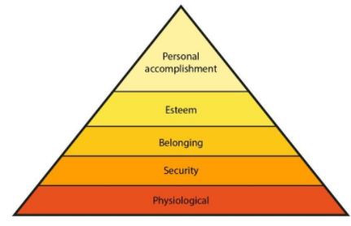
Appendix 2
(Pichere,P. 2015)

