Game Design and Critical Analysis (M6X02045)
Animation
Animating within Maya and Motion Builder Using Motion Capture
Chantelle Louise Hillman P141328
Creative Computer Games Design
5498 words (Not including references, bibliograpgy, contents and declaration)
Lecturer: John Carroll
Declaration
Declaration

I certify that this undergraduate Critical Analysis has not been accepted in any degree and is not under the submission for any degree or qualification – other than that of an undergraduate degree in BA Creative Computer Games Design at the University of Wales Trinity Saint David. I also declare that this work is the result of my own investigations, except where identified by references and free from plagiarism of the work of others.

Student Signature:
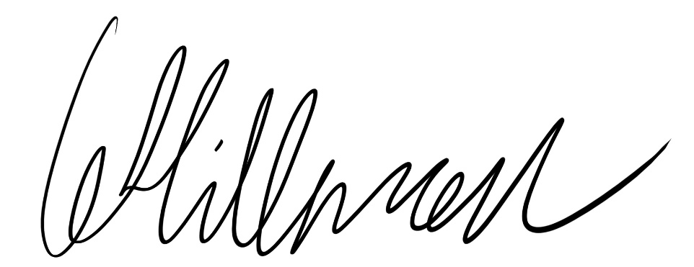

Date: 13/12/17

Abstract
This project is an experimental project which alongside had a written piece, this is the written piece.
A subject had to be chosen for the experiment to be on, and for this project the chosen subject was animating within Maya and animating using Motion Capture, the Gyro suit for Motion Capture and then completing the animations within Motion builder.
The experiment had to be timed, so two hours was given to each test and as much as possible had to be completed within them two hours.
The experiment had to be kept fair and none biased as possible to get the best results possible, although this can be quite hard to complete due to a variety of reasons
The methodology within this written piece was supposed to help work out how to conduct the tests, then the results sections spoke about the data which was gathered at the end of the tests, this data was the results of the tests. Once the results section had been completed an analysis section was then written up, this analysed the data which was collected and spoke about an overall outcome of the end results.

Contents

INTRODUCTION Page 4

LITERATURE REVIEW Page 5 - 6

MAIN BODY Page 7 - 12
Methodology Page 7 - 8

Results Page 9 - 10

Analysis Page 11 - 14

Conclusion Page 15

Further Work Page 16

REFERENCES Page 15

BIBLIOGRAPHY Page 17 - 18
Introduction
This written piece is for an experimental project which will be conducted throughout the first semester, a subject will need to be chosen at the start of the project of what will conducted during the experiment. Once a subject has been chosen for the experiment a methodology will need to be written up explaining what will be happening during the experiment, when it will be happening, where the experiment will be taking place and why it is taking place. Also during the methodology how the experiment is going to happen will need to note down, all this information will be looked back upon during the experiment to make sure that everything stays on track.
After the methodology has been created the experiment will then begin and notes will be taken down of what happens during the experiment along with videos which will be captured of what happens. These notes and videos will be used to write up the results section of this written piece along with the analysis as they will need to be analysed later on to come up with the end results of this experiment.
The results will be noted down during this project of what happened during the tests, once this part has been completed the results will then be analysed in the analysis section.
The results section will contain what happened during these tests for both Maya and Motion Builder, this section will also mention is the tests were kept fair or not plus how and why. Within this analysis section there will be three parts, one talking about using Maya, another part talking about using Motion Builder and the final part which will talk about the overall outcome. There will be a little bit of research which will be carried out to further help reach this final outcome, the final results of the test, as this test was to figure out which of the two programs would be better to use, the pros and cons of using each of the programs by analysing the different aspects of the programs.

Literature Review
For this experimentation project a comparison between creating animations using Maya and creating animations using MotionCapture, the Gyro Suit and MotionBuilder. These two program animate characters in completely different ways, where in Maya you need to create the animations by hand and mouse, whereas in MotionBuilder, the Gyro Suit collects the movement data from a person who is wearing it then analyses it and sends it to MotionBuilder.

The experiment in this project is to find out which of these programs is better to animate with, alongside finding their pros and cons, why they are good and why they are bad, each piece of software has their good and bad points and this experiment will find at least some of those points if not all. Although to find all good and bad points of using certain software would take a large amount of time, which means the software would have to be used nearly every day such as when working in a job that uses the software, as you are working with it every day you will learn new things, both good and bad.

For this project a character has already been rigged, all that is needed to be done to it is the animations being added, here is an image of the rigged character, a simple humanoid character.
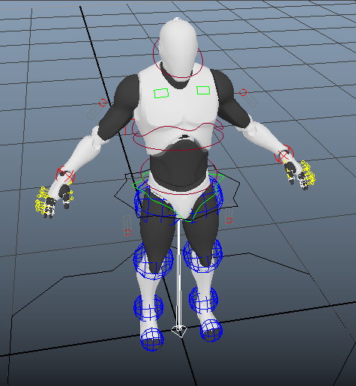

The software and equipment which will be used is listed below along with a description;
- Maya is a 3D Computer Graphics Software in which people can create 3D animations, Models and simulations, it is also used as rendering software and also provides an integrated powerful toolset. It can be used for animations, environments, motion graphics, virtual reality and character creation.
- MotionBuilder is 3D Animation Software which is used to capture, edit and play back complex characters animations in a highly responsive and interactive environment. This software has a display that is optimized for both animators and directors.
- The Gyro Suit which is also used for Animation within MotionBuilder is a suit that when a person is wearing will capture movement by sensors being placed on or near each joint in the body. While the person wearing the Gyro Suit is moving the movement is recorded and then analysed.

During this experimental project a methodology will be created to organise how the experiment is going to happen, what will need to be done, when and how, this will help find out the information that is require plus any possible problems that could be encountered.
Once the methodology has been the experiment will then be conducted and data will be collected and written down then analysed, what went well about the project and what didn’t will be noted and spoken about within the written piece alongside which software is better to use if there is one if not it will be explained why there isn’t.

One way for the data to be collected which is required a small list of animations will need to be created, they will have a small description next to each animation saying exactly what it is, how they should move etc. this will help keep the workload and the data balanced so nothing is biased.
If anything changed during the project, this will also have to been noted down and explained why certain things were changed and how, this will be alongside any problems encountered during the experiment. There are many things which will have to be considered when creating the methodology such as the list of animations listed before, also the rigged character, it may be rigged in Maya but some sort of skeleton will need to be added within MotionBuilder too, there will be other considerations to be made too.

During this project an experiment will be conducted on two pieces of software which are; Maya and MotionBuilder along with the Gyro Suit as the equipment, the frames within the software will be looked at to see which is better, what fixes are needed to be done etc. The Gyro Suit will be used to create the animations, this will also save, analyse and send the animations to the software. These two pieces of software will be compared with each other to see which is better to use, nothing should be unbalanced or biased within the project, and this will help reach a more accurate conclusion.

Main Body
Methodology
This experiment is to test which program is better than the other along with the pros and cons of each of the programs, these programs are Maya and Motion Builder.
During this project several things will need to be taken into consideration when conducting the experiment such as biased and unbiased data, as much data as possible needs to be balanced to get accurate results.

The first thing to do to prepare for the experiment is to make sure that a rigged model is ready to use within Maya and another ready to use within MotionBuilder, once this is done a short animation list should be created for the characters. Both of these two tasks will help keep the work balanced and nonbiased and also the results more accurate, if anything changes at any point during the experiment with these two tasks this will need to be analysed later on in the analysis section.
Part of the first two tasks have been completed already, from the start of the project a rigged character was acquired for Maya, this character is ready to be animated so the only task left there would be to create a skeleton for the character within MotionBuilder.
Once the character has had a skeleton completed on it within MotionBuilder the animating is then ready to be started. As Maya is software that is used quite frequently more time may be spent within MotionBuilder getting used to the controls, layout, also the look of it and how it works etc. before the experiment starts some time is been out into using MotionBuilder to get used to these things.

The experiment will be conducted by two people if possible, a third person may be required if any help is needed which during this experimental project help may be needed when using the Gyro Suit. A second person is there in case the first cannot conduct the experiment, so the experiment will be conducted by the person who has the project to complete, then if possible a second person as a second source.

For this project, the person who will be animating will need to take record and take notes, although they should try not to be biased as they have only worked within one of the programs properly before for other projects. As for the experiment, something that will be looked at during it is time, how long it will take to animate the character within the two engines, again though this is slightly biased as the person has worked within Maya for a while whereas she hasn’t worked within MotionBuilder on a character before.
Due to the problem, he/she might be better taking down notes, then organising them into two sections (possibly more), of ‘opinions’ and then any ‘issues encountered’. As Maya has been used plenty before some notes have been on some pros and cons associated with Maya, these also include opinions.

A second way of conducting the experiment is to set a set amount of animations to complete within a set time limit, possibly 3, maybe less depending on the animations chosen, but then if the animations can be completed within the time the test works and show how well the engine is, if it doesn’t work it shows how it doesn’t, one test will be working within Maya, another working within MotionBuilder. After the tests have been completed both these will need to be compared with each other plus any notes that were taken, recordings should also be taken while the tests are being conducted as this will help further with collecting data.
Another way to try and keep the work, data and results balanced would be to try and complete work in the same environment each time, as in every different environment people feel and act differently. So if some work was done at home and other bits were completed within University, more may be done within University due to the environment, there aren’t as many distraction as there would be at home.

Also a way to get a slight feel of how MotionBuilder is would be to research what other people have said about it plus other websites, this may also help when finding things out, as some people could say stuff which may not be found out while using the software during this experiment. Software can take a very long time to get used to and learn everything about it, during this experiment there isn’t enough time to do this. There could be a bug within MotionBuilder which may not be encountered during this project but someone else may have found it and taken note on it.
Data from questionnaires/surveys are something else which will be gathered to help towards the results of this project, the data which will be collected from people and the data which will be collected first hand will be compared between one another and then analysed.

Results
At the start of this project a rigged character had been collected ready for animating on within Maya, all the needed to be collected was the character ready within MotionBuilder, this was collected not long after the methodology section of this had been written, collecting this rather than making it from scratch help the project progress on faster.

Once these had both been collected the experiments then started, firstly starting with collecting the required MotionCapture data, this required someone to wear the suit for MotionCapture. The person wearing the suit was told what to do, what animations were required and how to be done, the person had to also be told the area he had to stick in for the data to be captured without the suit disconnecting from the computer. The area for this had to be worked out, so the person wearing the suit had to walk around while someone was watching the computer and watching if the suit disconnected, then another person had to pass on the message to the person wearing the suit on what was happening.

Once everything had been worked out for the suit the animations within Maya were started, while this was happening notes were taken on problems that were encountered and anything that was liked within Maya. Afterwards the animator attempted to create animations within MotionBuilder, this test was incomplete for a few reasons, the first time when creating the animation within MotionBuilder, it was not being recorded and later on the data was lost, and as there were only two hours to get as much as possible done, no animations had been completed. This part of test was going to be continued later on to see how long it would take to finish an animation within Motion Builder, however this didn’t happen in the end as other tasks had to be completed too.
As only one animation had been started and not complete within the given two hours and it took a long time to complete just one animation in the end, the run animation was not started.

The experiment did not go as well as expected, recordings were taken while the animations were being created to show how the progress was going along, the videos are still in the files on an external hard drive, but they would not play on some computers or only on certain software, luckily notes had also been taken on what went well and any problems that occurred during the recordings.
Within two hours on Maya, two animations had been created before the two hours had ended, whereas in MotionBuilder no animations had been completed, the test wasn’t continued later, as other tasks had to be completed, but this was going to be for; to find out how long it would take to complete the animation though.

For someone who has been working within Maya for a few years and in MotionBuilder for only a few weeks, Maya is a lot quicker and easier to use, there may be problems encountered but it’s easier to solve these problems too. This also makes the test unfair as one program was known better than the other, but this was something that could not be changed easily unless this test was conducted in a couple of years’ time instead and MotionBuilder was used a lot more throughout those two years.

For the second part of this experiment information was going to be collected from another person who had animated within MotionBuilder and Maya, however this did not happen as other tasks had to be completed. So work was being completed most of the time which led to forgetting to ask the other animator of his experience within the two programs. However collecting these notes could have helped further show the differences between the two programs, show people which one could possibly work better, the pros and cons of using the two different programs, unfortunately as said before this information was unable to be collected.

As said earlier notes had been taken on the different programs to help later on when analysing the results, here are the notes which were taking down:

Maya
- References are needed to get the animation mostly correct.
- Placing the controls in the right place is easy, easy to move controls.
- Editing the graph can get a little annoying if all the controls aren’t selected, if all controls aren’t selected when expanding then only that controls animations will be expanded, easy mistake to make.
- Not so much clean up when animating within Maya as controls have been placed individually and are most likely in the right place or close to it.
- Fortunately the problem with gimbal lock did not occur, a horrible problem to fix where the control messes up during the animation.
- Personal opinion - Maya was easy to learn, also due to simple videos which were given to me early on in university.
- However this was a skeleton already rigged by someone else which was collected, and the rig was unknown, I didn’t know how to fully use it as first and so I was confused when a control was selected and when a joint was selected.
- Keep forgetting to set key frames.

Motion Builder
- Animating was fun to experience.
- However the software didn’t fully capture the animation, it was off, out of place, messed up too.
- Connecting the joints to actor a little confusing at first but understood it after a little bit.
- A lot of clean up.
- Hard to work out how to clean up properly, took a while to get it all right.
- Seems longer to animate within Motion Builder, but if you count all the rigging and skinning within Maya they could be the same, the same amount of time to animate.
- Too much clean up
- First animation incomplete and second not even started.
- However I found it fun to learn and to animation, watching someone else using the motion suit and telling them what to do and how to do it was amusing to watch.

Analysis
Maya
As Maya has been used before animations were created a lot quicker, although not without any problems, many problems were encountered while animating. Maya was an easy program to learn to animate within, as videos were also used to help guide through how things worked within the program, what to do and how to do it.
There are two type of problems which were encountered while trying to animate within Maya, the ones which were not the animators fault and ones which were, so these could be a glitch within the software itself (not animators fault) or controls not being keyed, they had no key frames, so when the frames were changed everything that was put in a place would change (animators fault).

So the problems which were encountered during animating within Maya which were the animators fault were:
Firstly key frames were being set on joints and not controls this got a little confusing on times as the animator got confused on times when the joint was or wasn’t selected and when the control was or wasn’t too.

Secondly the animator kept forgetting every so often to actually set the key frames on controls, so when the frames were changed to another to position the controls, they would go back and realise the character wasn’t in the position they set them.
Another issue was that controls had to be changed due to not being in the right position the first time around. Animations will not be perfect the first time around and controls will need to be moved and changed whether that be a bit of a lot, this is why reference videos/images are used to help create a better animation.

The final issue was the animator not selecting all the point on the animation graph as all the controls had not been selected either. So when expanding on the graph it would only expand certain animations for certain joints, this had to be undone then all controls selected then all point in the graph selected then expanded.
All of these problems were problems that could be fixed, some took more time than others and some were more complicated than others, but they were all fixed in the end.

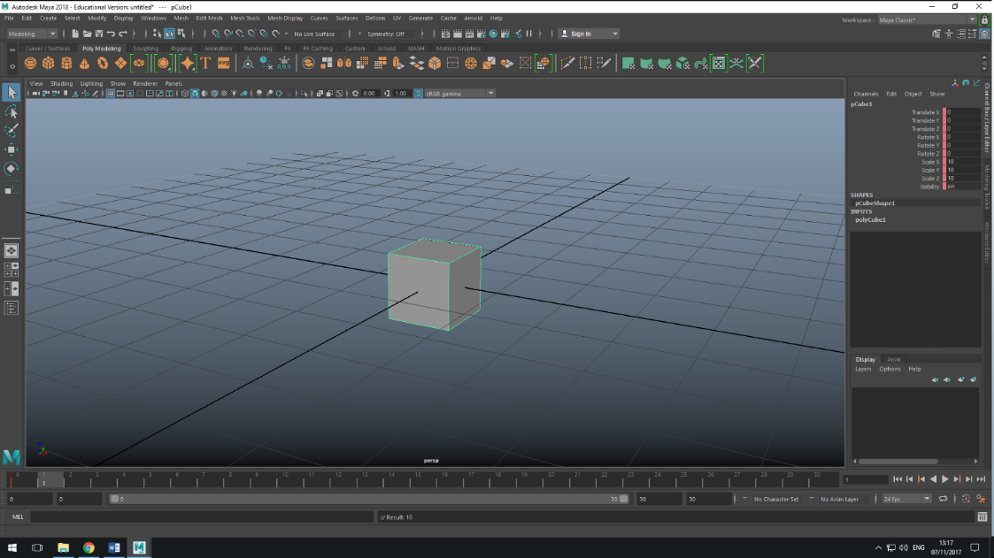
The problems which were encountered in Maya which were not the animators fault were; joints had key frames on them still even though they had been removed from the frames section, as the image below shows there is a key frame on the object set, this was not there for the joint which was moving as if it had a key frame on it.
Unfortunately this problem took a while to try and fix, as both the joint and control had to have ant frames deleted on them at the time required, and they had to be put back to their original positions to get this working, and finding this out took up quite a bit of time.

Another problem which was encountered was; when trying to set key frames on controls that had to be changed they wouldn’t always set them. So a frame would be set, then need to be changed slightly then set again but it wouldn’t set it, so when the frame was changed to another to be sorted it would return to its previous position. This had to be fixed by completely deleting the frame and placing the control in the right place again then setting the key frame, this problem didn’t take as long to figure out although it took a little bit of time placing the controls in the right position.

MotionBuilder
Once the Maya test had ended MotionBuilder was then used to create animation from MotionCapture data which was caught using the Mocap Suit. Again this test was going to be around 2 hours long, this was to keep the experiment as fair as possible.
MotionCapture hadn’t been used before this project by the animator as they had stuck to animating within Maya, the only time it had been used was a little before the test to try and understand the basics of the program, so this helped a little with the experiment.

This test was incomplete as no animations were fully completed within MotionBuilder due to several problems and due to the animator not fully understanding the program very well.
MotionBuilder can be a useful program to use if the person knows how to the use the program enough, this means knowing how to actually clean up characters and to attack the animation to the character itself. During this experiment a video was being watched on how to animate within MotionBuilder to help alongside while attempting to animate.
An actor was being used within MotionBuilder in place of the character for later on, so the actor would be animated then the actual character would be placed in later on once the actor has been set up and animated.
While using MotionBuilder as said before several problems were encountered, this made animating the character a lot harder and ended up being incomplete. The problems which were encountered were:

Firstly was connecting the right joints from the animation to the right joints on the actor, this was hard to figure out at first because then came the clean-up of the character.
So secondly was the clean-up, certain parts of the animation were simple to clean up but other parts could not be figured out at first, so different things had to be tested out. After trying what the video suggested to do, something else was tested out, on the joints on the actor there was an “orientated” section with check boxes, so checking these boxes was tested to see what would happen. It turned out this actually helped clean-up the animations a lot more, although they still weren’t perfect, but it wouldn’t be found out how well the animations were until the actor was replaced with the character. Unfortunately by the end of the time limit this was not reached, although this was going to be continued later on to find out more about MotionBuilder and the animation which was being created, also at this point there was no point in even starting the run animation as the test had ended.

The continuation of the animation after the test had ended was to find out how long it would take to finish a single animation using MotionCapture and MotionBuilder, this would help get a rough estimate for how long it would’ve taken to complete the run animation.
Thirdly when following the video trying to import the character over it was different on the video compared to what was happening in MotionBuilder there and then trying to animate, so this caused another problem trying to figure that out, but by the end of the time period this problem had not been solved.

Some research was conducted into the different program, looking at people’s opinions about them and what review websites say about them, some websites/people go on about Maya being one of the best programs to use;

“Autodesk’s Maya is simply one of the best, most robust, and most versatile software available.” Animation Mentor, (2014)

This was said on a blog, everyone has their own opinions and experiences with the different types of software, everybody experiences problems these could be the same or different problems. There are also other comments which say that Maya was great program to use but there were issues;

“I had last used the program when it was Maya 2015 and although the program was obviously top notch, I found it difficult to use and, frankly, intimidating.” Ricky Grove, (2017)

This shows that Maya may be a good program to use but there will be complications/problems which will be encountered when using it, this could be with the animations or the program itself. However the same can be said for Motion Builder, it seems to be a good program but there will be complications and problems when using the program, here are some comments from sites which people have said about Motion Builder;

“I'd dare say it's one of the best animation packages available to date.” Sergio Rosa, (2015)

“Damn! What a mess!” Sven, (2010)

The last comment here was a reply to a question “What do you think about MotionBuilder 2011?”, after explaining the problems this user encountered this was his final response to the question, so again as said before problem will be encountered although it can be a good program to use to animate. Also review websites can be very biased towards what they are reviewing, they will point out all the points about the item being reviewed but will point out very little or none of the problems with it.

Overall
Animating in Maya takes longer than animating using Mocap, as with Mocap it’s just a person wearing the Mocap suit and moving, the movements get recorded on a computer and then they get imported into MotionBuilder. Whereas in Maya the person has to place each joint separately in their own positions, this would also require having some sort of reference whether these be animatic drawings or videos. However there is less clean-up work to do within Maya than there is within Motion Builder, as with Maya the joints would have been placed close to or in the right position from the start and so afterwards only slight adjustments would need to be made.
Whereas animating using MotionCapture it is harder for the software to collect accurate data of the movements from when using the MotionCapture Suit, due to this more clean-up of the animations is required. The clean-up in Motion Builder will be sorting the different part of the body out making sure they are in the right place and facing the right way too, this can be a bit more complicated to clean up as found out during the experiment.

Both of these programs are good to use although as everybody learns different some people may learn one program easier than the other whereas others may learn both as easy or as hard. People will most likely always encounter some sort of problem when using the two different programs, whether this be with the software itself of with the animations etc. and each experience with the programs will be different than the last.
To attempt to keep this experiment fair, the times were kept the same for each test so 2 hours were given towards each test and any extra time that would have been required was noted down, along with if there was any time left over. In the end only two animations were required to be made, however by the end of the experiment as said earlier on not a single animation had been within MotionBuilder although two had been made within Maya.

Conclusion
This written piece is for an experiment which was conducted for this project, the experiment was about animation, animating within Maya and animating using MotionCapture. The experiment was to find out which program is better to use than the other, also to find out the pros and cons of using each.

Firstly a methodology was created for the experiment explaining what was going to happen during the experiment, what should be done, how, where and when, it also explain how to try and keep the tests as fair as possible. The methodology also says why the experiment will be carried out, saying that it is to find out which is the better program along with any pros and cons of using the two programs.

Once the methodology had been created the results from the tests were gathered and spoken about within this. The results section spoke about what happened within both of the tests, also what was spoken about was if anything else had to be sorted out before the tests were started, so for Motion Capture the suit had to be set up and an area had to be worked out for where the animations could be recorded. Also what was spoken about within the results section was the fairness of the tests, whether they were or weren’t fair and why.
Once the results had be spoken about these then had to be analysed and both programs compared against each other. The analysis section was split up into three parts, one part talking about Maya, another part talking about Motion Builder and then the final section which spoke about the overall outcome of the analysed results.
During the analysis section of this written piece some research was conducted to have a look at other people’s opinions on the programs to further help gather the final results for the project.

Further Work
During this project if more time was given or the project was continued another time there are a few things which could have also been researched or conducted to get a more accurate answer. Firstly one way to get a more accurate answer and more pros and cons of the software would be to have a couple more people to conduct the tests, this could be people that are new to the programs, or one person how knows one and the other person knows the other, or both people know both programs. As the second option out of those three would end up being more biased answers the first or third options would be a lot better to stick with, but this is another test that could’ve been conducted for this project.

Another thing that could’ve been done for the work would’ve been more research, so surveys/questionnaires could’ve been created and handed out to specific people, people who have used at least one of the programs before. These surveys/questionnaires would collect information on what the users think of the programs, their views on the pros and cons of the programs and which one they believe is better if the user has used both. Although these answers again can be quite biased if the user has only used one of the programs as they would most likely think the program they have used is better than the other. Also this one could be quite a difficult task to complete as it would be hard finding many people who have used one of the programs, as it requires looking and sending links out in the right place.

References
- Animation Mentor Blog. (2014). 5 Reasons Why 3D Animators Should Know Autodesk Maya ®. [online] Available at: http://blog.animationmentor.com/5-reasons-why-3d-animators-should-know-autodesk-maya/ [Accessed 7 Nov. 2017].

- Forums.autodesk.com. (2010). What do you think of MotionBuilder 2011?. [online] Available at: https://forums.autodesk.com/t5/motionbuilder-forum/what-do-you-think-of-motionbuilder-2011/td-p/4143227 [Accessed 7 Nov. 2017].

- Grove, R. (2017). Review: Autodesk's Maya 2017. [online] Renderosity Magazine. Available at: http://renderositymagazine.com/review-autodesks-maya-2017-cms-1030 [Accessed 7 Nov. 2017].

- Rosa, S. (2015). Review: Autodesk's MotionBuilder 2016. [online] Renderosity Magazine. Available at: http://renderositymagazine.com/review-autodesks-motionbuilder-2016-cms-208 [Accessed 7 Nov. 2017].

Bibliography
- Autodesk.co.uk. (n.d.). Company. [online] Available at: http://www.autodesk.co.uk/adsk/servlet/index?siteID=452932&id=16032914 [Accessed 7 Nov. 2017].

- Edulearn.com. (n.d.). What is Autodesk Maya?. [online] Available at: https://www.edulearn.com/article/what_is_autodesk_maya.html [Accessed 21 Oct. 2017].

- Images.autodesk.com. (n.d.). Cite a Website - Cite This For Me. [online] Available at: http://images.autodesk.com/apac_anz/files/motionbuilder_top_reasons_to_buy_brochure_us.pdf [Accessed 21 Oct. 2017].

- Images.autodesk.com. (n.d.). Cite a Website - Cite This For Me. [online] Available at: http://images.autodesk.com/adsk/files/motionbuilder_top_reasons_to_buy_us.pdf [Accessed 17 Oct. 2017].

- Maestri, G. (2014). Learning MotionBuilder. [online] Lynda.com - from LinkedIn. Available at: https://www.lynda.com/3D-Animation-Animation-tutorials/Up-Running-MotionBuilder/180809-2.html [Accessed 17 Oct. 2017].

- Majendie, T. (2011). Characterization & Mocap Animation in MotionBuilder. [online] Vimeo. Available at: https://vimeo.com/25409312 [Accessed 17 Oct. 2017].

- Motions, T. (2015). MotionBuilder to Unreal Engine, Character Animation Retargeting Tutorial. [online] YouTube. Available at: https://www.youtube.com/watch?v=C6nmvcMSjzE [Accessed 17 Oct. 2017].

- Parry, K. (2017). 100 Different Ways to Walk (Animation Reference). [online] YouTube. Available at: https://www.youtube.com/watch?v=HEoUhlesN9E [Accessed 7 Nov. 2017].

- Tutorials, M., Guides, M. and Tutorials, M. (n.d.). How to Rig a Character for MotionBuilder - Mocappys. [online] Mocappys. Available at: http://mocappys.com/how-to-rig-a-character-for-motionbuilder/#.WiZopkpl-71 [Accessed 17 Oct. 2017].

- Twycross, J. (2012). MotionBuilder part 1 - Using actors & motion capture data. [online] YouTube. Available at: https://www.youtube.com/watch?v=6k1ul5SGIUE [Accessed 17 Oct. 2017].

- YouTube. (2015). ALAN BECKER - Animating Run Cycles. [online] Available at: https://www.youtube.com/watch?v=jggdbxTJPG4 [Accessed 7 Nov. 2017].

- YouTube. (2015). Dancing Types A-Z. [online] Available at: https://www.youtube.com/watch?v=r5QiYGVpvZE [Accessed 7 Nov. 2017].

- YouTube. (2011). Run Cycle - Animation Reference. [online] Available at: https://www.youtube.com/watch?v=lCpotGr0TB4 [Accessed 7 Nov. 2017].

- YouTube. (2007). 3 type of running. [online] Available at: https://www.youtube.com/watch?v=XzAG4mPTz14 [Accessed 7 Nov. 2017].

