The ‘Nature vs Nurture’ Debate

Genetic vs Environmental Influences on Behaviour

by

David Rhys Jones (2204464) &
Theresa Kiernan (1910929)

Psychological Approaches & Perspectives (ECAP4003) Group Presentation

Historical Background

Nature

Sir Francis Galton

Coined phrase ‘Nature versus Nurture’

Evolutionary Theory & Eugenics

(Sperry, 2022)

Historical Background

Nurture

John Locke

Mind is a ‘tabula rasa’ or ‘blank slate’

Empiricism

(Sperry, 2022)

Definition

‘Nurture’ refers to environmental or exogenous factors which contribute towards behavioural development

(Redshaw, 2016)

Definition

According to Babu, (2018):

“Environment (nurture) refers to the sum of all external conditions other than genetic that affects a person. The human behaviour is not very much influenced by the heredity alone, but it is also greatly influenced by the other factors related to environment. Environment represented by the cultural, social and situational factors influence the actual development within the limits of an individual”.

Environmental Factors

Childhood

Familial
Experiences

Dynamics

Education

Social Group

Religious/Cultural Background

(Babu, 2018)

‘Nurture’ & Psychological Perspectives

‘Nature’ according to Biological Psychology

‘Nature’ & ‘Nurture’ according to Cognitive Psychology

‘Nurture’ according to Behaviourist Psychology

‘All behaviour is a result of conditioning’

(Parker, 2020)

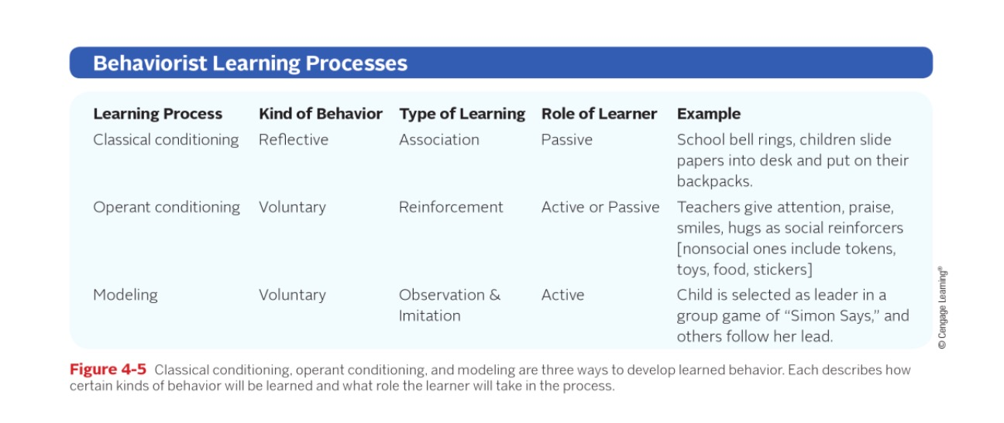
‘Nurture’ & Behavioural Modulation

(Gordon & Browne, 2015)

Empirical Evidence

Bandura’s Bobo Doll Experiment in 1961

Children emulated aggressive behaviour of adults

Evidence for ‘observational learning’

Supports ‘nurture’ side of debate

(Tassoni, 2008)

Evaluation

Evidence for ‘nurture’ e.g. ’Bobo’ Doll Experiment

‘Nurture’ does not account for innate behaviours

(Bergin et al, 2018)

‘Nature versus Nurture’ dichotomy is outmoded

Contemporary psychology supports ‘Nature and Nurture’

(Schaffner, 2016)

References

Babu, S. (2018). Psychology for Nurses. Second Edition. Elsevier Health Sciences

Bergin, C.A.C., Bergin, D.A., Walker, S., Daniel, G., Fenton, A., Subban, P. (2018). Child and Adolescent Development for Educators. Cengage LearningAustralia.

Gordon, A.M., Browne, K.W. (2015). Beginning Essentials in Early Childhood Education. Cengage Learning

Parker, J. (2020). Introducing Social Work. SAGE Publications

Schaffner, K.F. (2016). Behaving. Oxford University Press

Sperry, L. (2022). Teen Mental Health: An Encyclopedia of Issues and Solutions. ABC-CLIO

Tassoni, P. (2008). Children’s Care, Learning & Development. Pearson Education
Slide 1.

Hello, my name is David Rhys Jones, and in this presentation on ‘Nature vs Nurture’, I will be speaking on behalf of the ‘nurture’ side of the debate. The presentation will begin with a brief introduction to the historical background of the ‘nature vs nurture’ debate. This will be followed by explanations of how ‘nurture’ influences behaviour in the context of psychological approaches and psychological mechanisms, with an inclusion of empirical examples to support these explanations. The presentation will conclude with an evaluation of the ‘nurture’ side to the debate.

Slide 2.

Historically, the ‘nature vs nurture’ debate began with English writer, philosopher and scientist, Sir Francis Galton, who first coined the term ‘nature versus nurture’ during the 1860s and was a staunch advocate of ‘nature’ for explaining human traits and behaviour. Sir Francis Galton was influenced by the evolutionist theories of his half-cousin Charles Darwin and his 1859 publication ‘On the Origin of Species’ and was also influenced by the theory of eugenics which sought to improve human traits such as intelligence via selective breeding.

Slide 3.

On the other hand, enlightenment philosopher and physician John Locke advocated for the ‘nurture’ side of the debate and was influenced by the empiricist notion of the mind as a ‘tabula rasa’ or blank slate, devoid of innate ideas or capacities, which is then imprinted upon by environmental factors to shape individual traits and behaviour.

Slide 4.

To give a definition of ‘nurture’, within the context of psychology, ‘nurture’ refers to environmental or exogenous factors which contribute towards behavioural development.

Slide 5.

And according to Babu, 2018, environment or nurture refers to the sum of all external conditions other than genetic that affects a person. The human behaviour is not very much influenced by the heredity alone, but it is also greatly influenced by the other factors related to environment. Environment represented by the cultural, social, and situational factors influence the actual development within the limits of an individual.

Slide 6.

Examples of these environmental or exogenous factors include childhood experiences, familial dynamics, education, social group, and religious or cultural background.

Slide 7.

Psychological approaches vary in their attitude and opinions regarding the ‘nature versus nature’ debate, ranging from the purely ‘nature’ theory of biological psychology which asserts that all behaviour is based on ‘nature’, to the middle-ground, interactionist theory of cognitive psychology which asserts that a complex interplay of both ‘nature’ and ‘nurture’ influences behaviour, to the purely ‘nurture’ theory of behavioural psychology and its assertion that all behaviour is a result of conditioning or ‘nurture’. To advocate for the ‘nurture’ side to the debate, focus will be placed upon the behaviourist approach, particularly mechanisms of behaviourist psychology and behaviourist empirical studies which support the ‘nurture’ side to the debate.

Slide 8.

On this slide we have a table which indexes all the mechanisms of behavioural modification according to behavioural psychology, classical conditioning, operant conditioning, and modeling. The first mechanism is ‘classical conditioning’ which involves the passive association of involuntary reflexes with other environmental stimuli, a real-life example of which would be how a few painful experiences at a dentist during childhood could establish a lifelong phobia of dentistry. The second mechanism is ‘operant conditioning’ which differs from classical conditioning in that the response rather than the stimulus is the focus. In operant conditioning, behaviour is modulated through reinforcement, with the stimulus that increases the likelihood of repeated behaviour being called the reinforcer, which can be either positive or negative. An example of positive reinforcement through operant conditioning would be giving praise to reward good schoolwork, whereas an example of negative reinforcement would be reacting with anger towards a child who misbehaved. The third and final mechanism is ‘modeling’ or ‘observational learning’ which involves the process of learning from observation and emulating models. An example of modeling is children who observe their parents smoking are more likely to smoke themselves. Other behaviour occurs through modelling such as language acquisition through listening to others and engaging in violence through exposure to aggressive media content.

Slide 9.

Empirical evidence for the ‘nurture’ side of the debate exists in the form of the ‘Bobo’ doll experiment conducted by psychologist Albert Bandura. In Bandura's 'Bobo doll' experiment a film was shown to three groups of children. The film depicted an adult in a room with a large inflatable 'Bobo' doll. The three groups of children each saw a different variation on the behaviour of the adult towards the ‘Bobo’ doll. Group A saw the adult acting aggressively towards the doll, Group B saw the adult being aggressive towards the doll, but at the end of the film the adult was rewarded with sweets and lemonade by another adult. Group C saw the adult being aggressive towards the doll, but at the end a second adult appeared and castigated the adult. After the film, each group of children, in turn was shown into a playroom that contained a variety of toys, including the Bobo doll. The reactions of the children towards the ‘Bobo’ doll were recorded. The results were that group C children were the least aggressive towards the doll, but groups A and B were the most aggressive. The ‘Bobo’ doll experiment offers empirical support for behaviourist theories such as modelling in explaining behaviour and also supports the ‘nurture’ side to the debate that environmental factors can influence behaviour.

Slide 10.

To evaluate, there exists some empirical evidence for the ‘nurture’ side to the debate such as Bandura’s ‘Bobo’ doll experiment. However, a criticism of the ‘nurture’ argument is that it does not account for innate behaviours such as the universal facial expression of smiling despite cultural variance. Contemporary psychology, rather than explaining behaviour from a polarised, ‘nature versus nurture’ dichotomy, seeks to understand the complex interaction between ‘nature and nurture’. And this concludes my presentation, thank you for listening.

https://www.youtube.com/watch?v=EUT-R8RAsdw

I give my permission for anyone in possession of this link to view my video.

