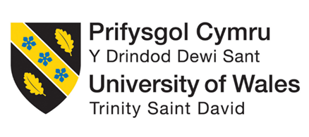

Programme: Master of Business Administration
Module Code: LCMB7034
Module: International Business Concepts
Lecturer: Gladius Kulothungan
Assignment Title: Report
Student Name: Sorbane Das Toma
Student ID: 2437417
Word Count: 5026

Table of Contents
1. Introduction 3
2. Industry and Country Overview 3
2a. UAE Tourism Industry 3
2b. Size, Scope, and Economic Importance 4
2c. Major Firms and Competitive Positioning 6
3. Porter's Diamond Model: Global Competitiveness of UAE Tourism 8
3a. Factor Conditions 8
3b. Demand Conditions 9
3c. Related and Supporting Industries 10
3d. Strategy, Structure and Rivalry in Firm. 10
3e. Government Role 11
4. PESTEL Analysis for Marriot International in the UAE. 11
4a. Political Factors 12
4b. Economic Factors 13
4c. Social and Cultural Factors. 14
4d. Technological Factors 16
4e. Legal Factors 16
4f. Environmental Factors 17
Conclusion 18
Reflective Account - Gibbs Reflective Cycle. 19
Reference List 22

1. Introduction
The United Arab Emirates (UAE) has established one of the fastest-developing tourism sectors globally. Within several decades, the nation has ceased to rely on oil and turned into a key business and leisure tourist spot. In 2024, tourism contributed AED 257.3 billion to national GDP, which is approximately 13% of total economy and UAE has ranked among the top seven destinations in the world in terms of tourist spending (WTTC, 2025).
The report will analyze the tourism industry in the UAE and the role of Marriott International in the industry. Marriott is the biggest hotel company in the world in terms of room count and runs a growing portfolio of hotels in the UAE. The report focuses on different analyses. Firstly, it discusses an overview of the industry and country; then an analysis is conducted using the Diamond Model by Porter to determine the global competitiveness of the industry in which Marriott operates in the UAE; followed by a PESTLE analysis of the factors that influence the operation of the Marriot in the UAE.. Throughout the analysis, recent industry data, government publications, and academic sources are used.

2. Industry and Country Overview

2a. UAE Tourism Industry
UAE tourism incorporates hotel accommodation, hospitality services, recreational attractions, events and facilitation of travel. The individuality of the UAE is that the tourism business was not gradually developed throughout generations. It was built in haste and intentionally, mostly by government planning and investment. The tourism infrastructure in the country was virtually nil in 1970s. It is an acknowledged international tourist destination today.
The seven emirates have different roles to play. The key leisure, shopping and massive events centre is Dubai. Abu Dhabi is oriented towards cultural destinations and luxury tourism. Ras Al Khaimah has come up with adventure and eco-tourism services. The whole industry is heavily dependent on the connectivity of aviation- Dubai international airport is the busiest international airport in the world. These big attractions include the burj khalifa, the Palm jumeirah, and the Louvre Abu Dhabi, which attracts a large number of tourists each year. The Tourism Strategy 2031 of the government focuses on achieving AED 450 billion and 40 million hotel guests every year as the contribution of tourism to the GDP (UAE Ministry of Economy, 2023).

2b. Size, Scope, and Economic Importance
The UAE tourism industry has proved to be a strong contributor to the economy and has emerged resiliently, especially in the post-pandemic era. In 2024, tourism and travel activities generated about AED 257.3 billion of the national economy of the UAE, which is around 13 percent of the overall GDP of the nation (World Travel and Tourism Council, 2024). The amount spent by international visitors was AED 217.3 billion and domestic tourism contributed AED 57.6 billion. The industry employed approximately 898 600 people, which is nearly one out of eight jobs in the nation.
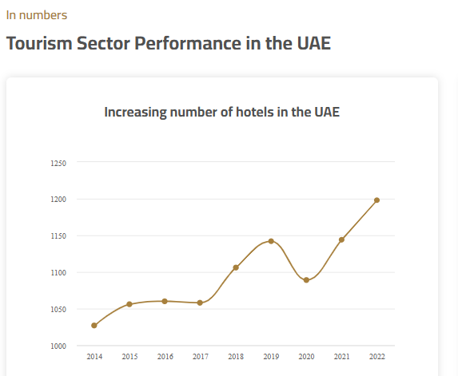
Figure 1: UAE's Tourism Sector Growth Performance (Ministry of Economy and Tourism UAE, 2026).
There has been good hotel performance. In 2024, the revenue was AED 45 billion and the occupancy rate was 78%, one of the highest in the world. In the year, 30.75 million hotel guests were hosted in the country in 1,243 hotels, and over 216,000 rooms (Arabian Business, 2025). The WTTC projected that by 2025, the sector would be contributing AED 267.5 billion, and the international visitor spending would be AED 228.5 billion, that is, 37% higher than in 2019. By 2035, the revenue will reach AED 287.8 billion (WTTC, 2025). The main figures are summarised in Table 1.

Indicator | 2022 | 2023 | 2024 | 2025F
GDP Contribution (AED bn) | 167 | 249 | 257.3 | 267.5
% of National GDP | 9% | 12.4% | 13% | ~13%
Intl. Visitor Spend (AED bn) | 117.6 | 205 | 217.3 | 228.5
Hotel Guests (millions) | ~25 | 28.08 | 30.75 | ~33
Hotel Occupancy Rate | ~72% | ~75% | 78% | ~79%
Jobs Supported | ~770,000 | ~860,000 | 898,600 | 925,000+
Table 1: UAE Tourism Industry’s Key Indicators. Source: WTTC (2025); Arabian Business (2025); UAE Ministry of Economy (2023).
Besides GDP contribution, the industry also produces a lot of employment and investment opportunities. It provides employment to more than 920,000 individuals in different sectors, such as aviation, hospitality, retail, and transportation (World Travel and Tourism Council, 2024). The area of tourism infrastructure investment has improved considerably.
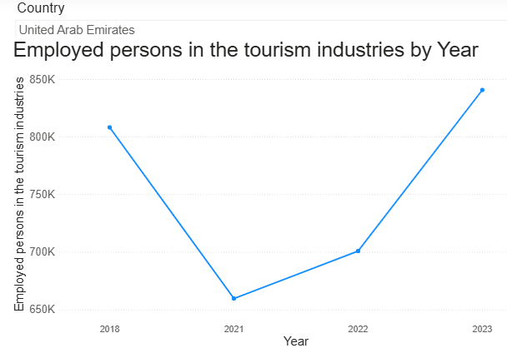
Figure 2: Employment in UAE's Tourism Industry (UN Tourism, 2026).

2c. Major Firms and Competitive Positioning
The UAE hotel market is characterized by giant international hotel chains, with the smaller number of local operators. Marriott International is the biggest worldwide hotel organization. By the end of 2024, it operated in almost 9,300 properties and had an estimated 1.7 million rooms in 139 countries (Marriott International, 2025). It operates The Ritz-Carlton, JW Marriott, W Hotels and Westin, Sheraton and Le Meridien properties in the UAE. It has a very asset-light business model - Marriott does not own the hotels, but runs them and franchises them. In 2024, its Bonvoy loyalty programme had nearly 228 million members worldwide, which provided the corporation with a solid customer retention edge.
The nearest international rival of Marriott is the Hilton Worldwide. In 2024 alone, it added almost 100,000 rooms, the highest rate of addition of rooms to the company in history (Hospitality-on, 2025). Hilton has developed Waldorf Astoria, Conrad, and DoubleTree in the UAE, primarily in Dubai. The company has spent a lot of money on online services and Hilton Honors loyalty program.
Accor is French and has extensive presence in the UAE in the Sofitel, Fairmont, Novotel and Pullman brands. In 2024, it boasted more than 5,680 hotels around the world, and revenue of EUR 5.606 billion. The key strength of Accor in the UAE is its presence in the low-end and high-end segments along with its experience of local development cooperation.
IHG Hotels and Resorts manage InterContinental, Crowne Plaza and Kimpton hotels in the UAE. One of the latest advances was its collaboration with Aldar Properties to operate six hotels in Yas Island, Abu Dhabi, to enhance its conference and resort sector (Mordor Intelligence, 2026).
Rotana Hotels is the most well-known regional player of the UAE tourism industry. It operates more than 100 hotels in the Middle East and Africa, operating under the Rotana, Centro and Rayhaan brands, and has its headquarters in Abu Dhabi. The local market expertise/knowledge about the Gulf Arab expectations as a guest and their business travel patterns, which has taken years to establish, is its competitive advantage over international chains.
Company | Origin | Core Strategy | Segments | UAE Brands | Key Advantage
Marriott Intl. | USA | Asset-light; franchising; loyalty | Luxury to select-service | Ritz-Carlton, JW, W, Westin | Largest portfolio; Bonvoy programme
Hilton | USA | Lifestyle brands; digital focus | Luxury to midscale | Waldorf, Conrad, DoubleTree | Record expansion; Honors loyalty
Accor | France | Broad segment coverage; local partnerships | Economy to luxury | Sofitel, Fairmont, Novotel | Widest price-tier range
IHG | UK | Resort and MICE integration | Premium to midscale | InterContinental, Crowne Plaza | Yas Island resort cluster
Rotana | UAE | Local market knowledge | Upscale and business | Rotana, Centro, Rayhaan | Gulf market expertise
Table 2: Competitive Positioning of Major Companies in UAE’s Tourism Sector.. Source: Mordor Intelligence (2026); Marriott International (2025); Hospitality-on (2025).
In the high-end market, the level of competition is stiff. Accor, Hilton and Marriott are all fighting after the same high-end guests which prompts investment into service quality, technology, and brand building. Rotana is a company whose difference is based on local knowledge and not scale. The indirect challenge posed by rental services such as Airbnb is increasing especially in the mid-market segment since it provides short term rent. In general, the hotel sector in the UAE is a rapidly developing and challenging one.

3. Porter's Diamond Model: Global Competitiveness of UAE Tourism
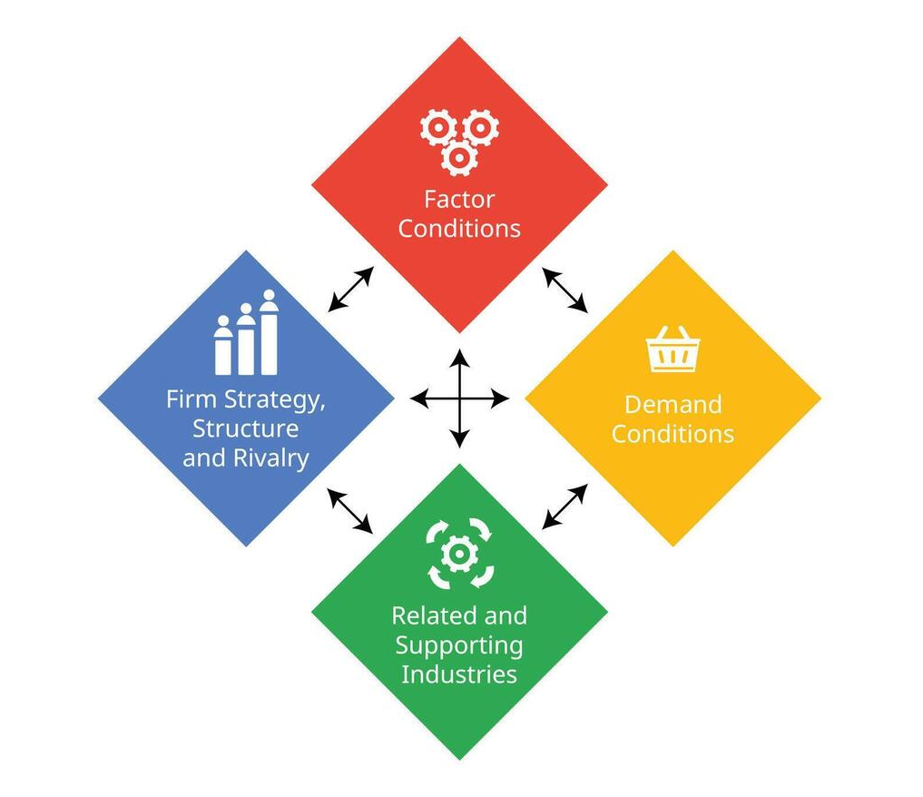
Porter Diamond Model is an extensive model that helps in the analysis of the global competitiveness of industries in a certain national setting. It demonstrates that for any industry competitive advantage is founded on four related and supportive factors including factor conditions, demand conditions, related and supporting industries, and firm strategy, structure, and rivalry (Porter, 1990). Additional variables are government and chance. Using this model to explain the situation in the UAE tourism industry would help understand why the industry has become competitive on an international level - and what the flaws in the industry are.
Figure 3: Porter's Diamond Model Framework

3a. Factor Conditions
Porter differentiates between the basic factors, which are natural resources, land, unskilled labour, and the advanced factors, which are skilled labour, technology, and research capacity. The success of tourism in UAE is not based on inherited factors but rather on advanced and created factors. The nation does not have any world-renowned beaches, no historical sites, and the summer weather is truly inhospitable to physical sightseeing. It has invested to establish a competitive position, and not based on geography (Hassan and Saad, 2023).
The physical infrastructure is impressive which is significantly created assets. Dubai International Airport has processed more than 102.9 million passengers in the first eight months of 2025 alone- an increase of 5.3% compared to the previous year (Arabian Business, 2025). The UAE also topped the list of mobile phone subscriptions in the world and second in ICT adoption in the Global Competitiveness Report. All of these, roads, digital connectivity and smart city systems are very significant in the seamless tourist experience. Government has also put its efforts on the training of hospitality, but still the industry largely relies on expatriate laborers who are South Asian and Southeast Asian.
This reliance on expatriate labour is a weakness the industry should take into consideration. The UAE has a foreign workforce of over 88%. With a shift in labour migration policies or geopolitical conditions, the provision of trained hotel workers can be upset soon. A different challenge is the summer climate which restrains outdoor tourism a few months annually. Indoor attractions and promotional campaigns like the Worlds Coolest Winter have partially helped the government to tackle this issue as there was a total of AED 6.7 billion in hotel revenues that were generated in five editions (Arabian Business, 2025). All these go a long way in assisting but they do not entirely solve the underlying vulnerability.

3b. Demand Conditions
According to Porter, advanced and demanding domestic market consumers force companies to do better and innovate. The demand in UAE is largely international as opposed to domestic. In 2024, leisure tourism contributed 84.7% of total tourism expenditure, 79% of which was expenditure by international visitors. In 2024, a record number of international visitors were registered in Dubai alone, 18.72 million around (The First Group, 2025).
The UAE is diversified in terms of visitors. High-net-worth leisure travellers, corporate guests, conference delegates, religious visitors to Abu Dhabi, adventure tourists in Ras Al Khaimah and cultural visitors to the Louvre are attracted to the UAE. This diversity compels hotels and attractions to improve and create new products on an ongoing basis. Demand is not smooth without any imposed risks. The COVID-19 crisis demonstrated the rapid decline in the number of visitors. The continued instability in the wider Middle East is periodically causing a lack of confidence in international travel and the UAE does not have a huge domestic population to absorb these shocks.

3c. Related and Supporting Industries
UAE tourism is supported highly by network industries. Emirates and Etihad Airways link UAE to more than 220 destinations around the world creating a steady stream of tourists and strengthening Dubai and Abu Dhabi as transit points. The retail industry is another pull, as the Dubai Mall is considered to be one of the biggest shopping centres in the world. Such events as Abu Dhabi Formula 1 Grand Prix and Dubai Shopping Festival generate a demand that directly transfers into hotel bookings.
The logistics, financial services, and digital infrastructure are all beneficial to tourism sector expansion. With the UAE free zones (DFIC in particular and ADGM) it is easy to set up and run an international hotel company in the country. In 2024, the government spent AED 32.2 billion on tourism-related infrastructure, and in 2025, the amount is anticipated to be AED 35.2 billion (Arabian Business, 2025). A vulnerability in the supply chain of food and beverages is one of the loopholes of the supporting cluster. The majority of the ingredients employed in UAE hotels are imported thus the sector is vulnerable to the world supply shocks. This is a structural constraint that is usually ignored during measurements of tourism competitiveness in the UAE.

3d. Strategy, Structure and Rivalry in Firm.
Porter contends that domestic competition is healthy and this compels companies to become better and better. The hotel market in the UAE is competitive particularly in the luxury and the high-end segment. The competition between Marriott, Hilton, Accor, IHG, Hyatt and Rotana is rather concentrated within a relatively small geographical region, which spurred the investment in the quality of services, brand image, and technology. International markets of Marriott, consisting of the UAE, increased their RevPAR by 7.2% in Q4 2024, much higher than the global average (Marriott International, 2025). Part of such performance is due to the competitive nature of firms.

A structural perspective is however something to be concerned with. A majority of the UAE hotel market competitive rivalry is not due to UAE-born hotel companies but foreign multinationals. The exception is Rotana. This is a fair question, has the UAE actually created real national competitive advantage or has it merely created a business environment to attract the world-class foreign companies? A similar criticism has been made by Waverman (1995) of the Porters model stating that it is capable of confusing the capacity of a country to receive foreign investment as endogenous competitive advantage. In the case of the UAE, this difference is significant to long-term thinking concerning the industry.

3e. Government Role
Government in the UAE is not a background factor, it is the key driver in tourism development. Government led are the Tourism Strategy 2031, trade agreements with India, Indonesia and Turkey and direct infrastructure investment. In February 2024, the UAE was taken off the FATF greylist, which further boosted investor confidence and increased the reputation of the country as a reputable financial and business hub (US State Department, 2025). The 24-million visitor Expo 2020 Dubai has left behind lasting benefits in infrastructure and brand recognition.
The weakness of this strategy is that when the state lays down the agenda in this manner, there is the risk of limiting organic development of the private sector. The kind of competition may be skewed towards acquisition of government contracts instead of real market innovation. It is a strain that needs to be considered in assessing the future sustainability of the UAE tourism model.

4. PESTEL Analysis for Marriot International in the UAE.
Marriott International is based in Bethesda, Maryland, USA. As of the year-end in 2024, it managed more than 9,300 properties with an approximate of 1.7 million rooms in over 139 countries (Marriott International, 2025). In 2024, it recorded the highest number of new gross rooms in its locations worldwide at 123,000, surpassing its previous year. Its brands are very luxurious (The Ritz-Carlton, St Regis, Edition) to midscale (Courtyard, Fairfield).
Marriot has in the UAE, The Ritz-Carlton, JW Marriott, W Hotels, Westin, Sheraton, and Le Meridien, among others, in Dubai, Abu Dhabi, Sharjah and Ras Al Khaimah. It is among the biggest foreign hotel operators within the nation.
PESTLE is a popular instrument that can be used to map the external factors influencing the operations of a company in a specific country (Johnson et al., 2017). It is best suited to the analysis of the opportunities and threats that Marriott is exposed to in the UAE.

4a. Political Factors
UAE is politically stable. It is an alliance of seven emirates that are under a leadership that has been supportive to the economy and to the influx of foreign investments. To an organization such as Marriott, this is very significant. There is enforcement of contracts, protection of property rights and there is no unpredictable change in the regulatory environment. It’s Comprehensive Economic Partnership Agreements (CEPAs) with India, Indonesia, Turkey, and more have expanded global connectivity and broadened the prospects of visitors (Accurate Middle East, 2025). ). The political corruption index of the United Arab Emirates is always low relative to the global level.
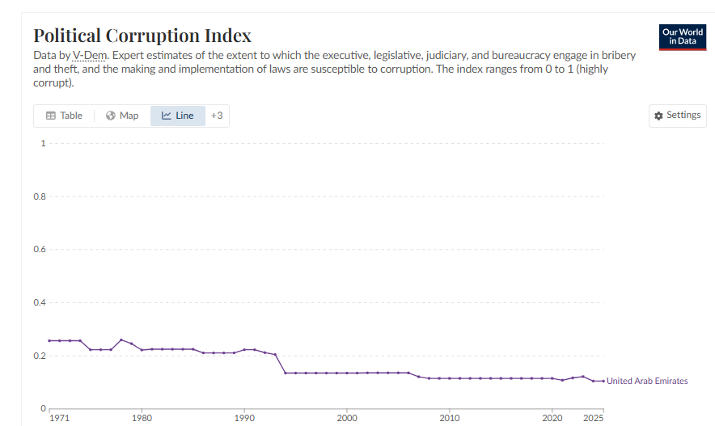
Figure 4: UAE's Political Corruption Index (Our World in Data, 2026).
Tourism Strategy 2031 of the government directly helps Marriott. It aims at 40 million hotel clients annually and an almost doubling of the share of tourism in GDP. The establishment of a federal Ministry of Investment (2023) and the National Investment Strategy passed in March 2025 (with an objective of over doubling the annual FDI to USD 65.3 billion by 2031) makes it clear that the government is interested in more foreign business, not less (US State Department, 2025).
However, the authoritarian UAE government and its ease of doing business may be commercially suitable, it also attracts human rights oriented investors and media. This reputational aspect cannot be completely ignored by a US-listed company such as Marriott.

4b. Economic Factors
The economy of the UAE is suitable to a luxury and premium hotel business. The contribution of non-oil GDP to the overall economic output was over 73% in 2024, as the economy was supported by tourism, logistics, finance, and other diversified sectors (Accurate Middle East, 2025).
There is positive hotel performance data. As of 2024, UAE hotel revenues amount to AED 45 billion, and the occupancy rate is 78% (Arabian Business, 2025). The growth in the GDP per capita in the United Arab Emirates is positive and relatively stable indicating perpetual investment in luxury infrastructure, transport and hospitality that increases the attractiveness of the UAE as a high-end tourist destination around the world
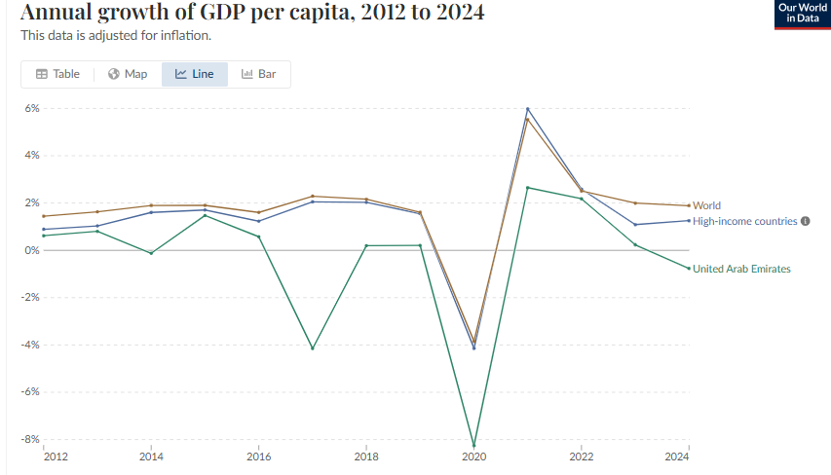
Figure 5: Annual Growth of GDP per Capita (Our World in Data, 2026).
There are two changes in economics that should be mentioned. Firstly, in 2023, the UAE implemented a corporate income tax with a rate of 9% on the profits exceeding about USD 102,000; the country has never taxed business profits in such a manner (US State Department, 2025). In the case of large multinationals such as Marriott - whose global revenues exceed the EUR 750 million mark - a Domestic Minimum Top-up Tax of 15% will also apply as of January 2025, as part of the OECD global minimum tax system (Crowe, 2025). The tax application in the UAE remains favourable against European or North American standards, however, the advantage of the zero-tax era is not present anymore. Second, since 2018, hospitality services are subject to a 5% VAT. This has increased the cost to the guests although it has not made an apparent impact on the total demand.
Continued infrastructure development by the government - AED 32.2 billion in 2024, and projected AED 35.2 billion in 2025 - will continue to provide the industry players with a chance to grow its managed and franchised hotel portfolio (Arabian Business, 2025).

4c. Social and Cultural Factors.
UAE is a highly multinational society worldwide. Approximately 88 to 89 per cent of the total population is comprised of expatriates. Majority of the residents are well-travelled international guests and are also knowledgeable in the brands of high-end hotels. This renders the UAE market a perfect fit with the offering of Marriott.
The cultural dimensions model by Hofstede is applicable in this case. The UAE has a high power distance, indicating respect to hierarchy and power, and a high uncertainty avoidance, indicating that people tend to enjoy orderly settings with set rules (Hofstede Insights, 2023). Being a company of US origin, Marriott has rather flat management and promotes individual initiative. These differences must be bridged through conscious effort so that the best service can be provided in day to day hotel management.
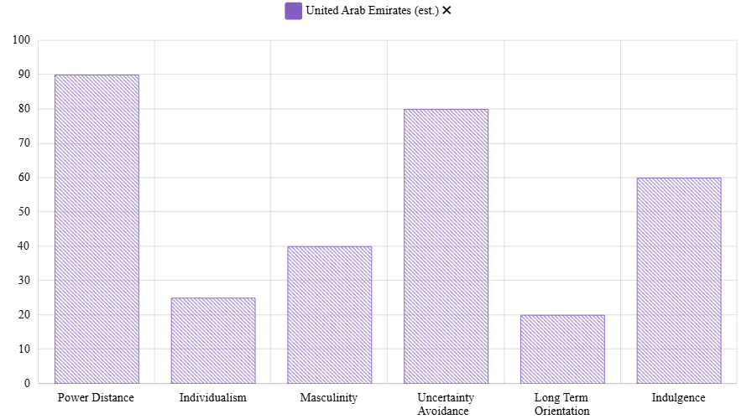
Figure 6: UAE's Hofstede Score (Hofstede, 2023).
To cater to diversified tourists, cultural awareness is highly necessary. UAE is an Islamic society, so hotels are run is influenced by dress code in the hotel public areas, prayer times and religious practices. Marriott has generally been very accommodating, by providing Ramadan packages, alcohol-free functions and cultural sensitization to employees. However, this equilibrium must be considered at all times.
UAE has massive growth in working age group population, which gives an edge for local tourists and declines dependency on international tourists. This population demographic also ensures labor pool sources for Marriot International, and overall industry.
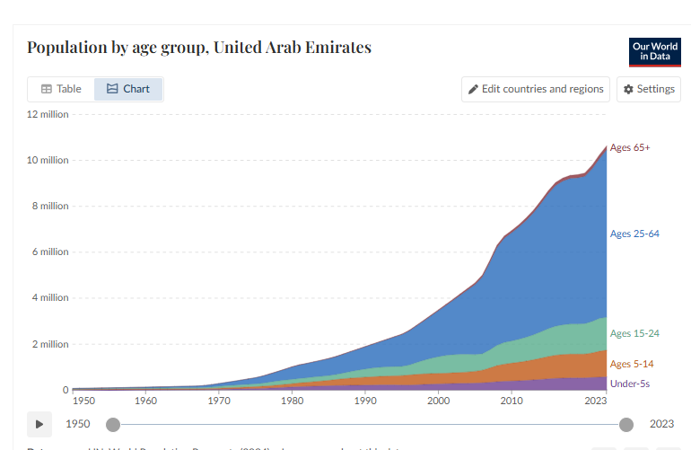
Figure 7: Population Demographic of the UAE (Our World in Data, 2026).
The increase of domestic UAE tourism is one of the social trends that need to be followed. In 2024, the amount spent by UAE residents on domestic travel increased by 41% compared to 2019 (WTTC, 2025). It is a new premium segment of relatively high value which Marriott could serve more actively with its Bonvoy loyalty programme and local packages.

4d. Technological Factors
UAE is among the most digitally interconnected nations in the world. It was the leading mobile phone subscription in the world and second in ICT adoptiop. The 5G networks are ubiquitous in big cities. It builds a robust platform in the case of a hotel company that focuses a lot on digital services.
Marriott is in the midst of a significant technology change. The AI incubator is working on the customer service tools, trip planning, and concierge functions. These investments have direct commercial value in the UAE where the rate of international visitors is very high as well as their expectations.
On the other hand, in 2018, Marriott was a victim of a major data breach due to the Starwood acquisition. The Personal Data Protection Law (PDPL), which has been in effect since November 2021, imposes harsh requirements on businesses that store or process personal data within the UAE (BSA Law, 2025). Marriott should uphold high standards of cyber-security and adhere to the local data protection regulations - not only to comply with the legal requirements but also to ensure that the guests trust it.

4e. Legal Factors
Over the past years the legal environment in the UAE has been getting better. The fact that the 51% local ownership requirement in most business sectors has been removed under the 2020 foreign investment reforms implies that Marriott will be able to design its hotel management and franchise deals more freely. In the vast majority of cases, the partnership of local ownership is no longer mandatory.
The majority of global hotel corporations choose to conduct their business using either DIFC (Dubai International Financial Centre) or ADGM (Abu Dhabi Global Market). Both free zones have a common law system, which is familiar to the US and UK based corporations, and have access to internationally recognised arbitration (Chambers and Partners, 2025).
The new competition law will lead to an increased enforcement in the future (Chambers and Partners, 2025). To a market giant such as Marriott, this is something to keep an eye on. Since 2024, large companies whose revenues exceed AED 1 billion will have to publish annual ESG reports (UAE Corporate Law, 2025)..

4f. Environmental Factors
UAE made a pledge to achieve net-zero carbon emissions by 2050. That put the UAE-based companies, such as large hotel operators, in the international spotlight as far as environmental performance is concerned. The carbon emissions of tourism constituted 13.3% of the total carbon emissions in the UAE in 2023, which is a large percentage and one that is being curbed by the government.
Marriott is faced with environmental pressures in a number of directions. Some facts increase the cost of operation and carbon emission. The global Serve360 sustainability programme by Marriott aims at achieving the target of net-zero by 2050 and the company is committed towards energy efficiency, water conservation, and eradication of single-use plastics (Marriott International, 2025). These commitments are practically commercial in the UAE market where European and North American tourists are increasingly considering sustainability in their travel decisions.
The UAE government has enforced mandatory e-sustainable reporting and green finance systems based on its COP28 plan (UAE Corporate Law, 2025). Firms that fail to take the issue of environmental performance seriously are subject to regulatory and reputational costs.
Overall, the UAE is a good market to Marriott. Political climate is stable, economy is developing and even the agenda of the government contributes to the development of hotel industry. All the challenges such as new corporate taxes, cultural management needs, increased environmental compliance and geopolitical risks in the region are real but can be handled by a company of the size of Marriot.

Conclusion
This report has analyzed the UAE tourism industry and evaluated the positioning of Marriott International in the industry. The UAE tourism industry is huge, expanding and diversified. A market performing at high level is attested by its contribution to GDP of AED 257.3 billion in 2024, 78% hotel occupancy rate and 30.75 million hotel guests. The government has a long-term plan in terms of Tourism Strategy 2031. The hotel business is competitive and Marriott, Hilton, Accor, IHG and Rotana all have their own segment of the market that targets a highly demanding international visitor market.
The analysis of the Diamond of Porter indicates that the level of competitiveness of the tourism industry in the UAE has been built but not handed over. Through careful policy, the country has developed world-class infrastructure, aviation connectivity and favourable business environment. However, it is flawed: an overdependence on expatriate labour, lack of a large home grown population, insufficient local supply chains, and reliance on foreign hotel multinational corporations to provide competitive competition at the luxury segment
In the case of Marriot, the UAE is a good market with a real growth potential. It has favourable factors such as political stability, high numbers of spending visitors, world-class infrastructure, and the government agenda that puts the growth of tourism at the forefront. The emerging business tax framework, the need to manage culture, the necessity to comply with the environment, and the sensitivity of the region to geopolitical factors are all challenges, yet not out of reach of a company with the experience and resources that Marriott has. The company is in good position to take advantage of the UAE tourism development in the next 10 years as long as it keeps on changing its operations to suit the new needs of the market.

Reflective Account - Gibbs Reflective Cycle.
The Reflective Cycle by Gibbs offers a sensible approach to guided reflection with six steps; Description, Feelings, Evaluation, Analysis, Conclusion and Action Plan (Gibbs, 1988). The following section adopts that structure to reflect on the process of researching, analysing and writing the report.
Stage 1: Description: What Happened?
The assignment involved choosing a pair of countries-industries and composing an international business report. UAE tourism industry has been selected and the company of interest is Marriott International. I selected this due to the presence of current and high quality public data, and the analytical appeal of the case namely the question of how a state with no traditional tourism resources, which is an oil producer, created a globally competitive tourism industry out of thin air.
The research sources included WTTC annual reports, investor releases published by Marriott, industry publications, academic sources on the Diamond of Porters and governmental materials such as the UAE Tourism Strategy 2031 and the Investment Climate Statements of 2025 published by the US State Department. I wrote it in multiple drafts, and its structure was adjusted in the process to control the number of words and analytical balance between sections.
Stage 2: Feelings What Were My thoughts?
The decision to target the UAE was like a good one to make. There was recent data that was strong and the subject was really interesting. As I felt stressed about the work depth and analysis, there were a lot of solid sources to guide.
Nonetheless, once I decided upon the UAE tourism sector and Marriot International, I became more confident because I realised that there was a lot of data to be obtained. The application of Porters diamond model to analyze the industry was interesting.
It was difficult to analyze the information and describe it distinctly. This necessitated a change in my approach especially in the way I would develop arguments as well as how I would back them up with written literature (Porter, 1990).
Stage 3: Evaluation - What Worked and What Did Not?
The use of a broad spectrum of reliable sources, such as academic journals, reports by organisations like IMF and WTTC, and annual reports of companies, was one of the strengths of my approach. This aided in the creation of a well-answered analysis and made sure that the arguments were founded on credible data.
The other good thing was the fact that theory was applied to practice. Indicatively, the Porters Diamond Model enabled me to critically examine the competitiveness of the tourism industry in the UAE. This assisted me to get out of the descriptive writing and get into more organized analysis.
Nevertheless, there were limitations, too. Sometimes, I struggled to create a balance between description, information, and critical analysis. Although I could fit in relevant data, I had to make sure that every point was well connected to either an argument or assessment. Also, there was the problem of word limitation and addressing all the necessary points because the subject was multi-dimensional.
Stage 4: Analysis - What Have I Learned?
The primary point of this process is that there is a distinction between description and critical analysis. Descriptive writing is a report of what is there. Critical analysis poses the question of why it is important, why the evidence is not exhaustive and what the drawbacks of the argument are. At a postgraduate level, the second kind of writing is what is to be anticipated - and this is the one that must be pursued consciously in order to be consistently accomplished throughout the length of a long report.
The second learning outcome was the use of various theoretical frameworks. The Diamond of Porter describes the situation of a national competitive advantage. Incorporation of Hofstede cultural dimensions provided additional detail to the social analysis that would have been overlooked by a macro-level tool. It is argued that none of the frameworks offers the full picture, and this assignment helped to strengthen this point (Johnson et al., 2017).

Stage 5: Conclusion - What Else Could Have Been Done?
On balance, this assignment was a good learning experience that helped me to develop a better understanding of concepts related to international business and how they could be applied in practice. I gained a better insight into the functioning of industries in a global environment and the elements that drive competitiveness.
As there were some difficulties with critical analysis and time management, the process allowed me to develop my research skills and the possibility to build the structured arguments. I also became confident in the application of theoretical frameworks to real business situations and businesses..
Stage 6: Action Plan - What Would I Do Differently?
I would use four things of this experience in the future. First, start with a literature map before writing - find out which frameworks are most appropriate to the particular country-industry situation by doing this before you start writing. This would avoid in-between draft restructuring.
Second, consult academic databases like EBSCO, JSTOR and Emerald Insight in greater detail in the first place. Grey literature is helpful with its data, whereas peer-reviewed journal articles offer the theoretical background. Third, the evaluation of each theoretical framework to be used critically. The limitations of Porters Diamond in service sector are documented and experiencing the limitations in service sector leads to deeper analysis rather than using the model as a template. Lastly, find some sort of primary data - even minimal practitioner commentary or expert interviews would provide originality and would respond more to the assessment criteria on independent research.

Reference List
Accurate Middle East (2025) PESTEL analysis of the UAE. Available at: https://meaccurate.com/rus-of-the-uae/ (Accessed: 20 April 2026).
Arabian Business (2025) UAE tourism sector reaches $70.1bn GDP contribution with record growth in 2024. Available at: https://www.arabianbusiness.com/industries/travel-hospitality/uae-tourism-sector-gdp-2024 (Accessed: 20 April 2026).
BSA Law (2025) UAE legal milestones 2024–2025: Key reforms and their impact on business and governance. Available at: https://www.bsalaw.com/insight/uae-legal-milestones-2024-2025-key-reforms-and-their-impact-on-business-and-governance/ (Accessed: 20 April 2026).
Chambers and Partners (2025) Doing business in... 2025 – UAE. Available at: https://practiceguides.chambers.com/practice-guides/doing-business-in-2025/uae/trends-and-developments (Accessed: 20 April 2026).
Crowe (2025) UAE business environment. Available at: https://www.crowe.com/uk/insights/uae-business-environment (Accessed: 20 April 2026).
Gibbs, G. (1988) Learning by doing: A guide to teaching and learning methods. Oxford: Further Education Unit, Oxford Polytechnic.
Hassan, R. and Saad, R. (2023) ‘Application of Porter’s Diamond Model: A case study of tourism cluster in UAE’, in Industry clusters and innovation in the Arab world. Bingley: Emerald Publishing. doi: 10.1108/978-1-80262-871-520231007.
Hofstede Insights (2023) Country comparison: United Arab Emirates. Available at: https://www.hofstede-insights.com/country-comparison/ (Accessed: 20 April 2026).
Hospitality-on (2025) Hotel groups see strong growth in 2024, with continued expansion in 2025. Available at: https://hospitality-on.com/en/hospitality/update-hotel-groups-see-strong-growth-2024-continued-expansion-2025 (Accessed: 20 April 2026).
Johnson, G., Whittington, R., Scholes, K., Angwin, D. and Regner, P. (2017) Exploring strategy: Text and cases. 11th edn. Harlow: Pearson Education.
Marriott International (2025) Marriott International reports fourth quarter and full year 2024 results. Available at: https://marriott.gcs-web.com/news-releases/news-release-details/marriott-international-reports-fourth-quarter-and-full-year-2024 (Accessed: 20 April 2026).
Ministry of Economy and Tourism UAE (2026) The contribution of the travel and tourism sector to the UAE’s GDP. Available at: (Accessed: 16 April 2026).
Mordor Intelligence (2026) Hospitality industry in UAE: Statistics, report, market size and share. Available at: https://www.mordorintelligence.com/industry-reports/hospitality-industry-in-the-united-arab-emirates (Accessed: 20 April 2026).
Our World in Data (2026) GDP per capita growth. Available at: https://ourworldindata.org/grapher/gdp-per-capita-growth?tab=line&time=2012..2024&country=ARE~OWID_WRL~OWID_HIC (Accessed: 20 April 2026).
Our World in Data (2026) Political corruption index (V-Dem). Available at: https://ourworldindata.org/grapher/political-corruption-index?tab=line&country=OWID_WRL~ARE (Accessed: 16 April 2026).
Porter, M.E. (1990) The competitive advantage of nations. New York: Free Press.
Rolfe, G., Freshwater, D. and Jasper, M. (2001) Critical reflection in nursing and the helping professions: A user’s guide. Basingstoke: Palgrave Macmillan.
Statista (2024) Marriott revenue 2023. Available at: https://www.statista.com/statistics/266279/revenue-of-the-marriott-international-inc-hotel-chain/ (Accessed: 20 April 2026).
The First Group (2025) Tourism’s contribution to Dubai’s economy revealed. Available at: https://www.thefirstgroup.com/en/news/tourisms-contribution-to-dubais-economy-revealed/ (Accessed: 20 April 2026).
Travel and Tour World (2025) UAE now ranks among top 7 global destinations for tourist spending. Available at: https://www.travelandtourworld.com/news/article/uae-now-ranks-among-top-7-global-destinations-for-tourist-spending-achieving-strong-growth-in-travel-and-tourism-in-2024/ (Accessed: 20 April 2026).
UAE Corporate Law (2025) UAE corporate law changes 2025. Available at: https://www.kayrouzandassociates.com/insights/uae-corporate-law-changes-and-compliance-trends-in-2025 (Accessed: 20 April 2026).
UAE Government (2023) UAE Tourism Strategy 2031. Available at: https://u.ae (Accessed: 15 April 2026).
UAE Ministry of Economy (2023) UAE Tourism Strategy 2031. Available at: https://www.moet.gov.ae/en/tourism-indicators (Accessed: 20 April 2026).
US State Department (2025) 2025 investment climate statements: United Arab Emirates. Available at: https://www.state.gov/reports/2025-investment-climate-statements/united-arab-emirates (Accessed: 20 April 2026).
Waverman, L. (1995) ‘A critical analysis of Porter’s framework on the competitive advantage of nations’, in Rugman, A.M., Van Den Broec, J. and Verbeke, A. (eds) Beyond the diamond. Greenwich, CT: JAI Press, pp. 67–96.
World Travel and Tourism Council (WTTC) (2024) Travel & tourism economic impact: United Arab Emirates. London: WTTC. Available at: https://wttc.org (Accessed: 15 April 2026).
World Travel and Tourism Council (WTTC) (2025) International traveller spend in the UAE to reach a record AED 228bn this year. Available at: https://wttc.org/news/international-traveller-spend-uae-to-reach-a-record-aed-228bn (Accessed: 20 April 2026).

