

Programme: Master of Business Administration

Module: Marketing Management
Module code: LCMB7024
Lecturer: Laila Maazouz
Taonga Kaonga Sobere-Snithers
Assignment Title: Marketing Environment Analysis

Student Name: Krishnaben Arbham modhvadiya
Student ID Number: 2542897
Word Count: 2673 Words

Table of Contents
1.0 Task 1: Marketing Environment Analysis 3
1.1 Introduction to the Chosen Company 3
1.2 Analysis of the Natural Environment Actor (Primary Focus) 4
1.3 Analysis of a Secondary External Actor 8
Task 2: Strategic Growth and Competitive Positioning 11
2.1 Recommendation of a strategic growth approach for Tata Steel using Ansoff Matrix 11
2.2 Achieving competitive advantage 13
Task 3: Critical Reflection on AI Usage 15
a. Tool Disclosure 15
b. Critical Evaluation of AI Output 15
c. Contribution Analysis 15
d. Ethical & Professional Reflection 16
Reference List 17

1.0 Task 1: Marketing Environment Analysis

1.1 Introduction to the Chosen Company
One of the top steelmakers in the world, Tata Steel is ranked tenth with crude steel production of about 30.02 million tonnes in the latest reporting period (Statista, 2026).
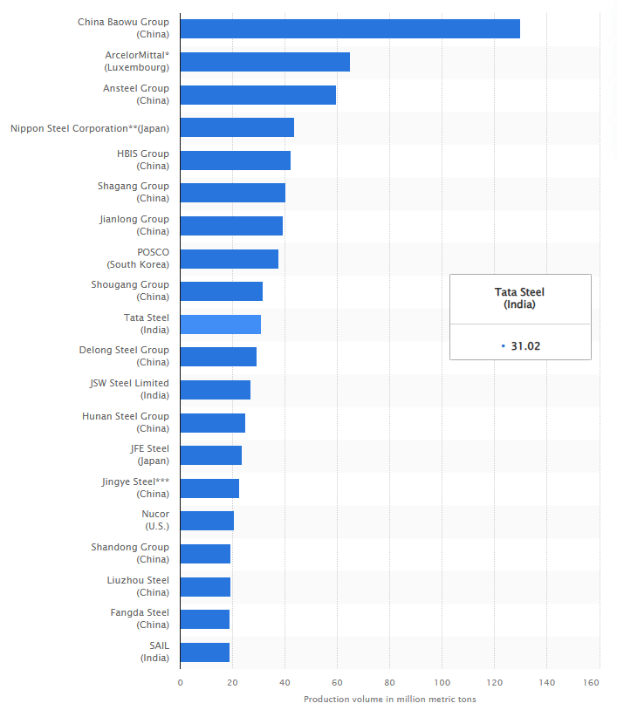
Figure 1: World's largest 15 crude steel producers in 2024
Source: (Statista, 2026)
Operating in India, Europe, and other areas, the company's Indian operations are geographically diversified and provide a strong market presence as India's leading steel company, with a crude steel capacity of about 30.02 million tonnes per year (Tatasteel.com, 2026) as part of the Tata Group.
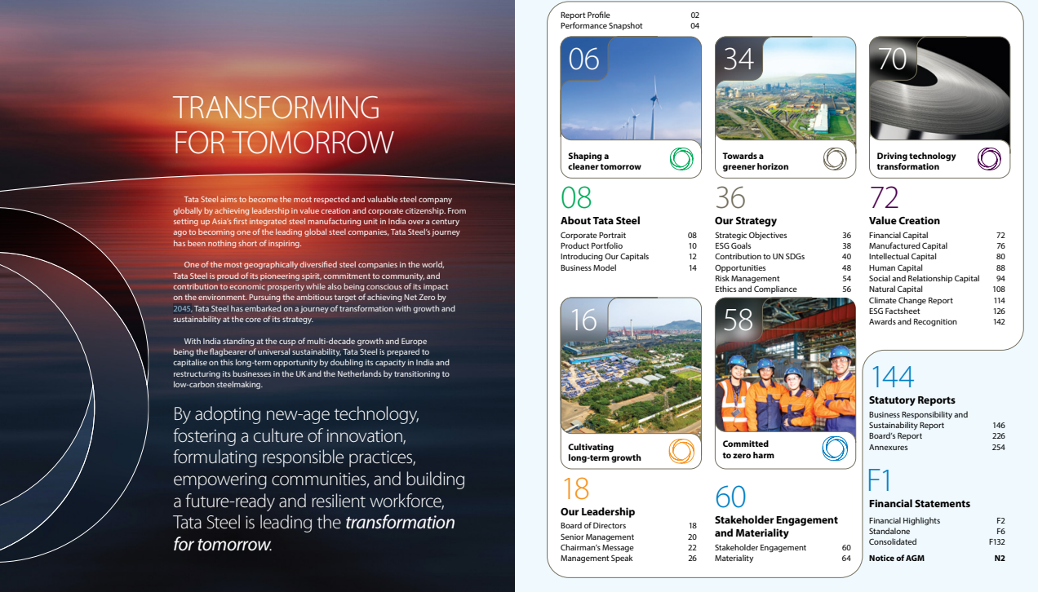
Figure 2: Tata Steel’s Goal for Net Zero Emissions
Source: (Tatasteel.com, 2024)
Due to this regulatory, stakeholder and market pressure being increasingly seen in the high-emission metals industry, the transition to lower-carbon products is critical for Tata Steel. As shown in Figure 2, the company has pledged to achieve net zero in its global operations by 2045. The transition is critical to remain competitive, ensure government support (such as for the UK EAF project), attract green investments and prevent carbon lock-in when expanding capacity.

1.2 Analysis of the Natural Environment Actor (Primary Focus)
The natural environment component of the marketing environment includes natural, ecological or significant forces that are impacting the organisations, from climate change to resource depletion, pollution and sustainability requirements (Bhattacharjee, Singh and Singh, 2025).
- Climate Change and Decarbonisation Imperative
Climate change drives regulatory and societal demand for emissions reductions in hard-to-abate industries like steel (Owusu, 2025). Tata Steel has set itself on the path to net zero by 2045 across all its global operations, an ambitious target, with milestones for its European operations aimed at transitioning to Electric Arc Furnace (EAF) technology. Overall, Tata Steel has consistently produced a lot despite having high scope 1 & 2 emissions (tens of M tonnes CO₂e per year), which would need to be drastically reduced to meet the 2030 emission intensity target of <1.8 tCO₂/tcs (Tatasteel.com, 2025b).
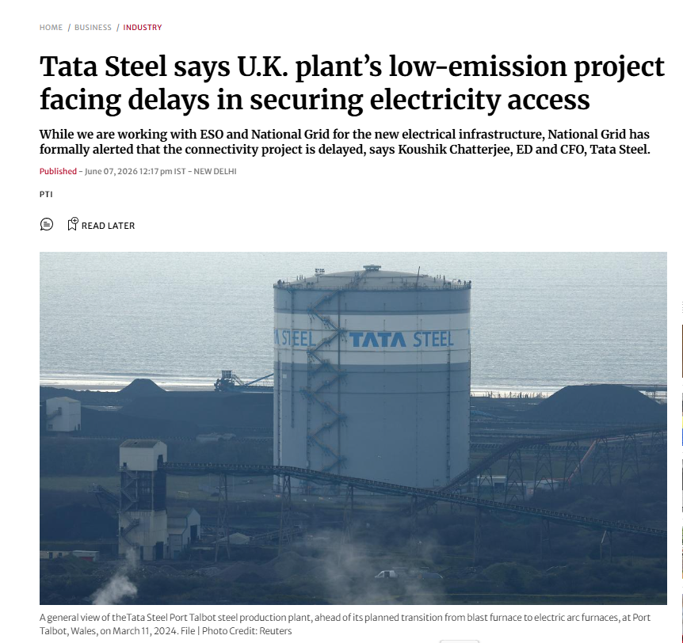
Figure 3: UK plant’s low-emission project facing delays
Source: (PTI, 2026)
The company has been continuing to press ahead with its project in Port Talbot, UK, despite issues with electricity grid access; it is expected that 90% of CO₂ will be reduced on site (around 5 million tonnes per year) (PTI, 2026). This change reduces threats to physical integrity because of weather events, and it also helps meet the world's climate targets, which means that it will be easier to sell low-carbon products such as Zeremis® Carbon Lite (up to 90% footprint reduction).
- Resource Scarcity and Raw Material Security
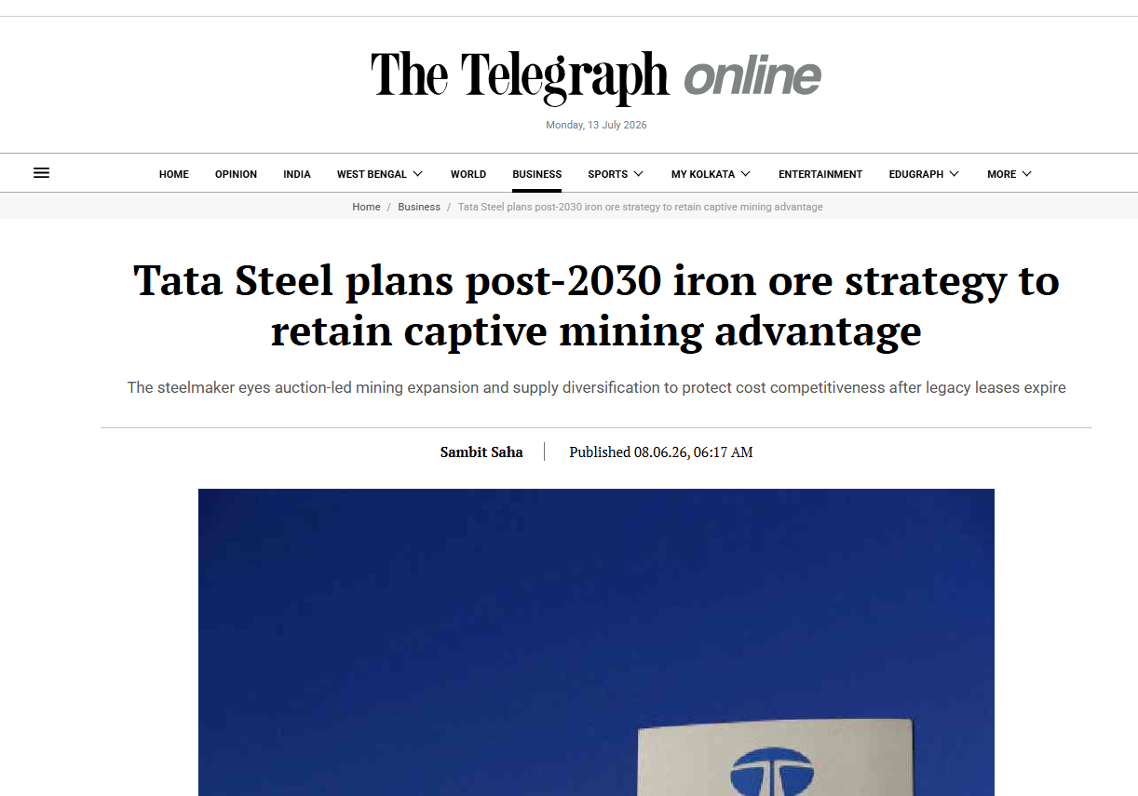
Figure 4: Tata Steel plans post-2030 iron
Source: (Saha, 2026)
Base metals such as high-quality iron ore and coking coal deplete their reserves and make them vulnerable, as per Dhadse and Khan (2026). During FY26, it picked up production of iron ore for 44 million tonnes; it has thought up a plan for how to operate beyond 2030, with the intention of ensuring at least 50% captive mining due to the impending closure of existing leases (Saha, 2026).
- Pollution Control and Sustainable Technologies
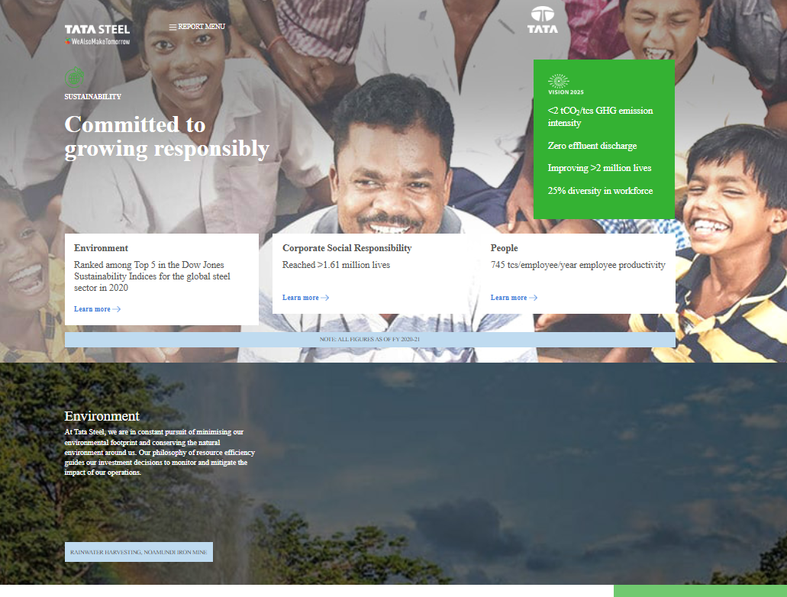
Figure 5: Committed to growing responsibly
Source: (Tatasteel.com, 2021)
Pollution standards and water stress are driving technological innovation in an extreme way, according to Gao (2025). In India, Tata Steel aims to achieve net carbon neutrality with a target of less than 1.8 tCO₂/tcs by 2030 and tailings management as per the GISTM standard by FY2025-26 (Tatasteel.com, 2021). Specifically, partnerships are employed with SMS Group for the EASyMelt technology in 2026, for example, which aims for a CO₂ reduction of more than 50% in blast furnaces.
- Political/Legal Interaction with Natural Environment
Nature pressures are importantly multiplied by political and legal aspects. The EU's Carbon Border Adjustment Mechanism will lead to the implementation of the CBAM carbon levies on steel imports from January 2026, which directly targets carbon leakage and will make Tata Steel face certain decarbonisation efforts if it wants to continue supplying its customers across Europe (Taxation and Customs Union, 2026). Both government support for green technologies and India's domestic emission standards plays a role, as do stricter European emission permits, such as those for Tata Steel Netherlands which start from FY2026, resulting in changes to operations. This what calls for technological changes but also poses a threat to carbon lock-in with continued expansion by India (Saha, 2026).

1.3 Analysis of a Secondary External Actor
The PESTEL political/legal actor signifies all government policies, regulations and international trade mechanisms which influence the operations of the industry (Anderson, 2025).
- EU CBAM and Carbon Leakage Prevention
The EU also has the Carbon Border Adjustment Mechanism (CBAM) in place, which came into its definitive regime on 1 January 2026 and includes carbon taxes on imports of carbon-intensive products such as steel (RIS, 2026). The implementation of the EU CBAM in March 2026 will increase compliance costs for Tata Steel's product exports, with potential carbon levies of 5-15% on ex-EU iron and steel product prices, unless Tata Steel produces them with even higher emissions (Dutta, 2026). CBAM will increase the cost of compliance for steel with high carbon intensity for Tata Steel, which has its major European business and exports steel from India. To address this issue, the company has accelerated the adoption of EAFs in the UK (Port Talbot project for 2027 operation) and the hydrogen/syngas technologies in India, thereby taking measures to reduce the emissions in scopes 1 & 2.
- Government Support and Domestic Policies
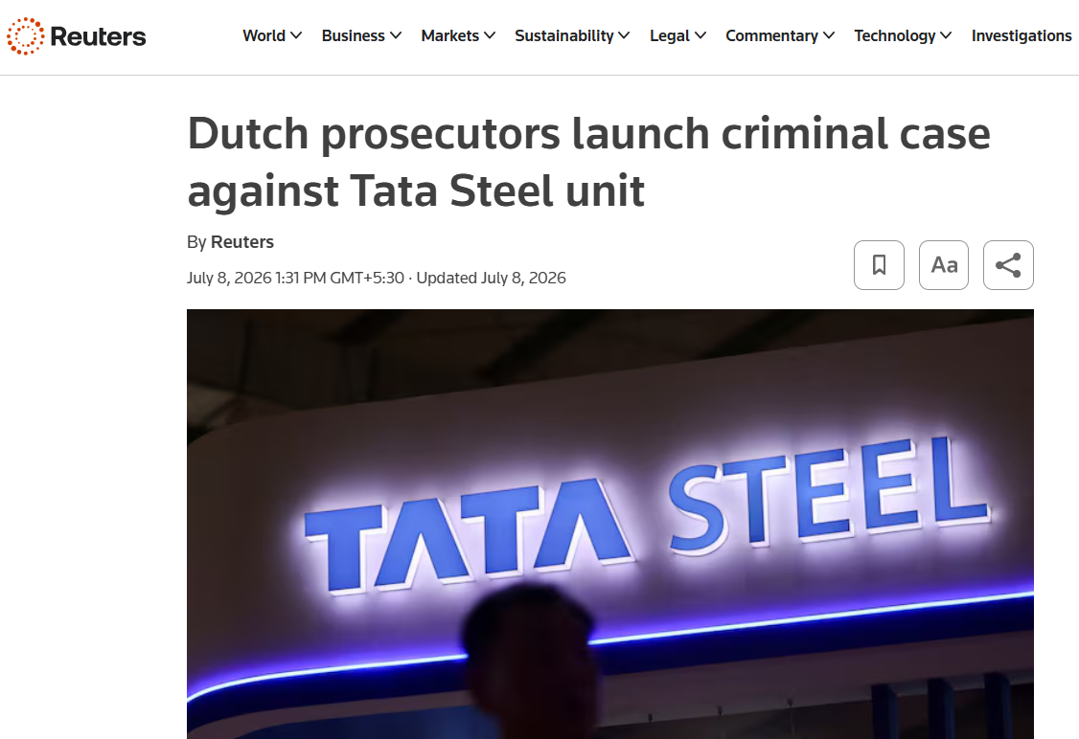
Figure 6: Tata Steel unit faced stricter emission permits and penalties
Source: (Reuters, 2026)
In India, Nachiappan (2026) suggested that funding and policy support are political decisions in harmony with the natural imperative to care for the environment. Tata Steel has the advantage of a supportive government when it comes to the green transition, but on the other hand, it faces the local regulations. More stringent emission permits and penalties (e.g., over €20 million for Tata Steel Netherlands in FY2026) force operational changes in the UK and Netherlands.
- Critical Interaction and Influence on Transition
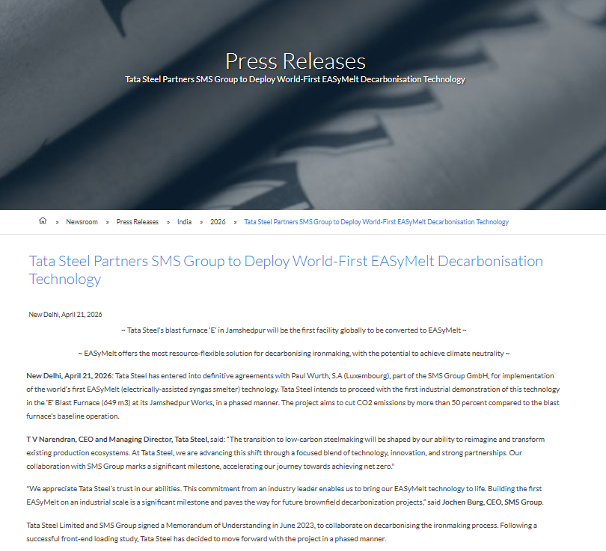
Figure 7: Tata Steel Partners SMS Group to Deploy World-First EASyMelt Decarbonisation Technology
Source: (Tatasteel.com, 2026d)
The Political/Legal actor strengthens the natural environment pressure. CBAM will internalize the externalities associated with the environment, eliminating the competitiveness of high-emission production in some markets (nearly 40% of Indian ex-steel products went to EU countries). This interaction puts Indonesia in the main spotlight of Tata Steel for expensive decarbonisation, such as a pilot for ‘scrap-based EAF' and ‘EASyMelt’, to keep the access to the market and circumvent penalties (Tatasteel.com, 2026d). Importantly, these regulations are not only a catalyst for innovation but also real action towards Net Zero 2045; yet, there are still challenges. Capacity expansion in India poses a risk of carbon lock-in, while there is a risk of carbon leakage in the form of CBAM if there is no technology transfer conducted adequately.

Task 2: Strategic Growth and Competitive Positioning

2.1 Recommendation of a strategic growth approach for Tata Steel using Ansoff Matrix
Tata Steel should pursue a balanced strategy using the Ansoff Matrix, which will focus on product development and market development with product penetration and slightly cautious diversification. Helps to gain a competitive advantage using low-carbon technologies in a steel sector powered by the sustainability of climate action, overcoming resource issues and regulatory uncertainties.

Figure 8: Ansoff Matrix
Source: (Self-Created)
- Market Penetration
Tata Steel has the opportunity to drive more growth in its current markets with its current products by making them more efficient and eco-friendlier. The company's penetration of these two plus automotive and construction segments will be effective, with strong foray performance held in FY26; best-ever 3QFY26 production (6.34 Mt) and deliveries above 6 Mt in India, exemplifying a business model to drive maximum value creation. For India, where the company reported strong FY26 performance with best-ever quarterly production of 6.34 Mt in 3QFY26 and deliveries in excess of 6 Mt, the focus can be on increasing shares in the two sectors through a business model that maximises value creation with branded, lower-emission steel (Tatasteel.com 2026a). Both crucially benefit from strong domestic demand, but face limitations from the high carbon intensity of existing blast furnaces and the prospect of domestic carbon pricing.
- Market Development
Tata Steel needs to grow its low-carbon offerings into these new geographical markets, especially in Europe and emerging markets that are seeking green steel. CBAM is now active (launched in 2026), which opens the door for exporting steel produced using CBAM with reduced emissions (i.e., using upgraded European assets, e.g., Port Talbot EAF), or from Indian pilots (Selvaraju, 2025). The company's European business continues to move towards its carbon neutrality goals, with the support of government financing. Perhaps it is a strategy to reduce trade barriers and satisfy EU green demand, and it involves significant investment in certification and traceability of the supply chains. Prajapati et al. (2025) assert that the key is to address the delay in accessing electricity and manage geopolitical risks, providing medium-term revenue diversification solutions and directly responding to the natural environment's demands.
- Product Development (Recommended Primary Focus)
Potential is especially great for markets for new, low-carbon products, such as Zeremis® Carbon Lite and hydrogen-reduced steel, already in existence or adjacent to us (Tatasteelnederland.com, 2024). Tata Steel has brought forward the deployment of its EASyMelt technology at Jamshedpur to reduce CO₂ by over 50% by 2026, and ongoing EAF capacities are based on scrap material. Sufficiently, this scheme aligns well with natural home pressures and CBAM compliance, leading to premium pricing and buyer loyalty in sustainable areas (e.g., automotive). At the same time, Jindal et al. (2026) illustrated how investments in R&D and capex (planned global investments of ~$30bn) can be financially risky given potential carbon lock-in from Indian investments.
- Diversification
Possible related diversification options for Tata Steel include steel recycling, growing services for the circular economy, and integration of renewable energy resources (Tatasteel.com, 2025). To gain access, the formal steel recycling in India and potential focus on green hydrogen represent long-term targets towards 2045 (net zero). More importantly, it is a risky approach that will create new sources of income and safeguard against raw material shortages but at the expense of primary business functions. It requires extensive investments and cooperation, and the pay-off is not guaranteed in the face of policy fluctuations.

2.2 Achieving competitive advantage
Leveraging innovation in the creation of green technologies, strategic positioning in regulated markets and differentiation in providing sustainable product offerings to Tata Steel can provide a competitive advantage in an era of transitioning into a lower-carbon business model. Tata Steel's 2045 Net Zero goal and ongoing EASyMelt installations give it a focused benefit over its competitors in line with the high investments costs associated with the transition (US$30bn pipeline investment), as ArcelorMittal pledges to become carbon neutral by 2050 with significant investments in Europe's green steel sector (Tatasteel.com, 2026d).
Investing in new technology such as the proposed EASyMelt electrically-assisted syngas smelter at Jamshedpur, projected to achieve blast furnace operations with more than 50% lower CO₂ emissions (announced 2026), and by pushing forward Electric Arc Furnace projects in the UK, Tata Steel is establishing itself as a "first mover" in green steel. In FY26, the company boasted solid operational results in India, producing a record 6.34 million tonnes of crude steel in the fourth quarter of the year, which gave it the financial strength to make these transitions while also increasing its capacity to produce crude steel using EAFs and a scrap-based input structure (Tatasteel.com, 2026a).
This technological advantage also allows us to offer a higher price for the premium product, such as Zeremis® Carbon Lite, which has a much-reduced carbon footprint in production (up to 90%) and impresses customers in the EU and internationally with the costs for CBAM and the requirements for Scope 3 emission reporting. Despite these setbacks to electricity access, European operations have a benefit in government support; for example, £500m UK financing is available for the Port Talbot EAF, which will be capable of cutting site emissions by 90% (an estimated 5 million tonnes of CO₂ per year) once it is operational around 2027 (Tatasteel.com, 2024a).
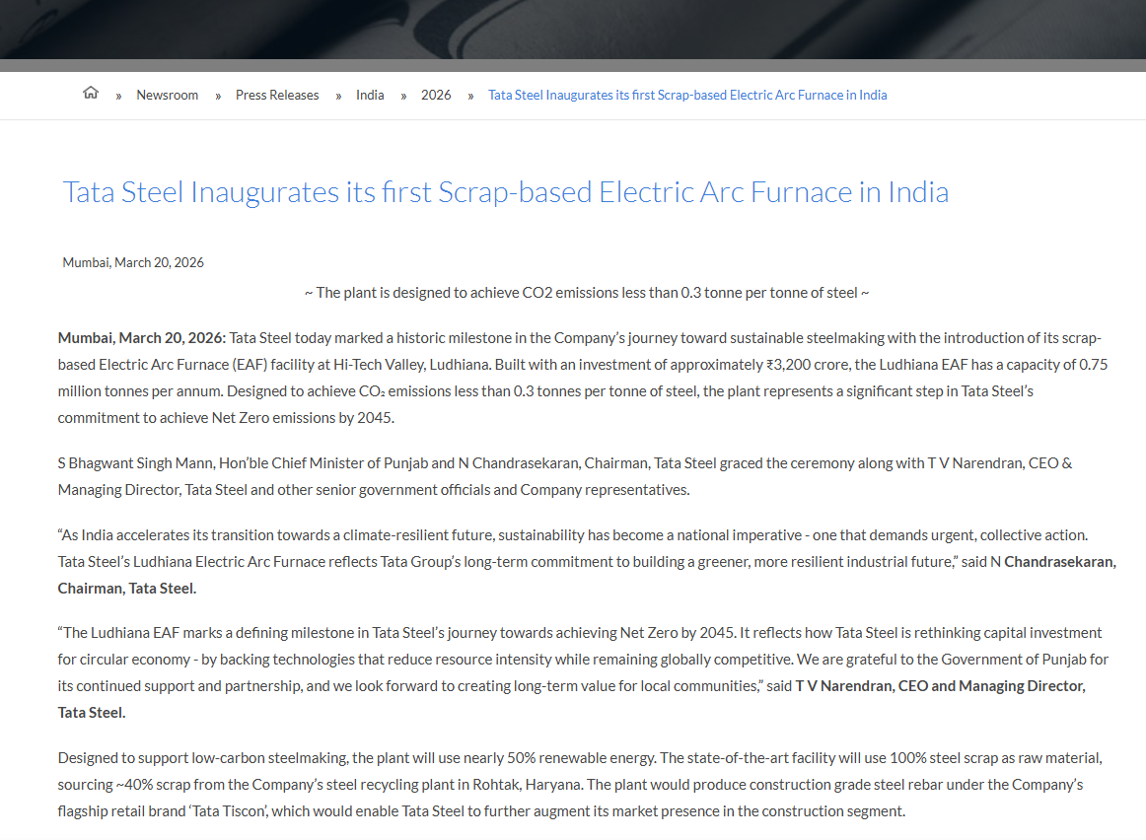
Figure 9: Tata Steel Inaugurates its first Scrap-based Electric Arc Furnace in India
Source: (Tatasteel.com, 2026)
Moreover, the combination of Tata Steel's Net Zero 2045 target, along with the implementation of circular economy activities such as increased steel recycling, strengthens its brand reputation and trust among stakeholders (Tatasteel.com, 2026c). Vertical integration in India lowers supply uncertainty and risk, making it more resilient due to the future plan to ensure captive sourcing of iron ore at over 50%, even after the upcoming rounds.
However, challenges persist. Important capital commitments, with a worldwide pipeline of US$30 billion or more and a strong focus on the Indian subcontinent, may lead to carbon lock-in if new blast furnaces make it coal-dependent in a future with more stringent regulatory environments, potentially losing credibility. The competitive effects of smaller competitors or rivals with quicker decarbonisation timelines may be impacting advantages, and high transition costs may negatively affect short-term margins in cost-sensitive Indian markets, according to Das and Malik (2025).

Task 3: Critical Reflection on AI Usage
The writing of this report also involved the use of artificial intelligence (AI) tools in a limited and structured way in accordance with the assessment's AI use acknowledgement statement, which allows for research support and proofreading but not for using AI to create core content or structure the argumentation.

a. Tool Disclosure
For this purpose, only Gemini and Perplexity were used in the case of initial outlining of the structure. These tools provided me with a higher-level outline of each section heading and a logical order of the information, based on the assignment brief provided. All subsequent content development, as well as the research material and critical writing, was done independently. To ensure adherence, reference to the use of acknowledgement was retained throughout the process of using the AI.

b. Critical Evaluation of AI Output
Structures were verified if they were automatically created by AI. Primary sources, such as Tata Steel's official website (post-2025 sustainability reports and press releases) and recent newspaper articles from the Telegraph (India, June 2026) and Business Standard, were used to cross-check with outputs. The process involved comparing with actual data (for example, verifying emission reduction claims with actual production data in different quarters of FY26 or plans for CBAM implementation). AI initially hallucinated percentages of emissions cuts for 2026, but these were corrected by checking against Tata Steel's actual production releases for FY26, as well as sustainability reports. The suggested connection between environmental analysis and the Ansoff recommendations has contained some logical inconsistencies, which were resolved by manual synthesis with the actual company evidence.

c. Contribution Analysis
AI has played a very limited role, merely suggesting basic organisational alternatives to the report structure, such as subheadings within the Ansoff Matrix framework. Independent human authorship has produced all critical analysis, including this evaluation of interactions with PESTEL and company-specific data integration (e.g., deployment of EASyMelt 2026 and project updates on Port Talbot), as well as all critical discussions. Data sourcing, post-2025 uranium development (e.g., CBAM impact on Indian uranium exports), and nuanced arguments that set the stage for opportunities and risks were conducted without the use of AI.

d. Ethical & Professional Reflection
One of the select uses of AI in this report undoubtedly brings up vital ethical considerations for marketing analysis. Beyond transparency, other issues include risks to data privacy as AI tools often deal with vast amounts of data, including potentially sensitive competitive intelligence information. The biases in the data models underlying complex model training can result in flawed interpretation of sustainability data, marketplace trends and flawed strategic proposals. An overreliance on AI may mean that essential human critical thinking and informed decision-making, needed for more complex marketing decisions, could be lost. Understanding these issues is particularly important within professional scenarios, as it highlights the importance of solid governance behaviours to avoid substituting AI for ethics, helping maintain the responsible development of marketing practices.

Reference List
Anderson, P. (2025). The pestel framework and its variants for analysing the strategic environment: Evolution, limitations and adoption in energy policy research. SSRN. [online] doi:10.2139/ssrn.5266562.
Bhattacharjee, J., Singh, R. and Singh, N.K. (2025). Embracing Sustainability: Role of Corporate Social Responsibility in Promoting Green Growth Amidst a Competitive Business Environment in India. World sustainability series, [online] pp.205–223. doi:10.1007/978-3-031-81469-3_9.
Das, P. and Malik, A. (2025). Challenges to Deep-Decarbonization to Achieve Net Zero for India: A Review. [online] CEEW. Available at: https://www.ceew.in/publications/challenges-deep-decarbonization-achieve-net-zero-india-review [Accessed 13 July 2026].
Dhadse, S. and Khan, S. (2026). Coal mining in India: A study of environmental problems and effects on soil resources due to surface coal mining. Environmental Science and Pollution Research, [online] 33(8), pp.3019–3037. doi:10.1007/s11356-026-37507-3.
Dutta, D. (2026). EU CBAM: A Wake-Up Call for Indian Steel Units to Decarbonise. [online] Outlook Business. Available at: https://www.outlookbusiness.com/magazine/eu-cbam-alerts-indian-steel-units-to-decarbonise [Accessed 13 July 2026].
Gao, C. (2025). The Impact of Technological Innovation, Good Governance, and Green Energy on Water Stress in Developed and Developing Economies. Land Degradation & Development, [online] 37(5), pp.1606–1621. doi:10.1002/ldr.70194.
Jindal, A., Shrimali, G., Bertrand, G., Buller, A., Jakub, C., Sarkar, A. and Marcin, B. (2026). Energy-transition risks create uneven financial impacts across India’s power sector. Communications Earth & Environment, [online] 7(1), p.517. doi:10.1038/s43247-026-03595-9.
Nachiappan, K. (2026). India’s New Climate Statecraft. [online] Cfr.org. Available at: https://www.cfr.org/articles/indias-new-climate-statecraft [Accessed 13 July 2026].
Owusu, S. (2025). Decarbonising Industry At Scale - A Systems Approach to Hard-to-Abate- Sectors. [online] Ssrn.com. Available at: https://papers.ssrn.com/sol3/papers.cfm?abstract_id=5319181 [Accessed 13 July 2026].
Prajapati, P., Guo, R., Cai, A. and Prasad, R. (2025). Navigating the Energy Transition in India: Challenges and Opportunities Towards Sustainable Energy Goal. Water-Energy Nexus, [online] 9, pp.1–18. doi:10.1016/j.wen.2025.07.004.
PTI (2026). Tata Steel says U.K. plant’s low-emission project facing delays in securing electricity access. [online] The Hindu. Available at: https://www.thehindu.com/business/industry/tata-steel-says-uk-plants-low-emission-project-facing-delays-in-securing-electricity-access/article71072482.ece [Accessed 13 July 2026].
Reuters (2026). Dutch prosecutors launch criminal case against Tata Steel unit. Reuters. [online] 8 July. Available at: https://www.reuters.com/sustainability/climate-energy/dutch-prosecutors-launch-criminal-case-against-tata-steel-unit-2026-07-08/ [Accessed 13 July 2026].
RIS (2026). EU-CBAM: Trade Implications and Policy Responses. [online] Available at: https://www.ris.org.in/sites/default/files/Publication/Policy_Brief-128_Rajeev-Kher_and_Anshuman-Gupta.pdf [Accessed 13 July 2026].
Saha, S. (2026). Tata Steel plans post-2030 iron ore strategy to retain captive mining advantage. [online] Ttindia. Available at: https://www.telegraphindia.com/business/tata-steel-plans-post-2030-iron-ore-strategy-to-retain-captive-mining-advantage-prnt/cid/2164461 [Accessed 13 July 2026].
Selvaraju, S. (2025). Finance and state support for low- carbon steel. [online] Available at: https://justtransitionfinance.org/wp-content/uploads/2025/12/Finance-and-state-support-for-low-carbon-steel-1.pdf [Accessed 13 July 2026].
Statista (2026). Largest steel producers worldwide based on production volume 2024. [online] Statista. Available at: https://www.statista.com/statistics/271979/the-largest-steel-producers-worldwide-ranked-by-production-volume/?srsltid=afmbooq6dbybhvspr0kelv7umelwh1xipb2sbsfq4fglblc8dk91thve [Accessed 13 July 2026].
Tatasteel.com (2021). TATA STEEL. [online] Www.tatasteel.com. Available at: https://www.tatasteel.com/tata-steel-brochure-2020-21/sustainability.html [Accessed 13 July 2026].
Tatasteel.com (2024a). Tata Steel signs £500 million Grant Funding Agreement with UK Government for £1.25 billion green steel project in Port Talbot. [online] Tatasteel.com. Available at: https://www.tatasteel.com/newsroom/press-releases/india/2024/tata-steel-signs-500-million-grant-funding-agreement-with-uk-government-for-125-billion-green-steel-project-in-port-talbot/ [Accessed 13 July 2026a].
Tatasteel.com (2024b). TRANSFORMING FOR TOMORROW. [online] Available at: https://www.tatasteel.com/investors/integrated-report-2023-24/pdf/tata-steel-limited-ir-2024.pdf [Accessed 13 July 2026b].
Tatasteel.com (2025a). Integrated Report and Annual Accounts 2024-25 118th year. [online] Tatasteel.com. Available at: https://www.tatasteel.com/investors/integrated-report-2024-25/esg-goals.html [Accessed 13 July 2026a].
Tatasteel.com (2025b). Tata Steel: 4QFY2025 and FY2025 Production and Delivery Volumes (Provisional). [online] Available at: https://www.tatasteel.com/newsroom/press-releases/india/2025/tata-steel-4qfy2025-and-fy2025-production-and-delivery-volumes-provisional/ [Accessed 13 July 2026b].
Tatasteel.com (2026a). Press Releases Tata Steel: 3QFY2026 Production and Delivery Volumes (Provisional). [online] Available at: https://www.tatasteel.com/newsroom/press-releases/india/2026/tata-steel-3qfy2026-production-and-delivery-volumes-provisional/ [Accessed 13 July 2026a].
Tatasteel.com (2026b). Tata Steel - Global Steel Company Pioneering in Steel Manufacturing. [online] Www.tatasteel.com. Available at: https://www.tatasteel.com/investors/integrated-report-2016-17/about-tata-steel.html [Accessed 13 July 2026b].
Tatasteel.com (2026c). Tata Steel Inaugurates its first Scrap-based Electric Arc Furnace in India. [online] Tatasteel.com. Available at: https://www.tatasteel.com/newsroom/press-releases/india/2026/tata-steel-inaugurates-its-first-scrap-based-electric-arc-furnace-in-india/ [Accessed 13 July 2026c].
Tatasteel.com (2026d). Tata Steel Partners SMS Group to Deploy World-First EASyMelt Decarbonisation Technology. [online] Tatasteel.com. Available at: https://www.tatasteel.com/newsroom/press-releases/india/2026/tata-steel-partners-sms-group-to-deploy-world-first-easymelt-decarbonisation-technology/ [Accessed 13 July 2026d].
Tatasteelnederland.com (2024). Tata Steel Nederland launches steel with high recycled content to support customers’ circularity goals. [online] Tata Steel Nederland launches steel with high recycled content to support customers’ circularity goals. Available at: https://www.tatasteelnederland.com/nieuws/en/tata-steel-nederland-launches-steel-with-high-recycled-content-to-support-customers-circularity-goals [Accessed 13 July 2026].
Taxation and Customs Union (2026). CBAM successfully entered into force on 1 January 2026. [online] Taxation and Customs Union. Available at: https://taxation-customs.ec.europa.eu/news/cbam-successfully-entered-force-1-january-2026-2026-01-14_en [Accessed 13 July 2026].

