NAME - VIJAY KUMAR
STUDENT NUMBER- 1918986
MODULE TITLE- LCMB7003
ASSIGNMENT TITLE- STRATEGIC MANAGEMENT

Table of Contents
1. Introduction 3
2. Situational analysis 4
3. Industry Analysis 5
3.1 Key Success Factors 5
4. Internal Analysis 5
4.1 Core competence and the resource-based view 5
4.2 SWOT 7
5. Strategic analysis of the cultural issues faced by the company 8
6. Application of theories and models to solve the central issues and how these can be deployed in the emergent strategies: 10
7. Bowman’s strategic clock 12
8. McKinsey 7S model 15
9. Analysis of strategic options of Biocon using Ansoff Matrix 17
11. Recommendations 19
12. Conclusion 21
References 22

1. Introduction
In the gargantuan business world to implement service exquisitely the requirement of proper strategic management is necessary. The improvement of the several industries is the key factors for the development of the country (Abrol, Prajapati and Singh, 2017). The proper strategic management exposes the innovation and sublime level of productivity in the global business platform. In the concept of strategic management, the innovative performance of a firm is an important factor. In this aspect, the Indian pharmaceutical industry implies great changes to the economy of India. For the last three decades, the pharmaceutical companies are constantly emerging their business in the Indian business market which builds the potential economy of the Indian government. The several industries in this industry are constantly emerging its business in this nation and foreign countries.
The innovative leadership approaches and the strategic management approaches help to construct the potent performance of a firm in the global business entity. Here in this assignment evaluate the management structure of Biocon India Group which is a manufacturing group for the enzyme. Under the Indian pharmaceutical industry, the long years' experience of this group helped to established Syngene international organisation to serve their services in the global context as a subsidiary (Banerji and Suri, 2017). This particular assignment has explained the several analytical approaches based on this group. In this assignment, the several internal and external approaches have helped to evaluate the different aspects of this group and its services to the business market. The productive thoughts and perspectives of the management can help to produce a strong field in a swift path.

Figure 1: Biocon Company Logo
Source: (Dey, 2019)

2. Situational analysis
Biocon is a fully integrated biopharmaceutical company driven by innovation that develops affordable biosimilars, unique biologics & complex APIs. This group is a joint venture with Bicon Ireland. This pharmaceutical group was established in Bangalore in 1978. The main objective of this firm is to produce enzymes to reduce the use of drugs. This pharmaceutical group established a subsidiary named Synegen based on its durable and long time experience. This is a joint venture pharmaceutical project. In the year of 1898, the Biocon Ireland acquired by the Unilever. This pharmaceutical group produced the enzymes for the food business of the Unilever. After some years this pharmaceutical group of India bought out the share of the Unilever in this firm and became an independent. In recent years the company has introduced a new subsidiary named Clinigene. As per the opinion of Pilon and Hadjielias (2017), this subsidiary launched in 2000 and this wide range of clinical services conducts the overall busbies suitably. In the Indian pharmaceutical market, the group of Biocon has extended its clinical testing and pharmaceutical business widely. In the year of 1997, this group has represented the $12 billion market for generic statins. It is a group of drugs which help to reduce the cholesterol level. The chief scientist of went to the Japanese factories to recognise the techniques of the solid-state procedure of the fermentation and which has conducted in their procedure. At this present time, this company has global business exposure. It has expanded its business in Mexico, Canada, Eastern Europe and several countries.
The clinical trial of the company has the beneficial effect for contact research organisation (CRO). Besides it, meticulous and strict terms and conditions are imposed by the local government to the company which is a great risk for the company in the process of the experiments. In the other hand, the company also faced allegation and several questions. The clinical test is a hazardous matter and sometimes it is not successful properly which raise the queries from the patients.

3. Industry Analysis
According to Shafique et al., (2019), Health industry in India had been promptly shaped and properly extended in the Indian market based on the economical policies. Several pharmaceutical companies from foreign countries occupied the local market of India. In this pharmaceutical industry, the executed chief scientist and the R&D team of Biocon India Group built an exclusive patented fermentation reactor which named PlaFactor^{TM,} which innovatively simplified the procedure of fermentation. The subsidiary of this company executes the several types of clinical studies due to the requirement of bio-equivalence and bio-availability to prove that the generic drugs have a similar dosage like as off-patent original drug. In the global market, this is a joint venture is a manufacturing firm which produces the enzyme. The company has two subsidiaries Clinigene and Syngene which has the pivotal role to emerge the services swiftly. Clinigene is the new subsidiary of this pharmaceutical group in the year of 2000.The company has a wide level of market at a global level. Biocon India group has extended its services in Canada, Mexico and European countries.

3.1 Key Success Factors
In the global market, this firm has extended its business in a wide path. The subsidiary of this company, Syngene is one the key success of this organisation. This subsidiary of this organisation has increased the profit level of this firm. In the other hand, the open culture of the company has trust among the employees. In returns, the employees reflect their responsibilities to the company (Mazumdar-Shaw, Prathipati and Sengupta, 2020). The organisation has focused on the innovative way, building the brand and reach to the customers' demand for their potential attendance in their pharmaceutical and biotechnological services.

4. Internal Analysis

4.1 Core competence and the resource-based view
In the global market expansion, there are several core competencies of this firm. The founder of this organisation Mazumder-Shaw fixed its business in the fermentation process to produce enzymes for several purposes. The fermentation process of Japanese’s recreated by the Biocon India innovatively. The organisation produced the patented fermentation reactor named PlaFractorTM. The ground-breaking fermentation base easy the course of action and build better management over it. In the other hand in the global platform of the pharmaceutical business, this firm has excellent research and development process. The research and development team is highly qualified and postgraduates from the several science streams who are enough capable to produce the prime level of complex and exigent molecules (Abrol, Prajapati and Singh, 2017). The organisation has the 50 up process engineers to regulate the functional system of the laboratory. In the other hand, the company has excellent performances in its manufacturing process. The company has the API manufacturing facilities. API manufacturing facilities are well equipped with a large range of equipment to regulate the process of fermentation and procedure. The formation of this manufacturing process helps the company to manufacture the molecule and chemicals potently.
On the other characteristic, the organisation has built a potential relationship with the customers. The strong relationship with the customers is assembling the strong organisational representation of the company. The company has tried to represent suitable program regarding the social and health requirements (Banerji and Suri, 2017) Besides this matter, the company have strong faith in its employees. The potential faith among the employees constructs a healthy environment in the company culture. The organisation motivates the employees to avoid the hierarchies and do their jobs in the best path. The subsidiaries of this organisation work the potent factors for the company to stand itself in the competitive platform. The company has two subsidiaries –Clinigene and Syngene. These subsidiaries are the key factors for the company to fetch its sublime level. The management in the Biocon is following the good practices for manufacturing, good storage practices and good distribution practices in their operational process to assure premium quality. The company have more than 200 well trained professional monitors with standard quality which implies the fruitful manufacturing process and guarantee the compliance of GMPs.
In the other hand, the primary potential resources of this organisation are the efficient roles of the leaders in the operational system. The CEO of the Biocon India group Siddharth Mittal has efficient roles in their operational project. The efficiency of the leadership roles has brought out the great ramification of the company in the global competitive market. This pharmaceutical group has constantly reflected the captivating missions with strategic entrepreneurship ethics. In the globally competitive world to gain the potential platform with the competitive advantages the resources and capabilities should be analysed through the VRIO analysis (Dey, 2019).
VRIO Analysis
Competitive Advantages (VRIO Analysis ) |  | Biocon India Group
Valuable | This firm has served good quality services to the customers | Yes
Rare | Offer innovative services | Yes
Inimitable | Hard for rivals to imitate | Yes
Organisation | Enough efficient to develop the ability | Yes

4.2 SWOT
Strengths:
The expertise in producing enzymes contributed to the growth of mass production of generic drugs, which provided Biocon India Group with the experience in establishing Syngene, a branch of contract-for-research (CRO) that supports the global pharmaceutical industry (Bisht, Jacob and Chandy, 2018). The knowledge in the production of enzymes led to the mass production of generic drugs. Therefore, in early 2003, Biocon generally parlayed earning and the company's employees were further boosted with annual revenue of US$75 million. The Biocon Group started Clinigene as a subsidiary in 2000, which is seen as one of the significant strength of the company for increasing its technical strength in clinical trials.
Weakness:
As Clinigene was Biocon India Group's latest innovation, the company and its customers may also be an immense distraction. It was also responsible for the absorption of precious resources in an area with little direct knowledge of Biocon (Lahiry and Rangarajan, 2019). Human clinical trials were highly complex and could lead to numerous multidimensional problems. Financial losses may result from unsuccessful clinical experiments, complex compensation processes for victims and dubious ethical problems for workers.
Opportunities:
In particular, in R&D and biotech, the Indian government acknowledged the tremendous potential for growth of the medical biotechnology industry and had therefore, generated both internal and external funding to promote growth in the industry. The high growth potential can be very beneficial for Clinigene's bigger likelihood to produce business revenues (Neenan, Burrier and Kim, 2018). The studies show that CRO's growth potential is very large in the Indian market. The current position of Clinigene is centred on the value chain in the small to the medium-value segment. By growing the value chain, the business and the subsidiary will benefit more in the long term as well.
Weakness:
Biocon India Group might become a victim of the success of Clinigene. The significant portion of a growing market can darken the involvement of Biocon and Syngene for Clinigene (Bisht, Jacob and Chandy, 2018). Aggressive growth will require the company and its policy-making process to broaden its resources and time. It may affect recruitment and reduce the time to restructure the environment of Biocon. Moreover, Biocon can harm their organisational culture in loose mechanisms and casual hierarchies. Besides,it may be a major challenge for the organisation to adopt to the new framework and cultural design. The company also needs to promote its other developed sectors to solve the obvious issues.

5. Strategic analysis of the cultural issues faced by the company
Strategic challenges faced by the owner
Establishing a new subsidiary: It is not simple to create a new subsidiary. Kiran Shaw faces challenges as a result of financial, credibility, gender, infrastructure and access to services. As external consumers for the CRO business, she wanted to retain the Clinigene on the market. There were a few challenges including market positioning, future market risk, adaptation to indifferent culture ads, and ethics, and after its establishment for two years(Biocon.com, 2019).
Business opportunity: The development of clinical research in India has started to be started and exploded in the next ten years with the increasing demand of the population. In this market, contract research organisations (CROs) were a key player. The increased potential market growth might be the opportunity of a favourable market place, but the presence of other MNCs in this sector could mean a risk of survival with a good position since Clinigene is now in low- to medium-term places.
Little or no direct market experience: As Clinigene was the Biocon India Group's novel invention, the organisation and its customers could be a major distraction. It was also in charge of an environment in which Biocon had very little direct experience of consuming precious resources(Lahiry and Rangarajan, 2019). For any company, this sort of start could be extremely dangerous. Biocon never considered what sort of result they might obtain from the market.
Organized culture: Clinigene increasing grows to a size that is outshined by Biocon and Syngene. The requirement is also high for this large site period and resources. Concerning a large number of employees, new designs of the company are necessary to launch procedures.
Dealing with central issues:
Developed consumer loyalty and improved market trends: Biocon India began its new journey with the effective launch of the new Clinigene subsidiary. With the availability of a broad range of clinical trial facilities, drug development processes based on two different fields in various forms of clinical trials, this was a challenge for such a preservative pharmaceutical industry (Neenan, Burrier and Kim, 2018). Non-patent original and generic medicines typically only have to pass clinical studies of bioequivalence and bioavailability (BE/BA) while more rigorous clinical trials were required on new medicines. So, BE/BA studies with both the concentrated partnership coordination research for hospital clinical trials focused on clinical laboratory services.
Taking precautions against the challenges from pharmaceutical giants: The high growth potential will enable Clinigene to make much better use of its business revenues. The present position of Clinigene is focused on the value chain in the low- to the medium-value segment. By increasing the value chain, the business and the subsidiary can be more profitable in the long term.
Profit from success and removal of cultural dilemmas: The Biocon Group India can be a victim of the success of Clinigene. The substantial chunk of rising demand for Clinigene can overlook the contribution of Biocon & Syngene(Biocon.com, 2019). Aggressive growth will allow time and money to be diverted into the company and its policies. It could also affect recruiting for new workers and reduce the time needed to redesign the Biocon community so that the organisation can address all the problems it needs to promote its other sectors. The organisation can find a loyal worker base for both the parent company and the subsidiary.

6. Application of theories and models to solve the central issues and how these can be deployed in the emergent strategies:
Porter’s generic strategies
Different models and theories are used to deal with the core problems of this business. Therefore, Porter's Generic strategies are one of the most appropriate models for solving the central issues related to Clinigene, which is Biocon’s new subsidiary. The model will be using four types of techniques to obtain the desired result and accurately use the model (Islami, Mustafa and Latkovikj, 2020). This includes cost leadership (no supplements), cost focus (producing service for a different niche market) differentiation (making extraordinarily acceptable services or goods) and differentiation focus. These four strategies are developed from two bases, is a source of sustainable competitive advantage vertically used, and are horizontally competitive markets for businesses. For a good discussion on them from the organisation's viewpoint and their efficient implementation of the following process of the subsidiary, Clinigene can be considered.
Cost Leadership: A Cost Leadership approach may be implemented by rising profit by reducing costs and prices centred on industry average prices. Concerning to increase the market share, this strategy is another form of market cost control (Smith et al., 2019). Biocon may thus target the masses as its preferred customers. When Biocon has established this strategy, this will help to reduce costs by setting access capital technology at the start of the company and strongly logistics. This strategy will enable Biocon to set its cost at a reduced rate and will further gain a competitive advantage over its competitors.
Differentiation strategy: The organisation must make for its consumers an innovative product. Here, the audience is not targeted. The business represents only a collection of people with the same needs. For this form of strategy, a strong team for research and development is essential for proper research and the creation of a high-quality product and need for an effective sales and marketing team which assures the value provided by the differentiated products. Otherwise, rivals in different market segments encounter the threat outbreak in several faces following focus differentiation strategies.
Focus Strategy: This strategy focuses on a particular niche marketing community of individuals. Being a strong brand should be unique in this market and try to maintain their loyalty. When any company have decided to go to cost control or marketing differentiation and the company can select a focus strategy (Islami, Mustafa and Latkovikj, 2020). As generally, the emphasis is not sufficient alone. Biocon may also add something extra to reduce costs or offer a unique product as per the client specifications through a detailed investigation of its customer segment.
By its opportunities and strengths on the local market, the company must reduce its vulnerabilities and capacities. With such an unpredictable marketplace, Clinigene is an essential attempt of the Biocon India Community. A subsidiary's outcome can affect Biocon's overall reputation and brand image (Smith et al., 2019). Consequently, the company must make very cautious efforts and take careful steps to advance future external and internal problems. Therefore, relative to many other local companies working in the Indian pharmaceutical industry, they are now in a better position. This business thus falls in the areas of cost control and differentiation leadership in the generic strategy of Porter. Therefore, the subsidiary wanted to improve on both sectors to end up making further efforts based on overall strategy factor of the porter.
By its opportunities and strengths on the local market, the organisation must reduce its weaknesses and capacities. In such an unpredictable marketplace, Clinigene is an important attempt of the Biocon India Community (Dev, 2019). A subsidiary's success or failure can affect Biocon's overall reputation and brand image. Therefore, the organisation must make very cautious attempts and take careful steps to overcome future external and internal issues. Therefore, compared to many other local companies operating in the Indian pharmaceutical industry, they are already in a better position. This company thus falls in the categories of cost control and differentiation leadership in the generic strategy of Porter. Therefore, the subsidiary must focus on each area to develop its further efforts successful depending on its generic strategy factor.
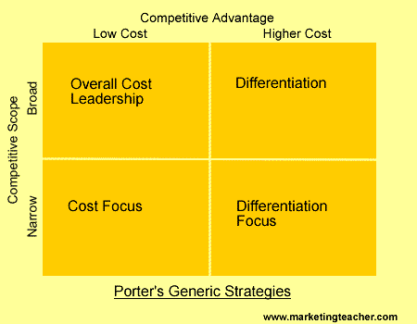
Figure: Porter’s Generic strategies
(Source: Islami, Mustafa and Latkovikj, 2020)

7. Bowman’s strategic clock
Bowman’s strategic clock is model which is exploring the diverse options for the strategic positioning of the business market. This particular model is the extended form of the porter’s five strategic forces into eight. This is mainly focused on the two dimensions – price and professed value(Pilon and Hadjielias, 2017).
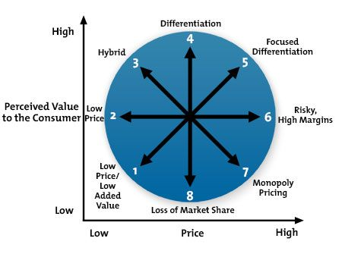
Figure 2: Bowman’s strategic clock
Source: (Kumar et al., 2020)
Position 1: Low price and Low added value
The company is good in this position. The price level is low and the product value of the product is high.
Position 2- Low price
The product cost of the product is a captivating factor for the customers. In that case, the product price is at a moderate level.
Position 3- Hybrid
This particular aspect uses the product distinguish, products are high in value and could below cost. This can easily attract and beneficial factor for the customers. This is appropriate for the Biocon India Group.
Position 4- Differentiation
Companies are implementing the innovative business strategies which are fruitful for the organisational business. It offers high quality and moderate price. In that case, Biocon India Group offer sthe highest value to its product at an affordable price. That is why customers have preferred their product (Shafique et al., 2019).
Position 5- Focused Differentiation
The products price is high and the quality of the product luxurious. For the Biocon India Group, this factor is not applicable.
Position 6- Risky High Margins
In this fact, the organisations are a charge for high prices of the product. In that case, the value of the product is reducing among the customers. This has not happened in the tactful business procedure of Biocon Group.
Position 7- Monopoly pricing
This is referred to as a free market without any competitors. But for Biocon group, the market is not free. The organisation has several competitors in their global business market.
Position 8- Loss of market share
This offers the high cost and low value of the product. This situation changes the perspectives of the customers. This is not following factor for this organisation. Biocon pharmaceutical group always try to offer the standard level of product and services (Mazumdar-Shaw, Prathipati and Sengupta, 2020).

8. McKinsey 7S model
Tom Peters and Robert Waterman, former McKinsey & Company consultants, developed the model at the end of the 1970s (Kaushik and Kaur, 2019). It helps in seeing how different elements of the organisation function together. It could be used for accessing the likelihood of organisational shifts. Seven components are described, three hard components; strategy, structure, systems and four Soft components include style, skills, shared value and staff.
Strategy: The Biocon section focuses on expanding its existence through strong regional collaboration in rapidly growing emerging markets. The complete business model of Biocon protects the entire value chain from preclinical research to clinical innovations and marketing strategies.

Structure: Small molecules, Branded formulations, biosimilars, novel molecules and research services are part of the business framework (Anand and Singh, 2019). The organization's functional framework involves marketing, accounting, production and Research and Growth.
System: It is simple and highly efficient to run the Biocon systems. Air (oxygen) is often used to directly oxidise the organic matter, combined with chlorine (recommended either 5% or 14%) to remove the germs.
Style: It can be seen that Kiran Shaw, the company's Managing Director, primarily employs transformational management to manage its business.
Skills: Soft skills are essential to the successful creation of a career and Biocon frequently conducts learning the lessons on topics like time management, emotional intelligence, stress management, and communication skills (Kaushik and Kaur, 2019). The initiatives are based on an interpersonal, strategic, functional and human-centred competences system.
Staff: Senior management, key experts, laboratory personnel and general managers are part of the core team of the company.
Shared value: The Company’s key value includes to become a recognized hub for advanced bioscience learning and the brand focuses mainly on the values of honesty, commitment, equality and trust (Bisht, Jacob and Chandy, 2018).
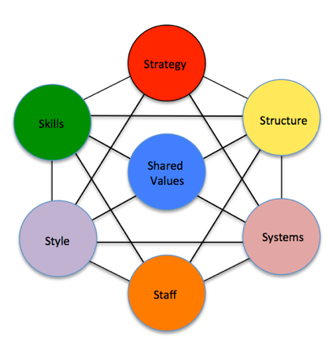
Figure: McKinsey 7s model
(Source:Kaushik and Kaur, 2019)

9. Analysis of strategic options of Biocon using Ansoff Matrix
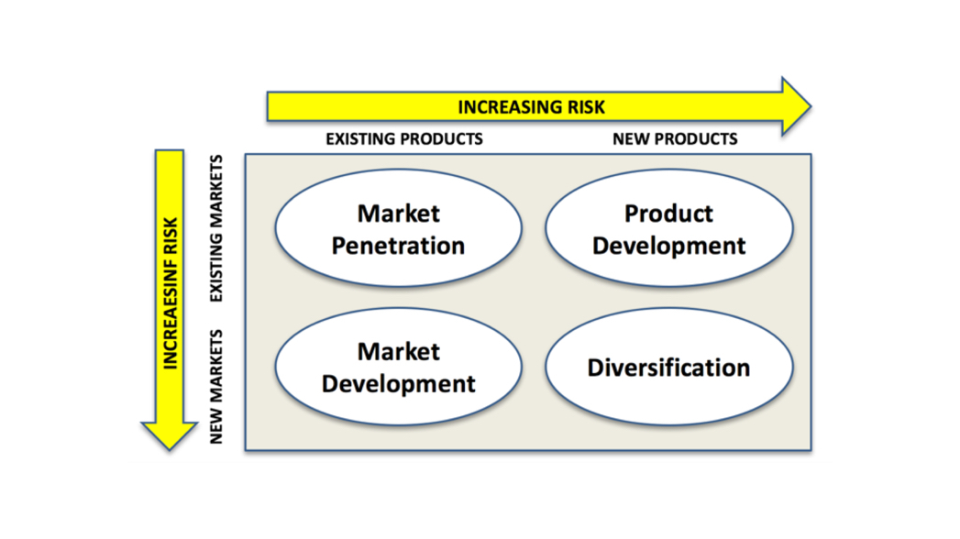
Figure: Ansoff Matrix
(Source: Aldieriet al., 2020)
Market penetration:
This matrix could be used both for-profits and for non-profits as it allows preparing a business growth strategy.
Market Penetration: This occurs as Biocon promotes its current market. This is primarily focused on maintaining its market share of existing goods (Farhan and Yameen, 2020). This is achieved utilizing correspondence, publicity and Personal sales. Growing its market penetration helps to secure domination in the local health sector. The price strategy and promotions allow the market to reorganise and remove rivals, thus making the market less attractive for competitors.
Market developments: It is necessary to explore more markets to increase incomes from all neighbouring villages. Canals of the Sales can be expanded to meet consumers quickly and at a lower price. The price policy may differ so that customers from different locations can be attracted as per ease (Aldieriet al., 2020). Biocon generally choose India for outsourcing its pharmaceutical products and it is apparent that India is generally a huge pool of English speaking professionals, and the Clinical trial service is generally emerging as main targets for outsourcing in India.
Product Development: Product development is a growth strategy as it includes an introduction to existing markets of new goods. This is all about creativity and innovation. By carefully reviewing, analysing, and being the first to explore customer needs. Biocon may also research current social development for its Clinical research services promotion. The introduction of the company’s clinical trial services would generate huge profits for the company.
Diversification: It is evident that the Biocon had generally expanded its enzyme business to the pharmaceutical industry. Moreover, the new subsidiary of Biocon named Clinigene will further help the company to increase its technical strength by providing services in clinical trials (Farhan and Yameen, 2020). Thus, the diversification of the company’s services will help Biocon to further grow and develop its business.
10. Findings
This study is a descriptive analysis centred on Biocon India Group's new subsidiary, Clinigene(Biocon.com, 2019). The Indian pharmaceutical industry is causing a big influence on their economic growth and the country's GDP development. The formation and service of drug business in India has several benefits and drawbacks.
Advantages:
- Several well-known research institutes are accessible in India as they have high-quality staff. Every year, such research institutions produce a high-quality workforce.
- In the 1970s, it imposed on the well-being of this industry two different patent laws.
- The general population of the country is gaining from clinical trials.
- The low cost of generic medicines is popular in India. In turn, R&D costs are cheaper than in any other region.
Disadvantages:
- Not strictly adhered to the Patent Law. It was removed after a certain time.
- The business plays a key role in competition there are some 20000 businesses.
- Due to ethical concerns and media, clinical trials are not so easy.
- International corporations' threats to this market are competitive due to the low cost of production and the high quality of their workforce.
- For this sector, profitable subsidies are imposed on raw resources and procurement
Challenges faced by Clinigene:
- As a subsidiary in 2000, Biocon launched Clinigene. After that, there had been big problems in the clinical trials.
- To develop the business on the competitive market in India, significant financial support was required.
- As future failures will occur, the risk was integrated into the establishment of the company and this group of investors would suffer a massive loss.
- Two types of service offered opportunities. One is a short-term and a long-term basis. The organization was secure in the short term and the long term is a risk.
- In this whole marketplace of rivals, the introduction of yet another field was a challenge.
- Another important challenge is the use of cheaper technology and the economic downturn.

11. Recommendations
In the whole report, the Indian pharmaceutical industry is taken into account, the Biocon India Group, and Clinigene clinical subsidiary, Biocon India Group Limited (Biocon.com, 2019). In the mentioned sector, the strategic viewpoints for this association were evaluated and different progress strategies were recommended based on the assessment. Some missing parameters are analysed in this descriptive report, in both the company and the pharmaceutical industry, and that needs to be greatly reduced or eliminated. Adequate steps to improve the current situation should be taken. The following steps are:
The patent law must be strictly imposed in the Indian Pharmaceutical industry. The best necessary measures for the company could not be covered without the proper patent process.
International companies must establish a significant binding obligation to do business in India. The industry will ensure that its local companies get the right growth and expansion possibility. In that scenario, the government will tax MNCs higher, offering the pharmaceutical industry in the country higher importance.
The Government may also apply certain structural controls to stop the production and elimination of a significant proportion of the market share by international organisations or pharmaceuticals.
Reducing unethical questions and controlling the media because false or partly accurate information can be transmitted via the media (Anand and Singh, 2019). It is important to control the media because people now rely much more on social media.
Since Clinigene is a risky project, massive risks may result in high profitability or a serious business loss, the employer should thus have a back-up plan.
Instead of inexpensive or backdated technology, the company should always rely upon using costly or emerging technology. They must focus on the process of innovation and still keep the new subsidiary adaptation up to date with their method.
The business should work to build a broad network of contact through the entire business sector in order very easy to meet clients and customers.
The Group should be more precise, reliable and detailed tactics that will help to define the corporation's current market position and to focus on the latest market access plan.
For better durability in the new subsidiary, Biocon India Group needs to implement its value chain mechanism seriously and retain the decentralised power process.
The system of internal control relies mainly on financial statements being compiled and presented. In this way, the company is in the proper direction to have more internal control.
For the company Clinigene, there is a need for large numbers of financial resources and a huge amount of people need the consistency of the operation (Lahiry and Rangarajan, 2019). Since the company is prone to failure, this company risks a major loss for the long-term.

12. Conclusion
In the global pharmaceutical industry, the Biocon India Group has splendid performances at the competitive level. In the year of 1978, this pharmaceutical organisation is founded in Bangalore city. This particular report has elaborated several effective strategies in the organisational context. In the initial stage, this venture has faced several obstacles. The efficient leadership roles of the leaders are the success key of the organisation to overcome the challenges. This report also refers to the SWOT analysis of the organisational context. SWOT analysis refers that the company has only a risk factor. The company was not confident about the profitability of the new subsidiary of this organisation Clinigene. This report has also referred to the core strategic analysis of the organisation and overcome the challenges of the company. In the global competitive pharmaceutical industry, the company has the potential key factors with innovation which has a beneficial aspect for it to sustain the business. In this report, VRIO analysis and the strategic clock has given the ramification that the company has maintained exquisitely all aspects of their strategic management.

References
Abrol, D., Prajapati, P. and Singh, N., 2017. Globalization of the Indian pharmaceutical industry: implications for innovation. Institutions and Economies, pp.327-365.
Aldieri, L., Bruno, B., Senatore, L. and Vinci, C.P., 2020. The future of pharmaceuticals industry within the triad: The role of knowledge spillovers in innovation process. Futures, 122, p.102600.
Anand, R. and Singh, B., 2019. Effect of Composition of Board and Promoter Group Retained Ownership on Underpricing of Indian IPO firms: An Empirical Study. Indian Journal of Corporate Governance, 12(1), pp.21-38.
Banerji, A. and Suri, F.K., 2017. Patents, R&D Expenditure, Regulatory Filings and Exports in Indian Pharmaceutical Industry.
Biocon.com. 2019. [online] Available at: https://www.biocon.com/docs/Biocon_AnnualReport_2010.pdf [Accessed 26.12 2020].
Bisht, L.K., Jacob, B. and Chandy, V., 2018. Indian Pharmaceutical Industry in 2018-SWOT Analysis. NOLEGEIN-Journal of Global Marketing, pp.7-11.
Dey, S., 2019. Biocon: Taking a Crack at the Global Biosimilar Market. South Asian Journal of Business and Management Cases, 8(1), pp.100-110.
Dey, S., 2019. Biocon: Taking a Crack at the Global Biosimilar Market. South Asian Journal of Business and Management Cases, 8(1), pp.100-110.
Farhan, N.H. and Yameen, M., 2020. The relationship between credit policy and firms’ profitability: empirical evidence from Indian pharmaceutical sector. Investment Management & Financial Innovations, 17(2), p.146.
Islami, X., Mustafa, N. and Latkovikj, M.T., 2020. Linking Porter’s generic strategies to firm performance. Future Business Journal, 6(1), p.3.
Kaushik, S. and Kaur, H., 2019. Optimal Resource Allocation for SQM: A Comparative Case Study in Pharmaceutical Industry. IUP Journal of Applied Economics, 18(3).
Kumar, A., Soni, R., Hawaldar, I.T., Vyas, M. and Yadav, V., 2020. The Testing of Efficient Market Hypotheses: A Study of Indian Pharmaceutical Industry. International Journal of Economics and Financial Issues, 10(3), pp.208-216.
Lahiry, S. and Rangarajan, K., 2018. A Strategic Insight. Flexible Strategies in VUCA Markets, p.31.
Lahiry, S.R. and Rangarajan, K., 2019. Strategic use of patents by an entrepreneurial multinational organisation in Indian context. Journal for Global Business Advancement, 12(3), pp.356-381.
Mazumdar-Shaw, K., Prathipati, S. and Sengupta, J., 2020. Why a cut-and-paste approach to digital transformation won’t cut it: An interview with the founder of Biocon. The McKinsey Quarterly.
Neenan, T.X., Burrier, R.E. and Kim, S., 2018. Biocon's target factory. Nature biotechnology, 36(9), pp.791-797.
Pilon, F. and Hadjielias, E., 2017. Strategic account management as a value co-creation selling model in the pharmaceutical industry. Journal of Business & Industrial Marketing.
Shafique, M.N., Khurshid, M.M., Rahman, H., Khanna, A. and Gupta, D., 2019. The role of big data predictive analytics and radio frequency identification in the pharmaceutical industry. IEEE Access, 7, pp.9013-9021.
Smith, R., Weaver, J., Lucco, J., and Jackson, T. 2019. 13 Strategic Planning Models To Consider | ClearPoint Strategy. [online] ClearPoint Strategy. Available at: https://www.clearpointstrategy.com/strategic-planning-models/ [Accessed 26.12. 2020].

