THE GLOBAL BUSINESS ENVIRONMENT
LCBB4005
Rexon Nting

Elena Blagoeva 1913400
BA Business Management
Group 1 Term 2
Assessment 2

Table of Contents
Introduction 2
Porter’s Value Chain Analysis of Electric Industry – Case of BMW i3 3
Primary Activities: 3
BMW i3 inbound logistics: 3
BMW i3 operations 4
BMW i3 outbound logistics 4
BMW Marketing and Sales 4
Support Activities 6
Technology: 6
HRM: 7
Infrastructure: 7
Procurement: 7
Product life cycle 8
Reference List 10

Introduction
In Munich, Germany, BMW is the leading premium vehicle brand. A broad network of car producers has preserved its worldwide presence. It is also well renowned worldwide, due to its strong emphasis on product efficiency, technical advancement, and public safety. BMW had also managed to maintain its growth lively even during challenging times.
In addition to increasing legislation and political instability, the automotive industries are facing many major challenges that impede demand and development in many of the main regions upon its market, including Britain. In addition to shifts in global patterns, customer dynamics, and other political and economic threats, the US and China trading wars have impacted the automotive industry. Throughout Oct and Nov 2019, it was very well sold in the US, which has helped to optimize service quality and to control operative costs as among the critical competitive advantages for any firm.
The i3 BMW is one of a high roof B-class BMW hatchback with back wheel driven electric motor and with Li-ion floor battery & an option of a range-extensive petrol engine. The battery is supplied by BMW. The i3 is one of the first non-emission mass-produced BMW vehicles which was introduced as BMW's BMW I3 sub-brand electric vehicle.
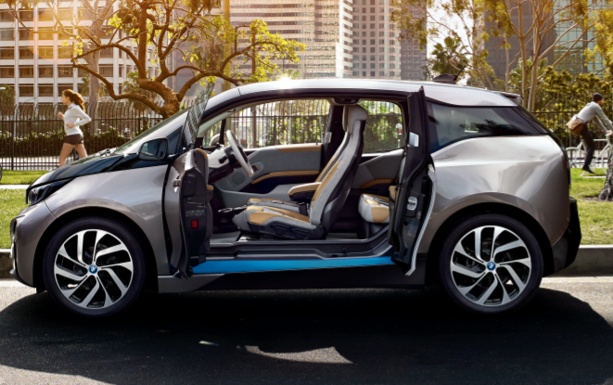

Porter’s Value Chain Analysis of Electric Industry – Case of BMW i3

Primary Activities:
The main activities of the valuation chain concern the emergence of services or products directly (Linkov et al., 2020).

BMW i3 inbound logistics:
About 12,000 manufacturers worldwide are BMW outlets. There are 31 manufacturing and distribution plants. Germany is the largest component of the network of suppliers. BMW alone came from Germany in 2018 to supply about 38% of raw resources. This accounts for 22.4% in Eastern Europe and 17% in Western Europe and 14.9% in North American countries (Linkov et al., 2020).
DHL is BMW i3’s official logistics partner. The supplier of logistics supports BMW operations across the entire supply chain from the supply to manufacturing and then the supply chain. In addition to Europe, the relationship between BMW and DHL spread across Asia-Pacific.

BMW i3 operations
In Munich, Germany, BMW is headquartered. Above 140 countries cover their global operations. BMW was founded in 1916 and became one of the best car and motorcycle manufacturers in the world. This is also one of Germany's biggest manufacturing companies. BMW has 31 manufacturing facilities in 15 countries, of which the BMW group owns 20 (Linkov et al., 2020).
Three of them come from the Chinese joint venture of BMW Genius Automotive. The remaining 8 are managed by partners & contractors of manufacturing (Linkov et al., 2020). Besides, the BMW Group has 43 distribution and financial services branches and 16 research & design locations around the world. Alone in Germany are 6 of its R & D facilities.

BMW i3 outbound logistics
This applies to the outward movement of the company’s products and resources to the customers. BMW created a broad network of distributors (Niemi et al., 2020). Other than Germany, its investments and products are mainly handled by BMW's subsidiary companies. DHL is a logistics management partner providing logistics operations for BMW in many other markets.

BMW Marketing and Sales
On the world market, BMW has preserved a good brand identity. It also helped develop strong brand awareness and generate higher client satisfaction through a clear focus on quality and innovations (Niemi et al., 2020)
For publicity, BMW primarily uses digital platforms. The company uses various social media networks to promote and engage its customers in addition to its official site. It uses various advertising techniques and the use of digital marketing equipped with the latest technologies (Niemi et al., 2020).
To express the BMW's special experience, BMW utilized the term "Sheer Driving Pleasure." BMW distribution network consists of 3500 BMW distributors including 1600 MINI distributors and 140 Rolls Royce distributors (Niemi et al., 2020). BMW has also built up a dealer network in the USA to serve its customers. More than 348 BMW traveller car and sport activities centres are located in the US market. In the United States, 121 Mini dealers, and 38 Rolls Royce retailers, 149 BMW motors distributors are operating on the market (Niemi et al., 2020)
On 18 Sept 2013 production started. The BMW i3 firstly released in 74 countries in March 2018. In Europe, the first i3 orders were held at an official launch ceremony on 15 Nov 2013 in Munich (Sayson et al., 2020).
After its official launch, BMW was faced with a flawed reception of the electric car range like so many other electric car manufacturers. BMW anticipated that by 2014, it will make to sell more than 30 000 units annually. In September 2014, global sales hit 10,000, and in May 2015 a total of 25,000, and in July 2016 the landmark of 50,000. In mid-2019, total world sales reached a unit level of 150,000 (Sayson et al., 2020).
Following on from the Nissan Leaf and Tesla Model S, the i3 ranked as the world's second or third-ever, best-selling all-electric cars in 2016, with far more over 65 000 total sales globally. The i3 is also sixth among the world-wide sales for 3 consecutive years for all-electric cars (Sayson et al., 2020).
Since its launch, i3 sales totalled above 165,000 units shipped globally by 2 January 2020. As of 2019, the U.S. was named the i3 leading sales market for 41,988 units and Norway is also the world's largest with 25,156 units signed up by mid-June 2020, followed by Germany with 26,722 units. The world's largest i3 per capita penetration is on the Norwegian market. The BMW i3 reported newly passenger car sales in Norway every month in November 2016 (Canevari et al., 2020).
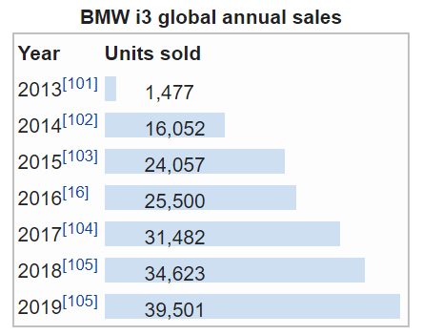
Source: (Sari et al., 2020)

Support Activities
Key activities are related to support activities in Porter's production chain. They allow primary operations to be better and more effective.

Technology:
The i3 is among the first large scale production vehicle to be made of carbon fibre enhanced plastic, its internal design, and bodies. The I3 consists of four entryways doors and seats with rear suicide doorways for four passengers (Serdijn et al., 2020). The newly developed i3 uses an electric motor that runs on 130 kilowatts (170 hp) and drives the back axle on lithium-ion batteries. To reduce weight at a battery power of 160 kWh, BMW aims to get a range which is the same as that expected of BMW ActiveE, but rather a weight of 30 kWh, with the battery power of 16 kWh (Serdijn et al., 2020)
In the automotive industry competitive environment has been increased a lot. For car manufacturers, technology is a major comparative advantage. The BMW Group has a strong commitment to technological advancement as a leading automotive brand.

HRM:
The automotive industry has been intensely competitive and the competition among the countries is now more increasing throughout the years. To retain its competing strength including growth, each automotive business needs skilled employees (Serdijn et al., 2020). Thus, the rivalry between auto companies is strong to attract competent individuals. The workforce of BMW in 2018 was 134,682. BMW hired 121,994 people in the automotive market. During 2018, the organization was named among the most appealing businessmen.
The annual turnover rate remained low in the year, at 2.78% (2018 Annual Report). The Company wants to enhance the satisfaction of customers and to offer an excellent opportunity and career development to its employees (Islam and Hasan, 2020). Employees from much more over 110 countries were hired by BMW in 2018. BMW also seeks to increase the workforce’s diversity. In 2018, women made up approximately 19.9% of their workers. We hold 17.2% of the BMW group's management positions. Therefore, BMW strives to create a balanced workplace composition of diverse origins and different abilities and know-how across a variety of fields.

Infrastructure:
BMW is categorized into two major automotive and motorcycle business segments. Also, there is a category of finance. Herald Kruger is the BMW CEO & Oliver Zipse is Director of the Management Board of BMW AG. HR does have its Directors or Executives in different fields, from finance to law and procurement (Islam and Hasan, 2020).

Procurement:
BMW depends on a wide pool of manufacturers to manufacture high-quality vehicles & motorcycles. The state of Germany is the largest raw material source, with approximately 38% of raw resources being provided by Germany in 2018, led by 22.4% from east Europe (Ankita et al., 2020). A buying and distribution network has been developed by the organization to manage procurement. Throughout the distribution chain, this network also provides quality assurance.
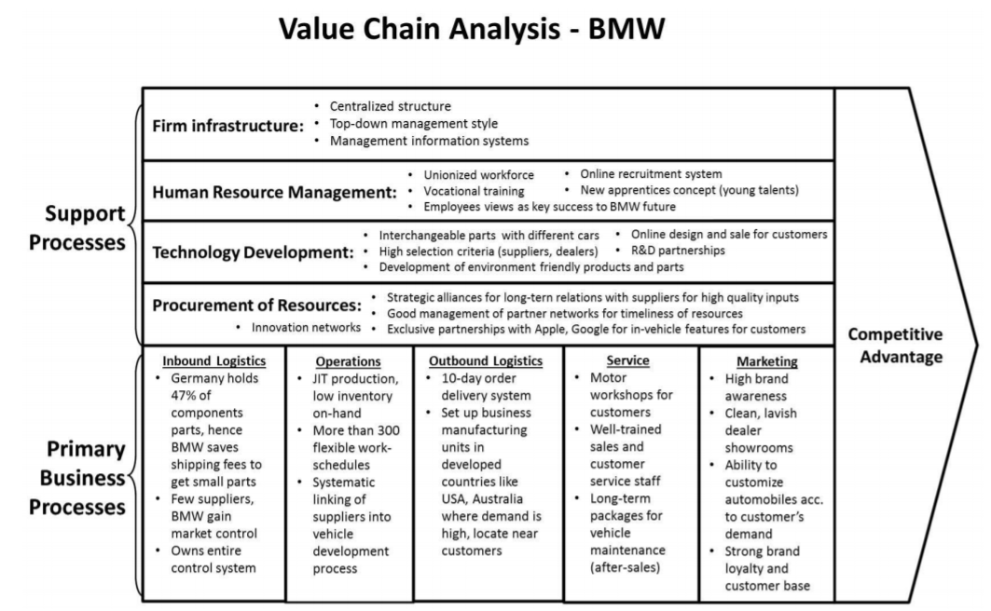
Source: (Ankita et al., 2020)

Product life cycle
Both products have four life cycle phases: initiation, development, ripeness, and decrease. This definition, however, doesn't fit into the goods of BMW. Jim McDowell, the VP (Vice President), Marketing for BMW says: "When a product goes down, we will prefer to take the product away from the market, instead of getting a decreasing inventory management plan," that is, in the course of BMW's production life cycle there are typically no phases of growth and decline. BMW takes it out of the market before a company hits the maturity stage marked by a decline in the revenue and profit levels. The product development of BMW cars is usually 7 years (Carril and Pavlova, 2020)
Just two phases of the product life cycle, launch, and growth apply to BMW vehicles. In 2000 and 2001, both the series of X5 and the 3 models were introduced. Such two sequences are both from the rising stage, based on the product development cycle of BMW. For each 3-series model, BMW produced three models. The X5 has 3 different versions which fulfil the preferences of different consumers. Also with the usual dealerships, BMW’s website offers great accessibility to its future customers. The customer can quickly recognize the advertising campaign of BMW from their website. The gap in price, such as a luxury car, the best car, and the best powerful vehicle, is also shown (Carril and Pavlova, 2020)
BMW employed strategically all the features and technical capabilities of its products and grouped them into special series models to optimize the launch and development phase of the product life cycles. With the opportunity to dominate, the company enhances the product life cycle model and keeps its brand one of the worldwide premium and prestigious brands.
The BMW i3 today offers several different ways of making the ultimate affordable electric vehicle. The first-ever serial passenger cell of production made up of light and durable carbon fibre, LifeDrive, is one of the main inventions. For a fully electric range, it dramatically reduces the vehicle weight. Also, aerodynamic stream flow decreases drag and the consumption of energy. The BMW i3 interiors feature raw materials based on natural fibres on instrument panels and the trim surfaces of doors (Pangestu and Setyorini, 2020). Seat covers are made of recycled fabrics up to 100 percent. The leather sections have a natural extract of the olive leaf that provides a unique, new fragrance for your leather. The wood panels in the interior consist of open-plan eucalyptus wood.
New Innovation is embedded into the BMW i3 production and development cycle itself: In an early strategic planning phase, concrete targets for the whole product life cycle, ranging from the raw materials to produce, use and recycle, have already been set for ensuring a long term sustainable material. These have been approved and tracked during the entire vehicle development stage.

Reference List
Ankita, R.S., Singh, P., and Vaidya, M.K. (2020) “Value chain analysis of pea: A case study in Kullu District of Himachal Pradesh” Journal of Value Chain, 9(3), pp.1546-1551.
Canevari‐Luzardo, L.M., Berkhout, F., and Pelling, M. (2020) “A relational view of climate adaptation in the private sector: How do value chain interactions shape business perceptions of climate risk and adaptive behaviours?” Business Strategy and the Environment Journal of Value Chain, 29(2), pp.432-444.
Carril‐Caccia, F., and Pavlova, E. (2020)”Mergers and acquisitions & trade: A global value chain analysis” The World Economy and Value chain, 43(3), pp.586-614.
Islam, A.H.M.S., and Hasan, M.R. (2020) “Characterization of the aquafeed sub-sector in Kyrgyz Republic: A value chain analysis” Journal of Value Chain, 524, p.735149.
Linkov, I., Carluccio, S., Pritchard, O., Bhreasail, Á.N., Galaitsi, S., Sarkis, J., and Keisler, J.M. (2020) “The case for value chain resilience” Management Research Review.
Niemi, J., Bennett, R., Clark, B., Frewer, L., Jones, P., Rimmler, T., and Tranter, R. (2020) “A value chain analysis of interventions to control production diseases in the intensive pig production sector” PloS one, 15(4), p.e0231338.
Pangestu, G.A., and Setyorini, R. (2020) “Value Chain Analysis At Bank Sampah Bersinar In Bandung Regency As A Competitive Advantage Strategy” Proceeding on Management, Education and Social Science and Value Chain, 1(1), pp.8-21.
Sari, S.R., Arifan, F., Triyono, T., and Niswah, U. (2020) “Value Chain Analysis on Handmade Batik Products” Journal of Value Chain, 13(1), pp.230-241.
Sayson, J., Jacob, S., Sujarwo, W., Imbiri, S., Saraswati, D., and Nazziwa, W. (2020) “Value Chain Analysis of Orange Commodity in the Bantama Market, Kumasi, Ghana” Journal of Value Chain, 3(1), pp.1-10.
Serdijn, M., Kolk, A., and Fransen, L. (2020) “Uncovering missing links in global value chain research–and implications for corporate social responsibility and international business” Critical perspectives on international business and Value chain.

