DS 1 Lauryn Cooper

My Screenshots/Photos

Screenshot/Photo 1
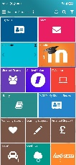
My University home screen
The screenshot above shows my home screen for University. I use this to look at my timetable, access assessment details and check emails. I find this app very useful as I can also look up any lessons I may have missed due to not being able to attend.

Screenshot/Photo 2
Phone alarm
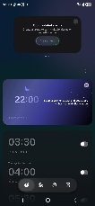
This screenshot shows my alarm on my phone, I use this every day. I am currently on maternity leave so I don’t use as much for morning alarms but I do use for school runs, cooking times and many more.

Screenshot/Photo 3
My mobile app screen homepage
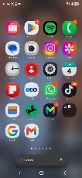
This is my mobile lock screen, I use my phone every day for a variety of things, I mostly use to make contact with family and friends, banking, social media, music, virtual card and google.

Screenshot/Photo 4
YAHOO account
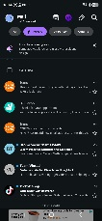
I use email on my laptop and phone pretty much every day. One example of using email is I pay my phone bills through email and utility bills using links from my email account.

Screenshot/Photo 5
WAZE – sat nav
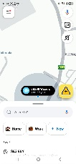

I use the above app Waze when I need to go somewhere were I do not know. I simply type in the post code and this takes me the quickest route and also helps avoid congestion charges and tolls. Waze also tells you a number of things including roadworks, live traffic updates and route changes.

Screenshot/Photo 6
BETTER –gym app
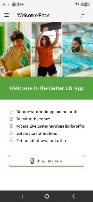
I use this app to book all my gym activities, gym sessions and swimming. My children attend swimming lessons also so I use a lot to book there lessons in.

My Short Reflection
I use digital tools in everyday life as soon as I wake up I am faced with a digital APP, one obviously an alarm which most people use to wake up. I will then either look at my social media and outlook emails.
I work for an advertising company so we are always using Microsoft software’s such as Outlook, Excel, PowerPoint and Teams. I am very interested in furthering my knowledge on these software’s and I am hoping this is what I am to gain from this module.
Sometimes I feel nervous when I don’t understand some things in my lectures, but I am improving on asking questions.
Digital skills are very important for me as I use digital software’s every day whether it be at home or at work. Digital is taking over the world so I expect to have a great understanding of the digital world.

