

Module code: (BMHP6022_LON)

Module name: Community Care and Development
Assessment Component 2

Written Report

Student name: Lecturer name:
Margareta Nicoleta Dragoi Mr.Jolly Nwankwo
Student ID: 2019145

Table of Contents
Introduction 3
Main social issue within Lambeth borough- Violence Against Women - and causes of domestic violence against women. 4
The use of media and social communications to promote to the community of Lambeth the intervention suggested. 7
Recommendations 7
Conclusion 8
References 9

Introduction
In this report a detailed discussion on the growing issue of domestic violence against women in Lambeth has been done. Firstly, the demography and diversity of the Lambeth community has been reported. The health and social care needs of the people there and the social, cultural, economic and other issues faced within the community have also been discussed. Identification of the causes of domestic violence against women has been done to understand the reasons and identify the solutions to the cause. One distinct approach has also been identified in terms of programs for the community to improve the health and social situation of the people in Lambeth.
While Lambeth’s people have their own diverse culture which contributes to the different characters of the community, it is important to understand that there are some factors that can give rise to issues like domestic violence against women. Diversified cultures might have different outlooks on gender roles and responsibilities which might clash when those expectations are not met (lambeth.gov.uk, 2023). Some cultural elements could lead to a patriarchal outlook of a given group of people which can raise concerns about women’s status within the society as well as their safety within their own homes (Reckwitz, 2020). In multiple cases, the dynamics of a community can lead to the exposure of women towards domestic violence. The compact community patterns can lead to less exposure to an individual's personal life. The isolated victims, who have no contact with other people in the community, might find it more difficult to reach out for help. Diversity in religion can also be a reason behind domestic violence. People of different religions can have different outlooks or perspectives on gender roles (Healey and Stepnick, 2019). Lambeth’s population is diversified, where 63% of the population identifies themselves as White British (lambeth.gov.uk, 2023). The total number of people living in the district is around 322,000. There are around 159,346 (49.5%) females in comparison to 162,467 (50.5%) males creating a gap in male female ratio and due to this uneven sex ratio; there could be exposure of women to more abusive men (lambeth.gov.uk, 2022).
Examining the health needs and other social, cultural and economic needs of the people in Lambeth can give valuable knowledge about the challenges they face in their everyday life. The concerns related to mental health of the people in Lambeth should be addressed significantly. They do not have proper access to healthcare which increases vulnerability among the population. Lambeth has a diversified cultural group, so balancing the social tensions between communities is essential to ensure peaceful living conditions in Lambeth. The people in Lambeth have been facing major economic issues because of low opportunities of employment. If the government addresses the low job opportunities and supports local businesses, then it can create more employment opportunities, diminishing unemployment from the district, contributing to drastic economic changes in that area. The people in Lambeth also face difficulties to get access to education, sometimes because of their socio-economic background or sometimes for their lack of resources. As it is considered a rural area, social services, support groups, and wellness programs are often ignored in Lambeth. Being a rural community, Lambeth does not have proper access to healthcare which leads to deterioration of people's physical as well as mental health which leads them to make unproductive and unethical decisions and the lack of education encourages people to make ineffective decisions. They do not have a stable economic condition leading to unemployment issues which forces few part of the population to adapt to criminal activities.

Main social issue within Lambeth borough- Violence Against Women - and causes of domestic violence against women.
There are multiple factors that could be the reason behind domestic violence against women. One of the factors is socioeconomic differences between men and women. It can be a present factor leading to domestic violence. Women who are financially dependent on other members of the family and are facing financial difficulties might be more exposed to domestic violence. Lack of education can be another reason for the increasing violence against women in Lambeth. People have no knowledge about women’s rights and the laws against domestic violence and because of this, the women who are victims of this abuse feel helpless and lack of education can lead to unethical and harmful behaviour. As Lambeth is a very small district in South London, the number of uneducated people is very high because they do not have the proper resources to opt for education (Patel et al., 2023). When the lack of education mixes up with the miseducation of religious teachings, it poses a higher threat to the people because people can begin to misuse religious teachings to justify their behaviour. Also, during Covid, there was an increase in domestic violence against women (Usta et al., 2021). There are several reasons to this, which includes the availability of predators in the home all day because of lockdown because of this women became more exposed to abuse at home, loss of jobs/ income of perpetrators led to the decline of people’s mental health because of this and they laid down their frustration towards women in their houses which led to physical and mental abuse of women in every home (Tisdell, 2020).
There are also certain policies and regulations established by the Government of the UK which deal with the issues of violence against women and children and the after effects of domestic violence (Peterman et al., 2020). For example, “The Care Act 2014” was established by the government of the United Kingdom which showed how care could be given to those people in need, which included men, women, and children regardless of their age. This act was established to promote the well -being of individuals. The next act is “Human Rights Act '' imposed by the UK government to let everyone defend their own rights in courts regardless of class, gender and race. It was initiated so that every individual can be treated equally and everyone gets a fair chance for justice. Another act is the Domestic Abuse Act 2021 implemented by the UK government which makes the victims of domestic violence already permitted to take specific proceedings against the predator in court on the grounds of any psychological harm like unease or distress (legislation.gov.uk, 2023).
There is one distinct initiative that was taken by the Lambeth borough which is very necessary for the social improvements especially for the domestic violence against women within the community. The Lambeth borough adopted the policy to fight against VAWG (Violence against Women and Girls) initiative in November 2021 which was the day that was marked as the International Day for the Elimination of Violence against Women (lambeth.gov.uk, 2021). This strategic plan was introduced on this day by Lambeth borough. This policy aims to fight against every type of violence or abuse against women and girls. The priority of this policy is to identify the victims of the violence within the entire council and take necessary steps to deal with it. The strategy of this initiative was structured by the people who helped the victims of the violence, they could understand the depth of the abuse as they had a direct experience with the victims, survivors and the children who faced the mental/physical abuse. Lambeth VAWG team does special patrolling 24*7 to make Lambeth safe for everyone. The aim of this strategy is to keep every citizen of Lambeth safe from the predators roaming around, work together as a team to reduce the cases of domestic violence, and give psychological assistance to the victims to overcome the trauma from the abuse. This initiative aims to bring the community as a whole to deal with the rising problem. The plan is to work tirelessly for the coming years, and the target is to use this initiative with the Safer Lambeth Partnership to directly address VAWG and reduce its impact up to 0 within 4 years. Also, the Lambeth community is working towards forming a VAWG Strategic Partnership Board in Lambeth which will help in the cause of changing these scattered strategies and ideas into one flawless action plan.
The “Violence against Girls and Women” or VAWG approach of the Lambeth council has had a significant impact on the affected people of the council since its inception (lambeth.gov.uk, 2021). But there are certain areas where, if acted upon, can address the loopholes that are present within the strategy. The VAWG initiative only prioritises on addressing the needs of the victims and the ones who are affected through medical facilities. It does not make an effort to identify the people in distress and are on the verge of receiving severe outcomes. It has currently no counselling session or strategies that would address the “prevention” element in this field.
In addition to this, there have been no awareness campaigns that have been launched on a local level to make the people of the community aware of the initiative. The approachability, the process of lodging complaints and the registration methodologies are also not clear at the grass root level where this kind of violence is prevalent. Along with this most of the doctors and the grassroots level workers are contractual. This creates difficulty for the council in operational continuity and thus reducing its efficiency in functioning. These instances, if addressed, can make VAWG a successful initiative that addresses domestic violence.
Some of the activities to promote health and social care in the Lambeth council have been enlisted below.
- Support Groups: These form a neglected yet essential part of the treatment of the victims of physical atrocities. Support Groups form a critical part in the upliftment of the mental health of the population of the county (Buchert et al., 2023).
- Yoga and Physical Education classes: These practices are deemed as crucial in the maintenance of the physical health of an individual. Lambeth council should form agreements with government medical facilities like the “National Health Service” and consult their doctors to provide live yoga and other physical lessons to the community.
- Community Engagement Activities: The administration of Lambeth council should organise community activities like sports and cultural performances to bring about an overall physical and mental upliftment in the community.
Maslow's hierarchy of needs concerning the Lambeth community.
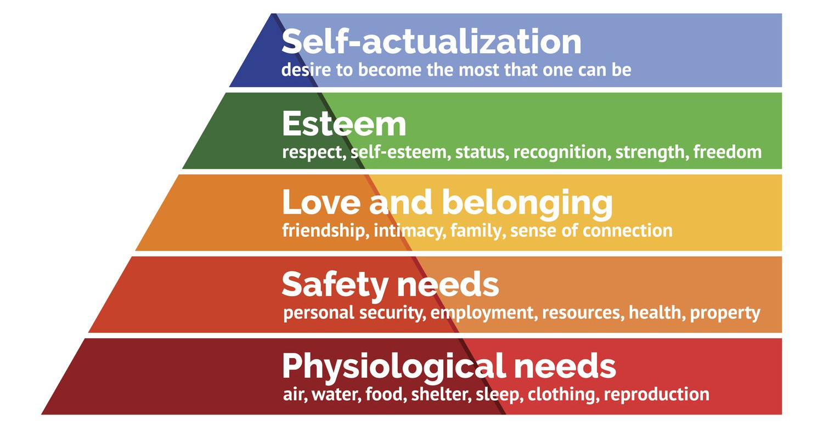
Image: Maslow's Hierarchy of Needs
(Source: Hale et al., 2019)
The first need under “Maslow’s hierarchical needs” is “physiological needs”, which, in reference to the Lambeth community, the community should be provided with proper healthcare facilities and safe place to live, food and water. The second need includes the “safety needs” where the people in the community should be provided with proper safety and security so that people do not fall victim to domestic violence. Also, personal security and resources should be provided to the victims of domestic violence so the victim does not have to deal with the traumatic experience again. The third needs refers to “love and belonging which can be provided to the people in the Lambeth community by providing them with programs that encourage and promote health relationships, and community engagement needs. The next need in the “pyramid of needs” states self-esteem and self-achievements (Trivedi and Mehta, 2019). The victims of VAWG in the Lambeth community must be provided with self-defence classes, education so that they can independently deal with any challenges that come their way. The last need talks about “self-actualisation” which can be implemented in the community by providing opportunities to the victims of VAWG and other community members so that they can get access to proper career opportunities, education which will help them to develop individually.
The use of media and social communications to promote to the community of Lambeth the intervention suggested.
The above mentioned practices of addressing the social and communal needs of the people of the Lambeth Council should be well communicated to the citizens so that they are completely aware of the steps that are taken by the government and the ways by which they can avail them.
The use of digital and social media has proved to be the fastest modes of communications in recent days (Kitmitto et al., 2022). Therefore the council can take the initial step towards communicating their policies by mentioning them in their official website. As a part of the next step, the Lambeth County’s social media platforms can be utilised by the administration to conduct live awareness campaigns among the affected section of the community.

Recommendations
Few recommendations to address the VAWG issue in the Lambeth community could start with implementing community awareness programs organised in schools, colleges, workplaces to raise awareness of the VAWG issue addressing the concerns and solutions of this (Addis and Snowdon, 2023). Programs could be initiated regarding the VAWG issue to teach people how to prevent domestic violence and special self-defence workshops should be provided for the women and girls in the Lambeth community so that they become well prepared to save themselves if any physical mishap arises (Hollander and Cunningham, 2020). People in the community should also be given psychological training on how to deal with domestic violence. Immediate Legal aid should be provided to those who step up against domestic violence (Stoever, 2019). Most people might not know the legal consequences of domestic violence. A spread of information should be done to instil a sense of fear in predators and a sense of trust in legal proceedings for the victims.

Conclusion
The report has critically discussed about the rising issue of domestic violence against women occurring in Lambeth. An analysis of the demography and diverse cultural groups and the religious groups and the ways it can lead to the cause of domestic violence in a community has been done. A discussion regarding the health needs and social, cultural, economic, and other issues faced within the community of Lambeth has been done including the necessary measures that could be taken to mitigate this. A detailed discussion on the causes of domestic violence in Lambeth is done where the socioeconomic difference, cultural difference and lack of education leading to increase in domestic abuse at homes has been addressed. A brief analysis is done on why domestic abuse in Lambeth increased during Covid 19. A distinct approach has been specified that could be implemented to address the VAWG issue faced by the community in Lambeth.

References
Addis, S. and Snowdon, L. (2023) What works to prevent violence against women, domestic abuse and sexual violence (VAWDASV)? A systematic evidence assessment: This article is related directly to the First European Conference on Law Enforcement and Public Health (LEPH) held in Umea, Sweden in May 2023. Journal of Community Safety and Well-Being, 8(2), pp.75-84.
Buchert, U., Kemppainen, L., Olakivi, A., Wrede, S. and Kouvonen, A. (2023) Is digitalisation of public health and social welfare services reinforcing social exclusion? The case of Russian-speaking older migrants in Finland. Critical Social Policy, 43(3), pp.375-400.
Clark, V.E. (2021) Victim-blaming discourse underpinning police responses to domestic violence: A critical social work perspective. Social Work & Policy Studies: Social Justice, Practice and Theory, 4(1).
Hale, A.J., Ricotta, D.N., Freed, J., Smith, C.C. and Huang, G.C. (2019) Adapting Maslow's hierarchy of needs as a framework for resident wellness. Teaching and learning in medicine, 31(1), pp.109-118.
Healey, J.F. and Stepnick, A. (2019) Diversity and society: Race, ethnicity, and gender. Sage Publications.
Hollander, J.A. and Cunningham, J. (2020) Empowerment self-defence training in a community population. Psychology of women quarterly, 44(2), pp.187-202.
Kitmitto, L., Mughal, R., Polley, M. and Chatterjee, H.J., 2022. How social welfare legal and financial issues affect health and wellbeing: the role of social prescribing. National Academy for Social Prescribing.
lambeth.gov.uk, (2021) Welcome to Lambeth [Online] Available at: <https://www.lambeth.gov.uk/> [Accessed on 23rd November 2023]
lambeth.gov.uk, (2022) State of the Borough 2022 [Online] Available at: <https://www.lambeth.gov.uk/sites/default/files/2022-07/state-of-the-borough-2022-report.pdf> [Accessed on 23rd November 2023]
lambeth.gov.uk, (2023) Demography [Online] Available at: <https://www.lambeth.gov.uk/adult-social-care-and-health/health-and-wellbeing/lambeth-health-profile/health-wellbeing-profile/demography#:~:text=Lambeth's%20population%20is%20highly%20diverse,%2C%20aged%2020%2D39%20years> [Accessed on 23rd November 2023]
lambeth.gov.uk, (2023) Equalities and diversity in Lambeth [Online] Available at: <https://www.lambeth.gov.uk/about-council/equalities-diversity-lambeth> [Accessed on 23rd November 2023]
legislation.gov.uk, (2023) https://legislation.gov.uk/ [Online] Available at: <https://www.legislation.gov.uk/ukpga/2014/23/contents> [Accessed on 7th December 2023]
Ollinheimo, A. and Hakkarainen, K. (2023) Critical thinking as cooperation and its relation to mental health and social welfare. New Ideas in Psychology, 68, p.100988.
Patel, M., Royle, F. and Micallef, R., 2023. A Pilot Study to Establish the Leadership Development Needs of Community Pharmacist Leads in Lambeth, South East London. Pharmacy, 11(4), p.114.
Peterman, A., Potts, A., O'Donnell, M., Thompson, K., Shah, N., Oertelt-Prigione, S. and Van Gelder, N. (2020) Pandemics and violence against women and children (Vol. 528, pp. 1-45). Washington, DC: Center for Global Development.
Reckwitz, A. (2020) The society of singularities.
Stoever, J.K. (2019) Access to safety and justice: Service of process in domestic violence cases. Wash. L. Rev., 94, p.333.
Tisdell, C.A. (2020) Economic, social and political issues raised by the COVID-19 pandemic. Economic analysis and policy, 68, pp.17-28.
Trivedi, A.J. and Mehta, A. (2019) Maslow's Hierarchy of Needs-Theory of Human Motivation. International Journal of Research in all Subjects in Multi Languages, 7(6), pp.38-41.
Usta, J., Murr, H. and El-Jarrah, R. (2021) COVID-19 lockdown and the increased violence against women: Understanding domestic violence during a pandemic. Violence and gender, 8(3), pp.133-139.

