

Programme: Master of Business Administration
Module Name & Code: International Business Concepts (LCMB7034)
Assignment Title: Report
Lecturer: Akshay Narayanan
Student Name: Miraz Mohammad Emon
Student ID: 2503793
Word Count: 5491

Contents
1. Introduction 1
2. OVERVIEW of the industry and country 2
A. Ireland Economic Context 2
B. Fast Fashion / Retail Industry. 3
C. Key Firms in Ireland 4
D. Comparison of the Major Firms. 4
3. DIAMOND MODEL of PORTER 5
3.1. Factor Conditions 6
3.2. Demand Conditions 6
3. 3. Related and Supporting Industries. 6
3.4. Firm Strategy, Structure and Rivalry. 7
3. 5. Government Role 8
3.6. Chance 8
4. MNC ANALYSIS – PRIMARK 9
A. Company Overview 9
B. PESTLE ANALYSIS 9
C. Market Attractiveness 14
D. CAGE Framework 14
E. Critical Evaluation 16
5. CONCLUSION 17
SECTION 2 – REFLECTION 18
1. Description (Problem Identification) 18
2. Feelings 19
3. Evaluation 19
4. Analysis (with Data + Examples) 20
5. Conclusion 21
6. Action Plan 21
References 22

List of Figure
Figure 1. Overview of the Fast Fashion Industry in Ireland (2026). Adapted from Irish retail market reports and EU sustainability directives (2025–2026). 2
Figure 2. Porter’s Diamond Model Applied to Ireland’s Fast Fashion Industry (Primark Case Study). Adapted from Porter (1990) and Irish retail strategy literature (2025–2026). 5
Figure 3 . PESTLE Analysis of Primark as a Multinational Retailer. Adapted from EU sustainability directives, Associated British Foods Annual Reports (2025–2026), 10
Figure 4 . CAGE Framework Analysis of Primark’s International Strategy. Adapted from Ghemawat (2001) and multinational retail strategy literature (2025–2026). 15
Figure 5 . Gibbs’ Reflective Cycle illustrating six stages of structured reflection. Adapted from Gibbs (1988). 18

1. Introduction
Globalisation has significantly accelerated the expansion of retail industries across international markets, with the fast fashion sector emerging as one of the most dynamic and competitive due to its rapid production cycles and cost-efficient business models. In this context, Ireland is considered to be an extremely open and export-led economy with strong integration into global trade and investment flows. With over 370,000 employees, the retail industry is a critical part of the domestic economy in Ireland, as it generates significant jobs, enterprise activity and economic impact, with a turnover of more than 57 billion (Central Statistics Office, 2023). Additionally, the sector contributes a large portion of the national economy and is the largest employer in the private sector (Department of Enterprise, 2025)
The current report critically analyses the competitiveness of the fast fashion retail business in Ireland in the framework of the Porters Diamond Model and reviews the strategic positioning and operational issues of Primark in this multidimensional international business context.

2. OVERVIEW of the industry and country
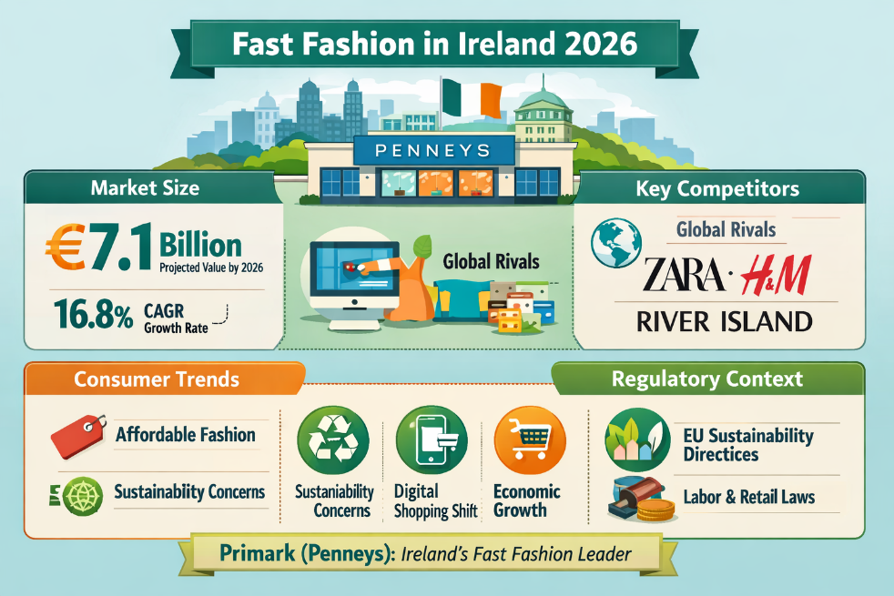
Figure 1. Overview of the Fast Fashion Industry in Ireland (2026). Adapted from Irish retail market reports and EU sustainability directives (2025–2026).
The infographic on Fast Fashion in Ireland 2026 highlights a rapidly expanding market projected to reach €7.1 billion, with a strong CAGR of 16.8%. Penneys (Primark) dominates locally, while global competitors like Zara, H&M, and River Island shape the competitive landscape. Consumer trends emphasize affordability, digital shopping, and rising sustainability concerns, reflecting shifting values among Irish shoppers.

A. Ireland Economic Context
Ireland is a high-income, open economy, and an important part of the European Union; it is strongly integrated into global trade and investment networks. The last ten years have seen a steady economic growth in Ireland, which has been facilitated by foreign direct investment (FDI) especially by the multinational corporations which have been lured to the country by favourable corporate tax policies and skilled labour force (Department of Finance, 2024). The growth in the GDP of the country has been one of the highest in Europe although it is typically overstated by the multinational activities, which may distort the local economic indicators (Central Statistics Office, 2023).
The retail industry is a prominent part of the economy of Ireland, with many contributions to the level of employment and national output. It is a mass employer and the biggest employer in the private sector, offering more than 370,000 people employment and causing a yearly turnover of more than 57 billion (Central Statistics Office, 2023).
Nevertheless, the Irish economy is very reliant on consumer spending, which is very strong, but susceptible to external shocks like inflation and increasing living standards. (European Commission, 2024).
Example: Retail is an important sector in Ireland's economy, as it generates employment and revenue. Specifically, it has more than 370,000 employees, and contributes more than €57 billion to the economy each year, representing the country's biggest private-sector employer (Central Statistics Office, 2023). This shows how important retail is to the domestic market in Ireland.

B. Fast Fashion / Retail Industry.
Fast fashion retail business is characterized by fast production and distribution of inexpensive clothing which mirrors the prevailing fashion. This model is based on short production cycles, lean supply chains, and rapid inventory turnover, allowing the companies to react swiftly to new consumer preferences (McKinsey & Company, 2023). In Ireland, fast fashion is a subset of the larger retail sector, which has fuelled pedestrian traffic in high street areas and has played a major role in employment and business.
The industry is not just significant in terms of contribution to the economy, but also the consumer culture and buying behaviour is influenced by the industry. Fast fashion retailers have taken center stage in the Irish retail sector as they have provided low-end and often-changing lines of clothing that are affordable and attractive to a large proportion of people.
A key trend is the fast transition to e-commerce, which is speeded up by the COVID-19 pandemic and altered consumer expectations in terms of convenience and accessibility (OECD, 2022). Secondly, sustainability has become a key issue, and there is growing concern regarding the environmental footprint, waste, and labour practices of global supply chains (European Environment Agency, 2023).
Example: Fast fashion is a growing phenomenon driven by globalisation that allows retailers like Primark to rapidly expand into the global market through low costs and high volume manufacturing (McKinsey & Company, 2023).

C. Key Firms in Ireland
Irish fast fashion retail market is typified with a combination of both domestic and multinational companies operating within the various segments. Primark is a leading domestic player that has created a cost leadership strategy and large physical retail presence that has made it a dominant player. Primark has been able to offer very low prices and this has helped it to acquire large numbers of customers, especially during economic uncertainties.
On the contrary, multinational companies like Zara and H&M have different strategies. Indicted, which includes Zara, is characterized by its extremely reactive supply chain, enabling it to introduce new designs to the market as fast as possible and stay well in tune with fashion trends (Inditex, 2024). H&M, on the other hand, adopts a hybrid strategy that combines affordability with increasing emphasis on sustainability initiatives, such as recycled materials and ethical sourcing (H&M Group, 2024). This
On the whole, the existence of these companies underscores the competitive nature of the Irish retail sector where businesses distinguish themselves based on price, speed, branding, and sustainability.

D. Comparison of the Major Firms.
Comparative analysis of the leading companies shows that there are great variations in strategic positioning and models of operation. Primark operates on a definite cost leadership strategy where it concentrates on the lowest possible prices which it has attained by the means of effective sourcing and minimum marketing spending. This will enable the company to appeal to price-sensitive consumers especially in times of economic uncertainties.
Conversely, Zara focuses on speed and innovation by its vertically integrated supply chain, allowing quick reaction to fashion trends and shortening time-to-market. This makes Zara fall under the middle to premium fashion segment and targets consumers who value fashion and urgency more than they do the price. H&M, on the other hand, follows a middle course, offering its customers competitive prices and sustainability measures to attract mass-market consumers.
In terms of performance and positioning, Primark enjoys high in-store traffic as a result of its low pricing but is not as advantaged since it does not offer e-commerce services. Conversely, Zara and H&M have effectively incorporated the use of digital channels in their business model, increasing accessibility and market penetration to customers (Statista, 2024).
Most importantly, although the cost advantage of Primark is still one of its main strengths, the lack of online retail is a major area of strategic weakness in a market that is becoming digitalized. Also, the company is exposed to reputational risks related to sustainability issues, which are increasingly gaining salience among the consumers.

3. DIAMOND MODEL of PORTER
The use of Porters Diamond model to the fast fashion retail sector in Ireland offers a systematic approach in determining the international competitiveness of the country.
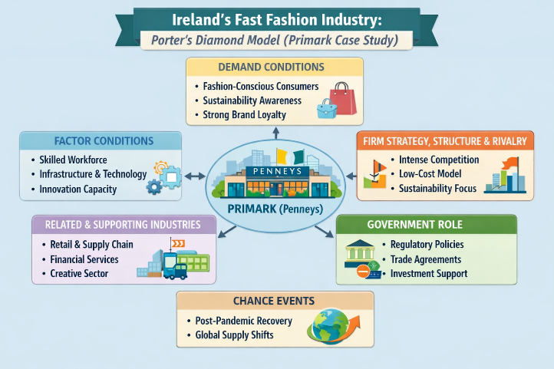
Figure 2. Porter’s Diamond Model Applied to Ireland’s Fast Fashion Industry (Primark Case Study). Adapted from Porter (1990) and Irish retail strategy literature (2025–2026).

3.1. Factor Conditions
Ireland enjoys a high level of factor conditions that aid in developing the retail sector. The nation has a comparatively skilled and educated labour force, with good tertiary education systems and the high level of labour productivity (OECD, 2023). Moreover, Ireland boasts an established retail network, especially in major cities like Dublin, where shopping areas and business establishments appeal to local and foreign shoppers. (European Commission, 2024).
These benefits, however, are somewhat neutralized by structural disadvantages. Ireland has some of the highest labour costs in Europe, which raise operational costs of retailers (Eurostat, 2024). This is a major limitation to fast fashion companies that are dependent on cost efficiency.

3.2. Demand Conditions
The Irish demand conditions are fairly good and advanced, which also adds to the competitiveness in the industry. Irish consumers tend to be highly purchasing power and show curiosity about fashion trends, which are encouraged by international brands and media (Central Statistics Office, 2023). This brings about a dynamic retailing environment whereby firms have to keep on innovating to match with the evolving consumer preference.
Meanwhile, the need in inexpensive apparel is also very high, especially in the conditions of the increase in living expenses. This is advantageous to fast fashion retailers who sell low priced products, enabling them to attract price sensitive market segments. Nevertheless, the situation in the market of demand is changing. Sustainability and ethical consumption are getting more popular, and the consumers are now more worried about environmental influence and labour procedures (European Environment Agency, 2023).

3. 3. Related and Supporting Industries.
The fact that Ireland has strong related and supporting industries is yet another boost to its competitiveness in the retail industry. There are efficient logistics and transport network that help in distribution of goods within the country and to more European markets. Moreover, Ireland enjoys the advantage of existing global supply chains, so retailers can obtain products produced in low-cost manufacturing nations, like Bangladesh and China (World Trade Organization, 2023).
The role of technological infrastructure is also becoming a progressively significant factor, with digital platforms and customer engagement and online sales channels being supported by inventory management (OECD, 2022).
Nevertheless, the main weakness is the overdependence of the industry on global supply chains. Geopolitical tensions, pandemics, or delays in transportation may greatly affect the availability of goods and their prices. These risks became apparent during the COVID-19 pandemic and revealed the vulnerability of the world sourcing networks (UNCTAD, 2022).

3.4. Firm Strategy, Structure and Rivalry.
The Irish fast fashion retail sector is distinguished by a great rivalry between the local and multinational companies, such as Primark, Zara and H&M. Such a competitive environment motivates companies to become efficient, innovative and distinguish their products.
Different strategic approaches are evident within the market. Primark concentrates on low cost leadership and has ultra-low prices so as to draw large number of customers. Conversely, Zara prioritizes speed and responsiveness based on its vertically integrated supply chain, whereas H&M is a hybrid brand that combines low prices with sustainability efforts (McKinsey and Company, 2023).
The existence of intensive competition spurs innovation as well, especially in terms of supply chain management and online retailing. Nonetheless, this level of competition will have the impact of decreasing profit margins because companies are compelled to either decrease their prices or invest more in the market to retain their market share.

3. 5. Government Role
Irish government has been a supportive government in improving national competitiveness. Ireland is reputed as a pro-business destination with relatively low corporate taxes and policies which are aimed at facilitating foreign investment (Department of Enterprise, 2025). This position is further reinforced by EU membership as it has access to a large single market and harmonised regulatory standards. Simultaneously, the government and the EU standards introduce the requirements regarding the labour standards, environmental protection, and consumer rights.

3.6. Chance
The Irish retail industry has been largely affected by external or chance factors in the past years. The COVID-19 pandemic has interrupted in-store physical retail, accelerated the transition to e-commerce, and revealed vulnerabilities in global supply chains (OECD, 2022). Moreover, sourcing and distribution have also been affected by geopolitical conflicts and increased transportation expenses.
These unexpected incidents underscore the significance of being flexible in the industry. Companies that could react swiftly to evolving dynamics, especially via digital transformation have been in a better position to stay competitive.
Example: Ireland's demand conditions are very favourable for fast fashion with consumers showing high purchasing power and fashion awareness. This drives demand for low-cost fashion and trends, improving the business case for retailers like Primark (OECD, 2023). But this demand is gradually moving towards sustainable consumption, which poses a threat to the fast fashion industry.
Overall Competitiveness
In general, the use of Porters Diamond Model indicates that the fast fashion retail sector in Ireland has a medium-high degree of international competitiveness. The nation enjoys the advantages of well-developed infrastructure, favourable demand environment, and favourable government policies.

4. MNC ANALYSIS – PRIMARK

A. Company Overview
Primark is an Irish-based fast fashion retailer, which was founded in 1969, known as Penneys. The firm has expanded to become one of the most successful value-fashion retailers in Europe, with operations in various global markets in the United Kingdom, continental Europe and the United States. Primark is a subsidiary company of Associated British foods which is a diversified multinational group that is financially stable and supporting of its retail business.
The business concept of Primark is a cost leadership, which provides trendy dresses and clothes at a considerably lower price than other brands as lean operations, bulk sourcing, and minimum spending on advertising keep the costs down. In contrast to most of its rivals, the company has not been engaged in e-commerce in the past and has rather concentrated on the high-volume sales using physical outlets in key retail locations. (McKinsey & Company, 2023).
Global expansion strategy of the company has been to venture into the developed markets with high consumer demand and capitalize on economies of scale in procurement and logistics.
Example: Primark is an Irish-owned fast fashion retailer (Associated British Foods) in Europe and the USA. It adopts a cost leadership approach with low-priced clothing accessible via efficient supply chains. Yet, its lack of investment in e-commerce is a major weakness in the highly digitalised global retail industry (McKinsey & Company, 2023).

B. PESTLE ANALYSIS
PESTLE analysis offers a detailed platform of analysis to examine the external macro-environmental forces that affect the operations of Primark in the fast fashion retail market in Ireland. This is a critical analysis in determining the attractiveness of the wider market and also the opportunities and limitations to long-term competitiveness.
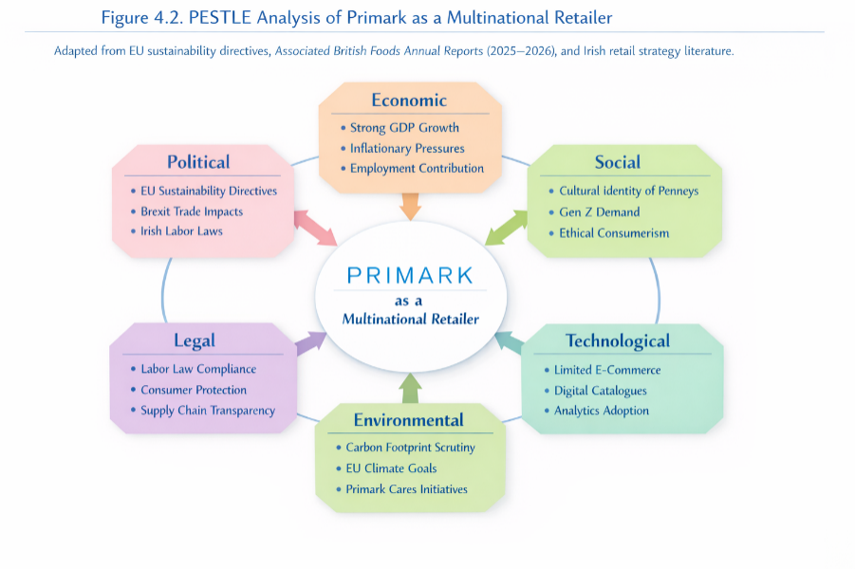
Figure 3 . PESTLE Analysis of Primark as a Multinational Retailer. Adapted from EU sustainability directives, Associated British Foods Annual Reports (2025–2026),
Political Factors
Ireland enjoys a stable political environment and a part of the European Union, which increases the possibilities of trade and the uniformity of the regulations. The EU membership enables Primark to engage in a unified market, which supports free movement of goods, services, and capital (European Commission, 2024). This minimizes the trade barriers and facilitates smooth distribution throughout the European markets.
Nevertheless, emerging complexities have been brought about by geo political developments like Brexit. Primark being a subsidiary of the Associated British Foods, has a strong operational relationship with the United Kingdom and as such, it is highly sensitive to post-Brexit trade agreements. Supply chain costs and operational uncertainty have risen due to the introduction of custom checks, regulatory divergence, and logistical delays (UK Trade Policy Observatory, 2023).
Most importantly, the political environment in Ireland is favourable, but external political factors like Brexit cause structural issues that may influence the sourcing effectiveness and cost control. This highlights the importance of supply chain flexibility and strategic adaptation.
Economic Factors
Consumer behaviour and retail performance are highly influenced by economic conditions. The economic growth and fairly high disposable income rates of Ireland provide a favourable environment to develop the retail (Central Statistics Office, 2023). But the recent inflationary pressure and increasing cost of living has caused a great effect on the consumer purchasing power and therefore price sensitivity has been heightened.
Here, the cost leadership strategy of Primark is an important competitive advantage. The fact that the company can sell low-cost clothes places it in a good position in times of economic recessions as people reduce their spending to cheaper alternatives. Such a counter-cyclical advantage enables Primark to continue its high sales performance even in periods when the overall consumer spending is down (McKinsey & Company, 2023).
Meanwhile, the currency changes may also impact the sourcing expenses, especially since Primark depends on imports greatly on selling its products to foreign manufacturers. The volatility of the exchange rate can make the cost of production high and this might either decrease the profit margin or necessitate adjustments in prices.
Importantly, although economic issues, like inflation, pose threats, they also strengthen the value proposition of Primark. To make it, however, cost management and efficiency in the supply chain are essential to remain profitable in a volatile economic environment.
Social Factors
The pace of the fast fashion industry is getting more and more affected by social tendencies. Ireland consumers are increasingly concerned about ethical and sustainability concerns, such as labour standards, environmental footprint, and product life cycle (European Environment Agency, 2023). This increased consciousness is shaping the consumer behaviour especially among younger consumers who have been putting more emphasis on ethical consumption.
Associated with unsustainable business practices such as overproduction, textile waste, and the use of low-cost labour in developing countries, fast fashion retailers such as Primark have been the subject of criticism. Such issues pose reputational risk and can impact brand perception in case they are not effectively resolved.
Nevertheless, Primark has started to act upon these pressures by launching sustainability initiatives, including pledges to source more sustainably and enhance the visibility of their supply chains (Primark Sustainability Report, 2024).
Importantly, although the demand in low-cost clothing is still high, the tendency towards more responsible consumption is evident. This poses a strain on business model of Primark because it may be difficult to remain low and at the same time enhance sustainability standards. Thus, the company needs to strike a balance between cost-effectiveness and social responsibility to be competitive.
Technological Factors
The retail sector is changing because of the technological development especially the rise of e-commerce, online marketing, and the use of data in decision-making. Other companies such as Zara and H&M have effectively applied online platforms to business model and have been able to target a larger customer base and provide greater convenience (Statista, 2024).
Primark on the contrary has long been opposed to e-commerce such that it relied on the physical retail outlets. Although this approach lowers the costs involved in conducting business in terms of logistics and returns, it is a major shortcoming in a more digitalized business market. With the COVID-19 pandemic, the transition to online shopping increased the significance of digital capabilities in keeping up with the competition (OECD, 2022).
Most importantly, the absence of an e-commerce is considered as the major strategic weakness of Primark. It limits the scope of reach of markets, limits customer’s interaction and resiliency in times of disruption to physical retail. The company has only started to venture into digital ventures, so the fact that the company has been slow in doing this might hurt its competitiveness against other competitors that are more technologically superior.
Legal Factors
The Irish legal landscape and the European Union as a whole have different regulatory obligations on businesses in the retail industry. These are labour standards, health and safety standards, consumer protection standards and supply chain transparency standards. These rules are necessary to ensure operational legitimacy and prevent legal actions (European Commission, 2024).
In the case of Primark, the legal issue is not limited to the domestic aspect, but also encompasses the global supply chain. The company should also make sure that the suppliers are compliant with the international labour standards such as fair wages and safe working conditions. The growing regulatory attention to such aspects as modern slavery or ethical sourcing places an extra burden on fast fashion retailers to prove their responsible behaviour.
Environmental Factors
The retail sector, especially fast fashion companies are increasingly focusing on environmental issues. Textile waste, carbon emissions, and consumption of resources are some of the issues that have contributed to increasing criticism of the environmental impact of the industry (European Environment Agency, 2023). The governments and the regulatory authorities are acting by initiating tougher environmental policies and sustainability standards.
Primark is under a lot of pressure to minimize its environmental footprint and be more sustainable. Although the company has implemented measures to enhance sustainability, including recycled materials and wastes, this should be offset by its low cost business model.
More importantly, enhancing environmental regulations will increase production and compliance expenses which may impact on the pricing strategy of Primark. Meanwhile, the inability to respond to the environmental issues may lead to reputational losses and market share.
In general, the success of Primark in Ireland will be determined by how the company is able to modify its traditional cost leadership model to suit the new demands associated with the digital transformation and environmental sustainability, without compromising its main value proposition of affordability.

C. Market Attractiveness
The market attractiveness is crucial to evaluate the extent to which Ireland is conducive to the business of Primark in the fast fashion retail sector. Altogether, Ireland is a fairly promising market, with good economic fundamentals, consumer demand, and institutional advantages, but with serious difficulties.
Opportunity wise, Ireland has a high-income economy that has a good consumer base with a good purchasing power. Although the inflationary pressure has been encountered recently, consumers still invest in clothing, especially in the affordable category, which perfectly fits the cost leadership strategy of Primark (Central Statistics Office, 2023).
Nevertheless, the market is not as attractive as it could be due to several threats. Irish retail market is a cut-throat business with influential multinational corporations like Zara and H&M trading in the same markets. The result of this stiff competition is that it puts a strain on pricing, margins, and innovation. Moreover, the increasing cost of operations, especially labour and logistic costs, pose financial difficulties to retailers in Ireland (Eurostat, 2024).
The sustainability expectations are also emerging threat. The growing consumer awareness and regulatory pressure demand that retailers implement more responsible and ethical practices, which can be more expensive and disrupt the low-pricing model of Primark (European Environment Agency, 2023).

D. CAGE Framework
The CAGE model (Cultural, Administrative, Geographic, and Economic distance) can be used as an effective approach to assess the appeal of Ireland as a market to expand its operations internationally by Primark in the fast fashion retail market. It assists in describing the impacts of similarities and differences among nations on business performance and international strategy.
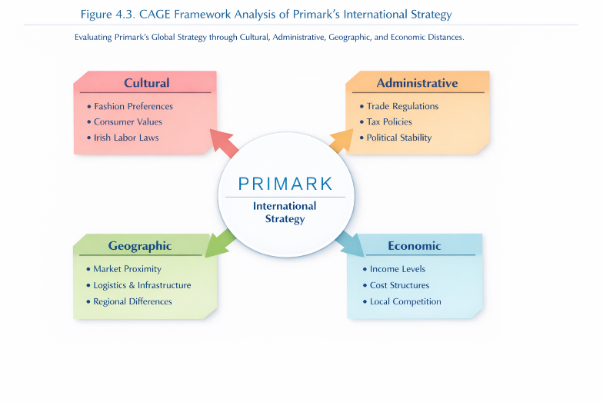
Figure 4 . CAGE Framework Analysis of Primark’s International Strategy. Adapted from Ghemawat (2001) and multinational retail strategy literature (2025–2026).
- Cultural Distance: Ireland has a culture that is greatly similar to the United Kingdom and further western European consumer markets. The predominant language is English and consumer preferences in fashion, retail experience, and brand expectations are relatively coherent.
- Administrative Distance: Administratively speaking, the fact that Ireland is a member of the European Union makes regulatory and institutional barriers a lot less. The single market allows the free flow of goods, services, and capital in the EU, allowing efficient retail operations across borders and integration of supply chains (European Commission, 2024).
- Geographic Distance: In terms of geography, Ireland is conveniently located to other key European markets and has a well-established logistical infrastructure which adds to its appeal. Good transport connections, such as air and sea transport, facilitate the distribution of goods in time and the incorporation into European supply chains.
- Economic Distance: Ireland is a high-income economy with a high consumer purchasing power economically, which presents good conditions to the retail demand. Nevertheless, there are rather high living expenses along with income levels, and the consumers are becoming more price-sensitive due to the inflationary pressure (Central Statistics Office, 2023).
Overall Conclusion
All in all, the CAGE analysis shows that Ireland would be a very appealing market to Primark because of the low cultural and administrative distance, the good geographical location, and the good economic demand. Nevertheless, although these are the benefits, the market is very competitive and expensive.

E. Critical Evaluation
The critical assessment of Primark in the context of the Irish and global fast fashion industry can be characterized by the balanced combination of strategic advantages, structural flaws, new opportunities, and major external threats. This is critical analysis to determine how the firm will be competitive in a very dynamic retailing environment in the long run.
A major strength of Primark is that it has a strong cost leadership strategy; this has been able to enable it to offer very low prices compared with most of its rivals. This pricing strength is especially efficient in the price-sensitive markets like Ireland where inflation and the growing costs of living have pushed consumers to demand inexpensive fashion (Central Statistics Office, 2023).
Nonetheless, even in the context of these strengths, its business model has some significant weaknesses. One of the weaknesses is that Primark has not developed a full-fledged e-commerce channel, which makes it disadvantaged over its competitors like Zara and H&M, who have already adopted digital retail channels effectively. (OECD, 2022).
On the whole, whereas Primark has a good competitive advantage, relying on cost leadership and brand strength, its success in the long term will be determined by its ability to overcome digital constraints and sustainability issues.

5. CONCLUSION
Summing up, the fast fashion retail sector in Ireland exhibits a rather moderately high but quite competitive environment, which is conditioned by globalisation, consumer behaviour changes, and growing sustainability concerns. There is high purchasing power, high income and access to the European Union single market which is beneficial to the industry. Nonetheless, it is also marked with stiff competition, escalating operation costs, and increasing environmental and ethical demands, which all create pressure on competition among companies in the industry.
As demonstrated by the application of the Porters Diamond Model, Ireland has a number of favourable factors in retail competitiveness, namely the availability of skilled labour, good infrastructure and access to associated industries like the logistics and supply chain networks. The demand conditions are rather good because of fashionable customers and high purchasing power, but changing tastes to ethical consumption pose new challenges. Although it has these merits, the industry is appealing but structurally challenging due to factor disadvantages like high labour costs and reliance on global supply chain in restricting overall competitiveness.
The analysis of Primark reveals that the company enjoys a good strategic position in the market as it has costs leadership model and brand recognition. This helps Primark to do well in price sensitive markets and has good consumer demand. Nevertheless, it has considerable structural issues, especially its inability to be digital and its growing sustainability demands, which can derail its competitiveness in the long term.
All in all, how well Primark adapts to digital transformation and how well it can enhance sustainability operations without losing its value propositions of affordability is what will determine its future success.

SECTION 2 – REFLECTION
Using Gibbs’ Reflective Cycle
This part is a reflection of the research process, analysis and preparation of the international business report on the fast fashion retail industry in Ireland with a special emphasis on Primark. The learning experience is evaluated systematically using Gibbs Reflective Cycle which entails description, feelings, evaluation, analysis, conclusion, and action plan.
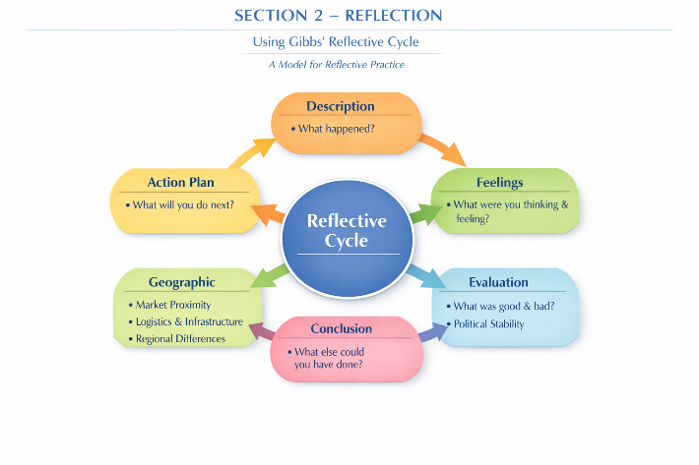
Figure 5 . Gibbs’ Reflective Cycle illustrating six stages of structured reflection. Adapted from Gibbs (1988).

1. Description (Problem Identification)
This worldwide trade report cantered on dissecting the quick design retail industry in Ireland, with Primark as the key multinational company. The task required applying worldwide trade systems such as PESTLE examination, Porter’s Jewel Demonstrate, and CAGE system to assess competitiveness and key positioning.
Amid the method, I confronted a few challenges. The most issue was trouble in applying hypothetical models to real-world information in a critical way. In spite of the fact that I caught on the systems conceptually, I at first battled to associate them with industry measurements and company illustrations. For occasion, Ireland’s retail division contributes approximately 57 billion yearly turnovers and utilizes over 370,000 individuals (CSO, 2023), but coordination such information into basic investigation instead of basic portrayal was challenging.
Another issue was recognizing between clear and basic composing. My early drafts primarily clarified hypotheses rather than assessing them. For illustration, rather than examining how Ireland’s retail reliance on buyer investing increments helplessness to swelling (European Commission, 2024), I at first as it were portrayed the retail segment.
Example: When dissecting Primark, I at first as it were expressed it works in over 400 stores universally (ABF, 2024), without connecting this extension to taken a toll authority methodology or competitive situating.

2. Feelings
At the starting of the task, I felt pushed and questionable due to the complexity of the assignment. The prerequisite to apply numerous systems and compose fundamentally at postgraduate level made me feel overpowered. I was not completely certain around how to connect hypothesis with genuine commerce illustrations such as Primark’s low-cost procedure and Ireland’s retail structure.
In any case, as I advanced, my certainty expanded. I got to be more comfortable examining genuine information, such as Primark working in over 400 stores over 14+ nations (Related British Foods, 2024). This made a difference me get it how hypothesis applies in genuine commerce settings.
In spite of change, I still felt challenged when attempting to type in fundamentally. I regularly found myself clarifying rather than assessing. Be that as it may, I felt spurred as I begun understanding how Porter’s Precious Stone Show clarifies Ireland’s competitive retail advantage through work, request, and EU integration (Doorman, 1990; European Commission, 2024).
Example: Understanding that quick mold contributes about 10% of worldwide carbon outflows (UNEP, 2023) made me more mindful of supportability issues and progressed my basic considering.

3. Evaluation
A few viewpoints of the assignment were fruitful. One major quality was my capacity to utilize dependable information sources such as CSO, OECD, and McKinsey reports. For case, Ireland’s GDP development of around 5.5% in later a long time fortified macroeconomic examination (IMF, 2024).
Another quality was organized investigation utilizing systems. Porter’s Precious stone Demonstrate made a difference assess Ireland’s competitiveness, counting request conditions where Irish buyers spend around 1,000+ per year on clothing per individual (EU Shopper Report,2023).
Another issue was lop-sidedness between portrayal and evaluation. Some segments clarified systems instead of basically applying them to Primark’s procedure.
Example: Rather than dissecting why Zara’s 2-3-week plan cycle makes competitive advantage, I at first as it were portrayed its quick mild demonstrate.

4. Analysis (with Data + Examples)
This task essentially progressed my academic and expository abilities. One key learning result was understanding how information reinforces contentions. For case, Primark’s item estimating beginning from 3-10 in basic clothing lines makes a difference clarify its cost authority technique compared to Zara and H&M (McKinsey & Company, 2023).
I moreover learned how macroeconomic conditions impact trade. For occurrence, Ireland’s expansion rate come to 6-7% in 2023, expanding request for low-cost retailers like Primark (CSO, 2023). This appears how financial weight straightforwardly influences shopper conduct.
From a hypothetical point of view, Porter’s Precious Stone Demonstrate made a difference me distinguish that Ireland’s solid coordination’s foundation and EU participation move forward competitiveness, whereas tall work costs (among the most elevated in Europe) diminish fetched advantage (Eurostat, 2024).
Example: Primark’s nonattendance of full e-commerce limits its computerized competitiveness compared to H&M, which has coordinates online deals into its procedure (H&M Gather, 2024).

5. Conclusion
In conclusion, this task made a difference me create a more profound understanding of universal trade examination and basic considering. I learned that scholarly work must go past portrayal and incorporate assessment supported by real-world information.I moreover figured it out that Primark’s victory is emphatically connected to Ireland’s solid retail segment worth over â57 billion, but too faces auxiliary challenges such as supportability weight and advanced change (CSO, 2023).

6. Action Plan
In order to enhance my academic performance in future business tasks overseas, I have designed a systematic action plan that concentrates on areas of development.
- Enhance Critical Thinking: I will also concentrate on going beyond description by always wondering why and so what when writing.
- Enhance the use of scholarly sources: I will also use more peer-reviewed journals, government publications, and industry publications. This will enhance the quality of my work and make arguments backed by quality evidence.
- Improve Theoretical Framework Usage: To make better use of models like PESTLE, Porters Diamond and CAGE I will practice applying these models directly to real business cases rather than defining them in the vacuum.
- Enhance academic style of writing: I will practice more concise, formal and structured writing. This involves elimination of repetition, better flow of paragraphs and logical development of ideas.
- Develop Time Management Skills: I will divide the research, writing, and editing time so that I can make balanced progress in all parts of assignments and eliminate the need to feel the pressure of time.
- Expand Analytical Depth: I will pay attention to the multi-faceted approach in my analysis, i.e. economic, political, and technological factors, to make my arguments more balanced and sophisticated.
This action plan will assist me in gradually enhancing my writing skills in academic work, analytical skills and general performance in postgraduate business courses.

References
- Associated British Foods (2024) Annual Report. Available at: https://www.abf.co.uk
- Business Insider (2024) Primark Strategy Analysis. Available at: https://www.businessinsider.com
- Central Statistics Office (2023) Background Notes Ireland Retail Economy. Available at: https://www.cso.ie/en/releasesandpublications/ep/p-ire/irelandsretaileconomy2022/backgroundnotes/
- Central Statistics Office (2023) Ireland’s Retail Economy 2022. Available at: https://www.cso.ie/en/releasesandpublications/ep/p- ire/irelandsretaileconomy2022/
- Central Statistics Office (2023) Retail Trade Key Variables. Available at: https://www.cso.ie/en/releasesandpublications/ep/p-ire/irelandsretaileconomy2022/retailtrade/
- Deloitte (2024) Global Retail Outlook. Available at: https://www2.deloitte.com
- Department of Enterprise, Tourism and Employment (2025) Retail Sector in Ireland. Available at: https://enterprise.gov.ie
- Eurostat (2024) Retail Statistics in the EU. Available at: https://ec.europa.eu/eurostat
- European Commission (2024) EU Single Market Overview. Available at: https://commission.europa.eu
- European Commission (2024) Retail Restrictiveness Indicator. Available at: https://ec.europa.eu
- European Environment Agency (2023) Textile Waste and Fast Fashion Impacts. Available at: https://www.eea.europa.eu
- Financial Times (2023) Retail Sector Challenges in Europe. Available at: https://www.ft.com
- H&M Group (2024) Annual Sustainability Report. Available at: https://hmgroup.com
- Inditex (Zara) (2024) Annual Report. Available at: https://www.inditex.com
- International Monetary Fund (2024) Global Economic Outlook. Available at: https://www.imf.org
- KPMG (2023) Future of Retail in Europe. Available at: https://kpmg.com
- McKinsey & Company (2023) Fast Fashion Market Analysis. Available at: https://www.mckinsey.com
- McKinsey & Company (2023) State of Fashion Report. Available at: https://www.mckinsey.com
- OECD (2022) Retail and Digital Transformation Report. Available at: https://www.oecd.org
- OECD (2024) Sustainability in Retail Sector. Available at: https://www.oecd.org
- OECD (2025) Retail Labour and Skills Shortages. Available at: https://www.oecd.org
- Primark (2024) Company Overview. Available at: https://www.primark.co
- Primark (2024) Sustainability Report. Available at: https://www.primark.com
- PwC (2024) Retail and Consumer Insights. Available at: https://www.pwc.com
- Retail Gazette (2023) Fast Fashion Industry Trends. Available at: https://www.retailgazette.co.uk
- Statista (2024) E-commerce Retail Trends. Available at: https://www.statista.com
- Statista (2024) Fast Fashion Industry Overview. Available at: https://www.statista.com
- UK Trade Policy Observatory (2023) Brexit Trade Impacts. Available at: https://blogs.sussex.ac.uk/uktpo
- UNCTAD (2023) Global Retail and Trade Report. Available at: https://unctad.org
- World Bank (2024) Ireland Economic Indicators. Available at: https://www.worldbank.org

